1.5,0.3,1

1 run......

training 1 epoch...

59.66152620315552 seconds used......

1 training finished! average train loss: 0.7345929871905934

evaluating...

Confusion matrix, without normalization

[[104 39 47]

[106 256 53]

[121 15 577]]

Normalized confusion matrix

[[0.54736842 0.20526316 0.24736842]

[0.25542169 0.61686747 0.12771084]

[0.16970547 0.02103787 0.80925666]]

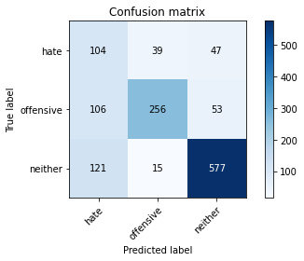

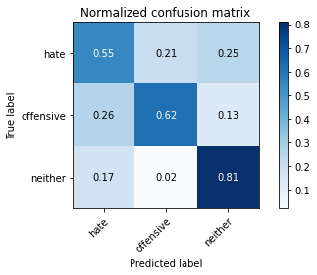

precision recall f1-score support

hate 0.31 0.55 0.40 190

offensive 0.83 0.62 0.71 415

neither 0.85 0.81 0.83 713

accuracy 0.71 1318

macro avg 0.66 0.66 0.65 1318

weighted avg 0.77 0.71 0.73 1318

average eval_loss: 0.6277588045958317, accuracy: 0.7109256449165402

training 2 epoch...

59.48968696594238 seconds used......

2 training finished! average train loss: 0.5182338079268282

evaluating...

Confusion matrix, without normalization

[[134 21 35]

[149 213 53]

[160 5 548]]

Normalized confusion matrix

[[0.70526316 0.11052632 0.18421053]

[0.35903614 0.51325301 0.12771084]

[0.22440393 0.00701262 0.76858345]]

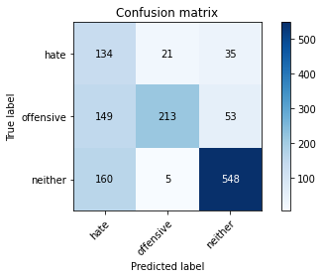

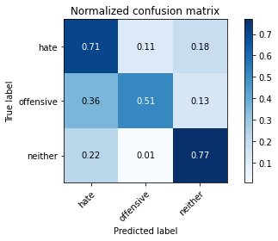

precision recall f1-score support

hate 0.30 0.71 0.42 190

offensive 0.89 0.51 0.65 415

neither 0.86 0.77 0.81 713

accuracy 0.68 1318

macro avg 0.69 0.66 0.63 1318

weighted avg 0.79 0.68 0.71 1318

average eval_loss: 0.5992171357978474, accuracy: 0.6790591805766313

training 3 epoch...

59.515538930892944 seconds used......

3 training finished! average train loss: 0.3295842999931086

evaluating...

Confusion matrix, without normalization

[[132 19 39]

[175 199 41]

[187 6 520]]

Normalized confusion matrix

[[0.69473684 0.1 0.20526316]

[0.42168675 0.47951807 0.09879518]

[0.26227209 0.00841515 0.72931276]]

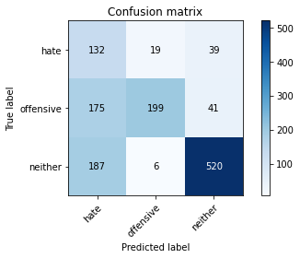

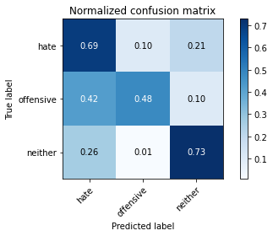

precision recall f1-score support

hate 0.27 0.69 0.39 190

offensive 0.89 0.48 0.62 415

neither 0.87 0.73 0.79 713

accuracy 0.65 1318

macro avg 0.67 0.63 0.60 1318

weighted avg 0.79 0.65 0.68 1318

average eval_loss: 0.7576058525027651, accuracy: 0.6456752655538694

training 4 epoch...

59.576059103012085 seconds used......

4 training finished! average train loss: 0.18416223151778632

evaluating...

Confusion matrix, without normalization

[[ 77 55 58]

[ 59 307 49]

[ 72 37 604]]

Normalized confusion matrix

[[0.40526316 0.28947368 0.30526316]

[0.14216867 0.73975904 0.11807229]

[0.10098177 0.05189341 0.84712482]]

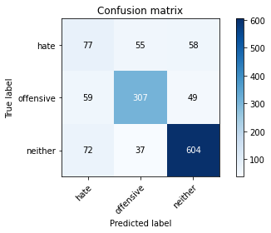

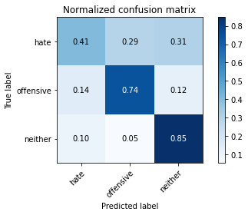

precision recall f1-score support

hate 0.37 0.41 0.39 190

offensive 0.77 0.74 0.75 415

neither 0.85 0.85 0.85 713

accuracy 0.75 1318

macro avg 0.66 0.66 0.66 1318

weighted avg 0.76 0.75 0.75 1318

average eval_loss: 0.8710910497289716, accuracy: 0.7496206373292867

training 5 epoch...

59.56535196304321 seconds used......

5 training finished! average train loss: 0.08859668269816956

evaluating...

Confusion matrix, without normalization

[[105 34 51]

[110 265 40]

[145 39 529]]

Normalized confusion matrix

[[0.55263158 0.17894737 0.26842105]

[0.26506024 0.63855422 0.09638554]

[0.20336606 0.05469846 0.74193548]]

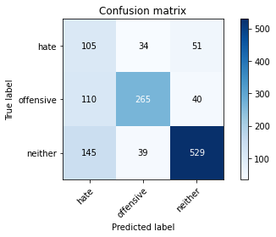

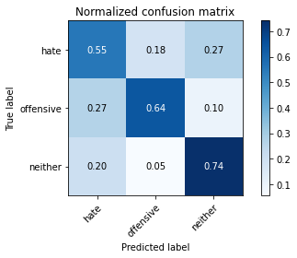

precision recall f1-score support

hate 0.29 0.55 0.38 190

offensive 0.78 0.64 0.70 415

neither 0.85 0.74 0.79 713

accuracy 0.68 1318

macro avg 0.64 0.64 0.63 1318

weighted avg 0.75 0.68 0.71 1318

average eval_loss: 1.0539887845516205, accuracy: 0.6820940819423369

training 6 epoch...

59.48191499710083 seconds used......

6 training finished! average train loss: 0.04844300286071798

evaluating...

Confusion matrix, without normalization

[[ 54 81 55]

[ 39 337 39]

[ 70 84 559]]

Normalized confusion matrix

[[0.28421053 0.42631579 0.28947368]

[0.0939759 0.81204819 0.0939759 ]

[0.09817672 0.11781206 0.78401122]]

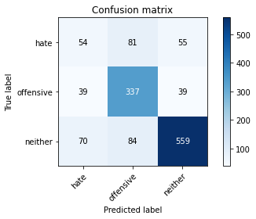

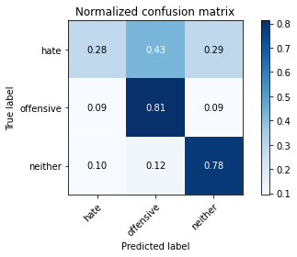

precision recall f1-score support

hate 0.33 0.28 0.31 190

offensive 0.67 0.81 0.74 415

neither 0.86 0.78 0.82 713

accuracy 0.72 1318

macro avg 0.62 0.63 0.62 1318

weighted avg 0.72 0.72 0.72 1318

average eval_loss: 1.5026166556459484, accuracy: 0.7207890743550834

training 7 epoch...

59.505181074142456 seconds used......

7 training finished! average train loss: 0.03908915490372403

evaluating...

Confusion matrix, without normalization

[[ 80 54 56]

[ 71 287 57]

[ 92 41 580]]

Normalized confusion matrix

[[0.42105263 0.28421053 0.29473684]

[0.17108434 0.69156627 0.1373494 ]

[0.12903226 0.05750351 0.81346424]]

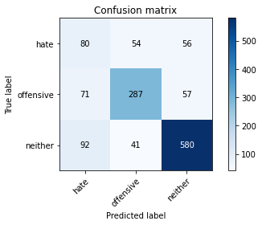

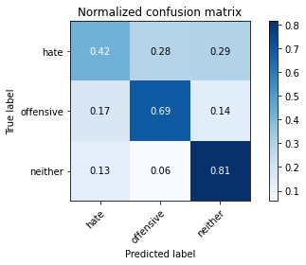

precision recall f1-score support

hate 0.33 0.42 0.37 190

offensive 0.75 0.69 0.72 415

neither 0.84 0.81 0.83 713

accuracy 0.72 1318

macro avg 0.64 0.64 0.64 1318

weighted avg 0.74 0.72 0.73 1318

average eval_loss: 1.1560713770714672, accuracy: 0.7185128983308042

training 8 epoch...

59.5543851852417 seconds used......

8 training finished! average train loss: 0.03837630575971244

evaluating...

Confusion matrix, without normalization

[[ 52 75 63]

[ 38 315 62]

[ 64 58 591]]

Normalized confusion matrix

[[0.27368421 0.39473684 0.33157895]

[0.09156627 0.75903614 0.14939759]

[0.08976157 0.08134642 0.82889201]]

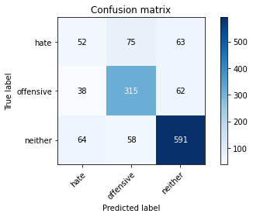

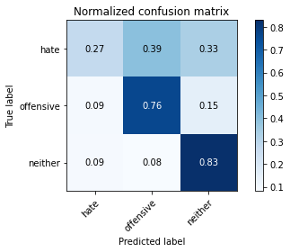

precision recall f1-score support

hate 0.34 0.27 0.30 190

offensive 0.70 0.76 0.73 415

neither 0.83 0.83 0.83 713

accuracy 0.73 1318

macro avg 0.62 0.62 0.62 1318

weighted avg 0.72 0.73 0.72 1318

average eval_loss: 1.3505198874256827, accuracy: 0.7268588770864947

training 9 epoch...

59.54988956451416 seconds used......

9 training finished! average train loss: 0.03500511634946716

evaluating...

Confusion matrix, without normalization

[[ 52 94 44]

[ 32 352 31]

[ 47 140 526]]

Normalized confusion matrix

[[0.27368421 0.49473684 0.23157895]

[0.07710843 0.84819277 0.0746988 ]

[0.06591865 0.19635344 0.73772791]]

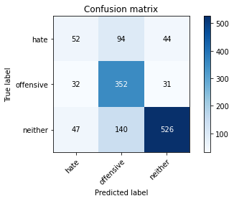

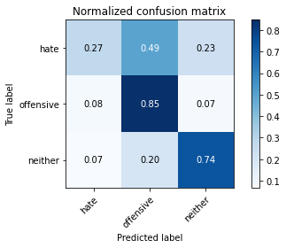

precision recall f1-score support

hate 0.40 0.27 0.32 190

offensive 0.60 0.85 0.70 415

neither 0.88 0.74 0.80 713

accuracy 0.71 1318

macro avg 0.62 0.62 0.61 1318

weighted avg 0.72 0.71 0.70 1318

average eval_loss: 1.8428247670332591, accuracy: 0.7056145675265554

training 10 epoch...

59.505635261535645 seconds used......

10 training finished! average train loss: 0.025196231208313043

evaluating...

Confusion matrix, without normalization

[[ 63 69 58]

[ 46 320 49]

[ 70 65 578]]

Normalized confusion matrix

[[0.33157895 0.36315789 0.30526316]

[0.11084337 0.77108434 0.11807229]

[0.09817672 0.0911641 0.81065919]]

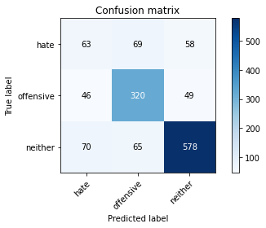

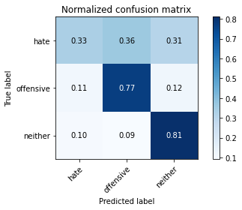

precision recall f1-score support

hate 0.35 0.33 0.34 190

offensive 0.70 0.77 0.74 415

neither 0.84 0.81 0.83 713

accuracy 0.73 1318

macro avg 0.63 0.64 0.63 1318

weighted avg 0.73 0.73 0.73 1318

average eval_loss: 1.5474293259057132, accuracy: 0.7291350531107739

2 run......

training 1 epoch...

59.559731006622314 seconds used......

1 training finished! average train loss: 0.7173278086564757

evaluating...

Confusion matrix, without normalization

[[129 37 24]

[122 273 20]

[193 27 493]]

Normalized confusion matrix

[[0.67894737 0.19473684 0.12631579]

[0.2939759 0.65783133 0.04819277]

[0.27068724 0.03786816 0.6914446 ]]

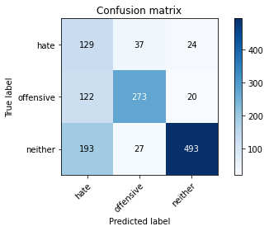

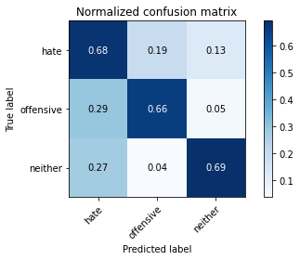

precision recall f1-score support

hate 0.29 0.68 0.41 190

offensive 0.81 0.66 0.73 415

neither 0.92 0.69 0.79 713

accuracy 0.68 1318

macro avg 0.67 0.68 0.64 1318

weighted avg 0.79 0.68 0.71 1318

average eval_loss: 0.6931528697411219, accuracy: 0.6790591805766313

training 2 epoch...

59.555229902267456 seconds used......

2 training finished! average train loss: 0.5158974533731288

evaluating...

Confusion matrix, without normalization

[[147 13 30]

[159 210 46]

[163 6 544]]

Normalized confusion matrix

[[0.77368421 0.06842105 0.15789474]

[0.38313253 0.5060241 0.11084337]

[0.2286115 0.00841515 0.76297335]]

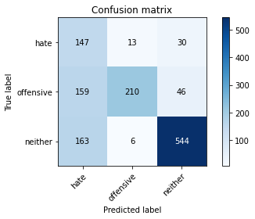

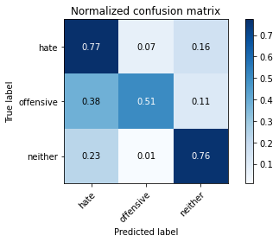

precision recall f1-score support

hate 0.31 0.77 0.45 190

offensive 0.92 0.51 0.65 415

neither 0.88 0.76 0.82 713

accuracy 0.68 1318

macro avg 0.70 0.68 0.64 1318

weighted avg 0.81 0.68 0.71 1318

average eval_loss: 0.6082995926791971, accuracy: 0.6836115326251897

training 3 epoch...

59.525957345962524 seconds used......

3 training finished! average train loss: 0.35027794243598526

evaluating...

Confusion matrix, without normalization

[[108 30 52]

[127 247 41]

[137 19 557]]

Normalized confusion matrix

[[0.56842105 0.15789474 0.27368421]

[0.3060241 0.59518072 0.09879518]

[0.19214586 0.02664797 0.78120617]]

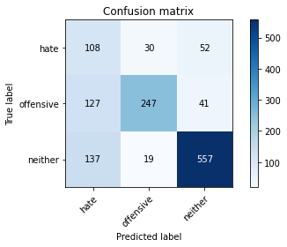

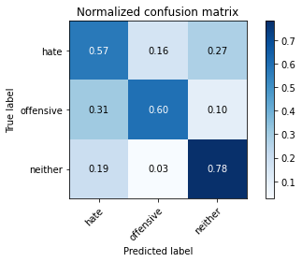

precision recall f1-score support

hate 0.29 0.57 0.38 190

offensive 0.83 0.60 0.69 415

neither 0.86 0.78 0.82 713

accuracy 0.69 1318

macro avg 0.66 0.65 0.63 1318

weighted avg 0.77 0.69 0.72 1318

average eval_loss: 0.7258395755832846, accuracy: 0.6919575113808801

training 4 epoch...

59.51988244056702 seconds used......

4 training finished! average train loss: 0.17519537997008724

evaluating...

Confusion matrix, without normalization

[[ 75 61 54]

[ 48 309 58]

[ 71 44 598]]

Normalized confusion matrix

[[0.39473684 0.32105263 0.28421053]

[0.11566265 0.74457831 0.13975904]

[0.09957924 0.06171108 0.83870968]]

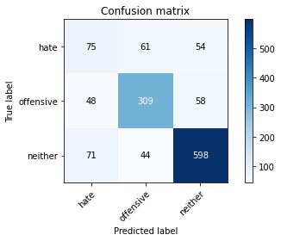

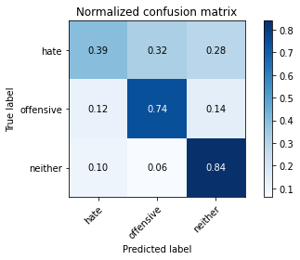

precision recall f1-score support

hate 0.39 0.39 0.39 190

offensive 0.75 0.74 0.75 415

neither 0.84 0.84 0.84 713

accuracy 0.75 1318

macro avg 0.66 0.66 0.66 1318

weighted avg 0.75 0.75 0.75 1318

average eval_loss: 0.9290731951142802, accuracy: 0.7450682852807283

training 5 epoch...

59.536548137664795 seconds used......

5 training finished! average train loss: 0.09748416693288495

evaluating...

Confusion matrix, without normalization

[[ 99 51 40]

[ 76 303 36]

[145 52 516]]

Normalized confusion matrix

[[0.52105263 0.26842105 0.21052632]

[0.18313253 0.73012048 0.08674699]

[0.20336606 0.07293128 0.72370266]]

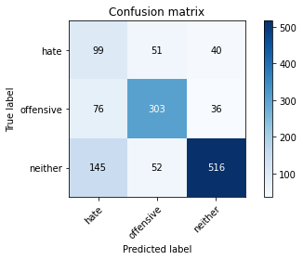

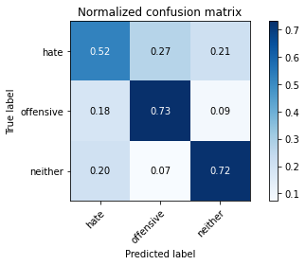

precision recall f1-score support

hate 0.31 0.52 0.39 190

offensive 0.75 0.73 0.74 415

neither 0.87 0.72 0.79 713

accuracy 0.70 1318

macro avg 0.64 0.66 0.64 1318

weighted avg 0.75 0.70 0.72 1318

average eval_loss: 1.2118755732521866, accuracy: 0.6965098634294385

training 6 epoch...

59.42140054702759 seconds used......

6 training finished! average train loss: 0.056041872360616585

evaluating...

Confusion matrix, without normalization

[[ 63 80 47]

[ 33 342 40]

[108 75 530]]

Normalized confusion matrix

[[0.33157895 0.42105263 0.24736842]

[0.07951807 0.82409639 0.09638554]

[0.15147265 0.10518934 0.74333801]]

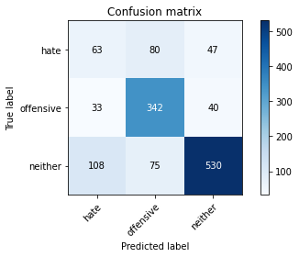

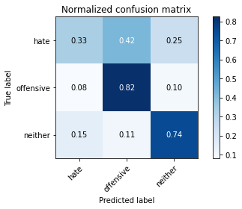

precision recall f1-score support

hate 0.31 0.33 0.32 190

offensive 0.69 0.82 0.75 415

neither 0.86 0.74 0.80 713

accuracy 0.71 1318

macro avg 0.62 0.63 0.62 1318

weighted avg 0.73 0.71 0.71 1318

average eval_loss: 1.4149945197683391, accuracy: 0.7094081942336874

training 7 epoch...

59.492130756378174 seconds used......

7 training finished! average train loss: 0.03628131364794998

evaluating...

Confusion matrix, without normalization

[[ 80 81 29]

[ 47 341 27]

[131 92 490]]

Normalized confusion matrix

[[0.42105263 0.42631579 0.15263158]

[0.11325301 0.82168675 0.06506024]

[0.18373072 0.12903226 0.68723703]]

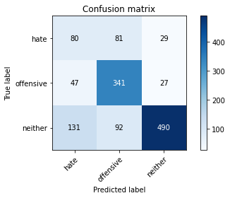

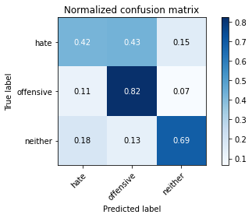

precision recall f1-score support

hate 0.31 0.42 0.36 190

offensive 0.66 0.82 0.73 415

neither 0.90 0.69 0.78 713

accuracy 0.69 1318

macro avg 0.62 0.64 0.62 1318

weighted avg 0.74 0.69 0.70 1318

average eval_loss: 1.6728847523530324, accuracy: 0.6911987860394537

training 8 epoch...

59.55412721633911 seconds used......

8 training finished! average train loss: 0.030743741465795955

evaluating...

Confusion matrix, without normalization

[[ 81 72 37]

[ 49 333 33]

[105 84 524]]

Normalized confusion matrix

[[0.42631579 0.37894737 0.19473684]

[0.11807229 0.80240964 0.07951807]

[0.14726508 0.11781206 0.73492286]]

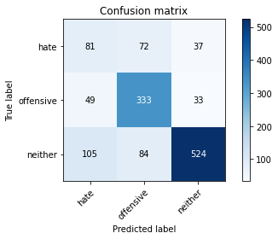

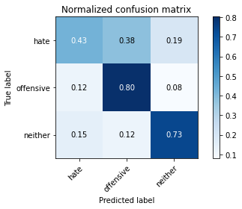

precision recall f1-score support

hate 0.34 0.43 0.38 190

offensive 0.68 0.80 0.74 415

neither 0.88 0.73 0.80 713

accuracy 0.71 1318

macro avg 0.64 0.65 0.64 1318

weighted avg 0.74 0.71 0.72 1318

average eval_loss: 1.6147798561688624, accuracy: 0.7116843702579666

training 9 epoch...

59.48981165885925 seconds used......

9 training finished! average train loss: 0.022164902711467056

evaluating...

Confusion matrix, without normalization

[[ 85 49 56]

[ 73 285 57]

[100 33 580]]

Normalized confusion matrix

[[0.44736842 0.25789474 0.29473684]

[0.17590361 0.68674699 0.1373494 ]

[0.14025245 0.04628331 0.81346424]]

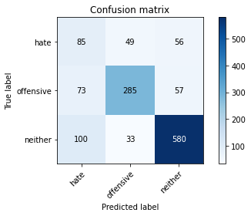

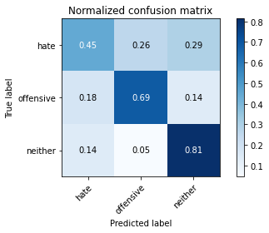

precision recall f1-score support

hate 0.33 0.45 0.38 190

offensive 0.78 0.69 0.73 415

neither 0.84 0.81 0.83 713

accuracy 0.72 1318

macro avg 0.65 0.65 0.64 1318

weighted avg 0.74 0.72 0.73 1318

average eval_loss: 1.462726744512717, accuracy: 0.7207890743550834

training 10 epoch...

59.4890456199646 seconds used......

10 training finished! average train loss: 0.02089882619250354

evaluating...

Confusion matrix, without normalization

[[ 61 81 48]

[ 36 329 50]

[ 70 80 563]]

Normalized confusion matrix

[[0.32105263 0.42631579 0.25263158]

[0.08674699 0.79277108 0.12048193]

[0.09817672 0.11220196 0.78962132]]

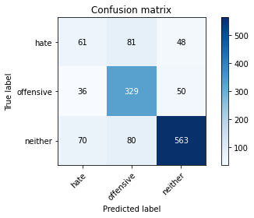

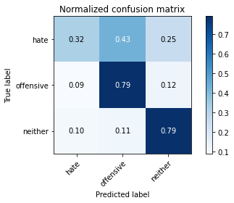

precision recall f1-score support

hate 0.37 0.32 0.34 190

offensive 0.67 0.79 0.73 415

neither 0.85 0.79 0.82 713

accuracy 0.72 1318

macro avg 0.63 0.63 0.63 1318

weighted avg 0.72 0.72 0.72 1318

average eval_loss: 1.7336967370726846, accuracy: 0.7230652503793626

3 run......

training 1 epoch...

59.49498724937439 seconds used......

1 training finished! average train loss: 0.7205034646120938

evaluating...

Confusion matrix, without normalization

[[115 28 47]

[119 247 49]

[119 8 586]]

Normalized confusion matrix

[[0.60526316 0.14736842 0.24736842]

[0.28674699 0.59518072 0.11807229]

[0.16690042 0.0112202 0.82187938]]

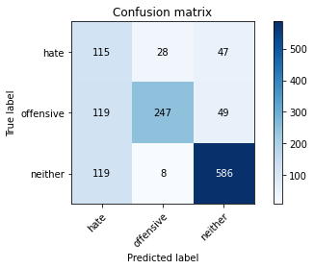

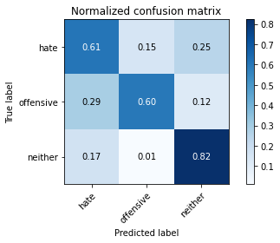

precision recall f1-score support

hate 0.33 0.61 0.42 190

offensive 0.87 0.60 0.71 415

neither 0.86 0.82 0.84 713

accuracy 0.72 1318

macro avg 0.69 0.67 0.66 1318

weighted avg 0.79 0.72 0.74 1318

average eval_loss: 0.6025539907542142, accuracy: 0.7192716236722306

training 2 epoch...

59.513965129852295 seconds used......

2 training finished! average train loss: 0.518452545797283

evaluating...

Confusion matrix, without normalization

[[120 22 48]

[148 207 60]

[132 5 576]]

Normalized confusion matrix

[[0.63157895 0.11578947 0.25263158]

[0.35662651 0.49879518 0.14457831]

[0.18513324 0.00701262 0.80785414]]

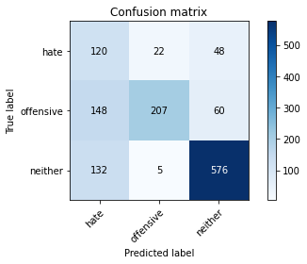

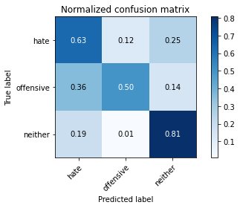

precision recall f1-score support

hate 0.30 0.63 0.41 190

offensive 0.88 0.50 0.64 415

neither 0.84 0.81 0.82 713

accuracy 0.69 1318

macro avg 0.68 0.65 0.62 1318

weighted avg 0.78 0.69 0.71 1318

average eval_loss: 0.5987281212300966, accuracy: 0.6851289833080425

training 3 epoch...

59.516974449157715 seconds used......

3 training finished! average train loss: 0.3418975127606907

evaluating...

Confusion matrix, without normalization

[[ 99 47 44]

[ 71 292 52]

[111 31 571]]

Normalized confusion matrix

[[0.52105263 0.24736842 0.23157895]

[0.17108434 0.70361446 0.1253012 ]

[0.15568022 0.04347826 0.80084151]]

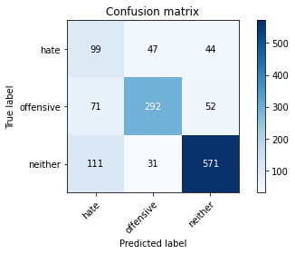

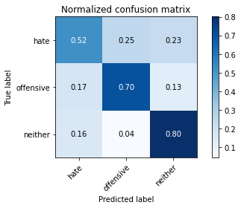

precision recall f1-score support

hate 0.35 0.52 0.42 190

offensive 0.79 0.70 0.74 415

neither 0.86 0.80 0.83 713

accuracy 0.73 1318

macro avg 0.67 0.68 0.66 1318

weighted avg 0.76 0.73 0.74 1318

average eval_loss: 0.7278033786199309, accuracy: 0.7298937784522003

training 4 epoch...

59.42319703102112 seconds used......

4 training finished! average train loss: 0.17465605903416873

evaluating...

Confusion matrix, without normalization

[[ 99 41 50]

[ 88 286 41]

[135 26 552]]

Normalized confusion matrix

[[0.52105263 0.21578947 0.26315789]

[0.21204819 0.68915663 0.09879518]

[0.18934081 0.03646564 0.77419355]]

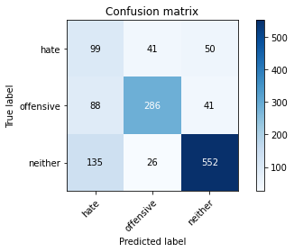

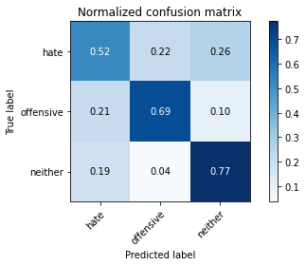

precision recall f1-score support

hate 0.31 0.52 0.39 190

offensive 0.81 0.69 0.74 415

neither 0.86 0.77 0.81 713

accuracy 0.71 1318

macro avg 0.66 0.66 0.65 1318

weighted avg 0.76 0.71 0.73 1318

average eval_loss: 0.9037662446498871, accuracy: 0.7109256449165402

training 5 epoch...

59.44086813926697 seconds used......

5 training finished! average train loss: 0.09740905764893713

evaluating...

Confusion matrix, without normalization

[[ 73 71 46]

[ 50 329 36]

[ 81 79 553]]

Normalized confusion matrix

[[0.38421053 0.37368421 0.24210526]

[0.12048193 0.79277108 0.08674699]

[0.11360449 0.11079944 0.77559607]]

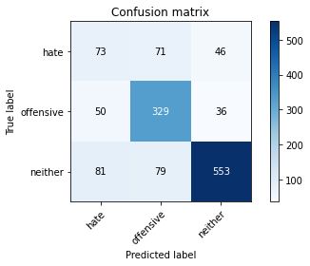

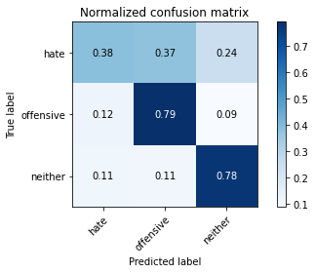

precision recall f1-score support

hate 0.36 0.38 0.37 190

offensive 0.69 0.79 0.74 415

neither 0.87 0.78 0.82 713

accuracy 0.72 1318

macro avg 0.64 0.65 0.64 1318

weighted avg 0.74 0.72 0.73 1318

average eval_loss: 1.2551273143652715, accuracy: 0.7245827010622155

training 6 epoch...

59.4944794178009 seconds used......

6 training finished! average train loss: 0.055032117660051554

evaluating...

Confusion matrix, without normalization

[[ 22 80 88]

[ 23 325 67]

[ 39 63 611]]

Normalized confusion matrix

[[0.11578947 0.42105263 0.46315789]

[0.05542169 0.78313253 0.16144578]

[0.05469846 0.08835905 0.8569425 ]]

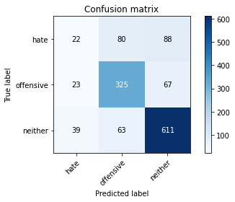

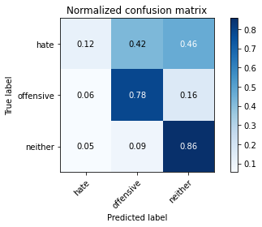

precision recall f1-score support

hate 0.26 0.12 0.16 190

offensive 0.69 0.78 0.74 415

neither 0.80 0.86 0.83 713

accuracy 0.73 1318

macro avg 0.58 0.59 0.57 1318

weighted avg 0.69 0.73 0.70 1318

average eval_loss: 1.5645017813552509, accuracy: 0.7268588770864947

training 7 epoch...

59.44450616836548 seconds used......

7 training finished! average train loss: 0.044318150550084694

evaluating...

Confusion matrix, without normalization

[[ 74 60 56]

[ 59 307 49]

[ 78 66 569]]

Normalized confusion matrix

[[0.38947368 0.31578947 0.29473684]

[0.14216867 0.73975904 0.11807229]

[0.10939691 0.09256662 0.79803647]]

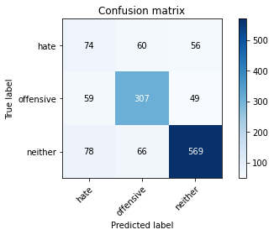

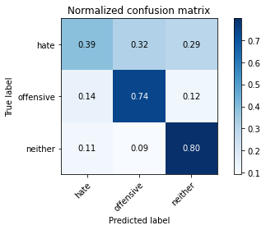

precision recall f1-score support

hate 0.35 0.39 0.37 190

offensive 0.71 0.74 0.72 415

neither 0.84 0.80 0.82 713

accuracy 0.72 1318

macro avg 0.63 0.64 0.64 1318

weighted avg 0.73 0.72 0.73 1318

average eval_loss: 1.334330406604391, accuracy: 0.7207890743550834

training 8 epoch...

59.4961953163147 seconds used......

8 training finished! average train loss: 0.03237767057937824

evaluating...

Confusion matrix, without normalization

[[ 45 63 82]

[ 35 301 79]

[ 40 41 632]]

Normalized confusion matrix

[[0.23684211 0.33157895 0.43157895]

[0.08433735 0.7253012 0.19036145]

[0.05610098 0.05750351 0.88639551]]

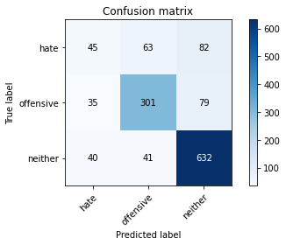

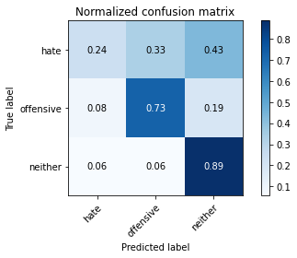

precision recall f1-score support

hate 0.38 0.24 0.29 190

offensive 0.74 0.73 0.73 415

neither 0.80 0.89 0.84 713

accuracy 0.74 1318

macro avg 0.64 0.62 0.62 1318

weighted avg 0.72 0.74 0.73 1318

average eval_loss: 1.6247849143815762, accuracy: 0.7420333839150227

training 9 epoch...

59.51593804359436 seconds used......

9 training finished! average train loss: 0.029054760497687807

evaluating...

Confusion matrix, without normalization

[[ 77 77 36]

[ 60 324 31]

[111 97 505]]

Normalized confusion matrix

[[0.40526316 0.40526316 0.18947368]

[0.14457831 0.78072289 0.0746988 ]

[0.15568022 0.13604488 0.70827489]]

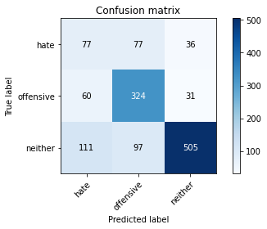

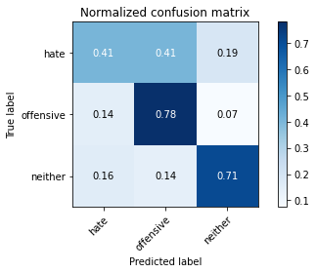

precision recall f1-score support

hate 0.31 0.41 0.35 190

offensive 0.65 0.78 0.71 415

neither 0.88 0.71 0.79 713

accuracy 0.69 1318

macro avg 0.61 0.63 0.62 1318

weighted avg 0.73 0.69 0.70 1318

average eval_loss: 1.6694285508358118, accuracy: 0.6874051593323217

training 10 epoch...

59.51408004760742 seconds used......

10 training finished! average train loss: 0.02500118829964115

evaluating...

Confusion matrix, without normalization

[[ 48 69 73]

[ 45 311 59]

[ 50 51 612]]

Normalized confusion matrix

[[0.25263158 0.36315789 0.38421053]

[0.10843373 0.74939759 0.14216867]

[0.07012623 0.07152875 0.85834502]]

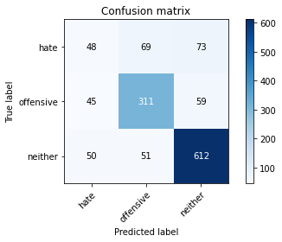

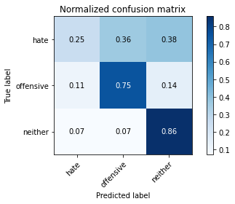

precision recall f1-score support

hate 0.34 0.25 0.29 190

offensive 0.72 0.75 0.74 415

neither 0.82 0.86 0.84 713

accuracy 0.74 1318

macro avg 0.63 0.62 0.62 1318

weighted avg 0.72 0.74 0.73 1318

average eval_loss: 1.7159345574451215, accuracy: 0.7367223065250379

4 run......

training 1 epoch...

59.53750944137573 seconds used......

1 training finished! average train loss: 0.7217776711691509

evaluating...

Confusion matrix, without normalization

[[157 12 21]

[200 191 24]

[243 6 464]]

Normalized confusion matrix

[[0.82631579 0.06315789 0.11052632]

[0.48192771 0.46024096 0.05783133]

[0.34081346 0.00841515 0.65077139]]

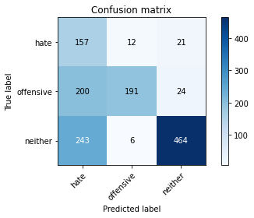

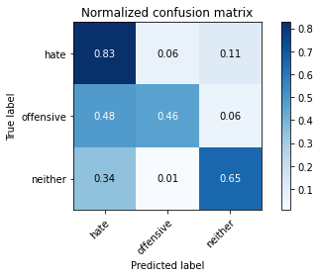

precision recall f1-score support

hate 0.26 0.83 0.40 190

offensive 0.91 0.46 0.61 415

neither 0.91 0.65 0.76 713

accuracy 0.62 1318

macro avg 0.70 0.65 0.59 1318

weighted avg 0.82 0.62 0.66 1318

average eval_loss: 0.689684656533328, accuracy: 0.6160849772382397

training 2 epoch...

59.56895303726196 seconds used......

2 training finished! average train loss: 0.533045626363971

evaluating...

Confusion matrix, without normalization

[[110 27 53]

[ 98 262 55]

[112 22 579]]

Normalized confusion matrix

[[0.57894737 0.14210526 0.27894737]

[0.23614458 0.6313253 0.13253012]

[0.15708275 0.03085554 0.81206171]]

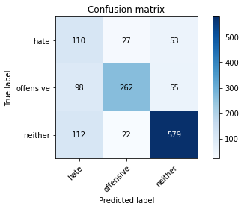

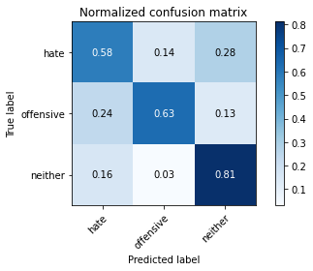

precision recall f1-score support

hate 0.34 0.58 0.43 190

offensive 0.84 0.63 0.72 415

neither 0.84 0.81 0.83 713

accuracy 0.72 1318

macro avg 0.68 0.67 0.66 1318

weighted avg 0.77 0.72 0.74 1318

average eval_loss: 0.6085632411819516, accuracy: 0.7215477996965098

training 3 epoch...

59.57597088813782 seconds used......

3 training finished! average train loss: 0.34576572051102467

evaluating...

Confusion matrix, without normalization

[[ 72 42 76]

[ 72 272 71]

[ 63 27 623]]

Normalized confusion matrix

[[0.37894737 0.22105263 0.4 ]

[0.17349398 0.65542169 0.17108434]

[0.08835905 0.03786816 0.87377279]]

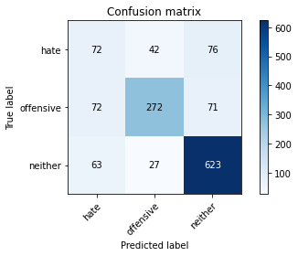

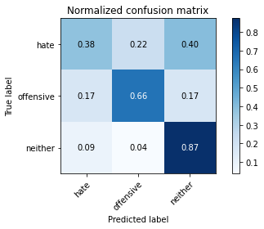

precision recall f1-score support

hate 0.35 0.38 0.36 190

offensive 0.80 0.66 0.72 415

neither 0.81 0.87 0.84 713

accuracy 0.73 1318

macro avg 0.65 0.64 0.64 1318

weighted avg 0.74 0.73 0.73 1318

average eval_loss: 0.7300075125513654, accuracy: 0.7336874051593323

training 4 epoch...

59.47426772117615 seconds used......

4 training finished! average train loss: 0.19448961861092937

evaluating...

Confusion matrix, without normalization

[[ 83 42 65]

[ 95 263 57]

[101 31 581]]

Normalized confusion matrix

[[0.43684211 0.22105263 0.34210526]

[0.22891566 0.63373494 0.1373494 ]

[0.14165498 0.04347826 0.81486676]]

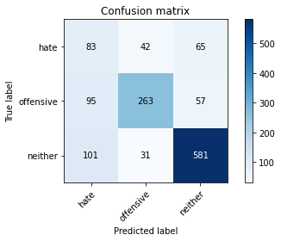

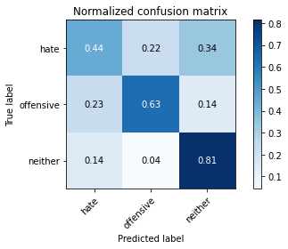

precision recall f1-score support

hate 0.30 0.44 0.35 190

offensive 0.78 0.63 0.70 415

neither 0.83 0.81 0.82 713

accuracy 0.70 1318

macro avg 0.64 0.63 0.62 1318

weighted avg 0.74 0.70 0.72 1318

average eval_loss: 0.8821545123602405, accuracy: 0.7033383915022762

training 5 epoch...

59.53948497772217 seconds used......

5 training finished! average train loss: 0.10161397129466587

evaluating...

Confusion matrix, without normalization

[[ 74 45 71]

[ 68 274 73]

[ 63 37 613]]

Normalized confusion matrix

[[0.38947368 0.23684211 0.37368421]

[0.16385542 0.66024096 0.17590361]

[0.08835905 0.05189341 0.85974755]]

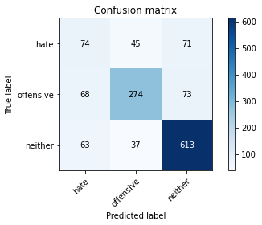

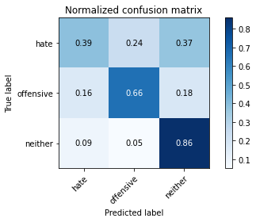

precision recall f1-score support

hate 0.36 0.39 0.37 190

offensive 0.77 0.66 0.71 415

neither 0.81 0.86 0.83 713

accuracy 0.73 1318

macro avg 0.65 0.64 0.64 1318

weighted avg 0.73 0.73 0.73 1318

average eval_loss: 0.9424177573034258, accuracy: 0.7291350531107739

training 6 epoch...

59.53245782852173 seconds used......

6 training finished! average train loss: 0.056972697950814936

evaluating...

Confusion matrix, without normalization

[[ 30 93 67]

[ 22 332 61]

[ 28 83 602]]

Normalized confusion matrix

[[0.15789474 0.48947368 0.35263158]

[0.05301205 0.8 0.14698795]

[0.03927069 0.11640954 0.84431978]]

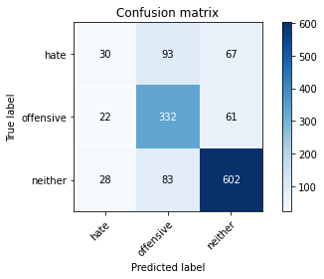

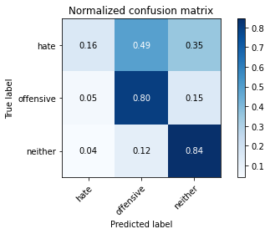

precision recall f1-score support

hate 0.38 0.16 0.22 190

offensive 0.65 0.80 0.72 415

neither 0.82 0.84 0.83 713

accuracy 0.73 1318

macro avg 0.62 0.60 0.59 1318

weighted avg 0.71 0.73 0.71 1318

average eval_loss: 1.5495972710125374, accuracy: 0.7314112291350531

training 7 epoch...

59.50442028045654 seconds used......

7 training finished! average train loss: 0.04000390634120611

evaluating...

Confusion matrix, without normalization

[[ 52 73 65]

[ 39 313 63]

[ 53 79 581]]

Normalized confusion matrix

[[0.27368421 0.38421053 0.34210526]

[0.0939759 0.75421687 0.15180723]

[0.0743338 0.11079944 0.81486676]]

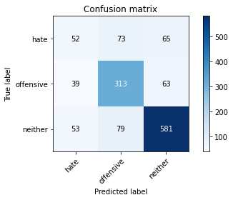

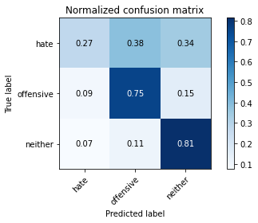

precision recall f1-score support

hate 0.36 0.27 0.31 190

offensive 0.67 0.75 0.71 415

neither 0.82 0.81 0.82 713

accuracy 0.72 1318

macro avg 0.62 0.61 0.61 1318

weighted avg 0.71 0.72 0.71 1318

average eval_loss: 1.4140369273496396, accuracy: 0.7177541729893778

training 8 epoch...

59.533212661743164 seconds used......

8 training finished! average train loss: 0.028981573848233726

evaluating...

Confusion matrix, without normalization

[[ 46 83 61]

[ 40 320 55]

[ 47 87 579]]

Normalized confusion matrix

[[0.24210526 0.43684211 0.32105263]

[0.09638554 0.77108434 0.13253012]

[0.06591865 0.12201964 0.81206171]]

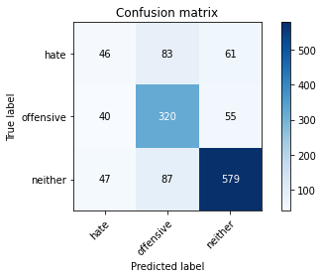

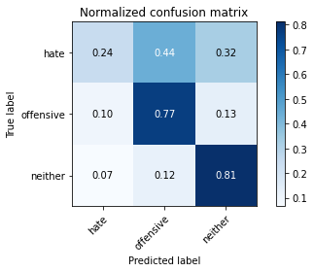

precision recall f1-score support

hate 0.35 0.24 0.28 190

offensive 0.65 0.77 0.71 415

neither 0.83 0.81 0.82 713

accuracy 0.72 1318

macro avg 0.61 0.61 0.60 1318

weighted avg 0.71 0.72 0.71 1318

average eval_loss: 1.6781329142324852, accuracy: 0.7169954476479514

training 9 epoch...

59.51596975326538 seconds used......

9 training finished! average train loss: 0.024130663928570523

evaluating...

Confusion matrix, without normalization

[[ 61 71 58]

[ 49 308 58]

[ 50 62 601]]

Normalized confusion matrix

[[0.32105263 0.37368421 0.30526316]

[0.11807229 0.74216867 0.13975904]

[0.07012623 0.08695652 0.84291725]]

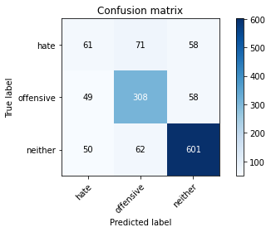

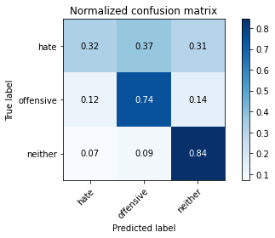

precision recall f1-score support

hate 0.38 0.32 0.35 190

offensive 0.70 0.74 0.72 415

neither 0.84 0.84 0.84 713

accuracy 0.74 1318

macro avg 0.64 0.64 0.64 1318

weighted avg 0.73 0.74 0.73 1318

average eval_loss: 1.5548438118262724, accuracy: 0.7359635811836115

training 10 epoch...

59.48542237281799 seconds used......

10 training finished! average train loss: 0.02288010398730297

evaluating...

Confusion matrix, without normalization

[[ 90 47 53]

[ 69 279 67]

[ 86 36 591]]

Normalized confusion matrix

[[0.47368421 0.24736842 0.27894737]

[0.16626506 0.67228916 0.16144578]

[0.12061711 0.05049088 0.82889201]]

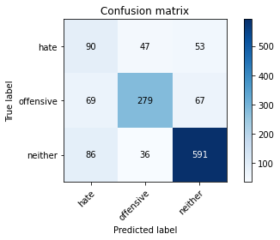

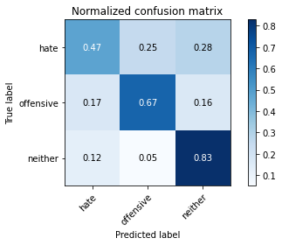

precision recall f1-score support

hate 0.37 0.47 0.41 190

offensive 0.77 0.67 0.72 415

neither 0.83 0.83 0.83 713

accuracy 0.73 1318

macro avg 0.66 0.66 0.65 1318

weighted avg 0.75 0.73 0.73 1318

average eval_loss: 1.3218680814360126, accuracy: 0.7283763277693475

5 run......

training 1 epoch...

59.45107078552246 seconds used......

1 training finished! average train loss: 0.7131709891964089

evaluating...

Confusion matrix, without normalization

[[ 97 17 76]

[121 195 99]

[ 57 5 651]]

Normalized confusion matrix

[[0.51052632 0.08947368 0.4 ]

[0.29156627 0.46987952 0.23855422]

[0.0799439 0.00701262 0.91304348]]

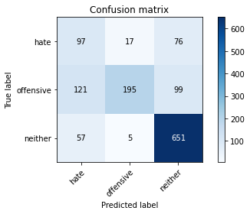

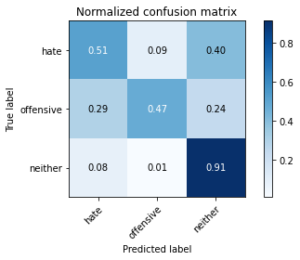

precision recall f1-score support

hate 0.35 0.51 0.42 190

offensive 0.90 0.47 0.62 415

neither 0.79 0.91 0.85 713

accuracy 0.72 1318

macro avg 0.68 0.63 0.63 1318

weighted avg 0.76 0.72 0.71 1318

average eval_loss: 0.5708456901889859, accuracy: 0.7154779969650986

training 2 epoch...

59.49587655067444 seconds used......

2 training finished! average train loss: 0.5098743625662544

evaluating...

Confusion matrix, without normalization

[[ 89 25 76]

[ 86 225 104]

[ 48 5 660]]

Normalized confusion matrix

[[0.46842105 0.13157895 0.4 ]

[0.20722892 0.54216867 0.25060241]

[0.06732118 0.00701262 0.9256662 ]]

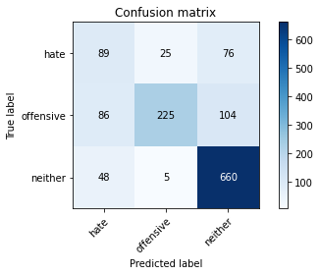

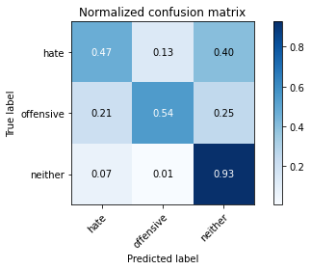

precision recall f1-score support

hate 0.40 0.47 0.43 190

offensive 0.88 0.54 0.67 415

neither 0.79 0.93 0.85 713

accuracy 0.74 1318

macro avg 0.69 0.65 0.65 1318

weighted avg 0.76 0.74 0.73 1318

average eval_loss: 0.5822133399320372, accuracy: 0.7389984825493171

training 3 epoch...

59.478352785110474 seconds used......

3 training finished! average train loss: 0.3275122309696268

evaluating...

Confusion matrix, without normalization

[[ 51 58 81]

[ 34 305 76]

[ 53 32 628]]

Normalized confusion matrix

[[0.26842105 0.30526316 0.42631579]

[0.08192771 0.73493976 0.18313253]

[0.0743338 0.04488079 0.88078541]]

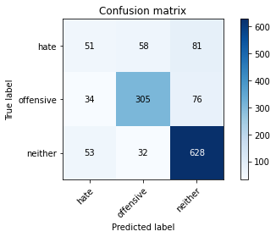

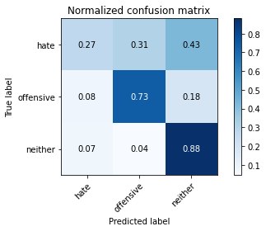

precision recall f1-score support

hate 0.37 0.27 0.31 190

offensive 0.77 0.73 0.75 415

neither 0.80 0.88 0.84 713

accuracy 0.75 1318

macro avg 0.65 0.63 0.63 1318

weighted avg 0.73 0.75 0.74 1318

average eval_loss: 0.8274639354962291, accuracy: 0.7465857359635811

training 4 epoch...

59.49128842353821 seconds used......

4 training finished! average train loss: 0.1731396644503217

evaluating...

Confusion matrix, without normalization

[[104 40 46]

[ 87 290 38]

[121 42 550]]

Normalized confusion matrix

[[0.54736842 0.21052632 0.24210526]

[0.20963855 0.69879518 0.09156627]

[0.16970547 0.05890603 0.7713885 ]]

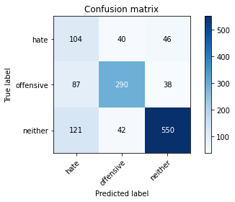

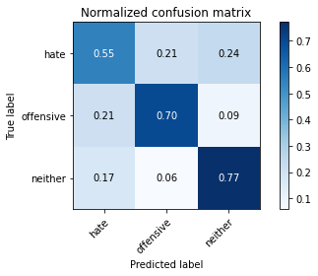

precision recall f1-score support

hate 0.33 0.55 0.41 190

offensive 0.78 0.70 0.74 415

neither 0.87 0.77 0.82 713

accuracy 0.72 1318

macro avg 0.66 0.67 0.66 1318

weighted avg 0.76 0.72 0.73 1318

average eval_loss: 1.0093736982706822, accuracy: 0.716236722306525

training 5 epoch...

59.51520490646362 seconds used......

5 training finished! average train loss: 0.1032315594366413

evaluating...

Confusion matrix, without normalization

[[ 59 70 61]

[ 38 324 53]

[ 69 64 580]]

Normalized confusion matrix

[[0.31052632 0.36842105 0.32105263]

[0.09156627 0.78072289 0.12771084]

[0.09677419 0.08976157 0.81346424]]

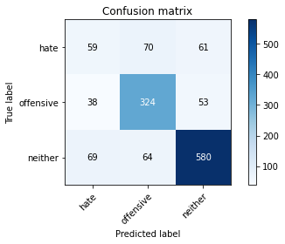

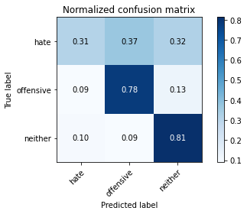

precision recall f1-score support

hate 0.36 0.31 0.33 190

offensive 0.71 0.78 0.74 415

neither 0.84 0.81 0.82 713

accuracy 0.73 1318

macro avg 0.63 0.63 0.63 1318

weighted avg 0.73 0.73 0.73 1318

average eval_loss: 1.307108385996385, accuracy: 0.7306525037936267

training 6 epoch...

59.49854564666748 seconds used......

6 training finished! average train loss: 0.05861479383628731

evaluating...

Confusion matrix, without normalization

[[ 71 52 67]

[ 63 295 57]

[ 88 39 586]]

Normalized confusion matrix

[[0.37368421 0.27368421 0.35263158]

[0.15180723 0.71084337 0.1373494 ]

[0.12342216 0.05469846 0.82187938]]

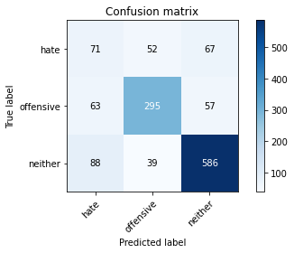

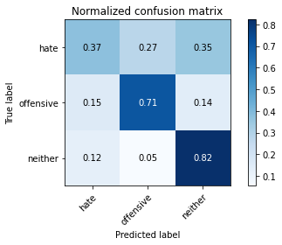

precision recall f1-score support

hate 0.32 0.37 0.34 190

offensive 0.76 0.71 0.74 415

neither 0.83 0.82 0.82 713

accuracy 0.72 1318

macro avg 0.64 0.64 0.63 1318

weighted avg 0.73 0.72 0.73 1318

average eval_loss: 1.2816668446316863, accuracy: 0.7223065250379362

training 7 epoch...

59.518455028533936 seconds used......

7 training finished! average train loss: 0.03686929328118409

evaluating...

Confusion matrix, without normalization

[[ 50 77 63]

[ 34 325 56]

[ 57 58 598]]

Normalized confusion matrix

[[0.26315789 0.40526316 0.33157895]

[0.08192771 0.78313253 0.13493976]

[0.0799439 0.08134642 0.83870968]]

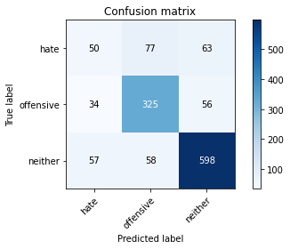

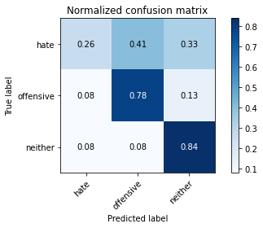

precision recall f1-score support

hate 0.35 0.26 0.30 190

offensive 0.71 0.78 0.74 415

neither 0.83 0.84 0.84 713

accuracy 0.74 1318

macro avg 0.63 0.63 0.63 1318

weighted avg 0.72 0.74 0.73 1318

average eval_loss: 1.574937302054781, accuracy: 0.7382397572078907

training 8 epoch...

59.57622790336609 seconds used......

8 training finished! average train loss: 0.0320999205250039

evaluating...

Confusion matrix, without normalization

[[ 43 73 74]

[ 28 322 65]

[ 43 57 613]]

Normalized confusion matrix

[[0.22631579 0.38421053 0.38947368]

[0.06746988 0.77590361 0.15662651]

[0.06030856 0.0799439 0.85974755]]

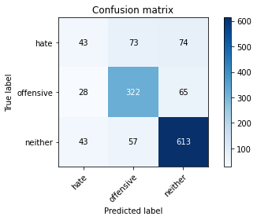

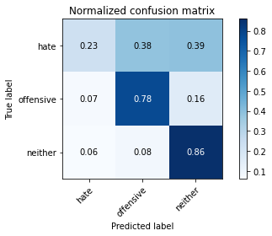

precision recall f1-score support

hate 0.38 0.23 0.28 190

offensive 0.71 0.78 0.74 415

neither 0.82 0.86 0.84 713

accuracy 0.74 1318

macro avg 0.63 0.62 0.62 1318

weighted avg 0.72 0.74 0.73 1318

average eval_loss: 1.570321317875024, accuracy: 0.7420333839150227

training 9 epoch...

59.501697301864624 seconds used......

9 training finished! average train loss: 0.020908938052062613

evaluating...

Confusion matrix, without normalization

[[ 65 67 58]

[ 38 316 61]

[ 68 51 594]]

Normalized confusion matrix

[[0.34210526 0.35263158 0.30526316]

[0.09156627 0.76144578 0.14698795]

[0.09537167 0.07152875 0.83309958]]

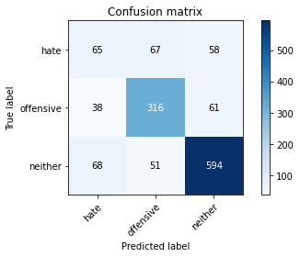

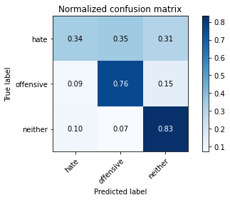

precision recall f1-score support

hate 0.38 0.34 0.36 190

offensive 0.73 0.76 0.74 415

neither 0.83 0.83 0.83 713

accuracy 0.74 1318

macro avg 0.65 0.65 0.65 1318

weighted avg 0.73 0.74 0.74 1318

average eval_loss: 1.5423878765467443, accuracy: 0.7397572078907435

training 10 epoch...

59.60946774482727 seconds used......

10 training finished! average train loss: 0.015486132254706965

evaluating...

Confusion matrix, without normalization

[[ 39 86 65]

[ 25 337 53]

[ 41 83 589]]

Normalized confusion matrix

[[0.20526316 0.45263158 0.34210526]

[0.06024096 0.81204819 0.12771084]

[0.05750351 0.11640954 0.82608696]]

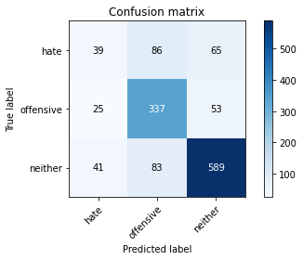

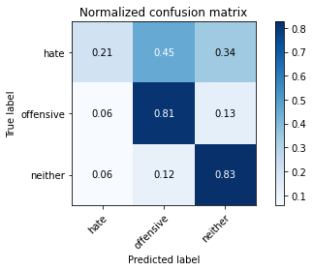

precision recall f1-score support

hate 0.37 0.21 0.26 190

offensive 0.67 0.81 0.73 415

neither 0.83 0.83 0.83 713

accuracy 0.73 1318

macro avg 0.62 0.61 0.61 1318

weighted avg 0.71 0.73 0.72 1318

average eval_loss: 1.875770777463913, accuracy: 0.7321699544764795