training 1 epoch...

45.316827058792114 seconds used......

1 training finished! average train loss: 0.6133858620771888

total clf loss: 108.45980726182461 total adv loss: 71.41649870574474

evaluating...

Confusion matrix, without normalization

[[ 246 35 13]

[ 906 2815 100]

[ 83 13 746]]

Normalized confusion matrix

[[0.83673469 0.11904762 0.04421769]

[0.2371107 0.73671814 0.02617116]

[0.09857482 0.01543943 0.88598575]]

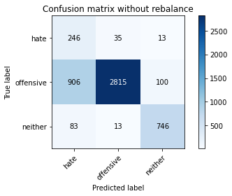

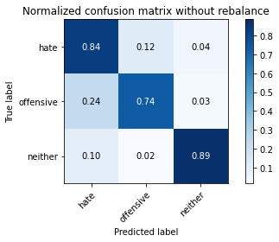

precision recall f1-score support

hate 0.20 0.84 0.32 294

offensive 0.98 0.74 0.84 3821

neither 0.87 0.89 0.88 842

accuracy 0.77 4957

macro avg 0.68 0.82 0.68 4957

weighted avg 0.92 0.77 0.82 4957

average eval_loss: 0.5540758429635917, accuracy: 0.7680048416380876

training 2 epoch...

44.525450706481934 seconds used......

2 training finished! average train loss: 0.3652332043438627

total clf loss: 64.9868950471282 total adv loss: 50.64034050703049

evaluating...

Confusion matrix, without normalization

[[ 175 85 34]

[ 259 3392 170]

[ 24 13 805]]

Normalized confusion matrix

[[0.5952381 0.28911565 0.11564626]

[0.0677833 0.88772573 0.04449097]

[0.02850356 0.01543943 0.95605701]]

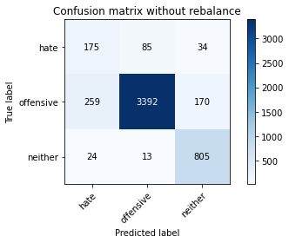

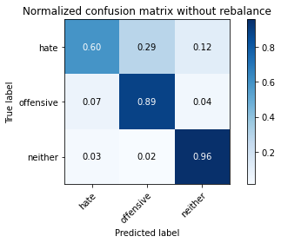

precision recall f1-score support

hate 0.38 0.60 0.47 294

offensive 0.97 0.89 0.93 3821

neither 0.80 0.96 0.87 842

accuracy 0.88 4957

macro avg 0.72 0.81 0.75 4957

weighted avg 0.91 0.88 0.89 4957

average eval_loss: 0.33764561316779546, accuracy: 0.8819850716158967

training 3 epoch...

44.43584966659546 seconds used......

3 training finished! average train loss: 0.2526904416341356

total clf loss: 45.11133921146393 total adv loss: 38.025478506460786

evaluating...

Confusion matrix, without normalization

[[ 230 47 17]

[ 796 2917 108]

[ 60 16 766]]

Normalized confusion matrix

[[0.78231293 0.15986395 0.05782313]

[0.20832243 0.76341272 0.02826485]

[0.07125891 0.01900238 0.90973872]]

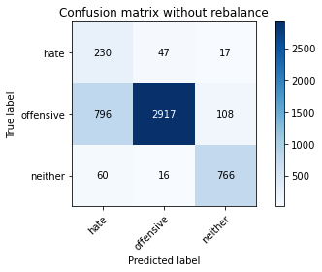

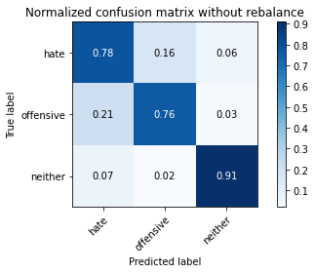

precision recall f1-score support

hate 0.21 0.78 0.33 294

offensive 0.98 0.76 0.86 3821

neither 0.86 0.91 0.88 842

accuracy 0.79 4957

macro avg 0.68 0.82 0.69 4957

weighted avg 0.91 0.79 0.83 4957

average eval_loss: 0.5426734835510293, accuracy: 0.7893887431914465

training 4 epoch...

44.479567527770996 seconds used......

4 training finished! average train loss: 0.15537674991381273

total clf loss: 27.99480927735567 total adv loss: 28.507700689136982

evaluating...

Confusion matrix, without normalization

[[ 243 32 19]

[1142 2571 108]

[ 58 23 761]]

Normalized confusion matrix

[[0.82653061 0.10884354 0.06462585]

[0.29887464 0.67286051 0.02826485]

[0.06888361 0.02731591 0.90380048]]

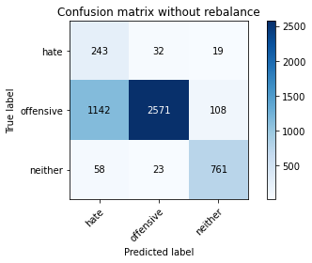

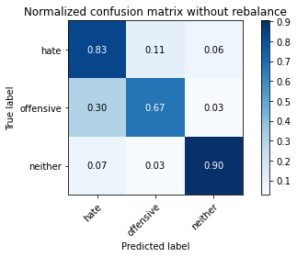

precision recall f1-score support

hate 0.17 0.83 0.28 294

offensive 0.98 0.67 0.80 3821

neither 0.86 0.90 0.88 842

accuracy 0.72 4957

macro avg 0.67 0.80 0.65 4957

weighted avg 0.91 0.72 0.78 4957

average eval_loss: 0.8050784959848369, accuracy: 0.7212023401250757

training 5 epoch...

44.5225555896759 seconds used......

5 training finished! average train loss: 0.07298429231622328

total clf loss: 13.123078619129956 total adv loss: 12.855293162807357

evaluating...

Confusion matrix, without normalization

[[ 241 40 13]

[1075 2668 78]

[ 84 24 734]]

Normalized confusion matrix

[[0.81972789 0.13605442 0.04421769]

[0.28133996 0.69824653 0.0204135 ]

[0.09976247 0.02850356 0.87173397]]

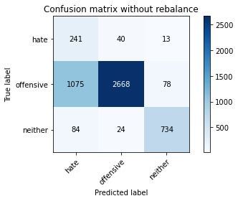

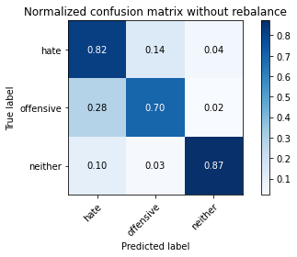

precision recall f1-score support

hate 0.17 0.82 0.28 294

offensive 0.98 0.70 0.81 3821

neither 0.89 0.87 0.88 842

accuracy 0.73 4957

macro avg 0.68 0.80 0.66 4957

weighted avg 0.91 0.73 0.79 4957

average eval_loss: 0.9609560845870404, accuracy: 0.7349203147064757

training 6 epoch...

44.91775107383728 seconds used......

6 training finished! average train loss: 0.042788543841905065

total clf loss: 7.702308357227594 total adv loss: 7.709347746102139

evaluating...

Confusion matrix, without normalization

[[ 214 60 20]

[ 629 3072 120]

[ 41 20 781]]

Normalized confusion matrix

[[0.72789116 0.20408163 0.06802721]

[0.16461659 0.80397802 0.03140539]

[0.04869359 0.02375297 0.92755344]]

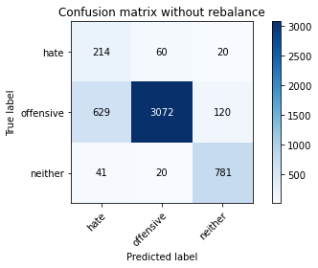

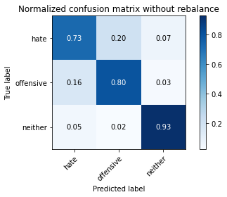

precision recall f1-score support

hate 0.24 0.73 0.36 294

offensive 0.97 0.80 0.88 3821

neither 0.85 0.93 0.89 842

accuracy 0.82 4957

macro avg 0.69 0.82 0.71 4957

weighted avg 0.91 0.82 0.85 4957

average eval_loss: 0.7415406448285906, accuracy: 0.8204559209199113

training 7 epoch...

44.54791593551636 seconds used......

7 training finished! average train loss: 0.0239215761011913

total clf loss: 4.295590920839459 total adv loss: 4.100027814129135

evaluating...

Confusion matrix, without normalization

[[ 247 32 15]

[1315 2395 111]

[ 75 14 753]]

Normalized confusion matrix

[[0.84013605 0.10884354 0.05102041]

[0.34415075 0.62679927 0.02904999]

[0.08907363 0.01662708 0.89429929]]

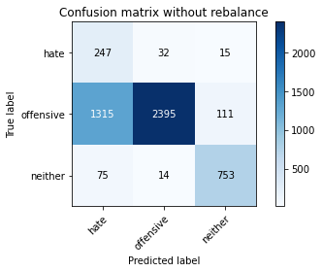

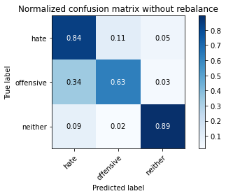

precision recall f1-score support

hate 0.15 0.84 0.26 294

offensive 0.98 0.63 0.76 3821

neither 0.86 0.89 0.88 842

accuracy 0.68 4957

macro avg 0.66 0.79 0.63 4957

weighted avg 0.91 0.68 0.75 4957

average eval_loss: 1.465315966694165, accuracy: 0.6848900544684284

training 8 epoch...

44.39984679222107 seconds used......

8 training finished! average train loss: 0.01545839291082951

total clf loss: 2.784457615111023 total adv loss: 2.8214486308897904

evaluating...

Confusion matrix, without normalization

[[ 200 75 19]

[ 598 3116 107]

[ 42 33 767]]

Normalized confusion matrix

[[0.68027211 0.25510204 0.06462585]

[0.15650353 0.81549333 0.02800314]

[0.04988124 0.0391924 0.91092637]]

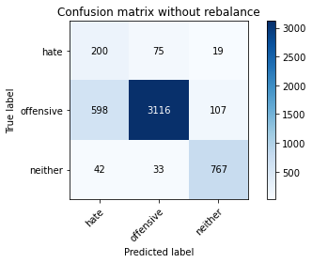

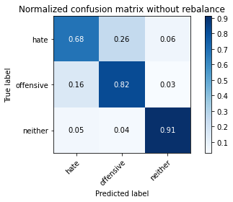

precision recall f1-score support

hate 0.24 0.68 0.35 294

offensive 0.97 0.82 0.88 3821

neither 0.86 0.91 0.88 842

accuracy 0.82 4957

macro avg 0.69 0.80 0.71 4957

weighted avg 0.91 0.82 0.85 4957

average eval_loss: 0.8014015756557309, accuracy: 0.8236836796449465

training 9 epoch...

44.4148805141449 seconds used......

9 training finished! average train loss: 0.010957857978030528

total clf loss: 1.9723332458524965 total adv loss: 1.9707903819985404

evaluating...

Confusion matrix, without normalization

[[ 213 55 26]

[ 705 2965 151]

[ 42 17 783]]

Normalized confusion matrix

[[0.7244898 0.18707483 0.08843537]

[0.18450667 0.77597488 0.03951845]

[0.04988124 0.02019002 0.92992874]]

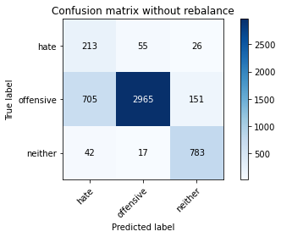

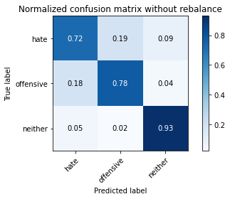

precision recall f1-score support

hate 0.22 0.72 0.34 294

offensive 0.98 0.78 0.86 3821

neither 0.82 0.93 0.87 842

accuracy 0.80 4957

macro avg 0.67 0.81 0.69 4957

weighted avg 0.90 0.80 0.83 4957

average eval_loss: 1.0822870594584533, accuracy: 0.7990720193665524

training 10 epoch...

44.399495363235474 seconds used......

10 training finished! average train loss: 0.01470557467003383

total clf loss: 2.651705168784247 total adv loss: 2.741038339558145

evaluating...

Confusion matrix, without normalization

[[ 217 56 21]

[ 716 2975 130]

[ 36 19 787]]

Normalized confusion matrix

[[0.73809524 0.19047619 0.07142857]

[0.1873855 0.77859199 0.03402251]

[0.04275534 0.02256532 0.93467933]]

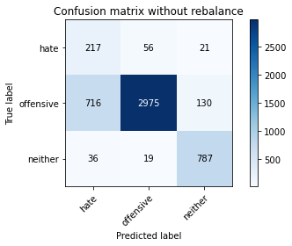

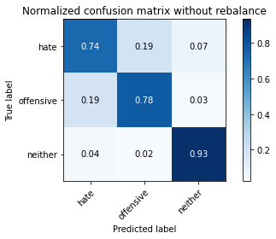

precision recall f1-score support

hate 0.22 0.74 0.34 294

offensive 0.98 0.78 0.87 3821

neither 0.84 0.93 0.88 842

accuracy 0.80 4957

macro avg 0.68 0.82 0.70 4957

weighted avg 0.91 0.80 0.84 4957

average eval_loss: 1.0269699893767885, accuracy: 0.802703247932217