1 run

[1.5, 0.5, 1]

training 1 epoch...

29.25216007232666 seconds used......

1 training finished! average train loss: 0.6155889526619549

evaluating...

Confusion matrix, without normalization

[[ 253 27 14]

[1454 2273 94]

[ 118 7 717]]

Normalized confusion matrix

[[0.86054422 0.09183673 0.04761905]

[0.38052866 0.59487045 0.02460089]

[0.14014252 0.00831354 0.85154394]]

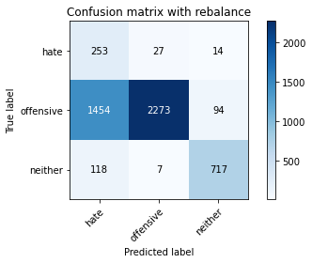

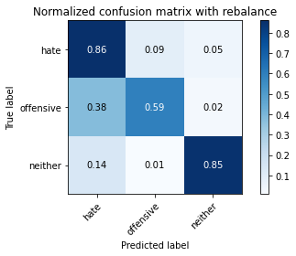

precision recall f1-score support

hate 0.14 0.86 0.24 294

offensive 0.99 0.59 0.74 3821

neither 0.87 0.85 0.86 842

accuracy 0.65 4957

macro avg 0.66 0.77 0.61 4957

weighted avg 0.92 0.65 0.73 4957

average eval_loss: 0.7473773119310217, accuracy: 0.6542263465805931

training 2 epoch...

28.366992712020874 seconds used......

2 training finished! average train loss: 0.36204553604648826

evaluating...

Confusion matrix, without normalization

[[ 256 26 12]

[1455 2274 92]

[ 67 15 760]]

Normalized confusion matrix

[[0.8707483 0.08843537 0.04081633]

[0.38079037 0.59513216 0.02407747]

[0.07957245 0.01781473 0.90261283]]

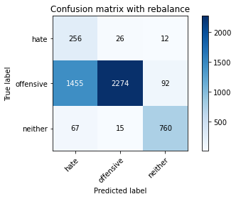

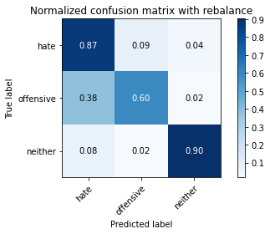

precision recall f1-score support

hate 0.14 0.87 0.25 294

offensive 0.98 0.60 0.74 3821

neither 0.88 0.90 0.89 842

accuracy 0.66 4957

macro avg 0.67 0.79 0.63 4957

weighted avg 0.92 0.66 0.74 4957

average eval_loss: 0.7106383573864737, accuracy: 0.6637078878353843

training 3 epoch...

28.282135725021362 seconds used......

3 training finished! average train loss: 0.242426943731064

evaluating...

Confusion matrix, without normalization

[[ 214 53 27]

[ 686 2947 188]

[ 29 8 805]]

Normalized confusion matrix

[[0.72789116 0.18027211 0.09183673]

[0.17953415 0.77126407 0.04920178]

[0.03444181 0.00950119 0.95605701]]

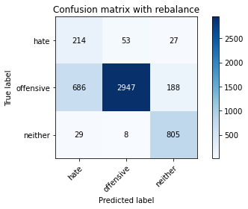

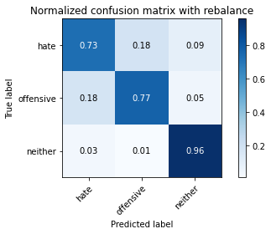

precision recall f1-score support

hate 0.23 0.73 0.35 294

offensive 0.98 0.77 0.86 3821

neither 0.79 0.96 0.86 842

accuracy 0.80 4957

macro avg 0.67 0.82 0.69 4957

weighted avg 0.90 0.80 0.83 4957

average eval_loss: 0.5500026534221345, accuracy: 0.8000806939681259

training 4 epoch...

28.2931170463562 seconds used......

4 training finished! average train loss: 0.14533371043701968

evaluating...

Confusion matrix, without normalization

[[ 220 52 22]

[ 815 2845 161]

[ 39 12 791]]

Normalized confusion matrix

[[0.74829932 0.17687075 0.07482993]

[0.21329495 0.74456948 0.04213557]

[0.04631829 0.01425178 0.93942993]]

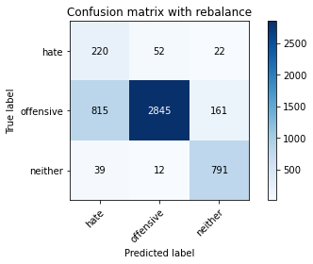

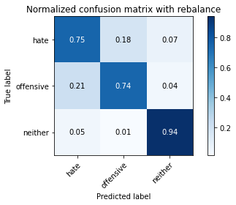

precision recall f1-score support

hate 0.20 0.75 0.32 294

offensive 0.98 0.74 0.85 3821

neither 0.81 0.94 0.87 842

accuracy 0.78 4957

macro avg 0.66 0.81 0.68 4957

weighted avg 0.90 0.78 0.82 4957

average eval_loss: 0.6301040085363051, accuracy: 0.7778898527335082

training 5 epoch...

28.264009714126587 seconds used......

5 training finished! average train loss: 0.0902172375159959

evaluating...

Confusion matrix, without normalization

[[ 243 38 13]

[1056 2666 99]

[ 73 24 745]]

Normalized confusion matrix

[[0.82653061 0.1292517 0.04421769]

[0.27636744 0.69772311 0.02590945]

[0.08669834 0.02850356 0.8847981 ]]

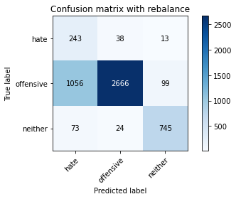

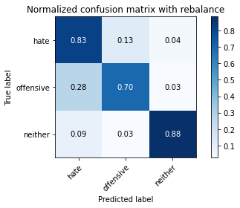

precision recall f1-score support

hate 0.18 0.83 0.29 294

offensive 0.98 0.70 0.81 3821

neither 0.87 0.88 0.88 842

accuracy 0.74 4957

macro avg 0.67 0.80 0.66 4957

weighted avg 0.91 0.74 0.79 4957

average eval_loss: 0.8059825234625849, accuracy: 0.7371393988299375

training 6 epoch...

28.212770223617554 seconds used......

6 training finished! average train loss: 0.04226542857328528

evaluating...

Confusion matrix, without normalization

[[ 225 51 18]

[ 694 3026 101]

[ 44 37 761]]

Normalized confusion matrix

[[0.76530612 0.17346939 0.06122449]

[0.18162785 0.79193928 0.02643287]

[0.05225653 0.04394299 0.90380048]]

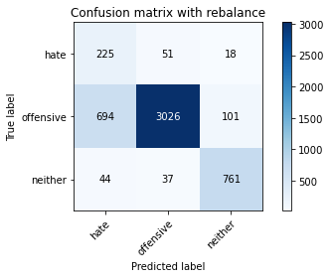

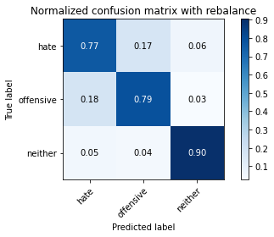

precision recall f1-score support

hate 0.23 0.77 0.36 294

offensive 0.97 0.79 0.87 3821

neither 0.86 0.90 0.88 842

accuracy 0.81 4957

macro avg 0.69 0.82 0.70 4957

weighted avg 0.91 0.81 0.84 4957

average eval_loss: 0.7996717252047553, accuracy: 0.8093605003026024

training 7 epoch...

28.19185757637024 seconds used......

7 training finished! average train loss: 0.024877255956767597

evaluating...

Confusion matrix, without normalization

[[ 236 43 15]

[ 865 2867 89]

[ 69 35 738]]

Normalized confusion matrix

[[0.80272109 0.1462585 0.05102041]

[0.22638053 0.75032714 0.02329233]

[0.08194774 0.0415677 0.87648456]]

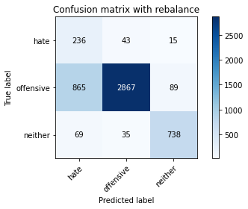

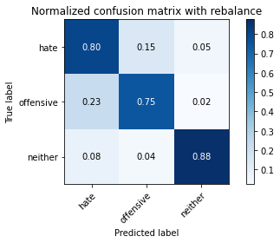

precision recall f1-score support

hate 0.20 0.80 0.32 294

offensive 0.97 0.75 0.85 3821

neither 0.88 0.88 0.88 842

accuracy 0.77 4957

macro avg 0.68 0.81 0.68 4957

weighted avg 0.91 0.77 0.82 4957

average eval_loss: 1.0495259231557288, accuracy: 0.7748638289287876

training 8 epoch...

28.131134033203125 seconds used......

8 training finished! average train loss: 0.028344043242549032

evaluating...

Confusion matrix, without normalization

[[ 244 31 19]

[1109 2582 130]

[ 56 18 768]]

Normalized confusion matrix

[[0.82993197 0.10544218 0.06462585]

[0.29023816 0.67573934 0.03402251]

[0.06650831 0.02137767 0.91211401]]

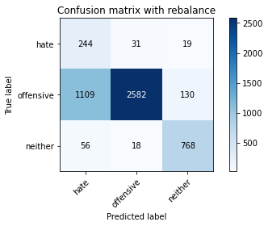

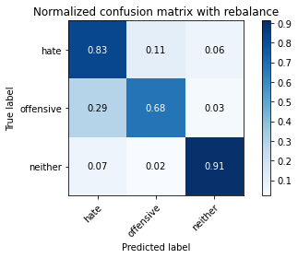

precision recall f1-score support

hate 0.17 0.83 0.29 294

offensive 0.98 0.68 0.80 3821

neither 0.84 0.91 0.87 842

accuracy 0.73 4957

macro avg 0.66 0.81 0.65 4957

weighted avg 0.91 0.73 0.78 4957

average eval_loss: 1.3041980571917169, accuracy: 0.7250353036110551

training 9 epoch...

28.22771906852722 seconds used......

9 training finished! average train loss: 0.02000183830063583

evaluating...

Confusion matrix, without normalization

[[ 227 52 15]

[ 746 2973 102]

[ 48 40 754]]

Normalized confusion matrix

[[0.77210884 0.17687075 0.05102041]

[0.19523685 0.77806857 0.02669458]

[0.05700713 0.04750594 0.89548694]]

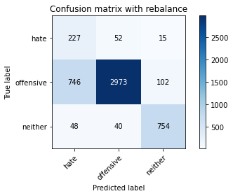

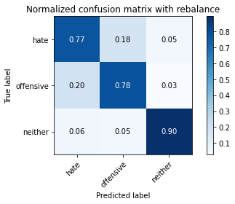

precision recall f1-score support

hate 0.22 0.77 0.35 294

offensive 0.97 0.78 0.86 3821

neither 0.87 0.90 0.88 842

accuracy 0.80 4957

macro avg 0.69 0.82 0.70 4957

weighted avg 0.91 0.80 0.84 4957

average eval_loss: 1.0238683845983036, accuracy: 0.7976598749243494

training 10 epoch...

28.253859519958496 seconds used......

10 training finished! average train loss: 0.012741527932594606

evaluating...

Confusion matrix, without normalization

[[ 241 42 11]

[ 998 2730 93]

[ 74 42 726]]

Normalized confusion matrix

[[0.81972789 0.14285714 0.03741497]

[0.26118817 0.71447265 0.02433918]

[0.08788599 0.04988124 0.86223278]]

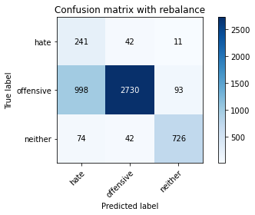

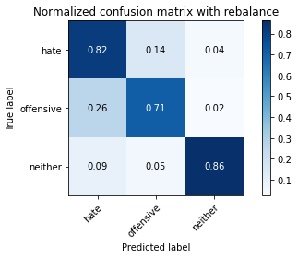

precision recall f1-score support

hate 0.18 0.82 0.30 294

offensive 0.97 0.71 0.82 3821

neither 0.87 0.86 0.87 842

accuracy 0.75 4957

macro avg 0.68 0.80 0.66 4957

weighted avg 0.91 0.75 0.80 4957

average eval_loss: 1.2728579299798566, accuracy: 0.7458140004034698

2 run

training 1 epoch...

28.36021900177002 seconds used......

1 training finished! average train loss: 0.6208407691521951

evaluating...

Confusion matrix, without normalization

[[ 249 27 18]

[1280 2428 113]

[ 63 8 771]]

Normalized confusion matrix

[[0.84693878 0.09183673 0.06122449]

[0.33499084 0.63543575 0.02957341]

[0.07482185 0.00950119 0.91567696]]

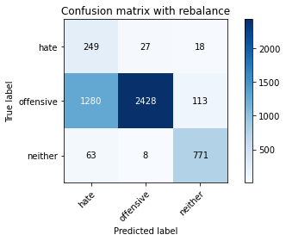

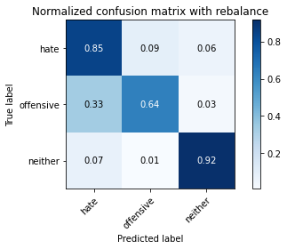

precision recall f1-score support

hate 0.16 0.85 0.26 294

offensive 0.99 0.64 0.77 3821

neither 0.85 0.92 0.88 842

accuracy 0.70 4957

macro avg 0.67 0.80 0.64 4957

weighted avg 0.91 0.70 0.76 4957

average eval_loss: 0.6848955837589118, accuracy: 0.6955820052451079

training 2 epoch...

28.279640197753906 seconds used......

2 training finished! average train loss: 0.35154356737757286

evaluating...

Confusion matrix, without normalization

[[ 229 47 18]

[ 737 2984 100]

[ 51 15 776]]

Normalized confusion matrix

[[0.77891156 0.15986395 0.06122449]

[0.19288144 0.7809474 0.02617116]

[0.06057007 0.01781473 0.9216152 ]]

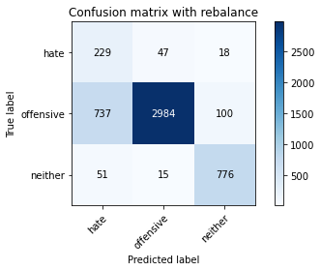

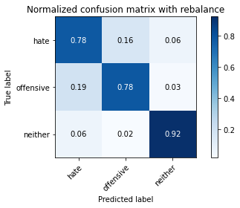

precision recall f1-score support

hate 0.23 0.78 0.35 294

offensive 0.98 0.78 0.87 3821

neither 0.87 0.92 0.89 842

accuracy 0.80 4957

macro avg 0.69 0.83 0.70 4957

weighted avg 0.92 0.80 0.84 4957

average eval_loss: 0.446989934741249, accuracy: 0.8047205971353641

training 3 epoch...

28.28604507446289 seconds used......

3 training finished! average train loss: 0.23759491462805118

evaluating...

Confusion matrix, without normalization

[[ 239 28 27]

[1094 2555 172]

[ 31 8 803]]

Normalized confusion matrix

[[0.81292517 0.0952381 0.09183673]

[0.28631248 0.66867312 0.04501439]

[0.0368171 0.00950119 0.95368171]]

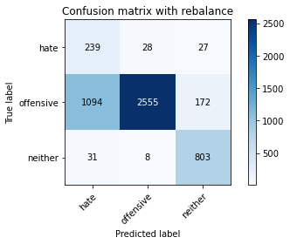

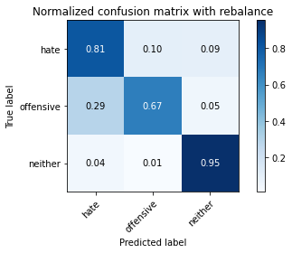

precision recall f1-score support

hate 0.18 0.81 0.29 294

offensive 0.99 0.67 0.80 3821

neither 0.80 0.95 0.87 842

accuracy 0.73 4957

macro avg 0.65 0.81 0.65 4957

weighted avg 0.91 0.73 0.78 4957

average eval_loss: 0.6929217344750801, accuracy: 0.7256405083719992

training 4 epoch...

28.329400300979614 seconds used......

4 training finished! average train loss: 0.14765056599563325

evaluating...

Confusion matrix, without normalization

[[ 240 39 15]

[ 997 2713 111]

[ 63 12 767]]

Normalized confusion matrix

[[0.81632653 0.13265306 0.05102041]

[0.26092646 0.71002355 0.02904999]

[0.07482185 0.01425178 0.91092637]]

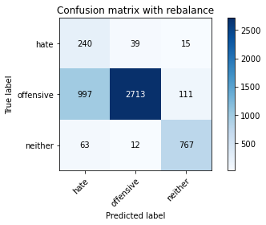

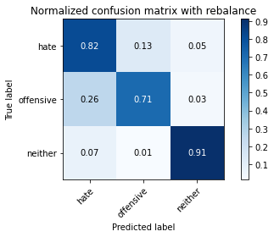

precision recall f1-score support

hate 0.18 0.82 0.30 294

offensive 0.98 0.71 0.82 3821

neither 0.86 0.91 0.88 842

accuracy 0.75 4957

macro avg 0.68 0.81 0.67 4957

weighted avg 0.91 0.75 0.80 4957

average eval_loss: 0.6578789513948704, accuracy: 0.7504539035707081

training 5 epoch...

28.303664922714233 seconds used......

5 training finished! average train loss: 0.09542223602827442

evaluating...

Confusion matrix, without normalization

[[ 252 23 19]

[1366 2330 125]

[ 63 9 770]]

Normalized confusion matrix

[[0.85714286 0.07823129 0.06462585]

[0.35749804 0.60978801 0.03271395]

[0.07482185 0.01068884 0.91448931]]

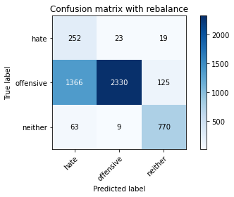

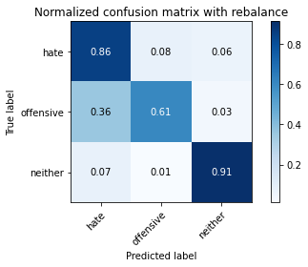

precision recall f1-score support

hate 0.15 0.86 0.26 294

offensive 0.99 0.61 0.75 3821

neither 0.84 0.91 0.88 842

accuracy 0.68 4957

macro avg 0.66 0.79 0.63 4957

weighted avg 0.91 0.68 0.75 4957

average eval_loss: 1.128945119949358, accuracy: 0.6762154528948962

training 6 epoch...

28.21180009841919 seconds used......

6 training finished! average train loss: 0.06097712372402437

evaluating...

Confusion matrix, without normalization

[[ 212 54 28]

[ 658 3014 149]

[ 40 13 789]]

Normalized confusion matrix

[[0.72108844 0.18367347 0.0952381 ]

[0.17220623 0.78879874 0.03899503]

[0.04750594 0.01543943 0.93705463]]

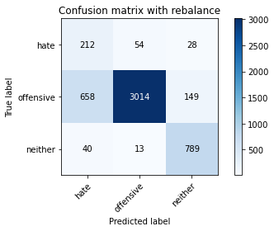

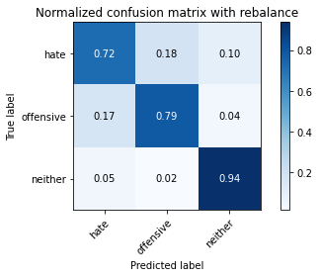

precision recall f1-score support

hate 0.23 0.72 0.35 294

offensive 0.98 0.79 0.87 3821

neither 0.82 0.94 0.87 842

accuracy 0.81 4957

macro avg 0.68 0.82 0.70 4957

weighted avg 0.91 0.81 0.84 4957

average eval_loss: 0.744369735535715, accuracy: 0.8099657050635465

training 7 epoch...

28.291496515274048 seconds used......

7 training finished! average train loss: 0.04516381201571213

evaluating...

Confusion matrix, without normalization

[[ 243 35 16]

[ 955 2754 112]

[ 66 12 764]]

Normalized confusion matrix

[[0.82653061 0.11904762 0.05442177]

[0.24993457 0.72075373 0.0293117 ]

[0.0783848 0.01425178 0.90736342]]

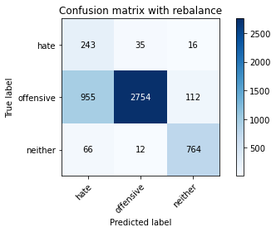

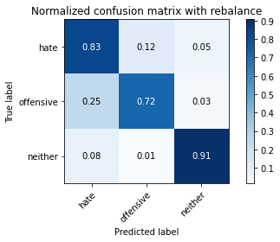

precision recall f1-score support

hate 0.19 0.83 0.31 294

offensive 0.98 0.72 0.83 3821

neither 0.86 0.91 0.88 842

accuracy 0.76 4957

macro avg 0.68 0.82 0.67 4957

weighted avg 0.91 0.76 0.81 4957

average eval_loss: 0.9421499928970251, accuracy: 0.758725035303611

training 8 epoch...

28.293809175491333 seconds used......

8 training finished! average train loss: 0.019688727897496577

evaluating...

Confusion matrix, without normalization

[[ 226 44 24]

[ 779 2923 119]

[ 42 17 783]]

Normalized confusion matrix

[[0.76870748 0.14965986 0.08163265]

[0.20387333 0.76498299 0.03114368]

[0.04988124 0.02019002 0.92992874]]

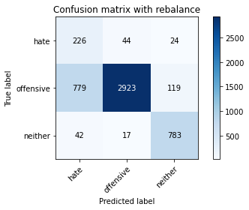

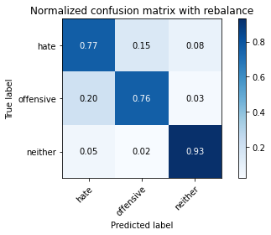

precision recall f1-score support

hate 0.22 0.77 0.34 294

offensive 0.98 0.76 0.86 3821

neither 0.85 0.93 0.89 842

accuracy 0.79 4957

macro avg 0.68 0.82 0.69 4957

weighted avg 0.91 0.79 0.83 4957

average eval_loss: 1.0272010018071018, accuracy: 0.7932217066774259

training 9 epoch...

28.342021942138672 seconds used......

9 training finished! average train loss: 0.00899473874273503

evaluating...

Confusion matrix, without normalization

[[ 218 54 22]

[ 665 3028 128]

[ 44 19 779]]

Normalized confusion matrix

[[0.7414966 0.18367347 0.07482993]

[0.17403821 0.79246271 0.03349908]

[0.05225653 0.02256532 0.92517815]]

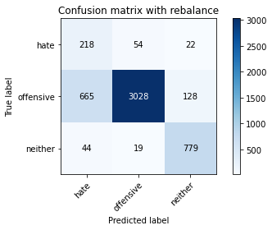

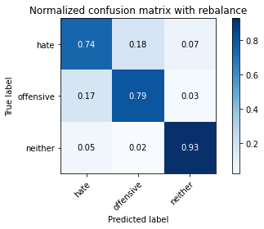

precision recall f1-score support

hate 0.24 0.74 0.36 294

offensive 0.98 0.79 0.87 3821

neither 0.84 0.93 0.88 842

accuracy 0.81 4957

macro avg 0.68 0.82 0.70 4957

weighted avg 0.91 0.81 0.85 4957

average eval_loss: 0.9580841789025843, accuracy: 0.8119830542666936

training 10 epoch...

28.30712389945984 seconds used......

10 training finished! average train loss: 0.020790337076361635

evaluating...

Confusion matrix, without normalization

[[ 246 32 16]

[1150 2556 115]

[ 85 27 730]]

Normalized confusion matrix

[[0.83673469 0.10884354 0.05442177]

[0.30096833 0.66893483 0.03009683]

[0.10095012 0.03206651 0.86698337]]

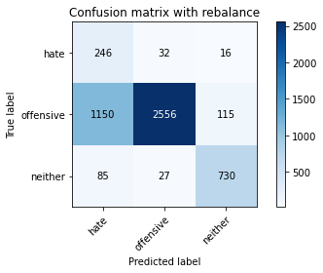

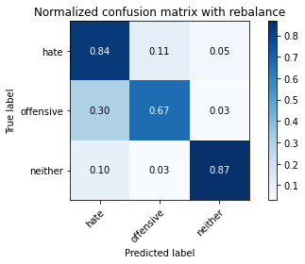

precision recall f1-score support

hate 0.17 0.84 0.28 294

offensive 0.98 0.67 0.79 3821

neither 0.85 0.87 0.86 842

accuracy 0.71 4957

macro avg 0.66 0.79 0.64 4957

weighted avg 0.91 0.71 0.77 4957

average eval_loss: 1.3204739299122124, accuracy: 0.7125277385515433

3 run

training 1 epoch...

28.394238710403442 seconds used......

1 training finished! average train loss: 0.6179676489000432

evaluating...

Confusion matrix, without normalization

[[ 246 26 22]

[1253 2411 157]

[ 68 7 767]]

Normalized confusion matrix

[[0.83673469 0.08843537 0.07482993]

[0.32792463 0.63098665 0.04108872]

[0.0807601 0.00831354 0.91092637]]

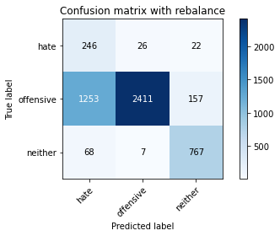

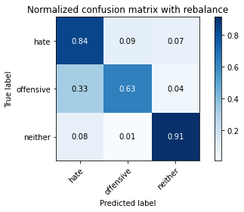

precision recall f1-score support

hate 0.16 0.84 0.26 294

offensive 0.99 0.63 0.77 3821

neither 0.81 0.91 0.86 842

accuracy 0.69 4957

macro avg 0.65 0.79 0.63 4957

weighted avg 0.91 0.69 0.75 4957

average eval_loss: 0.7312654878703817, accuracy: 0.6907403671575549

training 2 epoch...

28.35974621772766 seconds used......

2 training finished! average train loss: 0.3485520988354209

evaluating...

Confusion matrix, without normalization

[[ 252 31 11]

[ 955 2758 108]

[ 72 8 762]]

Normalized confusion matrix

[[0.85714286 0.10544218 0.03741497]

[0.24993457 0.72180058 0.02826485]

[0.08551069 0.00950119 0.90498812]]

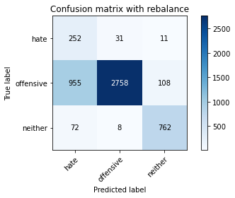

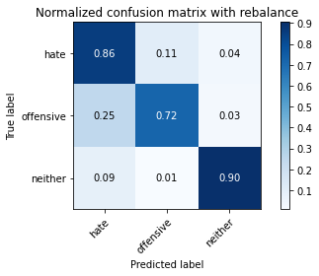

precision recall f1-score support

hate 0.20 0.86 0.32 294

offensive 0.99 0.72 0.83 3821

neither 0.86 0.90 0.88 842

accuracy 0.76 4957

macro avg 0.68 0.83 0.68 4957

weighted avg 0.92 0.76 0.81 4957

average eval_loss: 0.564772350052672, accuracy: 0.7609441194270729

training 3 epoch...

28.47823190689087 seconds used......

3 training finished! average train loss: 0.23150537377604616

evaluating...

Confusion matrix, without normalization

[[ 245 33 16]

[ 807 2898 116]

[ 45 18 779]]

Normalized confusion matrix

[[0.83333333 0.1122449 0.05442177]

[0.21120126 0.7584402 0.03035854]

[0.05344418 0.02137767 0.92517815]]

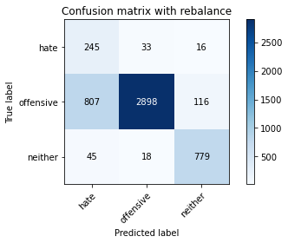

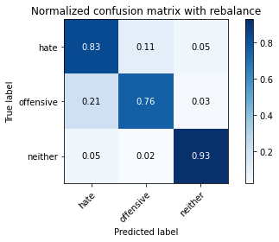

precision recall f1-score support

hate 0.22 0.83 0.35 294

offensive 0.98 0.76 0.86 3821

neither 0.86 0.93 0.89 842

accuracy 0.79 4957

macro avg 0.69 0.84 0.70 4957

weighted avg 0.92 0.79 0.83 4957

average eval_loss: 0.5447102136038724, accuracy: 0.7912043574742788

training 4 epoch...

28.37242317199707 seconds used......

4 training finished! average train loss: 0.13625374965761838

evaluating...

Confusion matrix, without normalization

[[ 251 28 15]

[1238 2479 104]

[ 73 16 753]]

Normalized confusion matrix

[[0.8537415 0.0952381 0.05102041]

[0.32399895 0.64878304 0.02721801]

[0.08669834 0.01900238 0.89429929]]

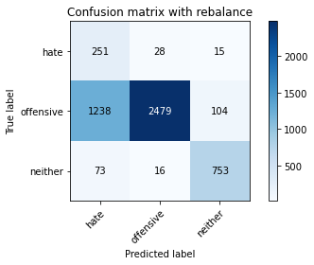

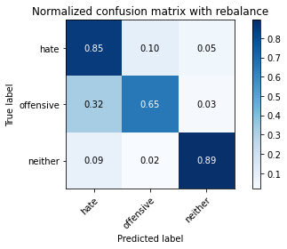

precision recall f1-score support

hate 0.16 0.85 0.27 294

offensive 0.98 0.65 0.78 3821

neither 0.86 0.89 0.88 842

accuracy 0.70 4957

macro avg 0.67 0.80 0.64 4957

weighted avg 0.91 0.70 0.77 4957

average eval_loss: 0.8609900766863458, accuracy: 0.7026427274561227

training 5 epoch...

28.672314643859863 seconds used......

5 training finished! average train loss: 0.09478127324343687

evaluating...

Confusion matrix, without normalization

[[ 249 33 12]

[1114 2578 129]

[ 95 9 738]]

Normalized confusion matrix

[[0.84693878 0.1122449 0.04081633]

[0.29154672 0.67469249 0.0337608 ]

[0.1128266 0.01068884 0.87648456]]

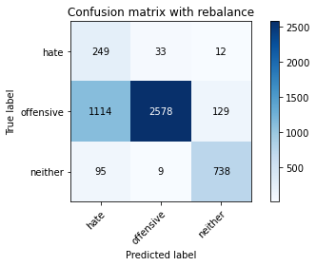

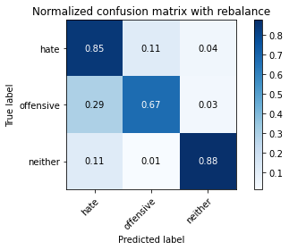

precision recall f1-score support

hate 0.17 0.85 0.28 294

offensive 0.98 0.67 0.80 3821

neither 0.84 0.88 0.86 842

accuracy 0.72 4957

macro avg 0.66 0.80 0.65 4957

weighted avg 0.91 0.72 0.78 4957

average eval_loss: 0.9194491311547256, accuracy: 0.7191849909219286

training 6 epoch...

28.320303201675415 seconds used......

6 training finished! average train loss: 0.055799309650370686

evaluating...

Confusion matrix, without normalization

[[ 243 39 12]

[1007 2699 115]

[ 68 18 756]]

Normalized confusion matrix

[[0.82653061 0.13265306 0.04081633]

[0.26354357 0.70635959 0.03009683]

[0.0807601 0.02137767 0.89786223]]

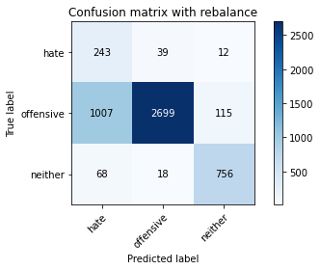

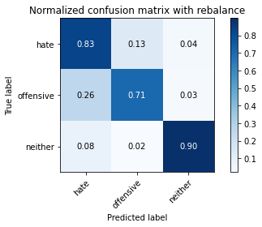

precision recall f1-score support

hate 0.18 0.83 0.30 294

offensive 0.98 0.71 0.82 3821

neither 0.86 0.90 0.88 842

accuracy 0.75 4957

macro avg 0.67 0.81 0.67 4957

weighted avg 0.91 0.75 0.80 4957

average eval_loss: 0.9151681927708729, accuracy: 0.7460157353237845

training 7 epoch...

28.362685203552246 seconds used......

7 training finished! average train loss: 0.03573022238646051

evaluating...

Confusion matrix, without normalization

[[ 223 45 26]

[ 751 2901 169]

[ 27 14 801]]

Normalized confusion matrix

[[0.7585034 0.15306122 0.08843537]

[0.19654541 0.75922533 0.04422926]

[0.03206651 0.01662708 0.95130641]]

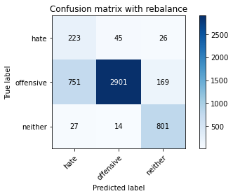

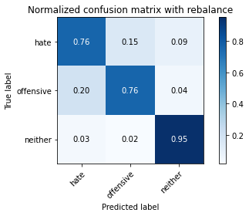

precision recall f1-score support

hate 0.22 0.76 0.34 294

offensive 0.98 0.76 0.86 3821

neither 0.80 0.95 0.87 842

accuracy 0.79 4957

macro avg 0.67 0.82 0.69 4957

weighted avg 0.91 0.79 0.83 4957

average eval_loss: 0.8611034074978482, accuracy: 0.7918095622352229

training 8 epoch...

28.33626914024353 seconds used......

8 training finished! average train loss: 0.033814439623567616

evaluating...

Confusion matrix, without normalization

[[ 233 47 14]

[ 795 2927 99]

[ 55 28 759]]

Normalized confusion matrix

[[0.79251701 0.15986395 0.04761905]

[0.20806072 0.76602984 0.02590945]

[0.06532067 0.03325416 0.90142518]]

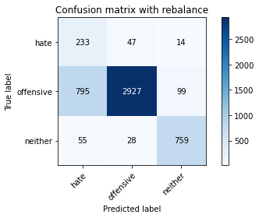

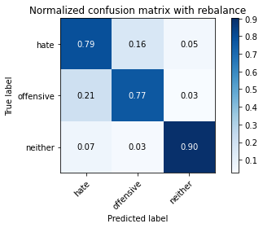

precision recall f1-score support

hate 0.22 0.79 0.34 294

offensive 0.98 0.77 0.86 3821

neither 0.87 0.90 0.89 842

accuracy 0.79 4957

macro avg 0.69 0.82 0.69 4957

weighted avg 0.91 0.79 0.83 4957

average eval_loss: 0.9625400400686739, accuracy: 0.7905991527133347

training 9 epoch...

28.271759748458862 seconds used......

9 training finished! average train loss: 0.03699098542017443

evaluating...

Confusion matrix, without normalization

[[ 243 37 14]

[ 963 2763 95]

[ 81 24 737]]

Normalized confusion matrix

[[0.82653061 0.12585034 0.04761905]

[0.25202826 0.72310913 0.0248626 ]

[0.09619952 0.02850356 0.87529691]]

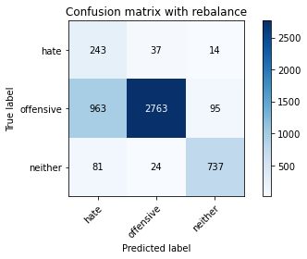

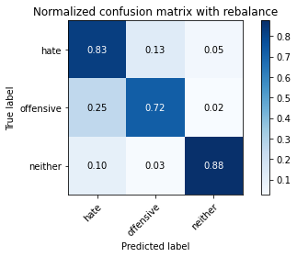

precision recall f1-score support

hate 0.19 0.83 0.31 294

offensive 0.98 0.72 0.83 3821

neither 0.87 0.88 0.87 842

accuracy 0.76 4957

macro avg 0.68 0.81 0.67 4957

weighted avg 0.91 0.76 0.81 4957

average eval_loss: 1.0499165807306137, accuracy: 0.7550938067379463

training 10 epoch...

28.25674033164978 seconds used......

10 training finished! average train loss: 0.01188512358709636

evaluating...

Confusion matrix, without normalization

[[ 222 53 19]

[ 700 2987 134]

[ 46 22 774]]

Normalized confusion matrix

[[0.75510204 0.18027211 0.06462585]

[0.18319812 0.78173253 0.03506935]

[0.05463183 0.02612827 0.9192399 ]]

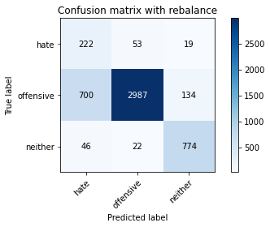

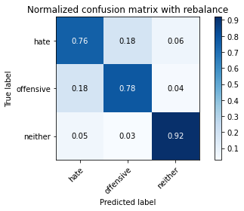

precision recall f1-score support

hate 0.23 0.76 0.35 294

offensive 0.98 0.78 0.87 3821

neither 0.83 0.92 0.88 842

accuracy 0.80 4957

macro avg 0.68 0.82 0.70 4957

weighted avg 0.91 0.80 0.84 4957

average eval_loss: 1.024560930757528, accuracy: 0.8035101876134759

4 run

training 1 epoch...

28.23186421394348 seconds used......

1 training finished! average train loss: 0.6363072306440588

evaluating...

Confusion matrix, without normalization

[[ 214 41 39]

[ 811 2807 203]

[ 22 10 810]]

Normalized confusion matrix

[[0.72789116 0.13945578 0.13265306]

[0.2122481 0.73462444 0.05312745]

[0.02612827 0.01187648 0.96199525]]

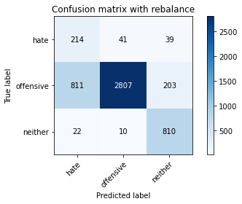

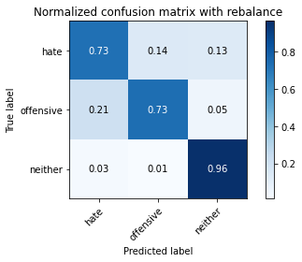

precision recall f1-score support

hate 0.20 0.73 0.32 294

offensive 0.98 0.73 0.84 3821

neither 0.77 0.96 0.86 842

accuracy 0.77 4957

macro avg 0.65 0.81 0.67 4957

weighted avg 0.90 0.77 0.81 4957

average eval_loss: 0.593261957529091, accuracy: 0.7728464797256405

training 2 epoch...

28.26168417930603 seconds used......

2 training finished! average train loss: 0.363534576450175

evaluating...

Confusion matrix, without normalization

[[ 237 40 17]

[ 839 2848 134]

[ 46 9 787]]

Normalized confusion matrix

[[0.80612245 0.13605442 0.05782313]

[0.21957603 0.74535462 0.03506935]

[0.05463183 0.01068884 0.93467933]]

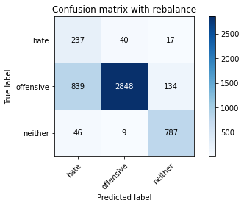

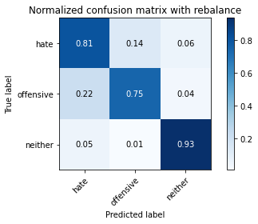

precision recall f1-score support

hate 0.21 0.81 0.33 294

offensive 0.98 0.75 0.85 3821

neither 0.84 0.93 0.88 842

accuracy 0.78 4957

macro avg 0.68 0.83 0.69 4957

weighted avg 0.91 0.78 0.82 4957

average eval_loss: 0.5198561903690139, accuracy: 0.7811176114585435

training 3 epoch...

28.346408367156982 seconds used......

3 training finished! average train loss: 0.2315145100287178

evaluating...

Confusion matrix, without normalization

[[ 230 45 19]

[ 858 2827 136]

[ 40 11 791]]

Normalized confusion matrix

[[0.78231293 0.15306122 0.06462585]

[0.22454855 0.73985868 0.03559278]

[0.04750594 0.01306413 0.93942993]]

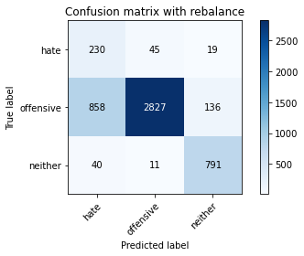

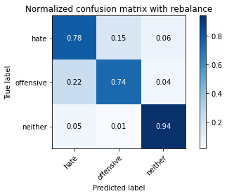

precision recall f1-score support

hate 0.20 0.78 0.32 294

offensive 0.98 0.74 0.84 3821

neither 0.84 0.94 0.88 842

accuracy 0.78 4957

macro avg 0.67 0.82 0.68 4957

weighted avg 0.91 0.78 0.82 4957

average eval_loss: 0.566612955693516, accuracy: 0.7762759733709905

training 4 epoch...

28.30401039123535 seconds used......

4 training finished! average train loss: 0.14080841459704246

evaluating...

Confusion matrix, without normalization

[[ 237 45 12]

[ 990 2730 101]

[ 57 19 766]]

Normalized confusion matrix

[[0.80612245 0.15306122 0.04081633]

[0.25909448 0.71447265 0.02643287]

[0.06769596 0.02256532 0.90973872]]

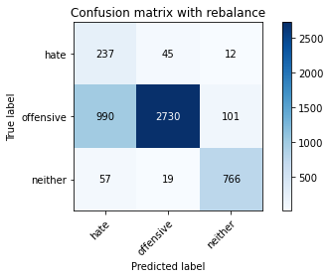

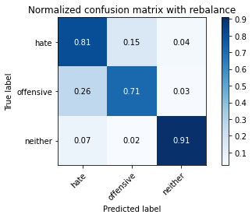

precision recall f1-score support

hate 0.18 0.81 0.30 294

offensive 0.98 0.71 0.83 3821

neither 0.87 0.91 0.89 842

accuracy 0.75 4957

macro avg 0.68 0.81 0.67 4957

weighted avg 0.91 0.75 0.81 4957

average eval_loss: 0.6469661527118015, accuracy: 0.7530764575347992

training 5 epoch...

28.31204605102539 seconds used......

5 training finished! average train loss: 0.09679516309556382

evaluating...

Confusion matrix, without normalization

[[ 227 52 15]

[ 810 2840 171]

[ 53 15 774]]

Normalized confusion matrix

[[0.77210884 0.17687075 0.05102041]

[0.21198639 0.74326093 0.04475268]

[0.06294537 0.01781473 0.9192399 ]]

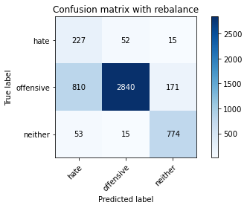

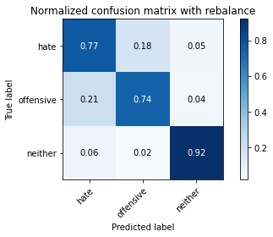

precision recall f1-score support

hate 0.21 0.77 0.33 294

offensive 0.98 0.74 0.84 3821

neither 0.81 0.92 0.86 842

accuracy 0.77 4957

macro avg 0.66 0.81 0.68 4957

weighted avg 0.90 0.77 0.82 4957

average eval_loss: 0.7152363990373429, accuracy: 0.7748638289287876

training 6 epoch...

28.299418687820435 seconds used......

6 training finished! average train loss: 0.05789179093482202

evaluating...

Confusion matrix, without normalization

[[ 226 48 20]

[ 878 2821 122]

[ 46 23 773]]

Normalized confusion matrix

[[0.76870748 0.16326531 0.06802721]

[0.22978278 0.73828841 0.03192881]

[0.05463183 0.02731591 0.91805226]]

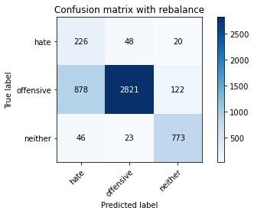

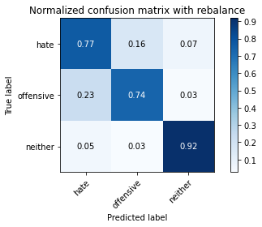

precision recall f1-score support

hate 0.20 0.77 0.31 294

offensive 0.98 0.74 0.84 3821

neither 0.84 0.92 0.88 842

accuracy 0.77 4957

macro avg 0.67 0.81 0.68 4957

weighted avg 0.91 0.77 0.82 4957

average eval_loss: 0.784970480918644, accuracy: 0.7706273956021787

training 7 epoch...

28.395957708358765 seconds used......

7 training finished! average train loss: 0.039057560152052875

evaluating...

Confusion matrix, without normalization

[[ 216 68 10]

[ 660 3086 75]

[ 73 39 730]]

Normalized confusion matrix

[[0.73469388 0.23129252 0.03401361]

[0.17272965 0.80764198 0.01962837]

[0.08669834 0.04631829 0.86698337]]

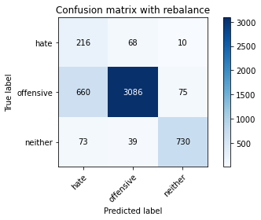

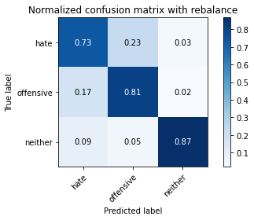

precision recall f1-score support

hate 0.23 0.73 0.35 294

offensive 0.97 0.81 0.88 3821

neither 0.90 0.87 0.88 842

accuracy 0.81 4957

macro avg 0.70 0.80 0.70 4957

weighted avg 0.91 0.81 0.85 4957

average eval_loss: 0.7179647187060196, accuracy: 0.8133951987088965

training 8 epoch...

28.241325855255127 seconds used......

8 training finished! average train loss: 0.025593164795601184

evaluating...

Confusion matrix, without normalization

[[ 219 60 15]

[ 749 2967 105]

[ 45 36 761]]

Normalized confusion matrix

[[0.74489796 0.20408163 0.05102041]

[0.19602198 0.7764983 0.02747972]

[0.05344418 0.04275534 0.90380048]]

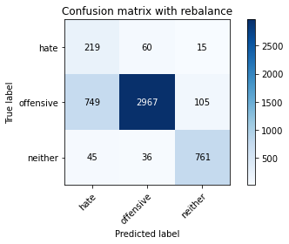

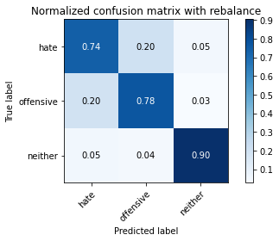

precision recall f1-score support

hate 0.22 0.74 0.34 294

offensive 0.97 0.78 0.86 3821

neither 0.86 0.90 0.88 842

accuracy 0.80 4957

macro avg 0.68 0.81 0.69 4957

weighted avg 0.91 0.80 0.83 4957

average eval_loss: 0.8759500666675458, accuracy: 0.7962477304821465

training 9 epoch...

28.357409715652466 seconds used......

9 training finished! average train loss: 0.026462195487420636

evaluating...

Confusion matrix, without normalization

[[ 240 43 11]

[ 913 2828 80]

[ 71 52 719]]

Normalized confusion matrix

[[0.81632653 0.1462585 0.03741497]

[0.23894269 0.74012039 0.02093693]

[0.08432304 0.06175772 0.85391924]]

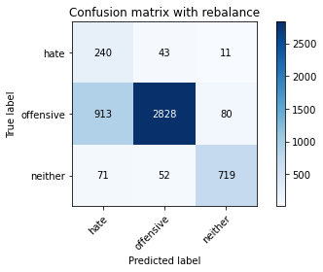

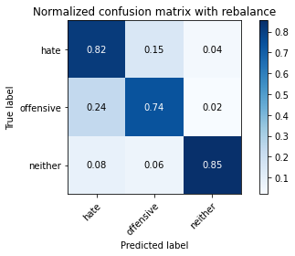

precision recall f1-score support

hate 0.20 0.82 0.32 294

offensive 0.97 0.74 0.84 3821

neither 0.89 0.85 0.87 842

accuracy 0.76 4957

macro avg 0.68 0.80 0.68 4957

weighted avg 0.91 0.76 0.81 4957

average eval_loss: 1.0231381559175545, accuracy: 0.7639701432317935

training 10 epoch...

28.368173360824585 seconds used......

10 training finished! average train loss: 0.013680824217841312

evaluating...

Confusion matrix, without normalization

[[ 220 57 17]

[ 700 3005 116]

[ 47 27 768]]

Normalized confusion matrix

[[0.74829932 0.19387755 0.05782313]

[0.18319812 0.78644334 0.03035854]

[0.05581948 0.03206651 0.91211401]]

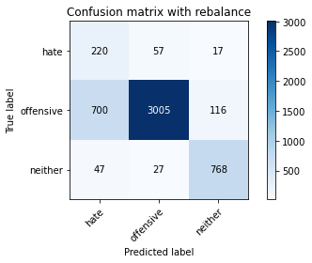

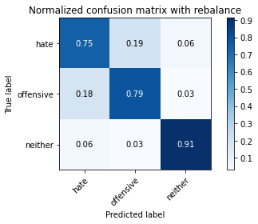

precision recall f1-score support

hate 0.23 0.75 0.35 294

offensive 0.97 0.79 0.87 3821

neither 0.85 0.91 0.88 842

accuracy 0.81 4957

macro avg 0.68 0.82 0.70 4957

weighted avg 0.91 0.81 0.84 4957

average eval_loss: 0.9623228035352733, accuracy: 0.8055275368166229

5 run

training 1 epoch...

28.29676866531372 seconds used......

1 training finished! average train loss: 0.6126662557236633

evaluating...

Confusion matrix, without normalization

[[ 249 27 18]

[1382 2325 114]

[ 70 9 763]]

Normalized confusion matrix

[[0.84693878 0.09183673 0.06122449]

[0.36168542 0.60847946 0.02983512]

[0.08313539 0.01068884 0.90617577]]

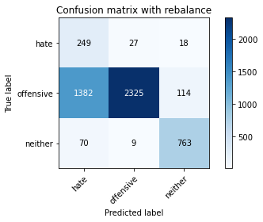

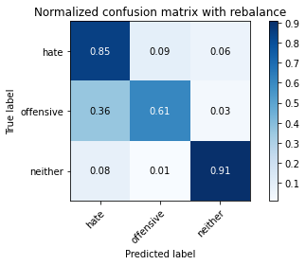

precision recall f1-score support

hate 0.15 0.85 0.25 294

offensive 0.98 0.61 0.75 3821

neither 0.85 0.91 0.88 842

accuracy 0.67 4957

macro avg 0.66 0.79 0.63 4957

weighted avg 0.91 0.67 0.74 4957

average eval_loss: 0.6874089036136866, accuracy: 0.6731894290901755

training 2 epoch...

28.40154719352722 seconds used......

2 training finished! average train loss: 0.34971812167014293

evaluating...

Confusion matrix, without normalization

[[ 258 22 14]

[1665 2045 111]

[ 88 9 745]]

Normalized confusion matrix

[[0.87755102 0.07482993 0.04761905]

[0.4357498 0.53520021 0.02904999]

[0.10451306 0.01068884 0.8847981 ]]

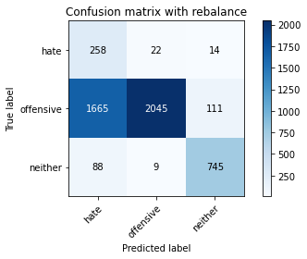

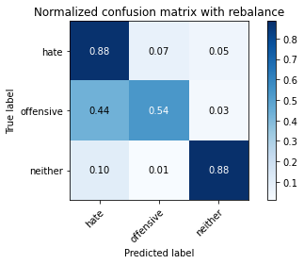

precision recall f1-score support

hate 0.13 0.88 0.22 294

offensive 0.99 0.54 0.69 3821

neither 0.86 0.88 0.87 842

accuracy 0.61 4957

macro avg 0.66 0.77 0.60 4957

weighted avg 0.91 0.61 0.70 4957

average eval_loss: 0.7973831560943396, accuracy: 0.6148880371192254

training 3 epoch...

28.366669416427612 seconds used......

3 training finished! average train loss: 0.24339808514940808

evaluating...

Confusion matrix, without normalization

[[ 253 28 13]

[1193 2529 99]

[ 74 9 759]]

Normalized confusion matrix

[[0.86054422 0.0952381 0.04421769]

[0.31222193 0.66186862 0.02590945]

[0.08788599 0.01068884 0.90142518]]

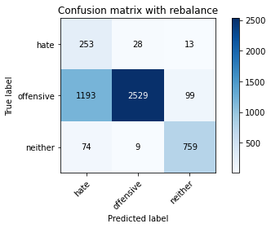

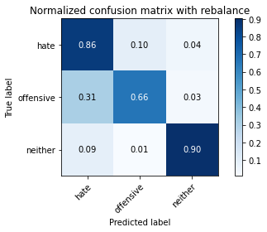

precision recall f1-score support

hate 0.17 0.86 0.28 294

offensive 0.99 0.66 0.79 3821

neither 0.87 0.90 0.89 842

accuracy 0.71 4957

macro avg 0.67 0.81 0.65 4957

weighted avg 0.92 0.71 0.78 4957

average eval_loss: 0.6652289893057558, accuracy: 0.7143433528343757

training 4 epoch...

28.37450075149536 seconds used......

4 training finished! average train loss: 0.14271167107471075

evaluating...

Confusion matrix, without normalization

[[ 241 37 16]

[1055 2624 142]

[ 60 12 770]]

Normalized confusion matrix

[[0.81972789 0.12585034 0.05442177]

[0.27610573 0.68673122 0.03716305]

[0.07125891 0.01425178 0.91448931]]

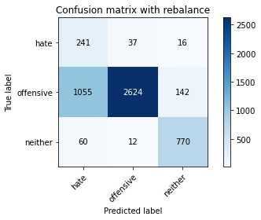

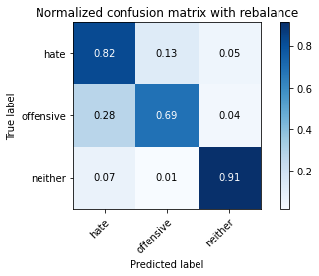

precision recall f1-score support

hate 0.18 0.82 0.29 294

offensive 0.98 0.69 0.81 3821

neither 0.83 0.91 0.87 842

accuracy 0.73 4957

macro avg 0.66 0.81 0.66 4957

weighted avg 0.91 0.73 0.79 4957

average eval_loss: 0.7483155538117693, accuracy: 0.733306435343958

training 5 epoch...

28.452281713485718 seconds used......

5 training finished! average train loss: 0.10260759949226651

evaluating...

Confusion matrix, without normalization

[[ 214 45 35]

[ 725 2874 222]

[ 27 9 806]]

Normalized confusion matrix

[[0.72789116 0.15306122 0.11904762]

[0.18974091 0.75215912 0.05809997]

[0.03206651 0.01068884 0.95724466]]

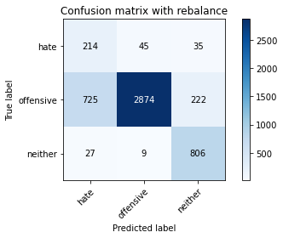

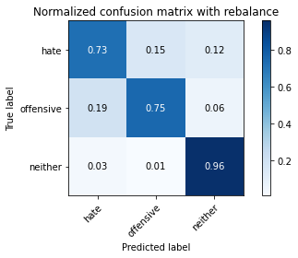

precision recall f1-score support

hate 0.22 0.73 0.34 294

offensive 0.98 0.75 0.85 3821

neither 0.76 0.96 0.85 842

accuracy 0.79 4957

macro avg 0.65 0.81 0.68 4957

weighted avg 0.90 0.79 0.82 4957

average eval_loss: 0.7061539678158418, accuracy: 0.785555779705467

training 6 epoch...

28.436818838119507 seconds used......

6 training finished! average train loss: 0.06984488733183615

evaluating...

Confusion matrix, without normalization

[[ 243 42 9]

[ 906 2828 87]

[ 78 34 730]]

Normalized confusion matrix

[[0.82653061 0.14285714 0.03061224]

[0.2371107 0.74012039 0.02276891]

[0.09263658 0.04038005 0.86698337]]

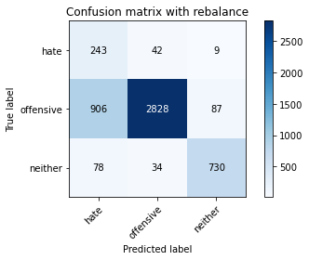

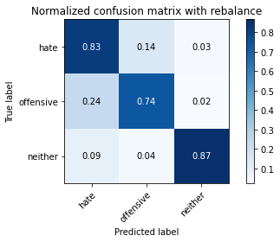

precision recall f1-score support

hate 0.20 0.83 0.32 294

offensive 0.97 0.74 0.84 3821

neither 0.88 0.87 0.88 842

accuracy 0.77 4957

macro avg 0.69 0.81 0.68 4957

weighted avg 0.91 0.77 0.82 4957

average eval_loss: 0.8805399158398711, accuracy: 0.7667944321161994

training 7 epoch...

28.363346099853516 seconds used......

7 training finished! average train loss: 0.047155494992321696

evaluating...

Confusion matrix, without normalization

[[ 250 29 15]

[1192 2515 114]

[ 69 15 758]]

Normalized confusion matrix

[[0.85034014 0.09863946 0.05102041]

[0.31196022 0.65820466 0.02983512]

[0.08194774 0.01781473 0.90023753]]

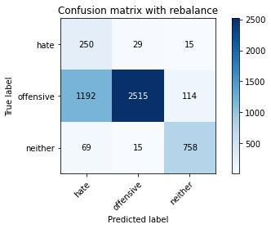

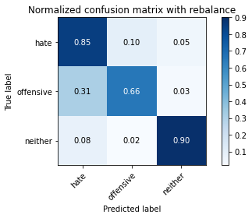

precision recall f1-score support

hate 0.17 0.85 0.28 294

offensive 0.98 0.66 0.79 3821

neither 0.85 0.90 0.88 842

accuracy 0.71 4957

macro avg 0.67 0.80 0.65 4957

weighted avg 0.91 0.71 0.77 4957

average eval_loss: 1.1061661663435158, accuracy: 0.7107121242687109

training 8 epoch...

28.516204357147217 seconds used......

8 training finished! average train loss: 0.03521553340384312

evaluating...

Confusion matrix, without normalization

[[ 245 32 17]

[ 952 2748 121]

[ 40 31 771]]

Normalized confusion matrix

[[0.83333333 0.10884354 0.05782313]

[0.24914944 0.71918346 0.0316671 ]

[0.04750594 0.0368171 0.91567696]]

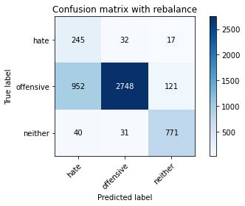

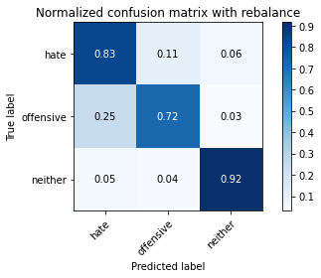

precision recall f1-score support

hate 0.20 0.83 0.32 294

offensive 0.98 0.72 0.83 3821

neither 0.85 0.92 0.88 842

accuracy 0.76 4957

macro avg 0.67 0.82 0.68 4957

weighted avg 0.91 0.76 0.81 4957

average eval_loss: 1.0695965092125979, accuracy: 0.7593302400645552

training 9 epoch...

28.60528063774109 seconds used......

9 training finished! average train loss: 0.02285102254177351

evaluating...

Confusion matrix, without normalization

[[ 238 45 11]

[ 868 2844 109]

[ 49 30 763]]

Normalized confusion matrix

[[0.80952381 0.15306122 0.03741497]

[0.22716566 0.74430777 0.02852656]

[0.05819477 0.03562945 0.90617577]]

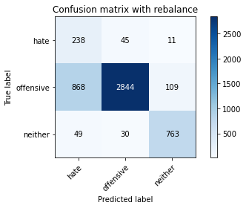

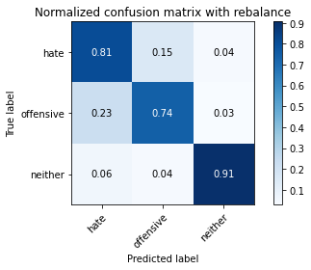

precision recall f1-score support

hate 0.21 0.81 0.33 294

offensive 0.97 0.74 0.84 3821

neither 0.86 0.91 0.88 842

accuracy 0.78 4957

macro avg 0.68 0.82 0.69 4957

weighted avg 0.91 0.78 0.82 4957

average eval_loss: 1.0372249139491618, accuracy: 0.7756707686100464

training 10 epoch...

28.511478185653687 seconds used......

10 training finished! average train loss: 0.012980330486615782

evaluating...

Confusion matrix, without normalization

[[ 225 52 17]

[ 724 2992 105]

[ 39 40 763]]

Normalized confusion matrix

[[0.76530612 0.17687075 0.05782313]

[0.18947919 0.78304109 0.02747972]

[0.04631829 0.04750594 0.90617577]]

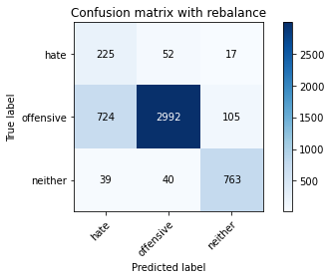

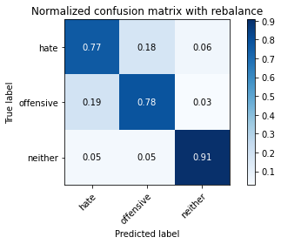

precision recall f1-score support

hate 0.23 0.77 0.35 294

offensive 0.97 0.78 0.87 3821

neither 0.86 0.91 0.88 842

accuracy 0.80 4957

macro avg 0.69 0.82 0.70 4957

weighted avg 0.91 0.80 0.84 4957

average eval_loss: 0.9501272700468807, accuracy: 0.8029049828525318