1 run

[1.5, 0.3, 1]

training 1 epoch...

28.43874478340149 seconds used......

1 training finished! average train loss: 0.5729136524493235

evaluating...

Confusion matrix, without normalization

[[ 223 35 36]

[ 830 2778 213]

[ 22 9 811]]

Normalized confusion matrix

[[0.7585034 0.11904762 0.12244898]

[0.21722062 0.72703481 0.05574457]

[0.02612827 0.01068884 0.9631829 ]]

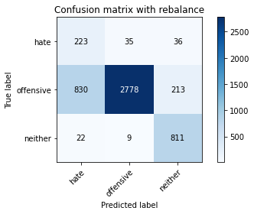

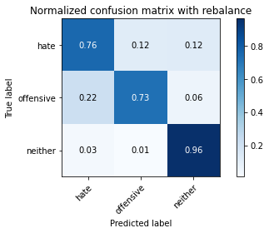

precision recall f1-score support

hate 0.21 0.76 0.33 294

offensive 0.98 0.73 0.84 3821

neither 0.77 0.96 0.85 842

accuracy 0.77 4957

macro avg 0.65 0.82 0.67 4957

weighted avg 0.90 0.77 0.81 4957

average eval_loss: 0.5259283966715297, accuracy: 0.7690135162396611

training 2 epoch...

27.87682008743286 seconds used......

2 training finished! average train loss: 0.32147414546612413

evaluating...

Confusion matrix, without normalization

[[ 254 19 21]

[1864 1791 166]

[ 51 6 785]]

Normalized confusion matrix

[[0.86394558 0.06462585 0.07142857]

[0.48783041 0.46872546 0.04344412]

[0.06057007 0.00712589 0.93230404]]

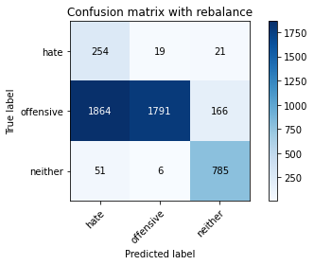

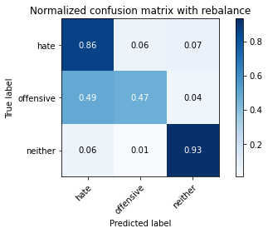

precision recall f1-score support

hate 0.12 0.86 0.21 294

offensive 0.99 0.47 0.64 3821

neither 0.81 0.93 0.87 842

accuracy 0.57 4957

macro avg 0.64 0.75 0.57 4957

weighted avg 0.90 0.57 0.65 4957

average eval_loss: 0.7591818911173651, accuracy: 0.5709098244906193

training 3 epoch...

27.85676336288452 seconds used......

3 training finished! average train loss: 0.20293073086013572

evaluating...

Confusion matrix, without normalization

[[ 251 20 23]

[1676 1977 168]

[ 44 6 792]]

Normalized confusion matrix

[[0.8537415 0.06802721 0.07823129]

[0.43862863 0.51740382 0.04396755]

[0.05225653 0.00712589 0.94061758]]

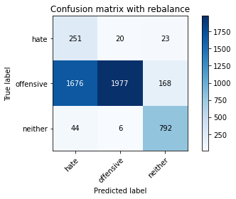

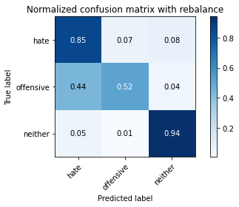

precision recall f1-score support

hate 0.13 0.85 0.22 294

offensive 0.99 0.52 0.68 3821

neither 0.81 0.94 0.87 842

accuracy 0.61 4957

macro avg 0.64 0.77 0.59 4957

weighted avg 0.91 0.61 0.68 4957

average eval_loss: 0.7401673151480574, accuracy: 0.6092394593504136

training 4 epoch...

27.872599124908447 seconds used......

4 training finished! average train loss: 0.12693397983995794

evaluating...

Confusion matrix, without normalization

[[ 249 29 16]

[1414 2306 101]

[ 88 12 742]]

Normalized confusion matrix

[[0.84693878 0.09863946 0.05442177]

[0.37006019 0.60350694 0.02643287]

[0.10451306 0.01425178 0.88123515]]

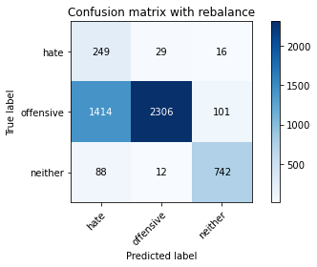

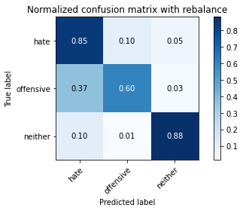

precision recall f1-score support

hate 0.14 0.85 0.24 294

offensive 0.98 0.60 0.75 3821

neither 0.86 0.88 0.87 842

accuracy 0.67 4957

macro avg 0.66 0.78 0.62 4957

weighted avg 0.91 0.67 0.74 4957

average eval_loss: 0.7835857622445591, accuracy: 0.6651200322775872

training 5 epoch...

27.802953004837036 seconds used......

5 training finished! average train loss: 0.09439723089075926

evaluating...

Confusion matrix, without normalization

[[ 243 31 20]

[1119 2533 169]

[ 50 7 785]]

Normalized confusion matrix

[[0.82653061 0.10544218 0.06802721]

[0.29285527 0.66291547 0.04422926]

[0.05938242 0.00831354 0.93230404]]

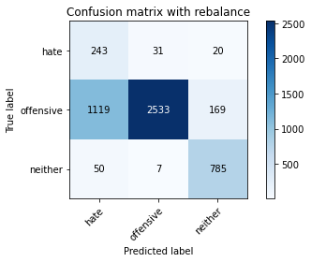

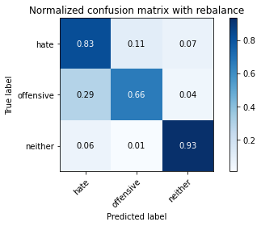

precision recall f1-score support

hate 0.17 0.83 0.28 294

offensive 0.99 0.66 0.79 3821

neither 0.81 0.93 0.86 842

accuracy 0.72 4957

macro avg 0.65 0.81 0.65 4957

weighted avg 0.91 0.72 0.77 4957

average eval_loss: 0.861581980761501, accuracy: 0.7183780512406698

training 6 epoch...

27.82518768310547 seconds used......

6 training finished! average train loss: 0.08265041708074815

evaluating...

Confusion matrix, without normalization

[[ 237 32 25]

[ 958 2710 153]

[ 39 9 794]]

Normalized confusion matrix

[[0.80612245 0.10884354 0.08503401]

[0.25071971 0.70923842 0.04004187]

[0.04631829 0.01068884 0.94299287]]

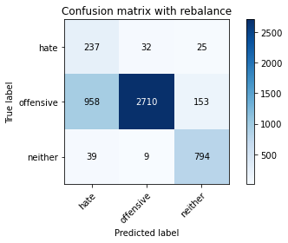

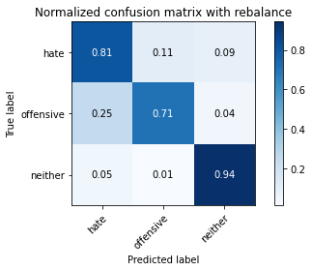

precision recall f1-score support

hate 0.19 0.81 0.31 294

offensive 0.99 0.71 0.82 3821

neither 0.82 0.94 0.88 842

accuracy 0.75 4957

macro avg 0.66 0.82 0.67 4957

weighted avg 0.91 0.75 0.80 4957

average eval_loss: 0.7030429643195784, accuracy: 0.7546903368973169

training 7 epoch...

27.81272864341736 seconds used......

7 training finished! average train loss: 0.043612576014912356

evaluating...

Confusion matrix, without normalization

[[ 215 55 24]

[ 702 2980 139]

[ 47 20 775]]

Normalized confusion matrix

[[0.73129252 0.18707483 0.08163265]

[0.18372154 0.77990055 0.03637791]

[0.05581948 0.02375297 0.92042755]]

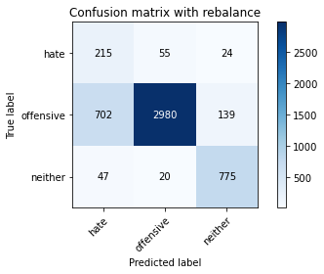

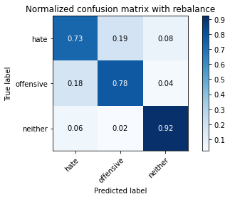

precision recall f1-score support

hate 0.22 0.73 0.34 294

offensive 0.98 0.78 0.87 3821

neither 0.83 0.92 0.87 842

accuracy 0.80 4957

macro avg 0.67 0.81 0.69 4957

weighted avg 0.91 0.80 0.84 4957

average eval_loss: 0.7666781013803331, accuracy: 0.8008876336493848

training 8 epoch...

27.76765203475952 seconds used......

8 training finished! average train loss: 0.027197588525837757

evaluating...

Confusion matrix, without normalization

[[ 241 34 19]

[1304 2379 138]

[ 76 12 754]]

Normalized confusion matrix

[[0.81972789 0.11564626 0.06462585]

[0.34127192 0.62261188 0.0361162 ]

[0.09026128 0.01425178 0.89548694]]

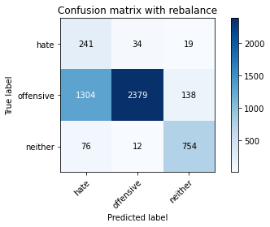

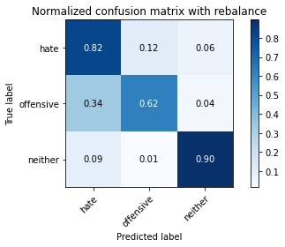

precision recall f1-score support

hate 0.15 0.82 0.25 294

offensive 0.98 0.62 0.76 3821

neither 0.83 0.90 0.86 842

accuracy 0.68 4957

macro avg 0.65 0.78 0.62 4957

weighted avg 0.91 0.68 0.75 4957

average eval_loss: 1.1470886920315904, accuracy: 0.6806536211418196

training 9 epoch...

27.79616403579712 seconds used......

9 training finished! average train loss: 0.024509752322599696

evaluating...

Confusion matrix, without normalization

[[ 200 61 33]

[ 615 2953 253]

[ 30 10 802]]

Normalized confusion matrix

[[0.68027211 0.20748299 0.1122449 ]

[0.16095263 0.77283434 0.06621303]

[0.03562945 0.01187648 0.95249406]]

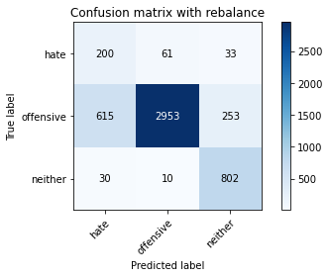

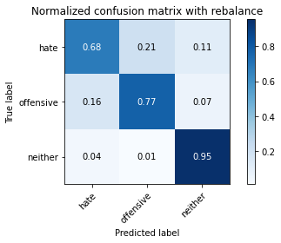

precision recall f1-score support

hate 0.24 0.68 0.35 294

offensive 0.98 0.77 0.86 3821

neither 0.74 0.95 0.83 842

accuracy 0.80 4957

macro avg 0.65 0.80 0.68 4957

weighted avg 0.89 0.80 0.83 4957

average eval_loss: 0.9654085849878385, accuracy: 0.7978616098446641

training 10 epoch...

27.79250144958496 seconds used......

10 training finished! average train loss: 0.018705434832219526

evaluating...

Confusion matrix, without normalization

[[ 231 33 30]

[1035 2589 197]

[ 29 8 805]]

Normalized confusion matrix

[[0.78571429 0.1122449 0.10204082]

[0.2708715 0.67757132 0.05155718]

[0.03444181 0.00950119 0.95605701]]

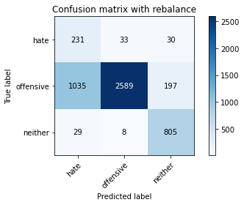

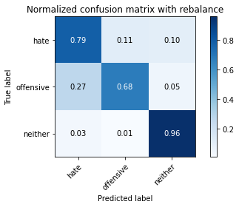

precision recall f1-score support

hate 0.18 0.79 0.29 294

offensive 0.98 0.68 0.80 3821

neither 0.78 0.96 0.86 842

accuracy 0.73 4957

macro avg 0.65 0.81 0.65 4957

weighted avg 0.90 0.73 0.78 4957

average eval_loss: 1.3590363293042174, accuracy: 0.731289086140811

2 run

training 1 epoch...

27.744269371032715 seconds used......

1 training finished! average train loss: 0.571509152912257

evaluating...

Confusion matrix, without normalization

[[ 235 32 27]

[ 950 2696 175]

[ 36 8 798]]

Normalized confusion matrix

[[0.79931973 0.10884354 0.09183673]

[0.24862601 0.70557446 0.04579953]

[0.04275534 0.00950119 0.94774347]]

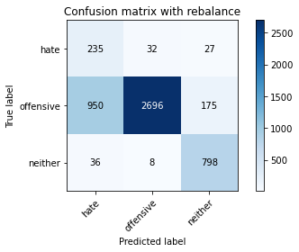

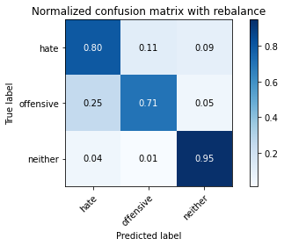

precision recall f1-score support

hate 0.19 0.80 0.31 294

offensive 0.99 0.71 0.82 3821

neither 0.80 0.95 0.87 842

accuracy 0.75 4957

macro avg 0.66 0.82 0.67 4957

weighted avg 0.91 0.75 0.80 4957

average eval_loss: 0.5597119183549958, accuracy: 0.7522695178535405

training 2 epoch...

27.711686611175537 seconds used......

2 training finished! average train loss: 0.32837063631816216

evaluating...

Confusion matrix, without normalization

[[ 253 21 20]

[1543 2079 199]

[ 39 7 796]]

Normalized confusion matrix

[[0.86054422 0.07142857 0.06802721]

[0.40382099 0.5440984 0.05208061]

[0.04631829 0.00831354 0.94536817]]

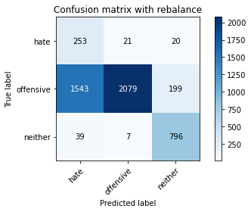

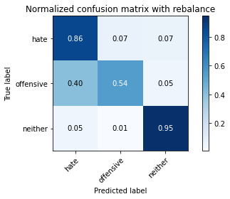

precision recall f1-score support

hate 0.14 0.86 0.24 294

offensive 0.99 0.54 0.70 3821

neither 0.78 0.95 0.86 842

accuracy 0.63 4957

macro avg 0.64 0.78 0.60 4957

weighted avg 0.90 0.63 0.70 4957

average eval_loss: 0.7023278817294105, accuracy: 0.6310268307444018

training 3 epoch...

27.791547060012817 seconds used......

3 training finished! average train loss: 0.19893114012802204

evaluating...

Confusion matrix, without normalization

[[ 245 25 24]

[1295 2346 180]

[ 43 6 793]]

Normalized confusion matrix

[[0.83333333 0.08503401 0.08163265]

[0.33891651 0.6139754 0.04710809]

[0.05106888 0.00712589 0.94180523]]

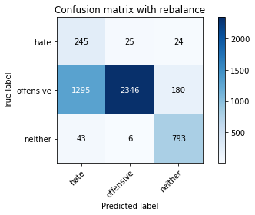

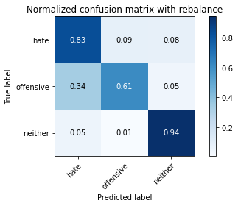

precision recall f1-score support

hate 0.15 0.83 0.26 294

offensive 0.99 0.61 0.76 3821

neither 0.80 0.94 0.86 842

accuracy 0.68 4957

macro avg 0.65 0.80 0.63 4957

weighted avg 0.91 0.68 0.75 4957

average eval_loss: 0.6784450323170712, accuracy: 0.6826709703449667

training 4 epoch...

27.729029655456543 seconds used......

4 training finished! average train loss: 0.12640657942001407

evaluating...

Confusion matrix, without normalization

[[ 256 27 11]

[1277 2446 98]

[ 121 31 690]]

Normalized confusion matrix

[[0.8707483 0.09183673 0.03741497]

[0.33420571 0.64014656 0.02564774]

[0.14370546 0.0368171 0.81947743]]

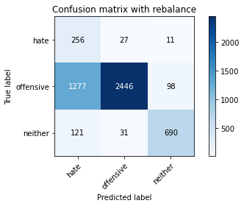

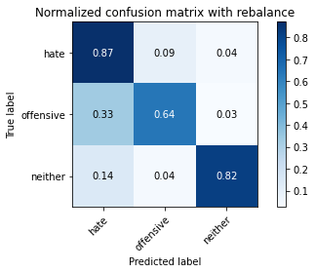

precision recall f1-score support

hate 0.15 0.87 0.26 294

offensive 0.98 0.64 0.77 3821

neither 0.86 0.82 0.84 842

accuracy 0.68 4957

macro avg 0.67 0.78 0.63 4957

weighted avg 0.91 0.68 0.75 4957

average eval_loss: 0.780373748812464, accuracy: 0.6842848497074844

training 5 epoch...

27.76368021965027 seconds used......

5 training finished! average train loss: 0.09589976262932981

evaluating...

Confusion matrix, without normalization

[[ 246 31 17]

[1125 2582 114]

[ 55 24 763]]

Normalized confusion matrix

[[0.83673469 0.10544218 0.05782313]

[0.29442554 0.67573934 0.02983512]

[0.06532067 0.02850356 0.90617577]]

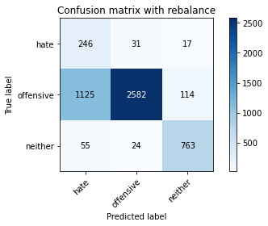

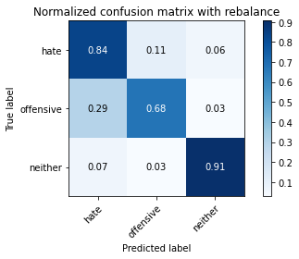

precision recall f1-score support

hate 0.17 0.84 0.29 294

offensive 0.98 0.68 0.80 3821

neither 0.85 0.91 0.88 842

accuracy 0.72 4957

macro avg 0.67 0.81 0.65 4957

weighted avg 0.91 0.72 0.78 4957

average eval_loss: 0.769333468149266, accuracy: 0.724430098850111

training 6 epoch...

27.757408380508423 seconds used......

6 training finished! average train loss: 0.06467830244593366

evaluating...

Confusion matrix, without normalization

[[ 229 44 21]

[ 955 2728 138]

[ 41 23 778]]

Normalized confusion matrix

[[0.77891156 0.14965986 0.07142857]

[0.24993457 0.71394923 0.0361162 ]

[0.04869359 0.02731591 0.9239905 ]]

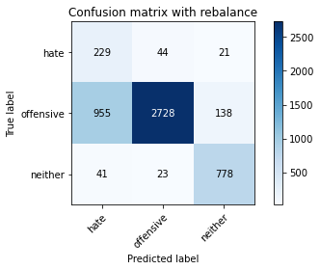

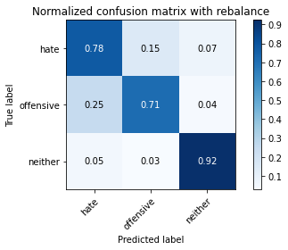

precision recall f1-score support

hate 0.19 0.78 0.30 294

offensive 0.98 0.71 0.82 3821

neither 0.83 0.92 0.87 842

accuracy 0.75 4957

macro avg 0.66 0.81 0.67 4957

weighted avg 0.90 0.75 0.80 4957

average eval_loss: 0.782665949983282, accuracy: 0.7534799273754287

training 7 epoch...

27.69326901435852 seconds used......

7 training finished! average train loss: 0.04200340524705247

evaluating...

Confusion matrix, without normalization

[[ 231 47 16]

[ 857 2823 141]

[ 61 17 764]]

Normalized confusion matrix

[[0.78571429 0.15986395 0.05442177]

[0.22428684 0.73881183 0.03690133]

[0.07244656 0.02019002 0.90736342]]

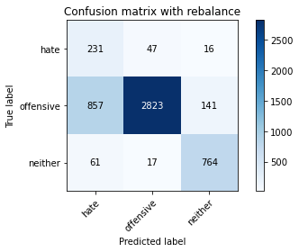

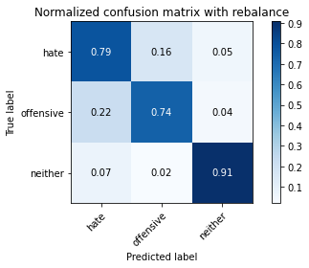

precision recall f1-score support

hate 0.20 0.79 0.32 294

offensive 0.98 0.74 0.84 3821

neither 0.83 0.91 0.87 842

accuracy 0.77 4957

macro avg 0.67 0.81 0.68 4957

weighted avg 0.91 0.77 0.82 4957

average eval_loss: 0.8395998342894018, accuracy: 0.7702239257615493

training 8 epoch...

27.771376132965088 seconds used......

8 training finished! average train loss: 0.027021374592587504

evaluating...

Confusion matrix, without normalization

[[ 220 58 16]

[ 701 3006 114]

[ 55 23 764]]

Normalized confusion matrix

[[0.74829932 0.19727891 0.05442177]

[0.18345983 0.78670505 0.02983512]

[0.06532067 0.02731591 0.90736342]]

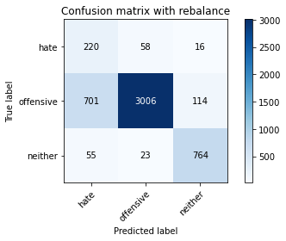

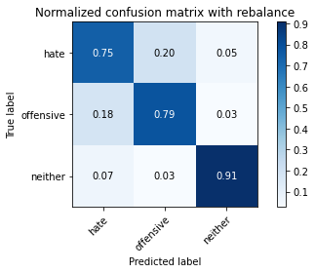

precision recall f1-score support

hate 0.23 0.75 0.35 294

offensive 0.97 0.79 0.87 3821

neither 0.85 0.91 0.88 842

accuracy 0.80 4957

macro avg 0.68 0.81 0.70 4957

weighted avg 0.91 0.80 0.84 4957

average eval_loss: 0.8437895466753792, accuracy: 0.8049223320556789

training 9 epoch...

27.80038809776306 seconds used......

9 training finished! average train loss: 0.019709721769952372

evaluating...

Confusion matrix, without normalization

[[ 243 26 25]

[1063 2385 373]

[ 47 7 788]]

Normalized confusion matrix

[[0.82653061 0.08843537 0.08503401]

[0.27819942 0.62418215 0.09761842]

[0.05581948 0.00831354 0.93586698]]

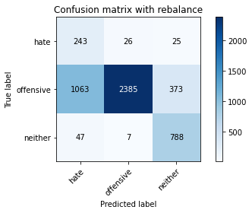

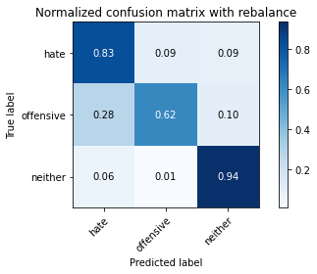

precision recall f1-score support

hate 0.18 0.83 0.30 294

offensive 0.99 0.62 0.76 3821

neither 0.66 0.94 0.78 842

accuracy 0.69 4957

macro avg 0.61 0.80 0.61 4957

weighted avg 0.88 0.69 0.74 4957

average eval_loss: 1.2957456709832074, accuracy: 0.6891264877950373

training 10 epoch...

27.683000326156616 seconds used......

10 training finished! average train loss: 0.016868762917713158

evaluating...

Confusion matrix, without normalization

[[ 250 30 14]

[1291 2445 85]

[ 99 35 708]]

Normalized confusion matrix

[[0.85034014 0.10204082 0.04761905]

[0.33786967 0.63988485 0.02224549]

[0.1175772 0.0415677 0.84085511]]

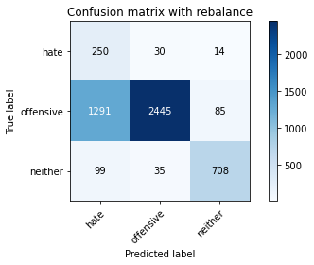

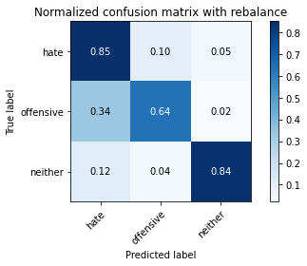

precision recall f1-score support

hate 0.15 0.85 0.26 294

offensive 0.97 0.64 0.77 3821

neither 0.88 0.84 0.86 842

accuracy 0.69 4957

macro avg 0.67 0.78 0.63 4957

weighted avg 0.91 0.69 0.76 4957

average eval_loss: 1.264786565195649, accuracy: 0.6865039338309461

3 run

training 1 epoch...

27.789506912231445 seconds used......

1 training finished! average train loss: 0.5780164810300571

evaluating...

Confusion matrix, without normalization

[[ 235 29 30]

[1236 2414 171]

[ 35 9 798]]

Normalized confusion matrix

[[0.79931973 0.09863946 0.10204082]

[0.32347553 0.63177179 0.04475268]

[0.0415677 0.01068884 0.94774347]]

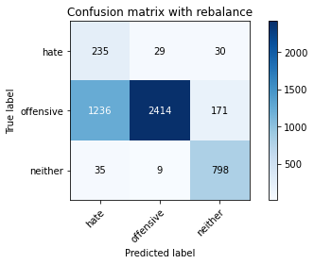

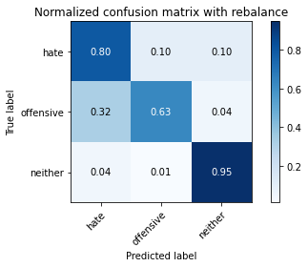

precision recall f1-score support

hate 0.16 0.80 0.26 294

offensive 0.98 0.63 0.77 3821

neither 0.80 0.95 0.87 842

accuracy 0.70 4957

macro avg 0.65 0.79 0.63 4957

weighted avg 0.90 0.70 0.76 4957

average eval_loss: 0.6475729345073623, accuracy: 0.6953802703247932

training 2 epoch...

27.7281277179718 seconds used......

2 training finished! average train loss: 0.318768984284143

evaluating...

Confusion matrix, without normalization

[[ 258 14 22]

[2053 1597 171]

[ 44 6 792]]

Normalized confusion matrix

[[0.87755102 0.04761905 0.07482993]

[0.5372939 0.41795342 0.04475268]

[0.05225653 0.00712589 0.94061758]]

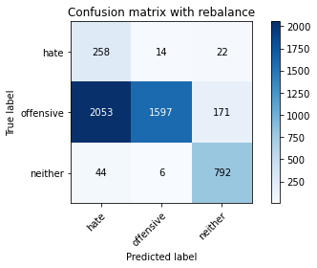

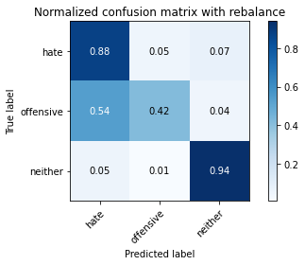

precision recall f1-score support

hate 0.11 0.88 0.19 294

offensive 0.99 0.42 0.59 3821

neither 0.80 0.94 0.87 842

accuracy 0.53 4957

macro avg 0.63 0.75 0.55 4957

weighted avg 0.90 0.53 0.61 4957

average eval_loss: 0.7846726022901074, accuracy: 0.533992334073028

training 3 epoch...

27.7363600730896 seconds used......

3 training finished! average train loss: 0.20598020602823697

evaluating...

Confusion matrix, without normalization

[[ 248 37 9]

[1066 2692 63]

[ 137 25 680]]

Normalized confusion matrix

[[0.84353741 0.12585034 0.03061224]

[0.27898456 0.70452761 0.01648783]

[0.16270784 0.02969121 0.80760095]]

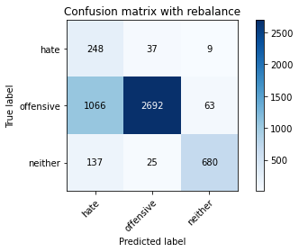

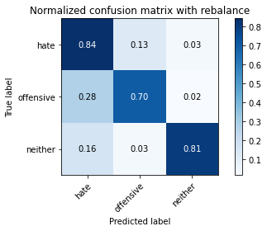

precision recall f1-score support

hate 0.17 0.84 0.28 294

offensive 0.98 0.70 0.82 3821

neither 0.90 0.81 0.85 842

accuracy 0.73 4957

macro avg 0.68 0.79 0.65 4957

weighted avg 0.92 0.73 0.79 4957

average eval_loss: 0.6256832885105283, accuracy: 0.7302804115392374

training 4 epoch...

27.7159423828125 seconds used......

4 training finished! average train loss: 0.12491763926149287

evaluating...

Confusion matrix, without normalization

[[ 253 28 13]

[1386 2342 93]

[ 76 20 746]]

Normalized confusion matrix

[[0.86054422 0.0952381 0.04421769]

[0.36273227 0.61292855 0.02433918]

[0.09026128 0.02375297 0.88598575]]

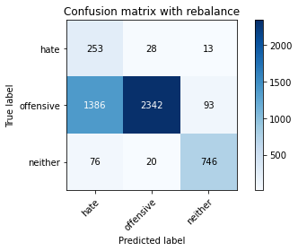

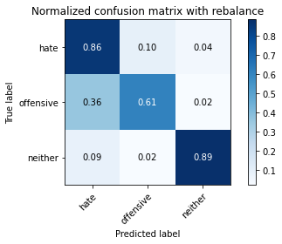

precision recall f1-score support

hate 0.15 0.86 0.25 294

offensive 0.98 0.61 0.75 3821

neither 0.88 0.89 0.88 842

accuracy 0.67 4957

macro avg 0.67 0.79 0.63 4957

weighted avg 0.91 0.67 0.75 4957

average eval_loss: 0.7766938851244988, accuracy: 0.6739963687714343

training 5 epoch...

27.736822366714478 seconds used......

5 training finished! average train loss: 0.09226374392403149

evaluating...

Confusion matrix, without normalization

[[ 234 36 24]

[1066 2591 164]

[ 31 15 796]]

Normalized confusion matrix

[[0.79591837 0.12244898 0.08163265]

[0.27898456 0.67809474 0.0429207 ]

[0.0368171 0.01781473 0.94536817]]

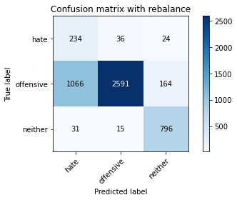

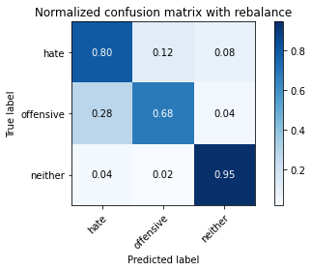

precision recall f1-score support

hate 0.18 0.80 0.29 294

offensive 0.98 0.68 0.80 3821

neither 0.81 0.95 0.87 842

accuracy 0.73 4957

macro avg 0.66 0.81 0.65 4957

weighted avg 0.90 0.73 0.78 4957

average eval_loss: 0.76777944838508, accuracy: 0.7304821464595521

training 6 epoch...

27.790093183517456 seconds used......

6 training finished! average train loss: 0.05818955208125867

evaluating...

Confusion matrix, without normalization

[[ 226 52 16]

[ 849 2851 121]

[ 48 20 774]]

Normalized confusion matrix

[[0.76870748 0.17687075 0.05442177]

[0.22219314 0.74613975 0.0316671 ]

[0.05700713 0.02375297 0.9192399 ]]

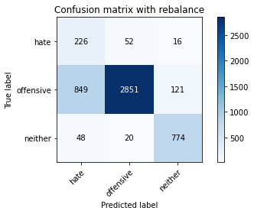

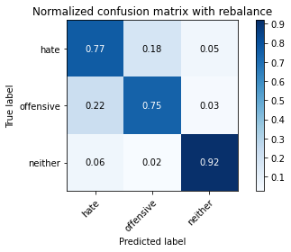

precision recall f1-score support

hate 0.20 0.77 0.32 294

offensive 0.98 0.75 0.85 3821

neither 0.85 0.92 0.88 842

accuracy 0.78 4957

macro avg 0.68 0.81 0.68 4957

weighted avg 0.91 0.78 0.82 4957

average eval_loss: 0.7216727587980248, accuracy: 0.7768811781319347

training 7 epoch...

27.674320220947266 seconds used......

7 training finished! average train loss: 0.04179588217854674

evaluating...

Confusion matrix, without normalization

[[ 223 57 14]

[ 738 3002 81]

[ 80 37 725]]

Normalized confusion matrix

[[0.7585034 0.19387755 0.04761905]

[0.19314316 0.7856582 0.02119864]

[0.09501188 0.04394299 0.86104513]]

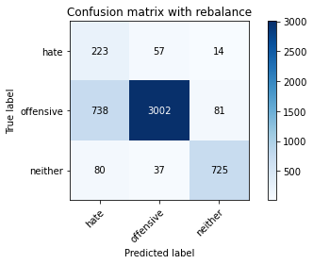

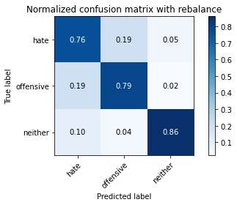

precision recall f1-score support

hate 0.21 0.76 0.33 294

offensive 0.97 0.79 0.87 3821

neither 0.88 0.86 0.87 842

accuracy 0.80 4957

macro avg 0.69 0.80 0.69 4957

weighted avg 0.91 0.80 0.84 4957

average eval_loss: 0.8328875733385493, accuracy: 0.7968529352430905

training 8 epoch...

27.809595108032227 seconds used......

8 training finished! average train loss: 0.035730346467493006

evaluating...

Confusion matrix, without normalization

[[ 228 47 19]

[ 830 2859 132]

[ 37 21 784]]

Normalized confusion matrix

[[0.7755102 0.15986395 0.06462585]

[0.21722062 0.74823345 0.03454593]

[0.04394299 0.02494062 0.93111639]]

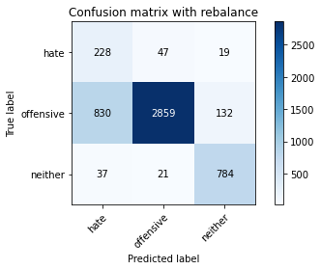

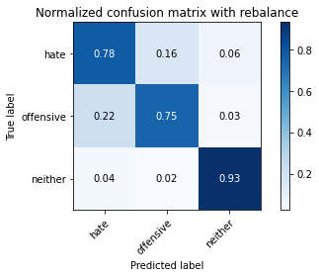

precision recall f1-score support

hate 0.21 0.78 0.33 294

offensive 0.98 0.75 0.85 3821

neither 0.84 0.93 0.88 842

accuracy 0.78 4957

macro avg 0.67 0.82 0.69 4957

weighted avg 0.91 0.78 0.82 4957

average eval_loss: 0.8790696254901348, accuracy: 0.7809158765382288

training 9 epoch...

27.724753379821777 seconds used......

9 training finished! average train loss: 0.01941708915023411

evaluating...

Confusion matrix, without normalization

[[ 243 37 14]

[1166 2566 89]

[ 69 32 741]]

Normalized confusion matrix

[[0.82653061 0.12585034 0.04761905]

[0.30515572 0.67155195 0.02329233]

[0.08194774 0.03800475 0.88004751]]

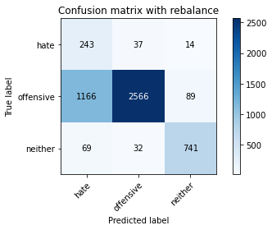

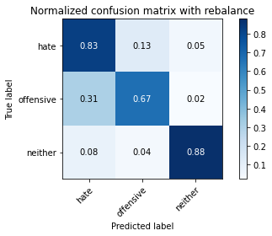

precision recall f1-score support

hate 0.16 0.83 0.27 294

offensive 0.97 0.67 0.79 3821

neither 0.88 0.88 0.88 842

accuracy 0.72 4957

macro avg 0.67 0.79 0.65 4957

weighted avg 0.91 0.72 0.78 4957

average eval_loss: 1.1865532254807711, accuracy: 0.716158967117208

training 10 epoch...

27.686136722564697 seconds used......

10 training finished! average train loss: 0.026323342474064468

evaluating...

Confusion matrix, without normalization

[[ 206 68 20]

[ 504 3199 118]

[ 39 36 767]]

Normalized confusion matrix

[[0.70068027 0.23129252 0.06802721]

[0.13190264 0.83721539 0.03088197]

[0.04631829 0.04275534 0.91092637]]

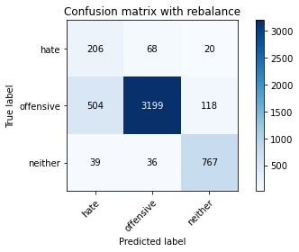

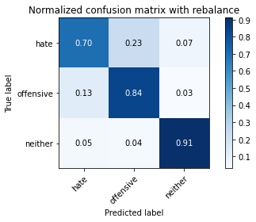

precision recall f1-score support

hate 0.28 0.70 0.40 294

offensive 0.97 0.84 0.90 3821

neither 0.85 0.91 0.88 842

accuracy 0.84 4957

macro avg 0.70 0.82 0.72 4957

weighted avg 0.91 0.84 0.86 4957

average eval_loss: 0.8372905152707151, accuracy: 0.8416380875529554

4 run

training 1 epoch...

27.78709387779236 seconds used......

1 training finished! average train loss: 0.582710755585927

evaluating...

Confusion matrix, without normalization

[[ 245 25 24]

[1149 2371 301]

[ 75 5 762]]

Normalized confusion matrix

[[0.83333333 0.08503401 0.08163265]

[0.30070662 0.62051819 0.07877519]

[0.08907363 0.00593824 0.90498812]]

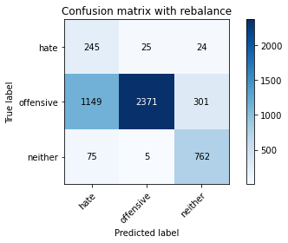

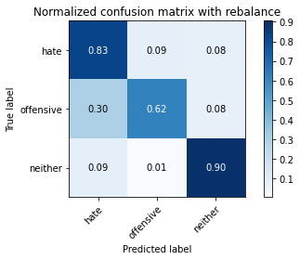

precision recall f1-score support

hate 0.17 0.83 0.28 294

offensive 0.99 0.62 0.76 3821

neither 0.70 0.90 0.79 842

accuracy 0.68 4957

macro avg 0.62 0.79 0.61 4957

weighted avg 0.89 0.68 0.74 4957

average eval_loss: 0.6600052830312522, accuracy: 0.6814605608230785

training 2 epoch...

27.706223011016846 seconds used......

2 training finished! average train loss: 0.3206955268325513

evaluating...

Confusion matrix, without normalization

[[ 259 13 22]

[2044 1481 296]

[ 64 3 775]]

Normalized confusion matrix

[[0.88095238 0.04421769 0.07482993]

[0.5349385 0.38759487 0.07746663]

[0.0760095 0.00356295 0.92042755]]

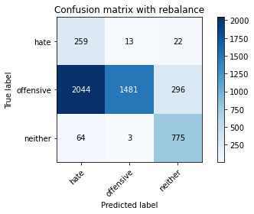

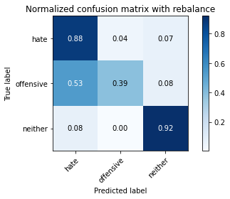

precision recall f1-score support

hate 0.11 0.88 0.19 294

offensive 0.99 0.39 0.56 3821

neither 0.71 0.92 0.80 842

accuracy 0.51 4957

macro avg 0.60 0.73 0.52 4957

weighted avg 0.89 0.51 0.58 4957

average eval_loss: 0.9964582786685036, accuracy: 0.5073633245914868

training 3 epoch...

27.712684154510498 seconds used......

3 training finished! average train loss: 0.2169988837899172

evaluating...

Confusion matrix, without normalization

[[ 249 26 19]

[1313 2340 168]

[ 56 9 777]]

Normalized confusion matrix

[[0.84693878 0.08843537 0.06462585]

[0.34362732 0.61240513 0.04396755]

[0.06650831 0.01068884 0.92280285]]

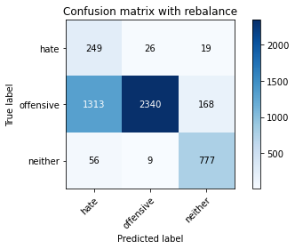

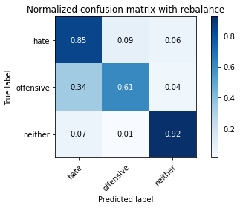

precision recall f1-score support

hate 0.15 0.85 0.26 294

offensive 0.99 0.61 0.76 3821

neither 0.81 0.92 0.86 842

accuracy 0.68 4957

macro avg 0.65 0.79 0.63 4957

weighted avg 0.91 0.68 0.74 4957

average eval_loss: 0.6477661467187347, accuracy: 0.679039741779302

training 4 epoch...

27.848323345184326 seconds used......

4 training finished! average train loss: 0.1295963249479731

evaluating...

Confusion matrix, without normalization

[[ 248 29 17]

[1161 2543 117]

[ 57 16 769]]

Normalized confusion matrix

[[0.84353741 0.09863946 0.05782313]

[0.30384716 0.66553258 0.03062026]

[0.06769596 0.01900238 0.91330166]]

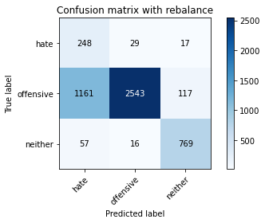

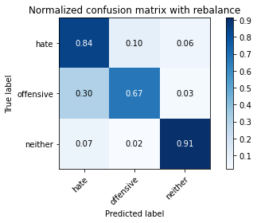

precision recall f1-score support

hate 0.17 0.84 0.28 294

offensive 0.98 0.67 0.79 3821

neither 0.85 0.91 0.88 842

accuracy 0.72 4957

macro avg 0.67 0.81 0.65 4957

weighted avg 0.91 0.72 0.78 4957

average eval_loss: 0.7542921189939783, accuracy: 0.7181763163203551

training 5 epoch...

27.675697803497314 seconds used......

5 training finished! average train loss: 0.09541610259105239

evaluating...

Confusion matrix, without normalization

[[ 252 29 13]

[1340 2354 127]

[ 66 14 762]]

Normalized confusion matrix

[[0.85714286 0.09863946 0.04421769]

[0.35069354 0.61606909 0.03323737]

[0.0783848 0.01662708 0.90498812]]

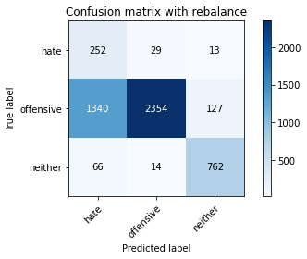

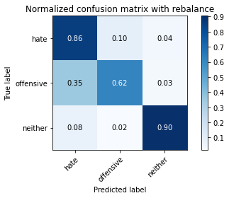

precision recall f1-score support

hate 0.15 0.86 0.26 294

offensive 0.98 0.62 0.76 3821

neither 0.84 0.90 0.87 842

accuracy 0.68 4957

macro avg 0.66 0.79 0.63 4957

weighted avg 0.91 0.68 0.75 4957

average eval_loss: 0.8102664081079345, accuracy: 0.6794432116199314

training 6 epoch...

27.735153198242188 seconds used......

6 training finished! average train loss: 0.06638018545362423

evaluating...

Confusion matrix, without normalization

[[ 235 38 21]

[ 917 2763 141]

[ 45 20 777]]

Normalized confusion matrix

[[0.79931973 0.1292517 0.07142857]

[0.23998953 0.72310913 0.03690133]

[0.05344418 0.02375297 0.92280285]]

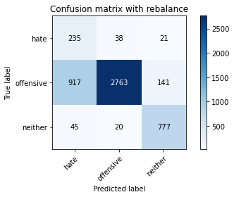

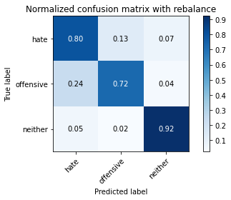

precision recall f1-score support

hate 0.20 0.80 0.32 294

offensive 0.98 0.72 0.83 3821

neither 0.83 0.92 0.87 842

accuracy 0.76 4957

macro avg 0.67 0.82 0.67 4957

weighted avg 0.91 0.76 0.81 4957

average eval_loss: 0.6969260448860305, accuracy: 0.7615493241880169

training 7 epoch...

27.657463550567627 seconds used......

7 training finished! average train loss: 0.04006479874359477

evaluating...

Confusion matrix, without normalization

[[ 247 33 14]

[1111 2581 129]

[ 61 16 765]]

Normalized confusion matrix

[[0.84013605 0.1122449 0.04761905]

[0.29076158 0.67547762 0.0337608 ]

[0.07244656 0.01900238 0.90855107]]

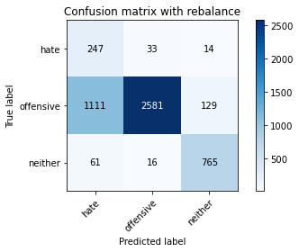

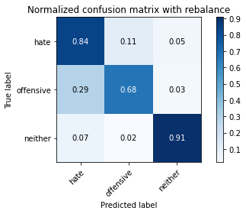

precision recall f1-score support

hate 0.17 0.84 0.29 294

offensive 0.98 0.68 0.80 3821

neither 0.84 0.91 0.87 842

accuracy 0.72 4957

macro avg 0.67 0.81 0.65 4957

weighted avg 0.91 0.72 0.78 4957

average eval_loss: 1.0354217265492245, accuracy: 0.7248335686907403

training 8 epoch...

27.660911798477173 seconds used......

8 training finished! average train loss: 0.03247615210140091

evaluating...

Confusion matrix, without normalization

[[ 212 60 22]

[ 691 2983 147]

[ 42 28 772]]

Normalized confusion matrix

[[0.72108844 0.20408163 0.07482993]

[0.18084271 0.78068568 0.0384716 ]

[0.04988124 0.03325416 0.91686461]]

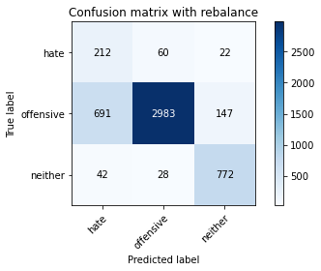

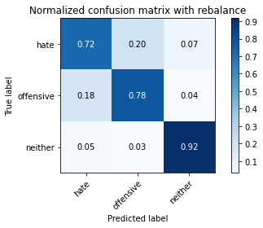

precision recall f1-score support

hate 0.22 0.72 0.34 294

offensive 0.97 0.78 0.87 3821

neither 0.82 0.92 0.87 842

accuracy 0.80 4957

macro avg 0.67 0.81 0.69 4957

weighted avg 0.90 0.80 0.83 4957

average eval_loss: 0.8370961205125035, accuracy: 0.8002824288884406

training 9 epoch...

27.666158199310303 seconds used......

9 training finished! average train loss: 0.024106644748230818

evaluating...

Confusion matrix, without normalization

[[ 225 48 21]

[ 945 2740 136]

[ 61 29 752]]

Normalized confusion matrix

[[0.76530612 0.16326531 0.07142857]

[0.24731746 0.71708977 0.03559278]

[0.07244656 0.03444181 0.89311164]]

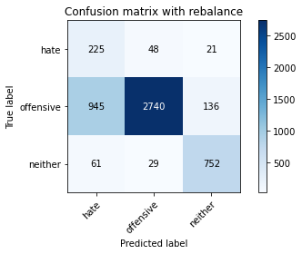

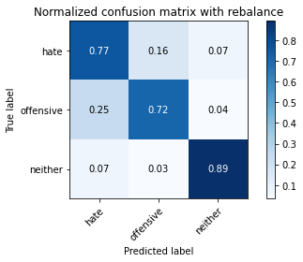

precision recall f1-score support

hate 0.18 0.77 0.30 294

offensive 0.97 0.72 0.83 3821

neither 0.83 0.89 0.86 842

accuracy 0.75 4957

macro avg 0.66 0.79 0.66 4957

weighted avg 0.90 0.75 0.80 4957

average eval_loss: 1.026787940900953, accuracy: 0.749848698809764

training 10 epoch...

27.754283905029297 seconds used......

10 training finished! average train loss: 0.03196747267478532

evaluating...

Confusion matrix, without normalization

[[ 247 34 13]

[1194 2527 100]

[ 74 24 744]]

Normalized confusion matrix

[[0.84013605 0.11564626 0.04421769]

[0.31248364 0.6613452 0.02617116]

[0.08788599 0.02850356 0.88361045]]

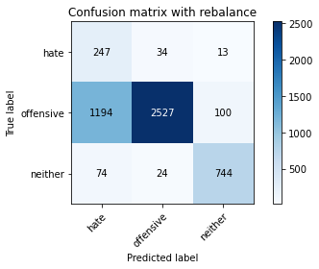

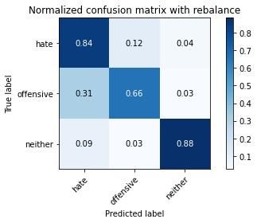

precision recall f1-score support

hate 0.16 0.84 0.27 294

offensive 0.98 0.66 0.79 3821

neither 0.87 0.88 0.88 842

accuracy 0.71 4957

macro avg 0.67 0.80 0.65 4957

weighted avg 0.91 0.71 0.77 4957

average eval_loss: 1.1497143739834428, accuracy: 0.7097034496671374

5 run

training 1 epoch...

27.749489545822144 seconds used......

1 training finished! average train loss: 0.5889176340305318

evaluating...

Confusion matrix, without normalization

[[ 231 29 34]

[1092 2533 196]

[ 32 8 802]]

Normalized confusion matrix

[[0.78571429 0.09863946 0.11564626]

[0.28578906 0.66291547 0.05129547]

[0.03800475 0.00950119 0.95249406]]

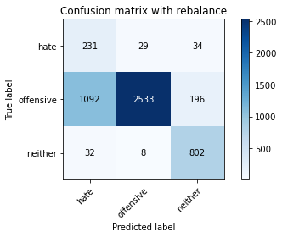

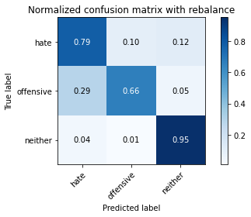

precision recall f1-score support

hate 0.17 0.79 0.28 294

offensive 0.99 0.66 0.79 3821

neither 0.78 0.95 0.86 842

accuracy 0.72 4957

macro avg 0.64 0.80 0.64 4957

weighted avg 0.90 0.72 0.77 4957

average eval_loss: 0.6073715963791455, accuracy: 0.7193867258422433

training 2 epoch...

27.70378804206848 seconds used......

2 training finished! average train loss: 0.3221720096312071

evaluating...

Confusion matrix, without normalization

[[ 258 22 14]

[1505 2117 199]

[ 68 6 768]]

Normalized confusion matrix

[[0.87755102 0.07482993 0.04761905]

[0.39387595 0.55404344 0.05208061]

[0.0807601 0.00712589 0.91211401]]

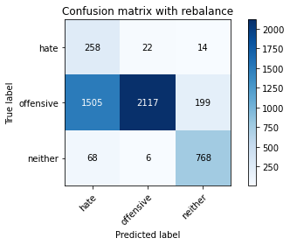

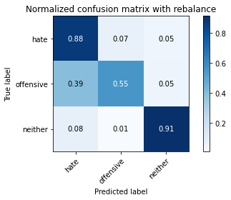

precision recall f1-score support

hate 0.14 0.88 0.24 294

offensive 0.99 0.55 0.71 3821

neither 0.78 0.91 0.84 842

accuracy 0.63 4957

macro avg 0.64 0.78 0.60 4957

weighted avg 0.90 0.63 0.70 4957

average eval_loss: 0.7221088544615815, accuracy: 0.6340528545491224

training 3 epoch...

27.718673944473267 seconds used......

3 training finished! average train loss: 0.20159799514109628

evaluating...

Confusion matrix, without normalization

[[ 249 26 19]

[1306 2390 125]

[ 60 10 772]]

Normalized confusion matrix

[[0.84693878 0.08843537 0.06462585]

[0.34179534 0.62549071 0.03271395]

[0.07125891 0.01187648 0.91686461]]

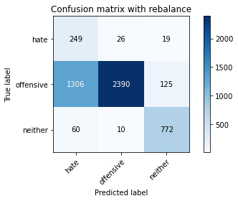

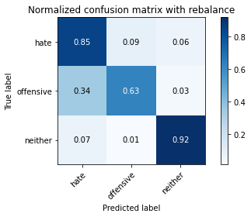

precision recall f1-score support

hate 0.15 0.85 0.26 294

offensive 0.99 0.63 0.77 3821

neither 0.84 0.92 0.88 842

accuracy 0.69 4957

macro avg 0.66 0.80 0.63 4957

weighted avg 0.91 0.69 0.75 4957

average eval_loss: 0.6583950331194266, accuracy: 0.6881178131934638

training 4 epoch...

27.81127691268921 seconds used......

4 training finished! average train loss: 0.13176096390322808

evaluating...

Confusion matrix, without normalization

[[ 250 28 16]

[1201 2512 108]

[ 64 13 765]]

Normalized confusion matrix

[[0.85034014 0.0952381 0.05442177]

[0.31431562 0.65741952 0.02826485]

[0.0760095 0.01543943 0.90855107]]

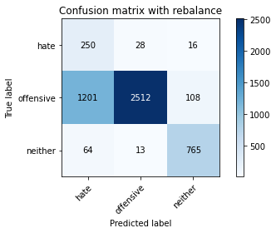

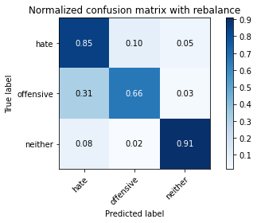

precision recall f1-score support

hate 0.17 0.85 0.28 294

offensive 0.98 0.66 0.79 3821

neither 0.86 0.91 0.88 842

accuracy 0.71 4957

macro avg 0.67 0.81 0.65 4957

weighted avg 0.91 0.71 0.77 4957

average eval_loss: 0.7104286908081943, accuracy: 0.7115190639499698

training 5 epoch...

27.813225746154785 seconds used......

5 training finished! average train loss: 0.09022347883958566

evaluating...

Confusion matrix, without normalization

[[ 249 31 14]

[1161 2525 135]

[ 67 15 760]]

Normalized confusion matrix

[[0.84693878 0.10544218 0.04761905]

[0.30384716 0.66082177 0.03533107]

[0.07957245 0.01781473 0.90261283]]

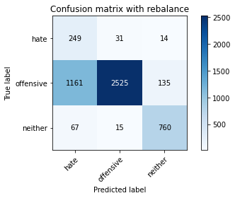

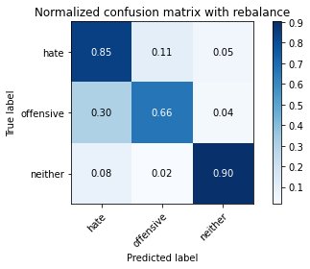

precision recall f1-score support

hate 0.17 0.85 0.28 294

offensive 0.98 0.66 0.79 3821

neither 0.84 0.90 0.87 842

accuracy 0.71 4957

macro avg 0.66 0.80 0.65 4957

weighted avg 0.91 0.71 0.77 4957

average eval_loss: 0.7475745631982723, accuracy: 0.7129312083921727

training 6 epoch...

27.719674587249756 seconds used......

6 training finished! average train loss: 0.06664830346847748

evaluating...

Confusion matrix, without normalization

[[ 236 37 21]

[ 915 2784 122]

[ 49 17 776]]

Normalized confusion matrix

[[0.80272109 0.12585034 0.07142857]

[0.23946611 0.72860508 0.03192881]

[0.05819477 0.02019002 0.9216152 ]]

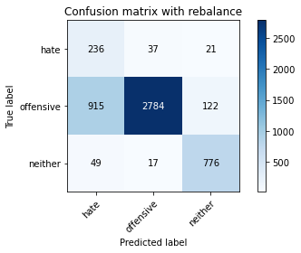

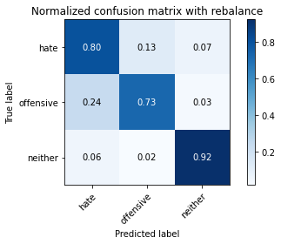

precision recall f1-score support

hate 0.20 0.80 0.32 294

offensive 0.98 0.73 0.84 3821

neither 0.84 0.92 0.88 842

accuracy 0.77 4957

macro avg 0.67 0.82 0.68 4957

weighted avg 0.91 0.77 0.81 4957

average eval_loss: 0.7066260048849208, accuracy: 0.7657857575146257

training 7 epoch...

27.732973098754883 seconds used......

7 training finished! average train loss: 0.04589920263391598

evaluating...

Confusion matrix, without normalization

[[ 247 26 21]

[1228 2469 124]

[ 53 15 774]]

Normalized confusion matrix

[[0.84013605 0.08843537 0.07142857]

[0.32138184 0.64616593 0.03245224]

[0.06294537 0.01781473 0.9192399 ]]

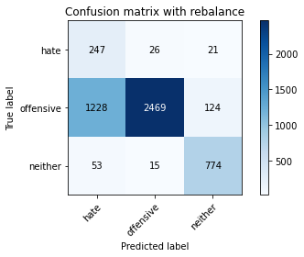

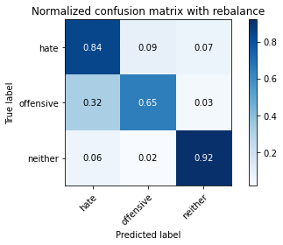

precision recall f1-score support

hate 0.16 0.84 0.27 294

offensive 0.98 0.65 0.78 3821

neither 0.84 0.92 0.88 842

accuracy 0.70 4957

macro avg 0.66 0.80 0.64 4957

weighted avg 0.91 0.70 0.77 4957

average eval_loss: 0.9739853289398935, accuracy: 0.7040548718983256

training 8 epoch...

27.7951602935791 seconds used......

8 training finished! average train loss: 0.02642964780751387

evaluating...

Confusion matrix, without normalization

[[ 240 37 17]

[ 993 2724 104]

[ 56 24 762]]

Normalized confusion matrix

[[0.81632653 0.12585034 0.05782313]

[0.25987961 0.71290238 0.02721801]

[0.06650831 0.02850356 0.90498812]]

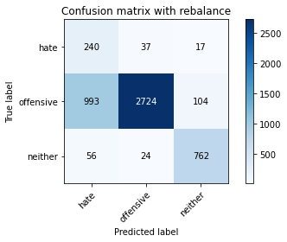

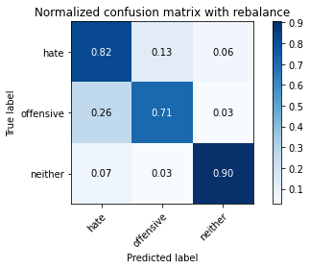

precision recall f1-score support

hate 0.19 0.82 0.30 294

offensive 0.98 0.71 0.82 3821

neither 0.86 0.90 0.88 842

accuracy 0.75 4957

macro avg 0.68 0.81 0.67 4957

weighted avg 0.91 0.75 0.80 4957

average eval_loss: 0.9926577753973224, accuracy: 0.7516643130925963

training 9 epoch...

27.773004293441772 seconds used......

9 training finished! average train loss: 0.022191482428965098

evaluating...

Confusion matrix, without normalization

[[ 230 55 9]

[1077 2679 65]

[ 90 56 696]]

Normalized confusion matrix

[[0.78231293 0.18707483 0.03061224]

[0.28186339 0.70112536 0.01701125]

[0.10688836 0.06650831 0.82660333]]

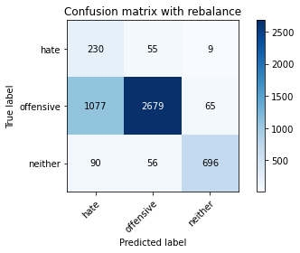

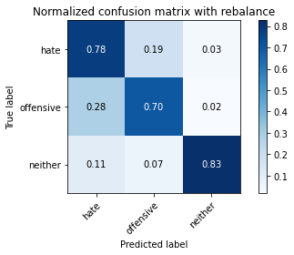

precision recall f1-score support

hate 0.16 0.78 0.27 294

offensive 0.96 0.70 0.81 3821

neither 0.90 0.83 0.86 842

accuracy 0.73 4957

macro avg 0.68 0.77 0.65 4957

weighted avg 0.90 0.73 0.79 4957

average eval_loss: 1.0765139762192004, accuracy: 0.7272543877345169

training 10 epoch...

27.836300373077393 seconds used......

10 training finished! average train loss: 0.0325643884835694

evaluating...

Confusion matrix, without normalization

[[ 238 38 18]

[ 935 2786 100]

[ 61 20 761]]

Normalized confusion matrix

[[0.80952381 0.1292517 0.06122449]

[0.24470034 0.7291285 0.02617116]

[0.07244656 0.02375297 0.90380048]]

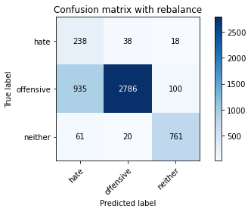

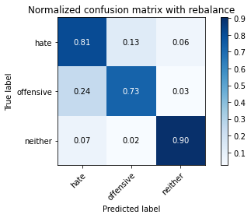

precision recall f1-score support

hate 0.19 0.81 0.31 294

offensive 0.98 0.73 0.84 3821

neither 0.87 0.90 0.88 842

accuracy 0.76 4957

macro avg 0.68 0.81 0.68 4957

weighted avg 0.91 0.76 0.81 4957

average eval_loss: 0.9910299279727042, accuracy: 0.763566673391164