1 run

[1.2,0.6,1]

training 1 epoch...

30.42461585998535 seconds used......

1 training finished! average train loss: 0.6660442786258564

evaluating...

Confusion matrix, without normalization

[[ 222 48 24]

[ 821 2872 128]

[ 45 15 782]]

Normalized confusion matrix

[[0.75510204 0.16326531 0.08163265]

[0.21486522 0.7516357 0.03349908]

[0.05344418 0.01781473 0.92874109]]

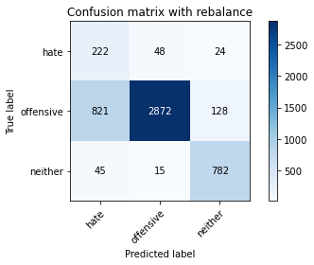

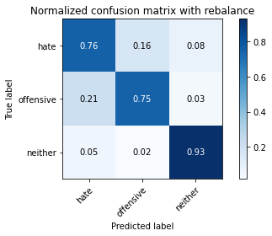

precision recall f1-score support

hate 0.20 0.76 0.32 294

offensive 0.98 0.75 0.85 3821

neither 0.84 0.93 0.88 842

accuracy 0.78 4957

macro avg 0.67 0.81 0.68 4957

weighted avg 0.91 0.78 0.82 4957

average eval_loss: 0.49653374403715134, accuracy: 0.7819245511398023

training 2 epoch...

29.716864109039307 seconds used......

2 training finished! average train loss: 0.37301944649358937

evaluating...

Confusion matrix, without normalization

[[ 254 27 13]

[1318 2402 101]

[ 63 9 770]]

Normalized confusion matrix

[[0.86394558 0.09183673 0.04421769]

[0.34493588 0.62863125 0.02643287]

[0.07482185 0.01068884 0.91448931]]

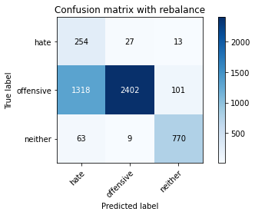

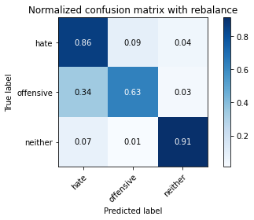

precision recall f1-score support

hate 0.16 0.86 0.26 294

offensive 0.99 0.63 0.77 3821

neither 0.87 0.91 0.89 842

accuracy 0.69 4957

macro avg 0.67 0.80 0.64 4957

weighted avg 0.92 0.69 0.76 4957

average eval_loss: 0.686643262003218, accuracy: 0.6911438369981844

training 3 epoch...

29.69011664390564 seconds used......

3 training finished! average train loss: 0.24571370440181237

evaluating...

Confusion matrix, without normalization

[[ 246 30 18]

[1171 2490 160]

[ 49 8 785]]

Normalized confusion matrix

[[0.83673469 0.10204082 0.06122449]

[0.30646428 0.65166187 0.04187386]

[0.05819477 0.00950119 0.93230404]]

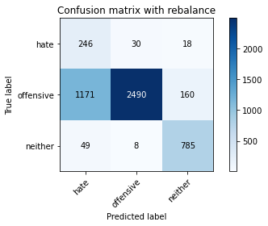

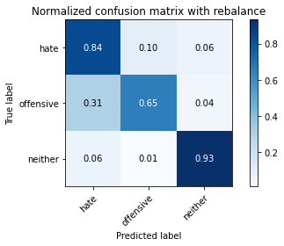

precision recall f1-score support

hate 0.17 0.84 0.28 294

offensive 0.98 0.65 0.78 3821

neither 0.82 0.93 0.87 842

accuracy 0.71 4957

macro avg 0.66 0.81 0.64 4957

weighted avg 0.91 0.71 0.77 4957

average eval_loss: 0.705069501673983, accuracy: 0.7103086544280816

training 4 epoch...

29.63351058959961 seconds used......

4 training finished! average train loss: 0.14698731000616885

evaluating...

Confusion matrix, without normalization

[[ 247 36 11]

[1057 2668 96]

[ 54 17 771]]

Normalized confusion matrix

[[0.84013605 0.12244898 0.03741497]

[0.27662915 0.69824653 0.02512431]

[0.06413302 0.02019002 0.91567696]]

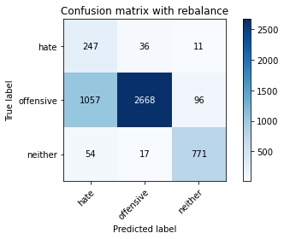

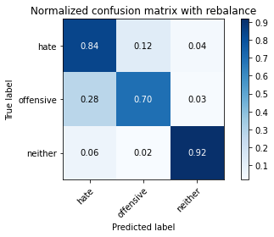

precision recall f1-score support

hate 0.18 0.84 0.30 294

offensive 0.98 0.70 0.82 3821

neither 0.88 0.92 0.90 842

accuracy 0.74 4957

macro avg 0.68 0.82 0.67 4957

weighted avg 0.92 0.74 0.80 4957

average eval_loss: 0.7329184828671597, accuracy: 0.7435949162800081

training 5 epoch...

29.62227702140808 seconds used......

5 training finished! average train loss: 0.08527733384745947

evaluating...

Confusion matrix, without normalization

[[ 206 66 22]

[ 620 3052 149]

[ 36 18 788]]

Normalized confusion matrix

[[0.70068027 0.2244898 0.07482993]

[0.16226119 0.79874378 0.03899503]

[0.04275534 0.02137767 0.93586698]]

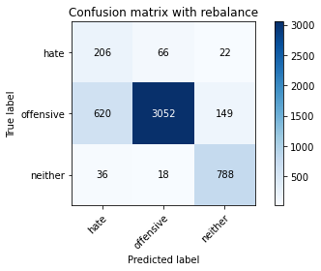

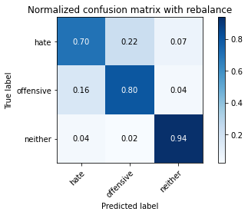

precision recall f1-score support

hate 0.24 0.70 0.36 294

offensive 0.97 0.80 0.88 3821

neither 0.82 0.94 0.88 842

accuracy 0.82 4957

macro avg 0.68 0.81 0.70 4957

weighted avg 0.90 0.82 0.85 4957

average eval_loss: 0.6384582725398603, accuracy: 0.8162194875933024

training 6 epoch...

29.337076425552368 seconds used......

6 training finished! average train loss: 0.04536048122491056

evaluating...

Confusion matrix, without normalization

[[ 243 35 16]

[ 994 2712 115]

[ 60 14 768]]

Normalized confusion matrix

[[0.82653061 0.11904762 0.05442177]

[0.26014132 0.70976184 0.03009683]

[0.07125891 0.01662708 0.91211401]]

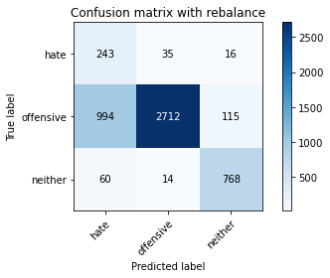

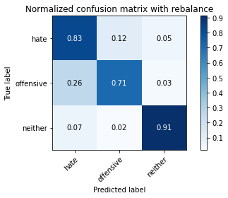

precision recall f1-score support

hate 0.19 0.83 0.31 294

offensive 0.98 0.71 0.82 3821

neither 0.85 0.91 0.88 842

accuracy 0.75 4957

macro avg 0.67 0.82 0.67 4957

weighted avg 0.91 0.75 0.80 4957

average eval_loss: 1.0233104437244154, accuracy: 0.7510591083316522

training 7 epoch...

29.4602153301239 seconds used......

7 training finished! average train loss: 0.035358295354880505

evaluating...

Confusion matrix, without normalization

[[ 239 31 24]

[1013 2637 171]

[ 42 11 789]]

Normalized confusion matrix

[[0.81292517 0.10544218 0.08163265]

[0.26511384 0.69013347 0.04475268]

[0.04988124 0.01306413 0.93705463]]

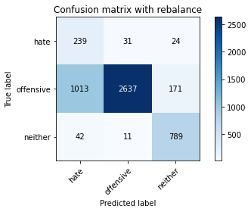

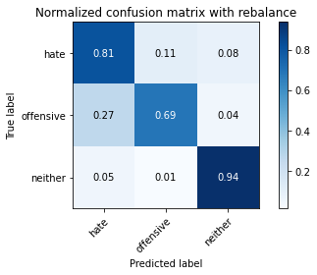

precision recall f1-score support

hate 0.18 0.81 0.30 294

offensive 0.98 0.69 0.81 3821

neither 0.80 0.94 0.86 842

accuracy 0.74 4957

macro avg 0.66 0.81 0.66 4957

weighted avg 0.91 0.74 0.79 4957

average eval_loss: 1.2452917935987633, accuracy: 0.7393584829533992

training 8 epoch...

29.498328685760498 seconds used......

8 training finished! average train loss: 0.025316407213706458

evaluating...

Confusion matrix, without normalization

[[ 223 49 22]

[ 903 2783 135]

[ 40 14 788]]

Normalized confusion matrix

[[0.7585034 0.16666667 0.07482993]

[0.23632557 0.72834337 0.03533107]

[0.04750594 0.01662708 0.93586698]]

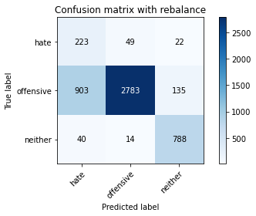

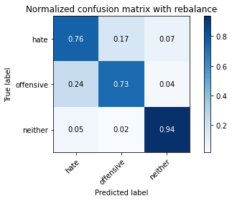

precision recall f1-score support

hate 0.19 0.76 0.31 294

offensive 0.98 0.73 0.83 3821

neither 0.83 0.94 0.88 842

accuracy 0.77 4957

macro avg 0.67 0.81 0.67 4957

weighted avg 0.91 0.77 0.81 4957

average eval_loss: 1.1151679796917784, accuracy: 0.7653822876739964

training 9 epoch...

29.434158325195312 seconds used......

9 training finished! average train loss: 0.012079165477104137

evaluating...

Confusion matrix, without normalization

[[ 247 27 20]

[1154 2541 126]

[ 54 14 774]]

Normalized confusion matrix

[[0.84013605 0.09183673 0.06802721]

[0.30201518 0.66500916 0.03297566]

[0.06413302 0.01662708 0.9192399 ]]

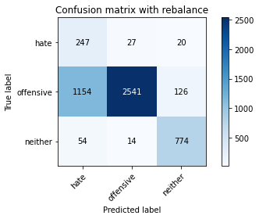

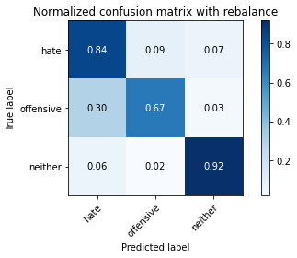

precision recall f1-score support

hate 0.17 0.84 0.28 294

offensive 0.98 0.67 0.79 3821

neither 0.84 0.92 0.88 842

accuracy 0.72 4957

macro avg 0.67 0.81 0.65 4957

weighted avg 0.91 0.72 0.78 4957

average eval_loss: 1.5814144276683368, accuracy: 0.7185797861609845

training 10 epoch...

29.47211718559265 seconds used......

10 training finished! average train loss: 0.02528898440347712

evaluating...

Confusion matrix, without normalization

[[ 186 88 20]

[ 444 3271 106]

[ 34 42 766]]

Normalized confusion matrix

[[0.63265306 0.29931973 0.06802721]

[0.11619995 0.85605862 0.02774143]

[0.04038005 0.04988124 0.90973872]]

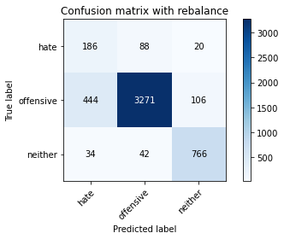

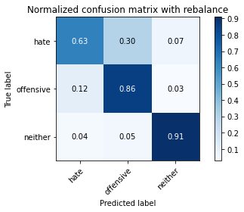

precision recall f1-score support

hate 0.28 0.63 0.39 294

offensive 0.96 0.86 0.91 3821

neither 0.86 0.91 0.88 842

accuracy 0.85 4957

macro avg 0.70 0.80 0.73 4957

weighted avg 0.90 0.85 0.87 4957

average eval_loss: 0.7083859449644918, accuracy: 0.8519265684890055

2 run

training 1 epoch...

29.459028720855713 seconds used......

1 training finished! average train loss: 0.6300002473313906

evaluating...

Confusion matrix, without normalization

[[ 222 33 39]

[ 868 2782 171]

[ 26 10 806]]

Normalized confusion matrix

[[0.75510204 0.1122449 0.13265306]

[0.22716566 0.72808165 0.04475268]

[0.03087886 0.01187648 0.95724466]]

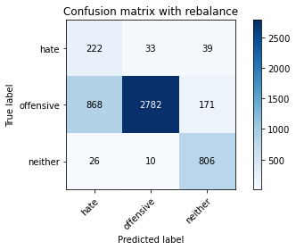

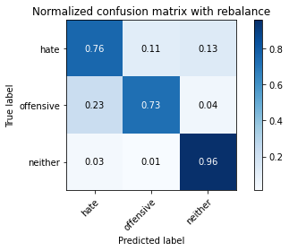

precision recall f1-score support

hate 0.20 0.76 0.31 294

offensive 0.98 0.73 0.84 3821

neither 0.79 0.96 0.87 842

accuracy 0.77 4957

macro avg 0.66 0.81 0.67 4957

weighted avg 0.91 0.77 0.81 4957

average eval_loss: 0.5414454476727594, accuracy: 0.7686100463990316

training 2 epoch...

29.410292625427246 seconds used......

2 training finished! average train loss: 0.3728166834739914

evaluating...

Confusion matrix, without normalization

[[ 259 26 9]

[1395 2316 110]

[ 66 10 766]]

Normalized confusion matrix

[[0.88095238 0.08843537 0.03061224]

[0.36508767 0.60612405 0.02878828]

[0.0783848 0.01187648 0.90973872]]

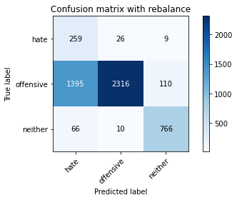

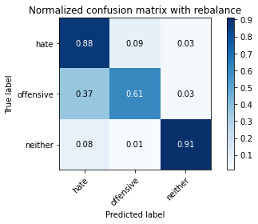

precision recall f1-score support

hate 0.15 0.88 0.26 294

offensive 0.98 0.61 0.75 3821

neither 0.87 0.91 0.89 842

accuracy 0.67 4957

macro avg 0.67 0.80 0.63 4957

weighted avg 0.91 0.67 0.74 4957

average eval_loss: 0.7881046562425552, accuracy: 0.6739963687714343

training 3 epoch...

29.332483053207397 seconds used......

3 training finished! average train loss: 0.25182286578050833

evaluating...

Confusion matrix, without normalization

[[ 245 39 10]

[ 995 2763 63]

[ 104 26 712]]

Normalized confusion matrix

[[0.83333333 0.13265306 0.03401361]

[0.26040304 0.72310913 0.01648783]

[0.12351544 0.03087886 0.8456057 ]]

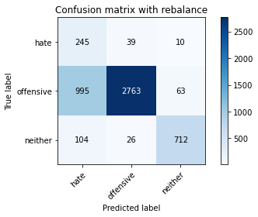

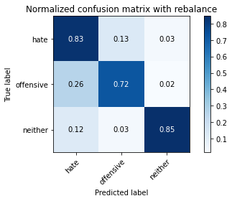

precision recall f1-score support

hate 0.18 0.83 0.30 294

offensive 0.98 0.72 0.83 3821

neither 0.91 0.85 0.88 842

accuracy 0.75 4957

macro avg 0.69 0.80 0.67 4957

weighted avg 0.92 0.75 0.81 4957

average eval_loss: 0.6998359262642841, accuracy: 0.7504539035707081

training 4 epoch...

29.330965995788574 seconds used......

4 training finished! average train loss: 0.14995924368152144

evaluating...

Confusion matrix, without normalization

[[ 237 43 14]

[ 910 2816 95]

[ 42 38 762]]

Normalized confusion matrix

[[0.80612245 0.1462585 0.04761905]

[0.23815755 0.73697985 0.0248626 ]

[0.04988124 0.04513064 0.90498812]]

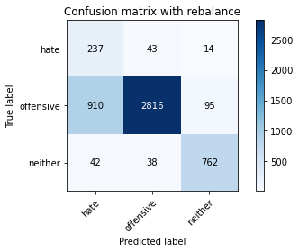

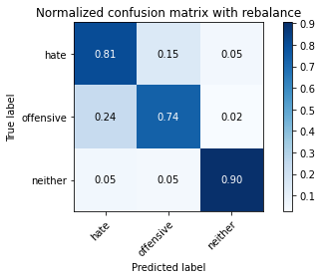

precision recall f1-score support

hate 0.20 0.81 0.32 294

offensive 0.97 0.74 0.84 3821

neither 0.87 0.90 0.89 842

accuracy 0.77 4957

macro avg 0.68 0.82 0.68 4957

weighted avg 0.91 0.77 0.82 4957

average eval_loss: 0.6363623104088248, accuracy: 0.7696187210006052

training 5 epoch...

29.408829927444458 seconds used......

5 training finished! average train loss: 0.08721941747098115

evaluating...

Confusion matrix, without normalization

[[ 242 41 11]

[1015 2716 90]

[ 70 25 747]]

Normalized confusion matrix

[[0.82312925 0.13945578 0.03741497]

[0.26563727 0.71080869 0.02355404]

[0.08313539 0.02969121 0.8871734 ]]

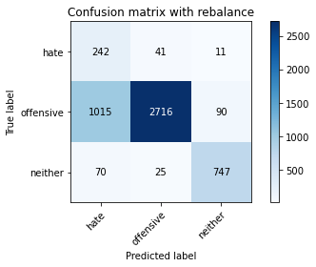

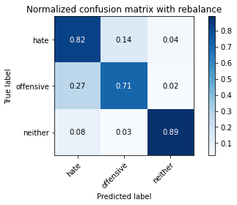

precision recall f1-score support

hate 0.18 0.82 0.30 294

offensive 0.98 0.71 0.82 3821

neither 0.88 0.89 0.88 842

accuracy 0.75 4957

macro avg 0.68 0.81 0.67 4957

weighted avg 0.91 0.75 0.80 4957

average eval_loss: 0.7373015115998925, accuracy: 0.7474278797659875

training 6 epoch...

29.45256805419922 seconds used......

6 training finished! average train loss: 0.056612681005182755

evaluating...

Confusion matrix, without normalization

[[ 218 54 22]

[ 708 2988 125]

[ 34 30 778]]

Normalized confusion matrix

[[0.7414966 0.18367347 0.07482993]

[0.18529181 0.78199424 0.03271395]

[0.04038005 0.03562945 0.9239905 ]]

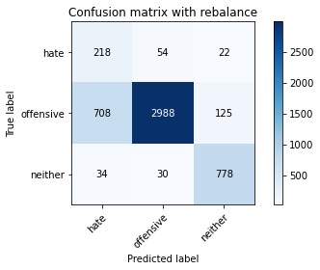

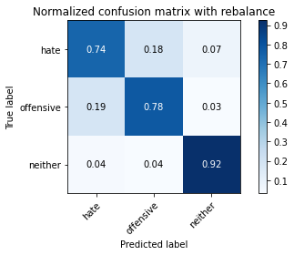

precision recall f1-score support

hate 0.23 0.74 0.35 294

offensive 0.97 0.78 0.87 3821

neither 0.84 0.92 0.88 842

accuracy 0.80 4957

macro avg 0.68 0.82 0.70 4957

weighted avg 0.91 0.80 0.84 4957

average eval_loss: 0.6938037123261658, accuracy: 0.8037119225337906

training 7 epoch...

29.334292888641357 seconds used......

7 training finished! average train loss: 0.03610933464965429

evaluating...

Confusion matrix, without normalization

[[ 243 31 20]

[1100 2574 147]

[ 54 14 774]]

Normalized confusion matrix

[[0.82653061 0.10544218 0.06802721]

[0.28788275 0.67364564 0.0384716 ]

[0.06413302 0.01662708 0.9192399 ]]

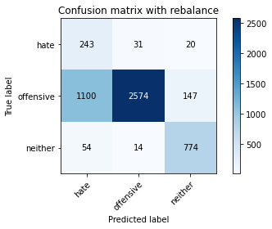

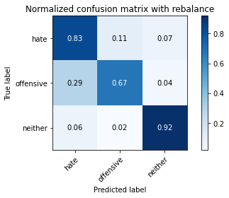

precision recall f1-score support

hate 0.17 0.83 0.29 294

offensive 0.98 0.67 0.80 3821

neither 0.82 0.92 0.87 842

accuracy 0.72 4957

macro avg 0.66 0.81 0.65 4957

weighted avg 0.91 0.72 0.78 4957

average eval_loss: 1.2005435669824722, accuracy: 0.724430098850111

training 8 epoch...

29.46548318862915 seconds used......

8 training finished! average train loss: 0.017127415527826536

evaluating...

Confusion matrix, without normalization

[[ 226 51 17]

[ 799 2904 118]

[ 47 29 766]]

Normalized confusion matrix

[[0.76870748 0.17346939 0.05782313]

[0.20910756 0.76001047 0.03088197]

[0.05581948 0.03444181 0.90973872]]

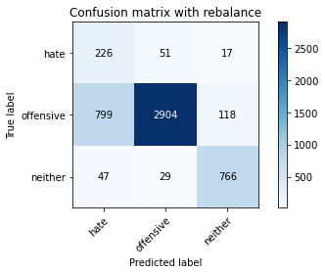

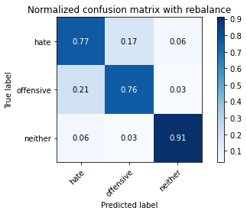

precision recall f1-score support

hate 0.21 0.77 0.33 294

offensive 0.97 0.76 0.85 3821

neither 0.85 0.91 0.88 842

accuracy 0.79 4957

macro avg 0.68 0.81 0.69 4957

weighted avg 0.91 0.79 0.83 4957

average eval_loss: 1.0427906473557795, accuracy: 0.7859592495460964

training 9 epoch...

29.50604486465454 seconds used......

9 training finished! average train loss: 0.02706522234798578

evaluating...

Confusion matrix, without normalization

[[ 233 42 19]

[ 889 2787 145]

[ 56 17 769]]

Normalized confusion matrix

[[0.79251701 0.14285714 0.06462585]

[0.23266161 0.72939021 0.03794818]

[0.06650831 0.02019002 0.91330166]]

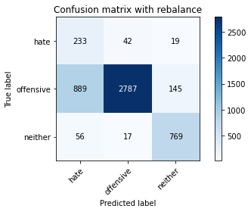

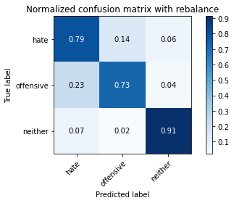

precision recall f1-score support

hate 0.20 0.79 0.32 294

offensive 0.98 0.73 0.84 3821

neither 0.82 0.91 0.87 842

accuracy 0.76 4957

macro avg 0.67 0.81 0.67 4957

weighted avg 0.91 0.76 0.81 4957

average eval_loss: 1.127081036207176, accuracy: 0.7643736130724228

training 10 epoch...

29.516711473464966 seconds used......

10 training finished! average train loss: 0.018033091950690517

evaluating...

Confusion matrix, without normalization

[[ 240 39 15]

[ 889 2828 104]

[ 64 25 753]]

Normalized confusion matrix

[[0.81632653 0.13265306 0.05102041]

[0.23266161 0.74012039 0.02721801]

[0.0760095 0.02969121 0.89429929]]

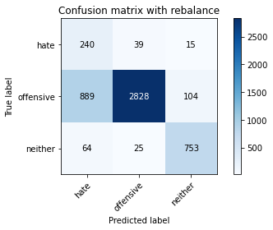

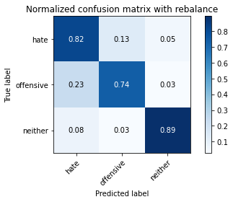

precision recall f1-score support

hate 0.20 0.82 0.32 294

offensive 0.98 0.74 0.84 3821

neither 0.86 0.89 0.88 842

accuracy 0.77 4957

macro avg 0.68 0.82 0.68 4957

weighted avg 0.91 0.77 0.82 4957

average eval_loss: 1.164268197362206, accuracy: 0.7708291305224935

3 run

training 1 epoch...

29.463652849197388 seconds used......

1 training finished! average train loss: 0.6453093183145189

evaluating...

Confusion matrix, without normalization

[[ 224 39 31]

[ 801 2857 163]

[ 38 9 795]]

Normalized confusion matrix

[[0.76190476 0.13265306 0.10544218]

[0.20963099 0.74771002 0.04265899]

[0.04513064 0.01068884 0.94418052]]

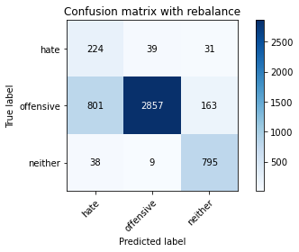

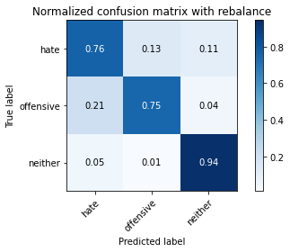

precision recall f1-score support

hate 0.21 0.76 0.33 294

offensive 0.98 0.75 0.85 3821

neither 0.80 0.94 0.87 842

accuracy 0.78 4957

macro avg 0.67 0.82 0.68 4957

weighted avg 0.91 0.78 0.82 4957

average eval_loss: 0.5308500694471502, accuracy: 0.7819245511398023

training 2 epoch...

29.432403326034546 seconds used......

2 training finished! average train loss: 0.3837496723260796

evaluating...

Confusion matrix, without normalization

[[ 247 30 17]

[1093 2622 106]

[ 49 11 782]]

Normalized confusion matrix

[[0.84013605 0.10204082 0.05782313]

[0.28605077 0.6862078 0.02774143]

[0.05819477 0.01306413 0.92874109]]

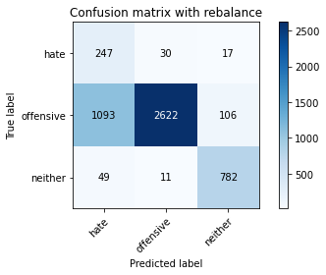

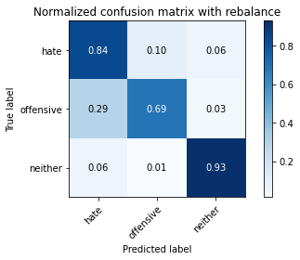

precision recall f1-score support

hate 0.18 0.84 0.29 294

offensive 0.98 0.69 0.81 3821

neither 0.86 0.93 0.90 842

accuracy 0.74 4957

macro avg 0.68 0.82 0.67 4957

weighted avg 0.92 0.74 0.79 4957

average eval_loss: 0.5849724055057571, accuracy: 0.7365341940689933

training 3 epoch...

29.505311250686646 seconds used......

3 training finished! average train loss: 0.25340109353351314

evaluating...

Confusion matrix, without normalization

[[ 249 39 6]

[ 939 2838 44]

[ 167 36 639]]

Normalized confusion matrix

[[0.84693878 0.13265306 0.02040816]

[0.24574719 0.7427375 0.01151531]

[0.19833729 0.04275534 0.75890736]]

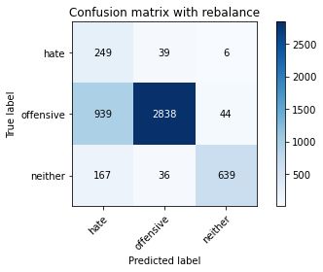

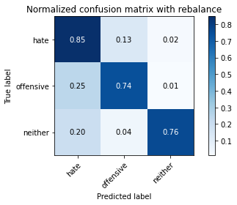

precision recall f1-score support

hate 0.18 0.85 0.30 294

offensive 0.97 0.74 0.84 3821

neither 0.93 0.76 0.83 842

accuracy 0.75 4957

macro avg 0.70 0.78 0.66 4957

weighted avg 0.92 0.75 0.81 4957

average eval_loss: 0.5852124091958807, accuracy: 0.7516643130925963

training 4 epoch...

29.377813816070557 seconds used......

4 training finished! average train loss: 0.17359180581804953

evaluating...

Confusion matrix, without normalization

[[ 242 38 14]

[ 877 2832 112]

[ 66 16 760]]

Normalized confusion matrix

[[0.82312925 0.1292517 0.04761905]

[0.22952107 0.74116723 0.0293117 ]

[0.0783848 0.01900238 0.90261283]]

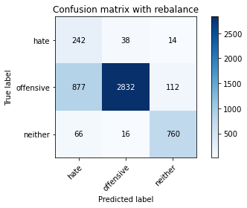

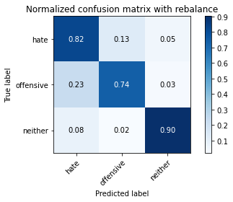

precision recall f1-score support

hate 0.20 0.82 0.33 294

offensive 0.98 0.74 0.84 3821

neither 0.86 0.90 0.88 842

accuracy 0.77 4957

macro avg 0.68 0.82 0.68 4957

weighted avg 0.91 0.77 0.82 4957

average eval_loss: 0.6066295359013302, accuracy: 0.7734516844865846

training 5 epoch...

29.347208261489868 seconds used......

5 training finished! average train loss: 0.10467372496465319

evaluating...

Confusion matrix, without normalization

[[ 234 40 20]

[ 785 2902 134]

[ 53 17 772]]

Normalized confusion matrix

[[0.79591837 0.13605442 0.06802721]

[0.2054436 0.75948705 0.03506935]

[0.06294537 0.02019002 0.91686461]]

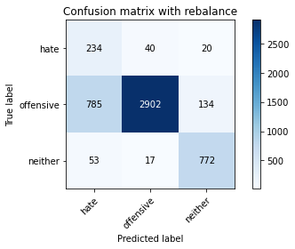

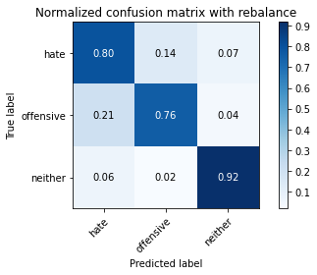

precision recall f1-score support

hate 0.22 0.80 0.34 294

offensive 0.98 0.76 0.86 3821

neither 0.83 0.92 0.87 842

accuracy 0.79 4957

macro avg 0.68 0.82 0.69 4957

weighted avg 0.91 0.79 0.83 4957

average eval_loss: 0.6466703788121982, accuracy: 0.7883800685898729

training 6 epoch...

29.365111351013184 seconds used......

6 training finished! average train loss: 0.06915195128330362

evaluating...

Confusion matrix, without normalization

[[ 224 50 20]

[ 733 2970 118]

[ 43 22 777]]

Normalized confusion matrix

[[0.76190476 0.17006803 0.06802721]

[0.1918346 0.77728343 0.03088197]

[0.05106888 0.02612827 0.92280285]]

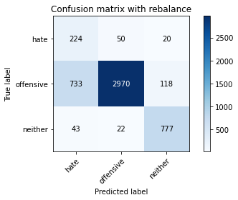

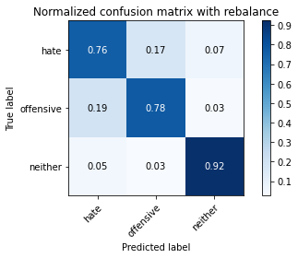

precision recall f1-score support

hate 0.22 0.76 0.35 294

offensive 0.98 0.78 0.87 3821

neither 0.85 0.92 0.88 842

accuracy 0.80 4957

macro avg 0.68 0.82 0.70 4957

weighted avg 0.91 0.80 0.84 4957

average eval_loss: 0.7831533119343447, accuracy: 0.8010893685696994

training 7 epoch...

29.4285888671875 seconds used......

7 training finished! average train loss: 0.027346584077908152

evaluating...

Confusion matrix, without normalization

[[ 207 63 24]

[ 643 3027 151]

[ 29 15 798]]

Normalized confusion matrix

[[0.70408163 0.21428571 0.08163265]

[0.16828055 0.79220099 0.03951845]

[0.03444181 0.01781473 0.94774347]]

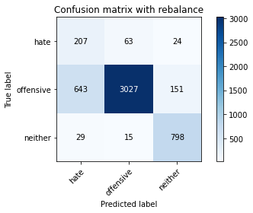

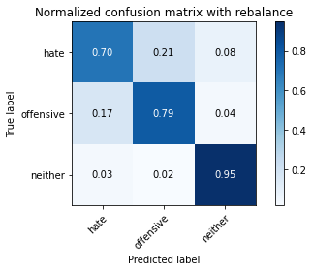

precision recall f1-score support

hate 0.24 0.70 0.35 294

offensive 0.97 0.79 0.87 3821

neither 0.82 0.95 0.88 842

accuracy 0.81 4957

macro avg 0.68 0.81 0.70 4957

weighted avg 0.90 0.81 0.84 4957

average eval_loss: 0.8565053293628632, accuracy: 0.8133951987088965

training 8 epoch...

29.45842170715332 seconds used......

8 training finished! average train loss: 0.02424167009643742

evaluating...

Confusion matrix, without normalization

[[ 240 35 19]

[1006 2660 155]

[ 46 13 783]]

Normalized confusion matrix

[[0.81632653 0.11904762 0.06462585]

[0.26328186 0.69615284 0.0405653 ]

[0.05463183 0.01543943 0.92992874]]

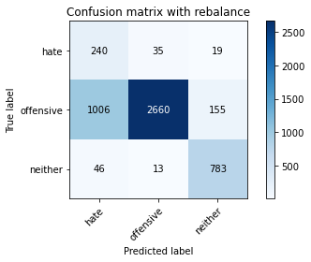

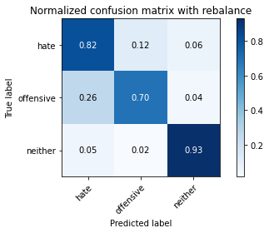

precision recall f1-score support

hate 0.19 0.82 0.30 294

offensive 0.98 0.70 0.81 3821

neither 0.82 0.93 0.87 842

accuracy 0.74 4957

macro avg 0.66 0.81 0.66 4957

weighted avg 0.91 0.74 0.79 4957

average eval_loss: 1.2291682556782277, accuracy: 0.7429897115190639

training 9 epoch...

29.289814472198486 seconds used......

9 training finished! average train loss: 0.016842335753608495

evaluating...

Confusion matrix, without normalization

[[ 241 37 16]

[1094 2604 123]

[ 63 15 764]]

Normalized confusion matrix

[[0.81972789 0.12585034 0.05442177]

[0.28631248 0.68149699 0.03219053]

[0.07482185 0.01781473 0.90736342]]

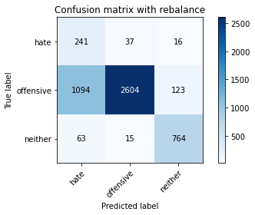

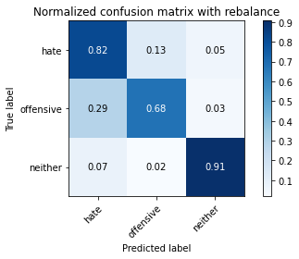

precision recall f1-score support

hate 0.17 0.82 0.28 294

offensive 0.98 0.68 0.80 3821

neither 0.85 0.91 0.88 842

accuracy 0.73 4957

macro avg 0.67 0.80 0.65 4957

weighted avg 0.91 0.73 0.79 4957

average eval_loss: 1.2605275424542808, accuracy: 0.7280613274157757

training 10 epoch...

29.44811248779297 seconds used......

10 training finished! average train loss: 0.022846680528372635

evaluating...

Confusion matrix, without normalization

[[ 235 38 21]

[ 966 2726 129]

[ 64 17 761]]

Normalized confusion matrix

[[0.79931973 0.1292517 0.07142857]

[0.2528134 0.7134258 0.0337608 ]

[0.0760095 0.02019002 0.90380048]]

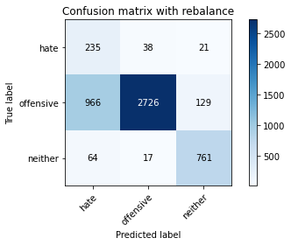

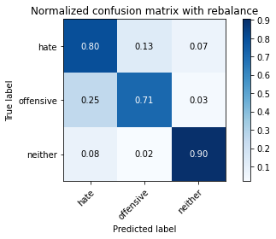

precision recall f1-score support

hate 0.19 0.80 0.30 294

offensive 0.98 0.71 0.83 3821

neither 0.84 0.90 0.87 842

accuracy 0.75 4957

macro avg 0.67 0.81 0.67 4957

weighted avg 0.91 0.75 0.80 4957

average eval_loss: 1.1856771518500717, accuracy: 0.7508573734113375

4 run

training 1 epoch...

29.496739625930786 seconds used......

1 training finished! average train loss: 0.6491686169341294

evaluating...

Confusion matrix, without normalization

[[ 239 31 24]

[ 959 2727 135]

[ 47 11 784]]

Normalized confusion matrix

[[0.81292517 0.10544218 0.08163265]

[0.25098142 0.71368752 0.03533107]

[0.05581948 0.01306413 0.93111639]]

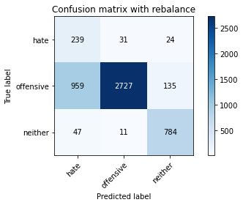

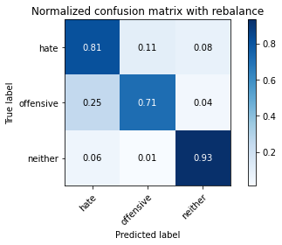

precision recall f1-score support

hate 0.19 0.81 0.31 294

offensive 0.98 0.71 0.83 3821

neither 0.83 0.93 0.88 842

accuracy 0.76 4957

macro avg 0.67 0.82 0.67 4957

weighted avg 0.91 0.76 0.81 4957

average eval_loss: 0.5908032285590326, accuracy: 0.7565059511801493

training 2 epoch...

29.444345235824585 seconds used......

2 training finished! average train loss: 0.3655091437854265

evaluating...

Confusion matrix, without normalization

[[ 251 27 16]

[1346 2358 117]

[ 62 13 767]]

Normalized confusion matrix

[[0.8537415 0.09183673 0.05442177]

[0.35226381 0.61711594 0.03062026]

[0.0736342 0.01543943 0.91092637]]

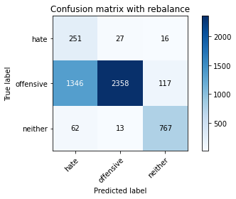

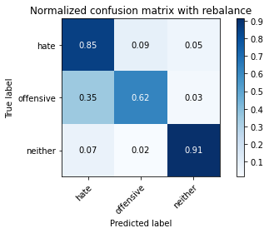

precision recall f1-score support

hate 0.15 0.85 0.26 294

offensive 0.98 0.62 0.76 3821

neither 0.85 0.91 0.88 842

accuracy 0.68 4957

macro avg 0.66 0.79 0.63 4957

weighted avg 0.91 0.68 0.75 4957

average eval_loss: 0.6495768159868256, accuracy: 0.681057090982449

training 3 epoch...

29.44967555999756 seconds used......

3 training finished! average train loss: 0.25324330154305313

evaluating...

Confusion matrix, without normalization

[[ 242 33 19]

[1097 2586 138]

[ 64 13 765]]

Normalized confusion matrix

[[0.82312925 0.1122449 0.06462585]

[0.28709762 0.67678618 0.0361162 ]

[0.0760095 0.01543943 0.90855107]]

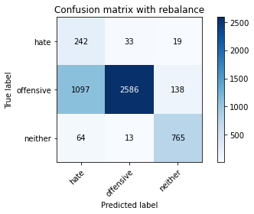

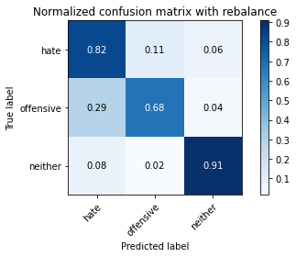

precision recall f1-score support

hate 0.17 0.82 0.29 294

offensive 0.98 0.68 0.80 3821

neither 0.83 0.91 0.87 842

accuracy 0.72 4957

macro avg 0.66 0.80 0.65 4957

weighted avg 0.91 0.72 0.78 4957

average eval_loss: 0.6422996769448922, accuracy: 0.7248335686907403

training 4 epoch...

29.543554544448853 seconds used......

4 training finished! average train loss: 0.1581461515048878

evaluating...

Confusion matrix, without normalization

[[ 245 34 15]

[1031 2678 112]

[ 63 29 750]]

Normalized confusion matrix

[[0.83333333 0.11564626 0.05102041]

[0.26982465 0.70086365 0.0293117 ]

[0.07482185 0.03444181 0.89073634]]

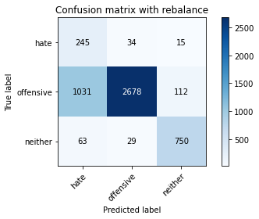

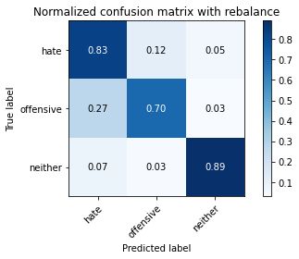

precision recall f1-score support

hate 0.18 0.83 0.30 294

offensive 0.98 0.70 0.82 3821

neither 0.86 0.89 0.87 842

accuracy 0.74 4957

macro avg 0.67 0.81 0.66 4957

weighted avg 0.91 0.74 0.80 4957

average eval_loss: 0.6546302188428179, accuracy: 0.7409723623159169

training 5 epoch...

29.51803684234619 seconds used......

5 training finished! average train loss: 0.07936408085481683

evaluating...

Confusion matrix, without normalization

[[ 230 42 22]

[ 917 2744 160]

[ 56 18 768]]

Normalized confusion matrix

[[0.78231293 0.14285714 0.07482993]

[0.23998953 0.71813661 0.04187386]

[0.06650831 0.02137767 0.91211401]]

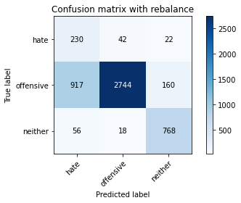

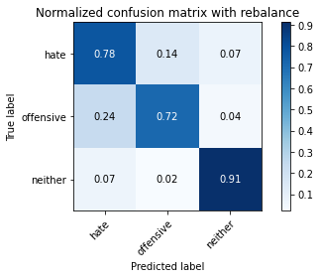

precision recall f1-score support

hate 0.19 0.78 0.31 294

offensive 0.98 0.72 0.83 3821

neither 0.81 0.91 0.86 842

accuracy 0.75 4957

macro avg 0.66 0.80 0.66 4957

weighted avg 0.90 0.75 0.80 4957

average eval_loss: 0.9271611612583059, accuracy: 0.7548920718176316

training 6 epoch...

29.404521465301514 seconds used......

6 training finished! average train loss: 0.04867767648940242

evaluating...

Confusion matrix, without normalization

[[ 192 80 22]

[ 522 3176 123]

[ 35 31 776]]

Normalized confusion matrix

[[0.65306122 0.27210884 0.07482993]

[0.13661345 0.83119602 0.03219053]

[0.0415677 0.0368171 0.9216152 ]]

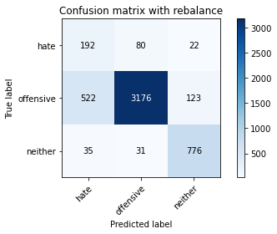

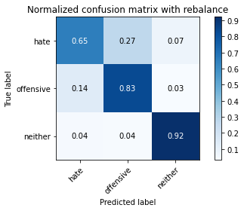

precision recall f1-score support

hate 0.26 0.65 0.37 294

offensive 0.97 0.83 0.89 3821

neither 0.84 0.92 0.88 842

accuracy 0.84 4957

macro avg 0.69 0.80 0.71 4957

weighted avg 0.90 0.84 0.86 4957

average eval_loss: 0.6492581091813683, accuracy: 0.8359895097841437

training 7 epoch...

29.404481649398804 seconds used......

7 training finished! average train loss: 0.04194766759657306

evaluating...

Confusion matrix, without normalization

[[ 210 65 19]

[ 828 2893 100]

[ 55 40 747]]

Normalized confusion matrix

[[0.71428571 0.22108844 0.06462585]

[0.2166972 0.75713164 0.02617116]

[0.06532067 0.04750594 0.8871734 ]]

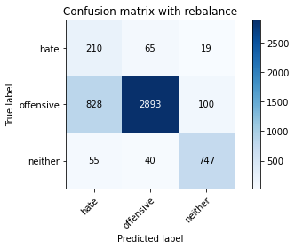

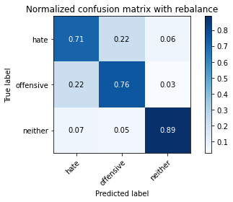

precision recall f1-score support

hate 0.19 0.71 0.30 294

offensive 0.96 0.76 0.85 3821

neither 0.86 0.89 0.87 842

accuracy 0.78 4957

macro avg 0.67 0.79 0.68 4957

weighted avg 0.90 0.78 0.82 4957

average eval_loss: 0.856638151070764, accuracy: 0.77667944321162

training 8 epoch...

29.39028024673462 seconds used......

8 training finished! average train loss: 0.025613009558966088

evaluating...

Confusion matrix, without normalization

[[ 222 58 14]

[ 749 2976 96]

[ 83 34 725]]

Normalized confusion matrix

[[0.75510204 0.19727891 0.04761905]

[0.19602198 0.7788537 0.02512431]

[0.09857482 0.04038005 0.86104513]]

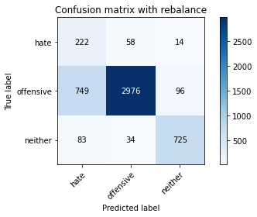

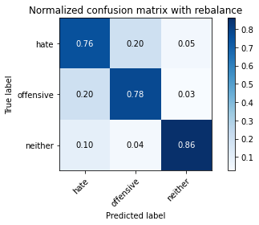

precision recall f1-score support

hate 0.21 0.76 0.33 294

offensive 0.97 0.78 0.86 3821

neither 0.87 0.86 0.86 842

accuracy 0.79 4957

macro avg 0.68 0.80 0.69 4957

weighted avg 0.91 0.79 0.83 4957

average eval_loss: 0.9146999989771435, accuracy: 0.7914060923945935

training 9 epoch...

29.408316612243652 seconds used......

9 training finished! average train loss: 0.01878714689485217

evaluating...

Confusion matrix, without normalization

[[ 231 47 16]

[ 967 2729 125]

[ 63 30 749]]

Normalized confusion matrix

[[0.78571429 0.15986395 0.05442177]

[0.25307511 0.71421094 0.03271395]

[0.07482185 0.03562945 0.88954869]]

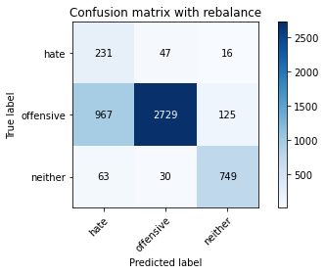

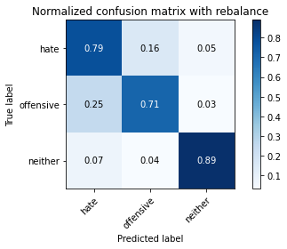

precision recall f1-score support

hate 0.18 0.79 0.30 294

offensive 0.97 0.71 0.82 3821

neither 0.84 0.89 0.86 842

accuracy 0.75 4957

macro avg 0.67 0.80 0.66 4957

weighted avg 0.90 0.75 0.80 4957

average eval_loss: 1.1749020046779826, accuracy: 0.7482348194472463

training 10 epoch...

29.501736640930176 seconds used......

10 training finished! average train loss: 0.007556533024388322

evaluating...

Confusion matrix, without normalization

[[ 217 48 29]

[ 726 2938 157]

[ 38 25 779]]

Normalized confusion matrix

[[0.73809524 0.16326531 0.09863946]

[0.19000262 0.76890866 0.04108872]

[0.04513064 0.02969121 0.92517815]]

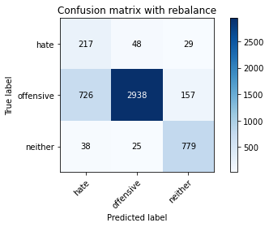

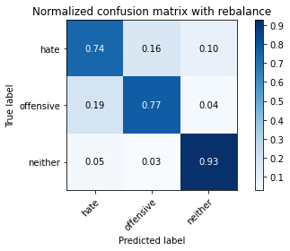

precision recall f1-score support

hate 0.22 0.74 0.34 294

offensive 0.98 0.77 0.86 3821

neither 0.81 0.93 0.86 842

accuracy 0.79 4957

macro avg 0.67 0.81 0.69 4957

weighted avg 0.90 0.79 0.83 4957

average eval_loss: 1.0763880192840118, accuracy: 0.7936251765180553

5 run

training 1 epoch...

28.769809007644653 seconds used......

1 training finished! average train loss: 0.6651135835556956

evaluating...

Confusion matrix, without normalization

[[ 234 28 32]

[1029 2477 315]

[ 39 4 799]]

Normalized confusion matrix

[[0.79591837 0.0952381 0.10884354]

[0.26930123 0.64825962 0.08243915]

[0.04631829 0.00475059 0.94893112]]

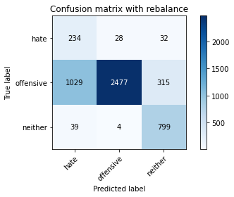

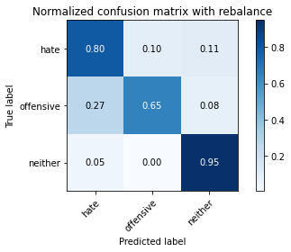

precision recall f1-score support

hate 0.18 0.80 0.29 294

offensive 0.99 0.65 0.78 3821

neither 0.70 0.95 0.80 842

accuracy 0.71 4957

macro avg 0.62 0.80 0.63 4957

weighted avg 0.89 0.71 0.76 4957

average eval_loss: 0.7051412518466672, accuracy: 0.7080895703046197

training 2 epoch...

28.075830936431885 seconds used......

2 training finished! average train loss: 0.3796753694700916

evaluating...

Confusion matrix, without normalization

[[ 245 34 15]

[1008 2656 157]

[ 62 5 775]]

Normalized confusion matrix

[[0.83333333 0.11564626 0.05102041]

[0.26380529 0.69510599 0.04108872]

[0.0736342 0.00593824 0.92042755]]

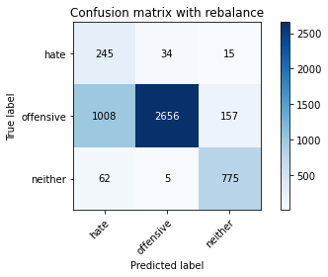

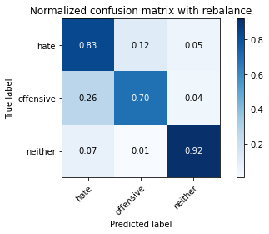

precision recall f1-score support

hate 0.19 0.83 0.30 294

offensive 0.99 0.70 0.82 3821

neither 0.82 0.92 0.87 842

accuracy 0.74 4957

macro avg 0.66 0.82 0.66 4957

weighted avg 0.91 0.74 0.79 4957

average eval_loss: 0.5857180726504133, accuracy: 0.741577567076861

training 3 epoch...

27.996113061904907 seconds used......

3 training finished! average train loss: 0.25039980432007747

evaluating...

Confusion matrix, without normalization

[[ 252 32 10]

[1207 2535 79]

[ 106 21 715]]

Normalized confusion matrix

[[0.85714286 0.10884354 0.03401361]

[0.31588589 0.66343889 0.02067522]

[0.12589074 0.02494062 0.84916865]]

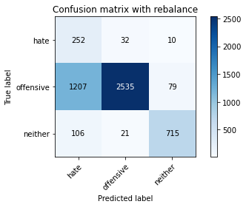

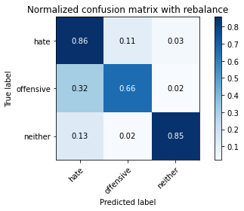

precision recall f1-score support

hate 0.16 0.86 0.27 294

offensive 0.98 0.66 0.79 3821

neither 0.89 0.85 0.87 842

accuracy 0.71 4957

macro avg 0.68 0.79 0.64 4957

weighted avg 0.92 0.71 0.77 4957

average eval_loss: 0.677422029957656, accuracy: 0.706475690942102

training 4 epoch...

28.015779733657837 seconds used......

4 training finished! average train loss: 0.15664901457215

evaluating...

Confusion matrix, without normalization

[[ 216 50 28]

[ 796 2812 213]

[ 36 11 795]]

Normalized confusion matrix

[[0.73469388 0.17006803 0.0952381 ]

[0.20832243 0.735933 0.05574457]

[0.04275534 0.01306413 0.94418052]]

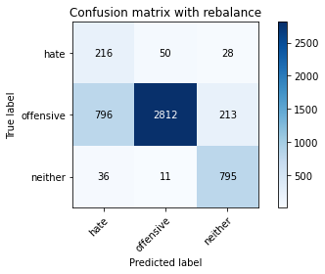

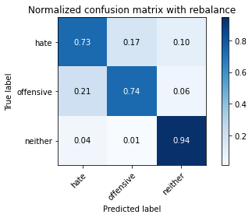

precision recall f1-score support

hate 0.21 0.73 0.32 294

offensive 0.98 0.74 0.84 3821

neither 0.77 0.94 0.85 842

accuracy 0.77 4957

macro avg 0.65 0.80 0.67 4957

weighted avg 0.90 0.77 0.81 4957

average eval_loss: 0.6538093131666463, accuracy: 0.7712326003631229

training 5 epoch...

28.024653673171997 seconds used......

5 training finished! average train loss: 0.0876428399150592

evaluating...

Confusion matrix, without normalization

[[ 222 55 17]

[ 926 2790 105]

[ 78 18 746]]

Normalized confusion matrix

[[0.75510204 0.18707483 0.05782313]

[0.24234494 0.73017535 0.02747972]

[0.09263658 0.02137767 0.88598575]]

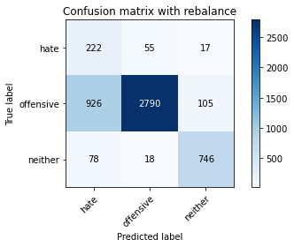

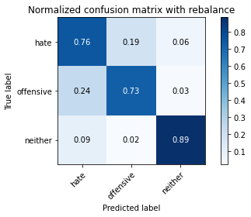

precision recall f1-score support

hate 0.18 0.76 0.29 294

offensive 0.97 0.73 0.83 3821

neither 0.86 0.89 0.87 842

accuracy 0.76 4957

macro avg 0.67 0.79 0.67 4957

weighted avg 0.91 0.76 0.81 4957

average eval_loss: 0.7532578217196128, accuracy: 0.758119830542667

training 6 epoch...

28.06149649620056 seconds used......

6 training finished! average train loss: 0.062081358146347236

evaluating...

Confusion matrix, without normalization

[[ 218 65 11]

[ 732 3009 80]

[ 65 52 725]]

Normalized confusion matrix

[[0.7414966 0.22108844 0.03741497]

[0.19157289 0.78749019 0.02093693]

[0.07719715 0.06175772 0.86104513]]

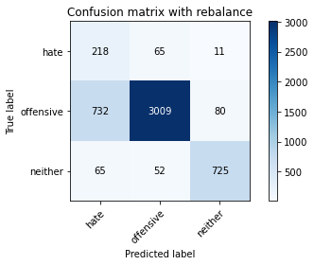

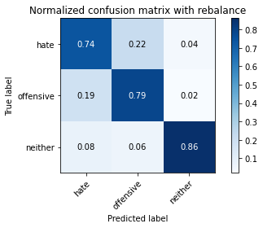

precision recall f1-score support

hate 0.21 0.74 0.33 294

offensive 0.96 0.79 0.87 3821

neither 0.89 0.86 0.87 842

accuracy 0.80 4957

macro avg 0.69 0.80 0.69 4957

weighted avg 0.91 0.80 0.84 4957

average eval_loss: 0.7272728027798415, accuracy: 0.79725640508372

training 7 epoch...

27.880749464035034 seconds used......

7 training finished! average train loss: 0.03203090012062624

evaluating...

Confusion matrix, without normalization

[[ 249 34 11]

[1340 2398 83]

[ 94 23 725]]

Normalized confusion matrix

[[0.84693878 0.11564626 0.03741497]

[0.35069354 0.6275844 0.02172206]

[0.11163895 0.02731591 0.86104513]]

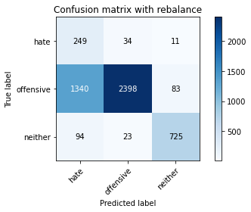

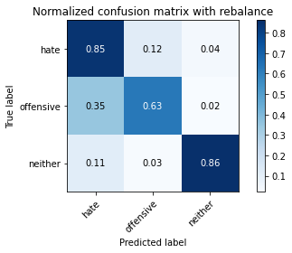

precision recall f1-score support

hate 0.15 0.85 0.25 294

offensive 0.98 0.63 0.76 3821

neither 0.89 0.86 0.87 842

accuracy 0.68 4957

macro avg 0.67 0.78 0.63 4957

weighted avg 0.91 0.68 0.75 4957

average eval_loss: 1.4203068710292779, accuracy: 0.6802501513011903

training 8 epoch...

28.088178396224976 seconds used......

8 training finished! average train loss: 0.028783571322609218

evaluating...

Confusion matrix, without normalization

[[ 182 78 34]

[ 465 3200 156]

[ 23 19 800]]

Normalized confusion matrix

[[0.61904762 0.26530612 0.11564626]

[0.12169589 0.8374771 0.04082701]

[0.02731591 0.02256532 0.95011876]]

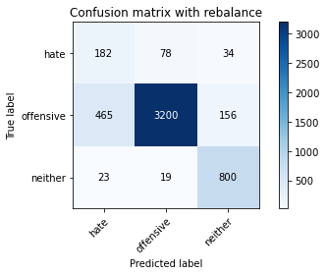

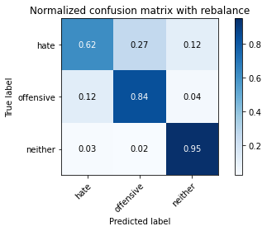

precision recall f1-score support

hate 0.27 0.62 0.38 294

offensive 0.97 0.84 0.90 3821

neither 0.81 0.95 0.87 842

accuracy 0.84 4957

macro avg 0.68 0.80 0.72 4957

weighted avg 0.90 0.84 0.86 4957

average eval_loss: 0.7628066133263693, accuracy: 0.8436554367561024

training 9 epoch...

27.91370439529419 seconds used......

9 training finished! average train loss: 0.018099724839146014

evaluating...

Confusion matrix, without normalization

[[ 223 55 16]

[ 772 2932 117]

[ 64 21 757]]

Normalized confusion matrix

[[0.7585034 0.18707483 0.05442177]

[0.20204135 0.76733839 0.03062026]

[0.0760095 0.02494062 0.89904988]]

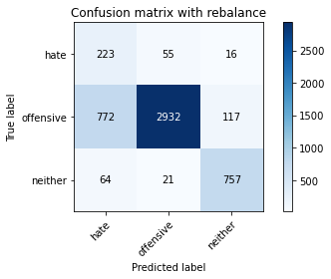

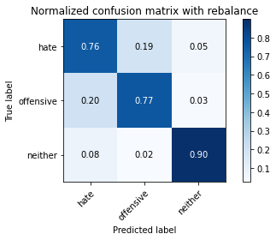

precision recall f1-score support

hate 0.21 0.76 0.33 294

offensive 0.97 0.77 0.86 3821

neither 0.85 0.90 0.87 842

accuracy 0.79 4957

macro avg 0.68 0.81 0.69 4957

weighted avg 0.91 0.79 0.83 4957

average eval_loss: 1.0297739899664697, accuracy: 0.7891870082711318

training 10 epoch...

27.963542938232422 seconds used......

10 training finished! average train loss: 0.012673853689342415

evaluating...

Confusion matrix, without normalization

[[ 245 35 14]

[1185 2517 119]

[ 93 21 728]]

Normalized confusion matrix

[[0.83333333 0.11904762 0.04761905]

[0.31012824 0.65872808 0.03114368]

[0.11045131 0.02494062 0.86460808]]

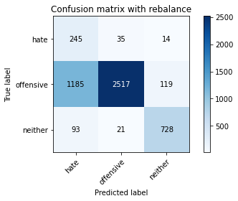

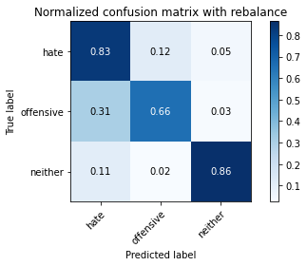

precision recall f1-score support

hate 0.16 0.83 0.27 294

offensive 0.98 0.66 0.79 3821

neither 0.85 0.86 0.85 842

accuracy 0.70 4957

macro avg 0.66 0.79 0.64 4957

weighted avg 0.91 0.70 0.77 4957

average eval_loss: 1.5521799029384349, accuracy: 0.7040548718983256