**first run:**

training 1 epoch...

27.78122615814209 seconds used......

1 training finished! average train loss: 0.6611728981050135

evaluating...

Confusion matrix, without normalization

[[ 231 38 25]

[ 863 2828 130]

[ 59 11 772]]

Normalized confusion matrix

[[0.78571429 0.1292517 0.08503401]

[0.22585711 0.74012039 0.03402251]

[0.07007126 0.01306413 0.91686461]]

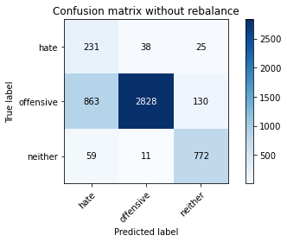

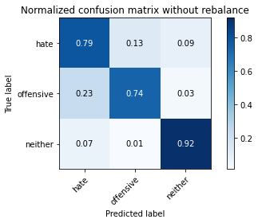

precision recall f1-score support

hate 0.20 0.79 0.32 294

offensive 0.98 0.74 0.84 3821

neither 0.83 0.92 0.87 842

accuracy 0.77 4957

macro avg 0.67 0.81 0.68 4957

weighted avg 0.91 0.77 0.82 4957

average eval_loss: 0.5233551014455096, accuracy: 0.7728464797256405

training 2 epoch...

27.782537698745728 seconds used......

2 training finished! average train loss: 0.3899604692532305

evaluating...

Confusion matrix, without normalization

[[ 213 53 28]

[ 583 3092 146]

[ 37 11 794]]

Normalized confusion matrix

[[0.7244898 0.18027211 0.0952381 ]

[0.15257786 0.80921225 0.03820989]

[0.04394299 0.01306413 0.94299287]]

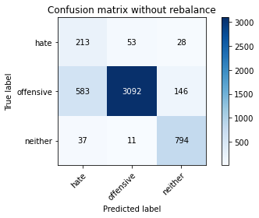

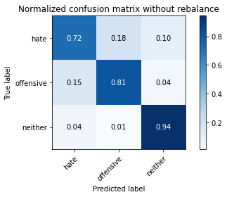

precision recall f1-score support

hate 0.26 0.72 0.38 294

offensive 0.98 0.81 0.89 3821

neither 0.82 0.94 0.88 842

accuracy 0.83 4957

macro avg 0.69 0.83 0.71 4957

weighted avg 0.91 0.83 0.85 4957

average eval_loss: 0.4659454610138651, accuracy: 0.8269114383699818

training 3 epoch...

27.765267372131348 seconds used......

3 training finished! average train loss: 0.2707447006601339

evaluating...

Confusion matrix, without normalization

[[ 217 60 17]

[ 597 3121 103]

[ 58 24 760]]

Normalized confusion matrix

[[0.73809524 0.20408163 0.05782313]

[0.15624182 0.81680188 0.02695629]

[0.06888361 0.02850356 0.90261283]]

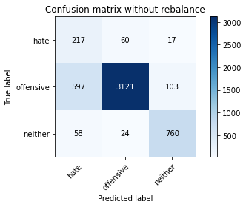

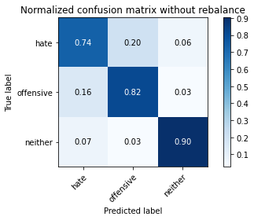

precision recall f1-score support

hate 0.25 0.74 0.37 294

offensive 0.97 0.82 0.89 3821

neither 0.86 0.90 0.88 842

accuracy 0.83 4957

macro avg 0.70 0.82 0.71 4957

weighted avg 0.91 0.83 0.86 4957

average eval_loss: 0.43741362356400537, accuracy: 0.8267097034496671

training 4 epoch...

27.78514790534973 seconds used......

4 training finished! average train loss: 0.17122579255952822

evaluating...

Confusion matrix, without normalization

[[ 205 70 19]

[ 554 3162 105]

[ 40 41 761]]

Normalized confusion matrix

[[0.69727891 0.23809524 0.06462585]

[0.14498822 0.82753206 0.02747972]

[0.04750594 0.04869359 0.90380048]]

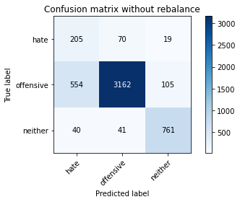

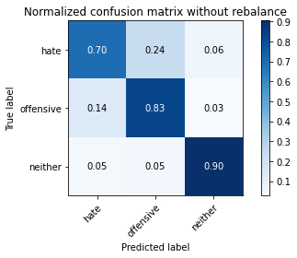

precision recall f1-score support

hate 0.26 0.70 0.38 294

offensive 0.97 0.83 0.89 3821

neither 0.86 0.90 0.88 842

accuracy 0.83 4957

macro avg 0.69 0.81 0.72 4957

weighted avg 0.91 0.83 0.86 4957

average eval_loss: 0.45620121660401985, accuracy: 0.8327617510591083

training 5 epoch...

27.718183755874634 seconds used......

5 training finished! average train loss: 0.08845282341108511

evaluating...

Confusion matrix, without normalization

[[ 217 66 11]

[ 724 3030 67]

[ 87 50 705]]

Normalized confusion matrix

[[0.73809524 0.2244898 0.03741497]

[0.18947919 0.79298613 0.01753468]

[0.10332542 0.05938242 0.83729216]]

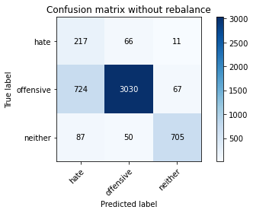

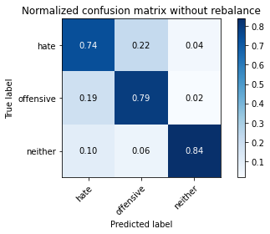

precision recall f1-score support

hate 0.21 0.74 0.33 294

offensive 0.96 0.79 0.87 3821

neither 0.90 0.84 0.87 842

accuracy 0.80 4957

macro avg 0.69 0.79 0.69 4957

weighted avg 0.91 0.80 0.84 4957

average eval_loss: 0.6767142618848612, accuracy: 0.79725640508372

training 6 epoch...

27.67617130279541 seconds used......

6 training finished! average train loss: 0.04500697817713327

evaluating...

Confusion matrix, without normalization

[[ 224 58 12]

[ 917 2822 82]

[ 89 39 714]]

Normalized confusion matrix

[[0.76190476 0.19727891 0.04081633]

[0.23998953 0.73855012 0.02146035]

[0.10570071 0.04631829 0.847981 ]]

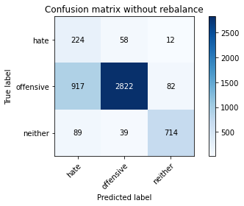

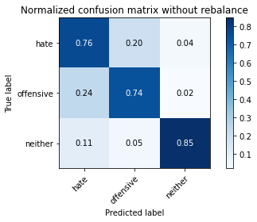

precision recall f1-score support

hate 0.18 0.76 0.29 294

offensive 0.97 0.74 0.84 3821

neither 0.88 0.85 0.87 842

accuracy 0.76 4957

macro avg 0.68 0.78 0.67 4957

weighted avg 0.91 0.76 0.81 4957

average eval_loss: 0.9485991791852059, accuracy: 0.7585233003832963

training 7 epoch...

27.655531883239746 seconds used......

7 training finished! average train loss: 0.03552509624475602

evaluating...

Confusion matrix, without normalization

[[ 192 78 24]

[ 516 3157 148]

[ 37 19 786]]

Normalized confusion matrix

[[0.65306122 0.26530612 0.08163265]

[0.13504318 0.8262235 0.03873332]

[0.04394299 0.02256532 0.93349169]]

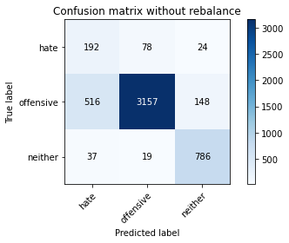

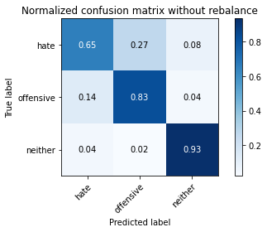

precision recall f1-score support

hate 0.26 0.65 0.37 294

offensive 0.97 0.83 0.89 3821

neither 0.82 0.93 0.87 842

accuracy 0.83 4957

macro avg 0.68 0.80 0.71 4957

weighted avg 0.90 0.83 0.86 4957

average eval_loss: 0.7326799570547601, accuracy: 0.8341738955013113

training 8 epoch...

27.779228448867798 seconds used......

8 training finished! average train loss: 0.013116368407122138

evaluating...

Confusion matrix, without normalization

[[ 217 63 14]

[ 723 3009 89]

[ 63 41 738]]

Normalized confusion matrix

[[0.73809524 0.21428571 0.04761905]

[0.18921748 0.78749019 0.02329233]

[0.07482185 0.04869359 0.87648456]]

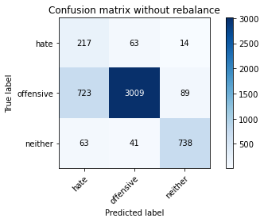

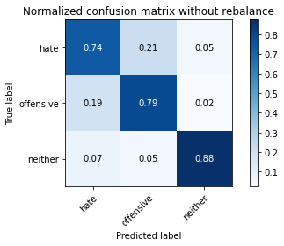

precision recall f1-score support

hate 0.22 0.74 0.33 294

offensive 0.97 0.79 0.87 3821

neither 0.88 0.88 0.88 842

accuracy 0.80 4957

macro avg 0.69 0.80 0.69 4957

weighted avg 0.91 0.80 0.84 4957

average eval_loss: 0.9605468523870748, accuracy: 0.7996772241274964

training 9 epoch...

27.736334323883057 seconds used......

9 training finished! average train loss: 0.017948523958704478

evaluating...

Confusion matrix, without normalization

[[ 226 50 18]

[ 807 2899 115]

[ 63 21 758]]

Normalized confusion matrix

[[0.76870748 0.17006803 0.06122449]

[0.21120126 0.75870191 0.03009683]

[0.07482185 0.02494062 0.90023753]]

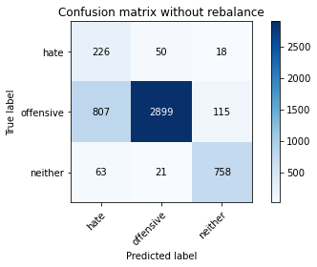

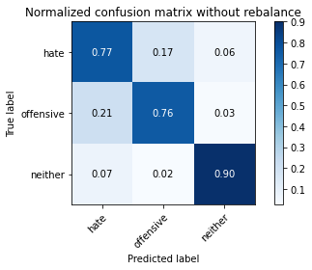

precision recall f1-score support

hate 0.21 0.77 0.33 294

offensive 0.98 0.76 0.85 3821

neither 0.85 0.90 0.87 842

accuracy 0.78 4957

macro avg 0.68 0.81 0.68 4957

weighted avg 0.91 0.78 0.83 4957

average eval_loss: 1.1766909262866736, accuracy: 0.7833366955820052

training 10 epoch...

27.717771768569946 seconds used......

10 training finished! average train loss: 0.005824472276682486

evaluating...

Confusion matrix, without normalization

[[ 201 72 21]

[ 683 3018 120]

[ 50 30 762]]

Normalized confusion matrix

[[0.68367347 0.24489796 0.07142857]

[0.17874902 0.78984559 0.03140539]

[0.05938242 0.03562945 0.90498812]]

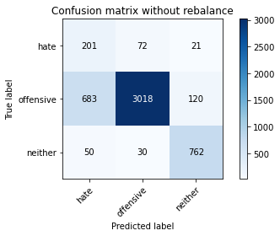

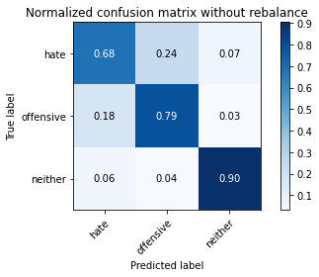

precision recall f1-score support

hate 0.22 0.68 0.33 294

offensive 0.97 0.79 0.87 3821

neither 0.84 0.90 0.87 842

accuracy 0.80 4957

macro avg 0.68 0.79 0.69 4957

weighted avg 0.90 0.80 0.84 4957

average eval_loss: 1.0994409305313904, accuracy: 0.8031067177728465

**second run:**

training 1 epoch...

27.739253759384155 seconds used......

1 training finished! average train loss: 0.6659800414627756

evaluating...

Confusion matrix, without normalization

[[ 224 37 33]

[ 893 2770 158]

[ 44 9 789]]

Normalized confusion matrix

[[0.76190476 0.12585034 0.1122449 ]

[0.23370845 0.72494111 0.04135043]

[0.05225653 0.01068884 0.93705463]]

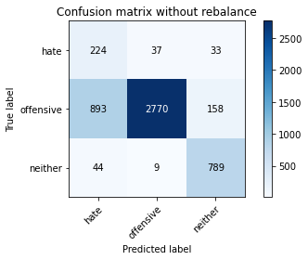

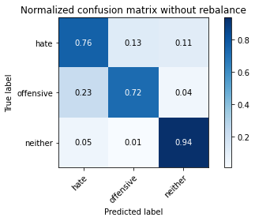

precision recall f1-score support

hate 0.19 0.76 0.31 294

offensive 0.98 0.72 0.83 3821

neither 0.81 0.94 0.87 842

accuracy 0.76 4957

macro avg 0.66 0.81 0.67 4957

weighted avg 0.91 0.76 0.81 4957

average eval_loss: 0.5971005930895766, accuracy: 0.7631632035505346

training 2 epoch...

27.791870594024658 seconds used......

2 training finished! average train loss: 0.38634497877101454

evaluating...

Confusion matrix, without normalization

[[ 230 46 18]

[ 764 2950 107]

[ 43 18 781]]

Normalized confusion matrix

[[0.78231293 0.15646259 0.06122449]

[0.19994766 0.7720492 0.02800314]

[0.05106888 0.02137767 0.92755344]]

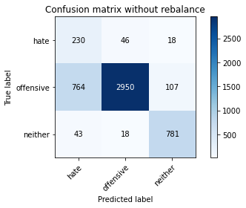

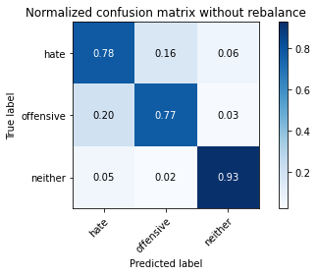

precision recall f1-score support

hate 0.22 0.78 0.35 294

offensive 0.98 0.77 0.86 3821

neither 0.86 0.93 0.89 842

accuracy 0.80 4957

macro avg 0.69 0.83 0.70 4957

weighted avg 0.91 0.80 0.84 4957

average eval_loss: 0.46276163457021596, accuracy: 0.7990720193665524

training 3 epoch...

27.88912343978882 seconds used......

3 training finished! average train loss: 0.26600806911786395

evaluating...

Confusion matrix, without normalization

[[ 222 52 20]

[ 793 2914 114]

[ 45 21 776]]

Normalized confusion matrix

[[0.75510204 0.17687075 0.06802721]

[0.20753729 0.76262758 0.02983512]

[0.05344418 0.02494062 0.9216152 ]]

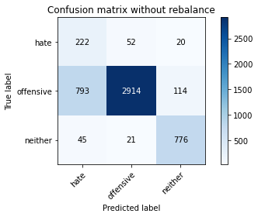

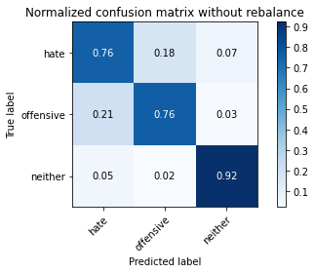

precision recall f1-score support

hate 0.21 0.76 0.33 294

offensive 0.98 0.76 0.86 3821

neither 0.85 0.92 0.89 842

accuracy 0.79 4957

macro avg 0.68 0.81 0.69 4957

weighted avg 0.91 0.79 0.83 4957

average eval_loss: 0.5047586704003474, accuracy: 0.7891870082711318

training 4 epoch...

27.91899800300598 seconds used......

4 training finished! average train loss: 0.13871644123604424

evaluating...

Confusion matrix, without normalization

[[ 227 54 13]

[ 710 3018 93]

[ 64 26 752]]

Normalized confusion matrix

[[0.77210884 0.18367347 0.04421769]

[0.18581523 0.78984559 0.02433918]

[0.0760095 0.03087886 0.89311164]]

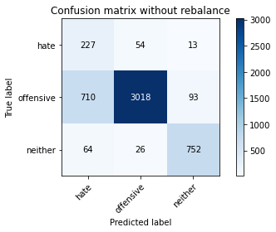

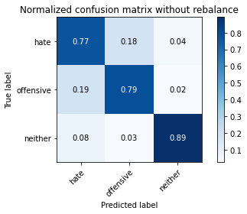

precision recall f1-score support

hate 0.23 0.77 0.35 294

offensive 0.97 0.79 0.87 3821

neither 0.88 0.89 0.88 842

accuracy 0.81 4957

macro avg 0.69 0.82 0.70 4957

weighted avg 0.91 0.81 0.84 4957

average eval_loss: 0.587918154369559, accuracy: 0.8063344764978818

training 5 epoch...

27.65470838546753 seconds used......

5 training finished! average train loss: 0.07125637715012488

evaluating...

Confusion matrix, without normalization

[[ 238 36 20]

[1060 2663 98]

[ 69 23 750]]

Normalized confusion matrix

[[0.80952381 0.12244898 0.06802721]

[0.27741429 0.69693797 0.02564774]

[0.08194774 0.02731591 0.89073634]]

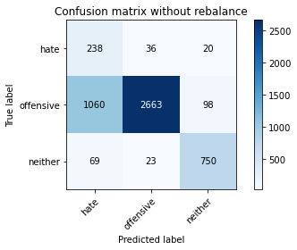

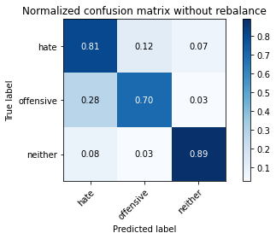

precision recall f1-score support

hate 0.17 0.81 0.29 294

offensive 0.98 0.70 0.81 3821

neither 0.86 0.89 0.88 842

accuracy 0.74 4957

macro avg 0.67 0.80 0.66 4957

weighted avg 0.91 0.74 0.79 4957

average eval_loss: 0.9613498018213338, accuracy: 0.7365341940689933

training 6 epoch...

27.748398065567017 seconds used......

6 training finished! average train loss: 0.04662540414893444

evaluating...

Confusion matrix, without normalization

[[ 210 64 20]

[ 601 3106 114]

[ 47 26 769]]

Normalized confusion matrix

[[0.71428571 0.21768707 0.06802721]

[0.15728867 0.81287621 0.02983512]

[0.05581948 0.03087886 0.91330166]]

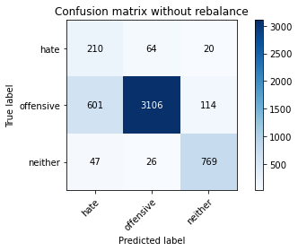

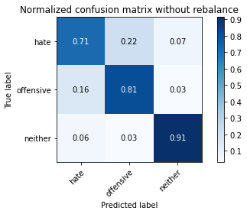

precision recall f1-score support

hate 0.24 0.71 0.36 294

offensive 0.97 0.81 0.89 3821

neither 0.85 0.91 0.88 842

accuracy 0.82 4957

macro avg 0.69 0.81 0.71 4957

weighted avg 0.91 0.82 0.85 4957

average eval_loss: 0.7580241890992189, accuracy: 0.8240871494855759

training 7 epoch...

27.7649986743927 seconds used......

7 training finished! average train loss: 0.03249874012000118

evaluating...

Confusion matrix, without normalization

[[ 225 54 15]

[ 859 2871 91]

[ 60 32 750]]

Normalized confusion matrix

[[0.76530612 0.18367347 0.05102041]

[0.22481026 0.75137399 0.02381576]

[0.07125891 0.03800475 0.89073634]]

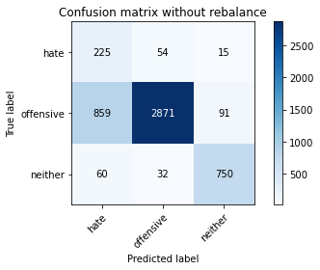

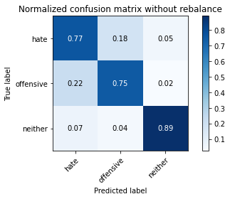

precision recall f1-score support

hate 0.20 0.77 0.31 294

offensive 0.97 0.75 0.85 3821

neither 0.88 0.89 0.88 842

accuracy 0.78 4957

macro avg 0.68 0.80 0.68 4957

weighted avg 0.91 0.78 0.82 4957

average eval_loss: 1.0650221961963502, accuracy: 0.7758725035303611

training 8 epoch...

27.784951210021973 seconds used......

8 training finished! average train loss: 0.026154230232690923

evaluating...

Confusion matrix, without normalization

[[ 229 52 13]

[ 852 2875 94]

[ 75 34 733]]

Normalized confusion matrix

[[0.77891156 0.17687075 0.04421769]

[0.22297828 0.75242083 0.02460089]

[0.08907363 0.04038005 0.87054632]]

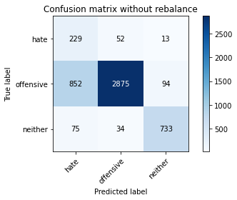

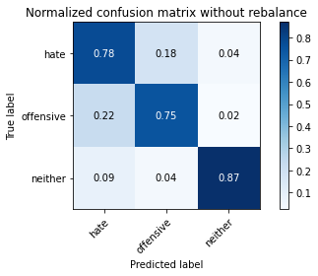

precision recall f1-score support

hate 0.20 0.78 0.32 294

offensive 0.97 0.75 0.85 3821

neither 0.87 0.87 0.87 842

accuracy 0.77 4957

macro avg 0.68 0.80 0.68 4957

weighted avg 0.91 0.77 0.82 4957

average eval_loss: 1.164105391633066, accuracy: 0.7740568892475288

training 9 epoch...

27.816619396209717 seconds used......

9 training finished! average train loss: 0.013504582111402387

evaluating...

Confusion matrix, without normalization

[[ 203 76 15]

[ 557 3141 123]

[ 51 35 756]]

Normalized confusion matrix

[[0.69047619 0.2585034 0.05102041]

[0.14577336 0.82203612 0.03219053]

[0.06057007 0.0415677 0.89786223]]

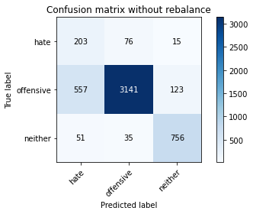

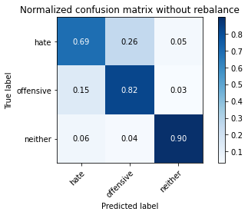

precision recall f1-score support

hate 0.25 0.69 0.37 294

offensive 0.97 0.82 0.89 3821

neither 0.85 0.90 0.87 842

accuracy 0.83 4957

macro avg 0.69 0.80 0.71 4957

weighted avg 0.90 0.83 0.85 4957

average eval_loss: 0.9065264147619957, accuracy: 0.8271131732902965

training 10 epoch...

27.78061079978943 seconds used......

10 training finished! average train loss: 0.005541203197106114

evaluating...

Confusion matrix, without normalization

[[ 227 58 9]

[ 829 2932 60]

[ 105 52 685]]

Normalized confusion matrix

[[0.77210884 0.19727891 0.03061224]

[0.21695891 0.76733839 0.0157027 ]

[0.12470309 0.06175772 0.81353919]]

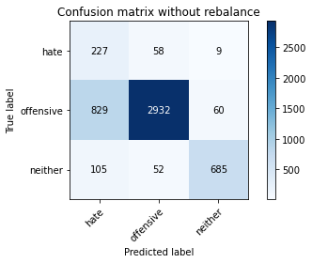

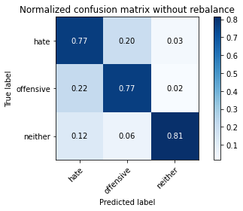

precision recall f1-score support

hate 0.20 0.77 0.31 294

offensive 0.96 0.77 0.85 3821

neither 0.91 0.81 0.86 842

accuracy 0.78 4957

macro avg 0.69 0.78 0.67 4957

weighted avg 0.91 0.78 0.82 4957

average eval_loss: 1.2561508759540776, accuracy: 0.7754690336897317

**third run:**

training 1 epoch...

27.72651219367981 seconds used......

1 training finished! average train loss: 0.6439185034026179

evaluating...

Confusion matrix, without normalization

[[ 228 46 20]

[ 714 2999 108]

[ 74 10 758]]

Normalized confusion matrix

[[0.7755102 0.15646259 0.06802721]

[0.18686208 0.78487307 0.02826485]

[0.08788599 0.01187648 0.90023753]]

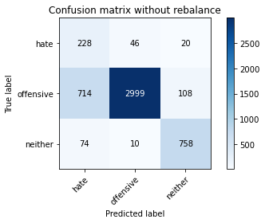

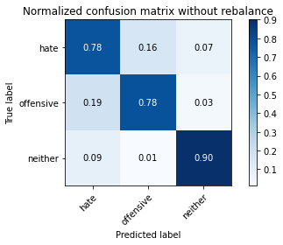

precision recall f1-score support

hate 0.22 0.78 0.35 294

offensive 0.98 0.78 0.87 3821

neither 0.86 0.90 0.88 842

accuracy 0.80 4957

macro avg 0.69 0.82 0.70 4957

weighted avg 0.92 0.80 0.84 4957

average eval_loss: 0.4923420353161712, accuracy: 0.8039136574541053

training 2 epoch...

27.755127429962158 seconds used......

2 training finished! average train loss: 0.3798541496371665

evaluating...

Confusion matrix, without normalization

[[ 224 54 16]

[ 690 3024 107]

[ 64 9 769]]

Normalized confusion matrix

[[0.76190476 0.18367347 0.05442177]

[0.180581 0.79141586 0.02800314]

[0.0760095 0.01068884 0.91330166]]

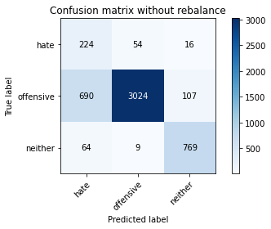

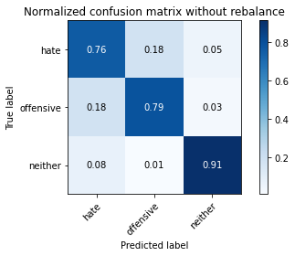

precision recall f1-score support

hate 0.23 0.76 0.35 294

offensive 0.98 0.79 0.88 3821

neither 0.86 0.91 0.89 842

accuracy 0.81 4957

macro avg 0.69 0.82 0.70 4957

weighted avg 0.92 0.81 0.85 4957

average eval_loss: 0.46520959632471204, accuracy: 0.8103691749041759

training 3 epoch...

27.737297773361206 seconds used......

3 training finished! average train loss: 0.268515658308888

evaluating...

Confusion matrix, without normalization

[[ 232 45 17]

[ 821 2861 139]

[ 60 13 769]]

Normalized confusion matrix

[[0.78911565 0.15306122 0.05782313]

[0.21486522 0.74875687 0.03637791]

[0.07125891 0.01543943 0.91330166]]

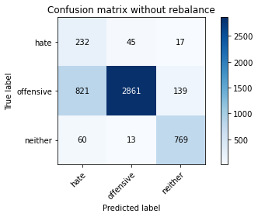

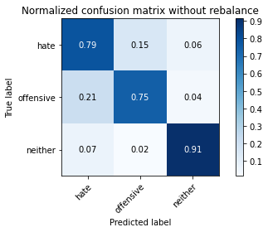

precision recall f1-score support

hate 0.21 0.79 0.33 294

offensive 0.98 0.75 0.85 3821

neither 0.83 0.91 0.87 842

accuracy 0.78 4957

macro avg 0.67 0.82 0.68 4957

weighted avg 0.91 0.78 0.82 4957

average eval_loss: 0.5459435406411367, accuracy: 0.7791002622553964

training 4 epoch...

27.66242790222168 seconds used......

4 training finished! average train loss: 0.15275636345845217

evaluating...

Confusion matrix, without normalization

[[ 244 38 12]

[ 970 2758 93]

[ 88 26 728]]

Normalized confusion matrix

[[0.82993197 0.1292517 0.04081633]

[0.25386025 0.72180058 0.02433918]

[0.10451306 0.03087886 0.86460808]]

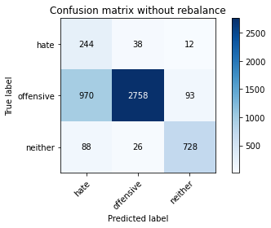

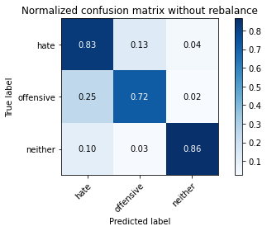

precision recall f1-score support

hate 0.19 0.83 0.31 294

offensive 0.98 0.72 0.83 3821

neither 0.87 0.86 0.87 842

accuracy 0.75 4957

macro avg 0.68 0.81 0.67 4957

weighted avg 0.91 0.75 0.81 4957

average eval_loss: 0.7104847573810408, accuracy: 0.7524712527738552

training 5 epoch...

27.702273845672607 seconds used......

5 training finished! average train loss: 0.08854913372105282

evaluating...

Confusion matrix, without normalization

[[ 221 57 16]

[ 633 3085 103]

[ 73 34 735]]

Normalized confusion matrix

[[0.75170068 0.19387755 0.05442177]

[0.16566344 0.80738027 0.02695629]

[0.08669834 0.04038005 0.87292162]]

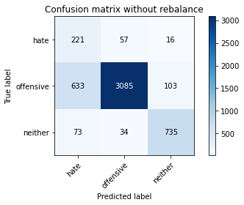

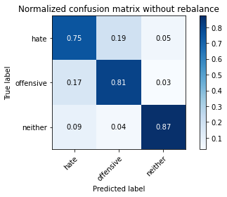

precision recall f1-score support

hate 0.24 0.75 0.36 294

offensive 0.97 0.81 0.88 3821

neither 0.86 0.87 0.87 842

accuracy 0.82 4957

macro avg 0.69 0.81 0.70 4957

weighted avg 0.91 0.82 0.85 4957

average eval_loss: 0.5948598013454748, accuracy: 0.8152108129917288

training 6 epoch...

27.64865517616272 seconds used......

6 training finished! average train loss: 0.050842805567458925

evaluating...

Confusion matrix, without normalization

[[ 224 57 13]

[ 705 3026 90]

[ 70 30 742]]

Normalized confusion matrix

[[0.76190476 0.19387755 0.04421769]

[0.18450667 0.79193928 0.02355404]

[0.08313539 0.03562945 0.88123515]]

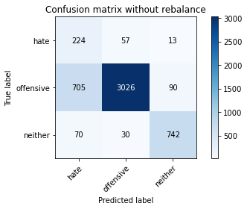

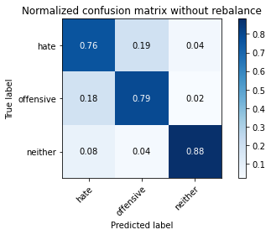

precision recall f1-score support

hate 0.22 0.76 0.35 294

offensive 0.97 0.79 0.87 3821

neither 0.88 0.88 0.88 842

accuracy 0.81 4957

macro avg 0.69 0.81 0.70 4957

weighted avg 0.91 0.81 0.84 4957

average eval_loss: 0.7953256066755257, accuracy: 0.8053258018963082

training 7 epoch...

27.66149616241455 seconds used......

7 training finished! average train loss: 0.021802416517214075

evaluating...

Confusion matrix, without normalization

[[ 194 85 15]

[ 498 3237 86]

[ 44 75 723]]

Normalized confusion matrix

[[0.65986395 0.28911565 0.05102041]

[0.13033237 0.84716043 0.0225072 ]

[0.05225653 0.08907363 0.85866983]]

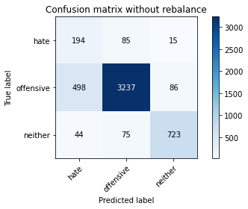

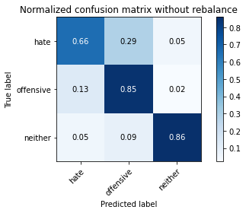

precision recall f1-score support

hate 0.26 0.66 0.38 294

offensive 0.95 0.85 0.90 3821

neither 0.88 0.86 0.87 842

accuracy 0.84 4957

macro avg 0.70 0.79 0.71 4957

weighted avg 0.90 0.84 0.86 4957

average eval_loss: 0.648023961674499, accuracy: 0.8380068589872907

training 8 epoch...

27.698190689086914 seconds used......

8 training finished! average train loss: 0.01847191035920449

evaluating...

Confusion matrix, without normalization

[[ 241 39 14]

[1105 2614 102]

[ 72 25 745]]

Normalized confusion matrix

[[0.81972789 0.13265306 0.04761905]

[0.28919131 0.68411411 0.02669458]

[0.08551069 0.02969121 0.8847981 ]]

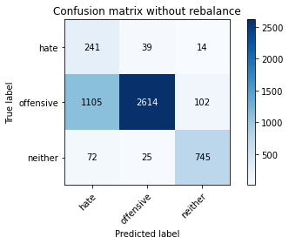

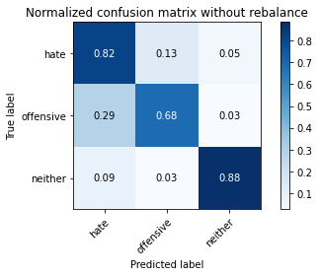

precision recall f1-score support

hate 0.17 0.82 0.28 294

offensive 0.98 0.68 0.80 3821

neither 0.87 0.88 0.87 842

accuracy 0.73 4957

macro avg 0.67 0.80 0.65 4957

weighted avg 0.91 0.73 0.79 4957

average eval_loss: 1.4218249967652223, accuracy: 0.7262457131329433

training 9 epoch...

27.735451459884644 seconds used......

9 training finished! average train loss: 0.011703446016348054

evaluating...

Confusion matrix, without normalization

[[ 188 77 29]

[ 466 3189 166]

[ 32 18 792]]

Normalized confusion matrix

[[0.63945578 0.26190476 0.09863946]

[0.1219576 0.83459827 0.04344412]

[0.03800475 0.02137767 0.94061758]]

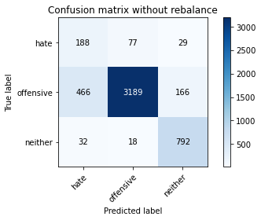

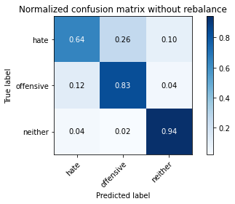

precision recall f1-score support

hate 0.27 0.64 0.38 294

offensive 0.97 0.83 0.90 3821

neither 0.80 0.94 0.87 842

accuracy 0.84 4957

macro avg 0.68 0.80 0.72 4957

weighted avg 0.90 0.84 0.86 4957

average eval_loss: 0.8560972875641328, accuracy: 0.8410328827920113

training 10 epoch...

27.642858743667603 seconds used......

10 training finished! average train loss: 0.018232349508880415

evaluating...

Confusion matrix, without normalization

[[ 212 52 30]

[ 652 3026 143]

[ 32 14 796]]

Normalized confusion matrix

[[0.72108844 0.17687075 0.10204082]

[0.17063596 0.79193928 0.03742476]

[0.03800475 0.01662708 0.94536817]]

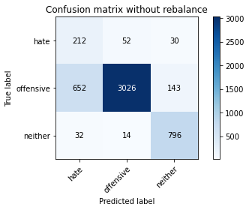

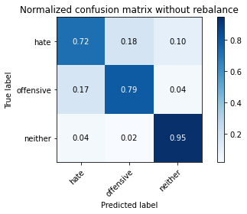

precision recall f1-score support

hate 0.24 0.72 0.36 294

offensive 0.98 0.79 0.88 3821

neither 0.82 0.95 0.88 842

accuracy 0.81 4957

macro avg 0.68 0.82 0.70 4957

weighted avg 0.91 0.81 0.85 4957

average eval_loss: 1.0632782411830117, accuracy: 0.8137986685495259

**fourth run:**

training 1 epoch...

27.679138898849487 seconds used......

1 training finished! average train loss: 0.6430355105658023

evaluating...

Confusion matrix, without normalization

[[ 223 35 36]

[ 905 2763 153]

[ 29 10 803]]

Normalized confusion matrix

[[0.7585034 0.11904762 0.12244898]

[0.23684899 0.72310913 0.04004187]

[0.03444181 0.01187648 0.95368171]]

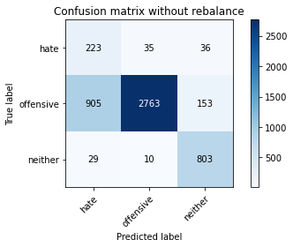

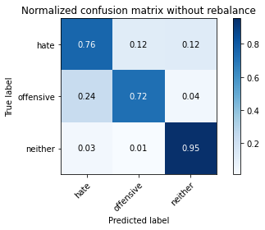

precision recall f1-score support

hate 0.19 0.76 0.31 294

offensive 0.98 0.72 0.83 3821

neither 0.81 0.95 0.88 842

accuracy 0.76 4957

macro avg 0.66 0.81 0.67 4957

weighted avg 0.91 0.76 0.81 4957

average eval_loss: 0.5655922877091554, accuracy: 0.7643736130724228

training 2 epoch...

27.659868240356445 seconds used......

2 training finished! average train loss: 0.3888000072094432

evaluating...

Confusion matrix, without normalization

[[ 219 57 18]

[ 602 3123 96]

[ 53 29 760]]

Normalized confusion matrix

[[0.74489796 0.19387755 0.06122449]

[0.15755038 0.81732531 0.02512431]

[0.06294537 0.03444181 0.90261283]]

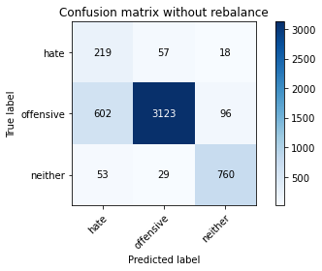

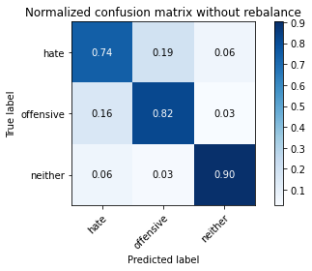

precision recall f1-score support

hate 0.25 0.74 0.38 294

offensive 0.97 0.82 0.89 3821

neither 0.87 0.90 0.89 842

accuracy 0.83 4957

macro avg 0.70 0.82 0.72 4957

weighted avg 0.91 0.83 0.86 4957

average eval_loss: 0.42995411917687426, accuracy: 0.827516643130926

training 3 epoch...

27.621131658554077 seconds used......

3 training finished! average train loss: 0.26718478024615877

evaluating...

Confusion matrix, without normalization

[[ 242 36 16]

[ 985 2730 106]

[ 68 13 761]]

Normalized confusion matrix

[[0.82312925 0.12244898 0.05442177]

[0.25778592 0.71447265 0.02774143]

[0.0807601 0.01543943 0.90380048]]

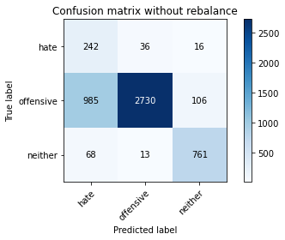

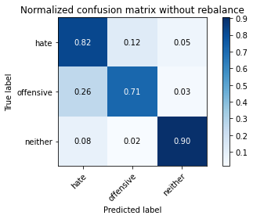

precision recall f1-score support

hate 0.19 0.82 0.30 294

offensive 0.98 0.71 0.83 3821

neither 0.86 0.90 0.88 842

accuracy 0.75 4957

macro avg 0.68 0.81 0.67 4957

weighted avg 0.91 0.75 0.81 4957

average eval_loss: 0.6321445716124389, accuracy: 0.7530764575347992

training 4 epoch...

27.665968418121338 seconds used......

4 training finished! average train loss: 0.14714236454548021

evaluating...

Confusion matrix, without normalization

[[ 210 65 19]

[ 608 3104 109]

[ 37 27 778]]

Normalized confusion matrix

[[0.71428571 0.22108844 0.06462585]

[0.15912065 0.81235279 0.02852656]

[0.04394299 0.03206651 0.9239905 ]]

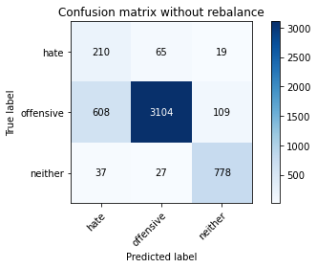

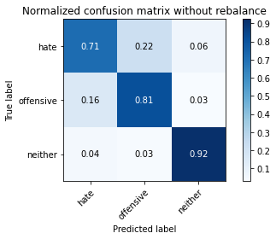

precision recall f1-score support

hate 0.25 0.71 0.37 294

offensive 0.97 0.81 0.88 3821

neither 0.86 0.92 0.89 842

accuracy 0.83 4957

macro avg 0.69 0.82 0.71 4957

weighted avg 0.91 0.83 0.85 4957

average eval_loss: 0.5392411040450116, accuracy: 0.8254992939277789

training 5 epoch...

27.67185926437378 seconds used......

5 training finished! average train loss: 0.08437647607738467

evaluating...

Confusion matrix, without normalization

[[ 229 47 18]

[ 884 2817 120]

[ 67 17 758]]

Normalized confusion matrix

[[0.77891156 0.15986395 0.06122449]

[0.23135305 0.73724156 0.03140539]

[0.07957245 0.02019002 0.90023753]]

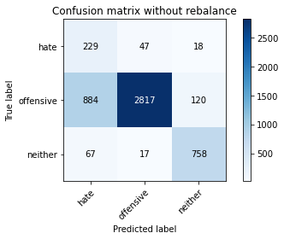

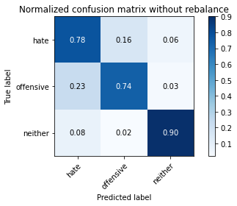

precision recall f1-score support

hate 0.19 0.78 0.31 294

offensive 0.98 0.74 0.84 3821

neither 0.85 0.90 0.87 842

accuracy 0.77 4957

macro avg 0.67 0.81 0.67 4957

weighted avg 0.91 0.77 0.81 4957

average eval_loss: 0.6959056252080407, accuracy: 0.7673996368771434

training 6 epoch...

27.613526821136475 seconds used......

6 training finished! average train loss: 0.040396033810745725

evaluating...

Confusion matrix, without normalization

[[ 229 47 18]

[ 745 2959 117]

[ 63 22 757]]

Normalized confusion matrix

[[0.77891156 0.15986395 0.06122449]

[0.19497514 0.77440461 0.03062026]

[0.07482185 0.02612827 0.89904988]]

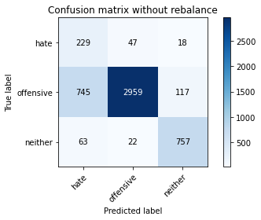

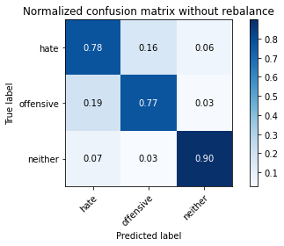

precision recall f1-score support

hate 0.22 0.78 0.34 294

offensive 0.98 0.77 0.86 3821

neither 0.85 0.90 0.87 842

accuracy 0.80 4957

macro avg 0.68 0.82 0.69 4957

weighted avg 0.91 0.80 0.83 4957

average eval_loss: 0.8887115250822277, accuracy: 0.795844260641517

training 7 epoch...

27.644232511520386 seconds used......

7 training finished! average train loss: 0.032886544104300613

evaluating...

Confusion matrix, without normalization

[[ 231 43 20]

[ 877 2831 113]

[ 56 24 762]]

Normalized confusion matrix

[[0.78571429 0.1462585 0.06802721]

[0.22952107 0.74090552 0.02957341]

[0.06650831 0.02850356 0.90498812]]

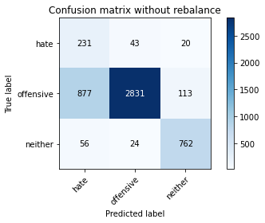

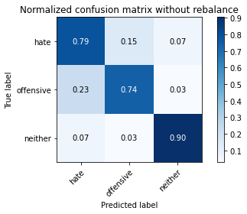

precision recall f1-score support

hate 0.20 0.79 0.32 294

offensive 0.98 0.74 0.84 3821

neither 0.85 0.90 0.88 842

accuracy 0.77 4957

macro avg 0.68 0.81 0.68 4957

weighted avg 0.91 0.77 0.82 4957

average eval_loss: 1.0053286539773727, accuracy: 0.7714343352834375

training 8 epoch...

27.636717796325684 seconds used......

8 training finished! average train loss: 0.03202249360378363

evaluating...

Confusion matrix, without normalization

[[ 192 82 20]

[ 487 3218 116]

[ 40 33 769]]

Normalized confusion matrix

[[0.65306122 0.27891156 0.06802721]

[0.12745355 0.84218791 0.03035854]

[0.04750594 0.0391924 0.91330166]]

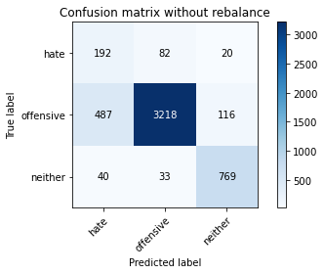

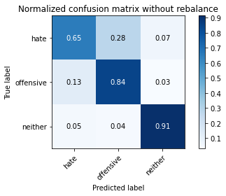

precision recall f1-score support

hate 0.27 0.65 0.38 294

offensive 0.97 0.84 0.90 3821

neither 0.85 0.91 0.88 842

accuracy 0.84 4957

macro avg 0.69 0.80 0.72 4957

weighted avg 0.90 0.84 0.87 4957

average eval_loss: 0.7256168105447995, accuracy: 0.8430502319951584

training 9 epoch...

27.71434998512268 seconds used......

9 training finished! average train loss: 0.013215808693472057

evaluating...

Confusion matrix, without normalization

[[ 211 64 19]

[ 603 3108 110]

[ 42 33 767]]

Normalized confusion matrix

[[0.71768707 0.21768707 0.06462585]

[0.15781209 0.81339963 0.02878828]

[0.04988124 0.0391924 0.91092637]]

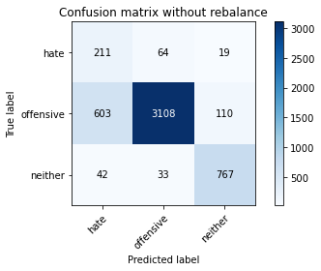

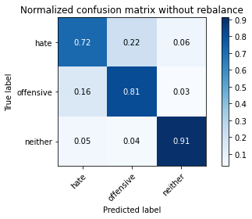

precision recall f1-score support

hate 0.25 0.72 0.37 294

offensive 0.97 0.81 0.88 3821

neither 0.86 0.91 0.88 842

accuracy 0.82 4957

macro avg 0.69 0.81 0.71 4957

weighted avg 0.91 0.82 0.85 4957

average eval_loss: 0.8801688011378921, accuracy: 0.8242888844058907

training 10 epoch...

27.68832039833069 seconds used......

10 training finished! average train loss: 0.007943064964421322

evaluating...

Confusion matrix, without normalization

[[ 219 55 20]

[ 753 2955 113]

[ 50 36 756]]

Normalized confusion matrix

[[0.74489796 0.18707483 0.06802721]

[0.19706883 0.77335776 0.02957341]

[0.05938242 0.04275534 0.89786223]]

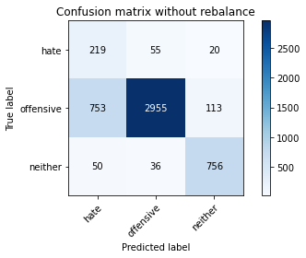

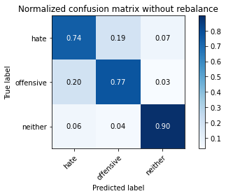

precision recall f1-score support

hate 0.21 0.74 0.33 294

offensive 0.97 0.77 0.86 3821

neither 0.85 0.90 0.87 842

accuracy 0.79 4957

macro avg 0.68 0.81 0.69 4957

weighted avg 0.90 0.79 0.83 4957

average eval_loss: 1.0958156636258918, accuracy: 0.7928182368367964

**fifth run**

training 1 epoch...

27.721719980239868 seconds used......

1 training finished! average train loss: 0.6642633028197706

evaluating...

Confusion matrix, without normalization

[[ 218 55 21]

[ 718 2992 111]

[ 60 11 771]]

Normalized confusion matrix

[[0.7414966 0.18707483 0.07142857]

[0.18790892 0.78304109 0.02904999]

[0.07125891 0.01306413 0.91567696]]

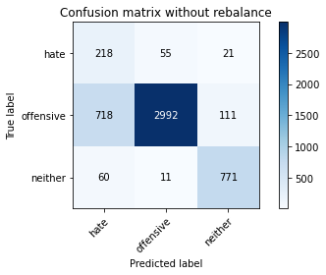

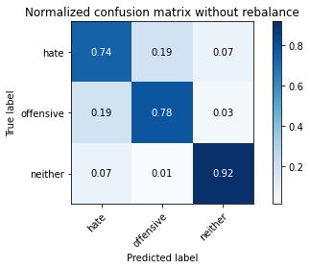

precision recall f1-score support

hate 0.22 0.74 0.34 294

offensive 0.98 0.78 0.87 3821

neither 0.85 0.92 0.88 842

accuracy 0.80 4957

macro avg 0.68 0.81 0.70 4957

weighted avg 0.91 0.80 0.84 4957

average eval_loss: 0.5428342415440467, accuracy: 0.8031067177728465

training 2 epoch...

27.731226444244385 seconds used......

2 training finished! average train loss: 0.39192403722227664

evaluating...

Confusion matrix, without normalization

[[ 220 53 21]

[ 634 3063 124]

[ 44 11 787]]

Normalized confusion matrix

[[0.74829932 0.18027211 0.07142857]

[0.16592515 0.80162261 0.03245224]

[0.05225653 0.01306413 0.93467933]]

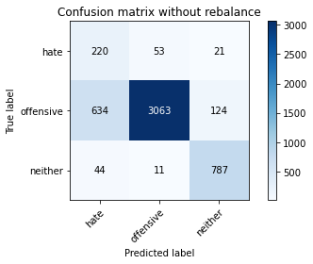

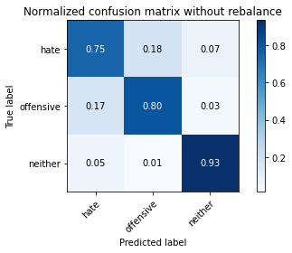

precision recall f1-score support

hate 0.24 0.75 0.37 294

offensive 0.98 0.80 0.88 3821

neither 0.84 0.93 0.89 842

accuracy 0.82 4957

macro avg 0.69 0.83 0.71 4957

weighted avg 0.91 0.82 0.85 4957

average eval_loss: 0.4528970922073049, accuracy: 0.8210611256808553

training 3 epoch...

27.598222970962524 seconds used......

3 training finished! average train loss: 0.28153929841971537

evaluating...

Confusion matrix, without normalization

[[ 247 28 19]

[1133 2579 109]

[ 46 15 781]]

Normalized confusion matrix

[[0.84013605 0.0952381 0.06462585]

[0.29651924 0.6749542 0.02852656]

[0.05463183 0.01781473 0.92755344]]

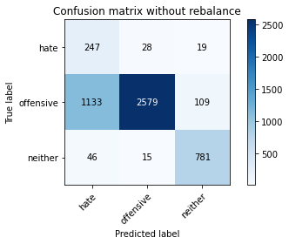

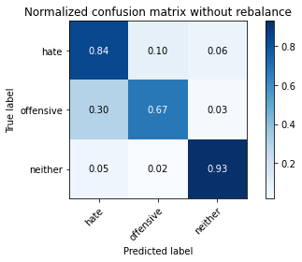

precision recall f1-score support

hate 0.17 0.84 0.29 294

offensive 0.98 0.67 0.80 3821

neither 0.86 0.93 0.89 842

accuracy 0.73 4957

macro avg 0.67 0.81 0.66 4957

weighted avg 0.91 0.73 0.79 4957

average eval_loss: 0.7012160854534276, accuracy: 0.7276578575751462

training 4 epoch...

27.736445903778076 seconds used......

4 training finished! average train loss: 0.1680311322190434

evaluating...

Confusion matrix, without normalization

[[ 218 56 20]

[ 674 3030 117]

[ 34 26 782]]

Normalized confusion matrix

[[0.7414966 0.19047619 0.06802721]

[0.17639361 0.79298613 0.03062026]

[0.04038005 0.03087886 0.92874109]]

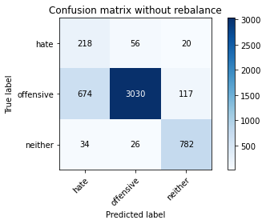

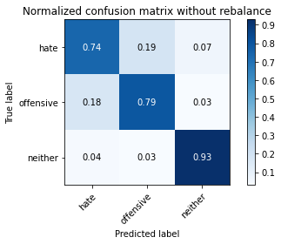

precision recall f1-score support

hate 0.24 0.74 0.36 294

offensive 0.97 0.79 0.87 3821

neither 0.85 0.93 0.89 842

accuracy 0.81 4957

macro avg 0.69 0.82 0.71 4957

weighted avg 0.91 0.81 0.85 4957

average eval_loss: 0.5140106729682414, accuracy: 0.8129917288682671

training 5 epoch...

27.694958925247192 seconds used......

5 training finished! average train loss: 0.09146405171809925

evaluating...

Confusion matrix, without normalization

[[ 227 47 20]

[ 727 2933 161]

[ 42 14 786]]

Normalized confusion matrix

[[0.77210884 0.15986395 0.06802721]

[0.19026433 0.7676001 0.04213557]

[0.04988124 0.01662708 0.93349169]]

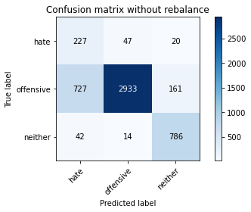

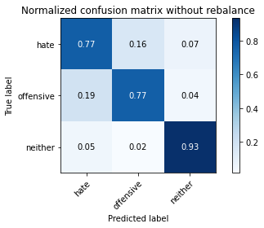

precision recall f1-score support

hate 0.23 0.77 0.35 294

offensive 0.98 0.77 0.86 3821

neither 0.81 0.93 0.87 842

accuracy 0.80 4957

macro avg 0.67 0.82 0.69 4957

weighted avg 0.91 0.80 0.83 4957

average eval_loss: 0.75633183903166, accuracy: 0.7960459955618318

training 6 epoch...

27.82396173477173 seconds used......

6 training finished! average train loss: 0.05024338029638172

evaluating...

Confusion matrix, without normalization

[[ 234 48 12]

[ 889 2839 93]

[ 62 32 748]]

Normalized confusion matrix

[[0.79591837 0.16326531 0.04081633]

[0.23266161 0.74299921 0.02433918]

[0.0736342 0.03800475 0.88836105]]

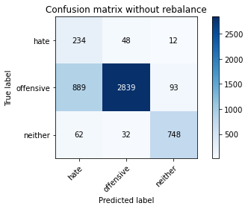

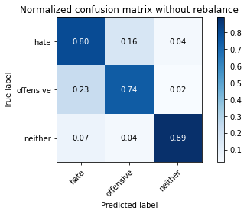

precision recall f1-score support

hate 0.20 0.80 0.32 294

offensive 0.97 0.74 0.84 3821

neither 0.88 0.89 0.88 842

accuracy 0.77 4957

macro avg 0.68 0.81 0.68 4957

weighted avg 0.91 0.77 0.82 4957

average eval_loss: 0.8900739319487324, accuracy: 0.7708291305224935

training 7 epoch...

27.896207332611084 seconds used......

7 training finished! average train loss: 0.029773791030945244

evaluating...

Confusion matrix, without normalization

[[ 213 63 18]

[ 616 3083 122]

[ 36 36 770]]

Normalized confusion matrix

[[0.7244898 0.21428571 0.06122449]

[0.16121434 0.80685684 0.03192881]

[0.04275534 0.04275534 0.91448931]]

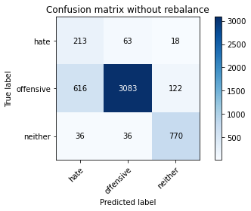

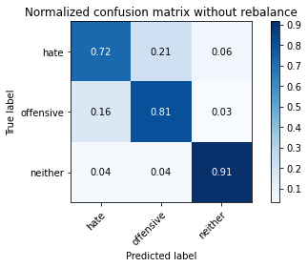

precision recall f1-score support

hate 0.25 0.72 0.37 294

offensive 0.97 0.81 0.88 3821

neither 0.85 0.91 0.88 842

accuracy 0.82 4957

macro avg 0.69 0.82 0.71 4957

weighted avg 0.91 0.82 0.85 4957

average eval_loss: 0.8103944706062095, accuracy: 0.8202541859995965

training 8 epoch...

27.832625150680542 seconds used......

8 training finished! average train loss: 0.015720479432541103

evaluating...

Confusion matrix, without normalization

[[ 219 61 14]

[ 664 3055 102]

[ 50 34 758]]

Normalized confusion matrix

[[0.74489796 0.20748299 0.04761905]

[0.1737765 0.79952892 0.02669458]

[0.05938242 0.04038005 0.90023753]]

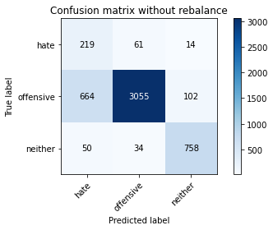

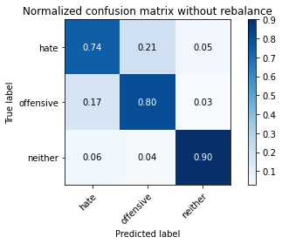

precision recall f1-score support

hate 0.23 0.74 0.36 294

offensive 0.97 0.80 0.88 3821

neither 0.87 0.90 0.88 842

accuracy 0.81 4957

macro avg 0.69 0.81 0.71 4957

weighted avg 0.91 0.81 0.85 4957

average eval_loss: 0.9605158534409823, accuracy: 0.8133951987088965

training 9 epoch...

27.77902364730835 seconds used......

9 training finished! average train loss: 0.02253251748325641

evaluating...

Confusion matrix, without normalization

[[ 249 32 13]

[1050 2686 85]

[ 57 41 744]]

Normalized confusion matrix

[[0.84693878 0.10884354 0.04421769]

[0.27479717 0.70295734 0.02224549]

[0.06769596 0.04869359 0.88361045]]

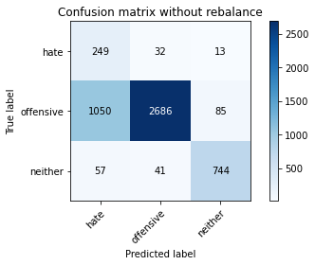

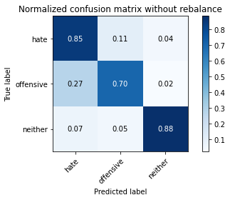

precision recall f1-score support

hate 0.18 0.85 0.30 294

offensive 0.97 0.70 0.82 3821

neither 0.88 0.88 0.88 842

accuracy 0.74 4957

macro avg 0.68 0.81 0.67 4957

weighted avg 0.91 0.74 0.80 4957

average eval_loss: 1.312740592030628, accuracy: 0.7421827718378051

training 10 epoch...

27.74630880355835 seconds used......

10 training finished! average train loss: 0.021758746602048292

evaluating...

Confusion matrix, without normalization

[[ 217 57 20]

[ 568 3137 116]

[ 36 42 764]]

Normalized confusion matrix

[[0.73809524 0.19387755 0.06802721]

[0.14865219 0.82098927 0.03035854]

[0.04275534 0.04988124 0.90736342]]

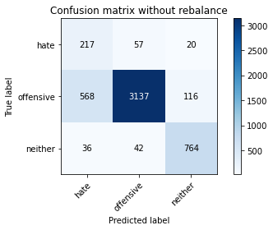

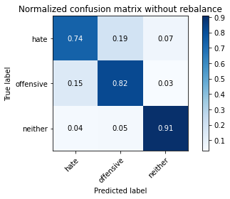

precision recall f1-score support

hate 0.26 0.74 0.39 294

offensive 0.97 0.82 0.89 3821

neither 0.85 0.91 0.88 842

accuracy 0.83 4957

macro avg 0.69 0.82 0.72 4957

weighted avg 0.91 0.83 0.86 4957

average eval_loss: 0.8617911976658844, accuracy: 0.8307444018559612