1 run

[1,0.5,1]

training 1 epoch...

64.22370052337646 seconds used......

1 training finished! average train loss: 0.6176147654391172

evaluating...

Confusion matrix, without normalization

[[ 224 36 34]

[ 876 2758 187]

[ 30 8 804]]

Normalized confusion matrix

[[0.76190476 0.12244898 0.11564626]

[0.22925936 0.72180058 0.04894007]

[0.03562945 0.00950119 0.95486936]]

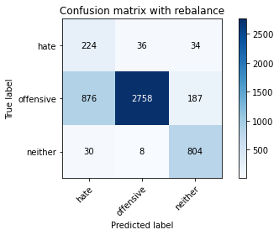

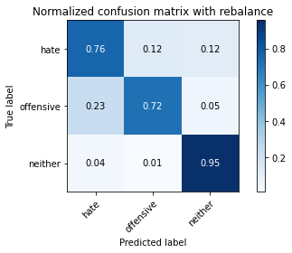

precision recall f1-score support

hate 0.20 0.76 0.31 294

offensive 0.98 0.72 0.83 3821

neither 0.78 0.95 0.86 842

accuracy 0.76 4957

macro avg 0.66 0.81 0.67 4957

weighted avg 0.90 0.76 0.81 4957

average eval_loss: 0.5927057326020252, accuracy: 0.7637684083114787

training 2 epoch...

63.640594244003296 seconds used......

2 training finished! average train loss: 0.370345728962045

evaluating...

Confusion matrix, without normalization

[[ 241 32 21]

[1129 2581 111]

[ 60 8 774]]

Normalized confusion matrix

[[0.81972789 0.10884354 0.07142857]

[0.29547239 0.67547762 0.02904999]

[0.07125891 0.00950119 0.9192399 ]]

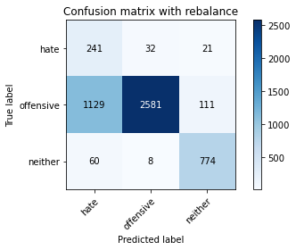

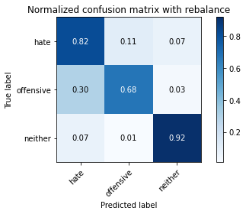

precision recall f1-score support

hate 0.17 0.82 0.28 294

offensive 0.98 0.68 0.80 3821

neither 0.85 0.92 0.89 842

accuracy 0.73 4957

macro avg 0.67 0.80 0.66 4957

weighted avg 0.91 0.73 0.78 4957

average eval_loss: 0.5853909978703145, accuracy: 0.7254387734516845

training 3 epoch...

63.65718913078308 seconds used......

3 training finished! average train loss: 0.23945537263974112

evaluating...

Confusion matrix, without normalization

[[ 241 38 15]

[1092 2642 87]

[ 77 15 750]]

Normalized confusion matrix

[[0.81972789 0.1292517 0.05102041]

[0.28578906 0.69144203 0.02276891]

[0.09144893 0.01781473 0.89073634]]

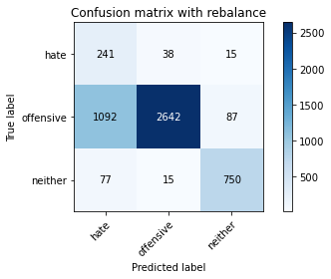

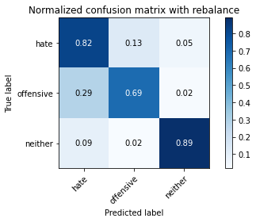

precision recall f1-score support

hate 0.17 0.82 0.28 294

offensive 0.98 0.69 0.81 3821

neither 0.88 0.89 0.89 842

accuracy 0.73 4957

macro avg 0.68 0.80 0.66 4957

weighted avg 0.92 0.73 0.79 4957

average eval_loss: 0.6141942054213535, accuracy: 0.7329029655033287

training 4 epoch...

63.60417985916138 seconds used......

4 training finished! average train loss: 0.15199768092287214

evaluating...

Confusion matrix, without normalization

[[ 219 59 16]

[ 632 3081 108]

[ 52 16 774]]

Normalized confusion matrix

[[0.74489796 0.20068027 0.05442177]

[0.16540173 0.80633342 0.02826485]

[0.06175772 0.01900238 0.9192399 ]]

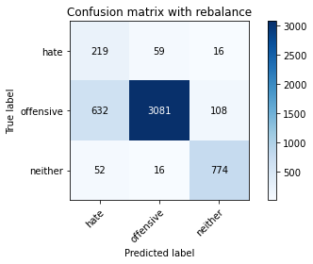

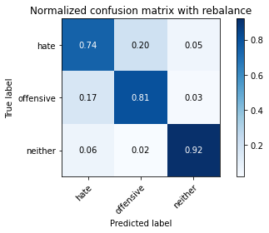

precision recall f1-score support

hate 0.24 0.74 0.37 294

offensive 0.98 0.81 0.88 3821

neither 0.86 0.92 0.89 842

accuracy 0.82 4957

macro avg 0.69 0.82 0.71 4957

weighted avg 0.91 0.82 0.85 4957

average eval_loss: 0.5356882053742846, accuracy: 0.8218680653621142

training 5 epoch...

63.62222671508789 seconds used......

5 training finished! average train loss: 0.08461520989147718

evaluating...

Confusion matrix, without normalization

[[ 231 45 18]

[1160 2553 108]

[ 58 25 759]]

Normalized confusion matrix

[[0.78571429 0.15306122 0.06122449]

[0.30358545 0.6681497 0.02826485]

[0.06888361 0.02969121 0.90142518]]

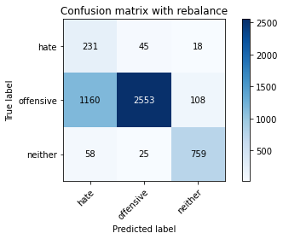

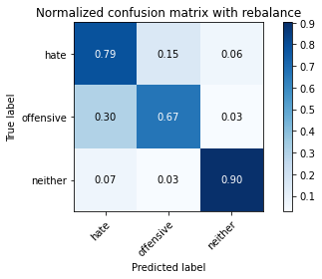

precision recall f1-score support

hate 0.16 0.79 0.27 294

offensive 0.97 0.67 0.79 3821

neither 0.86 0.90 0.88 842

accuracy 0.71 4957

macro avg 0.66 0.79 0.65 4957

weighted avg 0.91 0.71 0.78 4957

average eval_loss: 0.8863014356052924, accuracy: 0.714746822675005

training 6 epoch...

63.64124917984009 seconds used......

6 training finished! average train loss: 0.05656834258098831

evaluating...

Confusion matrix, without normalization

[[ 253 27 14]

[1400 2335 86]

[ 85 22 735]]

Normalized confusion matrix

[[0.86054422 0.09183673 0.04761905]

[0.36639623 0.61109657 0.0225072 ]

[0.10095012 0.02612827 0.87292162]]

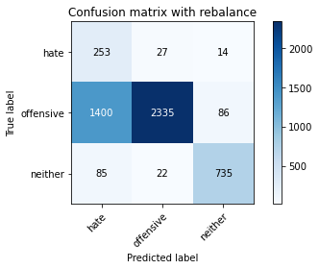

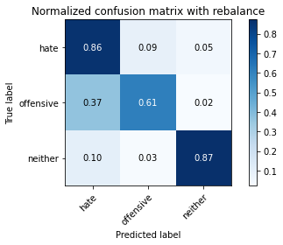

precision recall f1-score support

hate 0.15 0.86 0.25 294

offensive 0.98 0.61 0.75 3821

neither 0.88 0.87 0.88 842

accuracy 0.67 4957

macro avg 0.67 0.78 0.63 4957

weighted avg 0.91 0.67 0.74 4957

average eval_loss: 1.2665830999011956, accuracy: 0.6703651402057696

training 7 epoch...

63.56990838050842 seconds used......

7 training finished! average train loss: 0.036082147043988065

evaluating...

Confusion matrix, without normalization

[[ 222 55 17]

[ 728 2988 105]

[ 60 26 756]]

Normalized confusion matrix

[[0.75510204 0.18707483 0.05782313]

[0.19052604 0.78199424 0.02747972]

[0.07125891 0.03087886 0.89786223]]

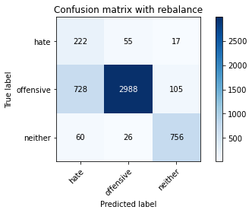

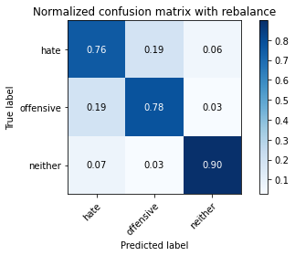

precision recall f1-score support

hate 0.22 0.76 0.34 294

offensive 0.97 0.78 0.87 3821

neither 0.86 0.90 0.88 842

accuracy 0.80 4957

macro avg 0.68 0.81 0.70 4957

weighted avg 0.91 0.80 0.84 4957

average eval_loss: 0.844221975151149, accuracy: 0.8000806939681259

training 8 epoch...

63.690136432647705 seconds used......

8 training finished! average train loss: 0.024528403813768265

evaluating...

Confusion matrix, without normalization

[[ 225 57 12]

[ 703 3032 86]

[ 78 31 733]]

Normalized confusion matrix

[[0.76530612 0.19387755 0.04081633]

[0.18398325 0.79350955 0.0225072 ]

[0.09263658 0.0368171 0.87054632]]

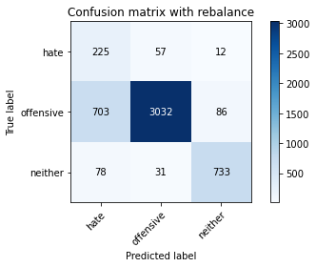

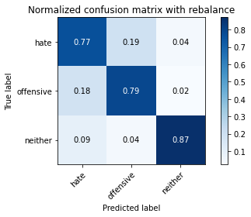

precision recall f1-score support

hate 0.22 0.77 0.35 294

offensive 0.97 0.79 0.87 3821

neither 0.88 0.87 0.88 842

accuracy 0.80 4957

macro avg 0.69 0.81 0.70 4957

weighted avg 0.91 0.80 0.84 4957

average eval_loss: 0.9072239277321065, accuracy: 0.8049223320556789

training 9 epoch...

63.641732692718506 seconds used......

9 training finished! average train loss: 0.013616163694444084

evaluating...

Confusion matrix, without normalization

[[ 201 70 23]

[ 511 3191 119]

[ 39 25 778]]

Normalized confusion matrix

[[0.68367347 0.23809524 0.07823129]

[0.13373462 0.8351217 0.03114368]

[0.04631829 0.02969121 0.9239905 ]]

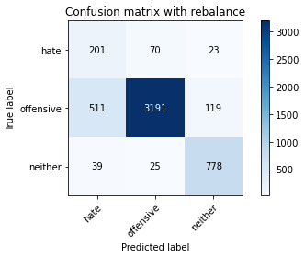

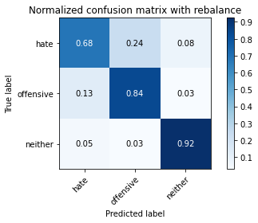

precision recall f1-score support

hate 0.27 0.68 0.38 294

offensive 0.97 0.84 0.90 3821

neither 0.85 0.92 0.88 842

accuracy 0.84 4957

macro avg 0.69 0.81 0.72 4957

weighted avg 0.91 0.84 0.87 4957

average eval_loss: 0.8094480911677238, accuracy: 0.841234617712326

training 10 epoch...

63.67322874069214 seconds used......

10 training finished! average train loss: 0.023618262437732525

evaluating...

Confusion matrix, without normalization

[[ 233 48 13]

[ 968 2767 86]

[ 79 31 732]]

Normalized confusion matrix

[[0.79251701 0.16326531 0.04421769]

[0.25333682 0.72415598 0.0225072 ]

[0.09382423 0.0368171 0.86935867]]

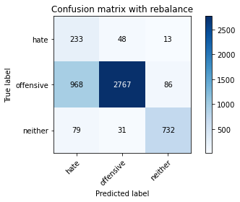

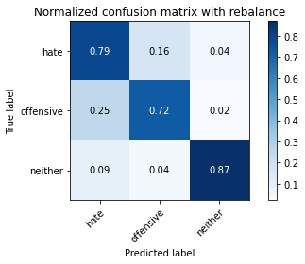

precision recall f1-score support

hate 0.18 0.79 0.30 294

offensive 0.97 0.72 0.83 3821

neither 0.88 0.87 0.88 842

accuracy 0.75 4957

macro avg 0.68 0.80 0.67 4957

weighted avg 0.91 0.75 0.81 4957

average eval_loss: 1.1968157328327276, accuracy: 0.7528747226144845

2 run

training 1 epoch...

63.6621253490448 seconds used......

1 training finished! average train loss: 0.6474798176633684

evaluating...

Confusion matrix, without normalization

[[ 245 26 23]

[1644 2049 128]

[ 76 9 757]]

Normalized confusion matrix

[[0.83333333 0.08843537 0.07823129]

[0.43025386 0.53624706 0.03349908]

[0.09026128 0.01068884 0.89904988]]

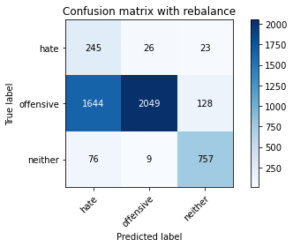

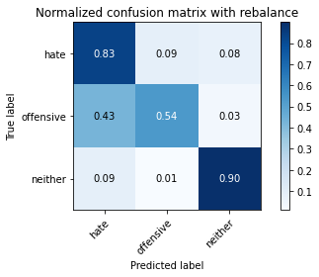

precision recall f1-score support

hate 0.12 0.83 0.22 294

offensive 0.98 0.54 0.69 3821

neither 0.83 0.90 0.87 842

accuracy 0.62 4957

macro avg 0.65 0.76 0.59 4957

weighted avg 0.91 0.62 0.69 4957

average eval_loss: 0.7682533599436283, accuracy: 0.6154932418801694

training 2 epoch...

63.64133977890015 seconds used......

2 training finished! average train loss: 0.3630189243377301

evaluating...

Confusion matrix, without normalization

[[ 231 35 28]

[ 904 2725 192]

[ 41 6 795]]

Normalized confusion matrix

[[0.78571429 0.11904762 0.0952381 ]

[0.23658728 0.71316409 0.05024863]

[0.04869359 0.00712589 0.94418052]]

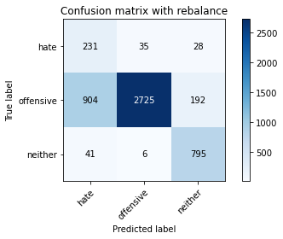

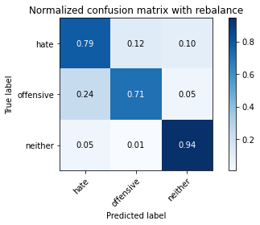

precision recall f1-score support

hate 0.20 0.79 0.31 294

offensive 0.99 0.71 0.83 3821

neither 0.78 0.94 0.86 842

accuracy 0.76 4957

macro avg 0.65 0.81 0.67 4957

weighted avg 0.90 0.76 0.80 4957

average eval_loss: 0.5575272382927998, accuracy: 0.756707686100464

training 3 epoch...

63.58547878265381 seconds used......

3 training finished! average train loss: 0.23455189780620803

evaluating...

Confusion matrix, without normalization

[[ 248 30 16]

[1250 2473 98]

[ 85 11 746]]

Normalized confusion matrix

[[0.84353741 0.10204082 0.05442177]

[0.32713949 0.64721277 0.02564774]

[0.10095012 0.01306413 0.88598575]]

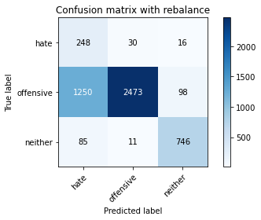

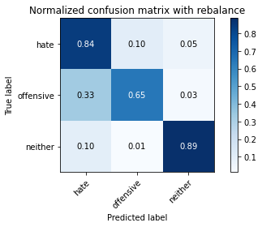

precision recall f1-score support

hate 0.16 0.84 0.26 294

offensive 0.98 0.65 0.78 3821

neither 0.87 0.89 0.88 842

accuracy 0.70 4957

macro avg 0.67 0.79 0.64 4957

weighted avg 0.91 0.70 0.77 4957

average eval_loss: 0.6850235736177813, accuracy: 0.6994149687310873

training 4 epoch...

63.71746349334717 seconds used......

4 training finished! average train loss: 0.1535717531091027

evaluating...

Confusion matrix, without normalization

[[ 227 38 29]

[ 892 2789 140]

[ 38 22 782]]

Normalized confusion matrix

[[0.77210884 0.1292517 0.09863946]

[0.23344674 0.72991364 0.03663962]

[0.04513064 0.02612827 0.92874109]]

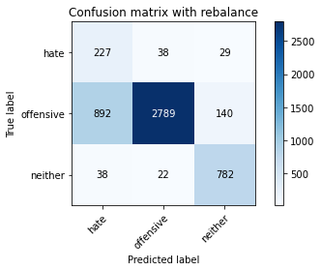

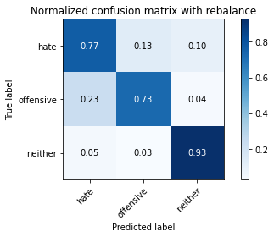

precision recall f1-score support

hate 0.20 0.77 0.31 294

offensive 0.98 0.73 0.84 3821

neither 0.82 0.93 0.87 842

accuracy 0.77 4957

macro avg 0.67 0.81 0.67 4957

weighted avg 0.91 0.77 0.81 4957

average eval_loss: 0.6011822171689521, accuracy: 0.7661892273552552

training 5 epoch...

63.74262094497681 seconds used......

5 training finished! average train loss: 0.09045261294956793

evaluating...

Confusion matrix, without normalization

[[ 231 38 25]

[ 883 2813 125]

[ 56 17 769]]

Normalized confusion matrix

[[0.78571429 0.1292517 0.08503401]

[0.23109134 0.73619471 0.03271395]

[0.06650831 0.02019002 0.91330166]]

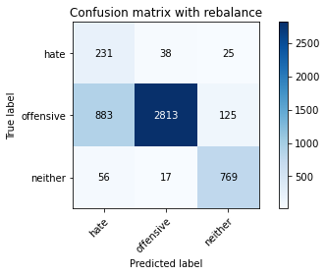

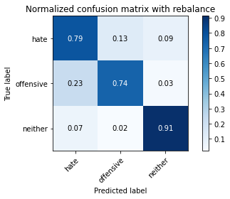

precision recall f1-score support

hate 0.20 0.79 0.32 294

offensive 0.98 0.74 0.84 3821

neither 0.84 0.91 0.87 842

accuracy 0.77 4957

macro avg 0.67 0.81 0.68 4957

weighted avg 0.91 0.77 0.82 4957

average eval_loss: 0.7720072399824858, accuracy: 0.7692152511599758

training 6 epoch...

63.690884590148926 seconds used......

6 training finished! average train loss: 0.06891885324114422

evaluating...

Confusion matrix, without normalization

[[ 213 63 18]

[ 698 3023 100]

[ 48 44 750]]

Normalized confusion matrix

[[0.7244898 0.21428571 0.06122449]

[0.18267469 0.79115415 0.02617116]

[0.05700713 0.05225653 0.89073634]]

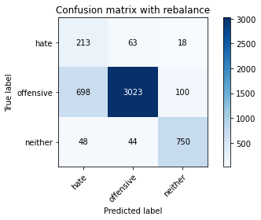

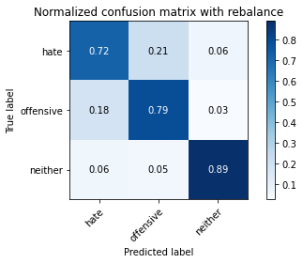

precision recall f1-score support

hate 0.22 0.72 0.34 294

offensive 0.97 0.79 0.87 3821

neither 0.86 0.89 0.88 842

accuracy 0.80 4957

macro avg 0.68 0.80 0.70 4957

weighted avg 0.90 0.80 0.84 4957

average eval_loss: 0.600152657502481, accuracy: 0.80411539237442

training 7 epoch...

63.71832227706909 seconds used......

7 training finished! average train loss: 0.038119534234113295

evaluating...

Confusion matrix, without normalization

[[ 224 54 16]

[ 872 2859 90]

[ 74 37 731]]

Normalized confusion matrix

[[0.76190476 0.18367347 0.05442177]

[0.22821251 0.74823345 0.02355404]

[0.08788599 0.04394299 0.86817102]]

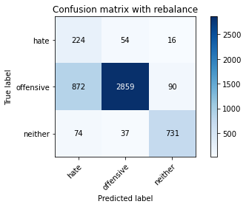

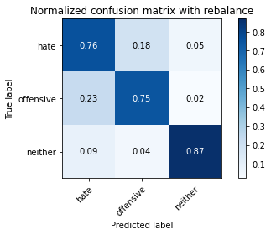

precision recall f1-score support

hate 0.19 0.76 0.31 294

offensive 0.97 0.75 0.84 3821

neither 0.87 0.87 0.87 842

accuracy 0.77 4957

macro avg 0.68 0.79 0.67 4957

weighted avg 0.91 0.77 0.82 4957

average eval_loss: 0.9396232055319894, accuracy: 0.7694169860802905

training 8 epoch...

63.77209782600403 seconds used......

8 training finished! average train loss: 0.029324116199604122

evaluating...

Confusion matrix, without normalization

[[ 218 44 32]

[ 951 2719 151]

[ 47 22 773]]

Normalized confusion matrix

[[0.7414966 0.14965986 0.10884354]

[0.24888773 0.71159382 0.03951845]

[0.05581948 0.02612827 0.91805226]]

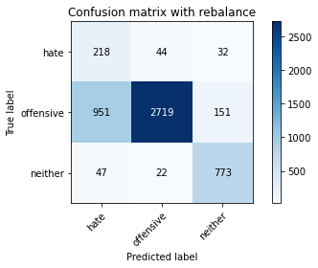

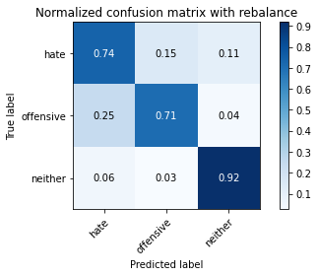

precision recall f1-score support

hate 0.18 0.74 0.29 294

offensive 0.98 0.71 0.82 3821

neither 0.81 0.92 0.86 842

accuracy 0.75 4957

macro avg 0.65 0.79 0.66 4957

weighted avg 0.90 0.75 0.80 4957

average eval_loss: 1.0015750765995752, accuracy: 0.7484365543675611

training 9 epoch...

63.72862243652344 seconds used......

9 training finished! average train loss: 0.016804954568768325

evaluating...

Confusion matrix, without normalization

[[ 235 39 20]

[1054 2644 123]

[ 76 20 746]]

Normalized confusion matrix

[[0.79931973 0.13265306 0.06802721]

[0.27584402 0.69196545 0.03219053]

[0.09026128 0.02375297 0.88598575]]

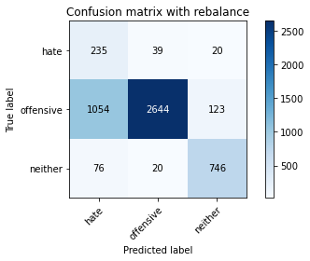

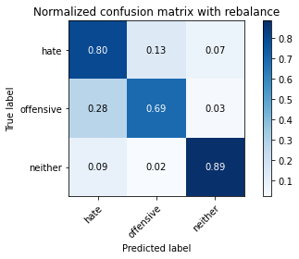

precision recall f1-score support

hate 0.17 0.80 0.28 294

offensive 0.98 0.69 0.81 3821

neither 0.84 0.89 0.86 842

accuracy 0.73 4957

macro avg 0.66 0.79 0.65 4957

weighted avg 0.91 0.73 0.79 4957

average eval_loss: 1.2461856605725423, accuracy: 0.731289086140811

training 10 epoch...

63.75211453437805 seconds used......

10 training finished! average train loss: 0.01689650904784137

evaluating...

Confusion matrix, without normalization

[[ 206 66 22]

[ 614 3100 107]

[ 42 46 754]]

Normalized confusion matrix

[[0.70068027 0.2244898 0.07482993]

[0.16069092 0.81130594 0.02800314]

[0.04988124 0.05463183 0.89548694]]

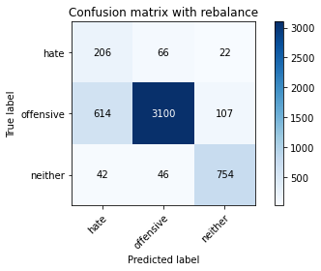

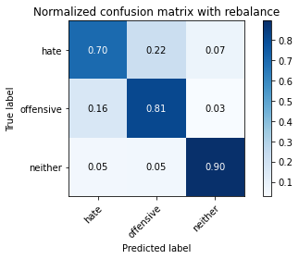

precision recall f1-score support

hate 0.24 0.70 0.36 294

offensive 0.97 0.81 0.88 3821

neither 0.85 0.90 0.87 842

accuracy 0.82 4957

macro avg 0.69 0.80 0.70 4957

weighted avg 0.90 0.82 0.85 4957

average eval_loss: 0.9104907081543182, accuracy: 0.8190437764777083

3 run

training 1 epoch...

63.728832960128784 seconds used......

1 training finished! average train loss: 0.6487567486644489

evaluating...

Confusion matrix, without normalization

[[ 248 34 12]

[ 980 2765 76]

[ 135 13 694]]

Normalized confusion matrix

[[0.84353741 0.11564626 0.04081633]

[0.25647736 0.72363256 0.01989008]

[0.16033254 0.01543943 0.82422803]]

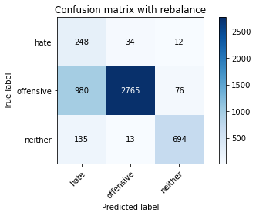

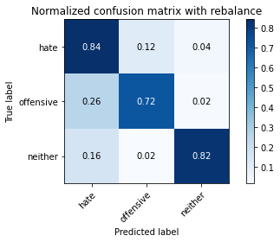

precision recall f1-score support

hate 0.18 0.84 0.30 294

offensive 0.98 0.72 0.83 3821

neither 0.89 0.82 0.85 842

accuracy 0.75 4957

macro avg 0.68 0.80 0.66 4957

weighted avg 0.92 0.75 0.81 4957

average eval_loss: 0.6148641357018102, accuracy: 0.7478313496066169

training 2 epoch...

63.793553829193115 seconds used......

2 training finished! average train loss: 0.35061224140444697

evaluating...

Confusion matrix, without normalization

[[ 227 48 19]

[ 760 2952 109]

[ 56 11 775]]

Normalized confusion matrix

[[0.77210884 0.16326531 0.06462585]

[0.19890081 0.77257262 0.02852656]

[0.06650831 0.01306413 0.92042755]]

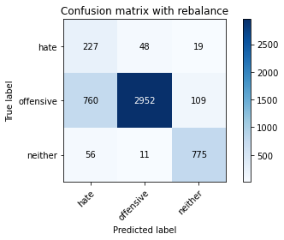

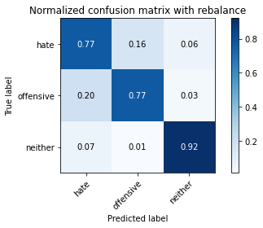

precision recall f1-score support

hate 0.22 0.77 0.34 294

offensive 0.98 0.77 0.86 3821

neither 0.86 0.92 0.89 842

accuracy 0.80 4957

macro avg 0.69 0.82 0.70 4957

weighted avg 0.91 0.80 0.84 4957

average eval_loss: 0.45432067371063656, accuracy: 0.7976598749243494

training 3 epoch...

63.79840397834778 seconds used......

3 training finished! average train loss: 0.22594174956194837

evaluating...

Confusion matrix, without normalization

[[ 241 37 16]

[1025 2694 102]

[ 84 17 741]]

Normalized confusion matrix

[[0.81972789 0.12585034 0.05442177]

[0.26825438 0.70505103 0.02669458]

[0.09976247 0.02019002 0.88004751]]

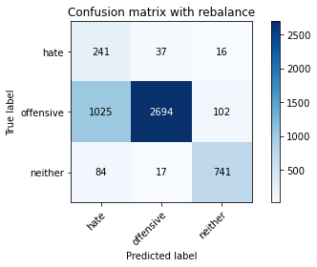

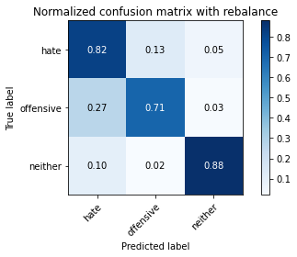

precision recall f1-score support

hate 0.18 0.82 0.29 294

offensive 0.98 0.71 0.82 3821

neither 0.86 0.88 0.87 842

accuracy 0.74 4957

macro avg 0.67 0.80 0.66 4957

weighted avg 0.91 0.74 0.80 4957

average eval_loss: 0.5778981518721388, accuracy: 0.741577567076861

training 4 epoch...

63.737332344055176 seconds used......

4 training finished! average train loss: 0.13688353534068978

evaluating...

Confusion matrix, without normalization

[[ 231 43 20]

[ 797 2911 113]

[ 72 20 750]]

Normalized confusion matrix

[[0.78571429 0.1462585 0.06802721]

[0.20858414 0.76184245 0.02957341]

[0.08551069 0.02375297 0.89073634]]

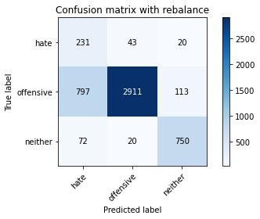

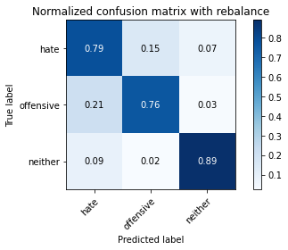

precision recall f1-score support

hate 0.21 0.79 0.33 294

offensive 0.98 0.76 0.86 3821

neither 0.85 0.89 0.87 842

accuracy 0.79 4957

macro avg 0.68 0.81 0.69 4957

weighted avg 0.91 0.79 0.83 4957

average eval_loss: 0.6228560841146616, accuracy: 0.7851523098648376

training 5 epoch...

63.767719984054565 seconds used......

5 training finished! average train loss: 0.09163128400809671

evaluating...

Confusion matrix, without normalization

[[ 234 38 22]

[ 921 2794 106]

[ 62 15 765]]

Normalized confusion matrix

[[0.79591837 0.1292517 0.07482993]

[0.24103638 0.73122219 0.02774143]

[0.0736342 0.01781473 0.90855107]]

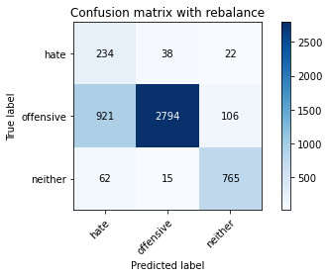

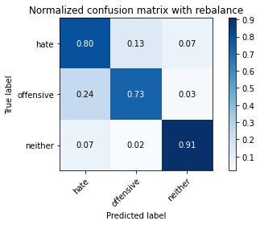

precision recall f1-score support

hate 0.19 0.80 0.31 294

offensive 0.98 0.73 0.84 3821

neither 0.86 0.91 0.88 842

accuracy 0.77 4957

macro avg 0.68 0.81 0.68 4957

weighted avg 0.91 0.77 0.81 4957

average eval_loss: 0.6919966853118592, accuracy: 0.7651805527536817

training 6 epoch...

63.832539796829224 seconds used......

6 training finished! average train loss: 0.06063687405004357

evaluating...

Confusion matrix, without normalization

[[ 244 37 13]

[1130 2618 73]

[ 108 33 701]]

Normalized confusion matrix

[[0.82993197 0.12585034 0.04421769]

[0.2957341 0.68516095 0.01910495]

[0.12826603 0.0391924 0.83254157]]

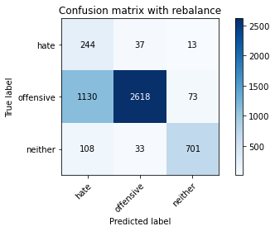

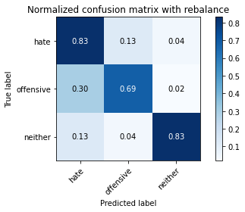

precision recall f1-score support

hate 0.16 0.83 0.27 294

offensive 0.97 0.69 0.80 3821

neither 0.89 0.83 0.86 842

accuracy 0.72 4957

macro avg 0.68 0.78 0.65 4957

weighted avg 0.91 0.72 0.78 4957

average eval_loss: 1.0399025205012051, accuracy: 0.7187815210812992

training 7 epoch...

63.746530055999756 seconds used......

7 training finished! average train loss: 0.029602104375868687

evaluating...

Confusion matrix, without normalization

[[ 233 50 11]

[ 805 2956 60]

[ 98 56 688]]

Normalized confusion matrix

[[0.79251701 0.17006803 0.03741497]

[0.21067783 0.77361947 0.0157027 ]

[0.11638955 0.06650831 0.81710214]]

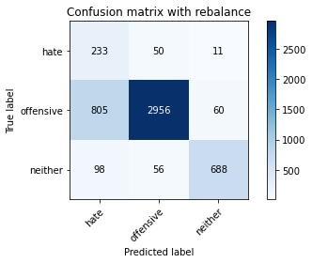

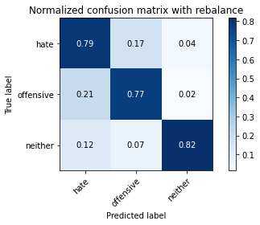

precision recall f1-score support

hate 0.21 0.79 0.33 294

offensive 0.97 0.77 0.86 3821

neither 0.91 0.82 0.86 842

accuracy 0.78 4957

macro avg 0.69 0.79 0.68 4957

weighted avg 0.91 0.78 0.83 4957

average eval_loss: 1.0218295477736261, accuracy: 0.782126286060117

training 8 epoch...

63.76296257972717 seconds used......

8 training finished! average train loss: 0.031497131154888815

evaluating...

Confusion matrix, without normalization

[[ 201 75 18]

[ 592 3129 100]

[ 45 38 759]]

Normalized confusion matrix

[[0.68367347 0.25510204 0.06122449]

[0.15493326 0.81889558 0.02617116]

[0.05344418 0.04513064 0.90142518]]

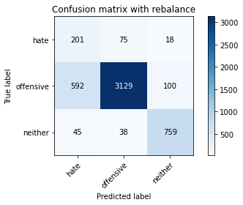

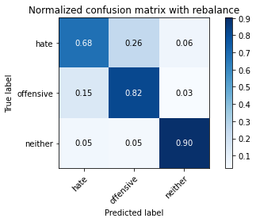

precision recall f1-score support

hate 0.24 0.68 0.36 294

offensive 0.97 0.82 0.89 3821

neither 0.87 0.90 0.88 842

accuracy 0.82 4957

macro avg 0.69 0.80 0.71 4957

weighted avg 0.91 0.82 0.85 4957

average eval_loss: 0.765889938590267, accuracy: 0.8248940891668348

training 9 epoch...

63.76690936088562 seconds used......

9 training finished! average train loss: 0.016960840982184828

evaluating...

Confusion matrix, without normalization

[[ 222 55 17]

[ 791 2946 84]

[ 72 39 731]]

Normalized confusion matrix

[[0.75510204 0.18707483 0.05782313]

[0.20701387 0.77100236 0.02198377]

[0.08551069 0.04631829 0.86817102]]

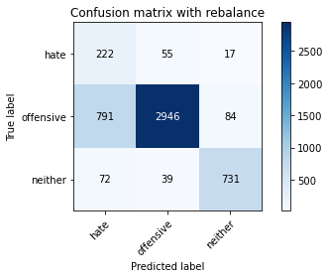

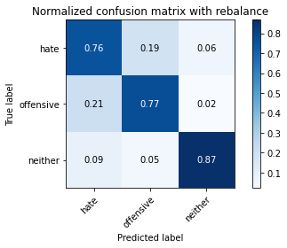

precision recall f1-score support

hate 0.20 0.76 0.32 294

offensive 0.97 0.77 0.86 3821

neither 0.88 0.87 0.87 842

accuracy 0.79 4957

macro avg 0.68 0.80 0.68 4957

weighted avg 0.91 0.79 0.83 4957

average eval_loss: 0.9942650625805161, accuracy: 0.7865644543070406

training 10 epoch...

63.769959449768066 seconds used......

10 training finished! average train loss: 0.007923145803155878

evaluating...

Confusion matrix, without normalization

[[ 214 61 19]

[ 743 2997 81]

[ 70 38 734]]

Normalized confusion matrix

[[0.72789116 0.20748299 0.06462585]

[0.19445171 0.78434965 0.02119864]

[0.08313539 0.04513064 0.87173397]]

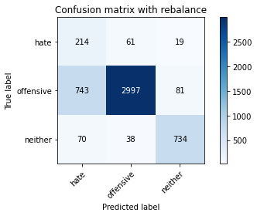

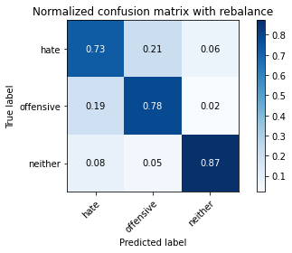

precision recall f1-score support

hate 0.21 0.73 0.32 294

offensive 0.97 0.78 0.87 3821

neither 0.88 0.87 0.88 842

accuracy 0.80 4957

macro avg 0.69 0.79 0.69 4957

weighted avg 0.91 0.80 0.84 4957

average eval_loss: 1.0025726099622496, accuracy: 0.795844260641517

4 run

training 1 epoch...

63.72601938247681 seconds used......

1 training finished! average train loss: 0.6224847528321004

evaluating...

Confusion matrix, without normalization

[[ 236 29 29]

[1118 2545 158]

[ 42 8 792]]

Normalized confusion matrix

[[0.80272109 0.09863946 0.09863946]

[0.29259356 0.66605601 0.04135043]

[0.04988124 0.00950119 0.94061758]]

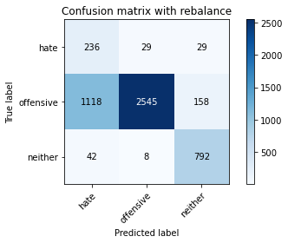

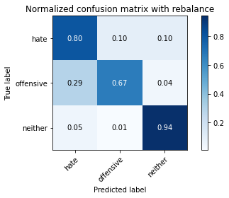

precision recall f1-score support

hate 0.17 0.80 0.28 294

offensive 0.99 0.67 0.79 3821

neither 0.81 0.94 0.87 842

accuracy 0.72 4957

macro avg 0.65 0.80 0.65 4957

weighted avg 0.91 0.72 0.78 4957

average eval_loss: 0.6023278923765305, accuracy: 0.7207988702844462

training 2 epoch...

63.73718070983887 seconds used......

2 training finished! average train loss: 0.3489721085854441

evaluating...

Confusion matrix, without normalization

[[ 255 29 10]

[1111 2618 92]

[ 91 10 741]]

Normalized confusion matrix

[[0.86734694 0.09863946 0.03401361]

[0.29076158 0.68516095 0.02407747]

[0.10807601 0.01187648 0.88004751]]

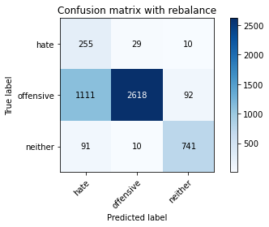

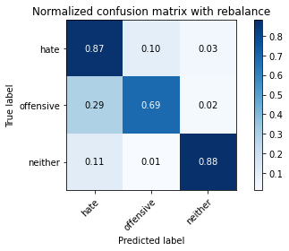

precision recall f1-score support

hate 0.18 0.87 0.29 294

offensive 0.99 0.69 0.81 3821

neither 0.88 0.88 0.88 842

accuracy 0.73 4957

macro avg 0.68 0.81 0.66 4957

weighted avg 0.92 0.73 0.79 4957

average eval_loss: 0.6148282377830436, accuracy: 0.7290700020173492

training 3 epoch...

63.82070469856262 seconds used......

3 training finished! average train loss: 0.2443735488412673

evaluating...

Confusion matrix, without normalization

[[ 250 32 12]

[1022 2699 100]

[ 112 12 718]]

Normalized confusion matrix

[[0.85034014 0.10884354 0.04081633]

[0.26746925 0.70635959 0.02617116]

[0.13301663 0.01425178 0.85273159]]

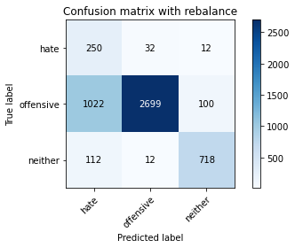

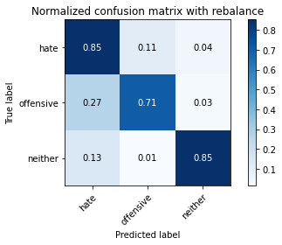

precision recall f1-score support

hate 0.18 0.85 0.30 294

offensive 0.98 0.71 0.82 3821

neither 0.87 0.85 0.86 842

accuracy 0.74 4957

macro avg 0.68 0.80 0.66 4957

weighted avg 0.92 0.74 0.80 4957

average eval_loss: 0.6261065906634734, accuracy: 0.7397619527940287

training 4 epoch...

63.72119617462158 seconds used......

4 training finished! average train loss: 0.14527447912733107

evaluating...

Confusion matrix, without normalization

[[ 245 37 12]

[1039 2698 84]

[ 94 23 725]]

Normalized confusion matrix

[[0.83333333 0.12585034 0.04081633]

[0.27191835 0.70609788 0.02198377]

[0.11163895 0.02731591 0.86104513]]

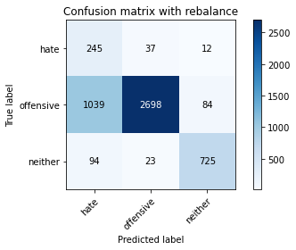

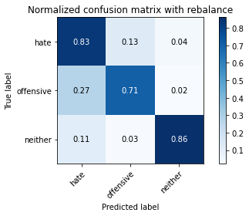

precision recall f1-score support

hate 0.18 0.83 0.29 294

offensive 0.98 0.71 0.82 3821

neither 0.88 0.86 0.87 842

accuracy 0.74 4957

macro avg 0.68 0.80 0.66 4957

weighted avg 0.91 0.74 0.80 4957

average eval_loss: 0.7063563277554368, accuracy: 0.7399636877143434

training 5 epoch...

63.688244581222534 seconds used......

5 training finished! average train loss: 0.09367212021385717

evaluating...

Confusion matrix, without normalization

[[ 234 39 21]

[ 883 2824 114]

[ 66 17 759]]

Normalized confusion matrix

[[0.79591837 0.13265306 0.07142857]

[0.23109134 0.73907354 0.02983512]

[0.0783848 0.02019002 0.90142518]]

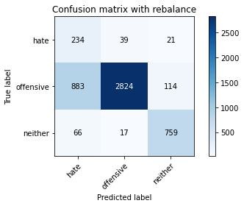

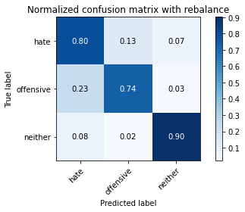

precision recall f1-score support

hate 0.20 0.80 0.32 294

offensive 0.98 0.74 0.84 3821

neither 0.85 0.90 0.87 842

accuracy 0.77 4957

macro avg 0.68 0.81 0.68 4957

weighted avg 0.91 0.77 0.82 4957

average eval_loss: 0.7025950448587537, accuracy: 0.7700221908412346

training 6 epoch...

63.684619426727295 seconds used......

6 training finished! average train loss: 0.06322524335837176

evaluating...

Confusion matrix, without normalization

[[ 246 37 11]

[1115 2628 78]

[ 111 38 693]]

Normalized confusion matrix

[[0.83673469 0.12585034 0.03741497]

[0.29180843 0.68777807 0.0204135 ]

[0.13182898 0.04513064 0.82304038]]

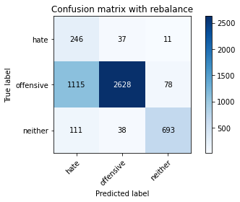

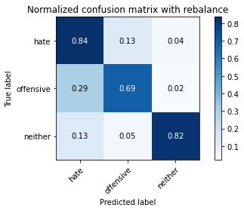

precision recall f1-score support

hate 0.17 0.84 0.28 294

offensive 0.97 0.69 0.81 3821

neither 0.89 0.82 0.85 842

accuracy 0.72 4957

macro avg 0.68 0.78 0.65 4957

weighted avg 0.91 0.72 0.78 4957

average eval_loss: 0.9734804170025934, accuracy: 0.719588460762558

training 7 epoch...

63.74619007110596 seconds used......

7 training finished! average train loss: 0.04153542941618624

evaluating...

Confusion matrix, without normalization

[[ 228 49 17]

[ 800 2929 92]

[ 66 34 742]]

Normalized confusion matrix

[[0.7755102 0.16666667 0.05782313]

[0.20936928 0.76655326 0.02407747]

[0.0783848 0.04038005 0.88123515]]

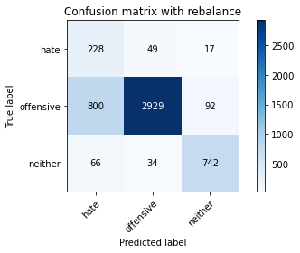

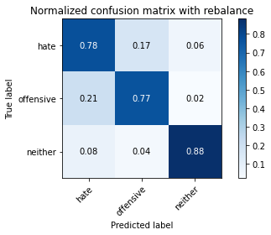

precision recall f1-score support

hate 0.21 0.78 0.33 294

offensive 0.97 0.77 0.86 3821

neither 0.87 0.88 0.88 842

accuracy 0.79 4957

macro avg 0.68 0.81 0.69 4957

weighted avg 0.91 0.79 0.83 4957

average eval_loss: 0.7903214500495984, accuracy: 0.7865644543070406

training 8 epoch...

63.71484136581421 seconds used......

8 training finished! average train loss: 0.026833762461728042

evaluating...

Confusion matrix, without normalization

[[ 233 49 12]

[ 794 2958 69]

[ 109 54 679]]

Normalized confusion matrix

[[0.79251701 0.16666667 0.04081633]

[0.20779901 0.77414289 0.0180581 ]

[0.12945368 0.06413302 0.8064133 ]]

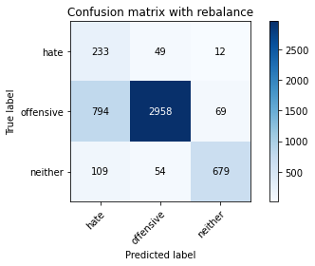

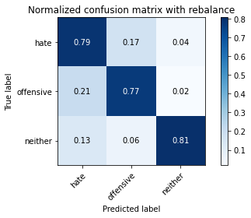

precision recall f1-score support

hate 0.21 0.79 0.33 294

offensive 0.97 0.77 0.86 3821

neither 0.89 0.81 0.85 842

accuracy 0.78 4957

macro avg 0.69 0.79 0.68 4957

weighted avg 0.91 0.78 0.83 4957

average eval_loss: 1.0273195444080498, accuracy: 0.7807141416179141

training 9 epoch...

63.765392780303955 seconds used......

9 training finished! average train loss: 0.022990249515012755

evaluating...

Confusion matrix, without normalization

[[ 236 46 12]

[1130 2548 143]

[ 101 63 678]]

Normalized confusion matrix

[[0.80272109 0.15646259 0.04081633]

[0.2957341 0.66684114 0.03742476]

[0.11995249 0.07482185 0.80522565]]

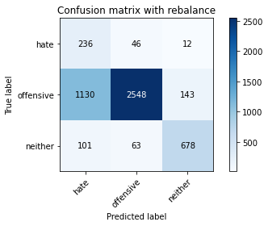

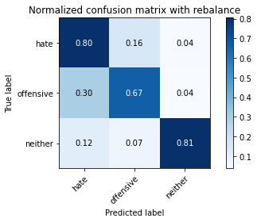

precision recall f1-score support

hate 0.16 0.80 0.27 294

offensive 0.96 0.67 0.79 3821

neither 0.81 0.81 0.81 842

accuracy 0.70 4957

macro avg 0.64 0.76 0.62 4957

weighted avg 0.89 0.70 0.76 4957

average eval_loss: 1.3427957696239314, accuracy: 0.6984062941295138

training 10 epoch...

63.746901750564575 seconds used......

10 training finished! average train loss: 0.030079920518338646

evaluating...

Confusion matrix, without normalization

[[ 227 49 18]

[ 759 2954 108]

[ 60 35 747]]

Normalized confusion matrix

[[0.77210884 0.16666667 0.06122449]

[0.1986391 0.77309605 0.02826485]

[0.07125891 0.0415677 0.8871734 ]]

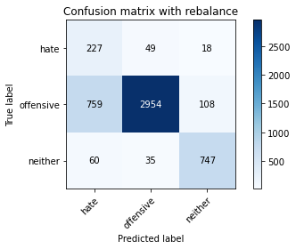

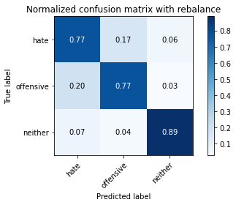

precision recall f1-score support

hate 0.22 0.77 0.34 294

offensive 0.97 0.77 0.86 3821

neither 0.86 0.89 0.87 842

accuracy 0.79 4957

macro avg 0.68 0.81 0.69 4957

weighted avg 0.91 0.79 0.83 4957

average eval_loss: 1.0223178084706888, accuracy: 0.7924147669961671

5 run

training 1 epoch...

63.6947762966156 seconds used......

1 training finished! average train loss: 0.6359633815567396

evaluating...

Confusion matrix, without normalization

[[ 236 28 30]

[1283 2398 140]

[ 30 9 803]]

Normalized confusion matrix

[[0.80272109 0.0952381 0.10204082]

[0.33577597 0.6275844 0.03663962]

[0.03562945 0.01068884 0.95368171]]

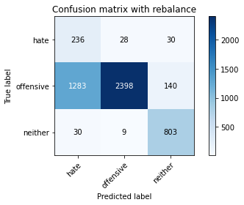

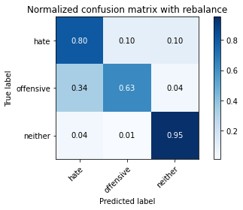

precision recall f1-score support

hate 0.15 0.80 0.26 294

offensive 0.98 0.63 0.77 3821

neither 0.83 0.95 0.88 842

accuracy 0.69 4957

macro avg 0.65 0.79 0.64 4957

weighted avg 0.91 0.69 0.76 4957

average eval_loss: 0.666183914448465, accuracy: 0.6933629211216461

training 2 epoch...

63.74279165267944 seconds used......

2 training finished! average train loss: 0.3550953387516981

evaluating...

Confusion matrix, without normalization

[[ 245 31 18]

[1119 2593 109]

[ 70 9 763]]

Normalized confusion matrix

[[0.83333333 0.10544218 0.06122449]

[0.29285527 0.67861816 0.02852656]

[0.08313539 0.01068884 0.90617577]]

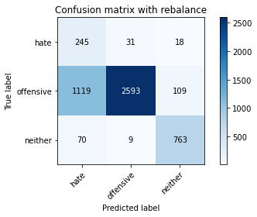

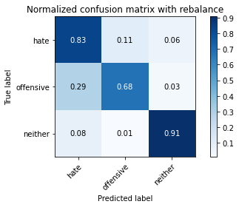

precision recall f1-score support

hate 0.17 0.83 0.28 294

offensive 0.98 0.68 0.80 3821

neither 0.86 0.91 0.88 842

accuracy 0.73 4957

macro avg 0.67 0.81 0.66 4957

weighted avg 0.91 0.73 0.79 4957

average eval_loss: 0.562941797678509, accuracy: 0.726447448053258

training 3 epoch...

63.69023299217224 seconds used......

3 training finished! average train loss: 0.23921474603097342

evaluating...

Confusion matrix, without normalization

[[ 241 33 20]

[1027 2667 127]

[ 52 10 780]]

Normalized confusion matrix

[[0.81972789 0.1122449 0.06802721]

[0.26877781 0.69798482 0.03323737]

[0.06175772 0.01187648 0.9263658 ]]

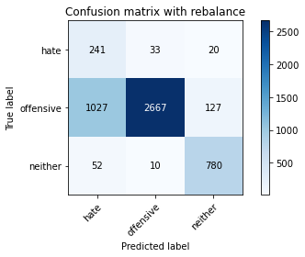

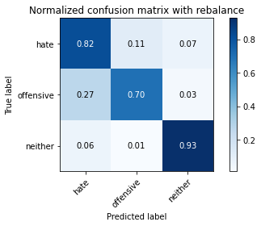

precision recall f1-score support

hate 0.18 0.82 0.30 294

offensive 0.98 0.70 0.82 3821

neither 0.84 0.93 0.88 842

accuracy 0.74 4957

macro avg 0.67 0.81 0.67 4957

weighted avg 0.91 0.74 0.80 4957

average eval_loss: 0.5776097815363638, accuracy: 0.7439983861206375

training 4 epoch...

63.745887994766235 seconds used......

4 training finished! average train loss: 0.15964769452200298

evaluating...

Confusion matrix, without normalization

[[ 238 34 22]

[1038 2641 142]

[ 51 10 781]]

Normalized confusion matrix

[[0.80952381 0.11564626 0.07482993]

[0.27165663 0.69118032 0.03716305]

[0.06057007 0.01187648 0.92755344]]

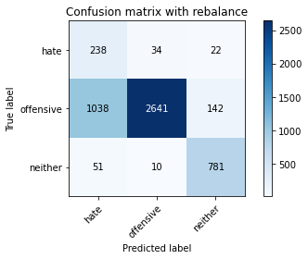

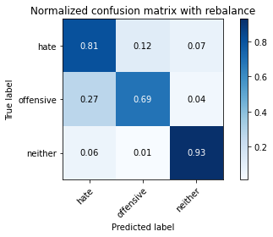

precision recall f1-score support

hate 0.18 0.81 0.29 294

offensive 0.98 0.69 0.81 3821

neither 0.83 0.93 0.87 842

accuracy 0.74 4957

macro avg 0.66 0.81 0.66 4957

weighted avg 0.91 0.74 0.79 4957

average eval_loss: 0.7471942712868294, accuracy: 0.7383498083518257

training 5 epoch...

63.73129105567932 seconds used......

5 training finished! average train loss: 0.09806885677852739

evaluating...

Confusion matrix, without normalization

[[ 239 38 17]

[1047 2675 99]

[ 77 21 744]]

Normalized confusion matrix

[[0.81292517 0.1292517 0.05782313]

[0.27401204 0.70007851 0.02590945]

[0.09144893 0.02494062 0.88361045]]

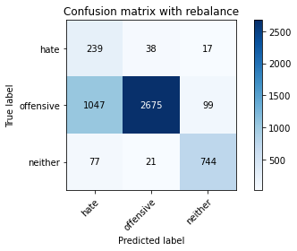

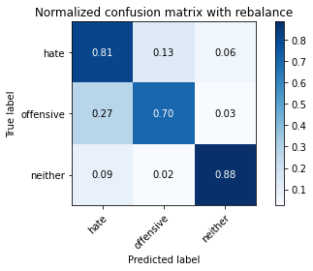

precision recall f1-score support

hate 0.18 0.81 0.29 294

offensive 0.98 0.70 0.82 3821

neither 0.87 0.88 0.87 842

accuracy 0.74 4957

macro avg 0.67 0.80 0.66 4957

weighted avg 0.91 0.74 0.79 4957

average eval_loss: 0.8031218076845811, accuracy: 0.7379463385111963

training 6 epoch...

63.79562211036682 seconds used......

6 training finished! average train loss: 0.06771584933117163

evaluating...

Confusion matrix, without normalization

[[ 220 48 26]

[ 760 2927 134]

[ 39 13 790]]

Normalized confusion matrix

[[0.74829932 0.16326531 0.08843537]

[0.19890081 0.76602984 0.03506935]

[0.04631829 0.01543943 0.93824228]]

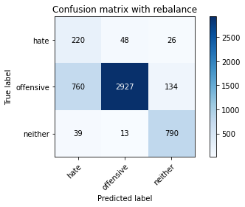

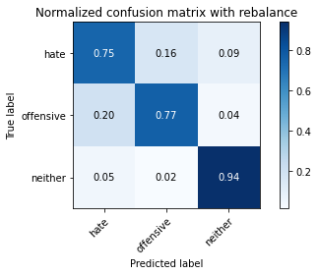

precision recall f1-score support

hate 0.22 0.75 0.34 294

offensive 0.98 0.77 0.86 3821

neither 0.83 0.94 0.88 842

accuracy 0.79 4957

macro avg 0.68 0.82 0.69 4957

weighted avg 0.91 0.79 0.83 4957

average eval_loss: 0.7528663928800773, accuracy: 0.7942303812789994

training 7 epoch...

63.66695046424866 seconds used......

7 training finished! average train loss: 0.03909228333818034

evaluating...

Confusion matrix, without normalization

[[ 236 44 14]

[ 882 2832 107]

[ 71 21 750]]

Normalized confusion matrix

[[0.80272109 0.14965986 0.04761905]

[0.23082963 0.74116723 0.02800314]

[0.08432304 0.02494062 0.89073634]]

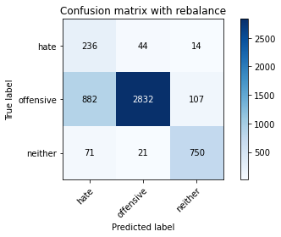

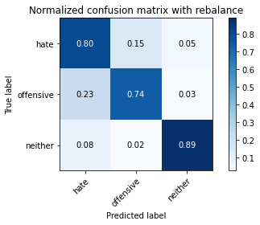

precision recall f1-score support

hate 0.20 0.80 0.32 294

offensive 0.98 0.74 0.84 3821

neither 0.86 0.89 0.88 842

accuracy 0.77 4957

macro avg 0.68 0.81 0.68 4957

weighted avg 0.91 0.77 0.82 4957

average eval_loss: 1.002594021051341, accuracy: 0.7702239257615493

training 8 epoch...

63.67915654182434 seconds used......

8 training finished! average train loss: 0.03627732398304326

evaluating...

Confusion matrix, without normalization

[[ 219 58 17]

[ 715 2984 122]

[ 46 27 769]]

Normalized confusion matrix

[[0.74489796 0.19727891 0.05782313]

[0.18712379 0.7809474 0.03192881]

[0.05463183 0.03206651 0.91330166]]

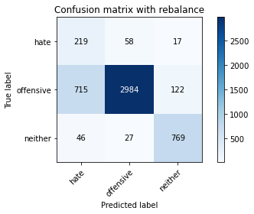

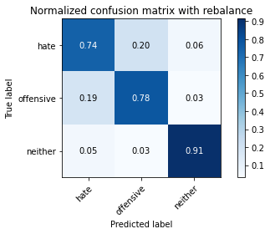

precision recall f1-score support

hate 0.22 0.74 0.34 294

offensive 0.97 0.78 0.87 3821

neither 0.85 0.91 0.88 842

accuracy 0.80 4957

macro avg 0.68 0.81 0.70 4957

weighted avg 0.91 0.80 0.84 4957

average eval_loss: 0.8812598410300017, accuracy: 0.8012911034900141

training 9 epoch...

63.77710938453674 seconds used......

9 training finished! average train loss: 0.017473602928193995

evaluating...

Confusion matrix, without normalization

[[ 230 49 15]

[ 845 2847 129]

[ 57 19 766]]

Normalized confusion matrix

[[0.78231293 0.16666667 0.05102041]

[0.2211463 0.74509291 0.0337608 ]

[0.06769596 0.02256532 0.90973872]]

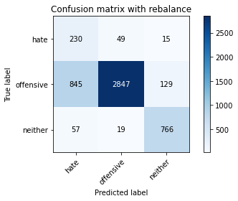

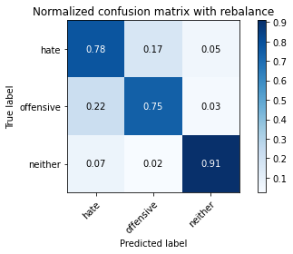

precision recall f1-score support

hate 0.20 0.78 0.32 294

offensive 0.98 0.75 0.85 3821

neither 0.84 0.91 0.87 842

accuracy 0.78 4957

macro avg 0.67 0.81 0.68 4957

weighted avg 0.91 0.78 0.82 4957

average eval_loss: 1.031378430753736, accuracy: 0.775267298769417

training 10 epoch...

63.73985242843628 seconds used......

10 training finished! average train loss: 0.009852581404725481

evaluating...

Confusion matrix, without normalization

[[ 208 66 20]

[ 625 3048 148]

[ 34 18 790]]

Normalized confusion matrix

[[0.70748299 0.2244898 0.06802721]

[0.16356975 0.79769694 0.03873332]

[0.04038005 0.02137767 0.93824228]]

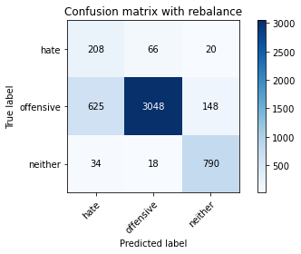

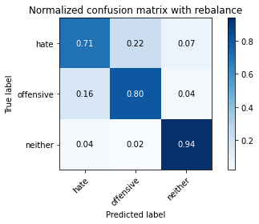

precision recall f1-score support

hate 0.24 0.71 0.36 294

offensive 0.97 0.80 0.88 3821

neither 0.82 0.94 0.88 842

accuracy 0.82 4957

macro avg 0.68 0.81 0.70 4957

weighted avg 0.90 0.82 0.85 4957

average eval_loss: 0.9675267758674079, accuracy: 0.8162194875933024