1 run

[1.5,0.5,1]

training 1 epoch...

64.69896173477173 seconds used......

1 training finished! average train loss: 0.5961903839954856

evaluating...

Confusion matrix, without normalization

[[ 225 29 40]

[ 978 2643 200]

[ 24 10 808]]

Normalized confusion matrix

[[0.76530612 0.09863946 0.13605442]

[0.25595394 0.69170374 0.05234232]

[0.02850356 0.01187648 0.95961995]]

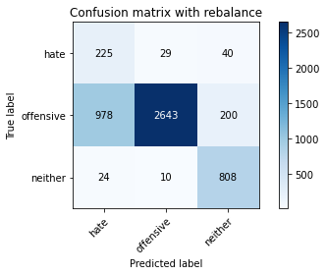

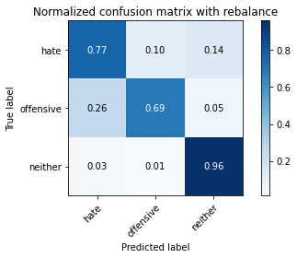

precision recall f1-score support

hate 0.18 0.77 0.30 294

offensive 0.99 0.69 0.81 3821

neither 0.77 0.96 0.86 842

accuracy 0.74 4957

macro avg 0.65 0.81 0.65 4957

weighted avg 0.90 0.74 0.79 4957

average eval_loss: 0.5798934115878036, accuracy: 0.741577567076861

training 2 epoch...

64.08116173744202 seconds used......

2 training finished! average train loss: 0.3445296653530054

evaluating...

Confusion matrix, without normalization

[[ 232 33 29]

[1024 2640 157]

[ 42 7 793]]

Normalized confusion matrix

[[0.78911565 0.1122449 0.09863946]

[0.26799267 0.69091861 0.04108872]

[0.04988124 0.00831354 0.94180523]]

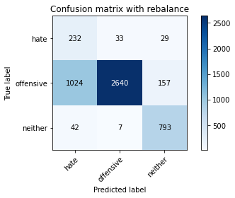

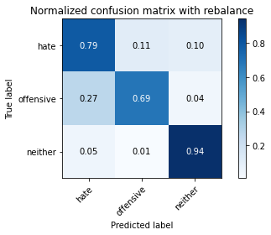

precision recall f1-score support

hate 0.18 0.79 0.29 294

offensive 0.99 0.69 0.81 3821

neither 0.81 0.94 0.87 842

accuracy 0.74 4957

macro avg 0.66 0.81 0.66 4957

weighted avg 0.91 0.74 0.79 4957

average eval_loss: 0.6227007373686759, accuracy: 0.7393584829533992

training 3 epoch...

64.02006149291992 seconds used......

3 training finished! average train loss: 0.23458326615567443

evaluating...

Confusion matrix, without normalization

[[ 242 29 23]

[1104 2569 148]

[ 60 8 774]]

Normalized confusion matrix

[[0.82312925 0.09863946 0.07823129]

[0.2889296 0.67233708 0.03873332]

[0.07125891 0.00950119 0.9192399 ]]

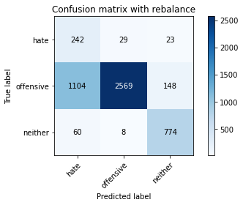

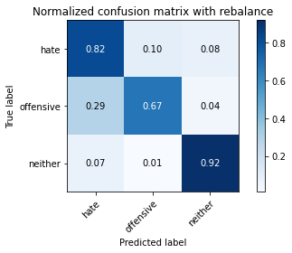

precision recall f1-score support

hate 0.17 0.82 0.28 294

offensive 0.99 0.67 0.80 3821

neither 0.82 0.92 0.87 842

accuracy 0.72 4957

macro avg 0.66 0.80 0.65 4957

weighted avg 0.91 0.72 0.78 4957

average eval_loss: 0.6435976025738543, accuracy: 0.7232196893282227

training 4 epoch...

64.11737990379333 seconds used......

4 training finished! average train loss: 0.1497115508724026

evaluating...

Confusion matrix, without normalization

[[ 224 46 24]

[ 787 2873 161]

[ 57 6 779]]

Normalized confusion matrix

[[0.76190476 0.15646259 0.08163265]

[0.20596702 0.75189741 0.04213557]

[0.06769596 0.00712589 0.92517815]]

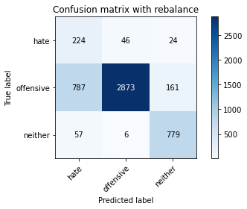

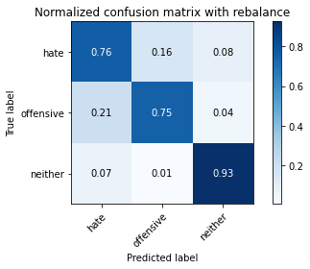

precision recall f1-score support

hate 0.21 0.76 0.33 294

offensive 0.98 0.75 0.85 3821

neither 0.81 0.93 0.86 842

accuracy 0.78 4957

macro avg 0.67 0.81 0.68 4957

weighted avg 0.91 0.78 0.82 4957

average eval_loss: 0.634520550453735, accuracy: 0.7819245511398023

training 5 epoch...

64.10507106781006 seconds used......

5 training finished! average train loss: 0.1037211942470126

evaluating...

Confusion matrix, without normalization

[[ 227 45 22]

[ 789 2918 114]

[ 49 22 771]]

Normalized confusion matrix

[[0.77210884 0.15306122 0.07482993]

[0.20649045 0.76367443 0.02983512]

[0.05819477 0.02612827 0.91567696]]

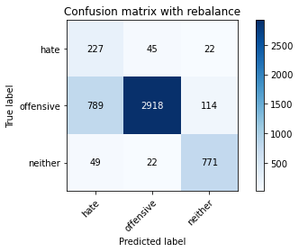

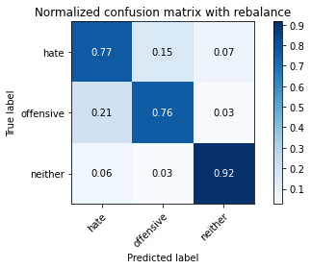

precision recall f1-score support

hate 0.21 0.77 0.33 294

offensive 0.98 0.76 0.86 3821

neither 0.85 0.92 0.88 842

accuracy 0.79 4957

macro avg 0.68 0.82 0.69 4957

weighted avg 0.91 0.79 0.83 4957

average eval_loss: 0.6309440238551507, accuracy: 0.7899939479523905

training 6 epoch...

64.0845582485199 seconds used......

6 training finished! average train loss: 0.07388817456044387

evaluating...

Confusion matrix, without normalization

[[ 234 47 13]

[ 914 2820 87]

[ 86 29 727]]

Normalized confusion matrix

[[0.79591837 0.15986395 0.04421769]

[0.2392044 0.73802669 0.02276891]

[0.10213777 0.03444181 0.86342043]]

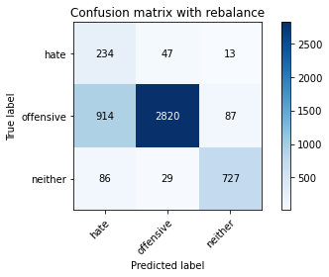

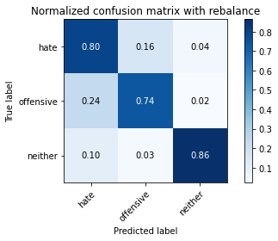

precision recall f1-score support

hate 0.19 0.80 0.31 294

offensive 0.97 0.74 0.84 3821

neither 0.88 0.86 0.87 842

accuracy 0.76 4957

macro avg 0.68 0.80 0.67 4957

weighted avg 0.91 0.76 0.81 4957

average eval_loss: 0.799038175869012, accuracy: 0.7627597337099051

training 7 epoch...

64.02754282951355 seconds used......

7 training finished! average train loss: 0.05232384176489118

evaluating...

Confusion matrix, without normalization

[[ 208 65 21]

[ 644 3068 109]

[ 56 26 760]]

Normalized confusion matrix

[[0.70748299 0.22108844 0.07142857]

[0.16854227 0.80293117 0.02852656]

[0.06650831 0.03087886 0.90261283]]

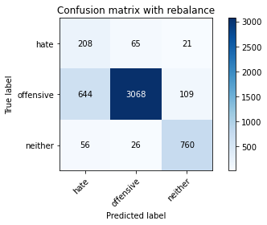

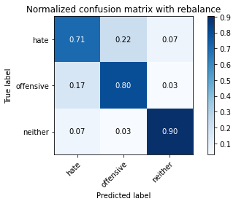

precision recall f1-score support

hate 0.23 0.71 0.35 294

offensive 0.97 0.80 0.88 3821

neither 0.85 0.90 0.88 842

accuracy 0.81 4957

macro avg 0.68 0.80 0.70 4957

weighted avg 0.91 0.81 0.85 4957

average eval_loss: 0.7516517289200677, accuracy: 0.8142021383901553

training 8 epoch...

63.947142362594604 seconds used......

8 training finished! average train loss: 0.02259484013033301

evaluating...

Confusion matrix, without normalization

[[ 243 36 15]

[1069 2655 97]

[ 79 15 748]]

Normalized confusion matrix

[[0.82653061 0.12244898 0.05102041]

[0.27976969 0.69484428 0.02538602]

[0.09382423 0.01781473 0.88836105]]

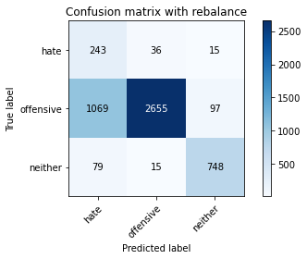

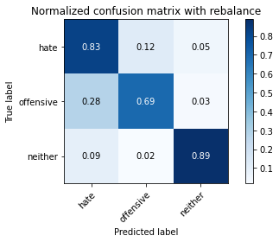

precision recall f1-score support

hate 0.17 0.83 0.29 294

offensive 0.98 0.69 0.81 3821

neither 0.87 0.89 0.88 842

accuracy 0.74 4957

macro avg 0.68 0.80 0.66 4957

weighted avg 0.91 0.74 0.79 4957

average eval_loss: 1.2091378862969577, accuracy: 0.7355255194674198

training 9 epoch...

63.97135519981384 seconds used......

9 training finished! average train loss: 0.022231560489108338

evaluating...

Confusion matrix, without normalization

[[ 222 56 16]

[ 759 2975 87]

[ 81 28 733]]

Normalized confusion matrix

[[0.75510204 0.19047619 0.05442177]

[0.1986391 0.77859199 0.02276891]

[0.09619952 0.03325416 0.87054632]]

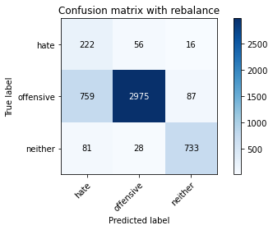

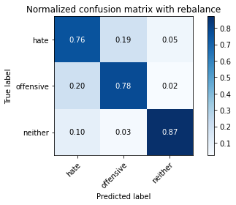

precision recall f1-score support

hate 0.21 0.76 0.33 294

offensive 0.97 0.78 0.86 3821

neither 0.88 0.87 0.87 842

accuracy 0.79 4957

macro avg 0.69 0.80 0.69 4957

weighted avg 0.91 0.79 0.83 4957

average eval_loss: 0.9758326713044587, accuracy: 0.7928182368367964

training 10 epoch...

64.03162097930908 seconds used......

10 training finished! average train loss: 0.022867576856872785

evaluating...

Confusion matrix, without normalization

[[ 207 67 20]

[ 608 3102 111]

[ 49 24 769]]

Normalized confusion matrix

[[0.70408163 0.22789116 0.06802721]

[0.15912065 0.81182936 0.02904999]

[0.05819477 0.02850356 0.91330166]]

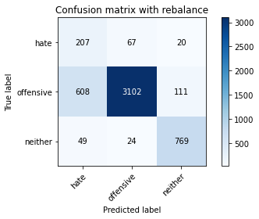

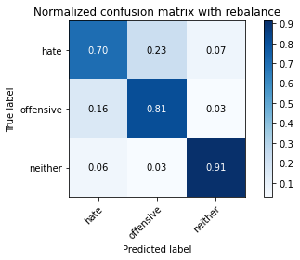

precision recall f1-score support

hate 0.24 0.70 0.36 294

offensive 0.97 0.81 0.88 3821

neither 0.85 0.91 0.88 842

accuracy 0.82 4957

macro avg 0.69 0.81 0.71 4957

weighted avg 0.91 0.82 0.85 4957

average eval_loss: 0.874124084942929, accuracy: 0.822675005043373

2 run

training 1 epoch...

63.95753479003906 seconds used......

1 training finished! average train loss: 0.6097557908087446

evaluating...

Confusion matrix, without normalization

[[ 239 40 15]

[ 874 2842 105]

[ 90 14 738]]

Normalized confusion matrix

[[0.81292517 0.13605442 0.05102041]

[0.22873593 0.74378435 0.02747972]

[0.10688836 0.01662708 0.87648456]]

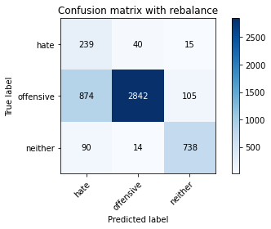

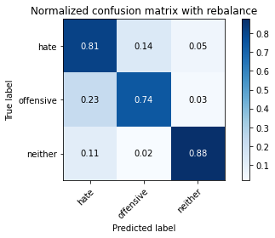

precision recall f1-score support

hate 0.20 0.81 0.32 294

offensive 0.98 0.74 0.85 3821

neither 0.86 0.88 0.87 842

accuracy 0.77 4957

macro avg 0.68 0.81 0.68 4957

weighted avg 0.91 0.77 0.82 4957

average eval_loss: 0.5290560123901213, accuracy: 0.770425660681864

training 2 epoch...

63.97805833816528 seconds used......

2 training finished! average train loss: 0.35497179400851153

evaluating...

Confusion matrix, without normalization

[[ 256 24 14]

[1722 2010 89]

[ 81 13 748]]

Normalized confusion matrix

[[0.8707483 0.08163265 0.04761905]

[0.45066736 0.5260403 0.02329233]

[0.09619952 0.01543943 0.88836105]]

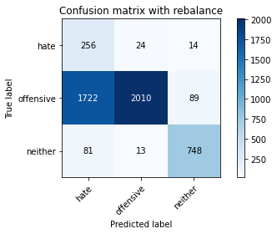

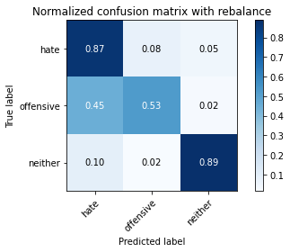

precision recall f1-score support

hate 0.12 0.87 0.22 294

offensive 0.98 0.53 0.69 3821

neither 0.88 0.89 0.88 842

accuracy 0.61 4957

macro avg 0.66 0.76 0.60 4957

weighted avg 0.91 0.61 0.69 4957

average eval_loss: 0.8068812719636387, accuracy: 0.6080290498285253

training 3 epoch...

63.987605571746826 seconds used......

3 training finished! average train loss: 0.2323379686744938

evaluating...

Confusion matrix, without normalization

[[ 250 28 16]

[1196 2528 97]

[ 104 11 727]]

Normalized confusion matrix

[[0.85034014 0.0952381 0.05442177]

[0.31300707 0.66160691 0.02538602]

[0.12351544 0.01306413 0.86342043]]

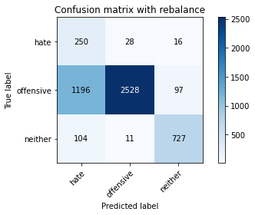

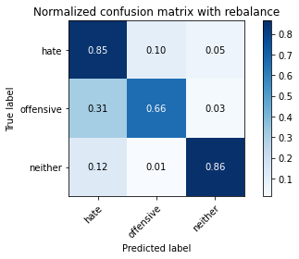

precision recall f1-score support

hate 0.16 0.85 0.27 294

offensive 0.98 0.66 0.79 3821

neither 0.87 0.86 0.86 842

accuracy 0.71 4957

macro avg 0.67 0.79 0.64 4957

weighted avg 0.92 0.71 0.77 4957

average eval_loss: 0.6797976168773828, accuracy: 0.7070808957030462

training 4 epoch...

64.03071022033691 seconds used......

4 training finished! average train loss: 0.14489177494631175

evaluating...

Confusion matrix, without normalization

[[ 218 44 32]

[ 937 2698 186]

[ 35 18 789]]

Normalized confusion matrix

[[0.7414966 0.14965986 0.10884354]

[0.24522376 0.70609788 0.04867836]

[0.0415677 0.02137767 0.93705463]]

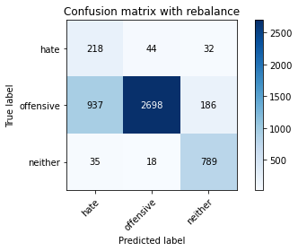

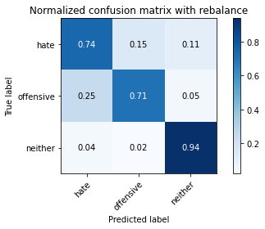

precision recall f1-score support

hate 0.18 0.74 0.29 294

offensive 0.98 0.71 0.82 3821

neither 0.78 0.94 0.85 842

accuracy 0.75 4957

macro avg 0.65 0.79 0.66 4957

weighted avg 0.90 0.75 0.79 4957

average eval_loss: 0.643553513132276, accuracy: 0.7474278797659875

training 5 epoch...

63.99692106246948 seconds used......

5 training finished! average train loss: 0.09969566931283613

evaluating...

Confusion matrix, without normalization

[[ 219 54 21]

[ 715 3010 96]

[ 64 37 741]]

Normalized confusion matrix

[[0.74489796 0.18367347 0.07142857]

[0.18712379 0.7877519 0.02512431]

[0.0760095 0.04394299 0.88004751]]

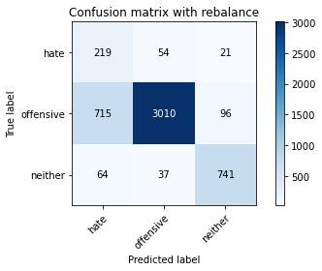

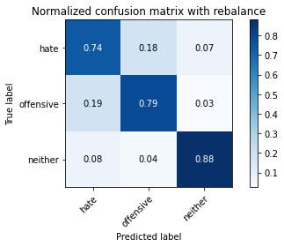

precision recall f1-score support

hate 0.22 0.74 0.34 294

offensive 0.97 0.79 0.87 3821

neither 0.86 0.88 0.87 842

accuracy 0.80 4957

macro avg 0.68 0.80 0.69 4957

weighted avg 0.91 0.80 0.84 4957

average eval_loss: 0.7046443742001429, accuracy: 0.8008876336493848

training 6 epoch...

63.944554567337036 seconds used......

6 training finished! average train loss: 0.06415060566117366

evaluating...

Confusion matrix, without normalization

[[ 242 34 18]

[1027 2690 104]

[ 80 28 734]]

Normalized confusion matrix

[[0.82312925 0.11564626 0.06122449]

[0.26877781 0.70400419 0.02721801]

[0.09501188 0.03325416 0.87173397]]

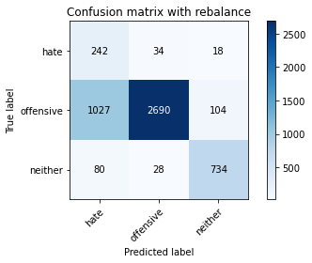

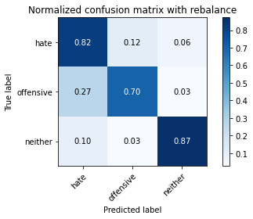

precision recall f1-score support

hate 0.18 0.82 0.29 294

offensive 0.98 0.70 0.82 3821

neither 0.86 0.87 0.86 842

accuracy 0.74 4957

macro avg 0.67 0.80 0.66 4957

weighted avg 0.91 0.74 0.80 4957

average eval_loss: 0.9508031473585195, accuracy: 0.739560217873714

training 7 epoch...

63.96713948249817 seconds used......

7 training finished! average train loss: 0.05161378655462847

evaluating...

Confusion matrix, without normalization

[[ 220 51 23]

[ 808 2876 137]

[ 43 26 773]]

Normalized confusion matrix

[[0.74829932 0.17346939 0.07823129]

[0.21146297 0.75268254 0.03585449]

[0.05106888 0.03087886 0.91805226]]

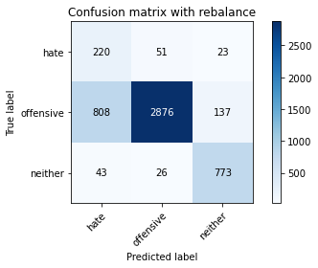

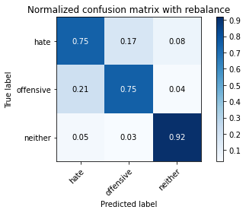

precision recall f1-score support

hate 0.21 0.75 0.32 294

offensive 0.97 0.75 0.85 3821

neither 0.83 0.92 0.87 842

accuracy 0.78 4957

macro avg 0.67 0.81 0.68 4957

weighted avg 0.90 0.78 0.82 4957

average eval_loss: 0.8182517764789443, accuracy: 0.7805124066975994

training 8 epoch...

63.99270725250244 seconds used......

8 training finished! average train loss: 0.030436295839652898

evaluating...

Confusion matrix, without normalization

[[ 234 44 16]

[1052 2659 110]

[ 80 31 731]]

Normalized confusion matrix

[[0.79591837 0.14965986 0.05442177]

[0.2753206 0.69589113 0.02878828]

[0.09501188 0.0368171 0.86817102]]

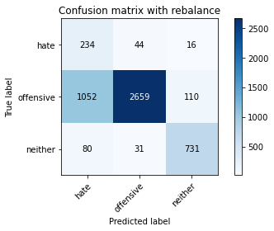

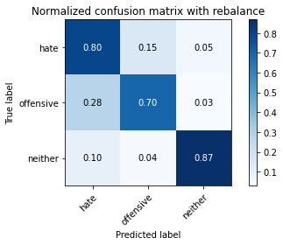

precision recall f1-score support

hate 0.17 0.80 0.28 294

offensive 0.97 0.70 0.81 3821

neither 0.85 0.87 0.86 842

accuracy 0.73 4957

macro avg 0.67 0.79 0.65 4957

weighted avg 0.90 0.73 0.79 4957

average eval_loss: 1.1526359459986129, accuracy: 0.7310873512204963

training 9 epoch...

63.962897300720215 seconds used......

9 training finished! average train loss: 0.01784736240876305

evaluating...

Confusion matrix, without normalization

[[ 228 45 21]

[ 930 2764 127]

[ 65 30 747]]

Normalized confusion matrix

[[0.7755102 0.15306122 0.07142857]

[0.24339178 0.72337085 0.03323737]

[0.07719715 0.03562945 0.8871734 ]]

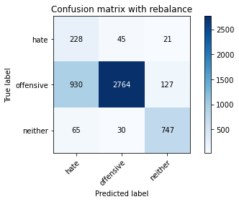

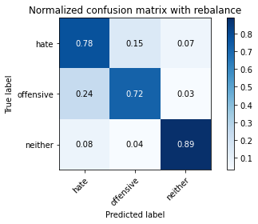

precision recall f1-score support

hate 0.19 0.78 0.30 294

offensive 0.97 0.72 0.83 3821

neither 0.83 0.89 0.86 842

accuracy 0.75 4957

macro avg 0.66 0.80 0.66 4957

weighted avg 0.90 0.75 0.80 4957

average eval_loss: 1.105779496306974, accuracy: 0.7542868670566875

training 10 epoch...

63.93008518218994 seconds used......

10 training finished! average train loss: 0.01280656925050953

evaluating...

Confusion matrix, without normalization

[[ 232 42 20]

[1028 2655 138]

[ 83 25 734]]

Normalized confusion matrix

[[0.78911565 0.14285714 0.06802721]

[0.26903952 0.69484428 0.0361162 ]

[0.09857482 0.02969121 0.87173397]]

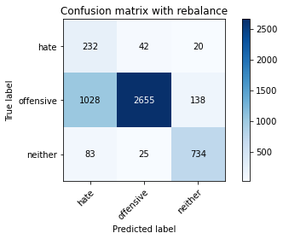

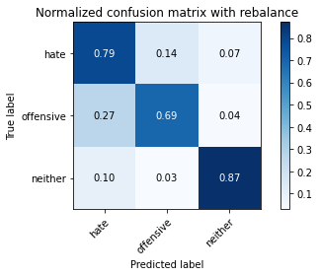

precision recall f1-score support

hate 0.17 0.79 0.28 294

offensive 0.98 0.69 0.81 3821

neither 0.82 0.87 0.85 842

accuracy 0.73 4957

macro avg 0.66 0.79 0.65 4957

weighted avg 0.90 0.73 0.79 4957

average eval_loss: 1.2350381816767397, accuracy: 0.7304821464595521

3 run

training 1 epoch...

63.98864436149597 seconds used......

1 training finished! average train loss: 0.6352147703979447

evaluating...

Confusion matrix, without normalization

[[ 275 12 7]

[2481 1289 51]

[ 203 5 634]]

Normalized confusion matrix

[[0.93537415 0.04081633 0.02380952]

[0.64930646 0.33734624 0.01334729]

[0.24109264 0.00593824 0.75296912]]

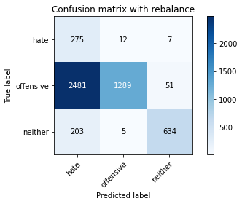

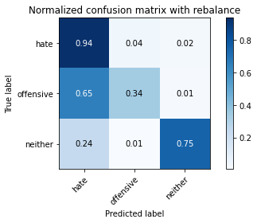

precision recall f1-score support

hate 0.09 0.94 0.17 294

offensive 0.99 0.34 0.50 3821

neither 0.92 0.75 0.83 842

accuracy 0.44 4957

macro avg 0.67 0.68 0.50 4957

weighted avg 0.92 0.44 0.54 4957

average eval_loss: 1.1137234578209538, accuracy: 0.44341335485172484

training 2 epoch...

63.953571796417236 seconds used......

2 training finished! average train loss: 0.3541824488263381

evaluating...

Confusion matrix, without normalization

[[ 230 41 23]

[ 816 2861 144]

[ 37 9 796]]

Normalized confusion matrix

[[0.78231293 0.13945578 0.07823129]

[0.21355666 0.74875687 0.03768647]

[0.04394299 0.01068884 0.94536817]]

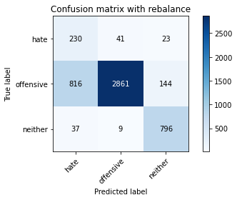

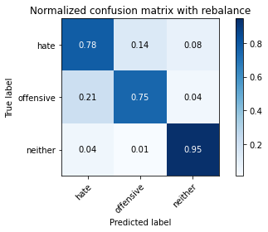

precision recall f1-score support

hate 0.21 0.78 0.33 294

offensive 0.98 0.75 0.85 3821

neither 0.83 0.95 0.88 842

accuracy 0.78 4957

macro avg 0.67 0.83 0.69 4957

weighted avg 0.91 0.78 0.82 4957

average eval_loss: 0.5288316241555637, accuracy: 0.784143635263264

training 3 epoch...

63.95662546157837 seconds used......

3 training finished! average train loss: 0.22826245972854003

evaluating...

Confusion matrix, without normalization

[[ 246 33 15]

[1118 2582 121]

[ 72 12 758]]

Normalized confusion matrix

[[0.83673469 0.1122449 0.05102041]

[0.29259356 0.67573934 0.0316671 ]

[0.08551069 0.01425178 0.90023753]]

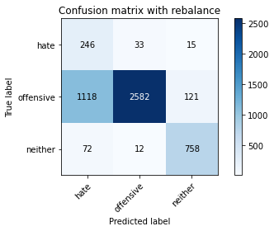

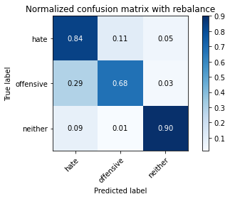

precision recall f1-score support

hate 0.17 0.84 0.28 294

offensive 0.98 0.68 0.80 3821

neither 0.85 0.90 0.87 842

accuracy 0.72 4957

macro avg 0.67 0.80 0.65 4957

weighted avg 0.91 0.72 0.78 4957

average eval_loss: 0.6335222883029811, accuracy: 0.7234214242485374

training 4 epoch...

64.01813769340515 seconds used......

4 training finished! average train loss: 0.1448080216191317

evaluating...

Confusion matrix, without normalization

[[ 228 43 23]

[ 922 2756 143]

[ 54 14 774]]

Normalized confusion matrix

[[0.7755102 0.1462585 0.07823129]

[0.24129809 0.72127715 0.03742476]

[0.06413302 0.01662708 0.9192399 ]]

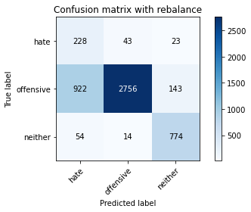

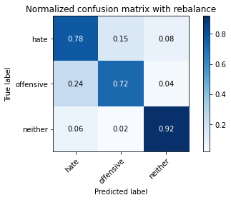

precision recall f1-score support

hate 0.19 0.78 0.30 294

offensive 0.98 0.72 0.83 3821

neither 0.82 0.92 0.87 842

accuracy 0.76 4957

macro avg 0.66 0.81 0.67 4957

weighted avg 0.91 0.76 0.81 4957

average eval_loss: 0.6478510510717188, accuracy: 0.758119830542667

training 5 epoch...

63.9723756313324 seconds used......

5 training finished! average train loss: 0.10412995344060555

evaluating...

Confusion matrix, without normalization

[[ 244 31 19]

[1238 2469 114]

[ 66 18 758]]

Normalized confusion matrix

[[0.82993197 0.10544218 0.06462585]

[0.32399895 0.64616593 0.02983512]

[0.0783848 0.02137767 0.90023753]]

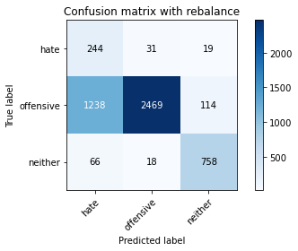

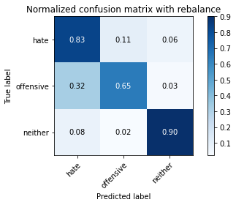

precision recall f1-score support

hate 0.16 0.83 0.26 294

offensive 0.98 0.65 0.78 3821

neither 0.85 0.90 0.87 842

accuracy 0.70 4957

macro avg 0.66 0.79 0.64 4957

weighted avg 0.91 0.70 0.76 4957

average eval_loss: 0.9627679061114548, accuracy: 0.7002219084123462

training 6 epoch...

63.92067551612854 seconds used......

6 training finished! average train loss: 0.06553710500671588

evaluating...

Confusion matrix, without normalization

[[ 225 51 18]

[ 778 2898 145]

[ 54 16 772]]

Normalized confusion matrix

[[0.76530612 0.17346939 0.06122449]

[0.20361162 0.7584402 0.03794818]

[0.06413302 0.01900238 0.91686461]]

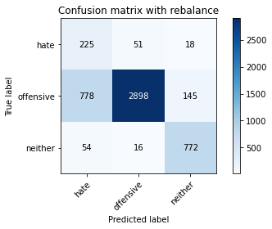

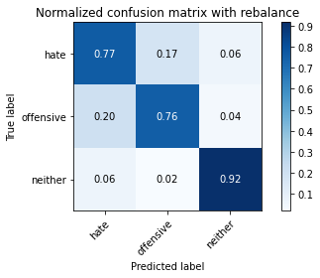

precision recall f1-score support

hate 0.21 0.77 0.33 294

offensive 0.98 0.76 0.85 3821

neither 0.83 0.92 0.87 842

accuracy 0.79 4957

macro avg 0.67 0.81 0.69 4957

weighted avg 0.91 0.79 0.83 4957

average eval_loss: 0.790115607590715, accuracy: 0.7857575146257817

training 7 epoch...

63.93860626220703 seconds used......

7 training finished! average train loss: 0.050165390952528394

evaluating...

Confusion matrix, without normalization

[[ 216 50 28]

[ 819 2852 150]

[ 42 22 778]]

Normalized confusion matrix

[[0.73469388 0.17006803 0.0952381 ]

[0.2143418 0.74640147 0.03925674]

[0.04988124 0.02612827 0.9239905 ]]

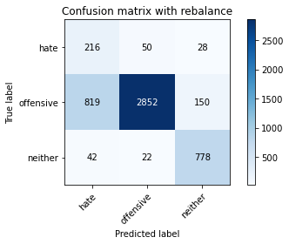

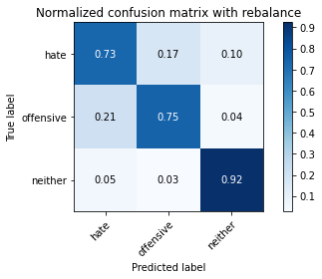

precision recall f1-score support

hate 0.20 0.73 0.32 294

offensive 0.98 0.75 0.85 3821

neither 0.81 0.92 0.87 842

accuracy 0.78 4957

macro avg 0.66 0.80 0.68 4957

weighted avg 0.90 0.78 0.82 4957

average eval_loss: 0.829524268951988, accuracy: 0.7758725035303611

training 8 epoch...

64.01221132278442 seconds used......

8 training finished! average train loss: 0.04167787874647149

evaluating...

Confusion matrix, without normalization

[[ 206 63 25]

[ 681 3000 140]

[ 30 39 773]]

Normalized confusion matrix

[[0.70068027 0.21428571 0.08503401]

[0.1782256 0.78513478 0.03663962]

[0.03562945 0.04631829 0.91805226]]

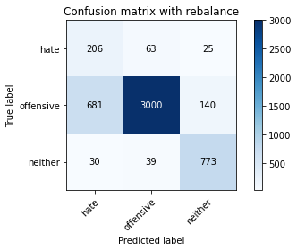

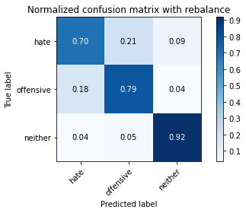

precision recall f1-score support

hate 0.22 0.70 0.34 294

offensive 0.97 0.79 0.87 3821

neither 0.82 0.92 0.87 842

accuracy 0.80 4957

macro avg 0.67 0.80 0.69 4957

weighted avg 0.90 0.80 0.84 4957

average eval_loss: 0.8393255743768907, accuracy: 0.802703247932217

training 9 epoch...

63.99897384643555 seconds used......

9 training finished! average train loss: 0.024614923623082777

evaluating...

Confusion matrix, without normalization

[[ 220 52 22]

[ 772 2927 122]

[ 42 31 769]]

Normalized confusion matrix

[[0.74829932 0.17687075 0.07482993]

[0.20204135 0.76602984 0.03192881]

[0.04988124 0.0368171 0.91330166]]

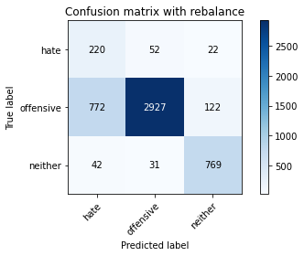

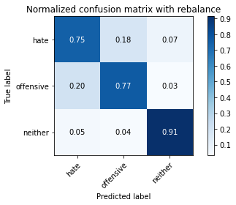

precision recall f1-score support

hate 0.21 0.75 0.33 294

offensive 0.97 0.77 0.86 3821

neither 0.84 0.91 0.88 842

accuracy 0.79 4957

macro avg 0.68 0.81 0.69 4957

weighted avg 0.91 0.79 0.83 4957

average eval_loss: 0.8962411654102916, accuracy: 0.7899939479523905

training 10 epoch...

63.926804065704346 seconds used......

10 training finished! average train loss: 0.02579572296508027

evaluating...

Confusion matrix, without normalization

[[ 246 35 13]

[1349 2379 93]

[ 86 28 728]]

Normalized confusion matrix

[[0.83673469 0.11904762 0.04421769]

[0.35304894 0.62261188 0.02433918]

[0.10213777 0.03325416 0.86460808]]

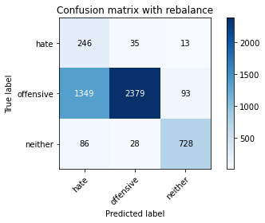

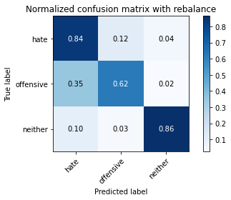

precision recall f1-score support

hate 0.15 0.84 0.25 294

offensive 0.97 0.62 0.76 3821

neither 0.87 0.86 0.87 842

accuracy 0.68 4957

macro avg 0.66 0.77 0.63 4957

weighted avg 0.91 0.68 0.75 4957

average eval_loss: 1.3802583884567983, accuracy: 0.6764171878152108

4 run

training 1 epoch...

64.04540014266968 seconds used......

1 training finished! average train loss: 0.6300982880836342

evaluating...

Confusion matrix, without normalization

[[ 234 37 23]

[ 871 2797 153]

[ 49 10 783]]

Normalized confusion matrix

[[0.79591837 0.12585034 0.07823129]

[0.2279508 0.73200733 0.04004187]

[0.05819477 0.01187648 0.92992874]]

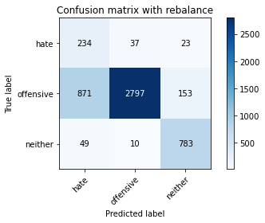

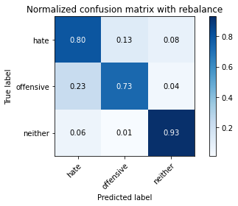

precision recall f1-score support

hate 0.20 0.80 0.32 294

offensive 0.98 0.73 0.84 3821

neither 0.82 0.93 0.87 842

accuracy 0.77 4957

macro avg 0.67 0.82 0.68 4957

weighted avg 0.91 0.77 0.81 4957

average eval_loss: 0.5358244393982233, accuracy: 0.7694169860802905

training 2 epoch...

64.05055642127991 seconds used......

2 training finished! average train loss: 0.34920275420473335

evaluating...

Confusion matrix, without normalization

[[ 241 34 19]

[1227 2460 134]

[ 64 9 769]]

Normalized confusion matrix

[[0.81972789 0.11564626 0.06462585]

[0.32112013 0.64381052 0.03506935]

[0.0760095 0.01068884 0.91330166]]

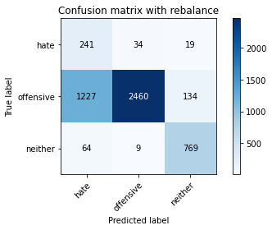

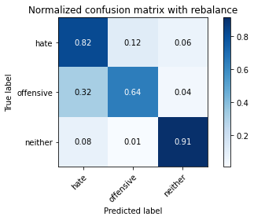

precision recall f1-score support

hate 0.16 0.82 0.26 294

offensive 0.98 0.64 0.78 3821

neither 0.83 0.91 0.87 842

accuracy 0.70 4957

macro avg 0.66 0.79 0.64 4957

weighted avg 0.91 0.70 0.76 4957

average eval_loss: 0.6184221641310761, accuracy: 0.7000201734920315

training 3 epoch...

64.04495596885681 seconds used......

3 training finished! average train loss: 0.22848458346306233

evaluating...

Confusion matrix, without normalization

[[ 223 60 11]

[ 711 3018 92]

[ 71 39 732]]

Normalized confusion matrix

[[0.7585034 0.20408163 0.03741497]

[0.18607694 0.78984559 0.02407747]

[0.08432304 0.04631829 0.86935867]]

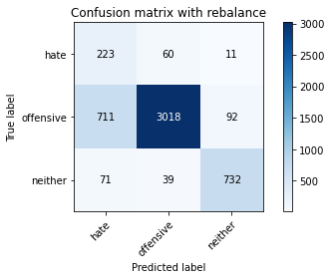

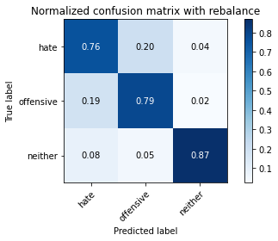

precision recall f1-score support

hate 0.22 0.76 0.34 294

offensive 0.97 0.79 0.87 3821

neither 0.88 0.87 0.87 842

accuracy 0.80 4957

macro avg 0.69 0.81 0.70 4957

weighted avg 0.91 0.80 0.84 4957

average eval_loss: 0.5032933557165726, accuracy: 0.8014928384103288

training 4 epoch...

64.1164402961731 seconds used......

4 training finished! average train loss: 0.14334268750328766

evaluating...

Confusion matrix, without normalization

[[ 244 33 17]

[1117 2573 131]

[ 65 14 763]]

Normalized confusion matrix

[[0.82993197 0.1122449 0.05782313]

[0.29233185 0.67338393 0.03428422]

[0.07719715 0.01662708 0.90617577]]

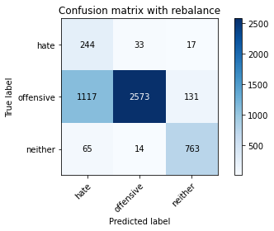

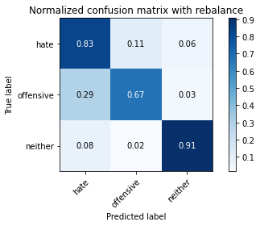

precision recall f1-score support

hate 0.17 0.83 0.28 294

offensive 0.98 0.67 0.80 3821

neither 0.84 0.91 0.87 842

accuracy 0.72 4957

macro avg 0.66 0.80 0.65 4957

weighted avg 0.91 0.72 0.78 4957

average eval_loss: 0.8054235932687598, accuracy: 0.7222110147266492

training 5 epoch...

64.10967946052551 seconds used......

5 training finished! average train loss: 0.09582384407237085

evaluating...

Confusion matrix, without normalization

[[ 220 56 18]

[ 772 2929 120]

[ 67 18 757]]

Normalized confusion matrix

[[0.74829932 0.19047619 0.06122449]

[0.20204135 0.76655326 0.03140539]

[0.07957245 0.02137767 0.89904988]]

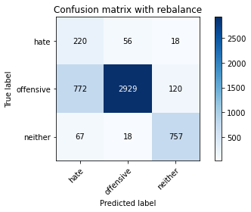

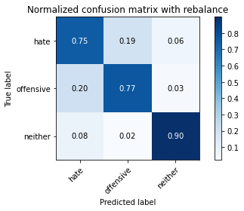

precision recall f1-score support

hate 0.21 0.75 0.33 294

offensive 0.98 0.77 0.86 3821

neither 0.85 0.90 0.87 842

accuracy 0.79 4957

macro avg 0.68 0.80 0.69 4957

weighted avg 0.91 0.79 0.83 4957

average eval_loss: 0.6747875033066638, accuracy: 0.7879765987492435

training 6 epoch...

64.12428379058838 seconds used......

6 training finished! average train loss: 0.0651755001251613

evaluating...

Confusion matrix, without normalization

[[ 239 39 16]

[1059 2662 100]

[ 85 29 728]]

Normalized confusion matrix

[[0.81292517 0.13265306 0.05442177]

[0.27715258 0.69667626 0.02617116]

[0.10095012 0.03444181 0.86460808]]

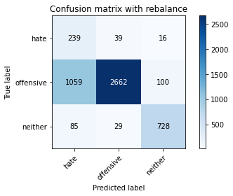

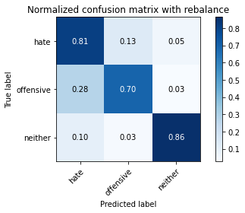

precision recall f1-score support

hate 0.17 0.81 0.29 294

offensive 0.98 0.70 0.81 3821

neither 0.86 0.86 0.86 842

accuracy 0.73 4957

macro avg 0.67 0.79 0.65 4957

weighted avg 0.91 0.73 0.79 4957

average eval_loss: 1.032557205807778, accuracy: 0.7320960258220698

training 7 epoch...

64.09360647201538 seconds used......

7 training finished! average train loss: 0.03353361957788206

evaluating...

Confusion matrix, without normalization

[[ 214 55 25]

[ 664 2928 229]

[ 37 9 796]]

Normalized confusion matrix

[[0.72789116 0.18707483 0.08503401]

[0.1737765 0.76629155 0.05993195]

[0.04394299 0.01068884 0.94536817]]

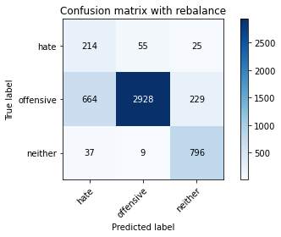

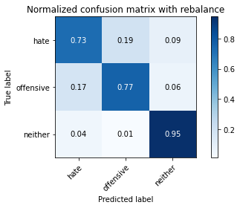

precision recall f1-score support

hate 0.23 0.73 0.35 294

offensive 0.98 0.77 0.86 3821

neither 0.76 0.95 0.84 842

accuracy 0.79 4957

macro avg 0.66 0.81 0.68 4957

weighted avg 0.90 0.79 0.83 4957

average eval_loss: 0.9049132038959332, accuracy: 0.7944321161993141

training 8 epoch...

64.1500551700592 seconds used......

8 training finished! average train loss: 0.029710920257303233

evaluating...

Confusion matrix, without normalization

[[ 192 83 19]

[ 489 3208 124]

[ 35 35 772]]

Normalized confusion matrix

[[0.65306122 0.28231293 0.06462585]

[0.12797697 0.83957079 0.03245224]

[0.0415677 0.0415677 0.91686461]]

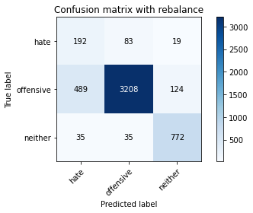

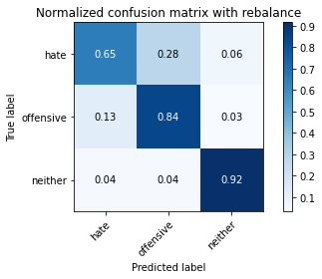

precision recall f1-score support

hate 0.27 0.65 0.38 294

offensive 0.96 0.84 0.90 3821

neither 0.84 0.92 0.88 842

accuracy 0.84 4957

macro avg 0.69 0.80 0.72 4957

weighted avg 0.90 0.84 0.86 4957

average eval_loss: 0.7887217189615306, accuracy: 0.8416380875529554

training 9 epoch...

64.09273743629456 seconds used......

9 training finished! average train loss: 0.03032175988644465

evaluating...

Confusion matrix, without normalization

[[ 210 69 15]

[ 715 2963 143]

[ 54 20 768]]

Normalized confusion matrix

[[0.71428571 0.23469388 0.05102041]

[0.18712379 0.77545145 0.03742476]

[0.06413302 0.02375297 0.91211401]]

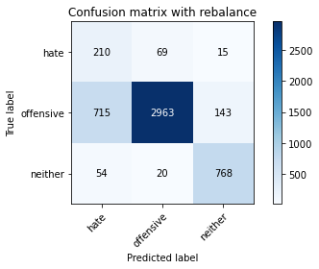

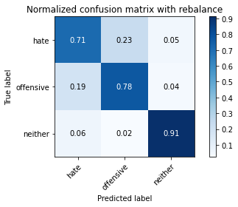

precision recall f1-score support

hate 0.21 0.71 0.33 294

offensive 0.97 0.78 0.86 3821

neither 0.83 0.91 0.87 842

accuracy 0.80 4957

macro avg 0.67 0.80 0.69 4957

weighted avg 0.90 0.80 0.83 4957

average eval_loss: 0.9604954529974249, accuracy: 0.7950373209602583

training 10 epoch...

64.05081033706665 seconds used......

10 training finished! average train loss: 0.02368779023969682

evaluating...

Confusion matrix, without normalization

[[ 218 58 18]

[ 713 2952 156]

[ 45 20 777]]

Normalized confusion matrix

[[0.7414966 0.19727891 0.06122449]

[0.18660037 0.77257262 0.04082701]

[0.05344418 0.02375297 0.92280285]]

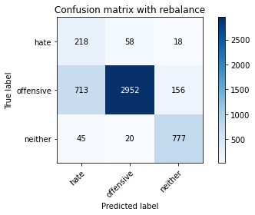

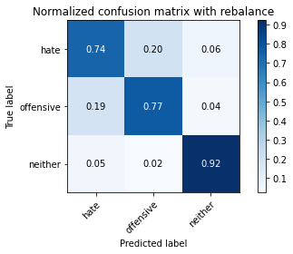

precision recall f1-score support

hate 0.22 0.74 0.34 294

offensive 0.97 0.77 0.86 3821

neither 0.82 0.92 0.87 842

accuracy 0.80 4957

macro avg 0.67 0.81 0.69 4957

weighted avg 0.90 0.80 0.83 4957

average eval_loss: 0.9928494971921488, accuracy: 0.7962477304821465

5 run

training 1 epoch...

64.10244297981262 seconds used......

1 training finished! average train loss: 0.6304906468119538

evaluating...

Confusion matrix, without normalization

[[ 259 21 14]

[1534 2180 107]

[ 108 7 727]]

Normalized confusion matrix

[[0.88095238 0.07142857 0.04761905]

[0.40146558 0.57053127 0.02800314]

[0.12826603 0.00831354 0.86342043]]

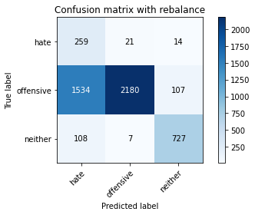

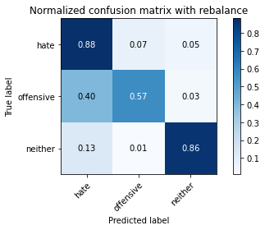

precision recall f1-score support

hate 0.14 0.88 0.24 294

offensive 0.99 0.57 0.72 3821

neither 0.86 0.86 0.86 842

accuracy 0.64 4957

macro avg 0.66 0.77 0.61 4957

weighted avg 0.91 0.64 0.72 4957

average eval_loss: 0.8744286862352202, accuracy: 0.6386927577163607

training 2 epoch...

64.15098142623901 seconds used......

2 training finished! average train loss: 0.3446649691601943

evaluating...

Confusion matrix, without normalization

[[ 252 25 17]

[1424 2270 127]

[ 84 11 747]]

Normalized confusion matrix

[[0.85714286 0.08503401 0.05782313]

[0.37267731 0.59408532 0.03323737]

[0.09976247 0.01306413 0.8871734 ]]

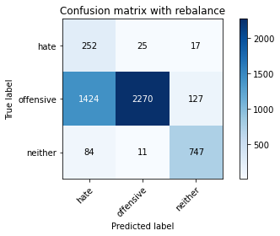

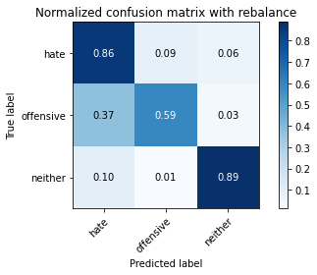

precision recall f1-score support

hate 0.14 0.86 0.25 294

offensive 0.98 0.59 0.74 3821

neither 0.84 0.89 0.86 842

accuracy 0.66 4957

macro avg 0.66 0.78 0.62 4957

weighted avg 0.91 0.66 0.73 4957

average eval_loss: 0.7022251301114598, accuracy: 0.6594714545087754

training 3 epoch...

64.04812574386597 seconds used......

3 training finished! average train loss: 0.2171313501894474

evaluating...

Confusion matrix, without normalization

[[ 246 33 15]

[ 984 2749 88]

[ 93 22 727]]

Normalized confusion matrix

[[0.83673469 0.1122449 0.05102041]

[0.25752421 0.71944517 0.02303062]

[0.11045131 0.02612827 0.86342043]]

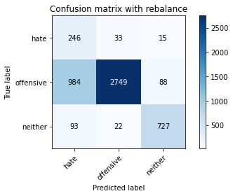

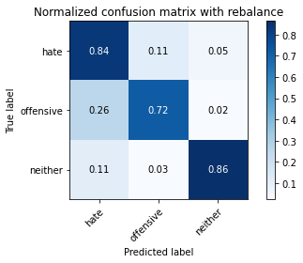

precision recall f1-score support

hate 0.19 0.84 0.30 294

offensive 0.98 0.72 0.83 3821

neither 0.88 0.86 0.87 842

accuracy 0.75 4957

macro avg 0.68 0.81 0.67 4957

weighted avg 0.92 0.75 0.81 4957

average eval_loss: 0.6610941586174792, accuracy: 0.7508573734113375

training 4 epoch...

64.24085688591003 seconds used......

4 training finished! average train loss: 0.14858293662403235

evaluating...

Confusion matrix, without normalization

[[ 237 35 22]

[ 937 2751 133]

[ 86 18 738]]

Normalized confusion matrix

[[0.80612245 0.11904762 0.07482993]

[0.24522376 0.71996859 0.03480764]

[0.10213777 0.02137767 0.87648456]]

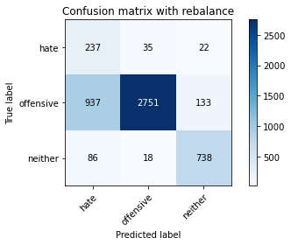

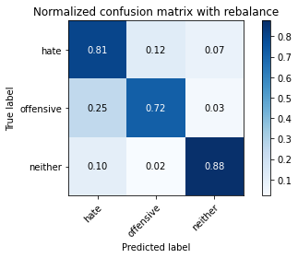

precision recall f1-score support

hate 0.19 0.81 0.31 294

offensive 0.98 0.72 0.83 3821

neither 0.83 0.88 0.85 842

accuracy 0.75 4957

macro avg 0.67 0.80 0.66 4957

weighted avg 0.91 0.75 0.80 4957

average eval_loss: 0.6476369893118259, accuracy: 0.7516643130925963

training 5 epoch...

64.01613283157349 seconds used......

5 training finished! average train loss: 0.09370333804852432

evaluating...

Confusion matrix, without normalization

[[ 256 25 13]

[1292 2445 84]

[ 100 26 716]]

Normalized confusion matrix

[[0.8707483 0.08503401 0.04421769]

[0.33813138 0.63988485 0.02198377]

[0.11876485 0.03087886 0.85035629]]

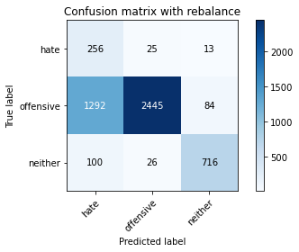

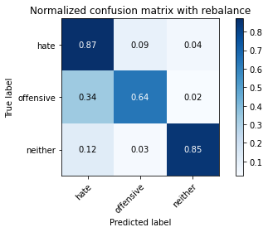

precision recall f1-score support

hate 0.16 0.87 0.26 294

offensive 0.98 0.64 0.77 3821

neither 0.88 0.85 0.87 842

accuracy 0.69 4957

macro avg 0.67 0.79 0.63 4957

weighted avg 0.91 0.69 0.76 4957

average eval_loss: 0.9871712255201512, accuracy: 0.689328222715352

training 6 epoch...

63.977076292037964 seconds used......

6 training finished! average train loss: 0.06450050976399703

evaluating...

Confusion matrix, without normalization

[[ 231 49 14]

[ 810 2939 72]

[ 94 53 695]]

Normalized confusion matrix

[[0.78571429 0.16666667 0.04761905]

[0.21198639 0.76917037 0.01884323]

[0.11163895 0.06294537 0.82541568]]

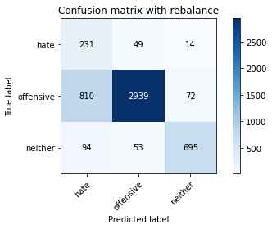

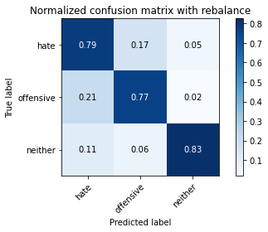

precision recall f1-score support

hate 0.20 0.79 0.32 294

offensive 0.97 0.77 0.86 3821

neither 0.89 0.83 0.86 842

accuracy 0.78 4957

macro avg 0.69 0.79 0.68 4957

weighted avg 0.91 0.78 0.82 4957

average eval_loss: 0.7657238041621542, accuracy: 0.7797054670163406

training 7 epoch...

63.94655179977417 seconds used......

7 training finished! average train loss: 0.034486748180787855

evaluating...

Confusion matrix, without normalization

[[ 233 41 20]

[ 968 2734 119]

[ 62 18 762]]

Normalized confusion matrix

[[0.79251701 0.13945578 0.06802721]

[0.25333682 0.7155195 0.03114368]

[0.0736342 0.02137767 0.90498812]]

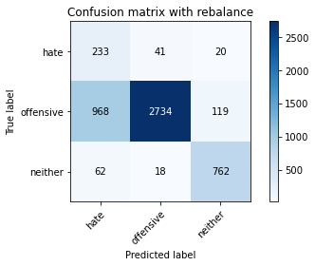

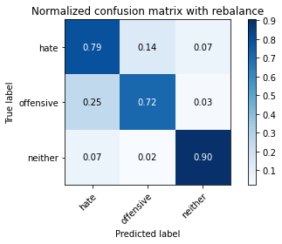

precision recall f1-score support

hate 0.18 0.79 0.30 294

offensive 0.98 0.72 0.83 3821

neither 0.85 0.90 0.87 842

accuracy 0.75 4957

macro avg 0.67 0.80 0.67 4957

weighted avg 0.91 0.75 0.80 4957

average eval_loss: 1.0735746711030631, accuracy: 0.7522695178535405

training 8 epoch...

64.00357866287231 seconds used......

8 training finished! average train loss: 0.02407923032569138

evaluating...

Confusion matrix, without normalization

[[ 207 65 22]

[ 633 3073 115]

[ 44 49 749]]

Normalized confusion matrix

[[0.70408163 0.22108844 0.07482993]

[0.16566344 0.80423973 0.03009683]

[0.05225653 0.05819477 0.88954869]]

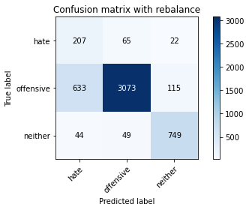

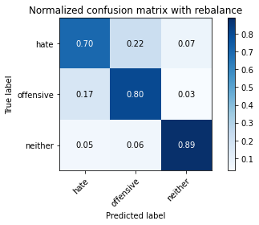

precision recall f1-score support

hate 0.23 0.70 0.35 294

offensive 0.96 0.80 0.88 3821

neither 0.85 0.89 0.87 842

accuracy 0.81 4957

macro avg 0.68 0.80 0.70 4957

weighted avg 0.90 0.81 0.84 4957

average eval_loss: 0.8667035035886651, accuracy: 0.8127899939479524

training 9 epoch...

63.97767734527588 seconds used......

9 training finished! average train loss: 0.02368934964284584

evaluating...

Confusion matrix, without normalization

[[ 215 57 22]

[ 802 2917 102]

[ 64 31 747]]

Normalized confusion matrix

[[0.73129252 0.19387755 0.07482993]

[0.2098927 0.76341272 0.02669458]

[0.0760095 0.0368171 0.8871734 ]]

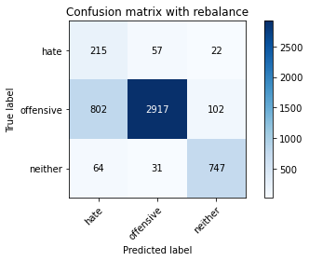

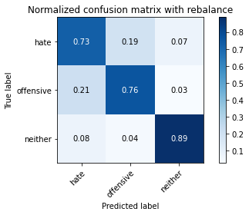

precision recall f1-score support

hate 0.20 0.73 0.31 294

offensive 0.97 0.76 0.85 3821

neither 0.86 0.89 0.87 842

accuracy 0.78 4957

macro avg 0.68 0.79 0.68 4957

weighted avg 0.91 0.78 0.83 4957

average eval_loss: 1.0005656822411824, accuracy: 0.7825297559007465

training 10 epoch...

64.02387738227844 seconds used......

10 training finished! average train loss: 0.024196782921732277

evaluating...

Confusion matrix, without normalization

[[ 211 59 24]

[ 666 3009 146]

[ 53 27 762]]

Normalized confusion matrix

[[0.71768707 0.20068027 0.08163265]

[0.17429992 0.78749019 0.03820989]

[0.06294537 0.03206651 0.90498812]]

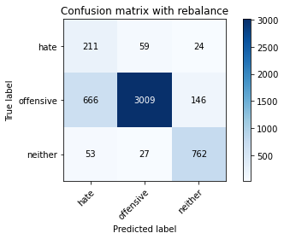

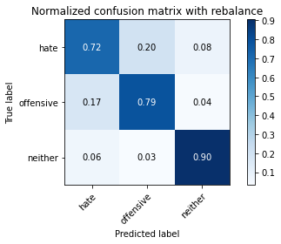

precision recall f1-score support

hate 0.23 0.72 0.34 294

offensive 0.97 0.79 0.87 3821

neither 0.82 0.90 0.86 842

accuracy 0.80 4957

macro avg 0.67 0.80 0.69 4957

weighted avg 0.90 0.80 0.84 4957

average eval_loss: 0.9243572251439365, accuracy: 0.8033084526931612