1 run

[1.2,0.6,1]

training 1 epoch...

66.01131176948547 seconds used......

1 training finished! average train loss: 0.663157670731433

evaluating...

Confusion matrix, without normalization

[[ 225 32 37]

[ 911 2754 156]

[ 53 9 780]]

Normalized confusion matrix

[[0.76530612 0.10884354 0.12585034]

[0.23841926 0.72075373 0.04082701]

[0.06294537 0.01068884 0.9263658 ]]

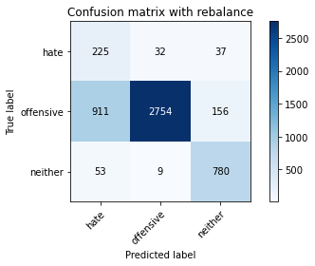

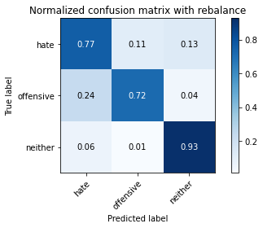

precision recall f1-score support

hate 0.19 0.77 0.30 294

offensive 0.99 0.72 0.83 3821

neither 0.80 0.93 0.86 842

accuracy 0.76 4957

macro avg 0.66 0.80 0.67 4957

weighted avg 0.91 0.76 0.81 4957

average eval_loss: 0.6216989618035094, accuracy: 0.7583215654629817

training 2 epoch...

65.28763127326965 seconds used......

2 training finished! average train loss: 0.3762018354664072

evaluating...

Confusion matrix, without normalization

[[ 228 32 34]

[ 924 2724 173]

[ 34 9 799]]

Normalized confusion matrix

[[0.7755102 0.10884354 0.11564626]

[0.24182151 0.71290238 0.04527611]

[0.04038005 0.01068884 0.94893112]]

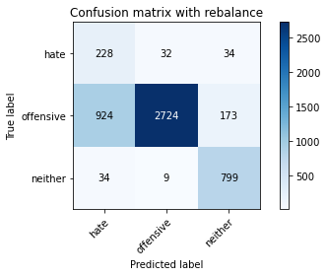

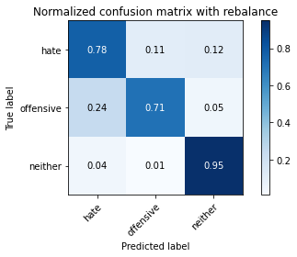

precision recall f1-score support

hate 0.19 0.78 0.31 294

offensive 0.99 0.71 0.83 3821

neither 0.79 0.95 0.86 842

accuracy 0.76 4957

macro avg 0.66 0.81 0.67 4957

weighted avg 0.91 0.76 0.80 4957

average eval_loss: 0.5791075070418658, accuracy: 0.756707686100464

training 3 epoch...

65.38643169403076 seconds used......

3 training finished! average train loss: 0.2601623062850439

evaluating...

Confusion matrix, without normalization

[[ 230 50 14]

[ 822 2924 75]

[ 93 34 715]]

Normalized confusion matrix

[[0.78231293 0.17006803 0.04761905]

[0.21512693 0.7652447 0.01962837]

[0.11045131 0.04038005 0.84916865]]

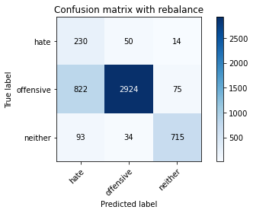

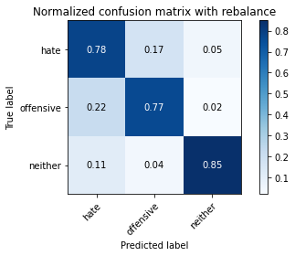

precision recall f1-score support

hate 0.20 0.78 0.32 294

offensive 0.97 0.77 0.86 3821

neither 0.89 0.85 0.87 842

accuracy 0.78 4957

macro avg 0.69 0.80 0.68 4957

weighted avg 0.91 0.78 0.83 4957

average eval_loss: 0.5076977856036636, accuracy: 0.7805124066975994

training 4 epoch...

65.30186343193054 seconds used......

4 training finished! average train loss: 0.15362006438928738

evaluating...

Confusion matrix, without normalization

[[ 228 36 30]

[ 865 2816 140]

[ 43 24 775]]

Normalized confusion matrix

[[0.7755102 0.12244898 0.10204082]

[0.22638053 0.73697985 0.03663962]

[0.05106888 0.02850356 0.92042755]]

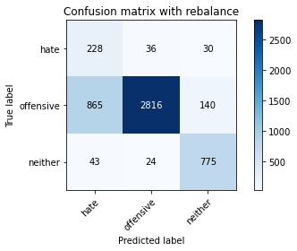

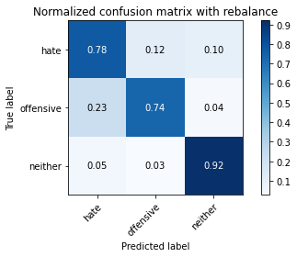

precision recall f1-score support

hate 0.20 0.78 0.32 294

offensive 0.98 0.74 0.84 3821

neither 0.82 0.92 0.87 842

accuracy 0.77 4957

macro avg 0.67 0.81 0.68 4957

weighted avg 0.91 0.77 0.81 4957

average eval_loss: 0.6582299045797798, accuracy: 0.770425660681864

training 5 epoch...

65.38654208183289 seconds used......

5 training finished! average train loss: 0.10136662563036757

evaluating...

Confusion matrix, without normalization

[[ 241 38 15]

[ 972 2762 87]

[ 86 26 730]]

Normalized confusion matrix

[[0.81972789 0.1292517 0.05102041]

[0.25438367 0.72284742 0.02276891]

[0.10213777 0.03087886 0.86698337]]

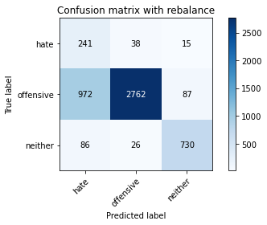

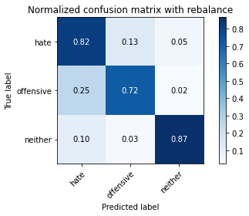

precision recall f1-score support

hate 0.19 0.82 0.30 294

offensive 0.98 0.72 0.83 3821

neither 0.88 0.87 0.87 842

accuracy 0.75 4957

macro avg 0.68 0.80 0.67 4957

weighted avg 0.91 0.75 0.81 4957

average eval_loss: 0.7914388859193893, accuracy: 0.7530764575347992

training 6 epoch...

65.34268808364868 seconds used......

6 training finished! average train loss: 0.06496624381700802

evaluating...

Confusion matrix, without normalization

[[ 225 56 13]

[ 707 3038 76]

[ 99 45 698]]

Normalized confusion matrix

[[0.76530612 0.19047619 0.04421769]

[0.1850301 0.79507982 0.01989008]

[0.1175772 0.05344418 0.82897862]]

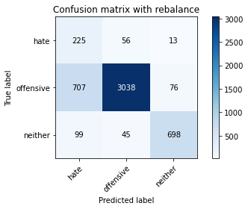

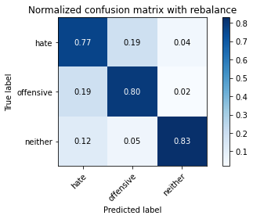

precision recall f1-score support

hate 0.22 0.77 0.34 294

offensive 0.97 0.80 0.87 3821

neither 0.89 0.83 0.86 842

accuracy 0.80 4957

macro avg 0.69 0.80 0.69 4957

weighted avg 0.91 0.80 0.84 4957

average eval_loss: 0.7766685130585346, accuracy: 0.7990720193665524

training 7 epoch...

65.39910984039307 seconds used......

7 training finished! average train loss: 0.03878796240042525

evaluating...

Confusion matrix, without normalization

[[ 212 62 20]

[ 745 2975 101]

[ 70 39 733]]

Normalized confusion matrix

[[0.72108844 0.21088435 0.06802721]

[0.19497514 0.77859199 0.02643287]

[0.08313539 0.04631829 0.87054632]]

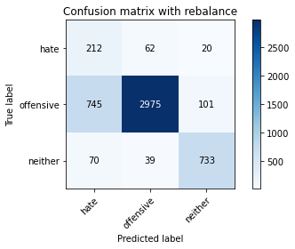

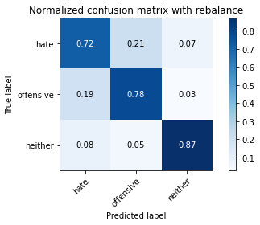

precision recall f1-score support

hate 0.21 0.72 0.32 294

offensive 0.97 0.78 0.86 3821

neither 0.86 0.87 0.86 842

accuracy 0.79 4957

macro avg 0.68 0.79 0.68 4957

weighted avg 0.90 0.79 0.83 4957

average eval_loss: 0.7742849502584807, accuracy: 0.7908008876336494

training 8 epoch...

65.34981393814087 seconds used......

8 training finished! average train loss: 0.024446423826888965

evaluating...

Confusion matrix, without normalization

[[ 208 60 26]

[ 695 2979 147]

[ 37 24 781]]

Normalized confusion matrix

[[0.70748299 0.20408163 0.08843537]

[0.18188956 0.77963884 0.0384716 ]

[0.04394299 0.02850356 0.92755344]]

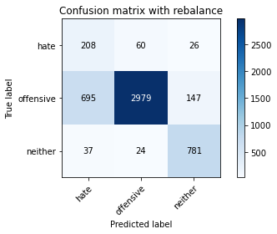

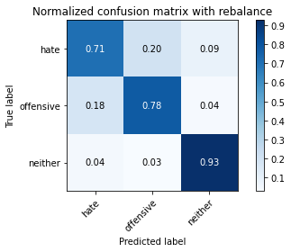

precision recall f1-score support

hate 0.22 0.71 0.34 294

offensive 0.97 0.78 0.87 3821

neither 0.82 0.93 0.87 842

accuracy 0.80 4957

macro avg 0.67 0.80 0.69 4957

weighted avg 0.90 0.80 0.83 4957

average eval_loss: 0.8521678371227256, accuracy: 0.8004841638087553

training 9 epoch...

65.46217107772827 seconds used......

9 training finished! average train loss: 0.020871016338851564

evaluating...

Confusion matrix, without normalization

[[ 217 58 19]

[ 806 2906 109]

[ 86 27 729]]

Normalized confusion matrix

[[0.73809524 0.19727891 0.06462585]

[0.21093954 0.76053389 0.02852656]

[0.10213777 0.03206651 0.86579572]]

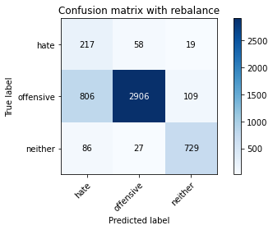

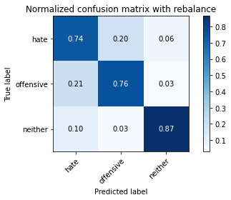

precision recall f1-score support

hate 0.20 0.74 0.31 294

offensive 0.97 0.76 0.85 3821

neither 0.85 0.87 0.86 842

accuracy 0.78 4957

macro avg 0.67 0.79 0.67 4957

weighted avg 0.91 0.78 0.82 4957

average eval_loss: 0.9641988419161569, accuracy: 0.7770829130522493

training 10 epoch...

65.37426257133484 seconds used......

10 training finished! average train loss: 0.020293866436518673

evaluating...

Confusion matrix, without normalization

[[ 208 63 23]

[ 669 3051 101]

[ 56 39 747]]

Normalized confusion matrix

[[0.70748299 0.21428571 0.07823129]

[0.17508506 0.79848207 0.02643287]

[0.06650831 0.04631829 0.8871734 ]]

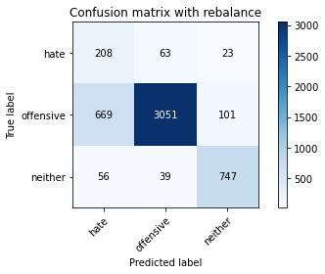

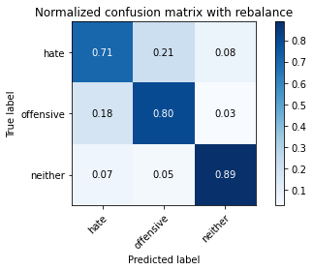

precision recall f1-score support

hate 0.22 0.71 0.34 294

offensive 0.97 0.80 0.87 3821

neither 0.86 0.89 0.87 842

accuracy 0.81 4957

macro avg 0.68 0.80 0.70 4957

weighted avg 0.90 0.81 0.84 4957

average eval_loss: 0.9356423474251172, accuracy: 0.8081500907807141

2 run

training 1 epoch...

66.56795501708984 seconds used......

1 training finished! average train loss: 0.6542250911394755

evaluating...

Confusion matrix, without normalization

[[ 235 27 32]

[1368 2265 188]

[ 44 9 789]]

Normalized confusion matrix

[[0.79931973 0.09183673 0.10884354]

[0.35802146 0.59277676 0.04920178]

[0.05225653 0.01068884 0.93705463]]

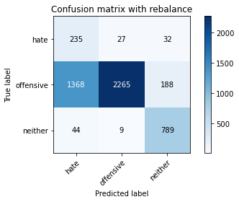

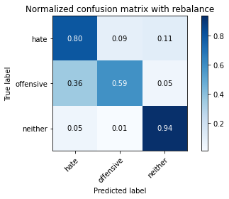

precision recall f1-score support

hate 0.14 0.80 0.24 294

offensive 0.98 0.59 0.74 3821

neither 0.78 0.94 0.85 842

accuracy 0.66 4957

macro avg 0.64 0.78 0.61 4957

weighted avg 0.90 0.66 0.73 4957

average eval_loss: 0.729627710076109, accuracy: 0.6635061529150696

training 2 epoch...

65.8059561252594 seconds used......

2 training finished! average train loss: 0.3697460257170493

evaluating...

Confusion matrix, without normalization

[[ 210 49 35]

[ 784 2876 161]

[ 44 10 788]]

Normalized confusion matrix

[[0.71428571 0.16666667 0.11904762]

[0.20518189 0.75268254 0.04213557]

[0.05225653 0.01187648 0.93586698]]

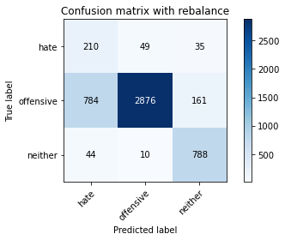

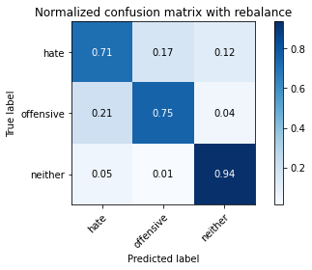

precision recall f1-score support

hate 0.20 0.71 0.32 294

offensive 0.98 0.75 0.85 3821

neither 0.80 0.94 0.86 842

accuracy 0.78 4957

macro avg 0.66 0.80 0.68 4957

weighted avg 0.90 0.78 0.82 4957

average eval_loss: 0.5203896567165371, accuracy: 0.7815210812991729

training 3 epoch...

65.79611945152283 seconds used......

3 training finished! average train loss: 0.24796316755271097

evaluating...

Confusion matrix, without normalization

[[ 215 48 31]

[ 842 2810 169]

[ 32 10 800]]

Normalized confusion matrix

[[0.73129252 0.16326531 0.10544218]

[0.22036116 0.73540958 0.04422926]

[0.03800475 0.01187648 0.95011876]]

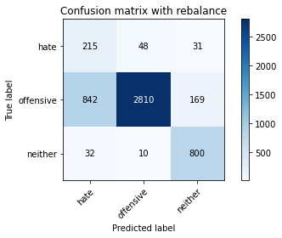

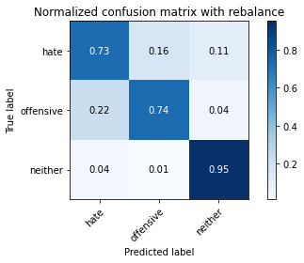

precision recall f1-score support

hate 0.20 0.73 0.31 294

offensive 0.98 0.74 0.84 3821

neither 0.80 0.95 0.87 842

accuracy 0.77 4957

macro avg 0.66 0.81 0.67 4957

weighted avg 0.90 0.77 0.81 4957

average eval_loss: 0.5915532664005314, accuracy: 0.7716360702037522

training 4 epoch...

65.88086652755737 seconds used......

4 training finished! average train loss: 0.15413882531639603

evaluating...

Confusion matrix, without normalization

[[ 236 37 21]

[1063 2612 146]

[ 60 14 768]]

Normalized confusion matrix

[[0.80272109 0.12585034 0.07142857]

[0.27819942 0.68359068 0.03820989]

[0.07125891 0.01662708 0.91211401]]

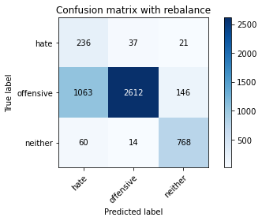

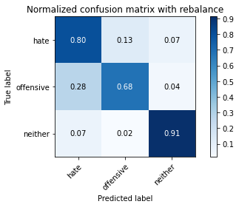

precision recall f1-score support

hate 0.17 0.80 0.29 294

offensive 0.98 0.68 0.81 3821

neither 0.82 0.91 0.86 842

accuracy 0.73 4957

macro avg 0.66 0.80 0.65 4957

weighted avg 0.91 0.73 0.78 4957

average eval_loss: 0.7487090506380604, accuracy: 0.7294734718579786

training 5 epoch...

65.74779295921326 seconds used......

5 training finished! average train loss: 0.09375418066891314

evaluating...

Confusion matrix, without normalization

[[ 225 54 15]

[ 734 3016 71]

[ 86 39 717]]

Normalized confusion matrix

[[0.76530612 0.18367347 0.05102041]

[0.19209631 0.78932217 0.01858152]

[0.10213777 0.04631829 0.85154394]]

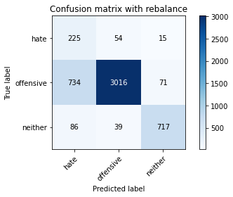

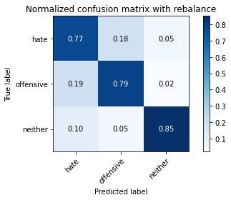

precision recall f1-score support

hate 0.22 0.77 0.34 294

offensive 0.97 0.79 0.87 3821

neither 0.89 0.85 0.87 842

accuracy 0.80 4957

macro avg 0.69 0.80 0.69 4957

weighted avg 0.91 0.80 0.84 4957

average eval_loss: 0.6858203662859816, accuracy: 0.7984668146056082

training 6 epoch...

65.52494144439697 seconds used......

6 training finished! average train loss: 0.058156943171998564

evaluating...

Confusion matrix, without normalization

[[ 222 51 21]

[ 822 2864 135]

[ 53 17 772]]

Normalized confusion matrix

[[0.75510204 0.17346939 0.07142857]

[0.21512693 0.749542 0.03533107]

[0.06294537 0.02019002 0.91686461]]

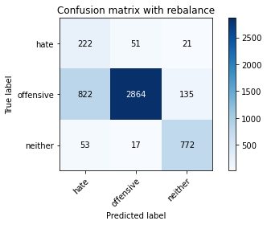

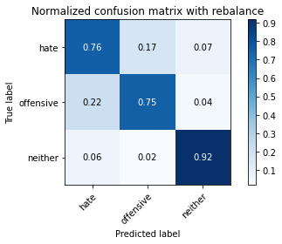

precision recall f1-score support

hate 0.20 0.76 0.32 294

offensive 0.98 0.75 0.85 3821

neither 0.83 0.92 0.87 842

accuracy 0.78 4957

macro avg 0.67 0.81 0.68 4957

weighted avg 0.91 0.78 0.82 4957

average eval_loss: 0.7750439057051535, accuracy: 0.7782933225741376

training 7 epoch...

65.48915815353394 seconds used......

7 training finished! average train loss: 0.023900262826961078

evaluating...

Confusion matrix, without normalization

[[ 219 59 16]

[ 616 3101 104]

[ 56 26 760]]

Normalized confusion matrix

[[0.74489796 0.20068027 0.05442177]

[0.16121434 0.81156765 0.02721801]

[0.06650831 0.03087886 0.90261283]]

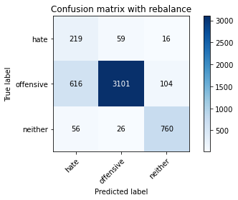

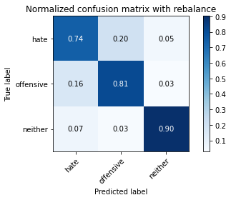

precision recall f1-score support

hate 0.25 0.74 0.37 294

offensive 0.97 0.81 0.89 3821

neither 0.86 0.90 0.88 842

accuracy 0.82 4957

macro avg 0.69 0.82 0.71 4957

weighted avg 0.91 0.82 0.85 4957

average eval_loss: 0.8592218765613413, accuracy: 0.8230784748840024

training 8 epoch...

65.73828673362732 seconds used......

8 training finished! average train loss: 0.02492082192309266

evaluating...

Confusion matrix, without normalization

[[ 226 52 16]

[ 809 2924 88]

[ 82 41 719]]

Normalized confusion matrix

[[0.76870748 0.17687075 0.05442177]

[0.21172468 0.7652447 0.02303062]

[0.09738717 0.04869359 0.85391924]]

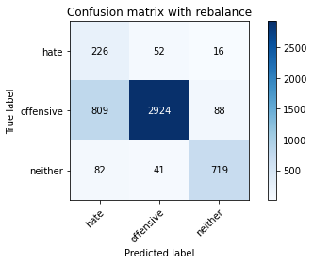

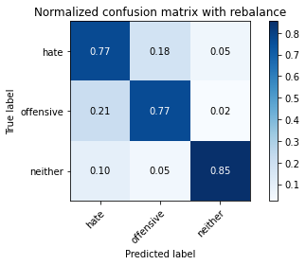

precision recall f1-score support

hate 0.20 0.77 0.32 294

offensive 0.97 0.77 0.86 3821

neither 0.87 0.85 0.86 842

accuracy 0.78 4957

macro avg 0.68 0.80 0.68 4957

weighted avg 0.91 0.78 0.82 4957

average eval_loss: 0.9766982579171928, accuracy: 0.7805124066975994

training 9 epoch...

65.59917855262756 seconds used......

9 training finished! average train loss: 0.023621456910330497

evaluating...

Confusion matrix, without normalization

[[ 239 42 13]

[1191 2551 79]

[ 127 19 696]]

Normalized confusion matrix

[[0.81292517 0.14285714 0.04421769]

[0.31169851 0.66762628 0.02067522]

[0.15083135 0.02256532 0.82660333]]

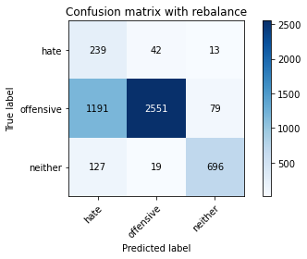

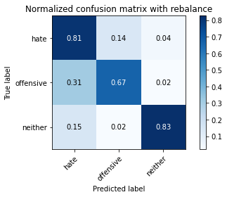

precision recall f1-score support

hate 0.15 0.81 0.26 294

offensive 0.98 0.67 0.79 3821

neither 0.88 0.83 0.85 842

accuracy 0.70 4957

macro avg 0.67 0.77 0.64 4957

weighted avg 0.91 0.70 0.77 4957

average eval_loss: 1.4180322240497316, accuracy: 0.7032479322170668

training 10 epoch...

65.78672504425049 seconds used......

10 training finished! average train loss: 0.030010134503531287

evaluating...

Confusion matrix, without normalization

[[ 213 61 20]

[ 629 3074 118]

[ 55 22 765]]

Normalized confusion matrix

[[0.7244898 0.20748299 0.06802721]

[0.16461659 0.80450144 0.03088197]

[0.06532067 0.02612827 0.90855107]]

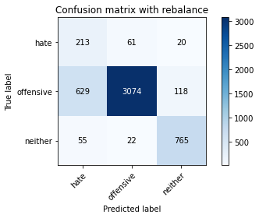

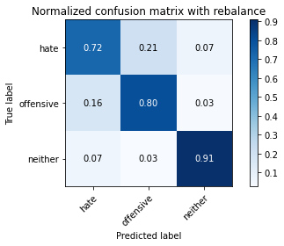

precision recall f1-score support

hate 0.24 0.72 0.36 294

offensive 0.97 0.80 0.88 3821

neither 0.85 0.91 0.88 842

accuracy 0.82 4957

macro avg 0.69 0.81 0.71 4957

weighted avg 0.91 0.82 0.85 4957

average eval_loss: 0.8817181275977243, accuracy: 0.8174298971151907

3 run

training 1 epoch...

65.64424061775208 seconds used......

1 training finished! average train loss: 0.6327750919855128

evaluating...

Confusion matrix, without normalization

[[ 212 52 30]

[ 695 2966 160]

[ 39 12 791]]

Normalized confusion matrix

[[0.72108844 0.17687075 0.10204082]

[0.18188956 0.77623659 0.04187386]

[0.04631829 0.01425178 0.93942993]]

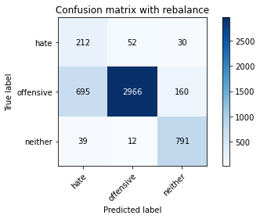

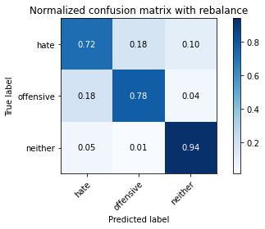

precision recall f1-score support

hate 0.22 0.72 0.34 294

offensive 0.98 0.78 0.87 3821

neither 0.81 0.94 0.87 842

accuracy 0.80 4957

macro avg 0.67 0.81 0.69 4957

weighted avg 0.90 0.80 0.84 4957

average eval_loss: 0.44572453164765913, accuracy: 0.80068589872907

training 2 epoch...

65.7442455291748 seconds used......

2 training finished! average train loss: 0.3702781199101816

evaluating...

Confusion matrix, without normalization

[[ 225 46 23]

[ 772 2898 151]

[ 55 10 777]]

Normalized confusion matrix

[[0.76530612 0.15646259 0.07823129]

[0.20204135 0.7584402 0.03951845]

[0.06532067 0.01187648 0.92280285]]

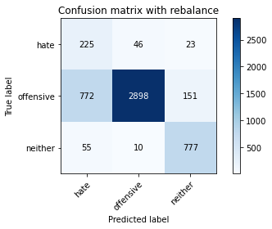

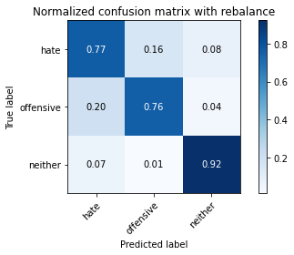

precision recall f1-score support

hate 0.21 0.77 0.33 294

offensive 0.98 0.76 0.86 3821

neither 0.82 0.92 0.87 842

accuracy 0.79 4957

macro avg 0.67 0.82 0.69 4957

weighted avg 0.91 0.79 0.83 4957

average eval_loss: 0.5107434857035836, accuracy: 0.7867661892273553

training 3 epoch...

65.73414134979248 seconds used......

3 training finished! average train loss: 0.23652667295165927

evaluating...

Confusion matrix, without normalization

[[ 238 36 20]

[ 907 2773 141]

[ 36 16 790]]

Normalized confusion matrix

[[0.80952381 0.12244898 0.06802721]

[0.23737242 0.72572625 0.03690133]

[0.04275534 0.01900238 0.93824228]]

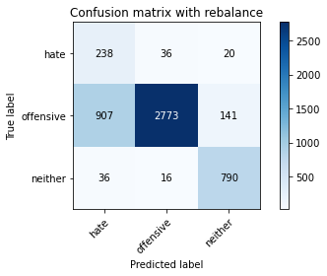

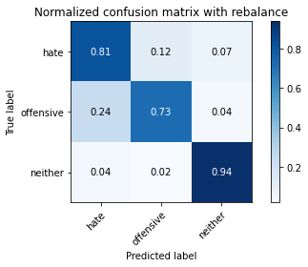

precision recall f1-score support

hate 0.20 0.81 0.32 294

offensive 0.98 0.73 0.83 3821

neither 0.83 0.94 0.88 842

accuracy 0.77 4957

macro avg 0.67 0.82 0.68 4957

weighted avg 0.91 0.77 0.81 4957

average eval_loss: 0.5614430149641609, accuracy: 0.7667944321161994

training 4 epoch...

65.60338115692139 seconds used......

4 training finished! average train loss: 0.14877260114169782

evaluating...

Confusion matrix, without normalization

[[ 242 33 19]

[1092 2622 107]

[ 68 24 750]]

Normalized confusion matrix

[[0.82312925 0.1122449 0.06462585]

[0.28578906 0.6862078 0.02800314]

[0.0807601 0.02850356 0.89073634]]

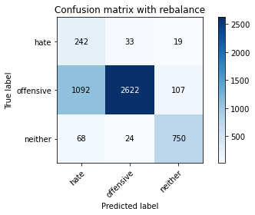

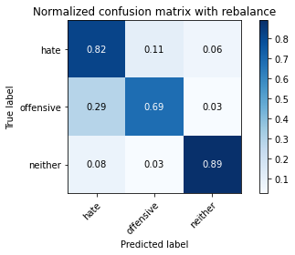

precision recall f1-score support

hate 0.17 0.82 0.29 294

offensive 0.98 0.69 0.81 3821

neither 0.86 0.89 0.87 842

accuracy 0.73 4957

macro avg 0.67 0.80 0.66 4957

weighted avg 0.91 0.73 0.79 4957

average eval_loss: 0.7771697392567031, accuracy: 0.7290700020173492

training 5 epoch...

65.60522794723511 seconds used......

5 training finished! average train loss: 0.09196059001413615

evaluating...

Confusion matrix, without normalization

[[ 222 53 19]

[ 731 2974 116]

[ 44 30 768]]

Normalized confusion matrix

[[0.75510204 0.18027211 0.06462585]

[0.19131118 0.77833028 0.03035854]

[0.05225653 0.03562945 0.91211401]]

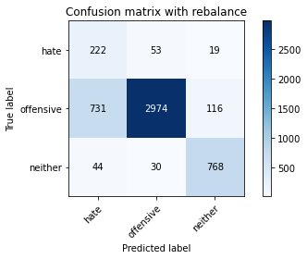

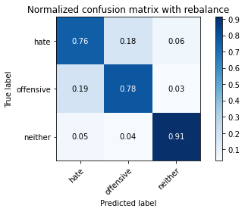

precision recall f1-score support

hate 0.22 0.76 0.34 294

offensive 0.97 0.78 0.86 3821

neither 0.85 0.91 0.88 842

accuracy 0.80 4957

macro avg 0.68 0.82 0.70 4957

weighted avg 0.91 0.80 0.84 4957

average eval_loss: 0.6754979804259604, accuracy: 0.7996772241274964

training 6 epoch...

65.58758211135864 seconds used......

6 training finished! average train loss: 0.06864713775456954

evaluating...

Confusion matrix, without normalization

[[ 225 52 17]

[ 753 2938 130]

[ 61 39 742]]

Normalized confusion matrix

[[0.76530612 0.17687075 0.05782313]

[0.19706883 0.76890866 0.03402251]

[0.07244656 0.04631829 0.88123515]]

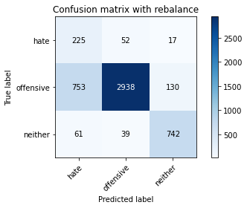

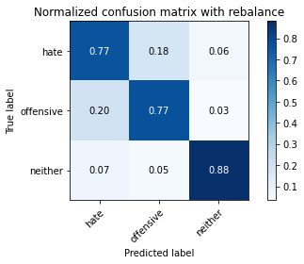

precision recall f1-score support

hate 0.22 0.77 0.34 294

offensive 0.97 0.77 0.86 3821

neither 0.83 0.88 0.86 842

accuracy 0.79 4957

macro avg 0.67 0.81 0.68 4957

weighted avg 0.90 0.79 0.83 4957

average eval_loss: 0.7485441537498827, accuracy: 0.7877748638289288

training 7 epoch...

65.50223422050476 seconds used......

7 training finished! average train loss: 0.03725965649205429

evaluating...

Confusion matrix, without normalization

[[ 232 43 19]

[ 919 2772 130]

[ 52 20 770]]

Normalized confusion matrix

[[0.78911565 0.1462585 0.06462585]

[0.24051295 0.72546454 0.03402251]

[0.06175772 0.02375297 0.91448931]]

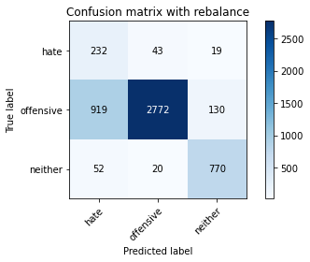

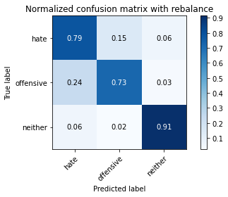

precision recall f1-score support

hate 0.19 0.79 0.31 294

offensive 0.98 0.73 0.83 3821

neither 0.84 0.91 0.87 842

accuracy 0.76 4957

macro avg 0.67 0.81 0.67 4957

weighted avg 0.91 0.76 0.81 4957

average eval_loss: 1.0009282636531298, accuracy: 0.7613475892677022

training 8 epoch...

65.64418029785156 seconds used......

8 training finished! average train loss: 0.039052529037897396

evaluating...

Confusion matrix, without normalization

[[ 212 61 21]

[ 681 3031 109]

[ 46 27 769]]

Normalized confusion matrix

[[0.72108844 0.20748299 0.07142857]

[0.1782256 0.79324784 0.02852656]

[0.05463183 0.03206651 0.91330166]]

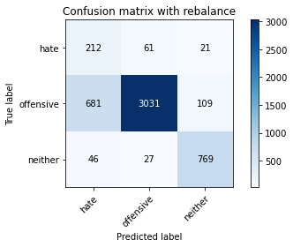

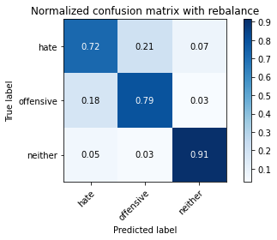

precision recall f1-score support

hate 0.23 0.72 0.34 294

offensive 0.97 0.79 0.87 3821

neither 0.86 0.91 0.88 842

accuracy 0.81 4957

macro avg 0.68 0.81 0.70 4957

weighted avg 0.91 0.81 0.84 4957

average eval_loss: 0.9021622219813927, accuracy: 0.8093605003026024

training 9 epoch...

65.64455389976501 seconds used......

9 training finished! average train loss: 0.014272555765220678

evaluating...

Confusion matrix, without normalization

[[ 206 71 17]

[ 630 3093 98]

[ 52 33 757]]

Normalized confusion matrix

[[0.70068027 0.2414966 0.05782313]

[0.1648783 0.80947396 0.02564774]

[0.06175772 0.0391924 0.89904988]]

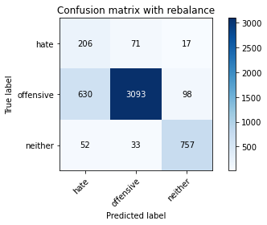

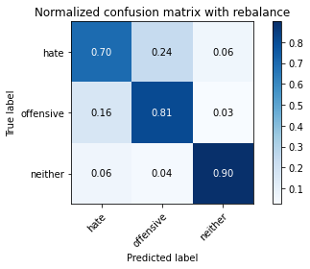

precision recall f1-score support

hate 0.23 0.70 0.35 294

offensive 0.97 0.81 0.88 3821

neither 0.87 0.90 0.88 842

accuracy 0.82 4957

macro avg 0.69 0.80 0.70 4957

weighted avg 0.91 0.82 0.85 4957

average eval_loss: 0.8974441693271435, accuracy: 0.8182368367964494

training 10 epoch...

65.74091982841492 seconds used......

10 training finished! average train loss: 0.012517853177932761

evaluating...

Confusion matrix, without normalization

[[ 210 66 18]

[ 629 3099 93]

[ 49 33 760]]

Normalized confusion matrix

[[0.71428571 0.2244898 0.06122449]

[0.16461659 0.81104423 0.02433918]

[0.05819477 0.0391924 0.90261283]]

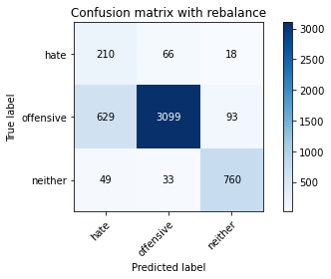

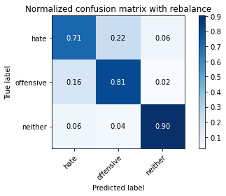

precision recall f1-score support

hate 0.24 0.71 0.36 294

offensive 0.97 0.81 0.88 3821

neither 0.87 0.90 0.89 842

accuracy 0.82 4957

macro avg 0.69 0.81 0.71 4957

weighted avg 0.91 0.82 0.85 4957

average eval_loss: 0.9419974838405794, accuracy: 0.8208593907605406

4 run

training 1 epoch...

62.82551574707031 seconds used......

1 training finished! average train loss: 0.6485489776782822

evaluating...

Confusion matrix, without normalization

[[ 232 38 24]

[ 854 2814 153]

[ 69 10 763]]

Normalized confusion matrix

[[0.78911565 0.1292517 0.08163265]

[0.2235017 0.73645643 0.04004187]

[0.08194774 0.01187648 0.90617577]]

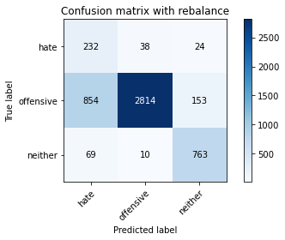

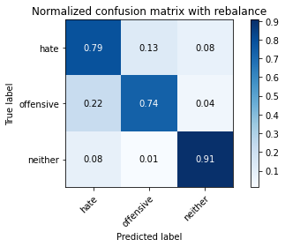

precision recall f1-score support

hate 0.20 0.79 0.32 294

offensive 0.98 0.74 0.84 3821

neither 0.81 0.91 0.86 842

accuracy 0.77 4957

macro avg 0.67 0.81 0.67 4957

weighted avg 0.91 0.77 0.81 4957

average eval_loss: 0.6087184367948267, accuracy: 0.768408311478717

training 2 epoch...

62.114293813705444 seconds used......

2 training finished! average train loss: 0.38654677988144387

evaluating...

Confusion matrix, without normalization

[[ 234 37 23]

[ 924 2767 130]

[ 52 15 775]]

Normalized confusion matrix

[[0.79591837 0.12585034 0.07823129]

[0.24182151 0.72415598 0.03402251]

[0.06175772 0.01781473 0.92042755]]

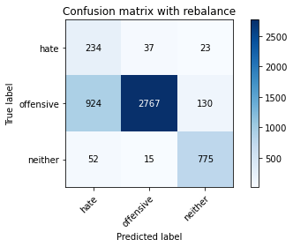

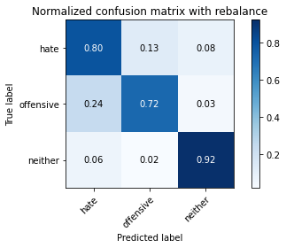

precision recall f1-score support

hate 0.19 0.80 0.31 294

offensive 0.98 0.72 0.83 3821

neither 0.84 0.92 0.88 842

accuracy 0.76 4957

macro avg 0.67 0.81 0.67 4957

weighted avg 0.91 0.76 0.81 4957

average eval_loss: 0.5360912786549833, accuracy: 0.7617510591083316

training 3 epoch...

62.01846122741699 seconds used......

3 training finished! average train loss: 0.27137546554992076

evaluating...

Confusion matrix, without normalization

[[ 239 44 11]

[ 972 2765 84]

[ 100 29 713]]

Normalized confusion matrix

[[0.81292517 0.14965986 0.03741497]

[0.25438367 0.72363256 0.02198377]

[0.11876485 0.03444181 0.84679335]]

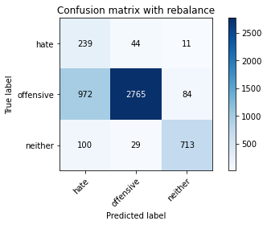

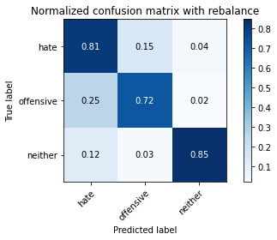

precision recall f1-score support

hate 0.18 0.81 0.30 294

offensive 0.97 0.72 0.83 3821

neither 0.88 0.85 0.86 842

accuracy 0.75 4957

macro avg 0.68 0.79 0.66 4957

weighted avg 0.91 0.75 0.80 4957

average eval_loss: 0.6090252720806972, accuracy: 0.749848698809764

training 4 epoch...

62.10931396484375 seconds used......

4 training finished! average train loss: 0.1723173303496942

evaluating...

Confusion matrix, without normalization

[[ 235 41 18]

[1038 2664 119]

[ 78 21 743]]

Normalized confusion matrix

[[0.79931973 0.13945578 0.06122449]

[0.27165663 0.69719969 0.03114368]

[0.09263658 0.02494062 0.8824228 ]]

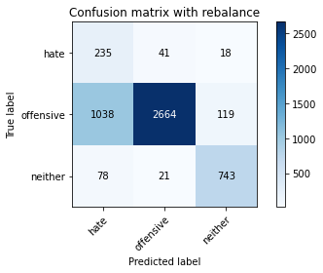

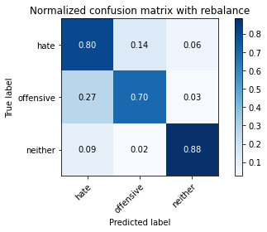

precision recall f1-score support

hate 0.17 0.80 0.29 294

offensive 0.98 0.70 0.81 3821

neither 0.84 0.88 0.86 842

accuracy 0.73 4957

macro avg 0.67 0.79 0.65 4957

weighted avg 0.91 0.73 0.79 4957

average eval_loss: 0.7395666220999626, accuracy: 0.734718579786161

training 5 epoch...

62.041640758514404 seconds used......

5 training finished! average train loss: 0.10235447691459405

evaluating...

Confusion matrix, without normalization

[[ 206 68 20]

[ 575 3109 137]

[ 48 31 763]]

Normalized confusion matrix

[[0.70068027 0.23129252 0.06802721]

[0.15048417 0.81366135 0.03585449]

[0.05700713 0.0368171 0.90617577]]

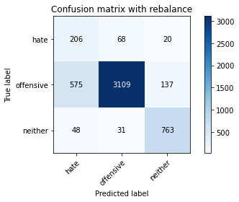

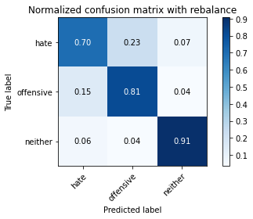

precision recall f1-score support

hate 0.25 0.70 0.37 294

offensive 0.97 0.81 0.88 3821

neither 0.83 0.91 0.87 842

accuracy 0.82 4957

macro avg 0.68 0.81 0.71 4957

weighted avg 0.90 0.82 0.85 4957

average eval_loss: 0.5982135506683445, accuracy: 0.822675005043373

training 6 epoch...

62.113834381103516 seconds used......

6 training finished! average train loss: 0.06468499517231657

evaluating...

Confusion matrix, without normalization

[[ 221 54 19]

[ 773 2919 129]

[ 55 25 762]]

Normalized confusion matrix

[[0.75170068 0.18367347 0.06462585]

[0.20230306 0.76393614 0.0337608 ]

[0.06532067 0.02969121 0.90498812]]

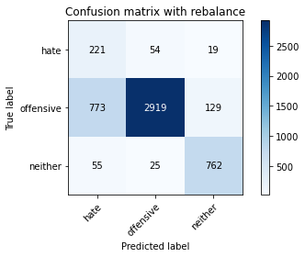

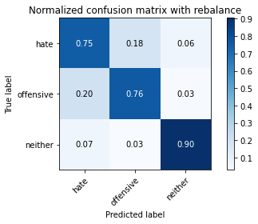

precision recall f1-score support

hate 0.21 0.75 0.33 294

offensive 0.97 0.76 0.86 3821

neither 0.84 0.90 0.87 842

accuracy 0.79 4957

macro avg 0.67 0.81 0.69 4957

weighted avg 0.91 0.79 0.83 4957

average eval_loss: 0.7997467430779733, accuracy: 0.7871696590679846

training 7 epoch...

62.102883100509644 seconds used......

7 training finished! average train loss: 0.04861834836233277

evaluating...

Confusion matrix, without normalization

[[ 208 64 22]

[ 668 3025 128]

[ 48 30 764]]

Normalized confusion matrix

[[0.70748299 0.21768707 0.07482993]

[0.17482334 0.79167757 0.03349908]

[0.05700713 0.03562945 0.90736342]]

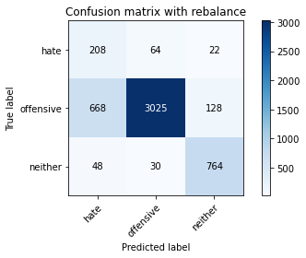

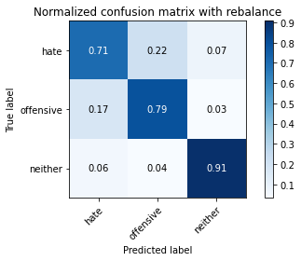

precision recall f1-score support

hate 0.23 0.71 0.34 294

offensive 0.97 0.79 0.87 3821

neither 0.84 0.91 0.87 842

accuracy 0.81 4957

macro avg 0.68 0.80 0.69 4957

weighted avg 0.90 0.81 0.84 4957

average eval_loss: 0.7930916313485927, accuracy: 0.8063344764978818

training 8 epoch...

62.027759313583374 seconds used......

8 training finished! average train loss: 0.03424171182498532

evaluating...

Confusion matrix, without normalization

[[ 202 76 16]

[ 555 3170 96]

[ 60 42 740]]

Normalized confusion matrix

[[0.68707483 0.2585034 0.05442177]

[0.14524993 0.82962575 0.02512431]

[0.07125891 0.04988124 0.87885986]]

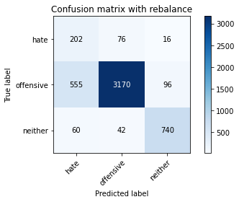

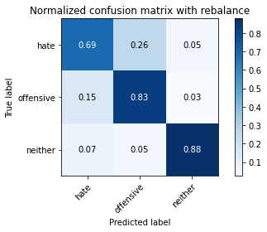

precision recall f1-score support

hate 0.25 0.69 0.36 294

offensive 0.96 0.83 0.89 3821

neither 0.87 0.88 0.87 842

accuracy 0.83 4957

macro avg 0.69 0.80 0.71 4957

weighted avg 0.91 0.83 0.86 4957

average eval_loss: 0.783417336149029, accuracy: 0.829533992334073

training 9 epoch...

62.0592086315155 seconds used......

9 training finished! average train loss: 0.024759143906984513

evaluating...

Confusion matrix, without normalization

[[ 195 83 16]

[ 512 3210 99]

[ 58 43 741]]

Normalized confusion matrix

[[0.66326531 0.28231293 0.05442177]

[0.13399634 0.84009422 0.02590945]

[0.06888361 0.05106888 0.88004751]]

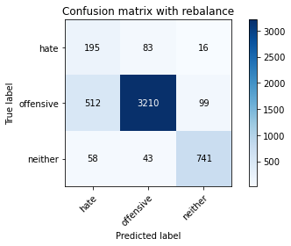

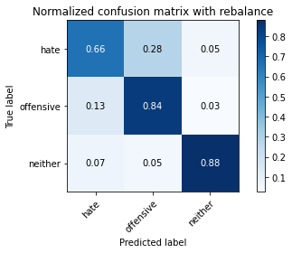

precision recall f1-score support

hate 0.25 0.66 0.37 294

offensive 0.96 0.84 0.90 3821

neither 0.87 0.88 0.87 842

accuracy 0.84 4957

macro avg 0.69 0.79 0.71 4957

weighted avg 0.90 0.84 0.86 4957

average eval_loss: 0.8356018088398928, accuracy: 0.8363929796247731

training 10 epoch...

62.02635383605957 seconds used......

10 training finished! average train loss: 0.014794823843291388

evaluating...

Confusion matrix, without normalization

[[ 196 84 14]

[ 554 3172 95]

[ 65 36 741]]

Normalized confusion matrix

[[0.66666667 0.28571429 0.04761905]

[0.14498822 0.83014918 0.0248626 ]

[0.07719715 0.04275534 0.88004751]]

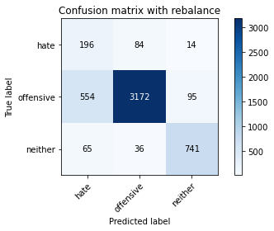

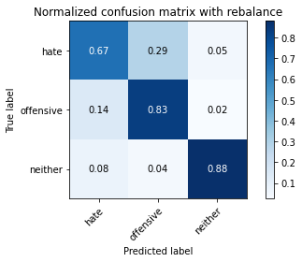

precision recall f1-score support

hate 0.24 0.67 0.35 294

offensive 0.96 0.83 0.89 3821

neither 0.87 0.88 0.88 842

accuracy 0.83 4957

macro avg 0.69 0.79 0.71 4957

weighted avg 0.91 0.83 0.86 4957

average eval_loss: 0.8892945445714945, accuracy: 0.8289287875731289

5 run

training 1 epoch...

65.37838554382324 seconds used......

1 training finished! average train loss: 0.6340872833603307

evaluating...

Confusion matrix, without normalization

[[ 203 51 40]

[ 634 2939 248]

[ 29 9 804]]

Normalized confusion matrix

[[0.69047619 0.17346939 0.13605442]

[0.16592515 0.76917037 0.06490448]

[0.03444181 0.01068884 0.95486936]]

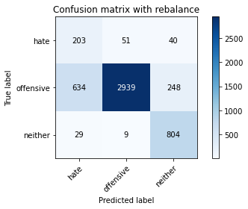

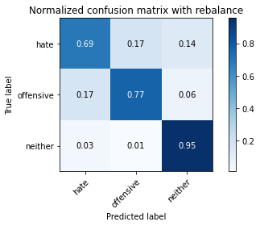

precision recall f1-score support

hate 0.23 0.69 0.35 294

offensive 0.98 0.77 0.86 3821

neither 0.74 0.95 0.83 842

accuracy 0.80 4957

macro avg 0.65 0.80 0.68 4957

weighted avg 0.89 0.80 0.83 4957

average eval_loss: 0.4795402461182206, accuracy: 0.7960459955618318

training 2 epoch...

65.48170590400696 seconds used......

2 training finished! average train loss: 0.3684890819223304

evaluating...

Confusion matrix, without normalization

[[ 231 43 20]

[ 885 2791 145]

[ 57 8 777]]

Normalized confusion matrix

[[0.78571429 0.1462585 0.06802721]

[0.23161476 0.73043706 0.03794818]

[0.06769596 0.00950119 0.92280285]]

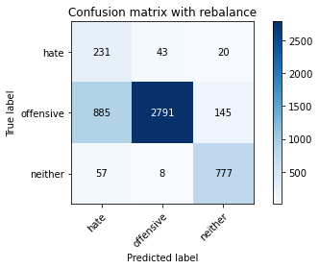

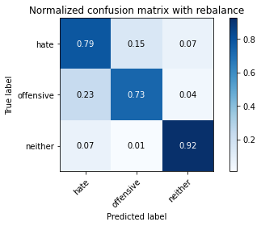

precision recall f1-score support

hate 0.20 0.79 0.31 294

offensive 0.98 0.73 0.84 3821

neither 0.82 0.92 0.87 842

accuracy 0.77 4957

macro avg 0.67 0.81 0.67 4957

weighted avg 0.91 0.77 0.81 4957

average eval_loss: 0.5044888709221156, accuracy: 0.7663909622755699

training 3 epoch...

65.36407518386841 seconds used......

3 training finished! average train loss: 0.23353236040089562

evaluating...

Confusion matrix, without normalization

[[ 227 43 24]

[ 875 2799 147]

[ 56 13 773]]

Normalized confusion matrix

[[0.77210884 0.1462585 0.08163265]

[0.22899764 0.73253075 0.0384716 ]

[0.06650831 0.01543943 0.91805226]]

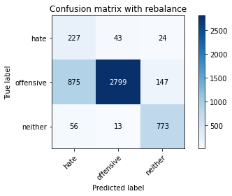

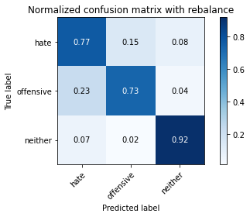

precision recall f1-score support

hate 0.20 0.77 0.31 294

offensive 0.98 0.73 0.84 3821

neither 0.82 0.92 0.87 842

accuracy 0.77 4957

macro avg 0.67 0.81 0.67 4957

weighted avg 0.91 0.77 0.81 4957

average eval_loss: 0.5652827137119828, accuracy: 0.7663909622755699

training 4 epoch...

65.43056273460388 seconds used......

4 training finished! average train loss: 0.1434913048335509

evaluating...

Confusion matrix, without normalization

[[ 235 35 24]

[ 922 2761 138]

[ 52 17 773]]

Normalized confusion matrix

[[0.79931973 0.11904762 0.08163265]

[0.24129809 0.72258571 0.0361162 ]

[0.06175772 0.02019002 0.91805226]]

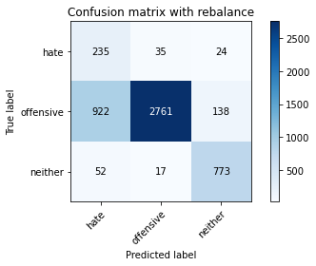

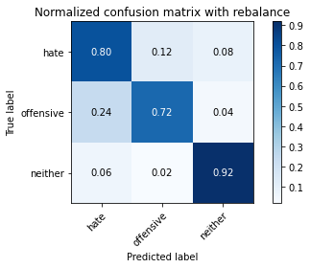

precision recall f1-score support

hate 0.19 0.80 0.31 294

offensive 0.98 0.72 0.83 3821

neither 0.83 0.92 0.87 842

accuracy 0.76 4957

macro avg 0.67 0.81 0.67 4957

weighted avg 0.91 0.76 0.81 4957

average eval_loss: 0.6856824478224641, accuracy: 0.7603389146661287

training 5 epoch...

65.4148690700531 seconds used......

5 training finished! average train loss: 0.09228015557879157

evaluating...

Confusion matrix, without normalization

[[ 235 45 14]

[ 955 2782 84]

[ 82 15 745]]

Normalized confusion matrix

[[0.79931973 0.15306122 0.04761905]

[0.24993457 0.72808165 0.02198377]

[0.09738717 0.01781473 0.8847981 ]]

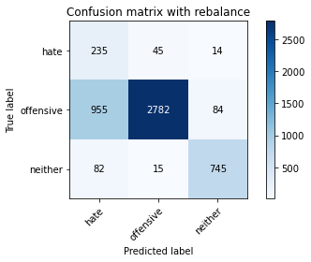

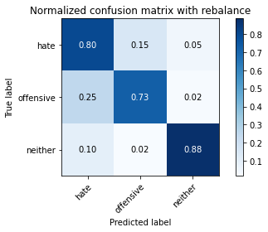

precision recall f1-score support

hate 0.18 0.80 0.30 294

offensive 0.98 0.73 0.84 3821

neither 0.88 0.88 0.88 842

accuracy 0.76 4957

macro avg 0.68 0.80 0.67 4957

weighted avg 0.92 0.76 0.81 4957

average eval_loss: 0.8157105764764692, accuracy: 0.7589267702239257

training 6 epoch...

65.39165782928467 seconds used......

6 training finished! average train loss: 0.06008357265882455

evaluating...

Confusion matrix, without normalization

[[ 215 51 28]

[ 659 3030 132]

[ 40 19 783]]

Normalized confusion matrix

[[0.73129252 0.17346939 0.0952381 ]

[0.17246794 0.79298613 0.03454593]

[0.04750594 0.02256532 0.92992874]]

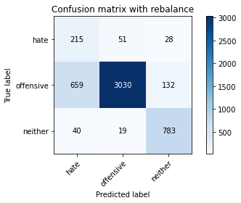

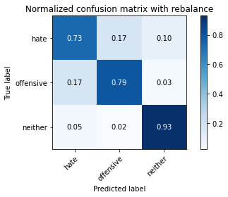

precision recall f1-score support

hate 0.24 0.73 0.36 294

offensive 0.98 0.79 0.88 3821

neither 0.83 0.93 0.88 842

accuracy 0.81 4957

macro avg 0.68 0.82 0.70 4957

weighted avg 0.91 0.81 0.85 4957

average eval_loss: 0.688658194120733, accuracy: 0.8125882590276376

training 7 epoch...

65.34903717041016 seconds used......

7 training finished! average train loss: 0.04678096616305737

evaluating...

Confusion matrix, without normalization

[[ 244 38 12]

[1193 2546 82]

[ 86 22 734]]

Normalized confusion matrix

[[0.82993197 0.1292517 0.04081633]

[0.31222193 0.66631772 0.02146035]

[0.10213777 0.02612827 0.87173397]]

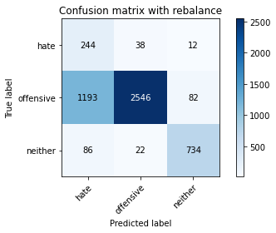

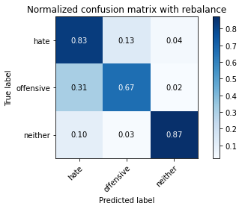

precision recall f1-score support

hate 0.16 0.83 0.27 294

offensive 0.98 0.67 0.79 3821

neither 0.89 0.87 0.88 842

accuracy 0.71 4957

macro avg 0.67 0.79 0.65 4957

weighted avg 0.91 0.71 0.78 4957

average eval_loss: 1.2056137663762896, accuracy: 0.7109138591890256

training 8 epoch...

65.38227963447571 seconds used......

8 training finished! average train loss: 0.019404973522780398

evaluating...

Confusion matrix, without normalization

[[ 227 55 12]

[ 787 2953 81]

[ 93 26 723]]

Normalized confusion matrix

[[0.77210884 0.18707483 0.04081633]

[0.20596702 0.77283434 0.02119864]

[0.11045131 0.03087886 0.85866983]]

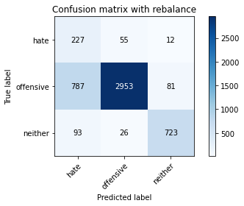

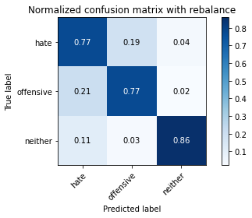

precision recall f1-score support

hate 0.21 0.77 0.32 294

offensive 0.97 0.77 0.86 3821

neither 0.89 0.86 0.87 842

accuracy 0.79 4957

macro avg 0.69 0.80 0.69 4957

weighted avg 0.91 0.79 0.83 4957

average eval_loss: 1.0223986328985062, accuracy: 0.7873713939882994

training 9 epoch...

65.61998248100281 seconds used......

9 training finished! average train loss: 0.022813162203467647

evaluating...

Confusion matrix, without normalization

[[ 218 52 24]

[ 688 3021 112]

[ 31 36 775]]

Normalized confusion matrix

[[0.7414966 0.17687075 0.08163265]

[0.18005758 0.79063072 0.0293117 ]

[0.0368171 0.04275534 0.92042755]]

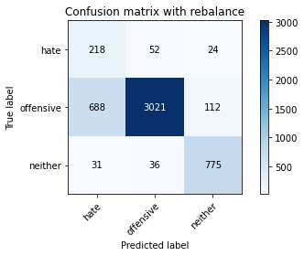

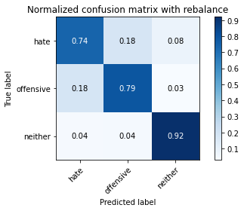

precision recall f1-score support

hate 0.23 0.74 0.35 294

offensive 0.97 0.79 0.87 3821

neither 0.85 0.92 0.88 842

accuracy 0.81 4957

macro avg 0.69 0.82 0.70 4957

weighted avg 0.91 0.81 0.84 4957

average eval_loss: 0.8626743382999613, accuracy: 0.8097639701432318

training 10 epoch...

65.3620958328247 seconds used......

10 training finished! average train loss: 0.01141544329839873

evaluating...

Confusion matrix, without normalization

[[ 218 52 24]

[ 806 2895 120]

[ 52 21 769]]

Normalized confusion matrix

[[0.7414966 0.17687075 0.08163265]

[0.21093954 0.75765506 0.03140539]

[0.06175772 0.02494062 0.91330166]]

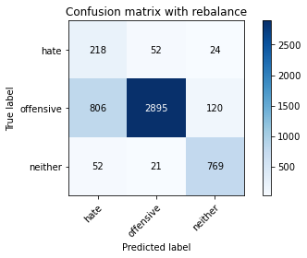

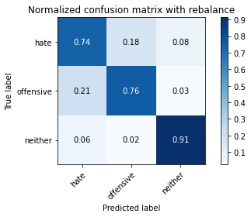

precision recall f1-score support

hate 0.20 0.74 0.32 294

offensive 0.98 0.76 0.85 3821

neither 0.84 0.91 0.88 842

accuracy 0.78 4957

macro avg 0.67 0.80 0.68 4957

weighted avg 0.91 0.78 0.83 4957

average eval_loss: 1.1462743767657346, accuracy: 0.7831349606616905