1 run

training 1 epoch...

64.2959451675415 seconds used......

1 training finished! average train loss: 0.6759240368914883

evaluating...

Confusion matrix, without normalization

[[ 227 41 26]

[ 797 2862 162]

[ 57 10 775]]

Normalized confusion matrix

[[0.77210884 0.13945578 0.08843537]

[0.20858414 0.74901858 0.04239728]

[0.06769596 0.01187648 0.92042755]]

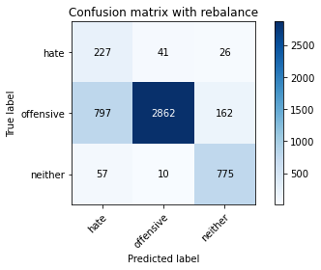

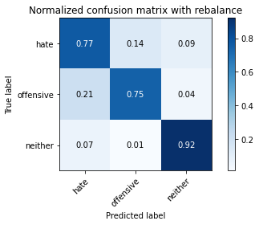

precision recall f1-score support

hate 0.21 0.77 0.33 294

offensive 0.98 0.75 0.85 3821

neither 0.80 0.92 0.86 842

accuracy 0.78 4957

macro avg 0.67 0.81 0.68 4957

weighted avg 0.91 0.78 0.82 4957

average eval_loss: 0.528242121540731, accuracy: 0.7795037320960259

training 2 epoch...

63.765780448913574 seconds used......

2 training finished! average train loss: 0.3981998428615213

evaluating...

Confusion matrix, without normalization

[[ 229 51 14]

[ 610 3124 87]

[ 67 25 750]]

Normalized confusion matrix

[[0.77891156 0.17346939 0.04761905]

[0.15964407 0.81758702 0.02276891]

[0.07957245 0.02969121 0.89073634]]

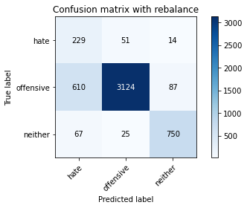

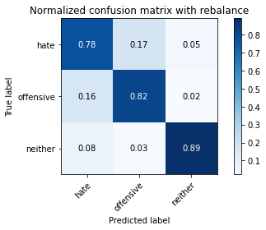

precision recall f1-score support

hate 0.25 0.78 0.38 294

offensive 0.98 0.82 0.89 3821

neither 0.88 0.89 0.89 842

accuracy 0.83 4957

macro avg 0.70 0.83 0.72 4957

weighted avg 0.92 0.83 0.86 4957

average eval_loss: 0.4132749231892728, accuracy: 0.8277183780512407

training 3 epoch...

63.77538990974426 seconds used......

3 training finished! average train loss: 0.2726690163999273

evaluating...

Confusion matrix, without normalization

[[ 197 70 27]

[ 404 3250 167]

[ 46 16 780]]

Normalized confusion matrix

[[0.67006803 0.23809524 0.09183673]

[0.10573148 0.85056268 0.04370584]

[0.05463183 0.01900238 0.9263658 ]]

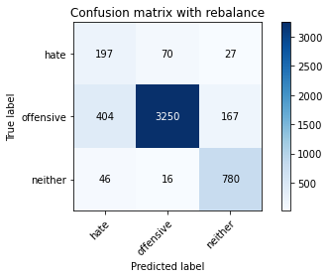

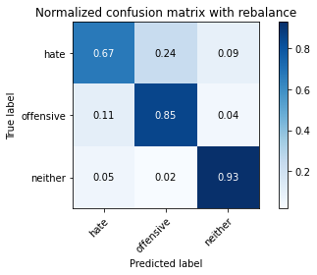

precision recall f1-score support

hate 0.30 0.67 0.42 294

offensive 0.97 0.85 0.91 3821

neither 0.80 0.93 0.86 842

accuracy 0.85 4957

macro avg 0.69 0.82 0.73 4957

weighted avg 0.91 0.85 0.87 4957

average eval_loss: 0.42608014926795035, accuracy: 0.8527335081702643

training 4 epoch...

63.819599866867065 seconds used......

4 training finished! average train loss: 0.1710333519598894

evaluating...

Confusion matrix, without normalization

[[ 207 71 16]

[ 514 3227 80]

[ 55 61 726]]

Normalized confusion matrix

[[0.70408163 0.2414966 0.05442177]

[0.13451976 0.84454331 0.02093693]

[0.06532067 0.07244656 0.86223278]]

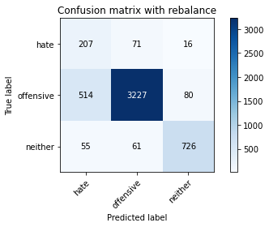

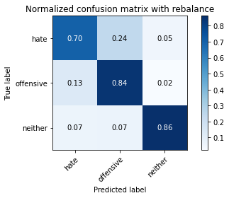

precision recall f1-score support

hate 0.27 0.70 0.39 294

offensive 0.96 0.84 0.90 3821

neither 0.88 0.86 0.87 842

accuracy 0.84 4957

macro avg 0.70 0.80 0.72 4957

weighted avg 0.91 0.84 0.86 4957

average eval_loss: 0.4456123863159108, accuracy: 0.839217268509179

training 5 epoch...

63.75051283836365 seconds used......

5 training finished! average train loss: 0.09146697560804543

evaluating...

Confusion matrix, without normalization

[[ 218 67 9]

[ 749 2974 98]

[ 98 37 707]]

Normalized confusion matrix

[[0.7414966 0.22789116 0.03061224]

[0.19602198 0.77833028 0.02564774]

[0.11638955 0.04394299 0.83966746]]

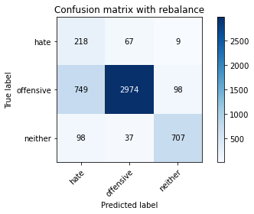

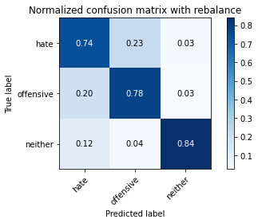

precision recall f1-score support

hate 0.20 0.74 0.32 294

offensive 0.97 0.78 0.86 3821

neither 0.87 0.84 0.85 842

accuracy 0.79 4957

macro avg 0.68 0.79 0.68 4957

weighted avg 0.90 0.79 0.83 4957

average eval_loss: 0.7270269747222623, accuracy: 0.7865644543070406

training 6 epoch...

63.77411103248596 seconds used......

6 training finished! average train loss: 0.04641744475512172

evaluating...

Confusion matrix, without normalization

[[ 230 45 19]

[ 866 2843 112]

[ 58 27 757]]

Normalized confusion matrix

[[0.78231293 0.15306122 0.06462585]

[0.22664224 0.74404606 0.0293117 ]

[0.06888361 0.03206651 0.89904988]]

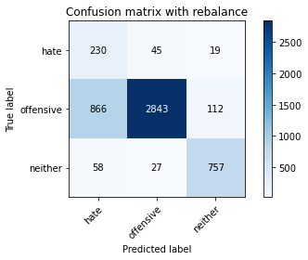

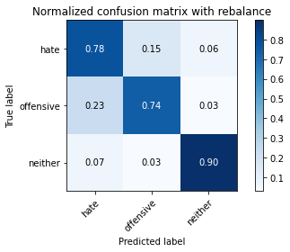

precision recall f1-score support

hate 0.20 0.78 0.32 294

offensive 0.98 0.74 0.84 3821

neither 0.85 0.90 0.88 842

accuracy 0.77 4957

macro avg 0.68 0.81 0.68 4957

weighted avg 0.91 0.77 0.82 4957

average eval_loss: 0.9159248350037923, accuracy: 0.7726447448053259

training 7 epoch...

63.83776664733887 seconds used......

7 training finished! average train loss: 0.03514460592233843

evaluating...

Confusion matrix, without normalization

[[ 215 67 12]

[ 645 3098 78]

[ 77 56 709]]

Normalized confusion matrix

[[0.73129252 0.22789116 0.04081633]

[0.16880398 0.81078252 0.0204135 ]

[0.09144893 0.06650831 0.84204276]]

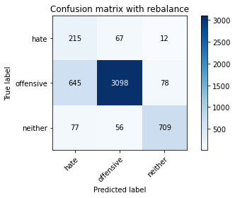

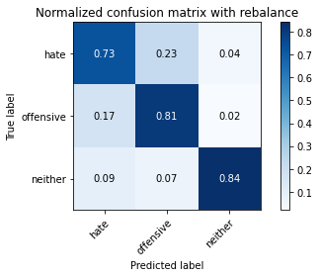

precision recall f1-score support

hate 0.23 0.73 0.35 294

offensive 0.96 0.81 0.88 3821

neither 0.89 0.84 0.86 842

accuracy 0.81 4957

macro avg 0.69 0.79 0.70 4957

weighted avg 0.91 0.81 0.85 4957

average eval_loss: 0.7720751388696954, accuracy: 0.8113778495057494

training 8 epoch...

63.857020139694214 seconds used......

8 training finished! average train loss: 0.015161203368728959

evaluating...

Confusion matrix, without normalization

[[ 224 57 13]

[ 771 2953 97]

[ 89 32 721]]

Normalized confusion matrix

[[0.76190476 0.19387755 0.04421769]

[0.20177964 0.77283434 0.02538602]

[0.10570071 0.03800475 0.85629454]]

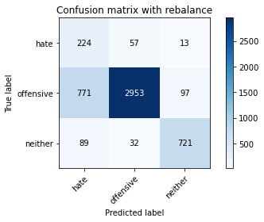

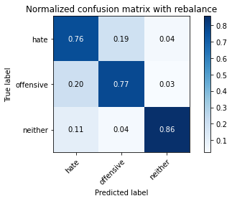

precision recall f1-score support

hate 0.21 0.76 0.33 294

offensive 0.97 0.77 0.86 3821

neither 0.87 0.86 0.86 842

accuracy 0.79 4957

macro avg 0.68 0.80 0.68 4957

weighted avg 0.91 0.79 0.83 4957

average eval_loss: 1.1058766355084615, accuracy: 0.7863627193867259

training 9 epoch...

63.80887293815613 seconds used......

9 training finished! average train loss: 0.01359099003878471

evaluating...

Confusion matrix, without normalization

[[ 211 65 18]

[ 548 3163 110]

[ 56 32 754]]

Normalized confusion matrix

[[0.71768707 0.22108844 0.06122449]

[0.14341795 0.82779377 0.02878828]

[0.06650831 0.03800475 0.89548694]]

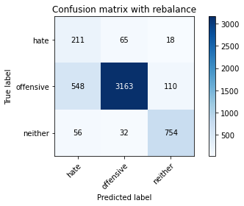

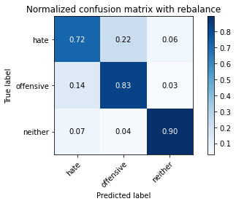

precision recall f1-score support

hate 0.26 0.72 0.38 294

offensive 0.97 0.83 0.89 3821

neither 0.85 0.90 0.87 842

accuracy 0.83 4957

macro avg 0.69 0.81 0.72 4957

weighted avg 0.91 0.83 0.86 4957

average eval_loss: 0.9352979600864215, accuracy: 0.8327617510591083

training 10 epoch...

63.78964591026306 seconds used......

10 training finished! average train loss: 0.012509932872234729

evaluating...

Confusion matrix, without normalization

[[ 216 58 20]

[ 668 3040 113]

[ 46 35 761]]

Normalized confusion matrix

[[0.73469388 0.19727891 0.06802721]

[0.17482334 0.79560325 0.02957341]

[0.05463183 0.0415677 0.90380048]]

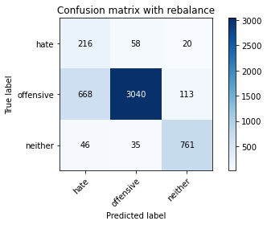

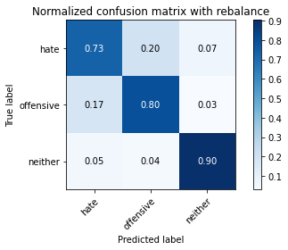

precision recall f1-score support

hate 0.23 0.73 0.35 294

offensive 0.97 0.80 0.87 3821

neither 0.85 0.90 0.88 842

accuracy 0.81 4957

macro avg 0.68 0.81 0.70 4957

weighted avg 0.91 0.81 0.84 4957

average eval_loss: 1.0652629511068001, accuracy: 0.8103691749041759

2 run

training 1 epoch...

63.75009107589722 seconds used......

1 training finished! average train loss: 0.6670153737939589

evaluating...

Confusion matrix, without normalization

[[ 223 52 19]

[ 744 2992 85]

[ 89 32 721]]

Normalized confusion matrix

[[0.7585034 0.17687075 0.06462585]

[0.19471343 0.78304109 0.02224549]

[0.10570071 0.03800475 0.85629454]]

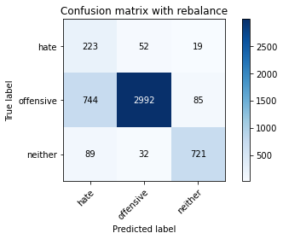

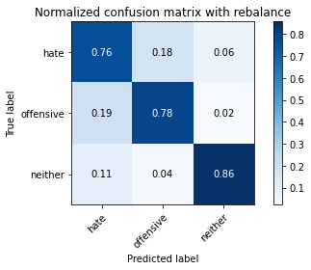

precision recall f1-score support

hate 0.21 0.76 0.33 294

offensive 0.97 0.78 0.87 3821

neither 0.87 0.86 0.87 842

accuracy 0.79 4957

macro avg 0.69 0.80 0.69 4957

weighted avg 0.91 0.79 0.84 4957

average eval_loss: 0.513420254592934, accuracy: 0.7940286463586846

training 2 epoch...

63.759225845336914 seconds used......

2 training finished! average train loss: 0.3876972014182492

evaluating...

Confusion matrix, without normalization

[[ 238 36 20]

[ 964 2746 111]

[ 65 11 766]]

Normalized confusion matrix

[[0.80952381 0.12244898 0.06802721]

[0.25228998 0.71866004 0.02904999]

[0.07719715 0.01306413 0.90973872]]

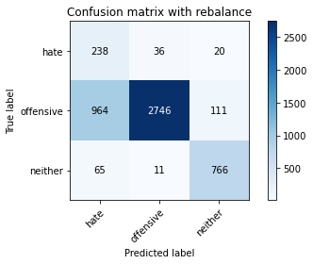

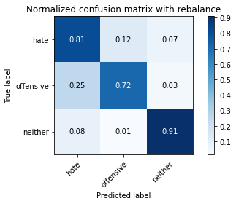

precision recall f1-score support

hate 0.19 0.81 0.30 294

offensive 0.98 0.72 0.83 3821

neither 0.85 0.91 0.88 842

accuracy 0.76 4957

macro avg 0.67 0.81 0.67 4957

weighted avg 0.91 0.76 0.81 4957

average eval_loss: 0.5566680554240462, accuracy: 0.7565059511801493

training 3 epoch...

63.827237129211426 seconds used......

3 training finished! average train loss: 0.264018946572354

evaluating...

Confusion matrix, without normalization

[[ 233 39 22]

[ 932 2761 128]

[ 51 18 773]]

Normalized confusion matrix

[[0.79251701 0.13265306 0.07482993]

[0.24391521 0.72258571 0.03349908]

[0.06057007 0.02137767 0.91805226]]

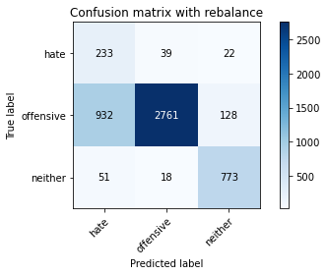

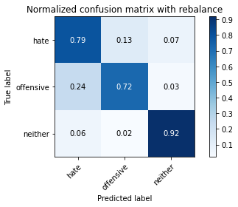

precision recall f1-score support

hate 0.19 0.79 0.31 294

offensive 0.98 0.72 0.83 3821

neither 0.84 0.92 0.88 842

accuracy 0.76 4957

macro avg 0.67 0.81 0.67 4957

weighted avg 0.91 0.76 0.81 4957

average eval_loss: 0.5425268998970428, accuracy: 0.7599354448254992

training 4 epoch...

63.74424934387207 seconds used......

4 training finished! average train loss: 0.16016735524287698

evaluating...

Confusion matrix, without normalization

[[ 199 60 35]

[ 559 3080 182]

[ 24 14 804]]

Normalized confusion matrix

[[0.67687075 0.20408163 0.11904762]

[0.14629678 0.80607171 0.04763151]

[0.02850356 0.01662708 0.95486936]]

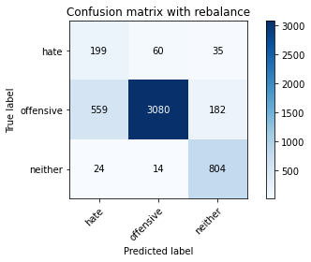

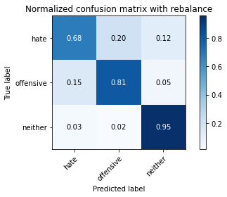

precision recall f1-score support

hate 0.25 0.68 0.37 294

offensive 0.98 0.81 0.88 3821

neither 0.79 0.95 0.86 842

accuracy 0.82 4957

macro avg 0.67 0.81 0.71 4957

weighted avg 0.90 0.82 0.85 4957

average eval_loss: 0.548224217645193, accuracy: 0.8236836796449465

training 5 epoch...

63.647313594818115 seconds used......

5 training finished! average train loss: 0.08298329483685002

evaluating...

Confusion matrix, without normalization

[[ 219 55 20]

[ 706 3001 114]

[ 49 21 772]]

Normalized confusion matrix

[[0.74489796 0.18707483 0.06802721]

[0.18476839 0.78539649 0.02983512]

[0.05819477 0.02494062 0.91686461]]

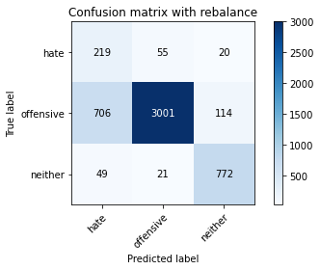

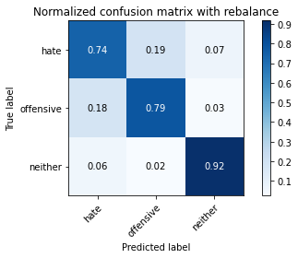

precision recall f1-score support

hate 0.22 0.74 0.35 294

offensive 0.98 0.79 0.87 3821

neither 0.85 0.92 0.88 842

accuracy 0.81 4957

macro avg 0.68 0.82 0.70 4957

weighted avg 0.91 0.81 0.84 4957

average eval_loss: 0.7485010216177832, accuracy: 0.8053258018963082

training 6 epoch...

63.63109850883484 seconds used......

6 training finished! average train loss: 0.0510761377858461

evaluating...

Confusion matrix, without normalization

[[ 229 50 15]

[ 798 2935 88]

[ 85 37 720]]

Normalized confusion matrix

[[0.77891156 0.17006803 0.05102041]

[0.20884585 0.76812353 0.02303062]

[0.10095012 0.04394299 0.85510689]]

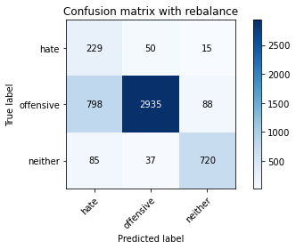

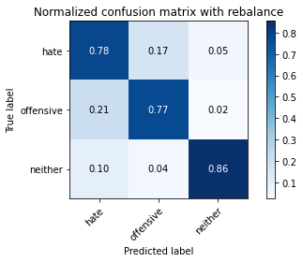

precision recall f1-score support

hate 0.21 0.78 0.33 294

offensive 0.97 0.77 0.86 3821

neither 0.87 0.86 0.86 842

accuracy 0.78 4957

macro avg 0.68 0.80 0.68 4957

weighted avg 0.91 0.78 0.83 4957

average eval_loss: 0.9010418668359278, accuracy: 0.78353843050232

training 7 epoch...

63.800904989242554 seconds used......

7 training finished! average train loss: 0.025782969331624783

evaluating...

Confusion matrix, without normalization

[[ 212 59 23]

[ 628 3078 115]

[ 51 30 761]]

Normalized confusion matrix

[[0.72108844 0.20068027 0.07823129]

[0.16435488 0.80554829 0.03009683]

[0.06057007 0.03562945 0.90380048]]

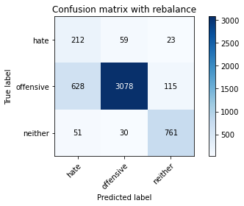

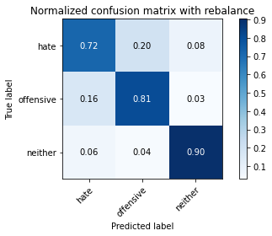

precision recall f1-score support

hate 0.24 0.72 0.36 294

offensive 0.97 0.81 0.88 3821

neither 0.85 0.90 0.87 842

accuracy 0.82 4957

macro avg 0.69 0.81 0.70 4957

weighted avg 0.91 0.82 0.85 4957

average eval_loss: 0.8686410896480083, accuracy: 0.8172281621948759

training 8 epoch...

63.649296045303345 seconds used......

8 training finished! average train loss: 0.01507819258646729

evaluating...

Confusion matrix, without normalization

[[ 200 71 23]

[ 578 3146 97]

[ 54 38 750]]

Normalized confusion matrix

[[0.68027211 0.2414966 0.07823129]

[0.1512693 0.82334467 0.02538602]

[0.06413302 0.04513064 0.89073634]]

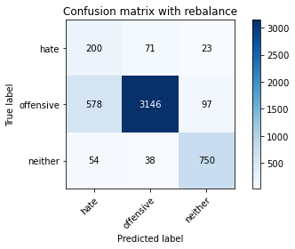

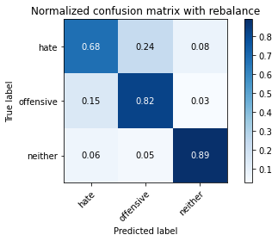

precision recall f1-score support

hate 0.24 0.68 0.36 294

offensive 0.97 0.82 0.89 3821

neither 0.86 0.89 0.88 842

accuracy 0.83 4957

macro avg 0.69 0.80 0.71 4957

weighted avg 0.91 0.83 0.86 4957

average eval_loss: 0.8617429578609459, accuracy: 0.8263062336090378

training 9 epoch...

63.739105463027954 seconds used......

9 training finished! average train loss: 0.01968289412471618

evaluating...

Confusion matrix, without normalization

[[ 205 66 23]

[ 691 2972 158]

[ 65 15 762]]

Normalized confusion matrix

[[0.69727891 0.2244898 0.07823129]

[0.18084271 0.77780686 0.04135043]

[0.07719715 0.01781473 0.90498812]]

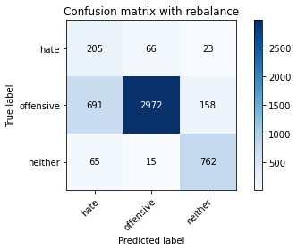

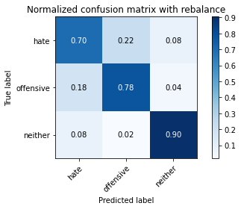

precision recall f1-score support

hate 0.21 0.70 0.33 294

offensive 0.97 0.78 0.86 3821

neither 0.81 0.90 0.85 842

accuracy 0.79 4957

macro avg 0.66 0.79 0.68 4957

weighted avg 0.90 0.79 0.83 4957

average eval_loss: 1.072382142662161, accuracy: 0.7946338511196288

training 10 epoch...

63.72385120391846 seconds used......

10 training finished! average train loss: 0.015249390635375282

evaluating...

Confusion matrix, without normalization

[[ 209 59 26]

[ 666 3010 145]

[ 48 19 775]]

Normalized confusion matrix

[[0.71088435 0.20068027 0.08843537]

[0.17429992 0.7877519 0.03794818]

[0.05700713 0.02256532 0.92042755]]

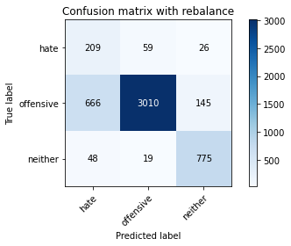

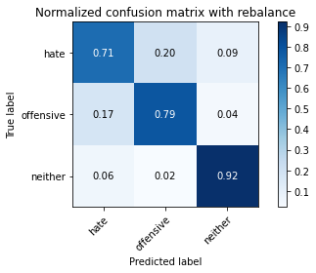

precision recall f1-score support

hate 0.23 0.71 0.34 294

offensive 0.97 0.79 0.87 3821

neither 0.82 0.92 0.87 842

accuracy 0.81 4957

macro avg 0.67 0.81 0.69 4957

weighted avg 0.90 0.81 0.84 4957

average eval_loss: 1.0639035663372207, accuracy: 0.8057292717369376

3 run

training 1 epoch...

63.6882529258728 seconds used......

1 training finished! average train loss: 0.6490085062227751

evaluating...

Confusion matrix, without normalization

[[ 168 94 32]

[ 247 3430 144]

[ 26 17 799]]

Normalized confusion matrix

[[0.57142857 0.31972789 0.10884354]

[0.06464276 0.89767077 0.03768647]

[0.03087886 0.02019002 0.94893112]]

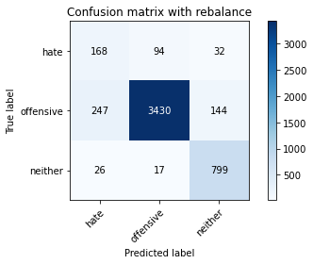

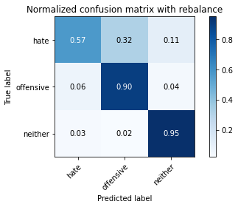

precision recall f1-score support

hate 0.38 0.57 0.46 294

offensive 0.97 0.90 0.93 3821

neither 0.82 0.95 0.88 842

accuracy 0.89 4957

macro avg 0.72 0.81 0.76 4957

weighted avg 0.91 0.89 0.89 4957

average eval_loss: 0.32848903575852034, accuracy: 0.8870284446237644

training 2 epoch...

63.74436569213867 seconds used......

2 training finished! average train loss: 0.38994411540310286

evaluating...

Confusion matrix, without normalization

[[ 198 66 30]

[ 429 3233 159]

[ 30 16 796]]

Normalized confusion matrix

[[0.67346939 0.2244898 0.10204082]

[0.11227427 0.84611358 0.04161214]

[0.03562945 0.01900238 0.94536817]]

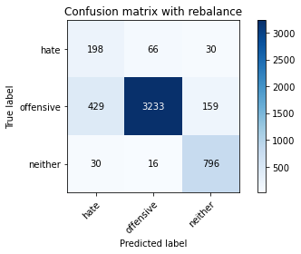

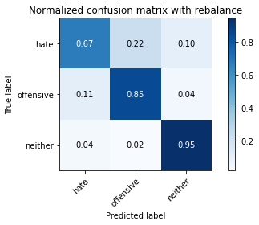

precision recall f1-score support

hate 0.30 0.67 0.42 294

offensive 0.98 0.85 0.91 3821

neither 0.81 0.95 0.87 842

accuracy 0.85 4957

macro avg 0.69 0.82 0.73 4957

weighted avg 0.91 0.85 0.87 4957

average eval_loss: 0.3915320279887847, accuracy: 0.8527335081702643

training 3 epoch...

63.74644470214844 seconds used......

3 training finished! average train loss: 0.2730176015729793

evaluating...

Confusion matrix, without normalization

[[ 234 38 22]

[ 918 2767 136]

[ 100 10 732]]

Normalized confusion matrix

[[0.79591837 0.1292517 0.07482993]

[0.24025124 0.72415598 0.03559278]

[0.11876485 0.01187648 0.86935867]]

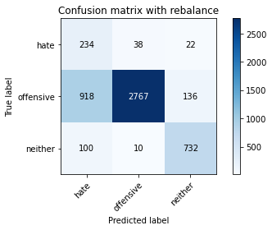

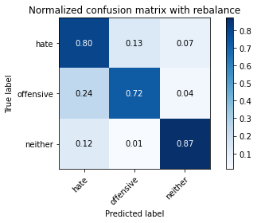

precision recall f1-score support

hate 0.19 0.80 0.30 294

offensive 0.98 0.72 0.83 3821

neither 0.82 0.87 0.85 842

accuracy 0.75 4957

macro avg 0.66 0.80 0.66 4957

weighted avg 0.91 0.75 0.80 4957

average eval_loss: 0.6507759847708287, accuracy: 0.7530764575347992

training 4 epoch...

63.87001371383667 seconds used......

4 training finished! average train loss: 0.18056180183258322

evaluating...

Confusion matrix, without normalization

[[ 204 70 20]

[ 502 3226 93]

[ 52 48 742]]

Normalized confusion matrix

[[0.69387755 0.23809524 0.06802721]

[0.13137922 0.8442816 0.02433918]

[0.06175772 0.05700713 0.88123515]]

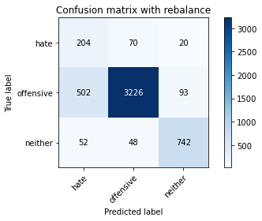

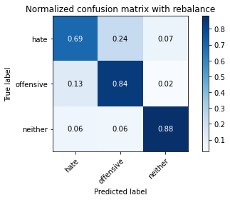

precision recall f1-score support

hate 0.27 0.69 0.39 294

offensive 0.96 0.84 0.90 3821

neither 0.87 0.88 0.87 842

accuracy 0.84 4957

macro avg 0.70 0.81 0.72 4957

weighted avg 0.91 0.84 0.87 4957

average eval_loss: 0.4360905587072334, accuracy: 0.8416380875529554

training 5 epoch...

63.72109246253967 seconds used......

5 training finished! average train loss: 0.09558961600914859

evaluating...

Confusion matrix, without normalization

[[ 247 37 10]

[1066 2691 64]

[ 103 43 696]]

Normalized confusion matrix

[[0.84013605 0.12585034 0.03401361]

[0.27898456 0.7042659 0.01674954]

[0.12232779 0.05106888 0.82660333]]

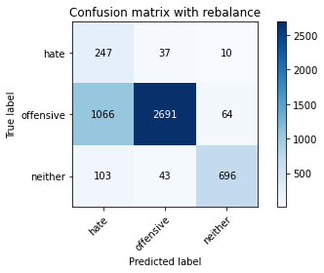

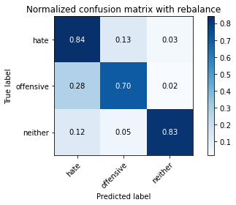

precision recall f1-score support

hate 0.17 0.84 0.29 294

offensive 0.97 0.70 0.82 3821

neither 0.90 0.83 0.86 842

accuracy 0.73 4957

macro avg 0.68 0.79 0.66 4957

weighted avg 0.91 0.73 0.79 4957

average eval_loss: 0.9266919926890442, accuracy: 0.7331047004236433

training 6 epoch...

63.85064888000488 seconds used......

6 training finished! average train loss: 0.05612227382486937

evaluating...

Confusion matrix, without normalization

[[ 209 62 23]

[ 736 2957 128]

[ 39 24 779]]

Normalized confusion matrix

[[0.71088435 0.21088435 0.07823129]

[0.19261973 0.77388118 0.03349908]

[0.04631829 0.02850356 0.92517815]]

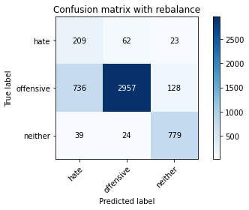

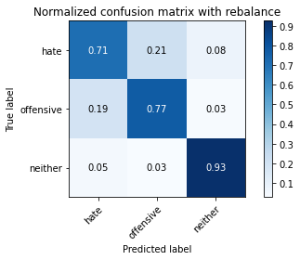

precision recall f1-score support

hate 0.21 0.71 0.33 294

offensive 0.97 0.77 0.86 3821

neither 0.84 0.93 0.88 842

accuracy 0.80 4957

macro avg 0.67 0.80 0.69 4957

weighted avg 0.90 0.80 0.83 4957

average eval_loss: 0.7326973826894837, accuracy: 0.795844260641517

training 7 epoch...

63.799824953079224 seconds used......

7 training finished! average train loss: 0.02958570527932634

evaluating...

Confusion matrix, without normalization

[[ 239 42 13]

[ 864 2849 108]

[ 88 15 739]]

Normalized confusion matrix

[[0.81292517 0.14285714 0.04421769]

[0.22611882 0.74561633 0.02826485]

[0.10451306 0.01781473 0.87767221]]

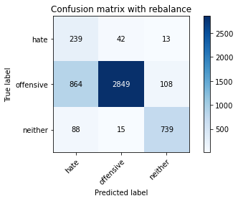

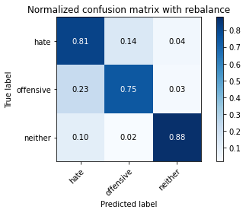

precision recall f1-score support

hate 0.20 0.81 0.32 294

offensive 0.98 0.75 0.85 3821

neither 0.86 0.88 0.87 842

accuracy 0.77 4957

macro avg 0.68 0.81 0.68 4957

weighted avg 0.91 0.77 0.82 4957

average eval_loss: 1.0118465025218264, accuracy: 0.7720395400443817

training 8 epoch...

63.674479484558105 seconds used......

8 training finished! average train loss: 0.022917782758806467

evaluating...

Confusion matrix, without normalization

[[ 214 62 18]

[ 755 2964 102]

[ 64 30 748]]

Normalized confusion matrix

[[0.72789116 0.21088435 0.06122449]

[0.19759225 0.77571316 0.02669458]

[0.0760095 0.03562945 0.88836105]]

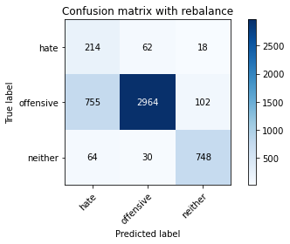

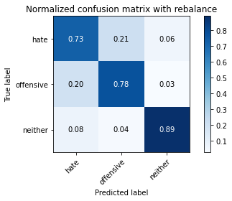

precision recall f1-score support

hate 0.21 0.73 0.32 294

offensive 0.97 0.78 0.86 3821

neither 0.86 0.89 0.87 842

accuracy 0.79 4957

macro avg 0.68 0.80 0.69 4957

weighted avg 0.91 0.79 0.83 4957

average eval_loss: 0.9181811776192438, accuracy: 0.7920112971555376

training 9 epoch...

63.70357942581177 seconds used......

9 training finished! average train loss: 0.017025779305388115

evaluating...

Confusion matrix, without normalization

[[ 246 37 11]

[1060 2675 86]

[ 92 22 728]]

Normalized confusion matrix

[[0.83673469 0.12585034 0.03741497]

[0.27741429 0.70007851 0.0225072 ]

[0.10926366 0.02612827 0.86460808]]

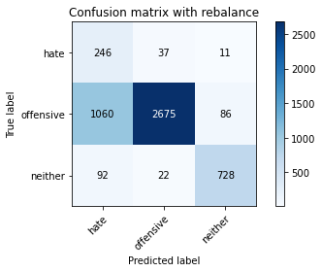

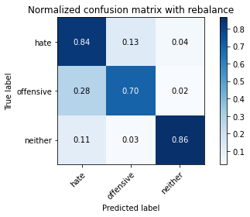

precision recall f1-score support

hate 0.18 0.84 0.29 294

offensive 0.98 0.70 0.82 3821

neither 0.88 0.86 0.87 842

accuracy 0.74 4957

macro avg 0.68 0.80 0.66 4957

weighted avg 0.91 0.74 0.79 4957

average eval_loss: 1.3862542861832245, accuracy: 0.7361307242283639

training 10 epoch...

63.73696780204773 seconds used......

10 training finished! average train loss: 0.01810697116701842

evaluating...

Confusion matrix, without normalization

[[ 229 50 15]

[ 738 2992 91]

[ 60 31 751]]

Normalized confusion matrix

[[0.77891156 0.17006803 0.05102041]

[0.19314316 0.78304109 0.02381576]

[0.07125891 0.0368171 0.89192399]]

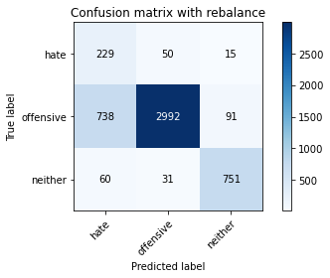

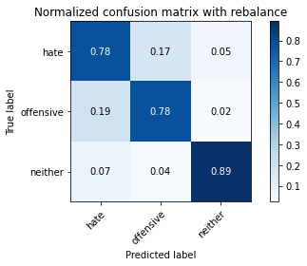

precision recall f1-score support

hate 0.22 0.78 0.35 294

offensive 0.97 0.78 0.87 3821

neither 0.88 0.89 0.88 842

accuracy 0.80 4957

macro avg 0.69 0.82 0.70 4957

weighted avg 0.91 0.80 0.84 4957

average eval_loss: 1.0581517697822662, accuracy: 0.8012911034900141

4 run

training 1 epoch...

63.719970703125 seconds used......

1 training finished! average train loss: 0.672798397422534

evaluating...

Confusion matrix, without normalization

[[ 220 38 36]

[ 752 2890 179]

[ 35 11 796]]

Normalized confusion matrix

[[0.74829932 0.1292517 0.12244898]

[0.19680712 0.75634651 0.04684638]

[0.0415677 0.01306413 0.94536817]]

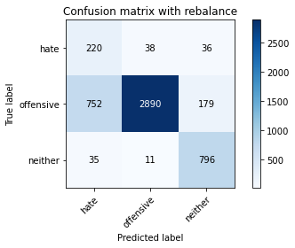

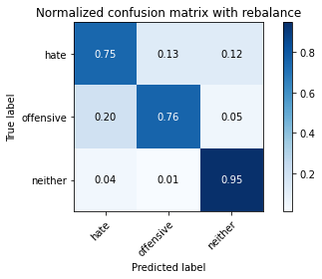

precision recall f1-score support

hate 0.22 0.75 0.34 294

offensive 0.98 0.76 0.86 3821

neither 0.79 0.95 0.86 842

accuracy 0.79 4957

macro avg 0.66 0.82 0.68 4957

weighted avg 0.90 0.79 0.83 4957

average eval_loss: 0.5129851113043485, accuracy: 0.7879765987492435

training 2 epoch...

63.738608837127686 seconds used......

2 training finished! average train loss: 0.4105170927723946

evaluating...

Confusion matrix, without normalization

[[ 243 35 16]

[ 951 2751 119]

[ 66 9 767]]

Normalized confusion matrix

[[0.82653061 0.11904762 0.05442177]

[0.24888773 0.71996859 0.03114368]

[0.0783848 0.01068884 0.91092637]]

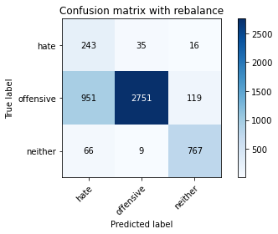

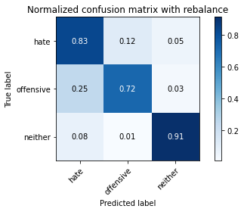

precision recall f1-score support

hate 0.19 0.83 0.31 294

offensive 0.98 0.72 0.83 3821

neither 0.85 0.91 0.88 842

accuracy 0.76 4957

macro avg 0.68 0.82 0.67 4957

weighted avg 0.91 0.76 0.81 4957

average eval_loss: 0.5610665206707293, accuracy: 0.758725035303611

training 3 epoch...

63.78472685813904 seconds used......

3 training finished! average train loss: 0.28188687497586534

evaluating...

Confusion matrix, without normalization

[[ 183 93 18]

[ 285 3424 112]

[ 56 40 746]]

Normalized confusion matrix

[[0.62244898 0.31632653 0.06122449]

[0.0745878 0.8961005 0.0293117 ]

[0.06650831 0.04750594 0.88598575]]

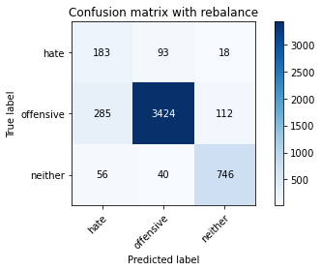

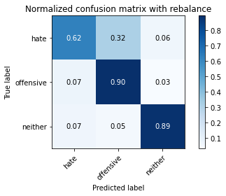

precision recall f1-score support

hate 0.35 0.62 0.45 294

offensive 0.96 0.90 0.93 3821

neither 0.85 0.89 0.87 842

accuracy 0.88 4957

macro avg 0.72 0.80 0.75 4957

weighted avg 0.91 0.88 0.89 4957

average eval_loss: 0.35095148568882817, accuracy: 0.8781521081299173

training 4 epoch...

63.695656299591064 seconds used......

4 training finished! average train loss: 0.1775068669247697

evaluating...

Confusion matrix, without normalization

[[ 216 55 23]

[ 701 3000 120]

[ 39 29 774]]

Normalized confusion matrix

[[0.73469388 0.18707483 0.07823129]

[0.18345983 0.78513478 0.03140539]

[0.04631829 0.03444181 0.9192399 ]]

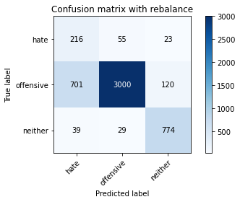

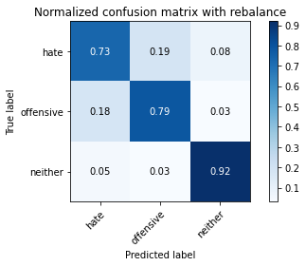

precision recall f1-score support

hate 0.23 0.73 0.35 294

offensive 0.97 0.79 0.87 3821

neither 0.84 0.92 0.88 842

accuracy 0.80 4957

macro avg 0.68 0.81 0.70 4957

weighted avg 0.91 0.80 0.84 4957

average eval_loss: 0.5527824435773636, accuracy: 0.8049223320556789

training 5 epoch...

63.78156495094299 seconds used......

5 training finished! average train loss: 0.08324244445767144

evaluating...

Confusion matrix, without normalization

[[ 229 46 19]

[ 853 2864 104]

[ 44 34 764]]

Normalized confusion matrix

[[0.77891156 0.15646259 0.06462585]

[0.22323999 0.749542 0.02721801]

[0.05225653 0.04038005 0.90736342]]

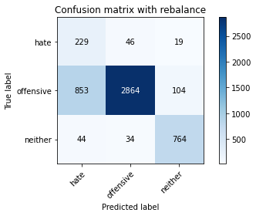

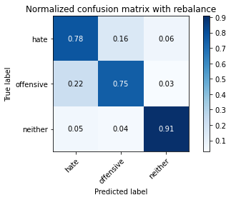

precision recall f1-score support

hate 0.20 0.78 0.32 294

offensive 0.97 0.75 0.85 3821

neither 0.86 0.91 0.88 842

accuracy 0.78 4957

macro avg 0.68 0.81 0.68 4957

weighted avg 0.91 0.78 0.82 4957

average eval_loss: 0.7497702065194326, accuracy: 0.7780915876538229

training 6 epoch...

63.81965637207031 seconds used......

6 training finished! average train loss: 0.04842529418791116

evaluating...

Confusion matrix, without normalization

[[ 214 64 16]

[ 584 3130 107]

[ 59 33 750]]

Normalized confusion matrix

[[0.72789116 0.21768707 0.05442177]

[0.15283957 0.81915729 0.02800314]

[0.07007126 0.0391924 0.89073634]]

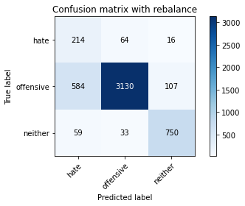

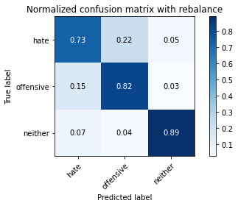

precision recall f1-score support

hate 0.25 0.73 0.37 294

offensive 0.97 0.82 0.89 3821

neither 0.86 0.89 0.87 842

accuracy 0.83 4957

macro avg 0.69 0.81 0.71 4957

weighted avg 0.91 0.83 0.86 4957

average eval_loss: 0.7156514787366764, accuracy: 0.8259027637684083

training 7 epoch...

63.816327810287476 seconds used......

7 training finished! average train loss: 0.03977715218717461

evaluating...

Confusion matrix, without normalization

[[ 221 62 11]

[ 601 3143 77]

[ 72 63 707]]

Normalized confusion matrix

[[0.75170068 0.21088435 0.03741497]

[0.15728867 0.82255954 0.02015179]

[0.08551069 0.07482185 0.83966746]]

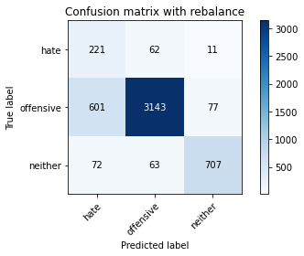

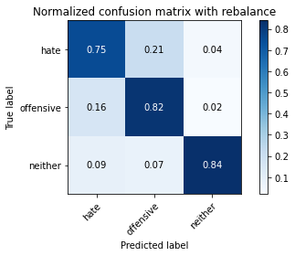

precision recall f1-score support

hate 0.25 0.75 0.37 294

offensive 0.96 0.82 0.89 3821

neither 0.89 0.84 0.86 842

accuracy 0.82 4957

macro avg 0.70 0.80 0.71 4957

weighted avg 0.91 0.82 0.85 4957

average eval_loss: 0.7769675009260555, accuracy: 0.82126286060117

training 8 epoch...

63.77831983566284 seconds used......

8 training finished! average train loss: 0.02390132214682046

evaluating...

Confusion matrix, without normalization

[[ 210 68 16]

[ 652 3050 119]

[ 61 27 754]]

Normalized confusion matrix

[[0.71428571 0.23129252 0.05442177]

[0.17063596 0.79822036 0.03114368]

[0.07244656 0.03206651 0.89548694]]

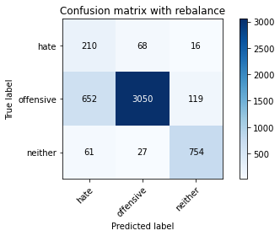

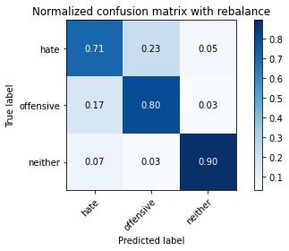

precision recall f1-score support

hate 0.23 0.71 0.35 294

offensive 0.97 0.80 0.88 3821

neither 0.85 0.90 0.87 842

accuracy 0.81 4957

macro avg 0.68 0.80 0.70 4957

weighted avg 0.91 0.81 0.84 4957

average eval_loss: 0.859571123467533, accuracy: 0.8097639701432318

training 9 epoch...

63.8352746963501 seconds used......

9 training finished! average train loss: 0.017768356901435564

evaluating...

Confusion matrix, without normalization

[[ 228 55 11]

[ 760 2964 97]

[ 88 35 719]]

Normalized confusion matrix

[[0.7755102 0.18707483 0.03741497]

[0.19890081 0.77571316 0.02538602]

[0.10451306 0.0415677 0.85391924]]

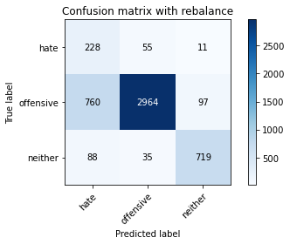

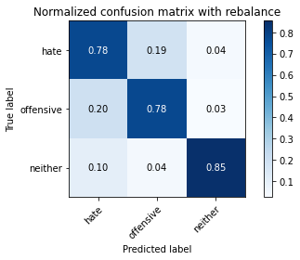

precision recall f1-score support

hate 0.21 0.78 0.33 294

offensive 0.97 0.78 0.86 3821

neither 0.87 0.85 0.86 842

accuracy 0.79 4957

macro avg 0.68 0.80 0.69 4957

weighted avg 0.91 0.79 0.83 4957

average eval_loss: 1.1072976341519896, accuracy: 0.788985273350817

training 10 epoch...

63.81842660903931 seconds used......

10 training finished! average train loss: 0.010731673978333094

evaluating...

Confusion matrix, without normalization

[[ 210 69 15]

[ 469 3249 103]

[ 71 39 732]]

Normalized confusion matrix

[[0.71428571 0.23469388 0.05102041]

[0.12274274 0.85030097 0.02695629]

[0.08432304 0.04631829 0.86935867]]

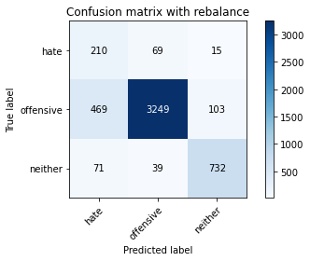

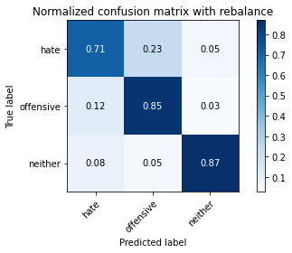

precision recall f1-score support

hate 0.28 0.71 0.40 294

offensive 0.97 0.85 0.91 3821

neither 0.86 0.87 0.87 842

accuracy 0.85 4957

macro avg 0.70 0.81 0.72 4957

weighted avg 0.91 0.85 0.87 4957

average eval_loss: 0.875031240475026, accuracy: 0.8454710510389348

5 run

training 1 epoch...

63.85490441322327 seconds used......

1 training finished! average train loss: 0.668383618892982

evaluating...

Confusion matrix, without normalization

[[ 219 52 23]

[ 728 2978 115]

[ 50 17 775]]

Normalized confusion matrix

[[0.74489796 0.17687075 0.07823129]

[0.19052604 0.77937713 0.03009683]

[0.05938242 0.02019002 0.92042755]]

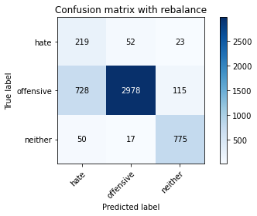

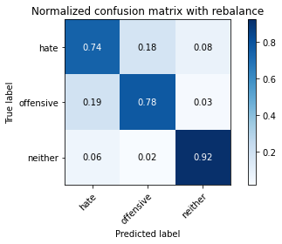

precision recall f1-score support

hate 0.22 0.74 0.34 294

offensive 0.98 0.78 0.87 3821

neither 0.85 0.92 0.88 842

accuracy 0.80 4957

macro avg 0.68 0.81 0.70 4957

weighted avg 0.91 0.80 0.84 4957

average eval_loss: 0.457081644705707, accuracy: 0.8012911034900141

training 2 epoch...

63.83333730697632 seconds used......

2 training finished! average train loss: 0.39776424338158806

evaluating...

Confusion matrix, without normalization

[[ 241 32 21]

[1147 2557 117]

[ 51 11 780]]

Normalized confusion matrix

[[0.81972789 0.10884354 0.07142857]

[0.3001832 0.66919655 0.03062026]

[0.06057007 0.01306413 0.9263658 ]]

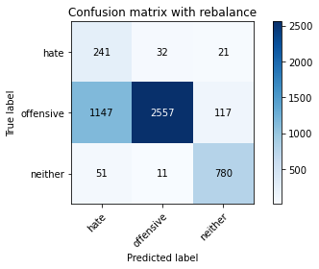

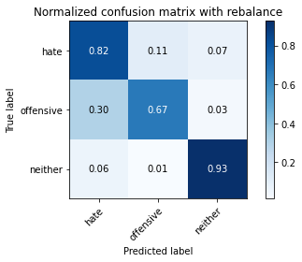

precision recall f1-score support

hate 0.17 0.82 0.28 294

offensive 0.98 0.67 0.80 3821

neither 0.85 0.93 0.89 842

accuracy 0.72 4957

macro avg 0.67 0.81 0.65 4957

weighted avg 0.91 0.72 0.78 4957

average eval_loss: 0.6166279384145333, accuracy: 0.7218075448860197

training 3 epoch...

63.73600673675537 seconds used......

3 training finished! average train loss: 0.2760930862604526

evaluating...

Confusion matrix, without normalization

[[ 237 40 17]

[ 886 2858 77]

[ 96 20 726]]

Normalized confusion matrix

[[0.80612245 0.13605442 0.05782313]

[0.23187647 0.74797174 0.02015179]

[0.11401425 0.02375297 0.86223278]]

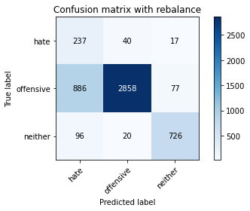

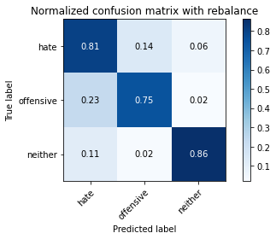

precision recall f1-score support

hate 0.19 0.81 0.31 294

offensive 0.98 0.75 0.85 3821

neither 0.89 0.86 0.87 842

accuracy 0.77 4957

macro avg 0.69 0.81 0.68 4957

weighted avg 0.92 0.77 0.82 4957

average eval_loss: 0.5680101168972831, accuracy: 0.7708291305224935

training 4 epoch...

63.88032054901123 seconds used......

4 training finished! average train loss: 0.16911553848556607

evaluating...

Confusion matrix, without normalization

[[ 207 71 16]

[ 558 3182 81]

[ 63 39 740]]

Normalized confusion matrix

[[0.70408163 0.2414966 0.05442177]

[0.14603507 0.83276629 0.02119864]

[0.07482185 0.04631829 0.87885986]]

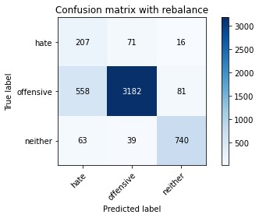

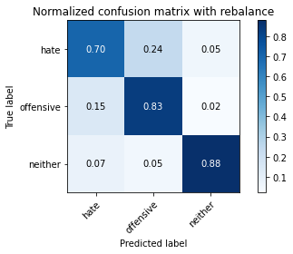

precision recall f1-score support

hate 0.25 0.70 0.37 294

offensive 0.97 0.83 0.89 3821

neither 0.88 0.88 0.88 842

accuracy 0.83 4957

macro avg 0.70 0.81 0.72 4957

weighted avg 0.91 0.83 0.86 4957

average eval_loss: 0.466513421056011, accuracy: 0.832963485979423

training 5 epoch...

63.982863664627075 seconds used......

5 training finished! average train loss: 0.10591393683584985

evaluating...

Confusion matrix, without normalization

[[ 201 74 19]

[ 574 3147 100]

[ 56 17 769]]

Normalized confusion matrix

[[0.68367347 0.25170068 0.06462585]

[0.15022245 0.82360639 0.02617116]

[0.06650831 0.02019002 0.91330166]]

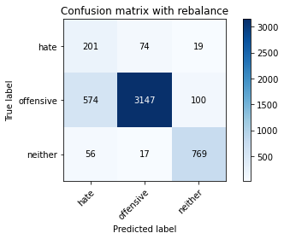

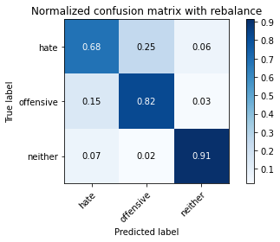

precision recall f1-score support

hate 0.24 0.68 0.36 294

offensive 0.97 0.82 0.89 3821

neither 0.87 0.91 0.89 842

accuracy 0.83 4957

macro avg 0.69 0.81 0.71 4957

weighted avg 0.91 0.83 0.86 4957

average eval_loss: 0.567439915426451, accuracy: 0.8305426669356466

training 6 epoch...

63.82036566734314 seconds used......

6 training finished! average train loss: 0.053604729310200924

evaluating...

Confusion matrix, without normalization

[[ 183 76 35]

[ 403 3255 163]

[ 29 18 795]]

Normalized confusion matrix

[[0.62244898 0.2585034 0.11904762]

[0.10546977 0.85187124 0.04265899]

[0.03444181 0.02137767 0.94418052]]

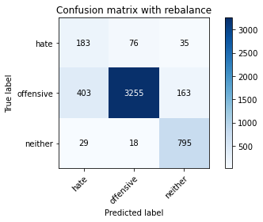

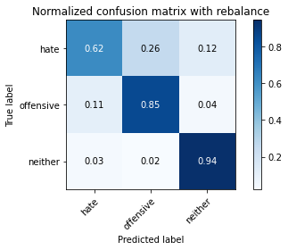

precision recall f1-score support

hate 0.30 0.62 0.40 294

offensive 0.97 0.85 0.91 3821

neither 0.80 0.94 0.87 842

accuracy 0.85 4957

macro avg 0.69 0.81 0.73 4957

weighted avg 0.90 0.85 0.87 4957

average eval_loss: 0.6233357258367299, accuracy: 0.8539439176921525

training 7 epoch...

63.81378221511841 seconds used......

7 training finished! average train loss: 0.02235574130042407

evaluating...

Confusion matrix, without normalization

[[ 227 44 23]

[ 970 2727 124]

[ 58 17 767]]

Normalized confusion matrix

[[0.77210884 0.14965986 0.07823129]

[0.25386025 0.71368752 0.03245224]

[0.06888361 0.02019002 0.91092637]]

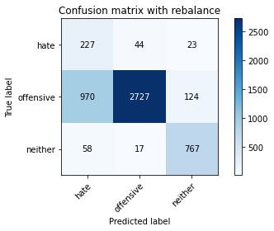

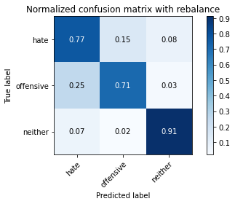

precision recall f1-score support

hate 0.18 0.77 0.29 294

offensive 0.98 0.71 0.83 3821

neither 0.84 0.91 0.87 842

accuracy 0.75 4957

macro avg 0.67 0.80 0.66 4957

weighted avg 0.91 0.75 0.80 4957

average eval_loss: 1.177362541893437, accuracy: 0.7506556384910228

training 8 epoch...

63.76791453361511 seconds used......

8 training finished! average train loss: 0.03030139413302797

evaluating...

Confusion matrix, without normalization

[[ 230 48 16]

[1010 2715 96]

[ 81 22 739]]

Normalized confusion matrix

[[0.78231293 0.16326531 0.05442177]

[0.26432871 0.71054698 0.02512431]

[0.09619952 0.02612827 0.87767221]]

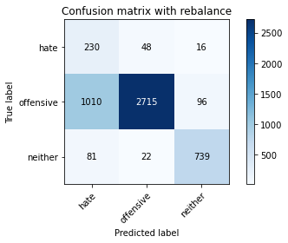

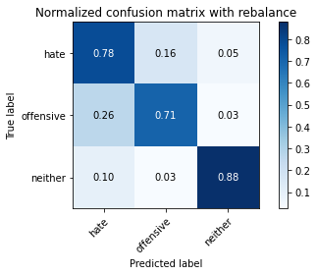

precision recall f1-score support

hate 0.17 0.78 0.28 294

offensive 0.97 0.71 0.82 3821

neither 0.87 0.88 0.87 842

accuracy 0.74 4957

macro avg 0.67 0.79 0.66 4957

weighted avg 0.91 0.74 0.80 4957

average eval_loss: 1.2334302385382714, accuracy: 0.7431914464393786

training 9 epoch...

63.77754783630371 seconds used......

9 training finished! average train loss: 0.014703828349065482

evaluating...

Confusion matrix, without normalization

[[ 226 47 21]

[ 802 2910 109]

[ 57 17 768]]

Normalized confusion matrix

[[0.76870748 0.15986395 0.07142857]

[0.2098927 0.76158074 0.02852656]

[0.06769596 0.02019002 0.91211401]]

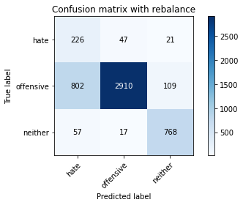

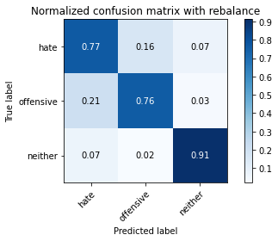

precision recall f1-score support

hate 0.21 0.77 0.33 294

offensive 0.98 0.76 0.86 3821

neither 0.86 0.91 0.88 842

accuracy 0.79 4957

macro avg 0.68 0.81 0.69 4957

weighted avg 0.91 0.79 0.83 4957

average eval_loss: 1.0902129430103213, accuracy: 0.7875731289086141

training 10 epoch...

63.750081300735474 seconds used......

10 training finished! average train loss: 0.010330151418313841

evaluating...

Confusion matrix, without normalization

[[ 212 66 16]

[ 649 3086 86]

[ 70 29 743]]

Normalized confusion matrix

[[0.72108844 0.2244898 0.05442177]

[0.16985082 0.80764198 0.0225072 ]

[0.08313539 0.03444181 0.8824228 ]]

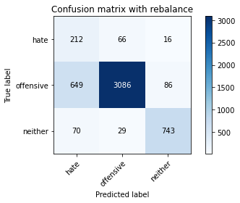

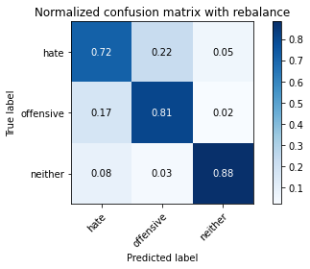

precision recall f1-score support

hate 0.23 0.72 0.35 294

offensive 0.97 0.81 0.88 3821

neither 0.88 0.88 0.88 842

accuracy 0.82 4957

macro avg 0.69 0.80 0.70 4957

weighted avg 0.91 0.82 0.85 4957

average eval_loss: 1.0170249813828935, accuracy: 0.8152108129917288