1 run

training 1 epoch...

28.63248896598816 seconds used......

1 training finished! average train loss: 0.6943630975240852

evaluating...

Confusion matrix, without normalization

[[ 242 37 15]

[ 880 2857 84]

[ 106 12 724]]

Normalized confusion matrix

[[0.82312925 0.12585034 0.05102041]

[0.2303062 0.74771002 0.02198377]

[0.12589074 0.01425178 0.85985748]]

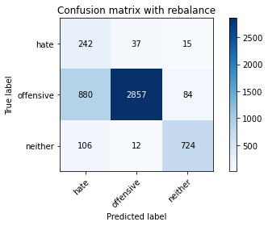

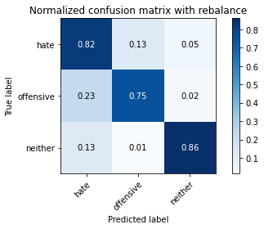

precision recall f1-score support

hate 0.20 0.82 0.32 294

offensive 0.98 0.75 0.85 3821

neither 0.88 0.86 0.87 842

accuracy 0.77 4957

macro avg 0.69 0.81 0.68 4957

weighted avg 0.92 0.77 0.82 4957

average eval_loss: 0.5493933291084343, accuracy: 0.7712326003631229

training 2 epoch...

28.007816791534424 seconds used......

2 training finished! average train loss: 0.4069190372151938

evaluating...

Confusion matrix, without normalization

[[ 240 43 11]

[ 821 2928 72]

[ 75 32 735]]

Normalized confusion matrix

[[0.81632653 0.1462585 0.03741497]

[0.21486522 0.76629155 0.01884323]

[0.08907363 0.03800475 0.87292162]]

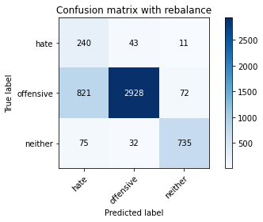

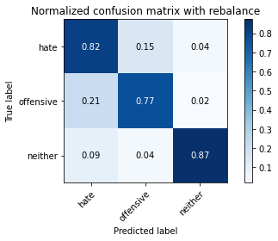

precision recall f1-score support

hate 0.21 0.82 0.34 294

offensive 0.98 0.77 0.86 3821

neither 0.90 0.87 0.89 842

accuracy 0.79 4957

macro avg 0.69 0.82 0.69 4957

weighted avg 0.92 0.79 0.83 4957

average eval_loss: 0.479127706839673, accuracy: 0.7873713939882994

training 3 epoch...

28.160919427871704 seconds used......

3 training finished! average train loss: 0.2793585041113067

evaluating...

Confusion matrix, without normalization

[[ 229 46 19]

[ 807 2870 144]

[ 46 18 778]]

Normalized confusion matrix

[[0.77891156 0.15646259 0.06462585]

[0.21120126 0.75111227 0.03768647]

[0.05463183 0.02137767 0.9239905 ]]

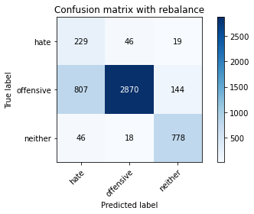

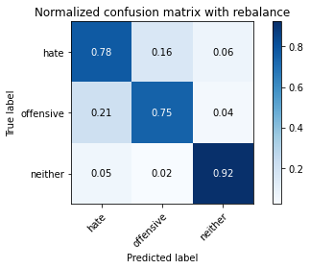

precision recall f1-score support

hate 0.21 0.78 0.33 294

offensive 0.98 0.75 0.85 3821

neither 0.83 0.92 0.87 842

accuracy 0.78 4957

macro avg 0.67 0.82 0.69 4957

weighted avg 0.91 0.78 0.82 4957

average eval_loss: 0.5346151823177934, accuracy: 0.782126286060117

training 4 epoch...

28.042017936706543 seconds used......

4 training finished! average train loss: 0.15700065930597265

evaluating...

Confusion matrix, without normalization

[[ 218 53 23]

[ 702 3017 102]

[ 44 44 754]]

Normalized confusion matrix

[[0.7414966 0.18027211 0.07823129]

[0.18372154 0.78958388 0.02669458]

[0.05225653 0.05225653 0.89548694]]

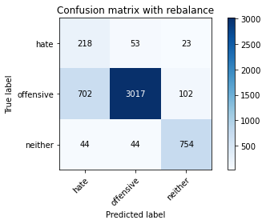

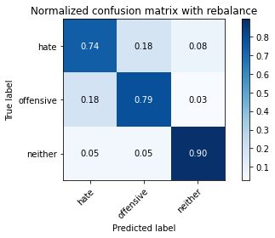

precision recall f1-score support

hate 0.23 0.74 0.35 294

offensive 0.97 0.79 0.87 3821

neither 0.86 0.90 0.88 842

accuracy 0.80 4957

macro avg 0.68 0.81 0.70 4957

weighted avg 0.91 0.80 0.84 4957

average eval_loss: 0.5865820189186882, accuracy: 0.8047205971353641

training 5 epoch...

28.02215003967285 seconds used......

5 training finished! average train loss: 0.0874265119547776

evaluating...

Confusion matrix, without normalization

[[ 232 40 22]

[ 929 2761 131]

[ 54 25 763]]

Normalized confusion matrix

[[0.78911565 0.13605442 0.07482993]

[0.24313007 0.72258571 0.03428422]

[0.06413302 0.02969121 0.90617577]]

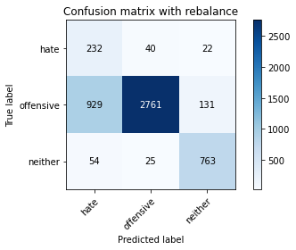

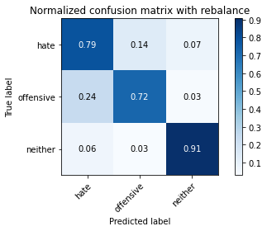

precision recall f1-score support

hate 0.19 0.79 0.31 294

offensive 0.98 0.72 0.83 3821

neither 0.83 0.91 0.87 842

accuracy 0.76 4957

macro avg 0.67 0.81 0.67 4957

weighted avg 0.91 0.76 0.81 4957

average eval_loss: 0.8557288813134355, accuracy: 0.7577163607020375

training 6 epoch...

27.904473066329956 seconds used......

6 training finished! average train loss: 0.04790602775960507

evaluating...

Confusion matrix, without normalization

[[ 206 68 20]

[ 622 3114 85]

[ 51 71 720]]

Normalized confusion matrix

[[0.70068027 0.23129252 0.06802721]

[0.16278461 0.8149699 0.02224549]

[0.06057007 0.08432304 0.85510689]]

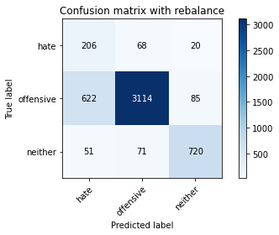

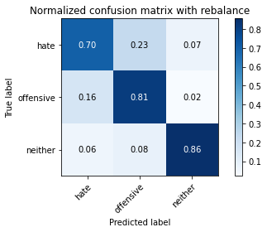

precision recall f1-score support

hate 0.23 0.70 0.35 294

offensive 0.96 0.81 0.88 3821

neither 0.87 0.86 0.86 842

accuracy 0.82 4957

macro avg 0.69 0.79 0.70 4957

weighted avg 0.90 0.82 0.85 4957

average eval_loss: 0.6829788885154431, accuracy: 0.8150090780714142

training 7 epoch...

28.00185751914978 seconds used......

7 training finished! average train loss: 0.02255554850130173

evaluating...

Confusion matrix, without normalization

[[ 189 81 24]

[ 489 3213 119]

[ 36 44 762]]

Normalized confusion matrix

[[0.64285714 0.2755102 0.08163265]

[0.12797697 0.84087935 0.03114368]

[0.04275534 0.05225653 0.90498812]]

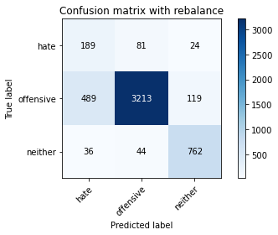

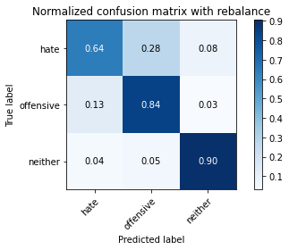

precision recall f1-score support

hate 0.26 0.64 0.37 294

offensive 0.96 0.84 0.90 3821

neither 0.84 0.90 0.87 842

accuracy 0.84 4957

macro avg 0.69 0.80 0.71 4957

weighted avg 0.90 0.84 0.86 4957

average eval_loss: 0.7447820013603045, accuracy: 0.8400242081904378

training 8 epoch...

27.963326930999756 seconds used......

8 training finished! average train loss: 0.01570393066810395

evaluating...

Confusion matrix, without normalization

[[ 209 67 18]

[ 610 3110 101]

[ 71 37 734]]

Normalized confusion matrix

[[0.71088435 0.22789116 0.06122449]

[0.15964407 0.81392306 0.02643287]

[0.08432304 0.04394299 0.87173397]]

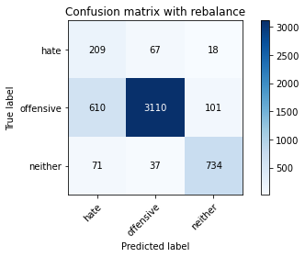

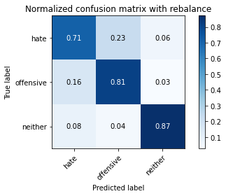

precision recall f1-score support

hate 0.23 0.71 0.35 294

offensive 0.97 0.81 0.88 3821

neither 0.86 0.87 0.87 842

accuracy 0.82 4957

macro avg 0.69 0.80 0.70 4957

weighted avg 0.91 0.82 0.85 4957

average eval_loss: 0.8772796040993266, accuracy: 0.8176316320355054

training 9 epoch...

27.94587516784668 seconds used......

9 training finished! average train loss: 0.02152951554312202

evaluating...

Confusion matrix, without normalization

[[ 233 43 18]

[ 860 2850 111]

[ 73 40 729]]

Normalized confusion matrix

[[0.79251701 0.1462585 0.06122449]

[0.22507197 0.74587804 0.02904999]

[0.08669834 0.04750594 0.86579572]]

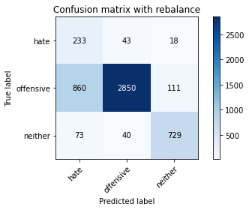

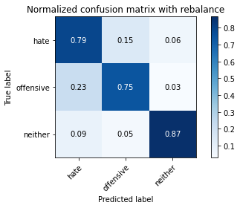

precision recall f1-score support

hate 0.20 0.79 0.32 294

offensive 0.97 0.75 0.84 3821

neither 0.85 0.87 0.86 842

accuracy 0.77 4957

macro avg 0.67 0.80 0.67 4957

weighted avg 0.91 0.77 0.82 4957

average eval_loss: 1.087673382884297, accuracy: 0.7690135162396611

training 10 epoch...

28.043175220489502 seconds used......

10 training finished! average train loss: 0.011051523333247914

evaluating...

Confusion matrix, without normalization

[[ 217 47 30]

[ 689 2956 176]

[ 30 16 796]]

Normalized confusion matrix

[[0.73809524 0.15986395 0.10204082]

[0.18031929 0.77361947 0.04606124]

[0.03562945 0.01900238 0.94536817]]

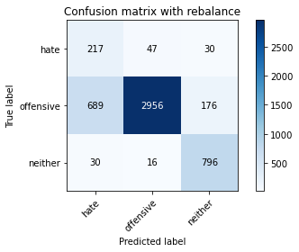

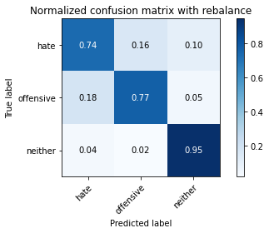

precision recall f1-score support

hate 0.23 0.74 0.35 294

offensive 0.98 0.77 0.86 3821

neither 0.79 0.95 0.86 842

accuracy 0.80 4957

macro avg 0.67 0.82 0.69 4957

weighted avg 0.90 0.80 0.83 4957

average eval_loss: 1.1635338434266047, accuracy: 0.80068589872907

2 run

training 1 epoch...

27.922107458114624 seconds used......

1 training finished! average train loss: 0.657794236613993

evaluating...

Confusion matrix, without normalization

[[ 211 44 39]

[ 685 2957 179]

[ 27 15 800]]

Normalized confusion matrix

[[0.71768707 0.14965986 0.13265306]

[0.17927244 0.77388118 0.04684638]

[0.03206651 0.01781473 0.95011876]]

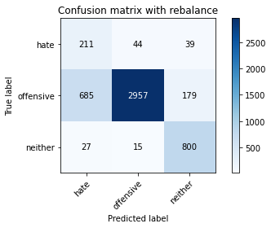

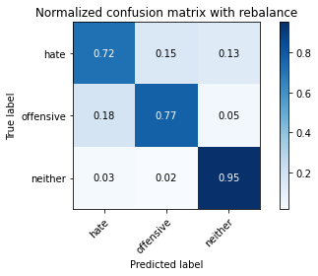

precision recall f1-score support

hate 0.23 0.72 0.35 294

offensive 0.98 0.77 0.86 3821

neither 0.79 0.95 0.86 842

accuracy 0.80 4957

macro avg 0.66 0.81 0.69 4957

weighted avg 0.90 0.80 0.83 4957

average eval_loss: 0.47718381551244565, accuracy: 0.8004841638087553

training 2 epoch...

27.79587483406067 seconds used......

2 training finished! average train loss: 0.42030908925491467

evaluating...

Confusion matrix, without normalization

[[ 220 54 20]

[ 598 3118 105]

[ 40 30 772]]

Normalized confusion matrix

[[0.74829932 0.18367347 0.06802721]

[0.15650353 0.81601675 0.02747972]

[0.04750594 0.03562945 0.91686461]]

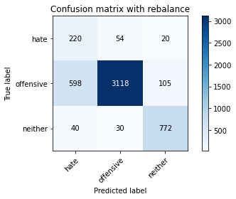

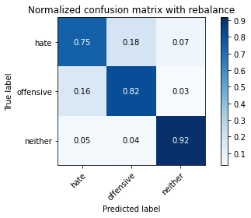

precision recall f1-score support

hate 0.26 0.75 0.38 294

offensive 0.97 0.82 0.89 3821

neither 0.86 0.92 0.89 842

accuracy 0.83 4957

macro avg 0.70 0.83 0.72 4957

weighted avg 0.91 0.83 0.86 4957

average eval_loss: 0.38545321679163363, accuracy: 0.8291305224934437

training 3 epoch...

27.73030400276184 seconds used......

3 training finished! average train loss: 0.29646076449351005

evaluating...

Confusion matrix, without normalization

[[ 236 48 10]

[ 703 3047 71]

[ 100 34 708]]

Normalized confusion matrix

[[0.80272109 0.16326531 0.03401361]

[0.18398325 0.79743523 0.01858152]

[0.11876485 0.04038005 0.84085511]]

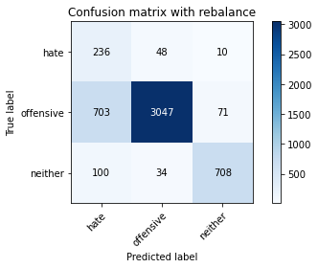

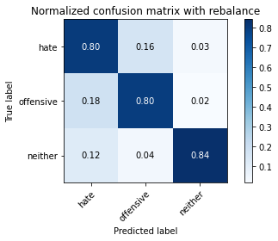

precision recall f1-score support

hate 0.23 0.80 0.35 294

offensive 0.97 0.80 0.88 3821

neither 0.90 0.84 0.87 842

accuracy 0.81 4957

macro avg 0.70 0.81 0.70 4957

weighted avg 0.92 0.81 0.84 4957

average eval_loss: 0.44656141548447553, accuracy: 0.8051240669759936

training 4 epoch...

27.780518531799316 seconds used......

4 training finished! average train loss: 0.1866661306710271

evaluating...

Confusion matrix, without normalization

[[ 182 91 21]

[ 425 3289 107]

[ 37 43 762]]

Normalized confusion matrix

[[0.61904762 0.30952381 0.07142857]

[0.11122743 0.86076943 0.02800314]

[0.04394299 0.05106888 0.90498812]]

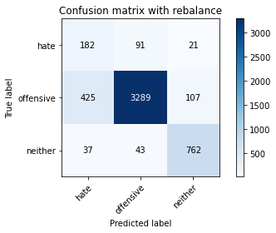

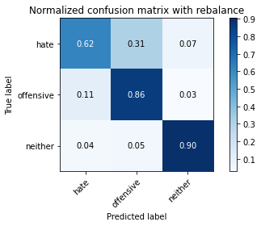

precision recall f1-score support

hate 0.28 0.62 0.39 294

offensive 0.96 0.86 0.91 3821

neither 0.86 0.90 0.88 842

accuracy 0.85 4957

macro avg 0.70 0.79 0.73 4957

weighted avg 0.90 0.85 0.87 4957

average eval_loss: 0.42896043399589195, accuracy: 0.8539439176921525

training 5 epoch...

27.87527322769165 seconds used......

5 training finished! average train loss: 0.09083842167805074

evaluating...

Confusion matrix, without normalization

[[ 211 70 13]

[ 604 3136 81]

[ 44 67 731]]

Normalized confusion matrix

[[0.71768707 0.23809524 0.04421769]

[0.1580738 0.82072756 0.02119864]

[0.05225653 0.07957245 0.86817102]]

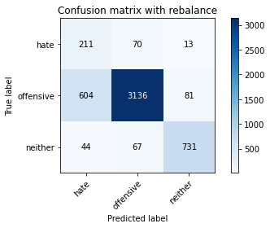

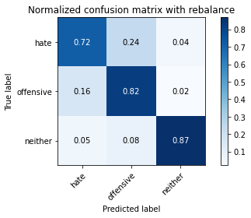

precision recall f1-score support

hate 0.25 0.72 0.37 294

offensive 0.96 0.82 0.88 3821

neither 0.89 0.87 0.88 842

accuracy 0.82 4957

macro avg 0.70 0.80 0.71 4957

weighted avg 0.90 0.82 0.85 4957

average eval_loss: 0.6254518241170914, accuracy: 0.822675005043373

training 6 epoch...

27.84345006942749 seconds used......

6 training finished! average train loss: 0.05516432090022476

evaluating...

Confusion matrix, without normalization

[[ 164 84 46]

[ 311 3314 196]

[ 17 29 796]]

Normalized confusion matrix

[[0.55782313 0.28571429 0.15646259]

[0.08139231 0.86731222 0.05129547]

[0.02019002 0.03444181 0.94536817]]

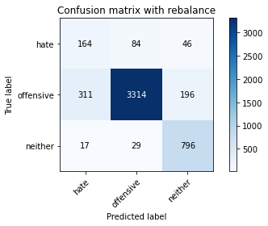

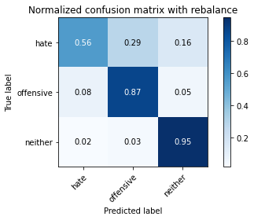

precision recall f1-score support

hate 0.33 0.56 0.42 294

offensive 0.97 0.87 0.91 3821

neither 0.77 0.95 0.85 842

accuracy 0.86 4957

macro avg 0.69 0.79 0.73 4957

weighted avg 0.90 0.86 0.87 4957

average eval_loss: 0.6622941558690078, accuracy: 0.8622150494250554

training 7 epoch...

27.78884768486023 seconds used......

7 training finished! average train loss: 0.03733860870090733

evaluating...

Confusion matrix, without normalization

[[ 239 42 13]

[ 961 2762 98]

[ 73 37 732]]

Normalized confusion matrix

[[0.81292517 0.14285714 0.04421769]

[0.25150484 0.72284742 0.02564774]

[0.08669834 0.04394299 0.86935867]]

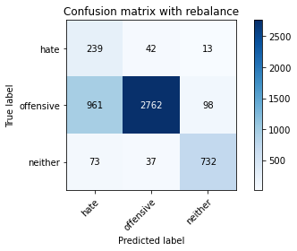

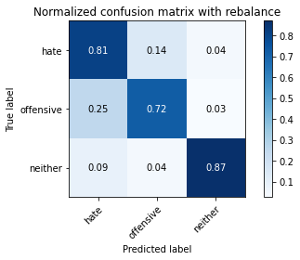

precision recall f1-score support

hate 0.19 0.81 0.31 294

offensive 0.97 0.72 0.83 3821

neither 0.87 0.87 0.87 842

accuracy 0.75 4957

macro avg 0.68 0.80 0.67 4957

weighted avg 0.91 0.75 0.80 4957

average eval_loss: 1.1705447228234862, accuracy: 0.7530764575347992

training 8 epoch...

27.802300930023193 seconds used......

8 training finished! average train loss: 0.020948512931878552

evaluating...

Confusion matrix, without normalization

[[ 222 50 22]

[ 725 2963 133]

[ 47 42 753]]

Normalized confusion matrix

[[0.75510204 0.17006803 0.07482993]

[0.18974091 0.77545145 0.03480764]

[0.05581948 0.04988124 0.89429929]]

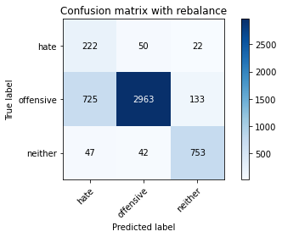

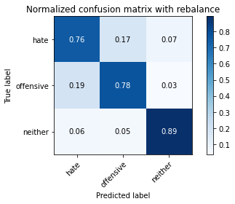

precision recall f1-score support

hate 0.22 0.76 0.34 294

offensive 0.97 0.78 0.86 3821

neither 0.83 0.89 0.86 842

accuracy 0.79 4957

macro avg 0.67 0.81 0.69 4957

weighted avg 0.90 0.79 0.83 4957

average eval_loss: 0.9480651341483838, accuracy: 0.7944321161993141

training 9 epoch...

27.8840970993042 seconds used......

9 training finished! average train loss: 0.026171777469387866

evaluating...

Confusion matrix, without normalization

[[ 249 36 9]

[1320 2441 60]

[ 143 34 665]]

Normalized confusion matrix

[[0.84693878 0.12244898 0.03061224]

[0.3454593 0.638838 0.0157027 ]

[0.16983373 0.04038005 0.78978622]]

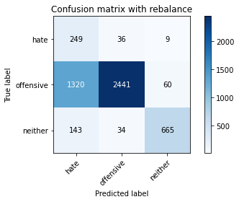

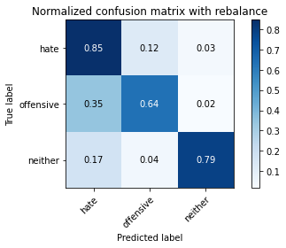

precision recall f1-score support

hate 0.15 0.85 0.25 294

offensive 0.97 0.64 0.77 3821

neither 0.91 0.79 0.84 842

accuracy 0.68 4957

macro avg 0.67 0.76 0.62 4957

weighted avg 0.91 0.68 0.75 4957

average eval_loss: 1.6672851902042185, accuracy: 0.6768206576558402

training 10 epoch...

27.78989863395691 seconds used......

10 training finished! average train loss: 0.021156393480861603

evaluating...

Confusion matrix, without normalization

[[ 212 68 14]

[ 696 3017 108]

[ 56 49 737]]

Normalized confusion matrix

[[0.72108844 0.23129252 0.04761905]

[0.18215127 0.78958388 0.02826485]

[0.06650831 0.05819477 0.87529691]]

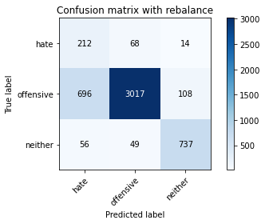

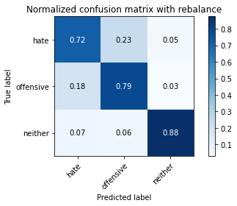

precision recall f1-score support

hate 0.22 0.72 0.34 294

offensive 0.96 0.79 0.87 3821

neither 0.86 0.88 0.87 842

accuracy 0.80 4957

macro avg 0.68 0.80 0.69 4957

weighted avg 0.90 0.80 0.84 4957

average eval_loss: 0.979501882808343, accuracy: 0.8000806939681259

3 run

training 1 epoch...

27.87532925605774 seconds used......

1 training finished! average train loss: 0.6534496100499616

evaluating...

Confusion matrix, without normalization

[[ 227 47 20]

[ 780 2939 102]

[ 69 17 756]]

Normalized confusion matrix

[[0.77210884 0.15986395 0.06802721]

[0.20413504 0.76917037 0.02669458]

[0.08194774 0.02019002 0.89786223]]

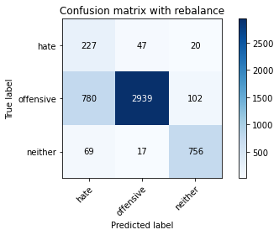

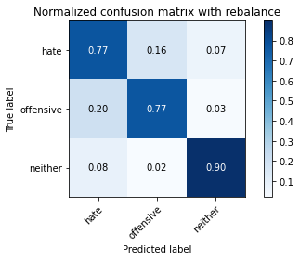

precision recall f1-score support

hate 0.21 0.77 0.33 294

offensive 0.98 0.77 0.86 3821

neither 0.86 0.90 0.88 842

accuracy 0.79 4957

macro avg 0.68 0.81 0.69 4957

weighted avg 0.91 0.79 0.83 4957

average eval_loss: 0.47147709065146987, accuracy: 0.7912043574742788

training 2 epoch...

27.83491826057434 seconds used......

2 training finished! average train loss: 0.40826184468136895

evaluating...

Confusion matrix, without normalization

[[ 208 65 21]

[ 511 3198 112]

[ 42 14 786]]

Normalized confusion matrix

[[0.70748299 0.22108844 0.07142857]

[0.13373462 0.83695368 0.0293117 ]

[0.04988124 0.01662708 0.93349169]]

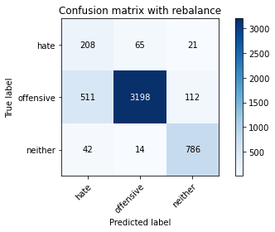

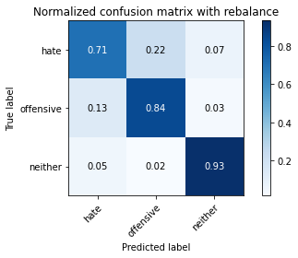

precision recall f1-score support

hate 0.27 0.71 0.39 294

offensive 0.98 0.84 0.90 3821

neither 0.86 0.93 0.89 842

accuracy 0.85 4957

macro avg 0.70 0.83 0.73 4957

weighted avg 0.91 0.85 0.87 4957

average eval_loss: 0.3986258885913318, accuracy: 0.8456727859592496

training 3 epoch...

27.831713914871216 seconds used......

3 training finished! average train loss: 0.28128125679771804

evaluating...

Confusion matrix, without normalization

[[ 209 72 13]

[ 537 3200 84]

[ 75 51 716]]

Normalized confusion matrix

[[0.71088435 0.24489796 0.04421769]

[0.14053913 0.8374771 0.02198377]

[0.08907363 0.06057007 0.85035629]]

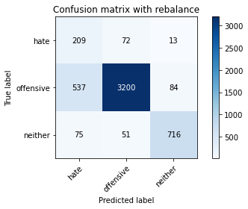

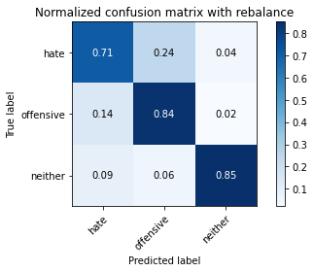

precision recall f1-score support

hate 0.25 0.71 0.37 294

offensive 0.96 0.84 0.90 3821

neither 0.88 0.85 0.87 842

accuracy 0.83 4957

macro avg 0.70 0.80 0.71 4957

weighted avg 0.91 0.83 0.86 4957

average eval_loss: 0.41698861661397163, accuracy: 0.8321565462981642

training 4 epoch...

27.859073877334595 seconds used......

4 training finished! average train loss: 0.1779429322729508

evaluating...

Confusion matrix, without normalization

[[ 212 69 13]

[ 574 3161 86]

[ 72 60 710]]

Normalized confusion matrix

[[0.72108844 0.23469388 0.04421769]

[0.15022245 0.82727035 0.0225072 ]

[0.08551069 0.07125891 0.8432304 ]]

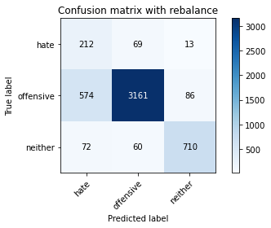

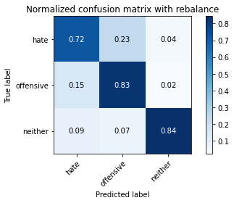

precision recall f1-score support

hate 0.25 0.72 0.37 294

offensive 0.96 0.83 0.89 3821

neither 0.88 0.84 0.86 842

accuracy 0.82 4957

macro avg 0.70 0.80 0.71 4957

weighted avg 0.90 0.82 0.85 4957

average eval_loss: 0.4844290448968569, accuracy: 0.8236836796449465

training 5 epoch...

27.864997386932373 seconds used......

5 training finished! average train loss: 0.09745922281368695

evaluating...

Confusion matrix, without normalization

[[ 230 51 13]

[ 751 2986 84]

[ 86 46 710]]

Normalized confusion matrix

[[0.78231293 0.17346939 0.04421769]

[0.19654541 0.78147082 0.02198377]

[0.10213777 0.05463183 0.8432304 ]]

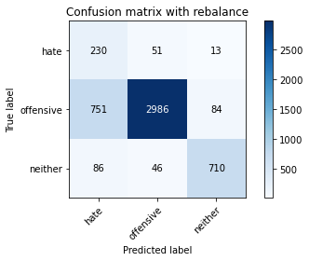

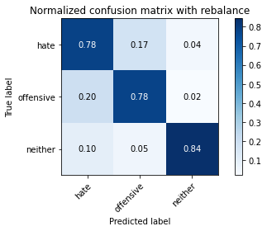

precision recall f1-score support

hate 0.22 0.78 0.34 294

offensive 0.97 0.78 0.87 3821

neither 0.88 0.84 0.86 842

accuracy 0.79 4957

macro avg 0.69 0.80 0.69 4957

weighted avg 0.91 0.79 0.83 4957

average eval_loss: 0.6802116809112411, accuracy: 0.7920112971555376

training 6 epoch...

27.863129377365112 seconds used......

6 training finished! average train loss: 0.050332655051821155

evaluating...

Confusion matrix, without normalization

[[ 212 57 25]

[ 681 2979 161]

[ 40 28 774]]

Normalized confusion matrix

[[0.72108844 0.19387755 0.08503401]

[0.1782256 0.77963884 0.04213557]

[0.04750594 0.03325416 0.9192399 ]]

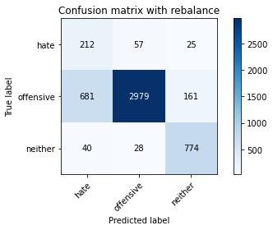

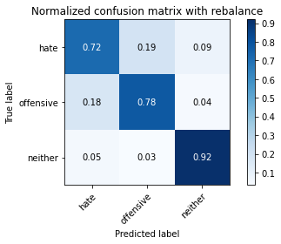

precision recall f1-score support

hate 0.23 0.72 0.35 294

offensive 0.97 0.78 0.87 3821

neither 0.81 0.92 0.86 842

accuracy 0.80 4957

macro avg 0.67 0.81 0.69 4957

weighted avg 0.90 0.80 0.83 4957

average eval_loss: 0.801613078963372, accuracy: 0.7998789590478111

training 7 epoch...

27.819833755493164 seconds used......

7 training finished! average train loss: 0.026187785424575297

evaluating...

Confusion matrix, without normalization

[[ 192 86 16]

[ 454 3273 94]

[ 54 51 737]]

Normalized confusion matrix

[[0.65306122 0.29251701 0.05442177]

[0.11881706 0.85658205 0.02460089]

[0.06413302 0.06057007 0.87529691]]

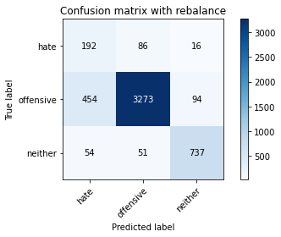

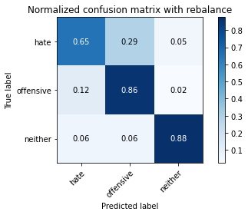

precision recall f1-score support

hate 0.27 0.65 0.39 294

offensive 0.96 0.86 0.91 3821

neither 0.87 0.88 0.87 842

accuracy 0.85 4957

macro avg 0.70 0.79 0.72 4957

weighted avg 0.90 0.85 0.87 4957

average eval_loss: 0.6920512587643198, accuracy: 0.8476901351623967

training 8 epoch...

27.91018772125244 seconds used......

8 training finished! average train loss: 0.030963456845700697

evaluating...

Confusion matrix, without normalization

[[ 204 69 21]

[ 594 3103 124]

[ 57 30 755]]

Normalized confusion matrix

[[0.69387755 0.23469388 0.07142857]

[0.15545669 0.81209108 0.03245224]

[0.06769596 0.03562945 0.89667458]]

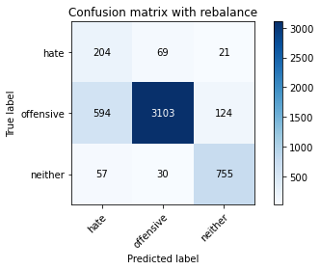

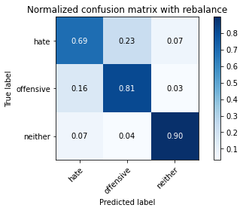

precision recall f1-score support

hate 0.24 0.69 0.36 294

offensive 0.97 0.81 0.88 3821

neither 0.84 0.90 0.87 842

accuracy 0.82 4957

macro avg 0.68 0.80 0.70 4957

weighted avg 0.90 0.82 0.85 4957

average eval_loss: 0.8378802295595843, accuracy: 0.8194472463183377

training 9 epoch...

27.864864587783813 seconds used......

9 training finished! average train loss: 0.014488157285213993

evaluating...

Confusion matrix, without normalization

[[ 228 49 17]

[ 827 2872 122]

[ 73 25 744]]

Normalized confusion matrix

[[0.7755102 0.16666667 0.05782313]

[0.21643549 0.7516357 0.03192881]

[0.08669834 0.02969121 0.88361045]]

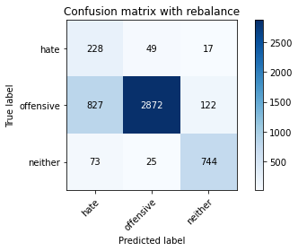

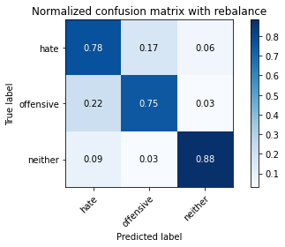

precision recall f1-score support

hate 0.20 0.78 0.32 294

offensive 0.97 0.75 0.85 3821

neither 0.84 0.88 0.86 842

accuracy 0.78 4957

macro avg 0.67 0.80 0.68 4957

weighted avg 0.91 0.78 0.82 4957

average eval_loss: 1.287108600793046, accuracy: 0.7754690336897317

training 10 epoch...

27.93761372566223 seconds used......

10 training finished! average train loss: 0.017810450807078985

evaluating...

Confusion matrix, without normalization

[[ 200 74 20]

[ 617 3098 106]

[ 57 43 742]]

Normalized confusion matrix

[[0.68027211 0.25170068 0.06802721]

[0.16147605 0.81078252 0.02774143]

[0.06769596 0.05106888 0.88123515]]

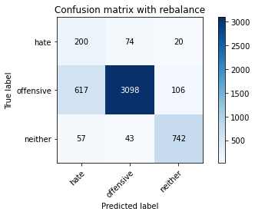

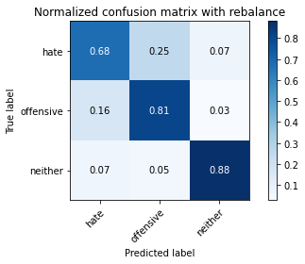

precision recall f1-score support

hate 0.23 0.68 0.34 294

offensive 0.96 0.81 0.88 3821

neither 0.85 0.88 0.87 842

accuracy 0.82 4957

macro avg 0.68 0.79 0.70 4957

weighted avg 0.90 0.82 0.85 4957

average eval_loss: 1.001914332099747, accuracy: 0.8150090780714142

4 run

training 1 epoch...

27.982183694839478 seconds used......

1 training finished! average train loss: 0.6928540737482539

evaluating...

Confusion matrix, without normalization

[[ 210 55 29]

[ 674 3024 123]

[ 31 28 783]]

Normalized confusion matrix

[[0.71428571 0.18707483 0.09863946]

[0.17639361 0.79141586 0.03219053]

[0.0368171 0.03325416 0.92992874]]

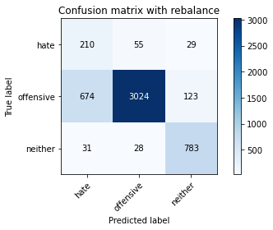

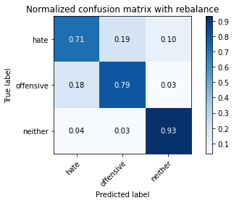

precision recall f1-score support

hate 0.23 0.71 0.35 294

offensive 0.97 0.79 0.87 3821

neither 0.84 0.93 0.88 842

accuracy 0.81 4957

macro avg 0.68 0.81 0.70 4957

weighted avg 0.91 0.81 0.84 4957

average eval_loss: 0.4514377528741475, accuracy: 0.8103691749041759

training 2 epoch...

27.879236459732056 seconds used......

2 training finished! average train loss: 0.4042200189933442

evaluating...

Confusion matrix, without normalization

[[ 214 65 15]

[ 561 3160 100]

[ 63 30 749]]

Normalized confusion matrix

[[0.72789116 0.22108844 0.05102041]

[0.1468202 0.82700864 0.02617116]

[0.07482185 0.03562945 0.88954869]]

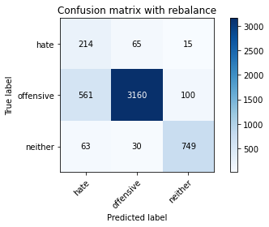

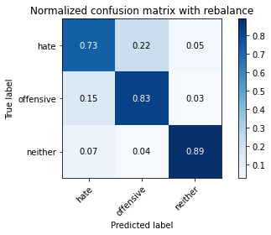

precision recall f1-score support

hate 0.26 0.73 0.38 294

offensive 0.97 0.83 0.89 3821

neither 0.87 0.89 0.88 842

accuracy 0.83 4957

macro avg 0.70 0.81 0.72 4957

weighted avg 0.91 0.83 0.86 4957

average eval_loss: 0.39119846959628407, accuracy: 0.8317530764575348

training 3 epoch...

27.77622628211975 seconds used......

3 training finished! average train loss: 0.27087572735478305

evaluating...

Confusion matrix, without normalization

[[ 221 49 24]

[ 762 2932 127]

[ 36 22 784]]

Normalized confusion matrix

[[0.75170068 0.16666667 0.08163265]

[0.19942423 0.76733839 0.03323737]

[0.04275534 0.02612827 0.93111639]]

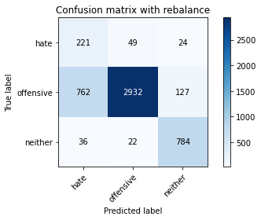

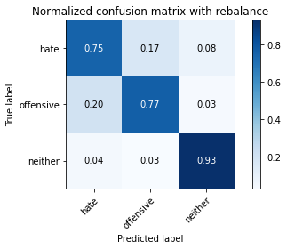

precision recall f1-score support

hate 0.22 0.75 0.34 294

offensive 0.98 0.77 0.86 3821

neither 0.84 0.93 0.88 842

accuracy 0.79 4957

macro avg 0.68 0.82 0.69 4957

weighted avg 0.91 0.79 0.83 4957

average eval_loss: 0.5024685696848938, accuracy: 0.7942303812789994

training 4 epoch...

27.740535974502563 seconds used......

4 training finished! average train loss: 0.15385943720367742

evaluating...

Confusion matrix, without normalization

[[ 205 74 15]

[ 587 3134 100]

[ 48 36 758]]

Normalized confusion matrix

[[0.69727891 0.25170068 0.05102041]

[0.15362471 0.82020414 0.02617116]

[0.05700713 0.04275534 0.90023753]]

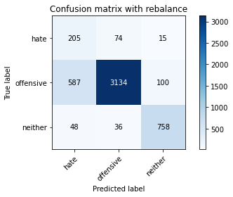

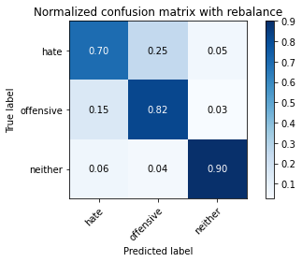

precision recall f1-score support

hate 0.24 0.70 0.36 294

offensive 0.97 0.82 0.89 3821

neither 0.87 0.90 0.88 842

accuracy 0.83 4957

macro avg 0.69 0.81 0.71 4957

weighted avg 0.91 0.83 0.86 4957

average eval_loss: 0.46807221593635695, accuracy: 0.8265079685293524

training 5 epoch...

27.727325201034546 seconds used......

5 training finished! average train loss: 0.07246720425686554

evaluating...

Confusion matrix, without normalization

[[ 220 56 18]

[ 698 3031 92]

[ 50 44 748]]

Normalized confusion matrix

[[0.74829932 0.19047619 0.06122449]

[0.18267469 0.79324784 0.02407747]

[0.05938242 0.05225653 0.88836105]]

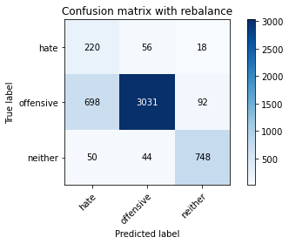

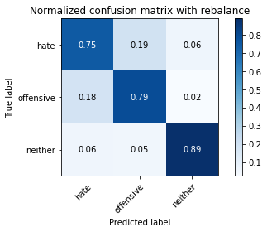

precision recall f1-score support

hate 0.23 0.75 0.35 294

offensive 0.97 0.79 0.87 3821

neither 0.87 0.89 0.88 842

accuracy 0.81 4957

macro avg 0.69 0.81 0.70 4957

weighted avg 0.91 0.81 0.84 4957

average eval_loss: 0.6678505410748203, accuracy: 0.8067379463385111

training 6 epoch...

27.780186414718628 seconds used......

6 training finished! average train loss: 0.032486473626119484

evaluating...

Confusion matrix, without normalization

[[ 204 66 24]

[ 559 3138 124]

[ 37 32 773]]

Normalized confusion matrix

[[0.69387755 0.2244898 0.08163265]

[0.14629678 0.82125098 0.03245224]

[0.04394299 0.03800475 0.91805226]]

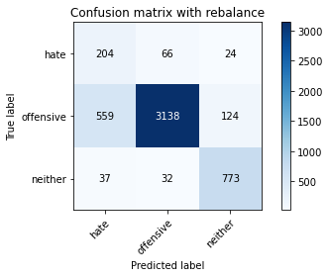

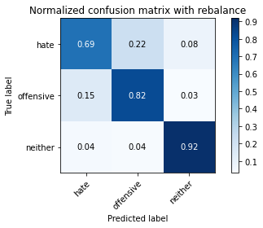

precision recall f1-score support

hate 0.26 0.69 0.37 294

offensive 0.97 0.82 0.89 3821

neither 0.84 0.92 0.88 842

accuracy 0.83 4957

macro avg 0.69 0.81 0.71 4957

weighted avg 0.91 0.83 0.86 4957

average eval_loss: 0.7275703924993474, accuracy: 0.8301391970950172

training 7 epoch...

27.988940954208374 seconds used......

7 training finished! average train loss: 0.018459081064640104

evaluating...

Confusion matrix, without normalization

[[ 219 57 18]

[ 666 3036 119]

[ 50 35 757]]

Normalized confusion matrix

[[0.74489796 0.19387755 0.06122449]

[0.17429992 0.7945564 0.03114368]

[0.05938242 0.0415677 0.89904988]]

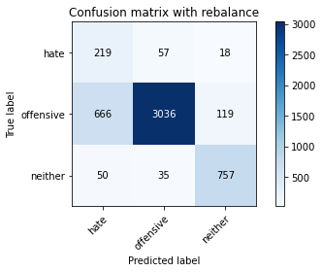

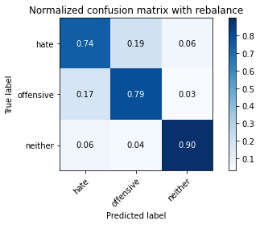

precision recall f1-score support

hate 0.23 0.74 0.36 294

offensive 0.97 0.79 0.87 3821

neither 0.85 0.90 0.87 842

accuracy 0.81 4957

macro avg 0.68 0.81 0.70 4957

weighted avg 0.91 0.81 0.84 4957

average eval_loss: 0.8594668620639676, accuracy: 0.8093605003026024

training 8 epoch...

27.9111008644104 seconds used......

8 training finished! average train loss: 0.013534367938726127

evaluating...

Confusion matrix, without normalization

[[ 227 44 23]

[ 938 2689 194]

[ 44 18 780]]

Normalized confusion matrix

[[0.77210884 0.14965986 0.07823129]

[0.24548548 0.70374248 0.05077205]

[0.05225653 0.02137767 0.9263658 ]]

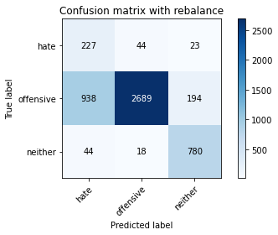

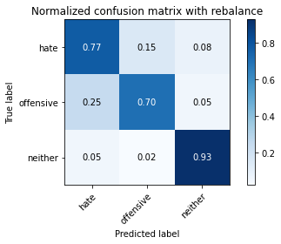

precision recall f1-score support

hate 0.19 0.77 0.30 294

offensive 0.98 0.70 0.82 3821

neither 0.78 0.93 0.85 842

accuracy 0.75 4957

macro avg 0.65 0.80 0.66 4957

weighted avg 0.90 0.75 0.79 4957

average eval_loss: 1.2788742414315142, accuracy: 0.7456122654831552

training 9 epoch...

27.84866452217102 seconds used......

9 training finished! average train loss: 0.02057943883357428

evaluating...

Confusion matrix, without normalization

[[ 231 48 15]

[ 903 2810 108]

[ 63 43 736]]

Normalized confusion matrix

[[0.78571429 0.16326531 0.05102041]

[0.23632557 0.73540958 0.02826485]

[0.07482185 0.05106888 0.87410926]]

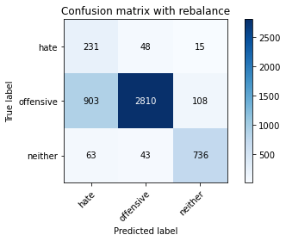

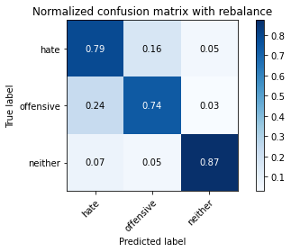

precision recall f1-score support

hate 0.19 0.79 0.31 294

offensive 0.97 0.74 0.84 3821

neither 0.86 0.87 0.87 842

accuracy 0.76 4957

macro avg 0.67 0.80 0.67 4957

weighted avg 0.90 0.76 0.81 4957

average eval_loss: 1.2437750164038246, accuracy: 0.7619527940286464

training 10 epoch...

27.853721618652344 seconds used......

10 training finished! average train loss: 0.015044875326566398

evaluating...

Confusion matrix, without normalization

[[ 206 72 16]

[ 558 3168 95]

[ 62 45 735]]

Normalized confusion matrix

[[0.70068027 0.24489796 0.05442177]

[0.14603507 0.82910233 0.0248626 ]

[0.0736342 0.05344418 0.87292162]]

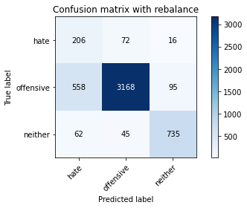

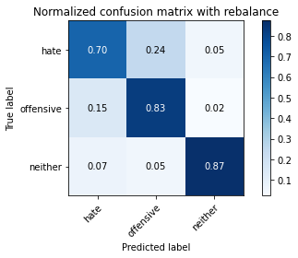

precision recall f1-score support

hate 0.25 0.70 0.37 294

offensive 0.96 0.83 0.89 3821

neither 0.87 0.87 0.87 842

accuracy 0.83 4957

macro avg 0.69 0.80 0.71 4957

weighted avg 0.91 0.83 0.86 4957

average eval_loss: 0.8868012363555834, accuracy: 0.8289287875731289

5 run

training 1 epoch...

27.850404262542725 seconds used......

1 training finished! average train loss: 0.6731123595732694

evaluating...

Confusion matrix, without normalization

[[ 228 35 31]

[ 854 2829 138]

[ 45 12 785]]

Normalized confusion matrix

[[0.7755102 0.11904762 0.10544218]

[0.2235017 0.7403821 0.0361162 ]

[0.05344418 0.01425178 0.93230404]]

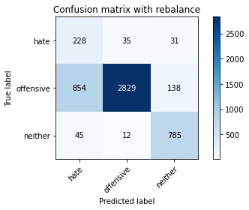

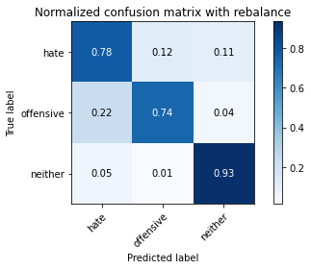

precision recall f1-score support

hate 0.20 0.78 0.32 294

offensive 0.98 0.74 0.84 3821

neither 0.82 0.93 0.87 842

accuracy 0.78 4957

macro avg 0.67 0.82 0.68 4957

weighted avg 0.91 0.78 0.82 4957

average eval_loss: 0.5104344368221299, accuracy: 0.7750655638491023

training 2 epoch...

27.777525424957275 seconds used......

2 training finished! average train loss: 0.38536569253917324

evaluating...

Confusion matrix, without normalization

[[ 243 38 13]

[ 988 2742 91]

[ 68 23 751]]

Normalized confusion matrix

[[0.82653061 0.1292517 0.04421769]

[0.25857105 0.71761319 0.02381576]

[0.0807601 0.02731591 0.89192399]]

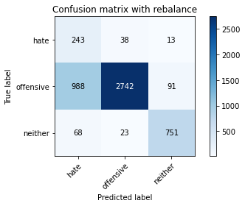

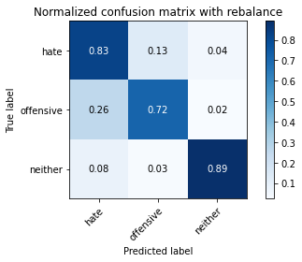

precision recall f1-score support

hate 0.19 0.83 0.31 294

offensive 0.98 0.72 0.83 3821

neither 0.88 0.89 0.89 842

accuracy 0.75 4957

macro avg 0.68 0.81 0.67 4957

weighted avg 0.91 0.75 0.81 4957

average eval_loss: 0.5833943789043734, accuracy: 0.7536816622957434

training 3 epoch...

27.753190994262695 seconds used......

3 training finished! average train loss: 0.24944493849897942

evaluating...

Confusion matrix, without normalization

[[ 205 69 20]

[ 508 3167 146]

[ 37 33 772]]

Normalized confusion matrix

[[0.69727891 0.23469388 0.06802721]

[0.13294949 0.82884062 0.03820989]

[0.04394299 0.0391924 0.91686461]]

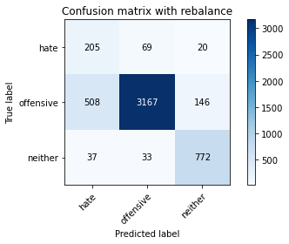

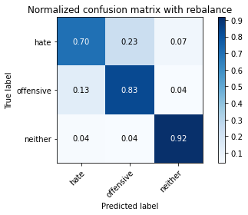

precision recall f1-score support

hate 0.27 0.70 0.39 294

offensive 0.97 0.83 0.89 3821

neither 0.82 0.92 0.87 842

accuracy 0.84 4957

macro avg 0.69 0.81 0.72 4957

weighted avg 0.90 0.84 0.86 4957

average eval_loss: 0.4305634575204984, accuracy: 0.8359895097841437

training 4 epoch...

27.835127115249634 seconds used......

4 training finished! average train loss: 0.134506676269815

evaluating...

Confusion matrix, without normalization

[[ 214 59 21]

[ 639 3076 106]

[ 52 39 751]]

Normalized confusion matrix

[[0.72789116 0.20068027 0.07142857]

[0.16723371 0.80502486 0.02774143]

[0.06175772 0.04631829 0.89192399]]

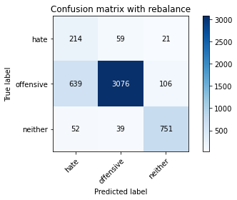

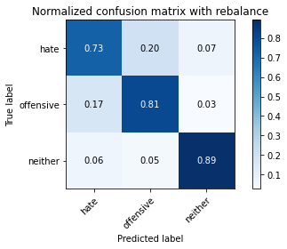

precision recall f1-score support

hate 0.24 0.73 0.36 294

offensive 0.97 0.81 0.88 3821

neither 0.86 0.89 0.87 842

accuracy 0.82 4957

macro avg 0.69 0.81 0.70 4957

weighted avg 0.91 0.82 0.85 4957

average eval_loss: 0.5701150413933059, accuracy: 0.8152108129917288

training 5 epoch...

27.964874029159546 seconds used......

5 training finished! average train loss: 0.06466092010115801

evaluating...

Confusion matrix, without normalization

[[ 223 56 15]

[ 784 2929 108]

[ 69 35 738]]

Normalized confusion matrix

[[0.7585034 0.19047619 0.05102041]

[0.20518189 0.76655326 0.02826485]

[0.08194774 0.0415677 0.87648456]]

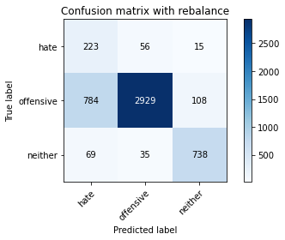

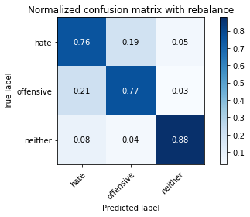

precision recall f1-score support

hate 0.21 0.76 0.33 294

offensive 0.97 0.77 0.86 3821

neither 0.86 0.88 0.87 842

accuracy 0.78 4957

macro avg 0.68 0.80 0.68 4957

weighted avg 0.91 0.78 0.83 4957

average eval_loss: 0.7906389744621852, accuracy: 0.7847488400242082

training 6 epoch...

27.847545623779297 seconds used......

6 training finished! average train loss: 0.035033545260077986

evaluating...

Confusion matrix, without normalization

[[ 244 35 15]

[1151 2559 111]

[ 72 27 743]]

Normalized confusion matrix

[[0.82993197 0.11904762 0.05102041]

[0.30123004 0.66971997 0.02904999]

[0.08551069 0.03206651 0.8824228 ]]

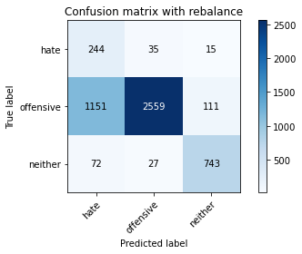

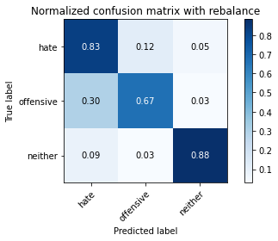

precision recall f1-score support

hate 0.17 0.83 0.28 294

offensive 0.98 0.67 0.79 3821

neither 0.86 0.88 0.87 842

accuracy 0.72 4957

macro avg 0.67 0.79 0.65 4957

weighted avg 0.91 0.72 0.78 4957

average eval_loss: 1.406212107180768, accuracy: 0.7153520274359492

training 7 epoch...

27.81787085533142 seconds used......

7 training finished! average train loss: 0.03289669901146199

evaluating...

Confusion matrix, without normalization

[[ 250 33 11]

[1180 2568 73]

[ 141 41 660]]

Normalized confusion matrix

[[0.85034014 0.1122449 0.03741497]

[0.30881968 0.67207537 0.01910495]

[0.16745843 0.04869359 0.78384798]]

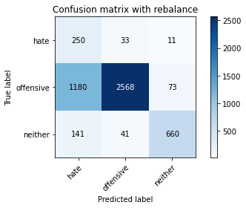

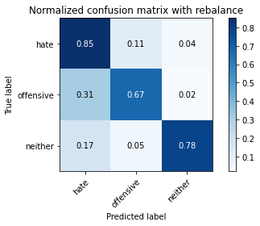

precision recall f1-score support

hate 0.16 0.85 0.27 294

offensive 0.97 0.67 0.79 3821

neither 0.89 0.78 0.83 842

accuracy 0.70 4957

macro avg 0.67 0.77 0.63 4957

weighted avg 0.91 0.70 0.77 4957

average eval_loss: 1.4586079060851085, accuracy: 0.7016340528545492

training 8 epoch...

27.83767056465149 seconds used......

8 training finished! average train loss: 0.02113854705951073

evaluating...

Confusion matrix, without normalization

[[ 223 53 18]

[ 764 2927 130]

[ 48 34 760]]

Normalized confusion matrix

[[0.7585034 0.18027211 0.06122449]

[0.19994766 0.76602984 0.03402251]

[0.05700713 0.04038005 0.90261283]]

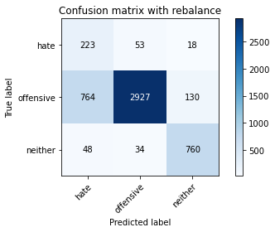

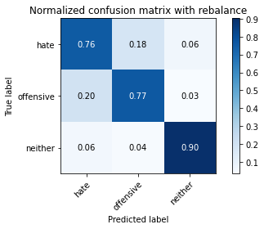

precision recall f1-score support

hate 0.22 0.76 0.34 294

offensive 0.97 0.77 0.86 3821

neither 0.84 0.90 0.87 842

accuracy 0.79 4957

macro avg 0.67 0.81 0.69 4957

weighted avg 0.90 0.79 0.83 4957

average eval_loss: 1.0621907946112896, accuracy: 0.7887835384305023

training 9 epoch...

27.866278886795044 seconds used......

9 training finished! average train loss: 0.011939340812965618

evaluating...

Confusion matrix, without normalization

[[ 230 51 13]

[ 754 2969 98]

[ 58 36 748]]

Normalized confusion matrix

[[0.78231293 0.17346939 0.04421769]

[0.19733054 0.77702172 0.02564774]

[0.06888361 0.04275534 0.88836105]]

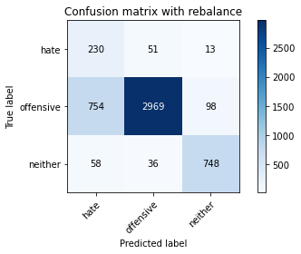

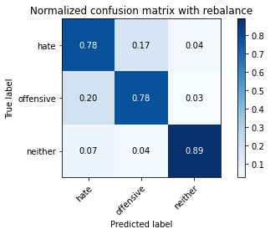

precision recall f1-score support

hate 0.22 0.78 0.34 294

offensive 0.97 0.78 0.86 3821

neither 0.87 0.89 0.88 842

accuracy 0.80 4957

macro avg 0.69 0.82 0.70 4957

weighted avg 0.91 0.80 0.84 4957

average eval_loss: 1.0703271676771222, accuracy: 0.7962477304821465

training 10 epoch...

27.831767559051514 seconds used......

10 training finished! average train loss: 0.009801485031783276

evaluating...

Confusion matrix, without normalization

[[ 201 74 19]

[ 520 3185 116]

[ 38 46 758]]

Normalized confusion matrix

[[0.68367347 0.25170068 0.06462585]

[0.13609003 0.83355143 0.03035854]

[0.04513064 0.05463183 0.90023753]]

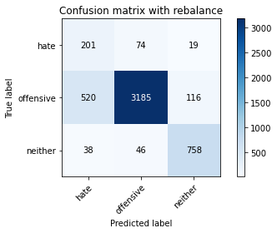

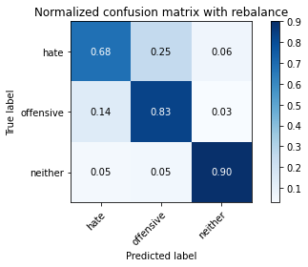

precision recall f1-score support

hate 0.26 0.68 0.38 294

offensive 0.96 0.83 0.89 3821

neither 0.85 0.90 0.87 842

accuracy 0.84 4957

macro avg 0.69 0.81 0.72 4957

weighted avg 0.90 0.84 0.86 4957

average eval_loss: 0.920719869398219, accuracy: 0.8359895097841437