training 1 epoch...

45.420695066452026 seconds used......

1 training finished! average train loss: 0.5521697824836796

evaluating...

Confusion matrix, without normalization

[[ 29 6 10]

[ 34 96 56]

[ 12 9 333]]

Normalized confusion matrix

[[0.64444444 0.13333333 0.22222222]

[0.1827957 0.51612903 0.30107527]

[0.03389831 0.02542373 0.94067797]]

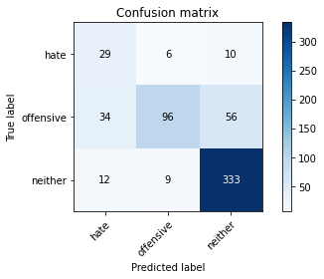

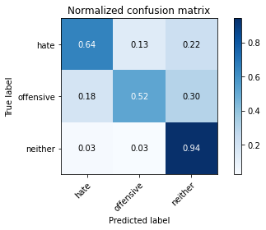

precision recall f1-score support

hate 0.39 0.64 0.48 45

offensive 0.86 0.52 0.65 186

neither 0.83 0.94 0.88 354

accuracy 0.78 585

macro avg 0.70 0.70 0.67 585

weighted avg 0.81 0.78 0.78 585

average eval_loss: 0.4080524792273839, accuracy: 0.7829059829059829

training 2 epoch...

44.779462575912476 seconds used......

2 training finished! average train loss: 0.3169163852516148

evaluating...

Confusion matrix, without normalization

[[ 23 10 12]

[ 12 117 57]

[ 5 7 342]]

Normalized confusion matrix

[[0.51111111 0.22222222 0.26666667]

[0.06451613 0.62903226 0.30645161]

[0.01412429 0.01977401 0.96610169]]

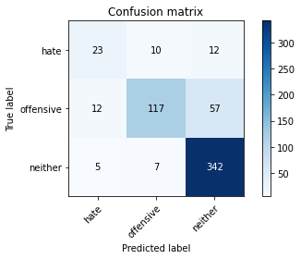

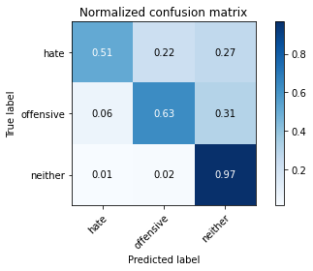

precision recall f1-score support

hate 0.57 0.51 0.54 45

offensive 0.87 0.63 0.73 186

neither 0.83 0.97 0.89 354

accuracy 0.82 585

macro avg 0.76 0.70 0.72 585

weighted avg 0.83 0.82 0.82 585

average eval_loss: 0.36205370364089806, accuracy: 0.8239316239316239

training 3 epoch...

44.649306774139404 seconds used......

3 training finished! average train loss: 0.15346422052790976

evaluating...

Confusion matrix, without normalization

[[ 20 15 10]

[ 6 151 29]

[ 0 38 316]]

Normalized confusion matrix

[[0.44444444 0.33333333 0.22222222]

[0.03225806 0.81182796 0.15591398]

[0. 0.10734463 0.89265537]]

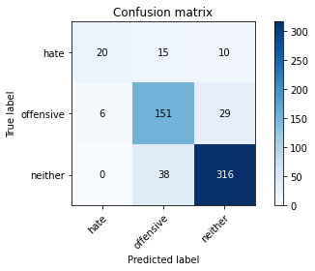

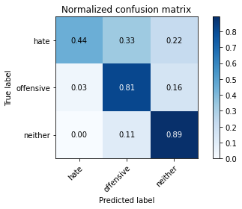

precision recall f1-score support

hate 0.77 0.44 0.56 45

offensive 0.74 0.81 0.77 186

neither 0.89 0.89 0.89 354

accuracy 0.83 585

macro avg 0.80 0.72 0.74 585

weighted avg 0.83 0.83 0.83 585

average eval_loss: 0.4597686397532622, accuracy: 0.8324786324786325

training 4 epoch...

44.719460010528564 seconds used......

4 training finished! average train loss: 0.07237670868615277

evaluating...

Confusion matrix, without normalization

[[ 25 9 11]

[ 15 129 42]

[ 3 22 329]]

Normalized confusion matrix

[[0.55555556 0.2 0.24444444]

[0.08064516 0.69354839 0.22580645]

[0.00847458 0.06214689 0.92937853]]

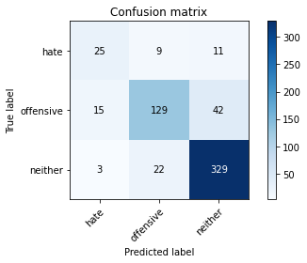

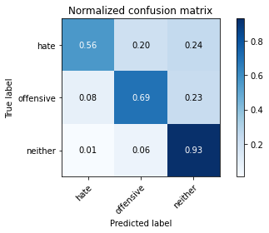

precision recall f1-score support

hate 0.58 0.56 0.57 45

offensive 0.81 0.69 0.75 186

neither 0.86 0.93 0.89 354

accuracy 0.83 585

macro avg 0.75 0.73 0.74 585

weighted avg 0.82 0.83 0.82 585

average eval_loss: 0.5119464312990506, accuracy: 0.8256410256410256

training 5 epoch...

44.67708492279053 seconds used......

5 training finished! average train loss: 0.04151018452780862

evaluating...

Confusion matrix, without normalization

[[ 27 7 11]

[ 20 114 52]

[ 5 13 336]]

Normalized confusion matrix

[[0.6 0.15555556 0.24444444]

[0.10752688 0.61290323 0.27956989]

[0.01412429 0.03672316 0.94915254]]

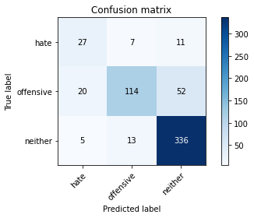

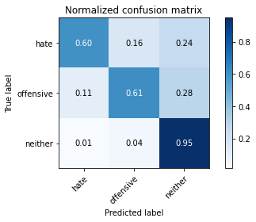

precision recall f1-score support

hate 0.52 0.60 0.56 45

offensive 0.85 0.61 0.71 186

neither 0.84 0.95 0.89 354

accuracy 0.82 585

macro avg 0.74 0.72 0.72 585

weighted avg 0.82 0.82 0.81 585

average eval_loss: 0.6938323500255744, accuracy: 0.8153846153846154

Confusion matrix, without normalization

[[ 36 4 11]

[ 31 82 56]

[ 13 11 341]]

Normalized confusion matrix

[[0.70588235 0.07843137 0.21568627]

[0.18343195 0.4852071 0.33136095]

[0.03561644 0.03013699 0.93424658]]

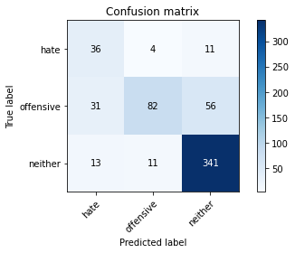

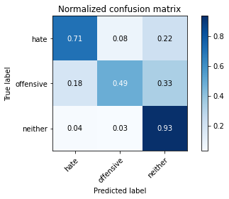

precision recall f1-score support

hate 0.45 0.71 0.55 51

offensive 0.85 0.49 0.62 169

neither 0.84 0.93 0.88 365

accuracy 0.78 585

macro avg 0.71 0.71 0.68 585

weighted avg 0.80 0.78 0.78 585

average eval_loss: 0.415372425566117, accuracy: 0.7846153846153846

[17]:

0.7846153846153846