training 1 epoch...

10.667560338973999 seconds used......

1 training finished! average train loss: 0.9553893368159022

evaluating...

Confusion matrix, without normalization

[[ 34 7 4]

[ 71 86 29]

[ 51 70 233]]

Normalized confusion matrix

[[0.75555556 0.15555556 0.08888889]

[0.38172043 0.46236559 0.15591398]

[0.1440678 0.19774011 0.65819209]]

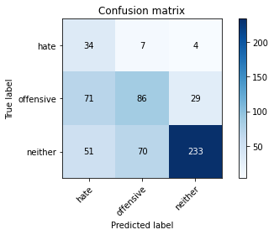

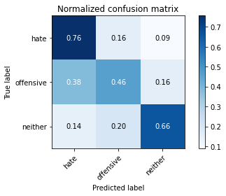

precision recall f1-score support

hate 0.22 0.76 0.34 45

offensive 0.53 0.46 0.49 186

neither 0.88 0.66 0.75 354

accuracy 0.60 585

macro avg 0.54 0.63 0.53 585

weighted avg 0.71 0.60 0.64 585

average eval_loss: 0.8287255624930064, accuracy: 0.6034188034188034

training 2 epoch...

10.674717426300049 seconds used......

2 training finished! average train loss: 0.6713236687438828

evaluating...

Confusion matrix, without normalization

[[ 34 6 5]

[ 48 77 61]

[ 24 23 307]]

Normalized confusion matrix

[[0.75555556 0.13333333 0.11111111]

[0.25806452 0.41397849 0.32795699]

[0.06779661 0.06497175 0.86723164]]

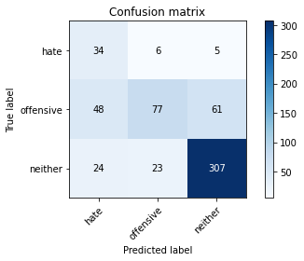

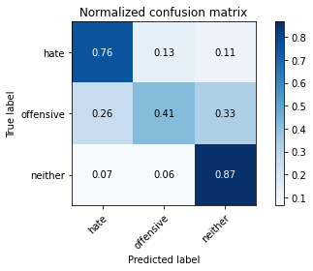

precision recall f1-score support

hate 0.32 0.76 0.45 45

offensive 0.73 0.41 0.53 186

neither 0.82 0.87 0.84 354

accuracy 0.71 585

macro avg 0.62 0.68 0.61 585

weighted avg 0.75 0.71 0.71 585

average eval_loss: 0.5714682221412659, accuracy: 0.7145299145299145

training 3 epoch...

10.746832847595215 seconds used......

3 training finished! average train loss: 0.40636917975332054

evaluating...

Confusion matrix, without normalization

[[ 36 4 5]

[ 57 78 51]

[ 23 16 315]]

Normalized confusion matrix

[[0.8 0.08888889 0.11111111]

[0.30645161 0.41935484 0.27419355]

[0.06497175 0.04519774 0.88983051]]

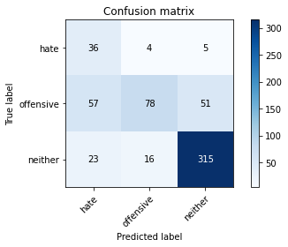

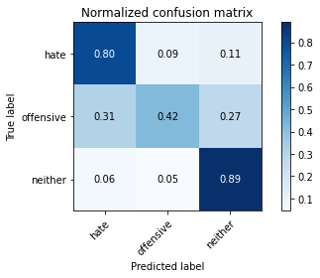

precision recall f1-score support

hate 0.31 0.80 0.45 45

offensive 0.80 0.42 0.55 186

neither 0.85 0.89 0.87 354

accuracy 0.73 585

macro avg 0.65 0.70 0.62 585

weighted avg 0.79 0.73 0.73 585

average eval_loss: 0.5433568542202314, accuracy: 0.7333333333333333

training 4 epoch...

10.716477155685425 seconds used......

4 training finished! average train loss: 0.19244995400575654

evaluating...

Confusion matrix, without normalization

[[ 39 5 1]

[ 64 98 24]

[ 52 51 251]]

Normalized confusion matrix

[[0.86666667 0.11111111 0.02222222]

[0.34408602 0.52688172 0.12903226]

[0.14689266 0.1440678 0.70903955]]

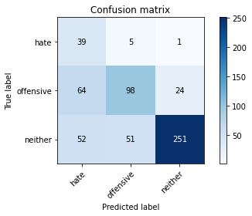

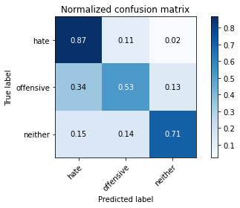

precision recall f1-score support

hate 0.25 0.87 0.39 45

offensive 0.64 0.53 0.58 186

neither 0.91 0.71 0.80 354

accuracy 0.66 585

macro avg 0.60 0.70 0.59 585

weighted avg 0.77 0.66 0.70 585

average eval_loss: 1.0411852260430654, accuracy: 0.6632478632478632

training 5 epoch...

10.8039391040802 seconds used......

5 training finished! average train loss: 0.08364665305374988

evaluating...

Confusion matrix, without normalization

[[ 32 10 3]

[ 19 142 25]

[ 18 80 256]]

Normalized confusion matrix

[[0.71111111 0.22222222 0.06666667]

[0.10215054 0.76344086 0.1344086 ]

[0.05084746 0.2259887 0.72316384]]

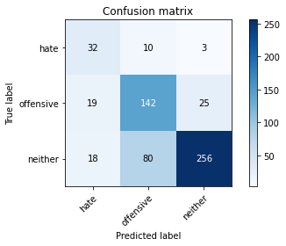

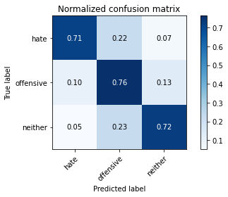

precision recall f1-score support

hate 0.46 0.71 0.56 45

offensive 0.61 0.76 0.68 186

neither 0.90 0.72 0.80 354

accuracy 0.74 585

macro avg 0.66 0.73 0.68 585

weighted avg 0.78 0.74 0.74 585

average eval_loss: 0.9445403366039197, accuracy: 0.7350427350427351

Confusion matrix, without normalization

[[ 48 2 1]

[ 55 89 25]

[ 68 48 249]]

Normalized confusion matrix

[[0.94117647 0.03921569 0.01960784]

[0.32544379 0.52662722 0.14792899]

[0.18630137 0.13150685 0.68219178]]

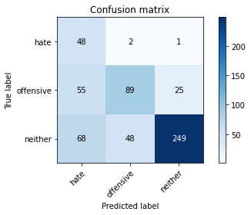

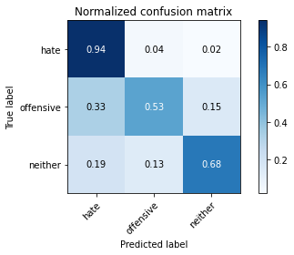

precision recall f1-score support

hate 0.28 0.94 0.43 51

offensive 0.64 0.53 0.58 169

neither 0.91 0.68 0.78 365

accuracy 0.66 585

macro avg 0.61 0.72 0.60 585

weighted avg 0.77 0.66 0.69 585

average eval_loss: 1.1099701901276906, accuracy: 0.6598290598290598

[23]:

0.6598290598290598