training 1 epoch...

40.44191360473633 seconds used......

1 training finished! average train loss: 0.6197605202468033

evaluating...

Confusion matrix, without normalization

[[ 24 1 20]

[ 44 56 86]

[ 7 2 345]]

Normalized confusion matrix

[[0.53333333 0.02222222 0.44444444]

[0.23655914 0.30107527 0.46236559]

[0.01977401 0.00564972 0.97457627]]

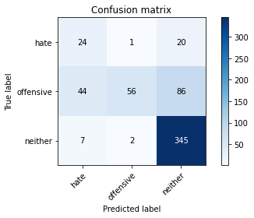

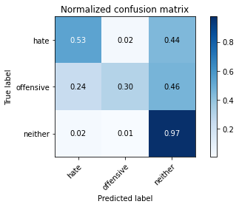

precision recall f1-score support

hate 0.32 0.53 0.40 45

offensive 0.95 0.30 0.46 186

neither 0.76 0.97 0.86 354

accuracy 0.73 585

macro avg 0.68 0.60 0.57 585

weighted avg 0.79 0.73 0.69 585

average eval_loss: 0.5147770792245865, accuracy: 0.7264957264957265

training 2 epoch...

39.640188455581665 seconds used......

2 training finished! average train loss: 0.420343390514708

evaluating...

Confusion matrix, without normalization

[[ 19 7 19]

[ 10 102 74]

[ 4 4 346]]

Normalized confusion matrix

[[0.42222222 0.15555556 0.42222222]

[0.05376344 0.5483871 0.39784946]

[0.01129944 0.01129944 0.97740113]]

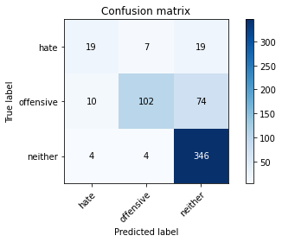

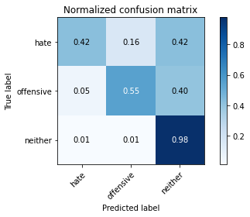

precision recall f1-score support

hate 0.58 0.42 0.49 45

offensive 0.90 0.55 0.68 186

neither 0.79 0.98 0.87 354

accuracy 0.80 585

macro avg 0.76 0.65 0.68 585

weighted avg 0.81 0.80 0.78 585

average eval_loss: 0.41913786679506304, accuracy: 0.7982905982905983

training 3 epoch...

39.57251191139221 seconds used......

3 training finished! average train loss: 0.26927109100879765

evaluating...

Confusion matrix, without normalization

[[ 23 6 16]

[ 17 124 45]

[ 7 13 334]]

Normalized confusion matrix

[[0.51111111 0.13333333 0.35555556]

[0.09139785 0.66666667 0.24193548]

[0.01977401 0.03672316 0.94350282]]

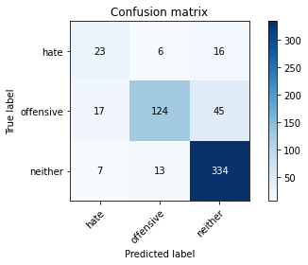

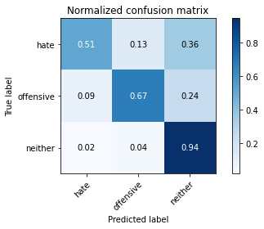

precision recall f1-score support

hate 0.49 0.51 0.50 45

offensive 0.87 0.67 0.75 186

neither 0.85 0.94 0.89 354

accuracy 0.82 585

macro avg 0.73 0.71 0.72 585

weighted avg 0.83 0.82 0.82 585

average eval_loss: 0.47439902399977046, accuracy: 0.8222222222222222

training 4 epoch...

39.61375880241394 seconds used......

4 training finished! average train loss: 0.1766192485522638

evaluating...

Confusion matrix, without normalization

[[ 18 11 16]

[ 10 126 50]

[ 6 22 326]]

Normalized confusion matrix

[[0.4 0.24444444 0.35555556]

[0.05376344 0.67741935 0.2688172 ]

[0.01694915 0.06214689 0.92090395]]

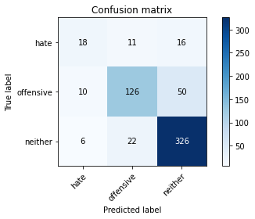

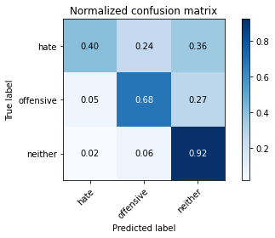

precision recall f1-score support

hate 0.53 0.40 0.46 45

offensive 0.79 0.68 0.73 186

neither 0.83 0.92 0.87 354

accuracy 0.80 585

macro avg 0.72 0.67 0.69 585

weighted avg 0.80 0.80 0.80 585

average eval_loss: 0.5486206836998463, accuracy: 0.8034188034188035

training 5 epoch...

39.626457929611206 seconds used......

5 training finished! average train loss: 0.09758958225456886

evaluating...

Confusion matrix, without normalization

[[ 23 6 16]

[ 24 132 30]

[ 7 30 317]]

Normalized confusion matrix

[[0.51111111 0.13333333 0.35555556]

[0.12903226 0.70967742 0.16129032]

[0.01977401 0.08474576 0.89548023]]

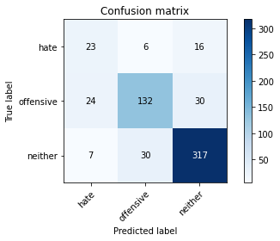

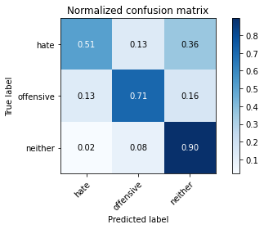

precision recall f1-score support

hate 0.43 0.51 0.46 45

offensive 0.79 0.71 0.75 186

neither 0.87 0.90 0.88 354

accuracy 0.81 585

macro avg 0.69 0.71 0.70 585

weighted avg 0.81 0.81 0.81 585

average eval_loss: 0.6113567132502794, accuracy: 0.8068376068376069

Confusion matrix, without normalization

[[ 32 1 18]

[ 41 40 88]

[ 8 2 355]]

Normalized confusion matrix

[[0.62745098 0.01960784 0.35294118]

[0.24260355 0.23668639 0.52071006]

[0.02191781 0.00547945 0.97260274]]

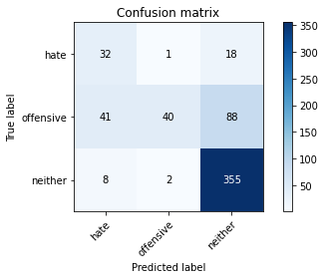

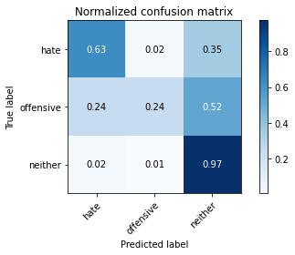

precision recall f1-score support

hate 0.40 0.63 0.48 51

offensive 0.93 0.24 0.38 169

neither 0.77 0.97 0.86 365

accuracy 0.73 585

macro avg 0.70 0.61 0.57 585

weighted avg 0.78 0.73 0.69 585

average eval_loss: 0.5153308515747388, accuracy: 0.7299145299145299

[17]:

0.7299145299145299