1 run

training 1 epoch...

9.953126192092896 seconds used......

1 training finished! average train loss: 0.9986970903617995

evaluating...

Confusion matrix, without normalization

[[ 23 3 19]

[ 64 37 85]

[ 60 4 290]]

Normalized confusion matrix

[[0.51111111 0.06666667 0.42222222]

[0.34408602 0.19892473 0.45698925]

[0.16949153 0.01129944 0.81920904]]

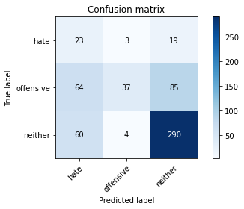

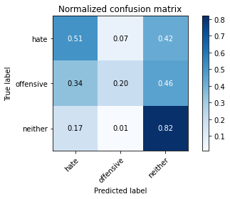

precision recall f1-score support

hate 0.16 0.51 0.24 45

offensive 0.84 0.20 0.32 186

neither 0.74 0.82 0.78 354

accuracy 0.60 585

macro avg 0.58 0.51 0.45 585

weighted avg 0.72 0.60 0.59 585

average eval_loss: 0.7620055665572484, accuracy: 0.5982905982905983

training 2 epoch...

9.024282217025757 seconds used......

2 training finished! average train loss: 0.7654499219996589

evaluating...

Confusion matrix, without normalization

[[ 33 2 10]

[ 64 79 43]

[ 62 39 253]]

Normalized confusion matrix

[[0.73333333 0.04444444 0.22222222]

[0.34408602 0.42473118 0.2311828 ]

[0.17514124 0.11016949 0.71468927]]

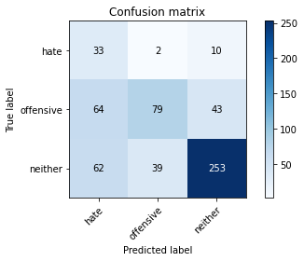

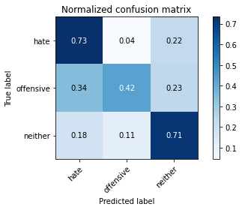

precision recall f1-score support

hate 0.21 0.73 0.32 45

offensive 0.66 0.42 0.52 186

neither 0.83 0.71 0.77 354

accuracy 0.62 585

macro avg 0.56 0.62 0.54 585

weighted avg 0.73 0.62 0.65 585

average eval_loss: 0.736889507373174, accuracy: 0.6239316239316239

training 3 epoch...

8.984661340713501 seconds used......

3 training finished! average train loss: 0.5380667591733592

evaluating...

Confusion matrix, without normalization

[[ 34 0 11]

[ 56 67 63]

[ 42 10 302]]

Normalized confusion matrix

[[0.75555556 0. 0.24444444]

[0.30107527 0.36021505 0.33870968]

[0.11864407 0.02824859 0.85310734]]

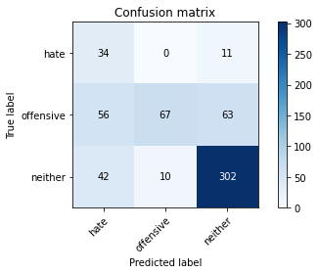

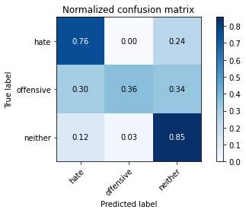

precision recall f1-score support

hate 0.26 0.76 0.38 45

offensive 0.87 0.36 0.51 186

neither 0.80 0.85 0.83 354

accuracy 0.69 585

macro avg 0.64 0.66 0.57 585

weighted avg 0.78 0.69 0.69 585

average eval_loss: 0.652587283651034, accuracy: 0.6888888888888889

training 4 epoch...

9.002269744873047 seconds used......

4 training finished! average train loss: 0.29742360221488134

evaluating...

Confusion matrix, without normalization

[[ 33 4 8]

[ 45 100 41]

[ 43 53 258]]

Normalized confusion matrix

[[0.73333333 0.08888889 0.17777778]

[0.24193548 0.53763441 0.22043011]

[0.12146893 0.14971751 0.72881356]]

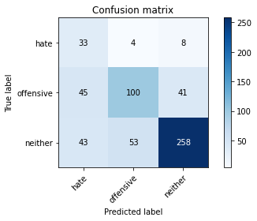

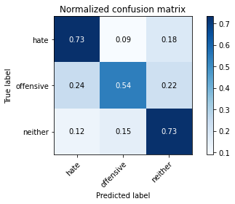

precision recall f1-score support

hate 0.27 0.73 0.40 45

offensive 0.64 0.54 0.58 186

neither 0.84 0.73 0.78 354

accuracy 0.67 585

macro avg 0.58 0.67 0.59 585

weighted avg 0.73 0.67 0.69 585

average eval_loss: 0.8995203549663225, accuracy: 0.6683760683760683

training 5 epoch...

8.985299348831177 seconds used......

5 training finished! average train loss: 0.15272895712405443

evaluating...

Confusion matrix, without normalization

[[ 35 6 4]

[ 37 125 24]

[ 45 95 214]]

Normalized confusion matrix

[[0.77777778 0.13333333 0.08888889]

[0.19892473 0.67204301 0.12903226]

[0.12711864 0.26836158 0.60451977]]

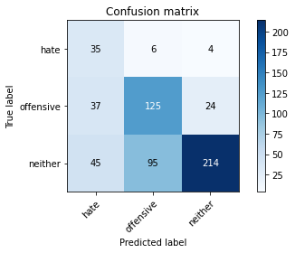

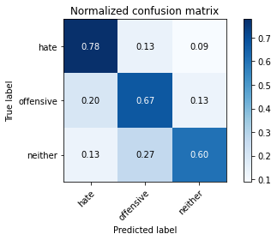

precision recall f1-score support

hate 0.30 0.78 0.43 45

offensive 0.55 0.67 0.61 186

neither 0.88 0.60 0.72 354

accuracy 0.64 585

macro avg 0.58 0.68 0.59 585

weighted avg 0.73 0.64 0.66 585

average eval_loss: 1.3524134089549382, accuracy: 0.6393162393162393

Confusion matrix, without normalization

[[ 39 5 7]

[ 53 81 35]

[ 55 65 245]]

Normalized confusion matrix

[[0.76470588 0.09803922 0.1372549 ]

[0.31360947 0.47928994 0.20710059]

[0.15068493 0.17808219 0.67123288]]

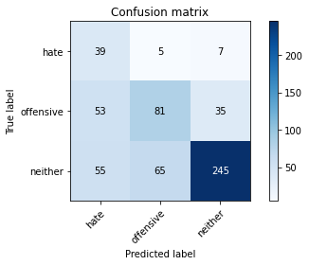

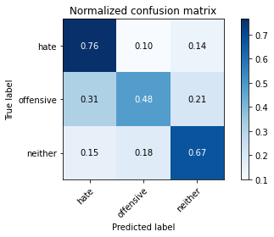

precision recall f1-score support

hate 0.27 0.76 0.39 51

offensive 0.54 0.48 0.51 169

neither 0.85 0.67 0.75 365

accuracy 0.62 585

macro avg 0.55 0.64 0.55 585

weighted avg 0.71 0.62 0.65 585

average eval_loss: 1.0540689170360564, accuracy: 0.6239316239316239

[21]:

0.6239316239316239

2 run

training 1 epoch...

10.090226650238037 seconds used......

1 training finished! average train loss: 1.0166845640965871

evaluating...

Confusion matrix, without normalization

[[ 23 0 22]

[ 76 22 88]

[ 64 3 287]]

Normalized confusion matrix

[[0.51111111 0. 0.48888889]

[0.40860215 0.11827957 0.47311828]

[0.18079096 0.00847458 0.81073446]]

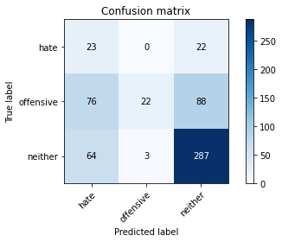

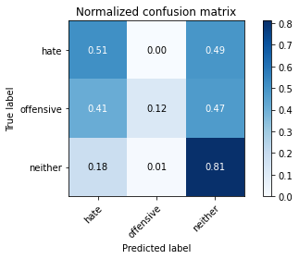

precision recall f1-score support

hate 0.14 0.51 0.22 45

offensive 0.88 0.12 0.21 186

neither 0.72 0.81 0.76 354

accuracy 0.57 585

macro avg 0.58 0.48 0.40 585

weighted avg 0.73 0.57 0.55 585

average eval_loss: 0.8345424056053161, accuracy: 0.5675213675213675

training 2 epoch...

8.973698139190674 seconds used......

2 training finished! average train loss: 0.79438266903162

evaluating...

Confusion matrix, without normalization

[[ 28 4 13]

[ 56 79 51]

[ 51 24 279]]

Normalized confusion matrix

[[0.62222222 0.08888889 0.28888889]

[0.30107527 0.42473118 0.27419355]

[0.1440678 0.06779661 0.78813559]]

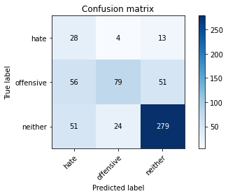

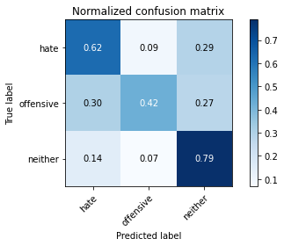

precision recall f1-score support

hate 0.21 0.62 0.31 45

offensive 0.74 0.42 0.54 186

neither 0.81 0.79 0.80 354

accuracy 0.66 585

macro avg 0.59 0.61 0.55 585

weighted avg 0.74 0.66 0.68 585

average eval_loss: 0.6960543066263198, accuracy: 0.6598290598290598

training 3 epoch...

8.954498052597046 seconds used......

3 training finished! average train loss: 0.5500194249408585

evaluating...

Confusion matrix, without normalization

[[ 27 4 14]

[ 39 87 60]

[ 37 27 290]]

Normalized confusion matrix

[[0.6 0.08888889 0.31111111]

[0.20967742 0.46774194 0.32258065]

[0.10451977 0.07627119 0.81920904]]

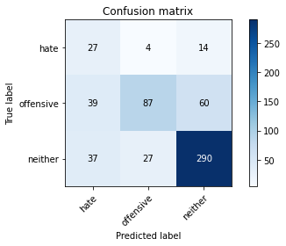

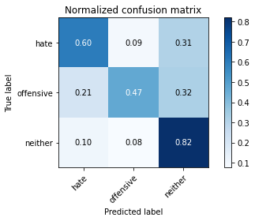

precision recall f1-score support

hate 0.26 0.60 0.36 45

offensive 0.74 0.47 0.57 186

neither 0.80 0.82 0.81 354

accuracy 0.69 585

macro avg 0.60 0.63 0.58 585

weighted avg 0.74 0.69 0.70 585

average eval_loss: 0.639080137014389, accuracy: 0.6905982905982906

training 4 epoch...

8.946027278900146 seconds used......

4 training finished! average train loss: 0.34592850918748547

evaluating...

Confusion matrix, without normalization

[[ 24 3 18]

[ 37 76 73]

[ 23 15 316]]

Normalized confusion matrix

[[0.53333333 0.06666667 0.4 ]

[0.19892473 0.40860215 0.39247312]

[0.06497175 0.04237288 0.89265537]]

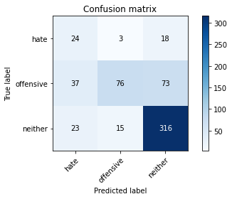

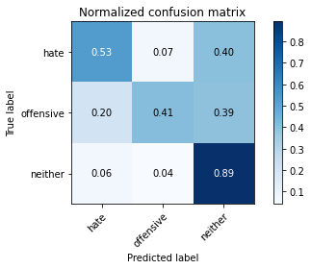

precision recall f1-score support

hate 0.29 0.53 0.37 45

offensive 0.81 0.41 0.54 186

neither 0.78 0.89 0.83 354

accuracy 0.71 585

macro avg 0.62 0.61 0.58 585

weighted avg 0.75 0.71 0.70 585

average eval_loss: 0.6547642221053441, accuracy: 0.7111111111111111

training 5 epoch...

8.9491126537323 seconds used......

5 training finished! average train loss: 0.21643745905852743

evaluating...

Confusion matrix, without normalization

[[ 25 10 10]

[ 25 119 42]

[ 20 63 271]]

Normalized confusion matrix

[[0.55555556 0.22222222 0.22222222]

[0.1344086 0.63978495 0.22580645]

[0.05649718 0.1779661 0.76553672]]

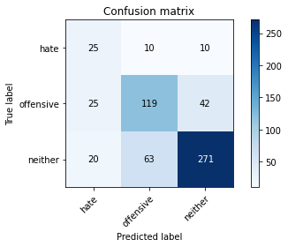

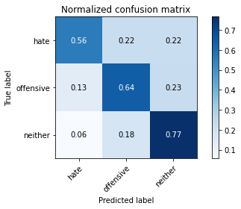

precision recall f1-score support

hate 0.36 0.56 0.43 45

offensive 0.62 0.64 0.63 186

neither 0.84 0.77 0.80 354

accuracy 0.71 585

macro avg 0.61 0.65 0.62 585

weighted avg 0.73 0.71 0.72 585

average eval_loss: 0.8470440059900284, accuracy: 0.7094017094017094

Confusion matrix, without normalization

[[ 40 1 10]

[ 54 50 65]

[ 56 36 273]]

Normalized confusion matrix

[[0.78431373 0.01960784 0.19607843]

[0.31952663 0.29585799 0.38461538]

[0.15342466 0.09863014 0.74794521]]

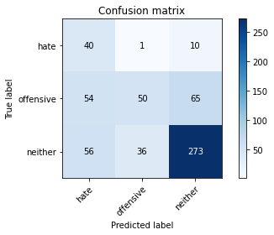

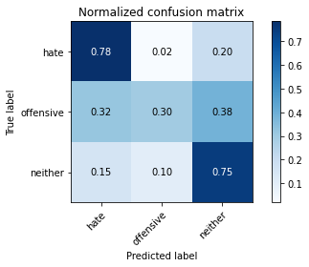

precision recall f1-score support

hate 0.27 0.78 0.40 51

offensive 0.57 0.30 0.39 169

neither 0.78 0.75 0.77 365

accuracy 0.62 585

macro avg 0.54 0.61 0.52 585

weighted avg 0.68 0.62 0.63 585

average eval_loss: 0.740692534049352, accuracy: 0.6205128205128205

[18]:

0.6205128205128205

3 run

training 1 epoch...

8.947689533233643 seconds used......

1 training finished! average train loss: 1.0149098123822893

evaluating...

Confusion matrix, without normalization

[[ 14 3 28]

[ 42 35 109]

[ 26 7 321]]

Normalized confusion matrix

[[0.31111111 0.06666667 0.62222222]

[0.22580645 0.18817204 0.58602151]

[0.07344633 0.01977401 0.90677966]]

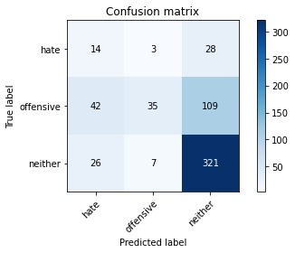

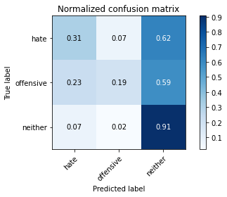

precision recall f1-score support

hate 0.17 0.31 0.22 45

offensive 0.78 0.19 0.30 186

neither 0.70 0.91 0.79 354

accuracy 0.63 585

macro avg 0.55 0.47 0.44 585

weighted avg 0.68 0.63 0.59 585

average eval_loss: 0.7420860489209493, accuracy: 0.6324786324786325

training 2 epoch...

8.982666730880737 seconds used......

2 training finished! average train loss: 0.8043165478323188

evaluating...

Confusion matrix, without normalization

[[ 30 4 11]

[ 80 69 37]

[ 94 36 224]]

Normalized confusion matrix

[[0.66666667 0.08888889 0.24444444]

[0.43010753 0.37096774 0.19892473]

[0.26553672 0.10169492 0.63276836]]

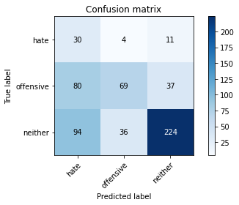

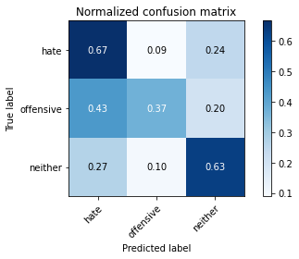

precision recall f1-score support

hate 0.15 0.67 0.24 45

offensive 0.63 0.37 0.47 186

neither 0.82 0.63 0.72 354

accuracy 0.55 585

macro avg 0.53 0.56 0.47 585

weighted avg 0.71 0.55 0.60 585

average eval_loss: 0.8671651105086009, accuracy: 0.5521367521367522

training 3 epoch...

8.932362794876099 seconds used......

3 training finished! average train loss: 0.5849443030144487

evaluating...

Confusion matrix, without normalization

[[ 35 4 6]

[ 75 76 35]

[ 87 36 231]]

Normalized confusion matrix

[[0.77777778 0.08888889 0.13333333]

[0.40322581 0.40860215 0.18817204]

[0.24576271 0.10169492 0.65254237]]

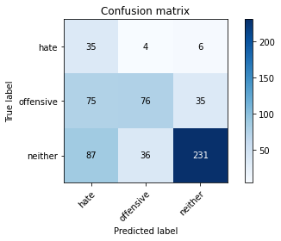

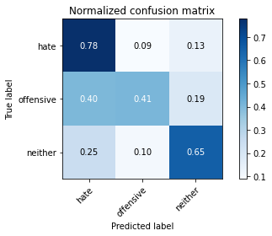

precision recall f1-score support

hate 0.18 0.78 0.29 45

offensive 0.66 0.41 0.50 186

neither 0.85 0.65 0.74 354

accuracy 0.58 585

macro avg 0.56 0.61 0.51 585

weighted avg 0.74 0.58 0.63 585

average eval_loss: 0.9559611986080806, accuracy: 0.5846153846153846

training 4 epoch...

8.936906337738037 seconds used......

4 training finished! average train loss: 0.36802876980176996

evaluating...

Confusion matrix, without normalization

[[ 26 3 16]

[ 43 96 47]

[ 23 48 283]]

Normalized confusion matrix

[[0.57777778 0.06666667 0.35555556]

[0.2311828 0.51612903 0.25268817]

[0.06497175 0.13559322 0.79943503]]

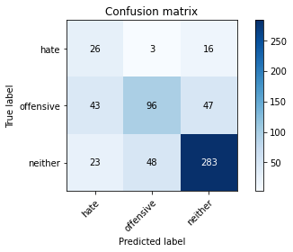

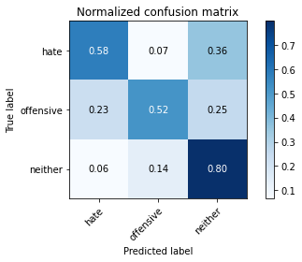

precision recall f1-score support

hate 0.28 0.58 0.38 45

offensive 0.65 0.52 0.58 186

neither 0.82 0.80 0.81 354

accuracy 0.69 585

macro avg 0.58 0.63 0.59 585

weighted avg 0.72 0.69 0.70 585

average eval_loss: 0.8355716720223427, accuracy: 0.6923076923076923

training 5 epoch...

8.916625738143921 seconds used......

5 training finished! average train loss: 0.20634335199637072

evaluating...

Confusion matrix, without normalization

[[ 32 7 6]

[ 44 108 34]

[ 35 73 246]]

Normalized confusion matrix

[[0.71111111 0.15555556 0.13333333]

[0.23655914 0.58064516 0.1827957 ]

[0.09887006 0.20621469 0.69491525]]

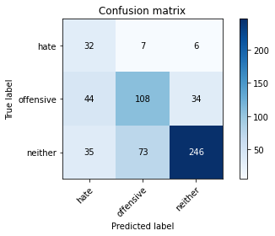

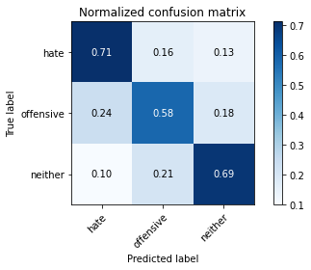

precision recall f1-score support

hate 0.29 0.71 0.41 45

offensive 0.57 0.58 0.58 186

neither 0.86 0.69 0.77 354

accuracy 0.66 585

macro avg 0.57 0.66 0.59 585

weighted avg 0.73 0.66 0.68 585

average eval_loss: 1.1206692785024643, accuracy: 0.6598290598290598

Confusion matrix, without normalization

[[ 43 1 7]

[ 76 57 36]

[101 44 220]]

Normalized confusion matrix

[[0.84313725 0.01960784 0.1372549 ]

[0.44970414 0.33727811 0.21301775]

[0.27671233 0.12054795 0.60273973]]

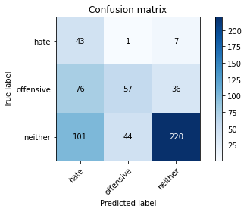

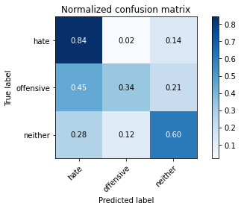

precision recall f1-score support

hate 0.20 0.84 0.32 51

offensive 0.56 0.34 0.42 169

neither 0.84 0.60 0.70 365

accuracy 0.55 585

macro avg 0.53 0.59 0.48 585

weighted avg 0.70 0.55 0.59 585

average eval_loss: 1.0386649469534557, accuracy: 0.5470085470085471

[20]:

0.5470085470085471