[1,0.5,1]

training 1 epoch...

509.78464698791504 seconds used......

1 training finished! average train loss: 0.36350480798489204

evaluating...

Confusion matrix, without normalization

[[ 59 61 14]

[ 65 1849 23]

[ 5 45 357]]

Normalized confusion matrix

[[0.44029851 0.45522388 0.10447761]

[0.03355705 0.95456892 0.01187403]

[0.01228501 0.11056511 0.87714988]]

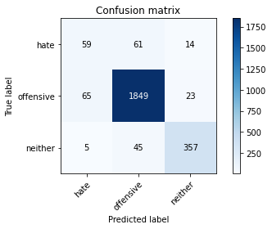

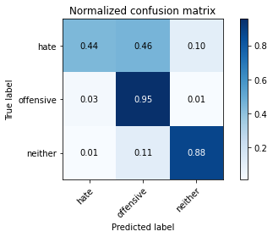

precision recall f1-score support

hate 0.46 0.44 0.45 134

offensive 0.95 0.95 0.95 1937

neither 0.91 0.88 0.89 407

accuracy 0.91 2478

macro avg 0.77 0.76 0.76 2478

weighted avg 0.91 0.91 0.91 2478

average eval_loss: 0.3124505241792048, accuracy: 0.914043583535109

training 2 epoch...

509.67036652565 seconds used......

2 training finished! average train loss: 0.25684163435230845

evaluating...

Confusion matrix, without normalization

[[ 47 69 18]

[ 40 1868 29]

[ 1 38 368]]

Normalized confusion matrix

[[0.35074627 0.51492537 0.13432836]

[0.02065049 0.9643779 0.01497161]

[0.002457 0.09336609 0.9041769 ]]

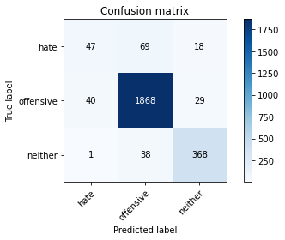

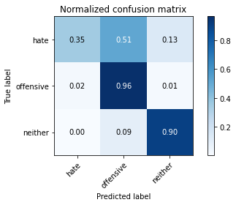

precision recall f1-score support

hate 0.53 0.35 0.42 134

offensive 0.95 0.96 0.96 1937

neither 0.89 0.90 0.90 407

accuracy 0.92 2478

macro avg 0.79 0.74 0.76 2478

weighted avg 0.91 0.92 0.92 2478

average eval_loss: 0.29178380673270554, accuracy: 0.9213075060532687

training 3 epoch...

509.7876958847046 seconds used......

3 training finished! average train loss: 0.18788259933447285

evaluating...

Confusion matrix, without normalization

[[ 62 57 15]

[ 81 1823 33]

[ 9 30 368]]

Normalized confusion matrix

[[0.46268657 0.42537313 0.1119403 ]

[0.04181724 0.9411461 0.01703665]

[0.02211302 0.07371007 0.9041769 ]]

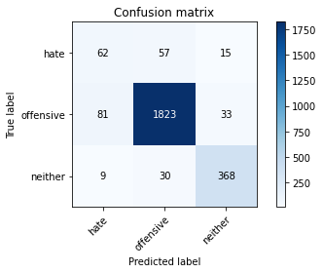

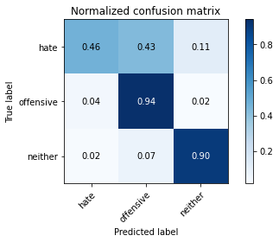

precision recall f1-score support

hate 0.41 0.46 0.43 134

offensive 0.95 0.94 0.95 1937

neither 0.88 0.90 0.89 407

accuracy 0.91 2478

macro avg 0.75 0.77 0.76 2478

weighted avg 0.91 0.91 0.91 2478

average eval_loss: 0.3053596193241256, accuracy: 0.9092009685230025

training 4 epoch...

509.7021327018738 seconds used......

4 training finished! average train loss: 0.11618593216788271

evaluating...

Confusion matrix, without normalization

[[ 62 52 20]

[ 95 1796 46]

[ 3 16 388]]

Normalized confusion matrix

[[0.46268657 0.3880597 0.14925373]

[0.04904491 0.92720702 0.02374806]

[0.00737101 0.03931204 0.95331695]]

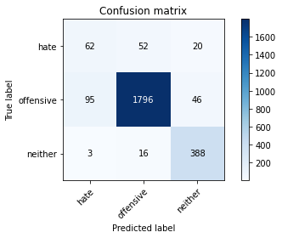

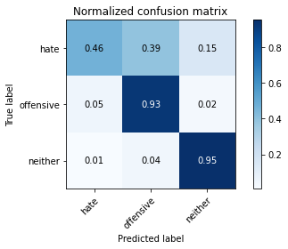

precision recall f1-score support

hate 0.39 0.46 0.42 134

offensive 0.96 0.93 0.95 1937

neither 0.85 0.95 0.90 407

accuracy 0.91 2478

macro avg 0.74 0.78 0.76 2478

weighted avg 0.91 0.91 0.91 2478

average eval_loss: 0.37629846934860034, accuracy: 0.9063761097659403

training 5 epoch...

509.90918731689453 seconds used......

5 training finished! average train loss: 0.06618633332859204

evaluating...

Confusion matrix, without normalization

[[ 58 60 16]

[ 74 1830 33]

[ 4 39 364]]

Normalized confusion matrix

[[0.43283582 0.44776119 0.11940299]

[0.03820341 0.94475994 0.01703665]

[0.00982801 0.0958231 0.89434889]]

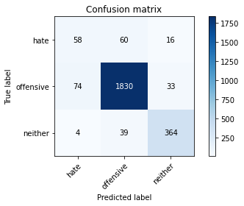

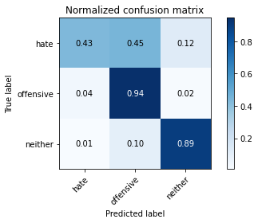

precision recall f1-score support

hate 0.43 0.43 0.43 134

offensive 0.95 0.94 0.95 1937

neither 0.88 0.89 0.89 407

accuracy 0.91 2478

macro avg 0.75 0.76 0.75 2478

weighted avg 0.91 0.91 0.91 2478

average eval_loss: 0.4535200617629603, accuracy: 0.9087974172719936

evaluate with model of 3 epoch

Confusion matrix, without normalization

[[ 68 51 5]

[ 109 1799 34]

[ 16 20 377]]

Normalized confusion matrix

[[0.5483871 0.41129032 0.04032258]

[0.0561277 0.92636457 0.01750772]

[0.03874092 0.04842615 0.91283293]]

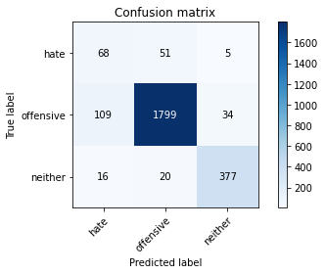

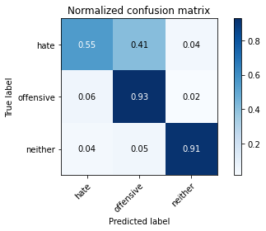

precision recall f1-score support

hate 0.35 0.55 0.43 124

offensive 0.96 0.93 0.94 1942

neither 0.91 0.91 0.91 413

accuracy 0.91 2479

macro avg 0.74 0.80 0.76 2479

weighted avg 0.92 0.91 0.91 2479

average eval_loss: 0.31425191526631674, accuracy: 0.9052037111738604