training 1 epoch...

66.35076928138733 seconds used......

1 training finished! average train loss: 0.6452277569438923

evaluating...

Confusion matrix, without normalization

[[ 102 12 20]

[ 466 1412 59]

[ 30 7 370]]

Normalized confusion matrix

[[0.76119403 0.08955224 0.14925373]

[0.24057821 0.72896231 0.03045947]

[0.07371007 0.01719902 0.90909091]]

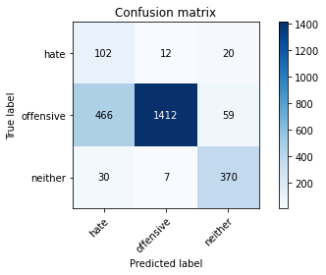

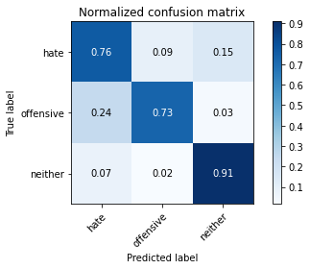

precision recall f1-score support

hate 0.17 0.76 0.28 134

offensive 0.99 0.73 0.84 1937

neither 0.82 0.91 0.86 407

accuracy 0.76 2478

macro avg 0.66 0.80 0.66 2478

weighted avg 0.92 0.76 0.81 2478

average eval_loss: 0.5311133543089512, accuracy: 0.7602905569007264

training 2 epoch...

65.5673303604126 seconds used......

2 training finished! average train loss: 0.3568892856128514

evaluating...

Confusion matrix, without normalization

[[ 97 20 17]

[ 332 1556 49]

[ 17 12 378]]

Normalized confusion matrix

[[0.7238806 0.14925373 0.12686567]

[0.17139907 0.80330408 0.02529685]

[0.04176904 0.02948403 0.92874693]]

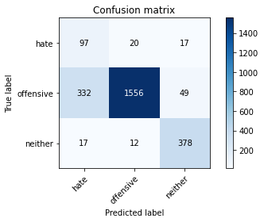

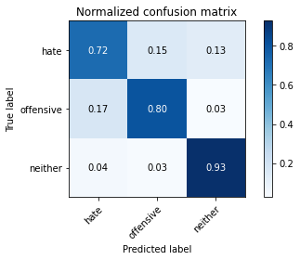

precision recall f1-score support

hate 0.22 0.72 0.33 134

offensive 0.98 0.80 0.88 1937

neither 0.85 0.93 0.89 407

accuracy 0.82 2478

macro avg 0.68 0.82 0.70 2478

weighted avg 0.92 0.82 0.85 2478

average eval_loss: 0.4673801310240261, accuracy: 0.8196125907990315

training 3 epoch...

65.50007104873657 seconds used......

3 training finished! average train loss: 0.22997478073970837

evaluating...

Confusion matrix, without normalization

[[ 101 14 19]

[ 533 1335 69]

[ 17 9 381]]

Normalized confusion matrix

[[0.75373134 0.10447761 0.14179104]

[0.27516779 0.68921012 0.0356221 ]

[0.04176904 0.02211302 0.93611794]]

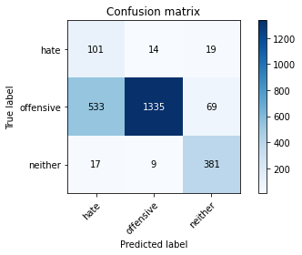

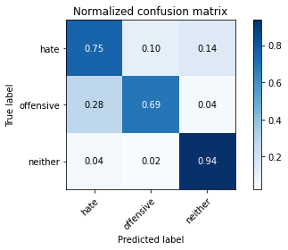

precision recall f1-score support

hate 0.16 0.75 0.26 134

offensive 0.98 0.69 0.81 1937

neither 0.81 0.94 0.87 407

accuracy 0.73 2478

macro avg 0.65 0.79 0.65 2478

weighted avg 0.91 0.73 0.79 2478

average eval_loss: 0.6059621077391409, accuracy: 0.7332526230831315

training 4 epoch...

65.59911870956421 seconds used......

4 training finished! average train loss: 0.12892310042463412

evaluating...

Confusion matrix, without normalization

[[ 101 24 9]

[ 328 1579 30]

[ 35 25 347]]

Normalized confusion matrix

[[0.75373134 0.17910448 0.06716418]

[0.16933402 0.81517811 0.01548787]

[0.08599509 0.06142506 0.85257985]]

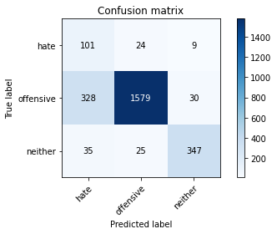

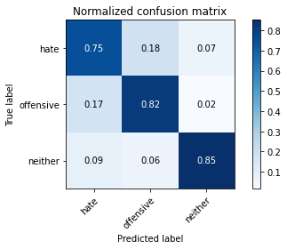

precision recall f1-score support

hate 0.22 0.75 0.34 134

offensive 0.97 0.82 0.89 1937

neither 0.90 0.85 0.88 407

accuracy 0.82 2478

macro avg 0.70 0.81 0.70 2478

weighted avg 0.92 0.82 0.85 2478

average eval_loss: 0.5618228736303507, accuracy: 0.817998385794996

training 5 epoch...

65.52146172523499 seconds used......

5 training finished! average train loss: 0.07167426603105427

evaluating...

Confusion matrix, without normalization

[[ 107 11 16]

[ 608 1278 51]

[ 32 8 367]]

Normalized confusion matrix

[[0.79850746 0.08208955 0.11940299]

[0.31388745 0.65978317 0.02632938]

[0.07862408 0.01965602 0.9017199 ]]

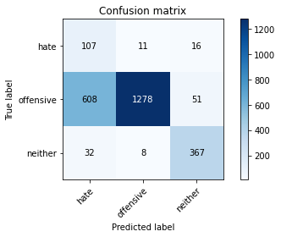

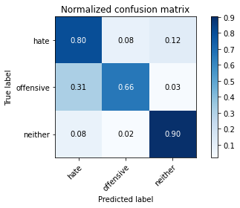

precision recall f1-score support

hate 0.14 0.80 0.24 134

offensive 0.99 0.66 0.79 1937

neither 0.85 0.90 0.87 407

accuracy 0.71 2478

macro avg 0.66 0.79 0.64 2478

weighted avg 0.92 0.71 0.77 2478

average eval_loss: 0.9907283613518361, accuracy: 0.7070217917675545

model of 5 epoch

Confusion matrix, without normalization

[[ 96 24 4]

[ 586 1291 65]

[ 31 10 372]]

Normalized confusion matrix

[[0.77419355 0.19354839 0.03225806]

[0.30175077 0.66477858 0.03347065]

[0.07506053 0.02421308 0.90072639]]

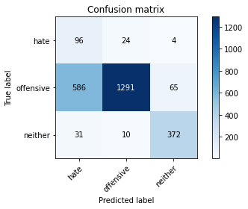

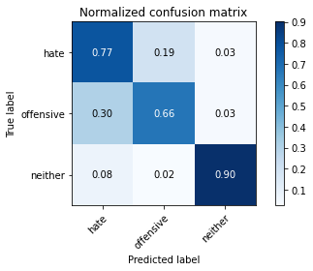

precision recall f1-score support

hate 0.13 0.77 0.23 124

offensive 0.97 0.66 0.79 1942

neither 0.84 0.90 0.87 413

accuracy 0.71 2479

macro avg 0.65 0.78 0.63 2479

weighted avg 0.91 0.71 0.78 2479

average eval_loss: 1.0583770466187308, accuracy: 0.709560306575232

2 run

training 1 epoch...

66.34774327278137 seconds used......

1 training finished! average train loss: 0.617921625517986

evaluating...

Confusion matrix, without normalization

[[ 101 16 17]

[ 421 1450 66]

[ 26 6 375]]

Normalized confusion matrix

[[0.75373134 0.11940299 0.12686567]

[0.21734641 0.74858028 0.03407331]

[0.06388206 0.01474201 0.92137592]]

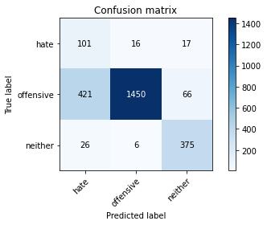

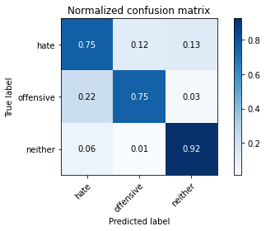

precision recall f1-score support

hate 0.18 0.75 0.30 134

offensive 0.99 0.75 0.85 1937

neither 0.82 0.92 0.87 407

accuracy 0.78 2478

macro avg 0.66 0.81 0.67 2478

weighted avg 0.91 0.78 0.82 2478

average eval_loss: 0.5060085741382453, accuracy: 0.7772397094430993

training 2 epoch...

65.76181125640869 seconds used......

2 training finished! average train loss: 0.35211004041643307

evaluating...

Confusion matrix, without normalization

[[ 107 9 18]

[ 541 1332 64]

[ 21 9 377]]

Normalized confusion matrix

[[0.79850746 0.06716418 0.13432836]

[0.27929788 0.68766133 0.03304078]

[0.05159705 0.02211302 0.92628993]]

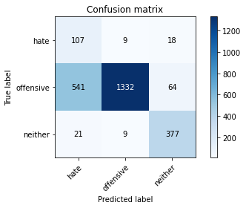

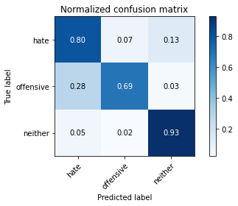

precision recall f1-score support

hate 0.16 0.80 0.27 134

offensive 0.99 0.69 0.81 1937

neither 0.82 0.93 0.87 407

accuracy 0.73 2478

macro avg 0.66 0.80 0.65 2478

weighted avg 0.91 0.73 0.79 2478

average eval_loss: 0.5906397786832625, accuracy: 0.7328490718321227

training 3 epoch...

65.46882152557373 seconds used......

3 training finished! average train loss: 0.23777751245705242

evaluating...

Confusion matrix, without normalization

[[ 103 15 16]

[ 476 1393 68]

[ 21 16 370]]

Normalized confusion matrix

[[0.76865672 0.1119403 0.11940299]

[0.24574084 0.71915333 0.03510583]

[0.05159705 0.03931204 0.90909091]]

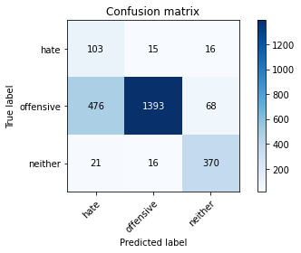

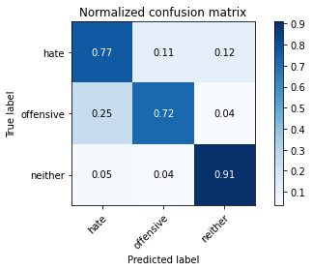

precision recall f1-score support

hate 0.17 0.77 0.28 134

offensive 0.98 0.72 0.83 1937

neither 0.81 0.91 0.86 407

accuracy 0.75 2478

macro avg 0.65 0.80 0.66 2478

weighted avg 0.91 0.75 0.80 2478

average eval_loss: 0.607061454485501, accuracy: 0.7530266343825666

training 4 epoch...

65.50212478637695 seconds used......

4 training finished! average train loss: 0.14760799895421686

evaluating...

Confusion matrix, without normalization

[[ 104 14 16]

[ 476 1348 113]

[ 20 12 375]]

Normalized confusion matrix

[[0.7761194 0.10447761 0.11940299]

[0.24574084 0.69592153 0.05833764]

[0.04914005 0.02948403 0.92137592]]

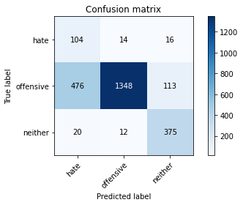

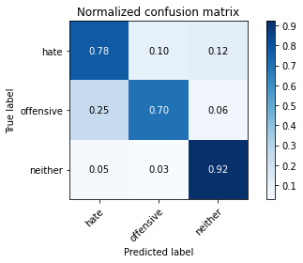

precision recall f1-score support

hate 0.17 0.78 0.28 134

offensive 0.98 0.70 0.81 1937

neither 0.74 0.92 0.82 407

accuracy 0.74 2478

macro avg 0.63 0.80 0.64 2478

weighted avg 0.90 0.74 0.79 2478

average eval_loss: 0.6799667495633325, accuracy: 0.7372881355932204

training 5 epoch...

65.50641417503357 seconds used......

5 training finished! average train loss: 0.08460029760714281

evaluating...

Confusion matrix, without normalization

[[ 100 19 15]

[ 431 1423 83]

[ 21 15 371]]

Normalized confusion matrix

[[0.74626866 0.14179104 0.1119403 ]

[0.22250903 0.7346412 0.04284977]

[0.05159705 0.03685504 0.91154791]]

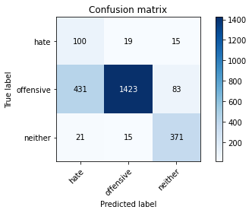

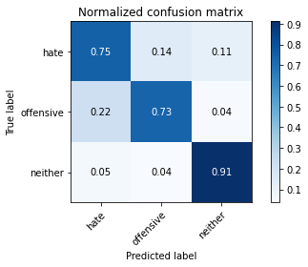

precision recall f1-score support

hate 0.18 0.75 0.29 134

offensive 0.98 0.73 0.84 1937

neither 0.79 0.91 0.85 407

accuracy 0.76 2478

macro avg 0.65 0.80 0.66 2478

weighted avg 0.90 0.76 0.81 2478

average eval_loss: 0.7670953732825094, accuracy: 0.7643260694108152

Confusion matrix, without normalization

[[ 97 20 7]

[ 525 1348 69]

[ 24 6 383]]

Normalized confusion matrix

[[0.78225806 0.16129032 0.05645161]

[0.27033986 0.69412976 0.03553038]

[0.05811138 0.01452785 0.92736077]]

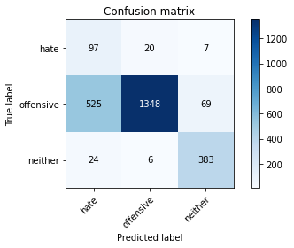

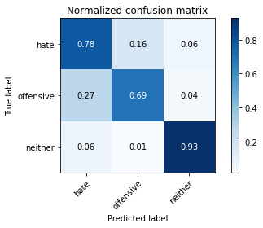

precision recall f1-score support

hate 0.15 0.78 0.25 124

offensive 0.98 0.69 0.81 1942

neither 0.83 0.93 0.88 413

accuracy 0.74 2479

macro avg 0.66 0.80 0.65 2479

weighted avg 0.92 0.74 0.80 2479

average eval_loss: 0.6126999096764673, accuracy: 0.7373941105284388

[21]:

0.7373941105284388

3 run

training 1 epoch...

65.54789423942566 seconds used......

1 training finished! average train loss: 0.6190709401430055

evaluating...

Confusion matrix, without normalization

[[ 106 8 20]

[ 572 1302 63]

[ 28 5 374]]

Normalized confusion matrix

[[0.79104478 0.05970149 0.14925373]

[0.29530201 0.67217346 0.03252452]

[0.06879607 0.01228501 0.91891892]]

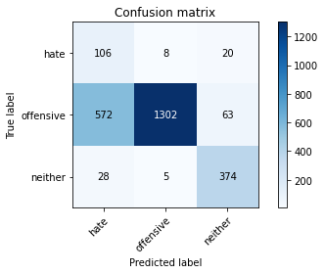

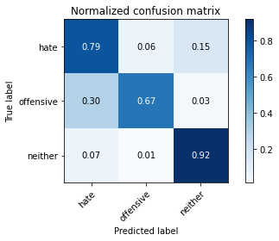

precision recall f1-score support

hate 0.15 0.79 0.25 134

offensive 0.99 0.67 0.80 1937

neither 0.82 0.92 0.87 407

accuracy 0.72 2478

macro avg 0.65 0.79 0.64 2478

weighted avg 0.92 0.72 0.78 2478

average eval_loss: 0.6708174444014027, accuracy: 0.7191283292978208

training 2 epoch...

65.51254916191101 seconds used......

2 training finished! average train loss: 0.3565267559394918

evaluating...

Confusion matrix, without normalization

[[ 104 13 17]

[ 402 1472 63]

[ 23 7 377]]

Normalized confusion matrix

[[0.7761194 0.09701493 0.12686567]

[0.20753743 0.75993805 0.03252452]

[0.05651106 0.01719902 0.92628993]]

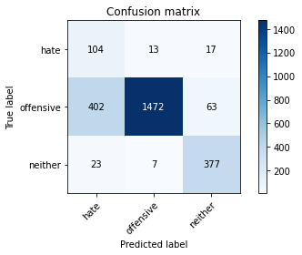

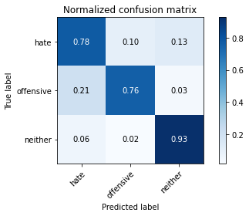

precision recall f1-score support

hate 0.20 0.78 0.31 134

offensive 0.99 0.76 0.86 1937

neither 0.82 0.93 0.87 407

accuracy 0.79 2478

macro avg 0.67 0.82 0.68 2478

weighted avg 0.92 0.79 0.83 2478

average eval_loss: 0.4885425227544, accuracy: 0.788135593220339

training 3 epoch...

65.5292181968689 seconds used......

3 training finished! average train loss: 0.23815777764486318

evaluating...

Confusion matrix, without normalization

[[ 103 13 18]

[ 464 1410 63]

[ 18 7 382]]

Normalized confusion matrix

[[0.76865672 0.09701493 0.13432836]

[0.23954569 0.72792979 0.03252452]

[0.04422604 0.01719902 0.93857494]]

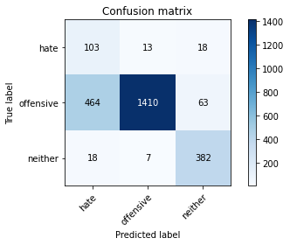

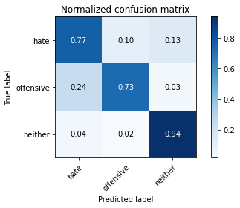

precision recall f1-score support

hate 0.18 0.77 0.29 134

offensive 0.99 0.73 0.84 1937

neither 0.83 0.94 0.88 407

accuracy 0.76 2478

macro avg 0.66 0.81 0.67 2478

weighted avg 0.92 0.76 0.81 2478

average eval_loss: 0.5839450596681526, accuracy: 0.764729620661824

training 4 epoch...

65.45651125907898 seconds used......

4 training finished! average train loss: 0.15177713237724014

evaluating...

Confusion matrix, without normalization

[[ 110 10 14]

[ 546 1317 74]

[ 33 7 367]]

Normalized confusion matrix

[[0.82089552 0.07462687 0.10447761]

[0.28187919 0.6799174 0.03820341]

[0.08108108 0.01719902 0.9017199 ]]

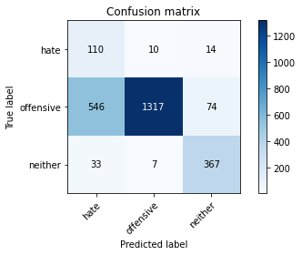

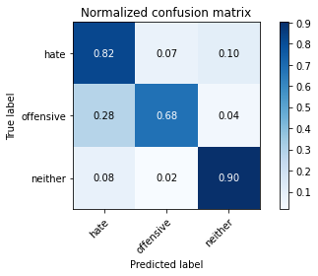

precision recall f1-score support

hate 0.16 0.82 0.27 134

offensive 0.99 0.68 0.81 1937

neither 0.81 0.90 0.85 407

accuracy 0.72 2478

macro avg 0.65 0.80 0.64 2478

weighted avg 0.91 0.72 0.78 2478

average eval_loss: 0.7483493165383416, accuracy: 0.7239709443099274

training 5 epoch...

65.43899703025818 seconds used......

5 training finished! average train loss: 0.09281729498020881

evaluating...

Confusion matrix, without normalization

[[ 107 17 10]

[ 423 1468 46]

[ 43 12 352]]

Normalized confusion matrix

[[0.79850746 0.12686567 0.07462687]

[0.21837894 0.757873 0.02374806]

[0.10565111 0.02948403 0.86486486]]

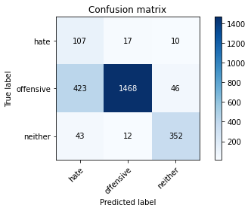

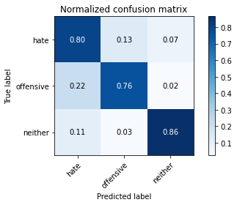

precision recall f1-score support

hate 0.19 0.80 0.30 134

offensive 0.98 0.76 0.85 1937

neither 0.86 0.86 0.86 407

accuracy 0.78 2478

macro avg 0.68 0.81 0.67 2478

weighted avg 0.92 0.78 0.83 2478

average eval_loss: 0.7217022636604886, accuracy: 0.7776432606941082

Confusion matrix, without normalization

[[ 100 18 6]

[ 541 1333 68]

[ 24 7 382]]

Normalized confusion matrix

[[0.80645161 0.14516129 0.0483871 ]

[0.27857878 0.68640577 0.03501545]

[0.05811138 0.01694915 0.92493947]]

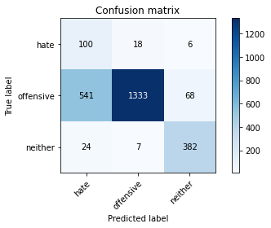

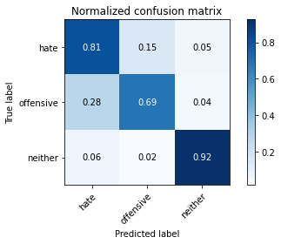

precision recall f1-score support

hate 0.15 0.81 0.25 124

offensive 0.98 0.69 0.81 1942

neither 0.84 0.92 0.88 413

accuracy 0.73 2479

macro avg 0.66 0.81 0.65 2479

weighted avg 0.92 0.73 0.79 2479

average eval_loss: 0.7648825780037911, accuracy: 0.7321500605082695

[23]:

0.7321500605082695