training 1 epoch...

1839.0999069213867 seconds used......

1 training finished! average train loss: 0.2801849576832814

evaluating...

Confusion matrix, without normalization

[[ 149 170 171]

[ 60 2506 131]

[ 18 171 5221]]

Normalized confusion matrix

[[0.30408163 0.34693878 0.34897959]

[0.02224694 0.92918057 0.04857249]

[0.00332717 0.03160813 0.9650647 ]]

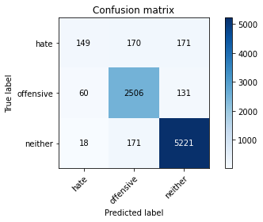

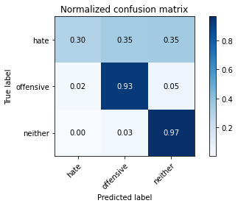

precision recall f1-score support

hate 0.66 0.30 0.42 490

offensive 0.88 0.93 0.90 2697

neither 0.95 0.97 0.96 5410

accuracy 0.92 8597

macro avg 0.83 0.73 0.76 8597

weighted avg 0.91 0.92 0.91 8597

average eval_loss: 0.2622556162564907, accuracy: 0.9161335349540537

training 2 epoch...

1839.020471572876 seconds used......

2 training finished! average train loss: 0.22498657267191888

evaluating...

Confusion matrix, without normalization

[[ 207 120 163]

[ 159 2381 157]

[ 75 126 5209]]

Normalized confusion matrix

[[0.42244898 0.24489796 0.33265306]

[0.05895439 0.88283278 0.05821283]

[0.01386322 0.0232902 0.96284658]]

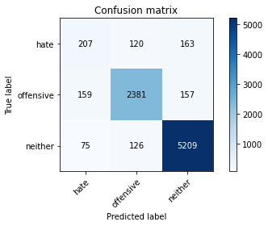

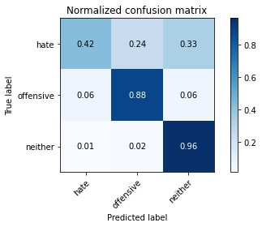

precision recall f1-score support

hate 0.47 0.42 0.44 490

offensive 0.91 0.88 0.89 2697

neither 0.94 0.96 0.95 5410

accuracy 0.91 8597

macro avg 0.77 0.76 0.76 8597

weighted avg 0.90 0.91 0.91 8597

average eval_loss: 0.2578842888391295, accuracy: 0.90694428288938

training 3 epoch...

1838.2660601139069 seconds used......

3 training finished! average train loss: 0.16706716767142604

evaluating...

Confusion matrix, without normalization

[[ 189 133 168]

[ 117 2399 181]

[ 57 133 5220]]

Normalized confusion matrix

[[0.38571429 0.27142857 0.34285714]

[0.04338154 0.88950686 0.06711161]

[0.01053604 0.0245841 0.96487985]]

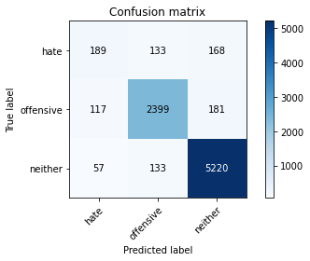

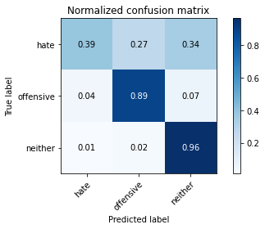

precision recall f1-score support

hate 0.52 0.39 0.44 490

offensive 0.90 0.89 0.89 2697

neither 0.94 0.96 0.95 5410

accuracy 0.91 8597

macro avg 0.79 0.75 0.76 8597

weighted avg 0.90 0.91 0.90 8597

average eval_loss: 0.2856844708280161, accuracy: 0.908223798999651

training 4 epoch...

1837.913775920868 seconds used......

4 training finished! average train loss: 0.11203353935816088

evaluating...

Confusion matrix, without normalization

[[ 194 129 167]

[ 171 2325 201]

[ 74 137 5199]]

Normalized confusion matrix

[[0.39591837 0.26326531 0.34081633]

[0.06340378 0.86206897 0.07452725]

[0.01367837 0.02532348 0.96099815]]

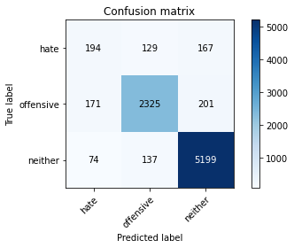

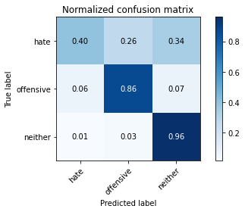

precision recall f1-score support

hate 0.44 0.40 0.42 490

offensive 0.90 0.86 0.88 2697

neither 0.93 0.96 0.95 5410

accuracy 0.90 8597

macro avg 0.76 0.74 0.75 8597

weighted avg 0.89 0.90 0.90 8597

average eval_loss: 0.3446929439474547, accuracy: 0.8977550308247063

training 5 epoch...

1839.1137664318085 seconds used......

5 training finished! average train loss: 0.08355082576279563

evaluating...

Confusion matrix, without normalization

[[ 199 129 162]

[ 243 2270 184]

[ 72 137 5201]]

Normalized confusion matrix

[[0.40612245 0.26326531 0.33061224]

[0.09010011 0.84167594 0.06822395]

[0.01330869 0.02532348 0.96136784]]

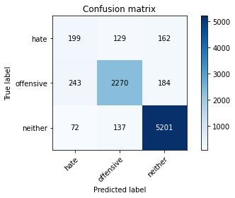

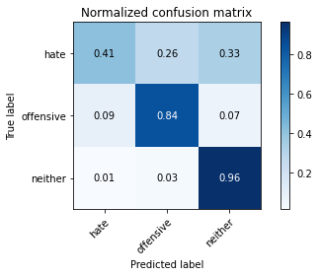

precision recall f1-score support

hate 0.39 0.41 0.40 490

offensive 0.90 0.84 0.87 2697

neither 0.94 0.96 0.95 5410

accuracy 0.89 8597

macro avg 0.74 0.74 0.74 8597

weighted avg 0.89 0.89 0.89 8597

average eval_loss: 0.4614848870719068, accuracy: 0.8921716877980691

Confusion matrix, without normalization

[[ 230 141 161]

[ 143 2430 137]

[ 80 137 5138]]

Normalized confusion matrix

[[0.43233083 0.26503759 0.30263158]

[0.05276753 0.89667897 0.05055351]

[0.01493931 0.02558357 0.95947712]]

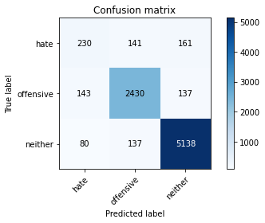

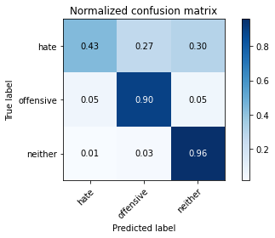

precision recall f1-score support

hate 0.51 0.43 0.47 532

offensive 0.90 0.90 0.90 2710

neither 0.95 0.96 0.95 5355

accuracy 0.91 8597

macro avg 0.78 0.76 0.77 8597

weighted avg 0.90 0.91 0.90 8597

average eval_loss: 0.2713401412807925, accuracy: 0.9070606025357683

[18]:

0.9070606025357683