1 run

training 1 epoch...

316.58061003685 seconds used......

1 training finished! average train loss: 0.5878599892697625

evaluating...

Confusion matrix, without normalization

[[ 359 50 81]

[ 569 2035 93]

[ 550 109 4751]]

Normalized confusion matrix

[[0.73265306 0.10204082 0.16530612]

[0.21097516 0.75454208 0.03448276]

[0.10166359 0.02014787 0.87818854]]

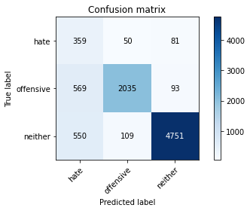

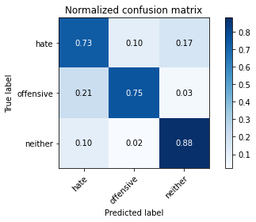

precision recall f1-score support

hate 0.24 0.73 0.36 490

offensive 0.93 0.75 0.83 2697

neither 0.96 0.88 0.92 5410

accuracy 0.83 8597

macro avg 0.71 0.79 0.71 8597

weighted avg 0.91 0.83 0.86 8597

average eval_loss: 0.43689578255248623, accuracy: 0.8311038734442248

training 2 epoch...

316.3990159034729 seconds used......

2 training finished! average train loss: 0.4410067870206124

evaluating...

Confusion matrix, without normalization

[[ 392 30 68]

[ 839 1779 79]

[ 672 95 4643]]

Normalized confusion matrix

[[0.8 0.06122449 0.13877551]

[0.31108639 0.6596218 0.02929181]

[0.12421442 0.01756007 0.85822551]]

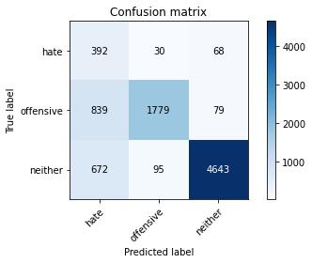

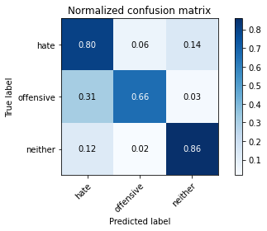

precision recall f1-score support

hate 0.21 0.80 0.33 490

offensive 0.93 0.66 0.77 2697

neither 0.97 0.86 0.91 5410

accuracy 0.79 8597

macro avg 0.70 0.77 0.67 8597

weighted avg 0.91 0.79 0.83 8597

average eval_loss: 0.4991901709936386, accuracy: 0.7926020704897057

training 3 epoch...

316.64184069633484 seconds used......

3 training finished! average train loss: 0.33086453429171564

evaluating...

Confusion matrix, without normalization

[[ 305 91 94]

[ 354 2244 99]

[ 480 153 4777]]

Normalized confusion matrix

[[0.62244898 0.18571429 0.19183673]

[0.13125695 0.8320356 0.03670745]

[0.08872458 0.02828096 0.88299445]]

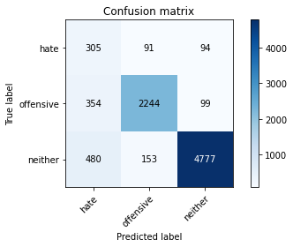

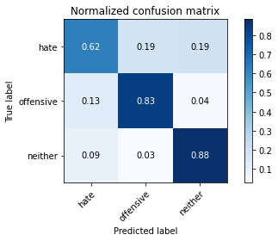

precision recall f1-score support

hate 0.27 0.62 0.37 490

offensive 0.90 0.83 0.87 2697

neither 0.96 0.88 0.92 5410

accuracy 0.85 8597

macro avg 0.71 0.78 0.72 8597

weighted avg 0.90 0.85 0.87 8597

average eval_loss: 0.41491524670706237, accuracy: 0.8521577294405025

training 4 epoch...

316.5846149921417 seconds used......

4 training finished! average train loss: 0.21530685019113022

evaluating...

Confusion matrix, without normalization

[[ 341 72 77]

[ 536 2079 82]

[ 669 162 4579]]

Normalized confusion matrix

[[0.69591837 0.14693878 0.15714286]

[0.19873934 0.77085651 0.03040415]

[0.12365989 0.02994455 0.84639556]]

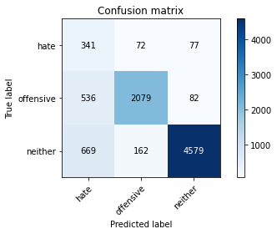

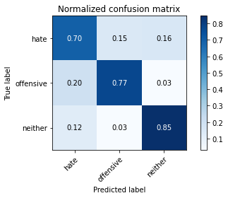

precision recall f1-score support

hate 0.22 0.70 0.33 490

offensive 0.90 0.77 0.83 2697

neither 0.97 0.85 0.90 5410

accuracy 0.81 8597

macro avg 0.70 0.77 0.69 8597

weighted avg 0.90 0.81 0.85 8597

average eval_loss: 0.6169658147188467, accuracy: 0.8141212050715366

training 5 epoch...

316.6802966594696 seconds used......

5 training finished! average train loss: 0.14658051583761778

evaluating...

Confusion matrix, without normalization

[[ 311 99 80]

[ 337 2282 78]

[ 609 226 4575]]

Normalized confusion matrix

[[0.63469388 0.20204082 0.16326531]

[0.12495365 0.84612532 0.02892102]

[0.11256932 0.04177449 0.84565619]]

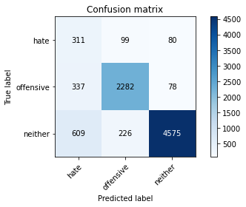

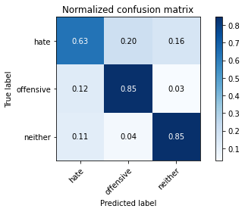

precision recall f1-score support

hate 0.25 0.63 0.36 490

offensive 0.88 0.85 0.86 2697

neither 0.97 0.85 0.90 5410

accuracy 0.83 8597

macro avg 0.70 0.78 0.71 8597

weighted avg 0.90 0.83 0.86 8597

average eval_loss: 0.7302622744878537, accuracy: 0.833779225311155

Confusion matrix, without normalization

[[ 417 40 75]

[ 847 1809 54]

[ 665 105 4585]]

Normalized confusion matrix

[[0.78383459 0.07518797 0.14097744]

[0.31254613 0.66752768 0.0199262 ]

[0.12418301 0.01960784 0.85620915]]

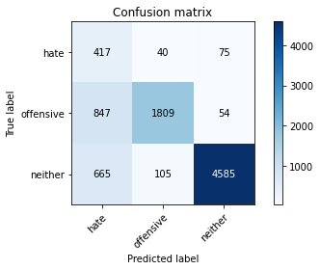

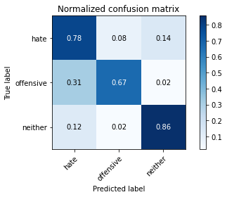

precision recall f1-score support

hate 0.22 0.78 0.34 532

offensive 0.93 0.67 0.78 2710

neither 0.97 0.86 0.91 5355

accuracy 0.79 8597

macro avg 0.70 0.77 0.68 8597

weighted avg 0.91 0.79 0.83 8597

average eval_loss: 0.5021174291192099, accuracy: 0.7922531115505409

2 run

training 1 epoch...

316.498375415802 seconds used......

1 training finished! average train loss: 0.5822299579158425

evaluating...

Confusion matrix, without normalization

[[ 330 61 99]

[ 519 2075 103]

[ 494 117 4799]]

Normalized confusion matrix

[[0.67346939 0.1244898 0.20204082]

[0.19243604 0.76937338 0.03819058]

[0.09131238 0.02162662 0.887061 ]]

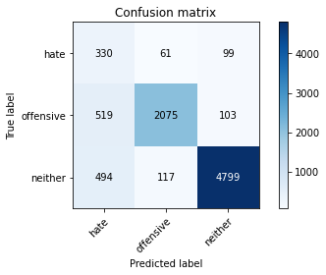

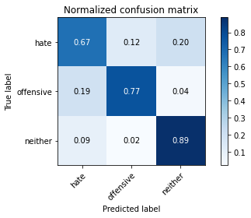

precision recall f1-score support

hate 0.25 0.67 0.36 490

offensive 0.92 0.77 0.84 2697

neither 0.96 0.89 0.92 5410

accuracy 0.84 8597

macro avg 0.71 0.78 0.71 8597

weighted avg 0.91 0.84 0.86 8597

average eval_loss: 0.3994042230206867, accuracy: 0.837966732581133

training 2 epoch...

316.5814616680145 seconds used......

2 training finished! average train loss: 0.43479782020723495

evaluating...

Confusion matrix, without normalization

[[ 339 65 86]

[ 513 2103 81]

[ 535 120 4755]]

Normalized confusion matrix

[[0.69183673 0.13265306 0.1755102 ]

[0.19021135 0.77975528 0.03003337]

[0.09889094 0.02218115 0.87892791]]

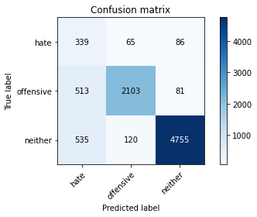

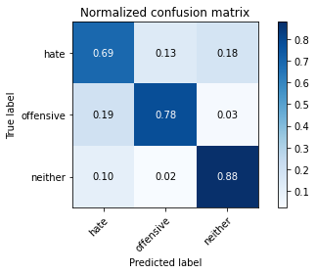

precision recall f1-score support

hate 0.24 0.69 0.36 490

offensive 0.92 0.78 0.84 2697

neither 0.97 0.88 0.92 5410

accuracy 0.84 8597

macro avg 0.71 0.78 0.71 8597

weighted avg 0.91 0.84 0.86 8597

average eval_loss: 0.427571966031263, accuracy: 0.837152495056415

training 3 epoch...

316.99011301994324 seconds used......

3 training finished! average train loss: 0.31410726941366857

evaluating...

Confusion matrix, without normalization

[[ 379 56 55]

[ 716 1930 51]

[ 966 138 4306]]

Normalized confusion matrix

[[0.77346939 0.11428571 0.1122449 ]

[0.26548016 0.71560994 0.0189099 ]

[0.17855823 0.02550832 0.79593346]]

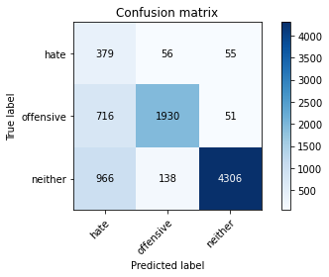

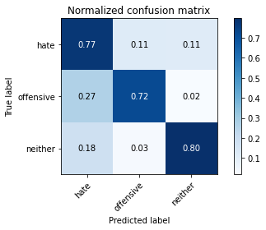

precision recall f1-score support

hate 0.18 0.77 0.30 490

offensive 0.91 0.72 0.80 2697

neither 0.98 0.80 0.88 5410

accuracy 0.77 8597

macro avg 0.69 0.76 0.66 8597

weighted avg 0.91 0.77 0.82 8597

average eval_loss: 0.690167584738066, accuracy: 0.7694544608584389

training 4 epoch...

316.39569211006165 seconds used......

4 training finished! average train loss: 0.19931849910927987

evaluating...

316.69063997268677 seconds used......

5 training finished! average train loss: 0.1427793123120618

evaluating...

Confusion matrix, without normalization

[[ 312 73 105]

[ 533 2051 113]

[ 520 140 4750]]

Normalized confusion matrix

[[0.63673469 0.14897959 0.21428571]

[0.19762699 0.7604746 0.04189841]

[0.0961183 0.025878 0.8780037 ]]

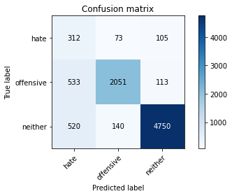

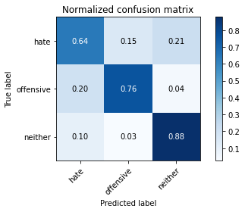

precision recall f1-score support

hate 0.23 0.64 0.34 490

offensive 0.91 0.76 0.83 2697

neither 0.96 0.88 0.92 5410

accuracy 0.83 8597

macro avg 0.70 0.76 0.69 8597

weighted avg 0.90 0.83 0.85 8597

average eval_loss: 0.6022029878484995, accuracy: 0.8273816447597999

Confusion matrix, without normalization

[[ 414 61 57]

[ 706 1960 44]

[ 971 141 4243]]

Normalized confusion matrix

[[0.77819549 0.11466165 0.10714286]

[0.26051661 0.72324723 0.01623616]

[0.18132586 0.02633053 0.7923436 ]]

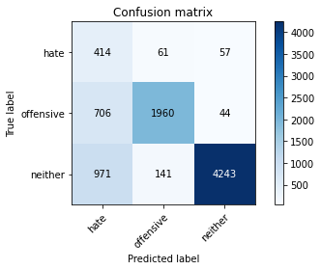

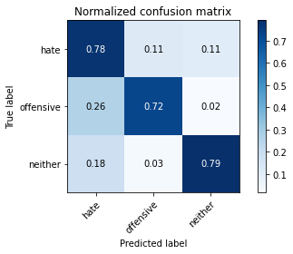

precision recall f1-score support

hate 0.20 0.78 0.32 532

offensive 0.91 0.72 0.80 2710

neither 0.98 0.79 0.87 5355

accuracy 0.77 8597

macro avg 0.69 0.76 0.67 8597

weighted avg 0.91 0.77 0.82 8597

average eval_loss: 0.7135781513743622, accuracy: 0.7696871001512156

[23]:

0.7696871001512156

3 run

training 1 epoch...

316.6650824546814 seconds used......

1 training finished! average train loss: 0.5686684257376033

evaluating...

Confusion matrix, without normalization

[[ 374 63 53]

[ 598 2054 45]

[ 862 134 4414]]

Normalized confusion matrix

[[0.76326531 0.12857143 0.10816327]

[0.22172785 0.76158695 0.01668521]

[0.15933457 0.02476895 0.81589649]]

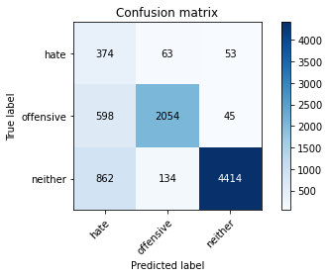

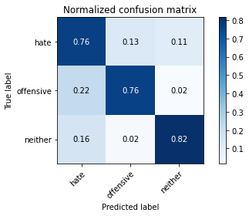

precision recall f1-score support

hate 0.20 0.76 0.32 490

offensive 0.91 0.76 0.83 2697

neither 0.98 0.82 0.89 5410

accuracy 0.80 8597

macro avg 0.70 0.78 0.68 8597

weighted avg 0.91 0.80 0.84 8597

average eval_loss: 0.5368072393328644, accuracy: 0.7958590205885774

training 2 epoch...

316.4851200580597 seconds used......

2 training finished! average train loss: 0.4316666848403779

evaluating...

Confusion matrix, without normalization

[[ 335 54 101]

[ 605 1993 99]

[ 505 104 4801]]

Normalized confusion matrix

[[0.68367347 0.11020408 0.20612245]

[0.22432332 0.73896923 0.03670745]

[0.09334566 0.01922366 0.88743068]]

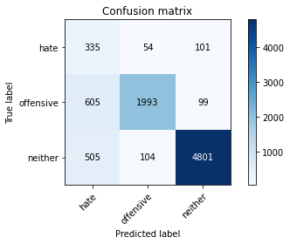

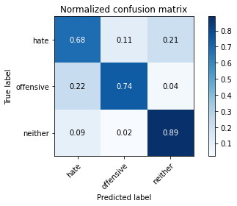

precision recall f1-score support

hate 0.23 0.68 0.35 490

offensive 0.93 0.74 0.82 2697

neither 0.96 0.89 0.92 5410

accuracy 0.83 8597

macro avg 0.71 0.77 0.70 8597

weighted avg 0.91 0.83 0.86 8597

average eval_loss: 0.43571377796835675, accuracy: 0.8292427591020123

training 3 epoch...

316.456423997879 seconds used......

3 training finished! average train loss: 0.32051413931657335

evaluating...

Confusion matrix, without normalization

[[ 364 54 72]

[ 673 1948 76]

[ 825 128 4457]]

Normalized confusion matrix

[[0.74285714 0.11020408 0.14693878]

[0.24953652 0.72228402 0.02817946]

[0.15249538 0.02365989 0.82384473]]

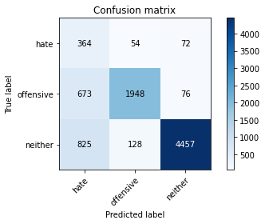

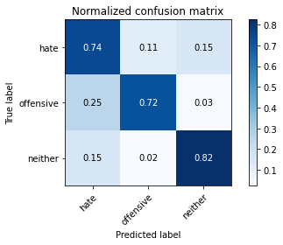

precision recall f1-score support

hate 0.20 0.74 0.31 490

offensive 0.91 0.72 0.81 2697

neither 0.97 0.82 0.89 5410

accuracy 0.79 8597

macro avg 0.69 0.76 0.67 8597

weighted avg 0.91 0.79 0.83 8597

average eval_loss: 0.583636519468801, accuracy: 0.7873676864022333

training 4 epoch...

316.4119908809662 seconds used......

4 training finished! average train loss: 0.21350272867287434

evaluating...

Confusion matrix, without normalization

[[ 332 65 93]

[ 690 1907 100]

[ 587 120 4703]]

Normalized confusion matrix

[[0.67755102 0.13265306 0.18979592]

[0.25583982 0.70708194 0.03707824]

[0.10850277 0.02218115 0.86931608]]

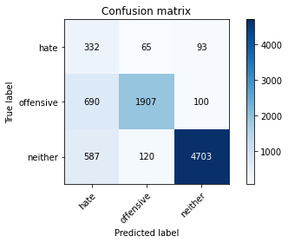

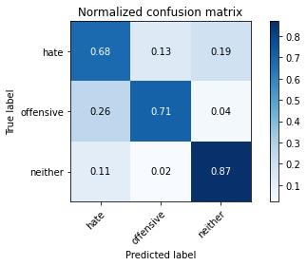

precision recall f1-score support

hate 0.21 0.68 0.32 490

offensive 0.91 0.71 0.80 2697

neither 0.96 0.87 0.91 5410

accuracy 0.81 8597

macro avg 0.69 0.75 0.68 8597

weighted avg 0.90 0.81 0.84 8597

average eval_loss: 0.5724457075342883, accuracy: 0.8074909852274049

training 5 epoch...

316.4623544216156 seconds used......

5 training finished! average train loss: 0.1422178014039968

evaluating...

Confusion matrix, without normalization

[[ 311 105 74]

[ 438 2163 96]

[ 670 162 4578]]

Normalized confusion matrix

[[0.63469388 0.21428571 0.15102041]

[0.16240267 0.80200222 0.03559511]

[0.12384473 0.02994455 0.84621072]]

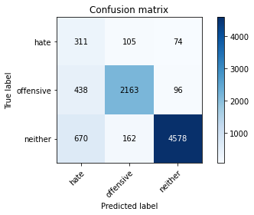

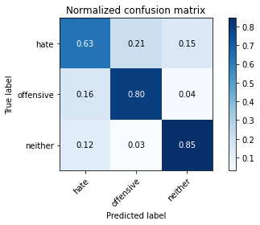

precision recall f1-score support

hate 0.22 0.63 0.33 490

offensive 0.89 0.80 0.84 2697

neither 0.96 0.85 0.90 5410

accuracy 0.82 8597

macro avg 0.69 0.76 0.69 8597

weighted avg 0.90 0.82 0.85 8597

average eval_loss: 0.691544494985841, accuracy: 0.8202861463301152

Confusion matrix, without normalization

[[ 406 68 58]

[ 576 2100 34]

[ 883 140 4332]]

Normalized confusion matrix

[[0.76315789 0.12781955 0.10902256]

[0.21254613 0.77490775 0.01254613]

[0.16489262 0.02614379 0.80896359]]

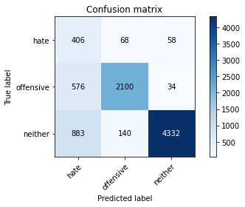

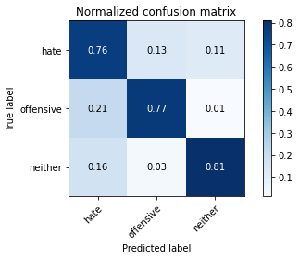

precision recall f1-score support

hate 0.22 0.76 0.34 532

offensive 0.91 0.77 0.84 2710

neither 0.98 0.81 0.89 5355

accuracy 0.80 8597

macro avg 0.70 0.78 0.69 8597

weighted avg 0.91 0.80 0.84 8597

average eval_loss: 0.5447839816295823, accuracy: 0.7953937420030243

[26]:

0.7953937420030243