training 1 epoch...

50.55243539810181 seconds used......

1 training finished! average train loss: 0.6567467451095581

evaluating...

Confusion matrix, without normalization

[[ 51 0 39]

[ 18 0 49]

[ 17 0 327]]

Normalized confusion matrix

[[0.56666667 0. 0.43333333]

[0.26865672 0. 0.73134328]

[0.0494186 0. 0.9505814 ]]

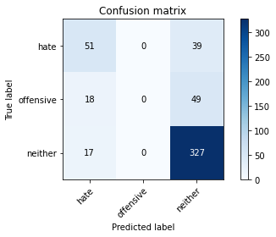

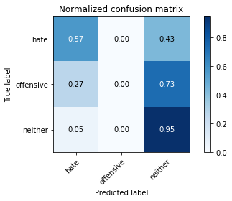

/opt/conda/lib/python3.7/site-packages/sklearn/metrics/_classification.py:1245: UndefinedMetricWarning: Precision and F-score are ill-defined and being set to 0.0 in labels with no predicted samples. Use `zero_division` parameter to control this behavior.

_warn_prf(average, modifier, msg_start, len(result))

/opt/conda/lib/python3.7/site-packages/sklearn/metrics/_classification.py:1245: UndefinedMetricWarning: Precision and F-score are ill-defined and being set to 0.0 in labels with no predicted samples. Use `zero_division` parameter to control this behavior.

_warn_prf(average, modifier, msg_start, len(result))

/opt/conda/lib/python3.7/site-packages/sklearn/metrics/_classification.py:1245: UndefinedMetricWarning: Precision and F-score are ill-defined and being set to 0.0 in labels with no predicted samples. Use `zero_division` parameter to control this behavior.

_warn_prf(average, modifier, msg_start, len(result))

precision recall f1-score support

hate 0.59 0.57 0.58 90

offensive 0.00 0.00 0.00 67

neither 0.79 0.95 0.86 344

accuracy 0.75 501

macro avg 0.46 0.51 0.48 501

weighted avg 0.65 0.75 0.70 501

average eval_loss: 0.4951320800643701, accuracy: 0.7544910179640718

training 2 epoch...

49.738969564437866 seconds used......

2 training finished! average train loss: 0.45808166588565946

evaluating...

Confusion matrix, without normalization

[[ 59 0 31]

[ 20 7 40]

[ 24 1 319]]

Normalized confusion matrix

[[0.65555556 0. 0.34444444]

[0.29850746 0.10447761 0.59701493]

[0.06976744 0.00290698 0.92732558]]

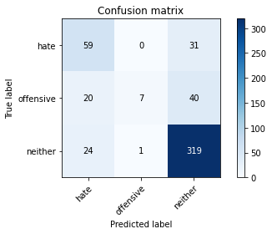

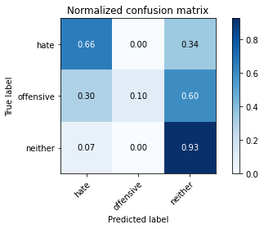

precision recall f1-score support

hate 0.57 0.66 0.61 90

offensive 0.88 0.10 0.19 67

neither 0.82 0.93 0.87 344

accuracy 0.77 501

macro avg 0.76 0.56 0.56 501

weighted avg 0.78 0.77 0.73 501

average eval_loss: 0.4797914925461205, accuracy: 0.7684630738522954

training 3 epoch...

49.68133544921875 seconds used......

3 training finished! average train loss: 0.2920798320751802

evaluating...

Confusion matrix, without normalization

[[ 48 0 42]

[ 17 10 40]

[ 15 2 327]]

Normalized confusion matrix

[[0.53333333 0. 0.46666667]

[0.25373134 0.14925373 0.59701493]

[0.04360465 0.00581395 0.9505814 ]]

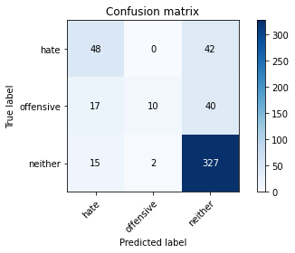

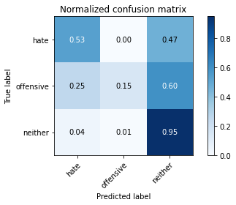

precision recall f1-score support

hate 0.60 0.53 0.56 90

offensive 0.83 0.15 0.25 67

neither 0.80 0.95 0.87 344

accuracy 0.77 501

macro avg 0.74 0.54 0.56 501

weighted avg 0.77 0.77 0.73 501

average eval_loss: 0.5262231944719903, accuracy: 0.7684630738522954

training 4 epoch...

49.63308358192444 seconds used......

4 training finished! average train loss: 0.13910900243862936

evaluating...

Confusion matrix, without normalization

[[ 61 4 25]

[ 26 23 18]

[ 35 12 297]]

Normalized confusion matrix

[[0.67777778 0.04444444 0.27777778]

[0.3880597 0.34328358 0.26865672]

[0.10174419 0.03488372 0.86337209]]

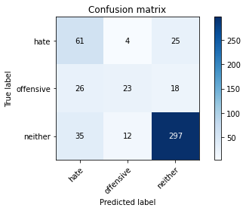

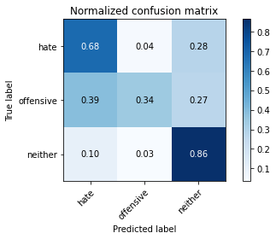

precision recall f1-score support

hate 0.50 0.68 0.58 90

offensive 0.59 0.34 0.43 67

neither 0.87 0.86 0.87 344

accuracy 0.76 501

macro avg 0.65 0.63 0.63 501

weighted avg 0.77 0.76 0.76 501

average eval_loss: 0.6837246492505074, accuracy: 0.7604790419161677

training 5 epoch...

49.54586911201477 seconds used......

5 training finished! average train loss: 0.0637107301025396

evaluating...

Confusion matrix, without normalization

[[ 60 8 22]

[ 18 29 20]

[ 31 15 298]]

Normalized confusion matrix

[[0.66666667 0.08888889 0.24444444]

[0.26865672 0.43283582 0.29850746]

[0.09011628 0.04360465 0.86627907]]

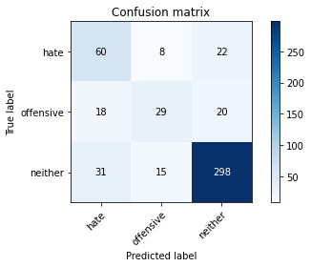

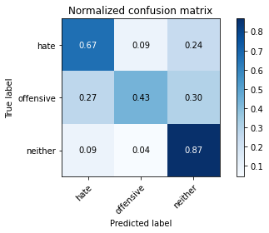

precision recall f1-score support

hate 0.55 0.67 0.60 90

offensive 0.56 0.43 0.49 67

neither 0.88 0.87 0.87 344

accuracy 0.77 501

macro avg 0.66 0.66 0.65 501

weighted avg 0.78 0.77 0.77 501

average eval_loss: 0.7554563126233496, accuracy: 0.7724550898203593

Confusion matrix, without normalization

[[ 412 54 307]

[ 121 120 189]

[ 196 84 2049]]

Normalized confusion matrix

[[0.53298836 0.0698577 0.39715395]

[0.28139535 0.27906977 0.43953488]

[0.08415629 0.03606698 0.87977673]]

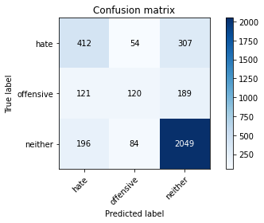

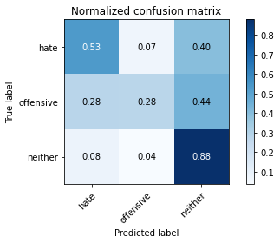

precision recall f1-score support

hate 0.57 0.53 0.55 773

offensive 0.47 0.28 0.35 430

neither 0.81 0.88 0.84 2329

accuracy 0.73 3532

macro avg 0.61 0.56 0.58 3532

weighted avg 0.71 0.73 0.72 3532

average eval_loss: 0.8945853630196576, accuracy: 0.7307474518686297

[16]:

0.7307474518686297