1 run

training 1 epoch...

16.4222252368927 seconds used......

1 training finished! average train loss: 0.9956096443865035

evaluating...

Confusion matrix, without normalization

[[ 77 3 10]

[ 36 15 16]

[ 97 18 229]]

Normalized confusion matrix

[[0.85555556 0.03333333 0.11111111]

[0.53731343 0.2238806 0.23880597]

[0.28197674 0.05232558 0.66569767]]

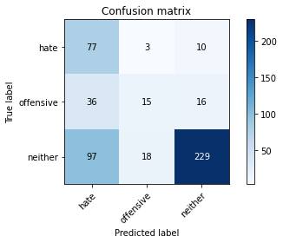

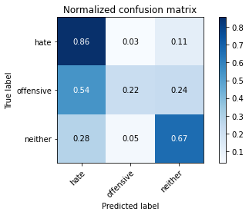

precision recall f1-score support

hate 0.37 0.86 0.51 90

offensive 0.42 0.22 0.29 67

neither 0.90 0.67 0.76 344

accuracy 0.64 501

macro avg 0.56 0.58 0.52 501

weighted avg 0.74 0.64 0.66 501

average eval_loss: 0.8142883748962328, accuracy: 0.6407185628742516

training 2 epoch...

16.70243000984192 seconds used......

2 training finished! average train loss: 0.7377419680356979

evaluating...

Confusion matrix, without normalization

[[ 69 2 19]

[ 31 19 17]

[ 59 13 272]]

Normalized confusion matrix

[[0.76666667 0.02222222 0.21111111]

[0.46268657 0.28358209 0.25373134]

[0.17151163 0.0377907 0.79069767]]

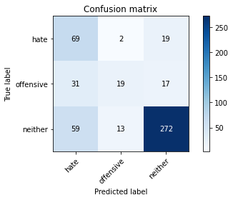

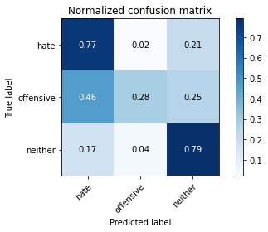

precision recall f1-score support

hate 0.43 0.77 0.55 90

offensive 0.56 0.28 0.38 67

neither 0.88 0.79 0.83 344

accuracy 0.72 501

macro avg 0.63 0.61 0.59 501

weighted avg 0.76 0.72 0.72 501

average eval_loss: 0.5988963203361402, accuracy: 0.718562874251497

training 3 epoch...

16.405303955078125 seconds used......

3 training finished! average train loss: 0.49662379456890954

evaluating...

Confusion matrix, without normalization

[[ 68 3 19]

[ 32 25 10]

[ 66 15 263]]

Normalized confusion matrix

[[0.75555556 0.03333333 0.21111111]

[0.47761194 0.37313433 0.14925373]

[0.19186047 0.04360465 0.76453488]]

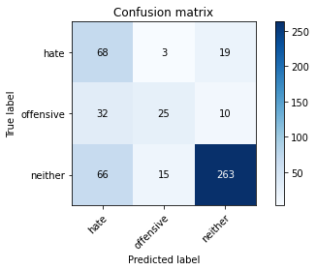

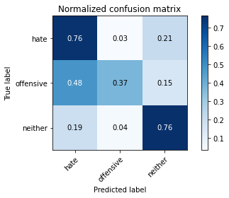

precision recall f1-score support

hate 0.41 0.76 0.53 90

offensive 0.58 0.37 0.45 67

neither 0.90 0.76 0.83 344

accuracy 0.71 501

macro avg 0.63 0.63 0.60 501

weighted avg 0.77 0.71 0.72 501

average eval_loss: 0.6689253919399701, accuracy: 0.7105788423153693

training 4 epoch...

16.667237997055054 seconds used......

4 training finished! average train loss: 0.276105443884929

evaluating...

Confusion matrix, without normalization

[[ 44 29 17]

[ 10 51 6]

[ 30 53 261]]

Normalized confusion matrix

[[0.48888889 0.32222222 0.18888889]

[0.14925373 0.76119403 0.08955224]

[0.0872093 0.15406977 0.75872093]]

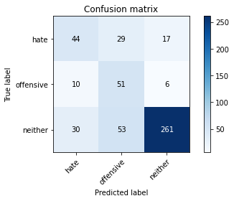

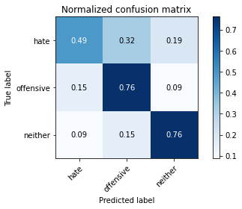

precision recall f1-score support

hate 0.52 0.49 0.51 90

offensive 0.38 0.76 0.51 67

neither 0.92 0.76 0.83 344

accuracy 0.71 501

macro avg 0.61 0.67 0.62 501

weighted avg 0.78 0.71 0.73 501

average eval_loss: 0.8079362511634827, accuracy: 0.7105788423153693

training 5 epoch...

16.394832372665405 seconds used......

5 training finished! average train loss: 0.12686278161903222

evaluating...

Confusion matrix, without normalization

[[ 57 10 23]

[ 16 38 13]

[ 35 30 279]]

Normalized confusion matrix

[[0.63333333 0.11111111 0.25555556]

[0.23880597 0.56716418 0.19402985]

[0.10174419 0.0872093 0.81104651]]

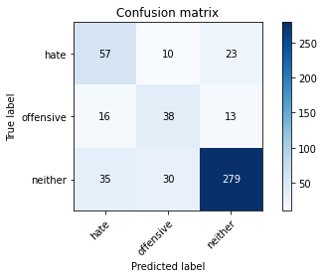

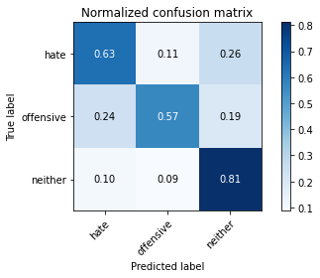

precision recall f1-score support

hate 0.53 0.63 0.58 90

offensive 0.49 0.57 0.52 67

neither 0.89 0.81 0.85 344

accuracy 0.75 501

macro avg 0.63 0.67 0.65 501

weighted avg 0.77 0.75 0.75 501

average eval_loss: 0.8601841290409749, accuracy: 0.7465069860279441

Confusion matrix, without normalization

[[ 519 22 232]

[ 218 71 141]

[ 563 80 1686]]

Normalized confusion matrix

[[0.67141009 0.02846054 0.30012937]

[0.50697674 0.16511628 0.32790698]

[0.24173465 0.03434951 0.72391584]]

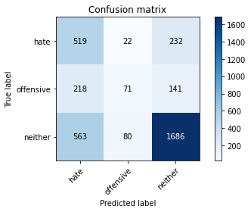

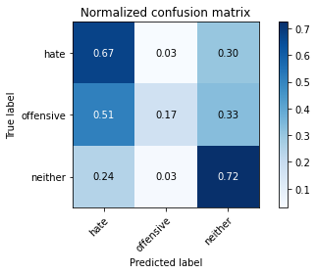

precision recall f1-score support

hate 0.40 0.67 0.50 773

offensive 0.41 0.17 0.24 430

neither 0.82 0.72 0.77 2329

accuracy 0.64 3532

macro avg 0.54 0.52 0.50 3532

weighted avg 0.68 0.64 0.64 3532

average eval_loss: 0.8384090224228337, accuracy: 0.6443941109852774

2 run

training 1 epoch...

15.664222002029419 seconds used......

1 training finished! average train loss: 0.9964114659362369

evaluating...

Confusion matrix, without normalization

[[ 71 1 18]

[ 41 1 25]

[ 82 0 262]]

Normalized confusion matrix

[[0.78888889 0.01111111 0.2 ]

[0.6119403 0.01492537 0.37313433]

[0.23837209 0. 0.76162791]]

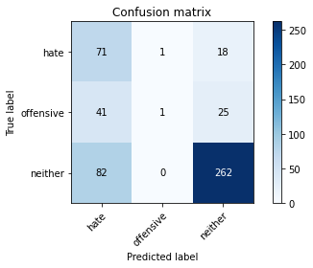

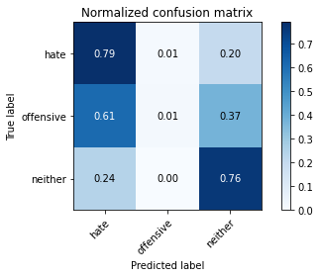

precision recall f1-score support

hate 0.37 0.79 0.50 90

offensive 0.50 0.01 0.03 67

neither 0.86 0.76 0.81 344

accuracy 0.67 501

macro avg 0.57 0.52 0.45 501

weighted avg 0.72 0.67 0.65 501

average eval_loss: 0.7438773054343003, accuracy: 0.6666666666666666

training 2 epoch...

15.571430206298828 seconds used......

2 training finished! average train loss: 0.7253157761361864

evaluating...

Confusion matrix, without normalization

[[ 76 6 8]

[ 35 25 7]

[ 98 23 223]]

Normalized confusion matrix

[[0.84444444 0.06666667 0.08888889]

[0.52238806 0.37313433 0.10447761]

[0.28488372 0.06686047 0.64825581]]

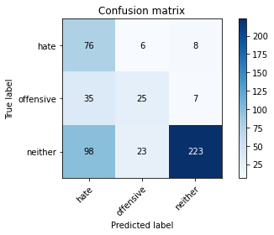

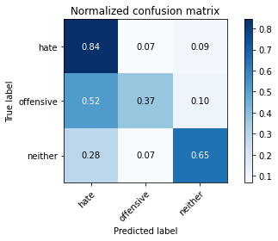

precision recall f1-score support

hate 0.36 0.84 0.51 90

offensive 0.46 0.37 0.41 67

neither 0.94 0.65 0.77 344

accuracy 0.65 501

macro avg 0.59 0.62 0.56 501

weighted avg 0.77 0.65 0.67 501

average eval_loss: 0.810164444721662, accuracy: 0.6467065868263473

training 3 epoch...

15.591689348220825 seconds used......

3 training finished! average train loss: 0.4679435236586465

evaluating...

Confusion matrix, without normalization

[[ 60 17 13]

[ 20 40 7]

[ 61 43 240]]

Normalized confusion matrix

[[0.66666667 0.18888889 0.14444444]

[0.29850746 0.59701493 0.10447761]

[0.17732558 0.125 0.69767442]]

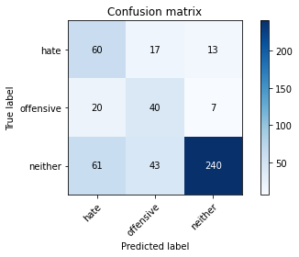

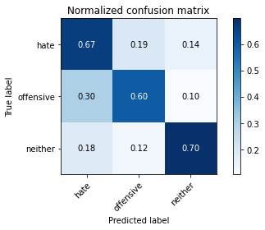

precision recall f1-score support

hate 0.43 0.67 0.52 90

offensive 0.40 0.60 0.48 67

neither 0.92 0.70 0.79 344

accuracy 0.68 501

macro avg 0.58 0.65 0.60 501

weighted avg 0.76 0.68 0.70 501

average eval_loss: 0.8954183252958151, accuracy: 0.6786427145708582

training 4 epoch...

15.620387077331543 seconds used......

4 training finished! average train loss: 0.22817047962711917

evaluating...

Confusion matrix, without normalization

[[ 72 7 11]

[ 29 31 7]

[ 91 25 228]]

Normalized confusion matrix

[[0.8 0.07777778 0.12222222]

[0.43283582 0.46268657 0.10447761]

[0.26453488 0.07267442 0.6627907 ]]

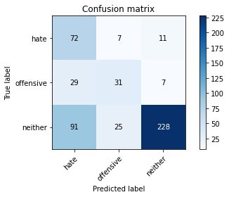

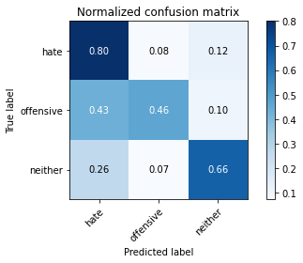

precision recall f1-score support

hate 0.38 0.80 0.51 90

offensive 0.49 0.46 0.48 67

neither 0.93 0.66 0.77 344

accuracy 0.66 501

macro avg 0.60 0.64 0.59 501

weighted avg 0.77 0.66 0.69 501

average eval_loss: 1.0389783691901426, accuracy: 0.6606786427145709

training 5 epoch...

15.585440158843994 seconds used......

5 training finished! average train loss: 0.10673280159632365

evaluating...

Confusion matrix, without normalization

[[ 51 20 19]

[ 10 48 9]

[ 41 50 253]]

Normalized confusion matrix

[[0.56666667 0.22222222 0.21111111]

[0.14925373 0.71641791 0.13432836]

[0.11918605 0.14534884 0.73546512]]

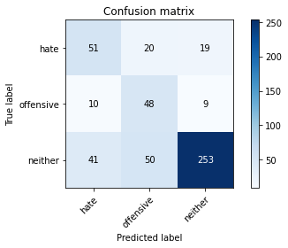

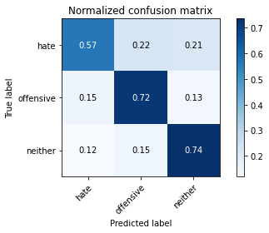

precision recall f1-score support

hate 0.50 0.57 0.53 90

offensive 0.41 0.72 0.52 67

neither 0.90 0.74 0.81 344

accuracy 0.70 501

macro avg 0.60 0.67 0.62 501

weighted avg 0.76 0.70 0.72 501

average eval_loss: 1.1997282833147507, accuracy: 0.7025948103792415

Confusion matrix, without normalization

[[ 526 77 170]

[ 202 136 92]

[ 519 204 1606]]

Normalized confusion matrix

[[0.68046572 0.0996119 0.21992238]

[0.46976744 0.31627907 0.21395349]

[0.22284242 0.08759124 0.68956634]]

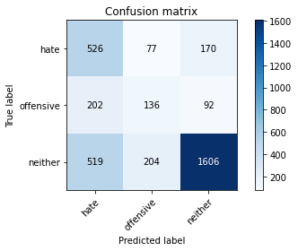

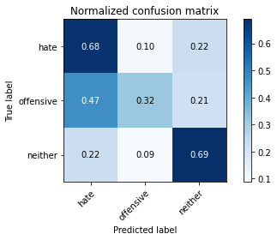

precision recall f1-score support

hate 0.42 0.68 0.52 773

offensive 0.33 0.32 0.32 430

neither 0.86 0.69 0.77 2329

accuracy 0.64 3532

macro avg 0.54 0.56 0.54 3532

weighted avg 0.70 0.64 0.66 3532

average eval_loss: 0.8048430679544891, accuracy: 0.6421291053227633

[22]:

0.6421291053227633

3 run

training 1 epoch...

15.565136909484863 seconds used......

1 training finished! average train loss: 1.010793901152081

evaluating...

Confusion matrix, without normalization

[[ 36 0 54]

[ 13 1 53]

[ 20 0 324]]

Normalized confusion matrix

[[0.4 0. 0.6 ]

[0.19402985 0.01492537 0.79104478]

[0.05813953 0. 0.94186047]]

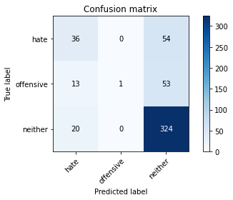

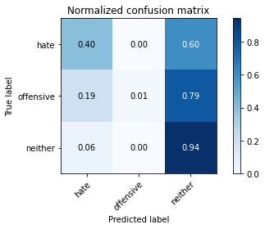

precision recall f1-score support

hate 0.52 0.40 0.45 90

offensive 1.00 0.01 0.03 67

neither 0.75 0.94 0.84 344

accuracy 0.72 501

macro avg 0.76 0.45 0.44 501

weighted avg 0.74 0.72 0.66 501

average eval_loss: 0.6920260190963745, accuracy: 0.720558882235529

training 2 epoch...

15.641184091567993 seconds used......

2 training finished! average train loss: 0.7669230351845423

evaluating...

Confusion matrix, without normalization

[[ 53 7 30]

[ 15 21 31]

[ 30 24 290]]

Normalized confusion matrix

[[0.58888889 0.07777778 0.33333333]

[0.2238806 0.31343284 0.46268657]

[0.0872093 0.06976744 0.84302326]]

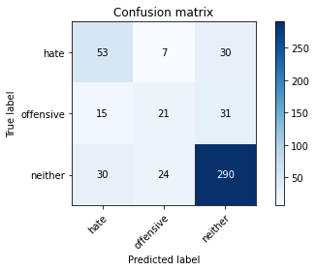

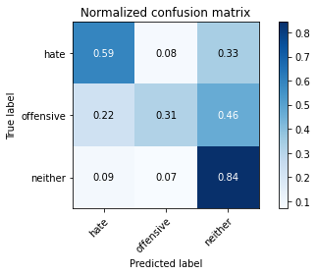

precision recall f1-score support

hate 0.54 0.59 0.56 90

offensive 0.40 0.31 0.35 67

neither 0.83 0.84 0.83 344

accuracy 0.73 501

macro avg 0.59 0.58 0.58 501

weighted avg 0.72 0.73 0.72 501

average eval_loss: 0.5871311153929967, accuracy: 0.7265469061876247

training 3 epoch...

15.627596616744995 seconds used......

3 training finished! average train loss: 0.510164925787184

evaluating...

Confusion matrix, without normalization

[[ 56 16 18]

[ 16 33 18]

[ 41 26 277]]

Normalized confusion matrix

[[0.62222222 0.17777778 0.2 ]

[0.23880597 0.49253731 0.26865672]

[0.11918605 0.0755814 0.80523256]]

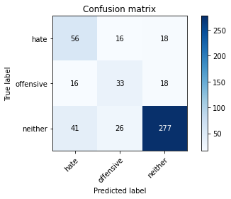

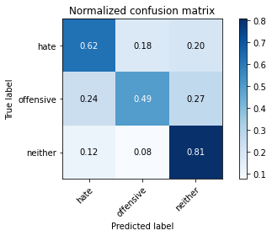

precision recall f1-score support

hate 0.50 0.62 0.55 90

offensive 0.44 0.49 0.46 67

neither 0.88 0.81 0.84 344

accuracy 0.73 501

macro avg 0.61 0.64 0.62 501

weighted avg 0.76 0.73 0.74 501

average eval_loss: 0.6056944911296551, accuracy: 0.7305389221556886

training 4 epoch...

15.565060377120972 seconds used......

4 training finished! average train loss: 0.29298849635654023

evaluating...

Confusion matrix, without normalization

[[ 72 10 8]

[ 22 35 10]

[ 73 34 237]]

Normalized confusion matrix

[[0.8 0.11111111 0.08888889]

[0.32835821 0.52238806 0.14925373]

[0.2122093 0.09883721 0.68895349]]

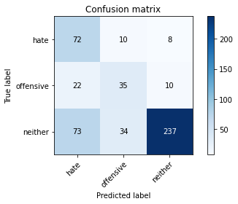

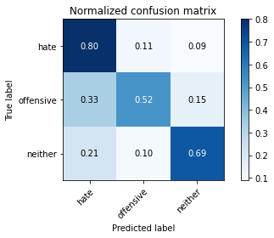

precision recall f1-score support

hate 0.43 0.80 0.56 90

offensive 0.44 0.52 0.48 67

neither 0.93 0.69 0.79 344

accuracy 0.69 501

macro avg 0.60 0.67 0.61 501

weighted avg 0.77 0.69 0.71 501

average eval_loss: 0.8786217524455144, accuracy: 0.6866267465069861

training 5 epoch...

15.570961713790894 seconds used......

5 training finished! average train loss: 0.1144558942773276

evaluating...

Confusion matrix, without normalization

[[ 68 15 7]

[ 23 36 8]

[ 79 37 228]]

Normalized confusion matrix

[[0.75555556 0.16666667 0.07777778]

[0.34328358 0.53731343 0.11940299]

[0.22965116 0.10755814 0.6627907 ]]

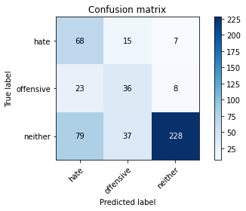

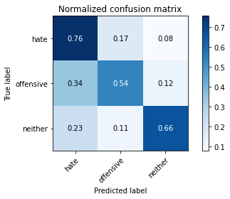

precision recall f1-score support

hate 0.40 0.76 0.52 90

offensive 0.41 0.54 0.46 67

neither 0.94 0.66 0.78 344

accuracy 0.66 501

macro avg 0.58 0.65 0.59 501

weighted avg 0.77 0.66 0.69 501

average eval_loss: 1.091986733345458, accuracy: 0.6626746506986028

Confusion matrix, without normalization

[[ 436 144 193]

[ 118 220 92]

[ 382 318 1629]]

Normalized confusion matrix

[[0.56403622 0.18628719 0.24967658]

[0.2744186 0.51162791 0.21395349]

[0.16401889 0.13653929 0.69944182]]

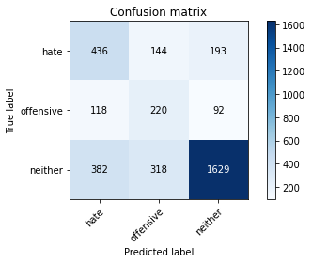

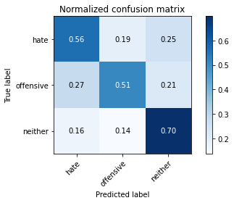

precision recall f1-score support

hate 0.47 0.56 0.51 773

offensive 0.32 0.51 0.40 430

neither 0.85 0.70 0.77 2329

accuracy 0.65 3532

macro avg 0.55 0.59 0.56 3532

weighted avg 0.70 0.65 0.67 3532

average eval_loss: 0.9241707260999302, accuracy: 0.6469422423556059

[24]:

0.6469422423556059