training 1 epoch...

28.66201090812683 seconds used......

1 training finished! average train loss: 0.30395111032263483

evaluating...

Confusion matrix, without normalization

[[ 0 0 13]

[ 0 0 29]

[ 0 0 340]]

Normalized confusion matrix

[[0. 0. 1.]

[0. 0. 1.]

[0. 0. 1.]]

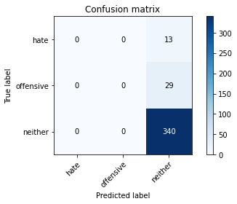

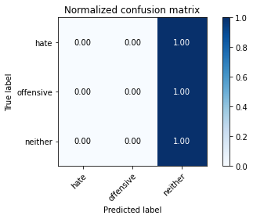

/opt/conda/lib/python3.7/site-packages/sklearn/metrics/_classification.py:1245: UndefinedMetricWarning: Precision and F-score are ill-defined and being set to 0.0 in labels with no predicted samples. Use `zero_division` parameter to control this behavior.

_warn_prf(average, modifier, msg_start, len(result))

/opt/conda/lib/python3.7/site-packages/sklearn/metrics/_classification.py:1245: UndefinedMetricWarning: Precision and F-score are ill-defined and being set to 0.0 in labels with no predicted samples. Use `zero_division` parameter to control this behavior.

_warn_prf(average, modifier, msg_start, len(result))

/opt/conda/lib/python3.7/site-packages/sklearn/metrics/_classification.py:1245: UndefinedMetricWarning: Precision and F-score are ill-defined and being set to 0.0 in labels with no predicted samples. Use `zero_division` parameter to control this behavior.

_warn_prf(average, modifier, msg_start, len(result))

precision recall f1-score support

hate 0.00 0.00 0.00 13

offensive 0.00 0.00 0.00 29

neither 0.89 1.00 0.94 340

accuracy 0.89 382

macro avg 0.30 0.33 0.31 382

weighted avg 0.79 0.89 0.84 382

average eval_loss: 0.2770018784329295, accuracy: 0.8900523560209425

training 2 epoch...

27.8911554813385 seconds used......

2 training finished! average train loss: 0.24622350525067643

evaluating...

Confusion matrix, without normalization

[[ 1 1 11]

[ 1 0 28]

[ 0 1 339]]

Normalized confusion matrix

[[0.07692308 0.07692308 0.84615385]

[0.03448276 0. 0.96551724]

[0. 0.00294118 0.99705882]]

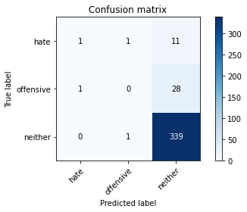

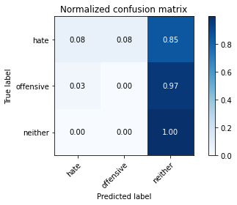

precision recall f1-score support

hate 0.50 0.08 0.13 13

offensive 0.00 0.00 0.00 29

neither 0.90 1.00 0.94 340

accuracy 0.89 382

macro avg 0.47 0.36 0.36 382

weighted avg 0.82 0.89 0.85 382

average eval_loss: 0.24999069068580865, accuracy: 0.8900523560209425

training 3 epoch...

27.809579133987427 seconds used......

3 training finished! average train loss: 0.17312854629139915

evaluating...

Confusion matrix, without normalization

[[ 1 2 10]

[ 0 3 26]

[ 2 2 336]]

Normalized confusion matrix

[[0.07692308 0.15384615 0.76923077]

[0. 0.10344828 0.89655172]

[0.00588235 0.00588235 0.98823529]]

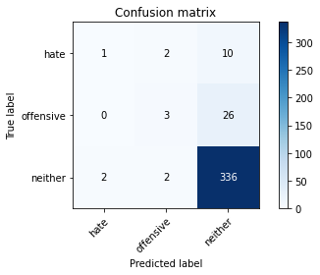

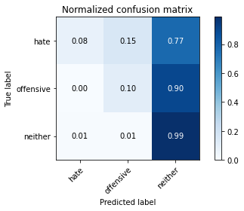

precision recall f1-score support

hate 0.33 0.08 0.12 13

offensive 0.43 0.10 0.17 29

neither 0.90 0.99 0.94 340

accuracy 0.89 382

macro avg 0.56 0.39 0.41 382

weighted avg 0.85 0.89 0.86 382

average eval_loss: 0.2905307439854369, accuracy: 0.8900523560209425

training 4 epoch...

27.8361873626709 seconds used......

4 training finished! average train loss: 0.07245541647006216

evaluating...

Confusion matrix, without normalization

[[ 1 3 9]

[ 0 10 19]

[ 2 8 330]]

Normalized confusion matrix

[[0.07692308 0.23076923 0.69230769]

[0. 0.34482759 0.65517241]

[0.00588235 0.02352941 0.97058824]]

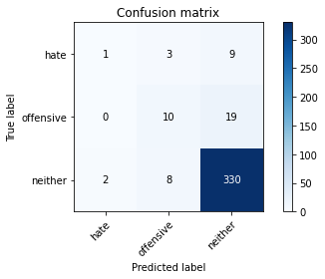

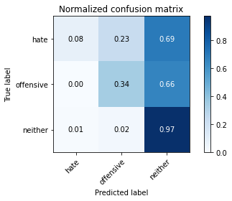

precision recall f1-score support

hate 0.33 0.08 0.12 13

offensive 0.48 0.34 0.40 29

neither 0.92 0.97 0.95 340

accuracy 0.89 382

macro avg 0.58 0.46 0.49 382

weighted avg 0.87 0.89 0.88 382

average eval_loss: 0.3535844293422997, accuracy: 0.8926701570680629

training 5 epoch...

27.82679009437561 seconds used......

5 training finished! average train loss: 0.023994313494429577

evaluating...

Confusion matrix, without normalization

[[ 1 1 11]

[ 1 4 24]

[ 1 5 334]]

Normalized confusion matrix

[[0.07692308 0.07692308 0.84615385]

[0.03448276 0.13793103 0.82758621]

[0.00294118 0.01470588 0.98235294]]

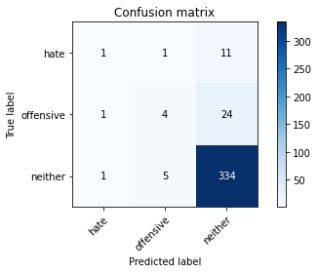

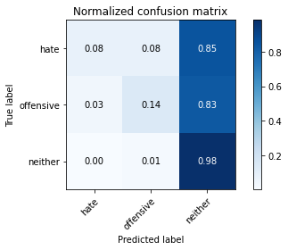

precision recall f1-score support

hate 0.33 0.08 0.12 13

offensive 0.40 0.14 0.21 29

neither 0.91 0.98 0.94 340

accuracy 0.89 382

macro avg 0.55 0.40 0.42 382

weighted avg 0.85 0.89 0.86 382

average eval_loss: 0.45189109491184354, accuracy: 0.887434554973822

Confusion matrix, without normalization

[[ 0 3 38]

[ 1 9 85]

[ 3 14 697]]

Normalized confusion matrix

[[0. 0.07317073 0.92682927]

[0.01052632 0.09473684 0.89473684]

[0.00420168 0.01960784 0.97619048]]

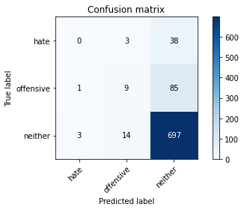

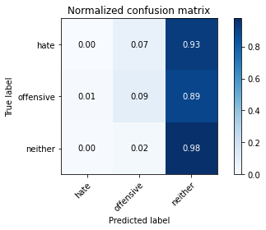

precision recall f1-score support

hate 0.00 0.00 0.00 41

offensive 0.35 0.09 0.15 95

neither 0.85 0.98 0.91 714

accuracy 0.83 850

macro avg 0.40 0.36 0.35 850

weighted avg 0.75 0.83 0.78 850

average eval_loss: 0.6006256794424316, accuracy: 0.8305882352941176

[18]:

0.8305882352941176