1 run

training 1 epoch...

1.7787368297576904 seconds used......

1 training finished! average train loss: 1.0529589891433715

evaluating...

Confusion matrix, without normalization

[[ 10 0 3]

[ 22 0 7]

[214 0 126]]

Normalized confusion matrix

[[0.76923077 0. 0.23076923]

[0.75862069 0. 0.24137931]

[0.62941176 0. 0.37058824]]

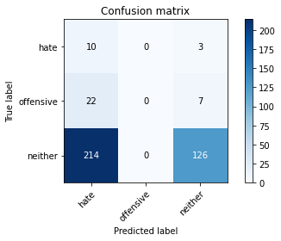

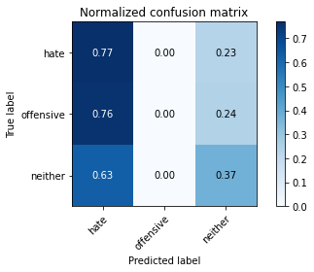

/opt/conda/lib/python3.7/site-packages/sklearn/metrics/_classification.py:1245: UndefinedMetricWarning: Precision and F-score are ill-defined and being set to 0.0 in labels with no predicted samples. Use `zero_division` parameter to control this behavior.

_warn_prf(average, modifier, msg_start, len(result))

/opt/conda/lib/python3.7/site-packages/sklearn/metrics/_classification.py:1245: UndefinedMetricWarning: Precision and F-score are ill-defined and being set to 0.0 in labels with no predicted samples. Use `zero_division` parameter to control this behavior.

_warn_prf(average, modifier, msg_start, len(result))

/opt/conda/lib/python3.7/site-packages/sklearn/metrics/_classification.py:1245: UndefinedMetricWarning: Precision and F-score are ill-defined and being set to 0.0 in labels with no predicted samples. Use `zero_division` parameter to control this behavior.

_warn_prf(average, modifier, msg_start, len(result))

precision recall f1-score support

hate 0.04 0.77 0.08 13

offensive 0.00 0.00 0.00 29

neither 0.93 0.37 0.53 340

accuracy 0.36 382

macro avg 0.32 0.38 0.20 382

weighted avg 0.83 0.36 0.47 382

average eval_loss: 0.9658485651016235, accuracy: 0.35602094240837695

training 2 epoch...

1.692082166671753 seconds used......

2 training finished! average train loss: 1.0010318597157797

evaluating...

Confusion matrix, without normalization

[[ 9 0 4]

[ 7 0 22]

[ 98 0 242]]

Normalized confusion matrix

[[0.69230769 0. 0.30769231]

[0.24137931 0. 0.75862069]

[0.28823529 0. 0.71176471]]

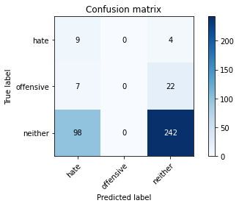

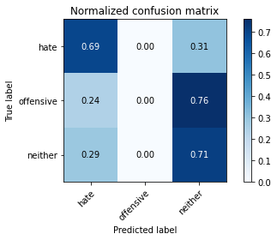

/opt/conda/lib/python3.7/site-packages/sklearn/metrics/_classification.py:1245: UndefinedMetricWarning: Precision and F-score are ill-defined and being set to 0.0 in labels with no predicted samples. Use `zero_division` parameter to control this behavior.

_warn_prf(average, modifier, msg_start, len(result))

/opt/conda/lib/python3.7/site-packages/sklearn/metrics/_classification.py:1245: UndefinedMetricWarning: Precision and F-score are ill-defined and being set to 0.0 in labels with no predicted samples. Use `zero_division` parameter to control this behavior.

_warn_prf(average, modifier, msg_start, len(result))

/opt/conda/lib/python3.7/site-packages/sklearn/metrics/_classification.py:1245: UndefinedMetricWarning: Precision and F-score are ill-defined and being set to 0.0 in labels with no predicted samples. Use `zero_division` parameter to control this behavior.

_warn_prf(average, modifier, msg_start, len(result))

precision recall f1-score support

hate 0.08 0.69 0.14 13

offensive 0.00 0.00 0.00 29

neither 0.90 0.71 0.80 340

accuracy 0.66 382

macro avg 0.33 0.47 0.31 382

weighted avg 0.81 0.66 0.71 382

average eval_loss: 0.870787039399147, accuracy: 0.6570680628272252

training 3 epoch...

1.6917521953582764 seconds used......

3 training finished! average train loss: 0.9108648260434469

evaluating...

Confusion matrix, without normalization

[[ 10 0 3]

[ 13 0 16]

[128 2 210]]

Normalized confusion matrix

[[0.76923077 0. 0.23076923]

[0.44827586 0. 0.55172414]

[0.37647059 0.00588235 0.61764706]]

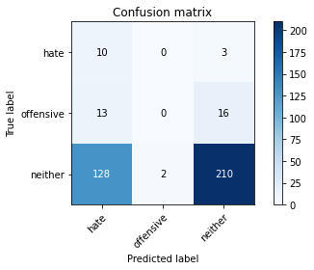

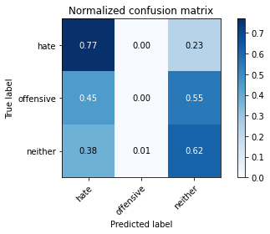

precision recall f1-score support

hate 0.07 0.77 0.12 13

offensive 0.00 0.00 0.00 29

neither 0.92 0.62 0.74 340

accuracy 0.58 382

macro avg 0.33 0.46 0.29 382

weighted avg 0.82 0.58 0.66 382

average eval_loss: 0.8611670047044754, accuracy: 0.5759162303664922

training 4 epoch...

1.6853666305541992 seconds used......

4 training finished! average train loss: 0.7787359833717347

evaluating...

Confusion matrix, without normalization

[[ 7 1 5]

[ 8 2 19]

[ 74 8 258]]

Normalized confusion matrix

[[0.53846154 0.07692308 0.38461538]

[0.27586207 0.06896552 0.65517241]

[0.21764706 0.02352941 0.75882353]]

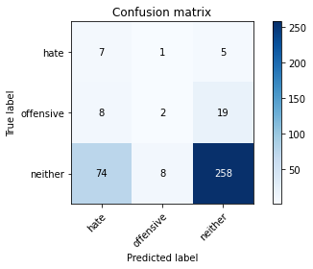

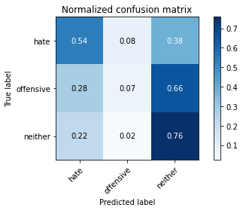

precision recall f1-score support

hate 0.08 0.54 0.14 13

offensive 0.18 0.07 0.10 29

neither 0.91 0.76 0.83 340

accuracy 0.70 382

macro avg 0.39 0.46 0.36 382

weighted avg 0.83 0.70 0.75 382

average eval_loss: 0.7155619189143181, accuracy: 0.6989528795811518

training 5 epoch...

1.6846230030059814 seconds used......

5 training finished! average train loss: 0.5860557715098064

evaluating...

Confusion matrix, without normalization

[[ 5 1 7]

[ 7 7 15]

[ 58 32 250]]

Normalized confusion matrix

[[0.38461538 0.07692308 0.53846154]

[0.24137931 0.24137931 0.51724138]

[0.17058824 0.09411765 0.73529412]]

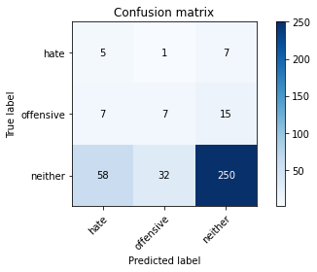

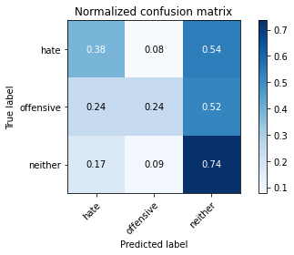

precision recall f1-score support

hate 0.07 0.38 0.12 13

offensive 0.17 0.24 0.20 29

neither 0.92 0.74 0.82 340

accuracy 0.69 382

macro avg 0.39 0.45 0.38 382

weighted avg 0.83 0.69 0.75 382

average eval_loss: 0.7271194726228714, accuracy: 0.6858638743455497

Confusion matrix, without normalization

[[ 39 0 2]

[ 49 0 46]

[377 5 332]]

Normalized confusion matrix

[[0.95121951 0. 0.04878049]

[0.51578947 0. 0.48421053]

[0.5280112 0.0070028 0.46498599]]

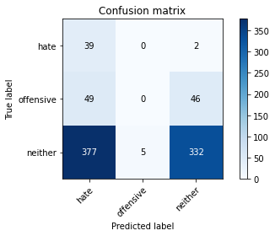

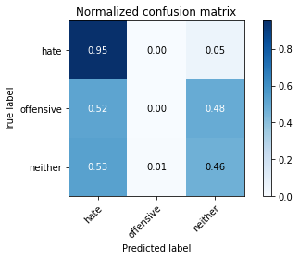

precision recall f1-score support

hate 0.08 0.95 0.15 41

offensive 0.00 0.00 0.00 95

neither 0.87 0.46 0.61 714

accuracy 0.44 850

macro avg 0.32 0.47 0.25 850

weighted avg 0.74 0.44 0.52 850

average eval_loss: 0.9885200421477474, accuracy: 0.4364705882352941

2 run

training 1 epoch...

2.7289304733276367 seconds used......

1 training finished! average train loss: 1.0458081126213075

evaluating...

Confusion matrix, without normalization

[[ 8 0 5]

[ 10 0 19]

[170 0 170]]

Normalized confusion matrix

[[0.61538462 0. 0.38461538]

[0.34482759 0. 0.65517241]

[0.5 0. 0.5 ]]

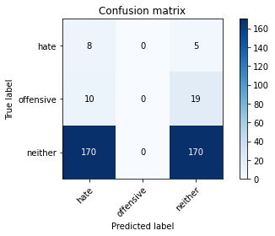

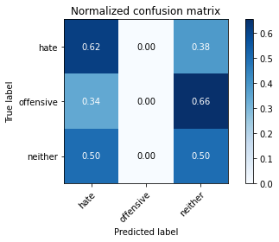

/opt/conda/lib/python3.7/site-packages/sklearn/metrics/_classification.py:1245: UndefinedMetricWarning: Precision and F-score are ill-defined and being set to 0.0 in labels with no predicted samples. Use `zero_division` parameter to control this behavior.

_warn_prf(average, modifier, msg_start, len(result))

/opt/conda/lib/python3.7/site-packages/sklearn/metrics/_classification.py:1245: UndefinedMetricWarning: Precision and F-score are ill-defined and being set to 0.0 in labels with no predicted samples. Use `zero_division` parameter to control this behavior.

_warn_prf(average, modifier, msg_start, len(result))

/opt/conda/lib/python3.7/site-packages/sklearn/metrics/_classification.py:1245: UndefinedMetricWarning: Precision and F-score are ill-defined and being set to 0.0 in labels with no predicted samples. Use `zero_division` parameter to control this behavior.

_warn_prf(average, modifier, msg_start, len(result))

precision recall f1-score support

hate 0.04 0.62 0.08 13

offensive 0.00 0.00 0.00 29

neither 0.88 0.50 0.64 340

accuracy 0.47 382

macro avg 0.31 0.37 0.24 382

weighted avg 0.78 0.47 0.57 382

average eval_loss: 0.9209144085645675, accuracy: 0.46596858638743455

training 2 epoch...

1.792527675628662 seconds used......

2 training finished! average train loss: 0.9827832341194153

evaluating...

Confusion matrix, without normalization

[[ 5 1 7]

[ 7 0 22]

[ 80 0 260]]

Normalized confusion matrix

[[0.38461538 0.07692308 0.53846154]

[0.24137931 0. 0.75862069]

[0.23529412 0. 0.76470588]]

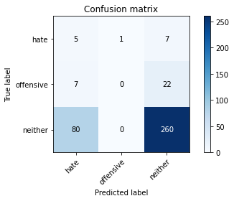

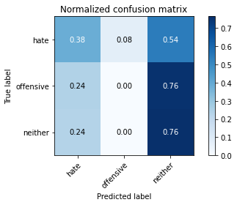

precision recall f1-score support

hate 0.05 0.38 0.10 13

offensive 0.00 0.00 0.00 29

neither 0.90 0.76 0.83 340

accuracy 0.69 382

macro avg 0.32 0.38 0.31 382

weighted avg 0.80 0.69 0.74 382

average eval_loss: 0.8300708383321762, accuracy: 0.693717277486911

training 3 epoch...

1.9508907794952393 seconds used......

3 training finished! average train loss: 0.9096859733263651

evaluating...

Confusion matrix, without normalization

[[ 8 1 4]

[ 18 4 7]

[238 4 98]]

Normalized confusion matrix

[[0.61538462 0.07692308 0.30769231]

[0.62068966 0.13793103 0.24137931]

[0.7 0.01176471 0.28823529]]

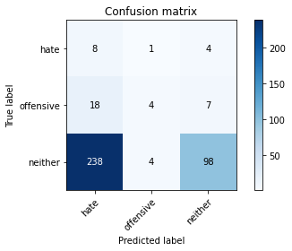

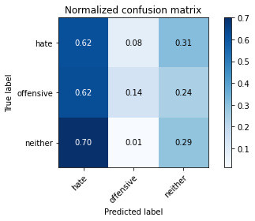

precision recall f1-score support

hate 0.03 0.62 0.06 13

offensive 0.44 0.14 0.21 29

neither 0.90 0.29 0.44 340

accuracy 0.29 382

macro avg 0.46 0.35 0.23 382

weighted avg 0.84 0.29 0.41 382

average eval_loss: 1.139506036043167, accuracy: 0.2879581151832461

training 4 epoch...

1.873946189880371 seconds used......

4 training finished! average train loss: 0.7692326863606771

evaluating...

Confusion matrix, without normalization

[[ 9 0 4]

[ 16 5 8]

[165 10 165]]

Normalized confusion matrix

[[0.69230769 0. 0.30769231]

[0.55172414 0.17241379 0.27586207]

[0.48529412 0.02941176 0.48529412]]

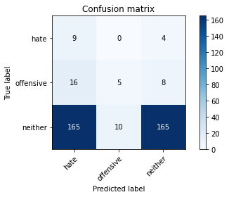

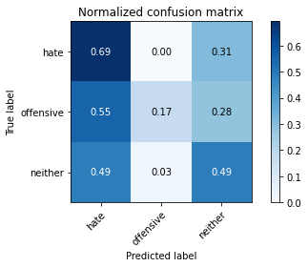

precision recall f1-score support

hate 0.05 0.69 0.09 13

offensive 0.33 0.17 0.23 29

neither 0.93 0.49 0.64 340

accuracy 0.47 382

macro avg 0.44 0.45 0.32 382

weighted avg 0.86 0.47 0.59 382

average eval_loss: 1.0766648679971695, accuracy: 0.468586387434555

training 5 epoch...

1.8266494274139404 seconds used......

5 training finished! average train loss: 0.591704640785853

evaluating...

Confusion matrix, without normalization

[[ 10 0 3]

[ 13 4 12]

[124 10 206]]

Normalized confusion matrix

[[0.76923077 0. 0.23076923]

[0.44827586 0.13793103 0.4137931 ]

[0.36470588 0.02941176 0.60588235]]

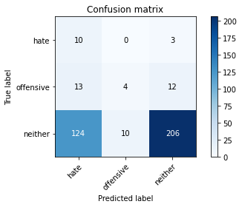

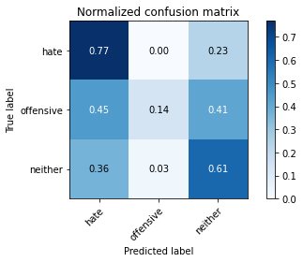

precision recall f1-score support

hate 0.07 0.77 0.13 13

offensive 0.29 0.14 0.19 29

neither 0.93 0.61 0.73 340

accuracy 0.58 382

macro avg 0.43 0.50 0.35 382

weighted avg 0.85 0.58 0.67 382

average eval_loss: 0.938477537035942, accuracy: 0.5759162303664922

Confusion matrix, without normalization

[[ 35 1 5]

[ 43 0 52]

[330 36 348]]

Normalized confusion matrix

[[0.85365854 0.02439024 0.12195122]

[0.45263158 0. 0.54736842]

[0.46218487 0.05042017 0.48739496]]

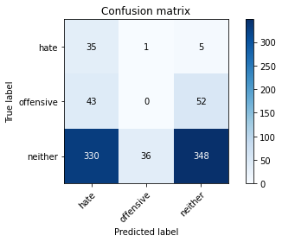

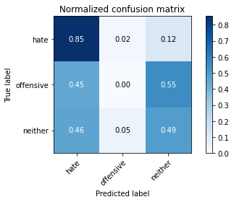

precision recall f1-score support

hate 0.09 0.85 0.16 41

offensive 0.00 0.00 0.00 95

neither 0.86 0.49 0.62 714

accuracy 0.45 850

macro avg 0.32 0.45 0.26 850

weighted avg 0.73 0.45 0.53 850

average eval_loss: 1.1617116692454317, accuracy: 0.4505882352941176

[18]:

3 run

training 1 epoch...

1.821913242340088 seconds used......

1 training finished! average train loss: 1.0967290202776592

evaluating...

Confusion matrix, without normalization

[[ 11 0 2]

[ 26 0 3]

[271 0 69]]

Normalized confusion matrix

[[0.84615385 0. 0.15384615]

[0.89655172 0. 0.10344828]

[0.79705882 0. 0.20294118]]

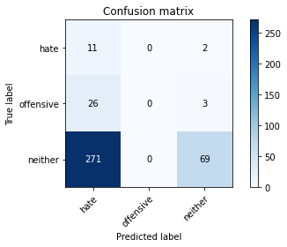

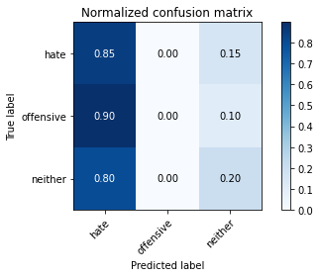

/opt/conda/lib/python3.7/site-packages/sklearn/metrics/_classification.py:1245: UndefinedMetricWarning: Precision and F-score are ill-defined and being set to 0.0 in labels with no predicted samples. Use `zero_division` parameter to control this behavior.

_warn_prf(average, modifier, msg_start, len(result))

/opt/conda/lib/python3.7/site-packages/sklearn/metrics/_classification.py:1245: UndefinedMetricWarning: Precision and F-score are ill-defined and being set to 0.0 in labels with no predicted samples. Use `zero_division` parameter to control this behavior.

_warn_prf(average, modifier, msg_start, len(result))

/opt/conda/lib/python3.7/site-packages/sklearn/metrics/_classification.py:1245: UndefinedMetricWarning: Precision and F-score are ill-defined and being set to 0.0 in labels with no predicted samples. Use `zero_division` parameter to control this behavior.

_warn_prf(average, modifier, msg_start, len(result))

precision recall f1-score support

hate 0.04 0.85 0.07 13

offensive 0.00 0.00 0.00 29

neither 0.93 0.20 0.33 340

accuracy 0.21 382

macro avg 0.32 0.35 0.13 382

weighted avg 0.83 0.21 0.30 382

average eval_loss: 0.9493748515844345, accuracy: 0.2094240837696335

training 2 epoch...

1.8156206607818604 seconds used......

2 training finished! average train loss: 1.0260259588559468

evaluating...

Confusion matrix, without normalization

[[ 1 1 11]

[ 4 0 25]

[ 16 0 324]]

Normalized confusion matrix

[[0.07692308 0.07692308 0.84615385]

[0.13793103 0. 0.86206897]

[0.04705882 0. 0.95294118]]

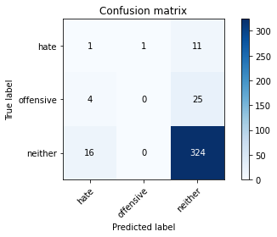

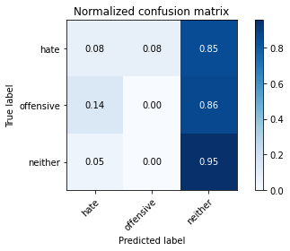

precision recall f1-score support

hate 0.05 0.08 0.06 13

offensive 0.00 0.00 0.00 29

neither 0.90 0.95 0.93 340

accuracy 0.85 382

macro avg 0.32 0.34 0.33 382

weighted avg 0.80 0.85 0.83 382

average eval_loss: 0.7950991272926331, accuracy: 0.8507853403141361

training 3 epoch...

1.8024709224700928 seconds used......

3 training finished! average train loss: 0.9605412165323893

evaluating...

Confusion matrix, without normalization

[[ 11 0 2]

[ 24 0 5]

[224 1 115]]

Normalized confusion matrix

[[0.84615385 0. 0.15384615]

[0.82758621 0. 0.17241379]

[0.65882353 0.00294118 0.33823529]]

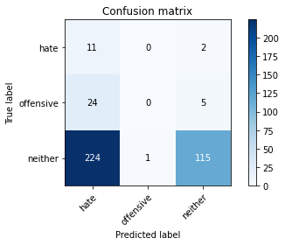

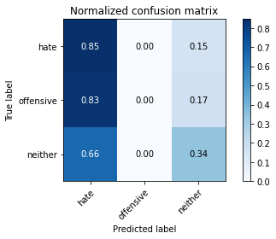

precision recall f1-score support

hate 0.04 0.85 0.08 13

offensive 0.00 0.00 0.00 29

neither 0.94 0.34 0.50 340

accuracy 0.33 382

macro avg 0.33 0.39 0.19 382

weighted avg 0.84 0.33 0.45 382

average eval_loss: 1.0003844678401947, accuracy: 0.3298429319371728

training 4 epoch...

1.9518780708312988 seconds used......

4 training finished! average train loss: 0.8763897657394409

evaluating...

Confusion matrix, without normalization

[[ 7 1 5]

[ 8 2 19]

[ 63 7 270]]

Normalized confusion matrix

[[0.53846154 0.07692308 0.38461538]

[0.27586207 0.06896552 0.65517241]

[0.18529412 0.02058824 0.79411765]]

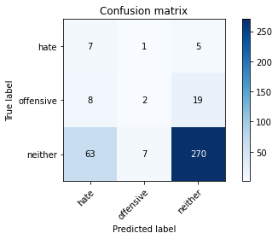

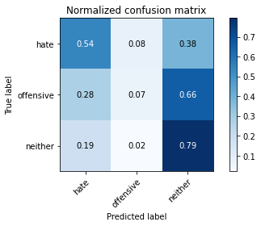

precision recall f1-score support

hate 0.09 0.54 0.15 13

offensive 0.20 0.07 0.10 29

neither 0.92 0.79 0.85 340

accuracy 0.73 382

macro avg 0.40 0.47 0.37 382

weighted avg 0.84 0.73 0.77 382

average eval_loss: 0.7403751701116562, accuracy: 0.7303664921465969

training 5 epoch...

1.851306676864624 seconds used......

5 training finished! average train loss: 0.7242507338523865

evaluating...

Confusion matrix, without normalization

[[ 9 2 2]

[ 15 6 8]

[147 16 177]]

Normalized confusion matrix

[[0.69230769 0.15384615 0.15384615]

[0.51724138 0.20689655 0.27586207]

[0.43235294 0.04705882 0.52058824]]

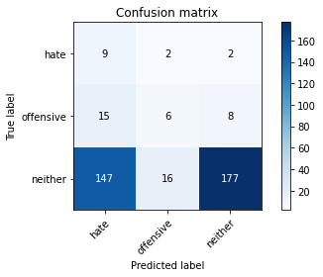

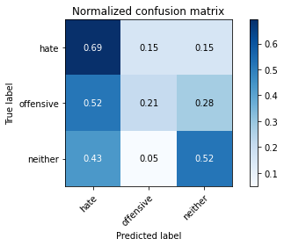

precision recall f1-score support

hate 0.05 0.69 0.10 13

offensive 0.25 0.21 0.23 29

neither 0.95 0.52 0.67 340

accuracy 0.50 382

macro avg 0.42 0.47 0.33 382

weighted avg 0.86 0.50 0.62 382

average eval_loss: 0.9997768521308898, accuracy: 0.5026178010471204

Confusion matrix, without normalization

[[ 40 0 1]

[ 92 0 3]

[518 4 192]]

Normalized confusion matrix

[[0.97560976 0. 0.02439024]

[0.96842105 0. 0.03157895]

[0.7254902 0.00560224 0.26890756]]

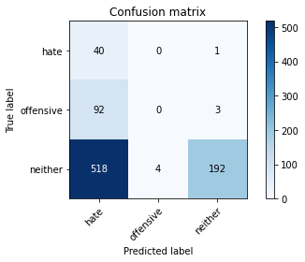

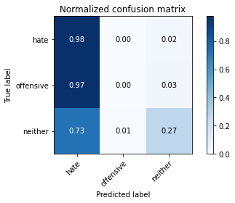

precision recall f1-score support

hate 0.06 0.98 0.12 41

offensive 0.00 0.00 0.00 95

neither 0.98 0.27 0.42 714

accuracy 0.27 850

macro avg 0.35 0.41 0.18 850

weighted avg 0.83 0.27 0.36 850

average eval_loss: 1.0909183718437372, accuracy: 0.27294117647058824

[22]:

0.27294117647058824