training 1 epoch...

124.52623772621155 seconds used......

1 training finished! average train loss: 0.7957721061327241

evaluating...

Confusion matrix, without normalization

[[ 6 0 115]

[ 5 37 65]

[ 5 15 338]]

Normalized confusion matrix

[[0.04958678 0. 0.95041322]

[0.04672897 0.34579439 0.60747664]

[0.01396648 0.04189944 0.94413408]]

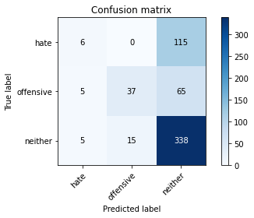

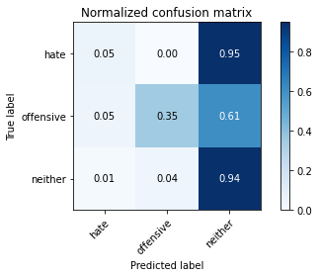

precision recall f1-score support

hate 0.38 0.05 0.09 121

offensive 0.71 0.35 0.47 107

neither 0.65 0.94 0.77 358

accuracy 0.65 586

macro avg 0.58 0.45 0.44 586

weighted avg 0.61 0.65 0.57 586

average eval_loss: 0.7442681401968002, accuracy: 0.6501706484641638

training 2 epoch...

123.73594355583191 seconds used......

2 training finished! average train loss: 0.7016161562818469

evaluating...

Confusion matrix, without normalization

[[ 15 1 105]

[ 11 23 73]

[ 16 4 338]]

Normalized confusion matrix

[[0.12396694 0.00826446 0.8677686 ]

[0.10280374 0.21495327 0.68224299]

[0.04469274 0.01117318 0.94413408]]

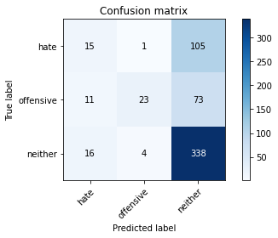

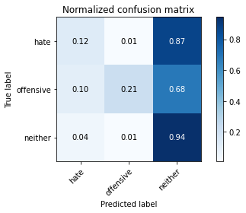

precision recall f1-score support

hate 0.36 0.12 0.18 121

offensive 0.82 0.21 0.34 107

neither 0.66 0.94 0.77 358

accuracy 0.64 586

macro avg 0.61 0.43 0.43 586

weighted avg 0.62 0.64 0.57 586

average eval_loss: 0.724535878499349, accuracy: 0.6416382252559727

training 3 epoch...

123.65681743621826 seconds used......

3 training finished! average train loss: 0.600668245757168

evaluating...

Confusion matrix, without normalization

[[ 22 3 96]

[ 12 37 58]

[ 22 18 318]]

Normalized confusion matrix

[[0.18181818 0.02479339 0.79338843]

[0.11214953 0.34579439 0.54205607]

[0.06145251 0.05027933 0.88826816]]

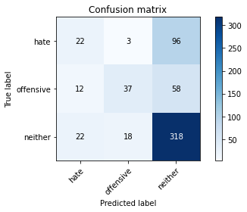

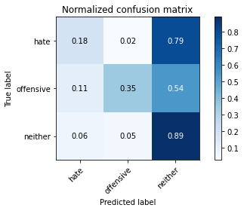

precision recall f1-score support

hate 0.39 0.18 0.25 121

offensive 0.64 0.35 0.45 107

neither 0.67 0.89 0.77 358

accuracy 0.64 586

macro avg 0.57 0.47 0.49 586

weighted avg 0.61 0.64 0.60 586

average eval_loss: 0.7790906856457392, accuracy: 0.643344709897611

training 4 epoch...

123.73674201965332 seconds used......

4 training finished! average train loss: 0.3954713380133564

evaluating...

Confusion matrix, without normalization

[[ 74 3 44]

[ 35 41 31]

[109 25 224]]

Normalized confusion matrix

[[0.61157025 0.02479339 0.36363636]

[0.3271028 0.38317757 0.28971963]

[0.30446927 0.0698324 0.62569832]]

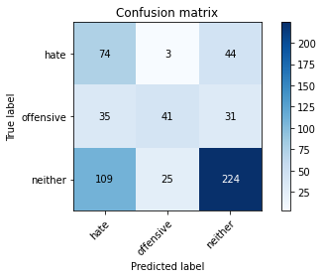

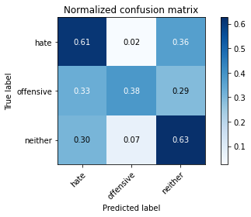

precision recall f1-score support

hate 0.34 0.61 0.44 121

offensive 0.59 0.38 0.47 107

neither 0.75 0.63 0.68 358

accuracy 0.58 586

macro avg 0.56 0.54 0.53 586

weighted avg 0.64 0.58 0.59 586

average eval_loss: 1.0642575045426688, accuracy: 0.5784982935153583

training 5 epoch...

123.68075966835022 seconds used......

5 training finished! average train loss: 0.21950431127863174

evaluating...

Confusion matrix, without normalization

[[ 53 4 64]

[ 32 28 47]

[ 74 12 272]]

Normalized confusion matrix

[[0.43801653 0.03305785 0.52892562]

[0.29906542 0.26168224 0.43925234]

[0.20670391 0.03351955 0.75977654]]

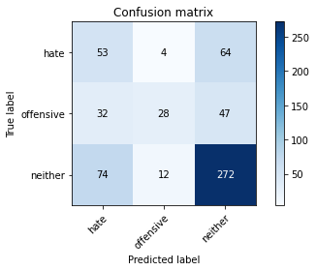

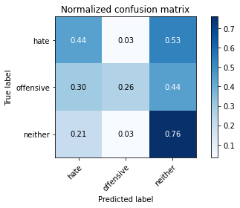

precision recall f1-score support

hate 0.33 0.44 0.38 121

offensive 0.64 0.26 0.37 107

neither 0.71 0.76 0.73 358

accuracy 0.60 586

macro avg 0.56 0.49 0.49 586

weighted avg 0.62 0.60 0.59 586

average eval_loss: 1.1420275588830313, accuracy: 0.6023890784982935

Confusion matrix, without normalization

[[ 96 5 23]

[ 69 75 20]

[387 20 458]]

Normalized confusion matrix

[[0.77419355 0.04032258 0.18548387]

[0.42073171 0.45731707 0.12195122]

[0.44739884 0.02312139 0.52947977]]

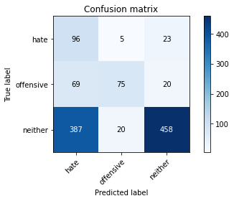

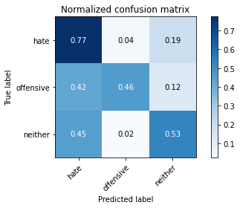

precision recall f1-score support

hate 0.17 0.77 0.28 124

offensive 0.75 0.46 0.57 164

neither 0.91 0.53 0.67 865

accuracy 0.55 1153

macro avg 0.61 0.59 0.51 1153

weighted avg 0.81 0.55 0.61 1153

average eval_loss: 1.1322456372195278, accuracy: 0.5455333911535126