1 run

training 1 epoch...

63.56665229797363 seconds used......

1 training finished! average train loss: 0.9978939890861511

evaluating...

Confusion matrix, without normalization

[[ 61 23 37]

[ 28 57 22]

[116 67 175]]

Normalized confusion matrix

[[0.50413223 0.19008264 0.30578512]

[0.26168224 0.53271028 0.20560748]

[0.32402235 0.18715084 0.48882682]]

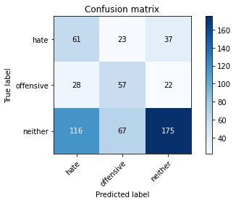

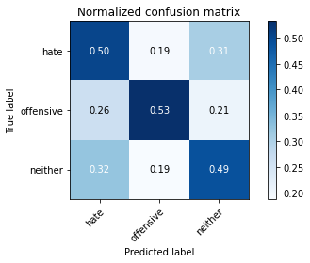

precision recall f1-score support

hate 0.30 0.50 0.37 121

offensive 0.39 0.53 0.45 107

neither 0.75 0.49 0.59 358

accuracy 0.50 586

macro avg 0.48 0.51 0.47 586

weighted avg 0.59 0.50 0.52 586

average eval_loss: 0.9119352102279663, accuracy: 0.5

training 2 epoch...

63.55006980895996 seconds used......

2 training finished! average train loss: 0.8578390161457815

evaluating...

Confusion matrix, without normalization

[[ 63 11 47]

[ 38 47 22]

[109 29 220]]

Normalized confusion matrix

[[0.52066116 0.09090909 0.38842975]

[0.35514019 0.43925234 0.20560748]

[0.30446927 0.08100559 0.61452514]]

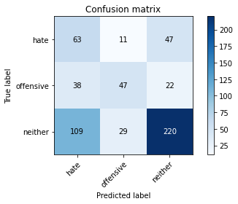

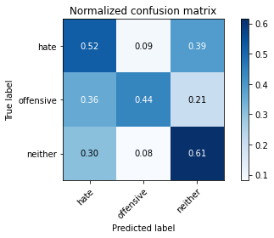

precision recall f1-score support

hate 0.30 0.52 0.38 121

offensive 0.54 0.44 0.48 107

neither 0.76 0.61 0.68 358

accuracy 0.56 586

macro avg 0.53 0.52 0.52 586

weighted avg 0.63 0.56 0.58 586

average eval_loss: 0.867255449295044, accuracy: 0.5631399317406144

training 3 epoch...

63.550212383270264 seconds used......

3 training finished! average train loss: 0.6881983989947721

evaluating...

Confusion matrix, without normalization

[[ 81 12 28]

[ 37 48 22]

[162 37 159]]

Normalized confusion matrix

[[0.66942149 0.09917355 0.23140496]

[0.34579439 0.44859813 0.20560748]

[0.45251397 0.10335196 0.44413408]]

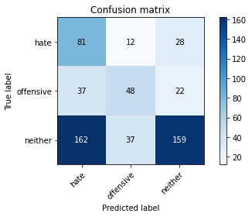

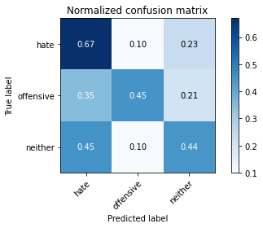

precision recall f1-score support

hate 0.29 0.67 0.40 121

offensive 0.49 0.45 0.47 107

neither 0.76 0.44 0.56 358

accuracy 0.49 586

macro avg 0.51 0.52 0.48 586

weighted avg 0.61 0.49 0.51 586

average eval_loss: 1.0963501969973246, accuracy: 0.49146757679180886

training 4 epoch...

63.55168652534485 seconds used......

4 training finished! average train loss: 0.43600106513813924

evaluating...

Confusion matrix, without normalization

[[ 67 30 24]

[ 22 71 14]

[138 89 131]]

Normalized confusion matrix

[[0.55371901 0.24793388 0.19834711]

[0.20560748 0.6635514 0.13084112]

[0.38547486 0.24860335 0.36592179]]

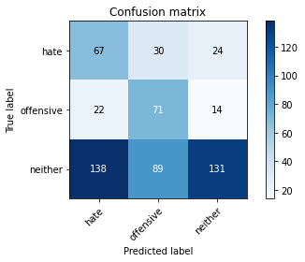

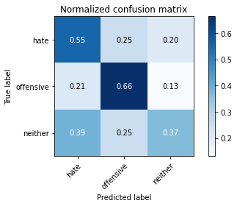

precision recall f1-score support

hate 0.30 0.55 0.39 121

offensive 0.37 0.66 0.48 107

neither 0.78 0.37 0.50 358

accuracy 0.46 586

macro avg 0.48 0.53 0.45 586

weighted avg 0.60 0.46 0.47 586

average eval_loss: 1.7705182452996573, accuracy: 0.4590443686006826

training 5 epoch...

63.56806802749634 seconds used......

5 training finished! average train loss: 0.1919306902165868

evaluating...

Confusion matrix, without normalization

[[ 66 16 39]

[ 30 56 21]

[121 49 188]]

Normalized confusion matrix

[[0.54545455 0.1322314 0.32231405]

[0.28037383 0.52336449 0.19626168]

[0.33798883 0.13687151 0.52513966]]

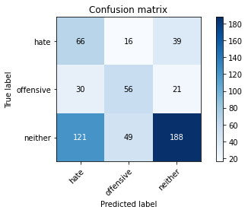

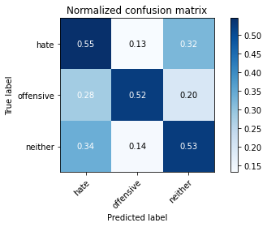

precision recall f1-score support

hate 0.30 0.55 0.39 121

offensive 0.46 0.52 0.49 107

neither 0.76 0.53 0.62 358

accuracy 0.53 586

macro avg 0.51 0.53 0.50 586

weighted avg 0.61 0.53 0.55 586

average eval_loss: 1.6385956346988677, accuracy: 0.5290102389078498

Confusion matrix, without normalization

[[103 15 6]

[ 58 102 4]

[490 38 337]]

Normalized confusion matrix

[[0.83064516 0.12096774 0.0483871 ]

[0.35365854 0.62195122 0.02439024]

[0.56647399 0.04393064 0.38959538]]

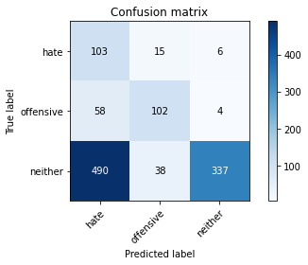

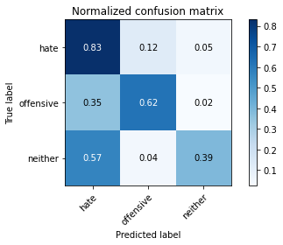

precision recall f1-score support

hate 0.16 0.83 0.27 124

offensive 0.66 0.62 0.64 164

neither 0.97 0.39 0.56 865

accuracy 0.47 1153

macro avg 0.60 0.61 0.49 1153

weighted avg 0.84 0.47 0.54 1153

average eval_loss: 1.0633205535082981, accuracy: 0.47007805724197743

2 run

training 1 epoch...

65.0276198387146 seconds used......

1 training finished! average train loss: 0.9986230389852273

evaluating...

Confusion matrix, without normalization

[[109 4 8]

[ 55 41 11]

[215 37 106]]

Normalized confusion matrix

[[0.90082645 0.03305785 0.0661157 ]

[0.51401869 0.38317757 0.10280374]

[0.60055866 0.10335196 0.29608939]]

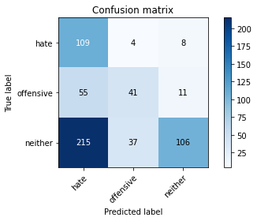

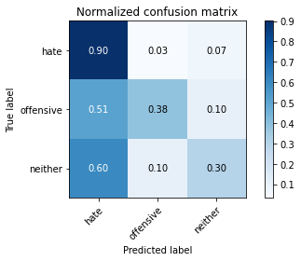

precision recall f1-score support

hate 0.29 0.90 0.44 121

offensive 0.50 0.38 0.43 107

neither 0.85 0.30 0.44 358

accuracy 0.44 586

macro avg 0.55 0.53 0.44 586

weighted avg 0.67 0.44 0.44 586

average eval_loss: 0.9399635791778564, accuracy: 0.43686006825938567

training 2 epoch...

65.09673857688904 seconds used......

2 training finished! average train loss: 0.8658886822430711

evaluating...

Confusion matrix, without normalization

[[ 74 16 31]

[ 30 55 22]

[124 55 179]]

Normalized confusion matrix

[[0.61157025 0.1322314 0.25619835]

[0.28037383 0.51401869 0.20560748]

[0.34636872 0.15363128 0.5 ]]

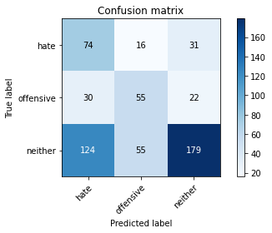

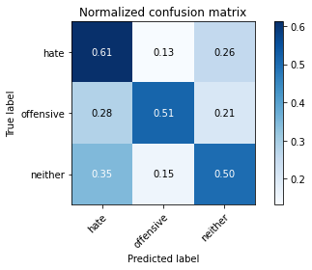

precision recall f1-score support

hate 0.32 0.61 0.42 121

offensive 0.44 0.51 0.47 107

neither 0.77 0.50 0.61 358

accuracy 0.53 586

macro avg 0.51 0.54 0.50 586

weighted avg 0.62 0.53 0.54 586

average eval_loss: 0.9255331218242645, accuracy: 0.5255972696245734

training 3 epoch...

65.00146555900574 seconds used......

3 training finished! average train loss: 0.7111795546585008

evaluating...

Confusion matrix, without normalization

[[ 67 10 44]

[ 31 45 31]

[120 31 207]]

Normalized confusion matrix

[[0.55371901 0.08264463 0.36363636]

[0.28971963 0.42056075 0.28971963]

[0.33519553 0.08659218 0.57821229]]

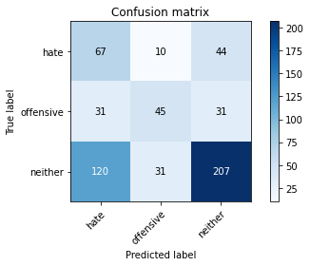

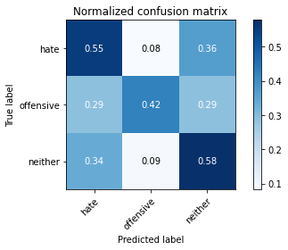

precision recall f1-score support

hate 0.31 0.55 0.40 121

offensive 0.52 0.42 0.47 107

neither 0.73 0.58 0.65 358

accuracy 0.54 586

macro avg 0.52 0.52 0.50 586

weighted avg 0.61 0.54 0.56 586

average eval_loss: 0.9214423378308614, accuracy: 0.5443686006825939

training 4 epoch...

65.04774618148804 seconds used......

4 training finished! average train loss: 0.45937528912174075

evaluating...

Confusion matrix, without normalization

[[ 58 10 53]

[ 30 42 35]

[ 95 30 233]]

Normalized confusion matrix

[[0.47933884 0.08264463 0.43801653]

[0.28037383 0.39252336 0.3271028 ]

[0.26536313 0.08379888 0.65083799]]

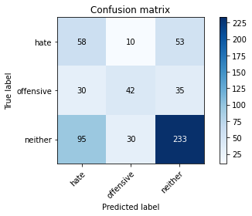

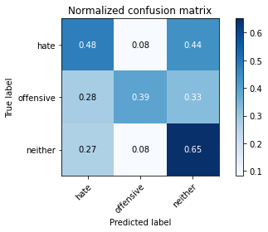

precision recall f1-score support

hate 0.32 0.48 0.38 121

offensive 0.51 0.39 0.44 107

neither 0.73 0.65 0.69 358

accuracy 0.57 586

macro avg 0.52 0.51 0.50 586

weighted avg 0.60 0.57 0.58 586

average eval_loss: 0.9890424688657125, accuracy: 0.568259385665529

training 5 epoch...

65.097501039505 seconds used......

5 training finished! average train loss: 0.2063953630185049

evaluating...

Confusion matrix, without normalization

[[ 48 28 45]

[ 16 70 21]

[ 80 80 198]]

Normalized confusion matrix

[[0.39669421 0.23140496 0.37190083]

[0.14953271 0.65420561 0.19626168]

[0.22346369 0.22346369 0.55307263]]

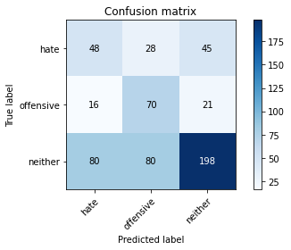

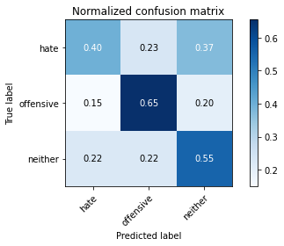

precision recall f1-score support

hate 0.33 0.40 0.36 121

offensive 0.39 0.65 0.49 107

neither 0.75 0.55 0.64 358

accuracy 0.54 586

macro avg 0.49 0.53 0.50 586

weighted avg 0.60 0.54 0.55 586

average eval_loss: 1.636949356396993, accuracy: 0.5392491467576792

Confusion matrix, without normalization

[[112 12 0]

[ 83 74 7]

[717 26 122]]

Normalized confusion matrix

[[0.90322581 0.09677419 0. ]

[0.50609756 0.45121951 0.04268293]

[0.82890173 0.0300578 0.14104046]]

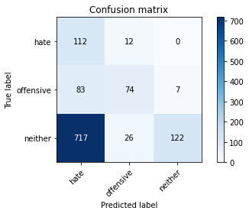

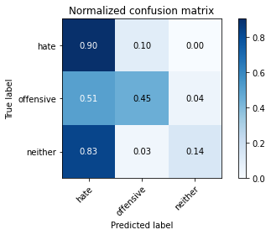

precision recall f1-score support

hate 0.12 0.90 0.22 124

offensive 0.66 0.45 0.54 164

neither 0.95 0.14 0.25 865

accuracy 0.27 1153

macro avg 0.58 0.50 0.33 1153

weighted avg 0.82 0.27 0.28 1153

average eval_loss: 0.9992997697715101, accuracy: 0.26712922810060713

[38]:

0.26712922810060713

3 run

training 1 epoch...

65.18610525131226 seconds used......

1 training finished! average train loss: 0.985719338843697

evaluating...

Confusion matrix, without normalization

[[ 92 14 15]

[ 44 57 6]

[177 69 112]]

Normalized confusion matrix

[[0.76033058 0.11570248 0.12396694]

[0.41121495 0.53271028 0.05607477]

[0.49441341 0.19273743 0.31284916]]

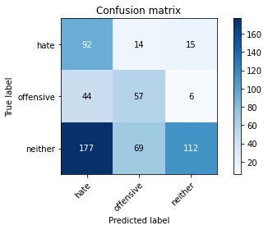

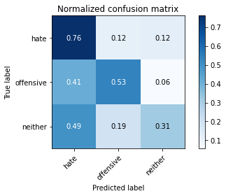

precision recall f1-score support

hate 0.29 0.76 0.42 121

offensive 0.41 0.53 0.46 107

neither 0.84 0.31 0.46 358

accuracy 0.45 586

macro avg 0.51 0.54 0.45 586

weighted avg 0.65 0.45 0.45 586

average eval_loss: 0.9610311965147654, accuracy: 0.4453924914675768

training 2 epoch...

65.05238771438599 seconds used......

2 training finished! average train loss: 0.8549246035124126

evaluating...

Confusion matrix, without normalization

[[ 94 9 18]

[ 40 49 18]

[170 45 143]]

Normalized confusion matrix

[[0.7768595 0.07438017 0.14876033]

[0.37383178 0.45794393 0.1682243 ]

[0.47486034 0.12569832 0.39944134]]

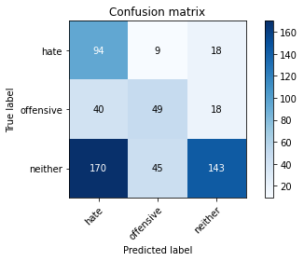

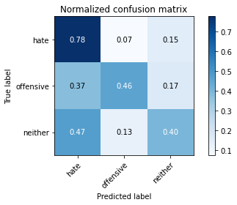

precision recall f1-score support

hate 0.31 0.78 0.44 121

offensive 0.48 0.46 0.47 107

neither 0.80 0.40 0.53 358

accuracy 0.49 586

macro avg 0.53 0.54 0.48 586

weighted avg 0.64 0.49 0.50 586

average eval_loss: 0.9316867152849834, accuracy: 0.4880546075085324

training 3 epoch...

65.07327198982239 seconds used......

3 training finished! average train loss: 0.6863921868957972

evaluating...

Confusion matrix, without normalization

[[ 69 14 38]

[ 29 56 22]

[117 62 179]]

Normalized confusion matrix

[[0.57024793 0.11570248 0.31404959]

[0.27102804 0.52336449 0.20560748]

[0.32681564 0.17318436 0.5 ]]

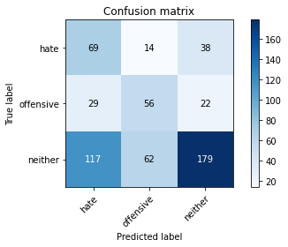

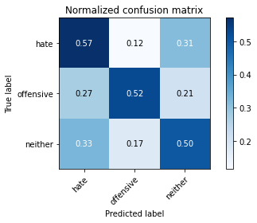

precision recall f1-score support

hate 0.32 0.57 0.41 121

offensive 0.42 0.52 0.47 107

neither 0.75 0.50 0.60 358

accuracy 0.52 586

macro avg 0.50 0.53 0.49 586

weighted avg 0.60 0.52 0.54 586

average eval_loss: 0.9658990780512492, accuracy: 0.5187713310580204

training 4 epoch...

65.2120726108551 seconds used......

4 training finished! average train loss: 0.37649309370470674

evaluating...

Confusion matrix, without normalization

[[ 64 19 38]

[ 27 63 17]

[124 66 168]]

Normalized confusion matrix

[[0.52892562 0.15702479 0.31404959]

[0.25233645 0.58878505 0.1588785 ]

[0.34636872 0.18435754 0.46927374]]

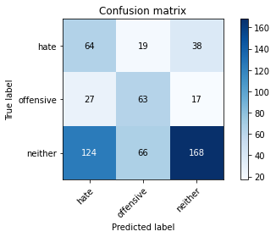

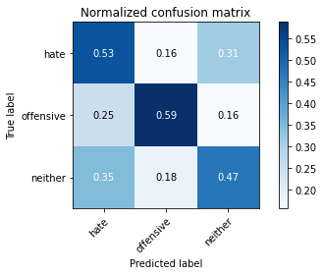

precision recall f1-score support

hate 0.30 0.53 0.38 121

offensive 0.43 0.59 0.49 107

neither 0.75 0.47 0.58 358

accuracy 0.50 586

macro avg 0.49 0.53 0.48 586

weighted avg 0.60 0.50 0.52 586

average eval_loss: 1.3749516208966572, accuracy: 0.5034129692832765

training 5 epoch...

65.15757536888123 seconds used......

5 training finished! average train loss: 0.17801566305570304

evaluating...

Confusion matrix, without normalization

[[ 70 13 38]

[ 27 56 24]

[110 52 196]]

Normalized confusion matrix

[[0.5785124 0.10743802 0.31404959]

[0.25233645 0.52336449 0.22429907]

[0.30726257 0.1452514 0.54748603]]

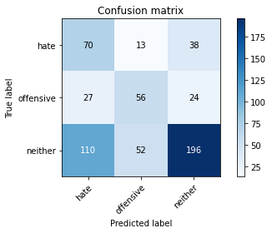

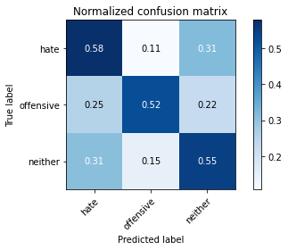

precision recall f1-score support

hate 0.34 0.58 0.43 121

offensive 0.46 0.52 0.49 107

neither 0.76 0.55 0.64 358

accuracy 0.55 586

macro avg 0.52 0.55 0.52 586

weighted avg 0.62 0.55 0.57 586

average eval_loss: 1.6623696933190029, accuracy: 0.5494880546075085

Confusion matrix, without normalization

[[108 12 4]

[ 67 87 10]

[548 30 287]]

Normalized confusion matrix

[[0.87096774 0.09677419 0.03225806]

[0.40853659 0.5304878 0.06097561]

[0.63352601 0.03468208 0.33179191]]

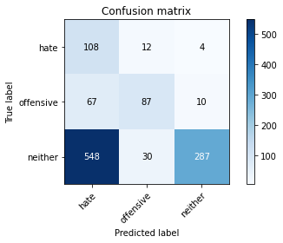

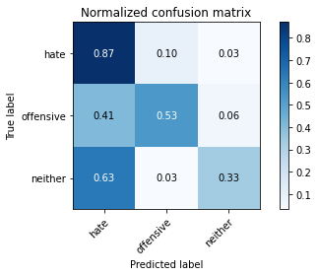

precision recall f1-score support

hate 0.15 0.87 0.26 124

offensive 0.67 0.53 0.59 164

neither 0.95 0.33 0.49 865

accuracy 0.42 1153

macro avg 0.59 0.58 0.45 1153

weighted avg 0.83 0.42 0.48 1153

average eval_loss: 0.9207971157698795, accuracy: 0.41803989592367735

[40]:

0.41803989592367735