training 1 epoch...

57.33721399307251 seconds used......

1 training finished! average train loss: 0.6705647510432061

evaluating...

Confusion matrix, without normalization

[[ 11 14 28]

[ 17 136 28]

[ 9 12 212]]

Normalized confusion matrix

[[0.20754717 0.26415094 0.52830189]

[0.09392265 0.75138122 0.15469613]

[0.03862661 0.05150215 0.90987124]]

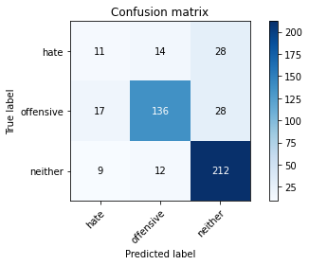

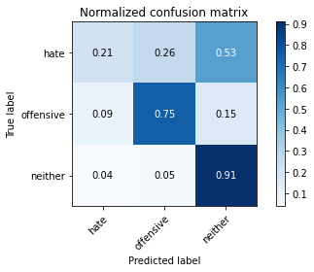

precision recall f1-score support

hate 0.30 0.21 0.24 53

offensive 0.84 0.75 0.79 181

neither 0.79 0.91 0.85 233

accuracy 0.77 467

macro avg 0.64 0.62 0.63 467

weighted avg 0.75 0.77 0.76 467

average eval_loss: 0.5445511564612389, accuracy: 0.7687366167023555

training 2 epoch...

56.5723295211792 seconds used......

2 training finished! average train loss: 0.473838005640677

evaluating...

Confusion matrix, without normalization

[[ 21 14 18]

[ 25 138 18]

[ 19 18 196]]

Normalized confusion matrix

[[0.39622642 0.26415094 0.33962264]

[0.13812155 0.76243094 0.09944751]

[0.08154506 0.07725322 0.84120172]]

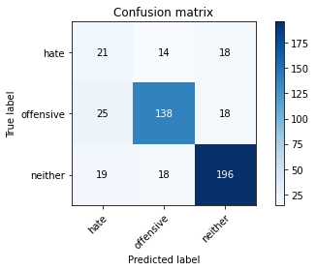

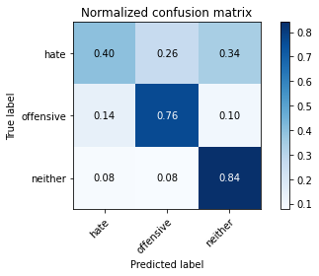

precision recall f1-score support

hate 0.32 0.40 0.36 53

offensive 0.81 0.76 0.79 181

neither 0.84 0.84 0.84 233

accuracy 0.76 467

macro avg 0.66 0.67 0.66 467

weighted avg 0.77 0.76 0.77 467

average eval_loss: 0.6167063564062119, accuracy: 0.7601713062098501

training 3 epoch...

56.552125215530396 seconds used......

3 training finished! average train loss: 0.3223619391875608

evaluating...

Confusion matrix, without normalization

[[ 9 14 30]

[ 15 138 28]

[ 5 17 211]]

Normalized confusion matrix

[[0.16981132 0.26415094 0.56603774]

[0.08287293 0.76243094 0.15469613]

[0.02145923 0.07296137 0.9055794 ]]

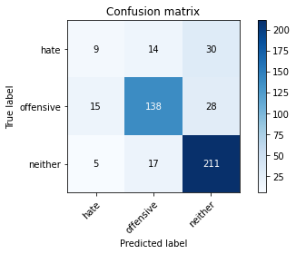

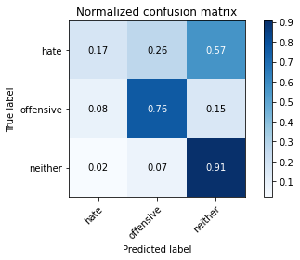

precision recall f1-score support

hate 0.31 0.17 0.22 53

offensive 0.82 0.76 0.79 181

neither 0.78 0.91 0.84 233

accuracy 0.77 467

macro avg 0.64 0.61 0.62 467

weighted avg 0.74 0.77 0.75 467

average eval_loss: 0.6597801459332308, accuracy: 0.7665952890792291

training 4 epoch...

56.55694103240967 seconds used......

4 training finished! average train loss: 0.17060336589458444

evaluating...

Confusion matrix, without normalization

[[ 13 15 25]

[ 15 143 23]

[ 9 29 195]]

Normalized confusion matrix

[[0.24528302 0.28301887 0.47169811]

[0.08287293 0.79005525 0.12707182]

[0.03862661 0.12446352 0.83690987]]

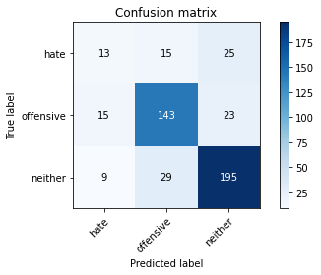

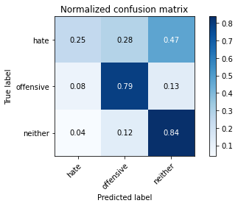

precision recall f1-score support

hate 0.35 0.25 0.29 53

offensive 0.76 0.79 0.78 181

neither 0.80 0.84 0.82 233

accuracy 0.75 467

macro avg 0.64 0.62 0.63 467

weighted avg 0.74 0.75 0.74 467

average eval_loss: 0.8986530900001526, accuracy: 0.7516059957173448

training 5 epoch...

56.541887283325195 seconds used......

5 training finished! average train loss: 0.074614601106649

evaluating...

Confusion matrix, without normalization

[[ 15 13 25]

[ 19 135 27]

[ 9 16 208]]

Normalized confusion matrix

[[0.28301887 0.24528302 0.47169811]

[0.10497238 0.74585635 0.14917127]

[0.03862661 0.06866953 0.89270386]]

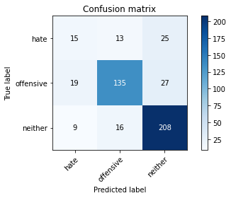

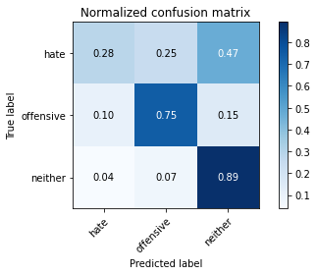

precision recall f1-score support

hate 0.35 0.28 0.31 53

offensive 0.82 0.75 0.78 181

neither 0.80 0.89 0.84 233

accuracy 0.77 467

macro avg 0.66 0.64 0.65 467

weighted avg 0.76 0.77 0.76 467

average eval_loss: 1.0709867949287097, accuracy: 0.7665952890792291

Confusion matrix, without normalization

[[ 72 70 48]

[ 59 321 35]

[113 51 549]]

Normalized confusion matrix

[[0.37894737 0.36842105 0.25263158]

[0.14216867 0.77349398 0.08433735]

[0.15848527 0.07152875 0.76998597]]

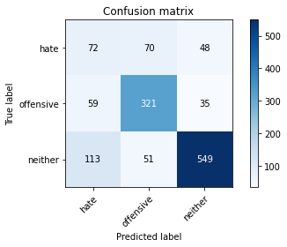

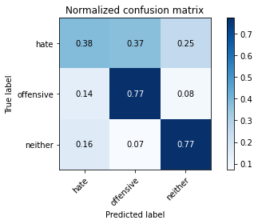

precision recall f1-score support

hate 0.30 0.38 0.33 190

offensive 0.73 0.77 0.75 415

neither 0.87 0.77 0.82 713

accuracy 0.71 1318

macro avg 0.63 0.64 0.63 1318

weighted avg 0.74 0.71 0.73 1318

average eval_loss: 0.6772198108109561, accuracy: 0.7147192716236722

[16]:

0.7147192716236722