1 run

training 1 epoch...

14.713821172714233 seconds used......

1 training finished! average train loss: 0.8769531626450388

evaluating...

Confusion matrix, without normalization

[[ 39 3 11]

[ 78 88 15]

[ 55 9 169]]

Normalized confusion matrix

[[0.73584906 0.05660377 0.20754717]

[0.43093923 0.48618785 0.08287293]

[0.2360515 0.03862661 0.72532189]]

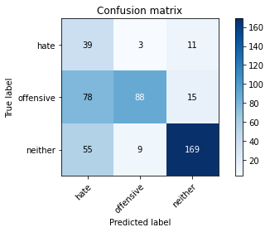

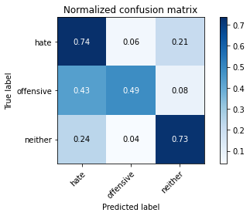

precision recall f1-score support

hate 0.23 0.74 0.35 53

offensive 0.88 0.49 0.63 181

neither 0.87 0.73 0.79 233

accuracy 0.63 467

macro avg 0.66 0.65 0.59 467

weighted avg 0.80 0.63 0.68 467

average eval_loss: 0.784963625172774, accuracy: 0.6338329764453962

training 2 epoch...

14.67512035369873 seconds used......

2 training finished! average train loss: 0.6440229733523569

evaluating...

Confusion matrix, without normalization

[[ 33 4 16]

[ 64 102 15]

[ 43 9 181]]

Normalized confusion matrix

[[0.62264151 0.0754717 0.30188679]

[0.35359116 0.56353591 0.08287293]

[0.18454936 0.03862661 0.77682403]]

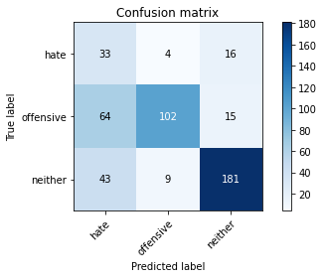

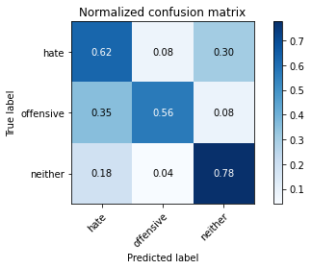

precision recall f1-score support

hate 0.24 0.62 0.34 53

offensive 0.89 0.56 0.69 181

neither 0.85 0.78 0.81 233

accuracy 0.68 467

macro avg 0.66 0.65 0.61 467

weighted avg 0.80 0.68 0.71 467

average eval_loss: 0.6728271146615347, accuracy: 0.6766595289079229

training 3 epoch...

14.769611597061157 seconds used......

3 training finished! average train loss: 0.44180853390379954

evaluating...

Confusion matrix, without normalization

[[ 32 5 16]

[ 56 106 19]

[ 40 6 187]]

Normalized confusion matrix

[[0.60377358 0.09433962 0.30188679]

[0.30939227 0.58563536 0.10497238]

[0.17167382 0.02575107 0.80257511]]

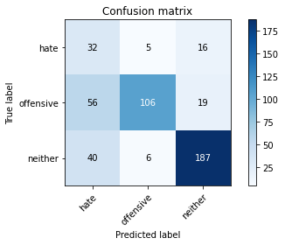

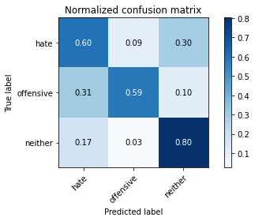

precision recall f1-score support

hate 0.25 0.60 0.35 53

offensive 0.91 0.59 0.71 181

neither 0.84 0.80 0.82 233

accuracy 0.70 467

macro avg 0.67 0.66 0.63 467

weighted avg 0.80 0.70 0.73 467

average eval_loss: 0.7055796446899573, accuracy: 0.69593147751606

training 4 epoch...

14.701918363571167 seconds used......

4 training finished! average train loss: 0.2645538769858448

evaluating...

Confusion matrix, without normalization

[[ 30 8 15]

[ 53 111 17]

[ 39 9 185]]

Normalized confusion matrix

[[0.56603774 0.1509434 0.28301887]

[0.29281768 0.61325967 0.09392265]

[0.16738197 0.03862661 0.79399142]]

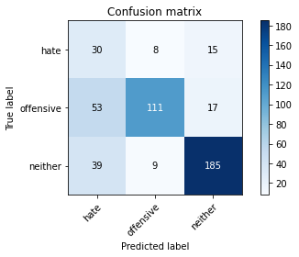

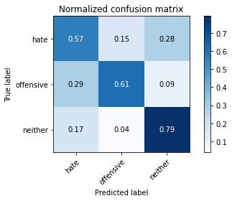

precision recall f1-score support

hate 0.25 0.57 0.34 53

offensive 0.87 0.61 0.72 181

neither 0.85 0.79 0.82 233

accuracy 0.70 467

macro avg 0.66 0.66 0.63 467

weighted avg 0.79 0.70 0.73 467

average eval_loss: 0.7725376139084498, accuracy: 0.6980728051391863

training 5 epoch...

14.766237497329712 seconds used......

5 training finished! average train loss: 0.11350972950458527

evaluating...

Confusion matrix, without normalization

[[ 32 6 15]

[ 51 115 15]

[ 43 11 179]]

Normalized confusion matrix

[[0.60377358 0.11320755 0.28301887]

[0.28176796 0.63535912 0.08287293]

[0.18454936 0.0472103 0.76824034]]

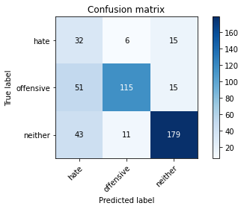

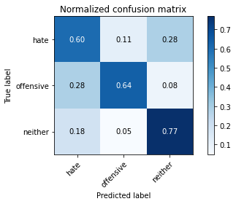

precision recall f1-score support

hate 0.25 0.60 0.36 53

offensive 0.87 0.64 0.73 181

neither 0.86 0.77 0.81 233

accuracy 0.70 467

macro avg 0.66 0.67 0.63 467

weighted avg 0.79 0.70 0.73 467

average eval_loss: 0.9395322824517885, accuracy: 0.6980728051391863

Confusion matrix, without normalization

[[161 7 22]

[258 133 24]

[250 6 457]]

Normalized confusion matrix

[[0.84736842 0.03684211 0.11578947]

[0.62168675 0.32048193 0.05783133]

[0.35063114 0.00841515 0.64095372]]

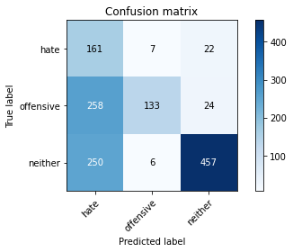

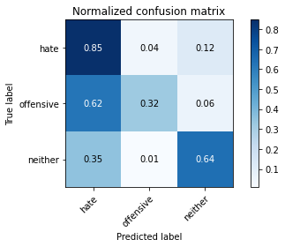

precision recall f1-score support

hate 0.24 0.85 0.37 190

offensive 0.91 0.32 0.47 415

neither 0.91 0.64 0.75 713

accuracy 0.57 1318

macro avg 0.69 0.60 0.53 1318

weighted avg 0.81 0.57 0.61 1318

average eval_loss: 0.8080196958599668, accuracy: 0.5698027314112292

[27]:

0.5698027314112292

2 run

training 1 epoch...

14.632108449935913 seconds used......

1 training finished! average train loss: 0.8630189252527136

evaluating...

Confusion matrix, without normalization

[[ 27 7 19]

[ 49 114 18]

[ 33 16 184]]

Normalized confusion matrix

[[0.50943396 0.13207547 0.35849057]

[0.27071823 0.62983425 0.09944751]

[0.1416309 0.06866953 0.78969957]]

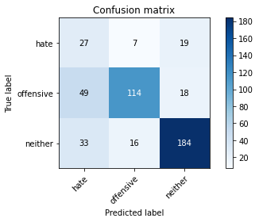

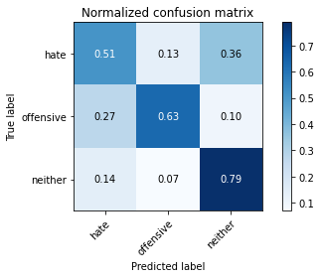

precision recall f1-score support

hate 0.25 0.51 0.33 53

offensive 0.83 0.63 0.72 181

neither 0.83 0.79 0.81 233

accuracy 0.70 467

macro avg 0.64 0.64 0.62 467

weighted avg 0.77 0.70 0.72 467

average eval_loss: 0.682045329362154, accuracy: 0.69593147751606

training 2 epoch...

14.678121328353882 seconds used......

2 training finished! average train loss: 0.6158310088672136

evaluating...

Confusion matrix, without normalization

[[ 31 6 16]

[ 52 112 17]

[ 26 12 195]]

Normalized confusion matrix

[[0.58490566 0.11320755 0.30188679]

[0.28729282 0.61878453 0.09392265]

[0.11158798 0.05150215 0.83690987]]

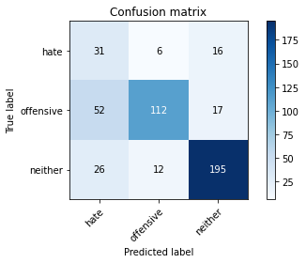

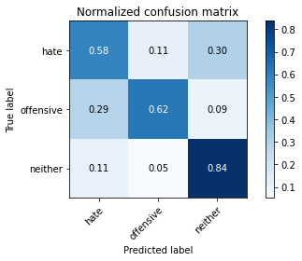

precision recall f1-score support

hate 0.28 0.58 0.38 53

offensive 0.86 0.62 0.72 181

neither 0.86 0.84 0.85 233

accuracy 0.72 467

macro avg 0.67 0.68 0.65 467

weighted avg 0.79 0.72 0.74 467

average eval_loss: 0.6427666569749514, accuracy: 0.7237687366167024

training 3 epoch...

14.626185417175293 seconds used......

3 training finished! average train loss: 0.4138376199101147

evaluating...

Confusion matrix, without normalization

[[ 20 7 26]

[ 34 121 26]

[ 13 8 212]]

Normalized confusion matrix

[[0.37735849 0.13207547 0.49056604]

[0.1878453 0.66850829 0.14364641]

[0.05579399 0.03433476 0.90987124]]

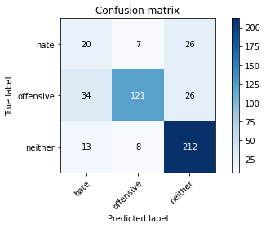

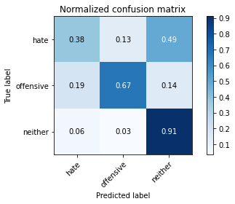

precision recall f1-score support

hate 0.30 0.38 0.33 53

offensive 0.89 0.67 0.76 181

neither 0.80 0.91 0.85 233

accuracy 0.76 467

macro avg 0.66 0.65 0.65 467

weighted avg 0.78 0.76 0.76 467

average eval_loss: 0.6654696352779865, accuracy: 0.7558886509635975

training 4 epoch...

14.66979718208313 seconds used......

4 training finished! average train loss: 0.24224857574230746

evaluating...

Confusion matrix, without normalization

[[ 26 9 18]

[ 41 122 18]

[ 22 18 193]]

Normalized confusion matrix

[[0.49056604 0.16981132 0.33962264]

[0.22651934 0.67403315 0.09944751]

[0.0944206 0.07725322 0.82832618]]

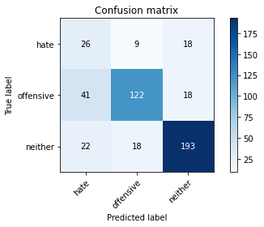

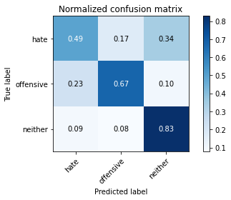

precision recall f1-score support

hate 0.29 0.49 0.37 53

offensive 0.82 0.67 0.74 181

neither 0.84 0.83 0.84 233

accuracy 0.73 467

macro avg 0.65 0.66 0.65 467

weighted avg 0.77 0.73 0.74 467

average eval_loss: 0.8198682653407255, accuracy: 0.7301927194860813

training 5 epoch...

14.642335176467896 seconds used......

5 training finished! average train loss: 0.12454956122919132

evaluating...

Confusion matrix, without normalization

[[ 26 11 16]

[ 33 133 15]

[ 35 22 176]]

Normalized confusion matrix

[[0.49056604 0.20754717 0.30188679]

[0.18232044 0.73480663 0.08287293]

[0.15021459 0.0944206 0.75536481]]

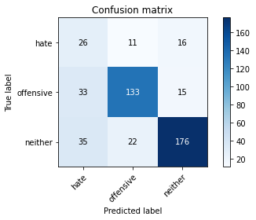

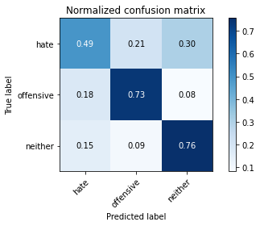

precision recall f1-score support

hate 0.28 0.49 0.35 53

offensive 0.80 0.73 0.77 181

neither 0.85 0.76 0.80 233

accuracy 0.72 467

macro avg 0.64 0.66 0.64 467

weighted avg 0.77 0.72 0.74 467

average eval_loss: 0.9821984258790811, accuracy: 0.7173447537473233

Confusion matrix, without normalization

[[122 25 43]

[156 218 41]

[146 17 550]]

Normalized confusion matrix

[[0.64210526 0.13157895 0.22631579]

[0.37590361 0.5253012 0.09879518]

[0.20476858 0.02384292 0.7713885 ]]

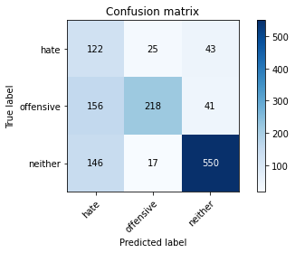

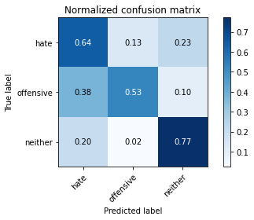

precision recall f1-score support

hate 0.29 0.64 0.40 190

offensive 0.84 0.53 0.65 415

neither 0.87 0.77 0.82 713

accuracy 0.68 1318

macro avg 0.66 0.65 0.62 1318

weighted avg 0.77 0.68 0.70 1318

average eval_loss: 0.6773686151612889, accuracy: 0.6752655538694993

[22]:

0.6752655538694993

3 run

training 1 epoch...

14.609689712524414 seconds used......

1 training finished! average train loss: 0.8937315235012456

evaluating...

Confusion matrix, without normalization

[[ 32 3 18]

[ 66 83 32]

[ 31 3 199]]

Normalized confusion matrix

[[0.60377358 0.05660377 0.33962264]

[0.36464088 0.45856354 0.17679558]

[0.13304721 0.01287554 0.85407725]]

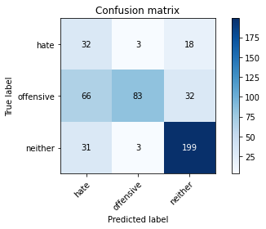

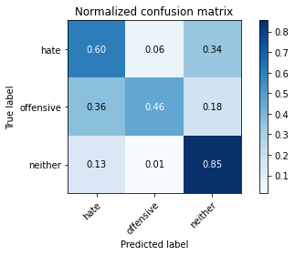

precision recall f1-score support

hate 0.25 0.60 0.35 53

offensive 0.93 0.46 0.61 181

neither 0.80 0.85 0.83 233

accuracy 0.67 467

macro avg 0.66 0.64 0.60 467

weighted avg 0.79 0.67 0.69 467

average eval_loss: 0.7144061302145323, accuracy: 0.6723768736616702

training 2 epoch...

14.640198707580566 seconds used......

2 training finished! average train loss: 0.637658487417196

evaluating...

Confusion matrix, without normalization

[[ 37 7 9]

[ 66 101 14]

[ 59 14 160]]

Normalized confusion matrix

[[0.69811321 0.13207547 0.16981132]

[0.36464088 0.55801105 0.07734807]

[0.25321888 0.06008584 0.68669528]]

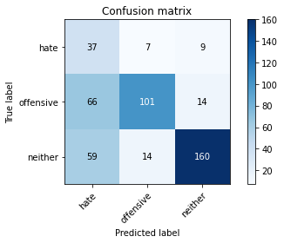

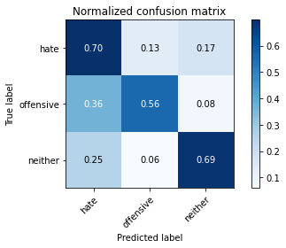

precision recall f1-score support

hate 0.23 0.70 0.34 53

offensive 0.83 0.56 0.67 181

neither 0.87 0.69 0.77 233

accuracy 0.64 467

macro avg 0.64 0.65 0.59 467

weighted avg 0.78 0.64 0.68 467

average eval_loss: 0.7475990081826845, accuracy: 0.6381156316916489

training 3 epoch...

14.6072678565979 seconds used......

3 training finished! average train loss: 0.42981445750123576

evaluating...

Confusion matrix, without normalization

[[ 37 6 10]

[ 59 111 11]

[ 68 14 151]]

Normalized confusion matrix

[[0.69811321 0.11320755 0.18867925]

[0.32596685 0.61325967 0.06077348]

[0.29184549 0.06008584 0.64806867]]

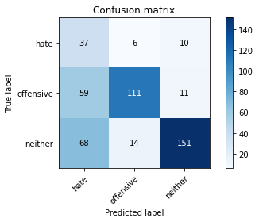

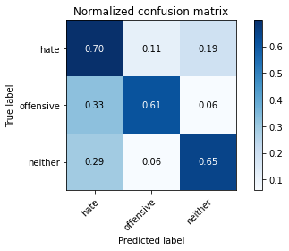

precision recall f1-score support

hate 0.23 0.70 0.34 53

offensive 0.85 0.61 0.71 181

neither 0.88 0.65 0.75 233

accuracy 0.64 467

macro avg 0.65 0.65 0.60 467

weighted avg 0.79 0.64 0.69 467

average eval_loss: 0.8545171283185482, accuracy: 0.6402569593147751

training 4 epoch...

14.719238519668579 seconds used......

4 training finished! average train loss: 0.23591115659004763

evaluating...

Confusion matrix, without normalization

[[ 26 9 18]

[ 45 117 19]

[ 33 13 187]]

Normalized confusion matrix

[[0.49056604 0.16981132 0.33962264]

[0.24861878 0.64640884 0.10497238]

[0.1416309 0.05579399 0.80257511]]

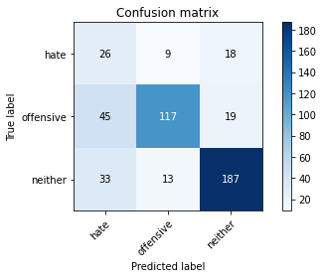

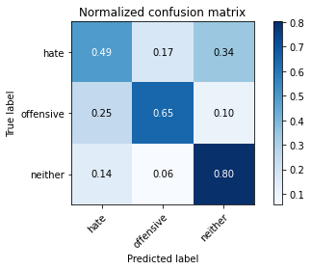

precision recall f1-score support

hate 0.25 0.49 0.33 53

offensive 0.84 0.65 0.73 181

neither 0.83 0.80 0.82 233

accuracy 0.71 467

macro avg 0.64 0.65 0.63 467

weighted avg 0.77 0.71 0.73 467

average eval_loss: 0.8366831056773663, accuracy: 0.7066381156316917

training 5 epoch...

14.609890222549438 seconds used......

5 training finished! average train loss: 0.10597792159962027

evaluating...

Confusion matrix, without normalization

[[ 22 11 20]

[ 40 119 22]

[ 25 15 193]]

Normalized confusion matrix

[[0.41509434 0.20754717 0.37735849]

[0.22099448 0.65745856 0.12154696]

[0.10729614 0.06437768 0.82832618]]

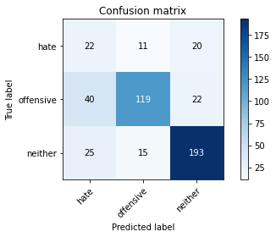

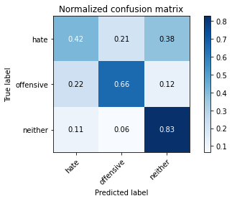

precision recall f1-score support

hate 0.25 0.42 0.31 53

offensive 0.82 0.66 0.73 181

neither 0.82 0.83 0.82 233

accuracy 0.72 467

macro avg 0.63 0.63 0.62 467

weighted avg 0.76 0.72 0.73 467

average eval_loss: 0.9403801821172237, accuracy: 0.715203426124197

Confusion matrix, without normalization

[[135 33 22]

[158 237 20]

[246 21 446]]

Normalized confusion matrix

[[0.71052632 0.17368421 0.11578947]

[0.38072289 0.57108434 0.04819277]

[0.34502104 0.02945302 0.62552595]]

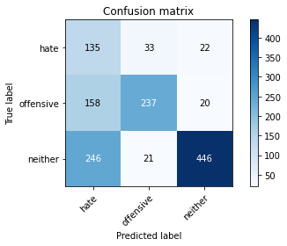

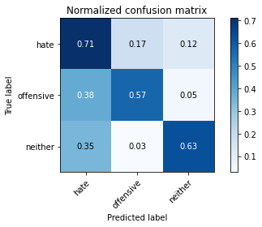

precision recall f1-score support

hate 0.25 0.71 0.37 190

offensive 0.81 0.57 0.67 415

neither 0.91 0.63 0.74 713

accuracy 0.62 1318

macro avg 0.66 0.64 0.59 1318

weighted avg 0.79 0.62 0.67 1318

average eval_loss: 0.9024784262433196, accuracy: 0.6206373292867982

[24]:

0.6206373292867982