training 1 epoch...

3023.441341638565 seconds used......

1 training finished! average train loss: 0.3730215011985658

evaluating...

Confusion matrix, without normalization

[[ 265 225 456]

[ 221 4473 510]

[ 33 168 7245]]

Normalized confusion matrix

[[0.28012685 0.23784355 0.4820296 ]

[0.04246733 0.85953113 0.09800154]

[0.00443191 0.02256245 0.97300564]]

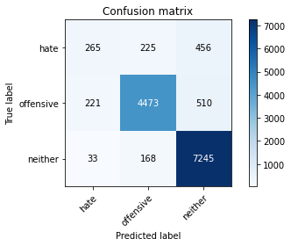

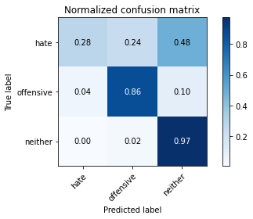

precision recall f1-score support

hate 0.51 0.28 0.36 946

offensive 0.92 0.86 0.89 5204

neither 0.88 0.97 0.93 7446

accuracy 0.88 13596

macro avg 0.77 0.70 0.73 13596

weighted avg 0.87 0.88 0.87 13596

average eval_loss: 0.32669435215785225, accuracy: 0.8813621653427479

training 2 epoch...

3025.5828425884247 seconds used......

2 training finished! average train loss: 0.2979214784035555

evaluating...

Confusion matrix, without normalization

[[ 333 224 389]

[ 257 4578 369]

[ 82 237 7127]]

Normalized confusion matrix

[[0.35200846 0.23678647 0.41120507]

[0.04938509 0.87970792 0.07090699]

[0.01101262 0.03182917 0.95715821]]

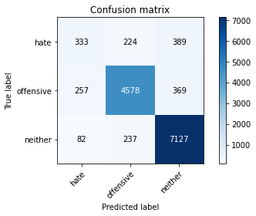

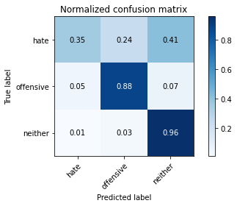

precision recall f1-score support

hate 0.50 0.35 0.41 946

offensive 0.91 0.88 0.89 5204

neither 0.90 0.96 0.93 7446

accuracy 0.89 13596

macro avg 0.77 0.73 0.75 13596

weighted avg 0.88 0.89 0.88 13596

average eval_loss: 0.3254663316916455, accuracy: 0.8854074727861135

training 3 epoch...

3025.551325559616 seconds used......

3 training finished! average train loss: 0.23169020535129894

evaluating...

Confusion matrix, without normalization

[[ 246 283 417]

[ 145 4630 429]

[ 43 226 7177]]

Normalized confusion matrix

[[0.26004228 0.29915433 0.44080338]

[0.02786318 0.88970023 0.08243659]

[0.00577491 0.03035187 0.96387322]]

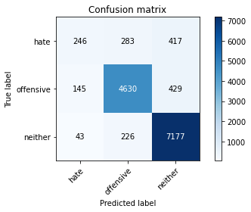

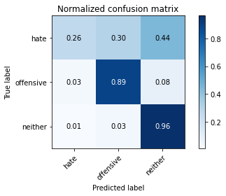

precision recall f1-score support

hate 0.57 0.26 0.36 946

offensive 0.90 0.89 0.90 5204

neither 0.89 0.96 0.93 7446

accuracy 0.89 13596

macro avg 0.79 0.70 0.73 13596

weighted avg 0.87 0.89 0.88 13596

average eval_loss: 0.36935727749814223, accuracy: 0.8865107384524861

Confusion matrix, without normalization

[[ 632 376 827]

[ 352 4871 702]

[ 250 322 10182]]

Normalized confusion matrix

[[0.34441417 0.20490463 0.4506812 ]

[0.05940928 0.8221097 0.11848101]

[0.02324716 0.02994235 0.94681049]]

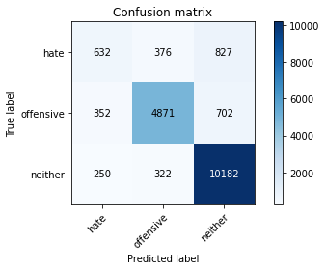

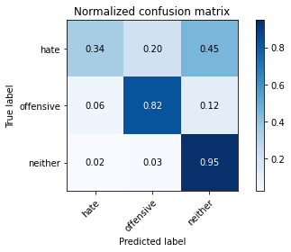

precision recall f1-score support

hate 0.51 0.34 0.41 1835

offensive 0.87 0.82 0.85 5925

neither 0.87 0.95 0.91 10754

accuracy 0.85 18514

macro avg 0.75 0.70 0.72 18514

weighted avg 0.84 0.85 0.84 18514

average eval_loss: 0.40707542182431106, accuracy: 0.8471967159987037

[18]:

0.8471967159987037