training 1 epoch...

971.166491985321 seconds used......

1 training finished! average train loss: 0.6562168899161221

evaluating...

Confusion matrix, without normalization

[[ 620 104 222]

[1071 3769 364]

[ 736 189 6521]]

Normalized confusion matrix

[[0.65539112 0.10993658 0.2346723 ]

[0.20580323 0.72425058 0.0699462 ]

[0.09884502 0.02538276 0.87577223]]

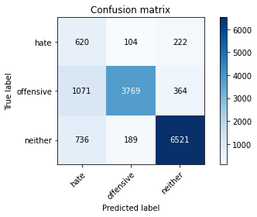

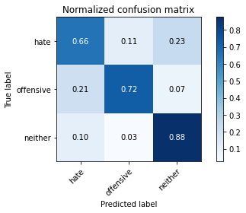

precision recall f1-score support

hate 0.26 0.66 0.37 946

offensive 0.93 0.72 0.81 5204

neither 0.92 0.88 0.90 7446

accuracy 0.80 13596

macro avg 0.70 0.75 0.69 13596

weighted avg 0.88 0.80 0.83 13596

average eval_loss: 0.46661084763267463, accuracy: 0.8024418946749043

training 2 epoch...

971.1017370223999 seconds used......

2 training finished! average train loss: 0.5149602623349295

evaluating...

Confusion matrix, without normalization

[[ 791 88 67]

[1308 3793 103]

[2130 267 5049]]

Normalized confusion matrix

[[0.83615222 0.09302326 0.07082452]

[0.25134512 0.72886241 0.01979247]

[0.28605963 0.03585818 0.67808219]]

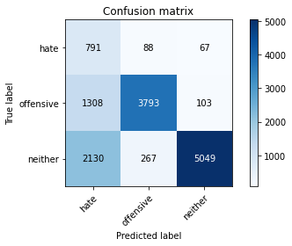

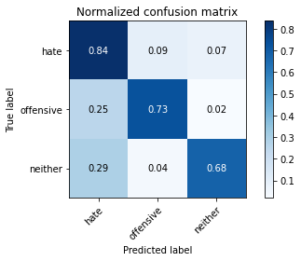

precision recall f1-score support

hate 0.19 0.84 0.31 946

offensive 0.91 0.73 0.81 5204

neither 0.97 0.68 0.80 7446

accuracy 0.71 13596

macro avg 0.69 0.75 0.64 13596

weighted avg 0.89 0.71 0.77 13596

average eval_loss: 0.7108262140084716, accuracy: 0.7085172109443955

training 3 epoch...

971.4622189998627 seconds used......

3 training finished! average train loss: 0.41682095641105155

evaluating...

Confusion matrix, without normalization

[[ 771 73 102]

[1540 3506 158]

[1616 184 5646]]

Normalized confusion matrix

[[0.81501057 0.07716702 0.10782241]

[0.29592621 0.67371253 0.03036126]

[0.21702928 0.02471125 0.75825947]]

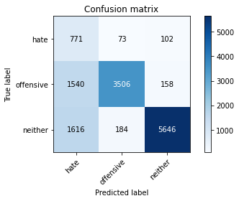

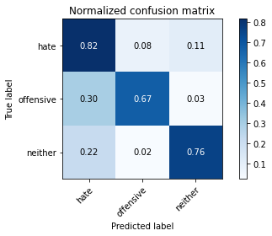

precision recall f1-score support

hate 0.20 0.82 0.32 946

offensive 0.93 0.67 0.78 5204

neither 0.96 0.76 0.85 7446

accuracy 0.73 13596

macro avg 0.69 0.75 0.65 13596

weighted avg 0.89 0.73 0.78 13596

average eval_loss: 0.6319225150215275, accuracy: 0.7298470138275963

Confusion matrix, without normalization

[[1630 109 96]

[1890 3884 151]

[4310 284 6160]]

Normalized confusion matrix

[[0.88828338 0.05940054 0.05231608]

[0.31898734 0.65552743 0.02548523]

[0.4007811 0.02640878 0.57281012]]

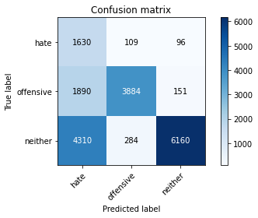

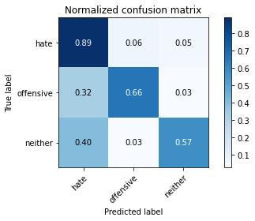

precision recall f1-score support

hate 0.21 0.89 0.34 1835

offensive 0.91 0.66 0.76 5925

neither 0.96 0.57 0.72 10754

accuracy 0.63 18514

macro avg 0.69 0.71 0.61 18514

weighted avg 0.87 0.63 0.69 18514

average eval_loss: 0.8868227704039917, accuracy: 0.6305498541644161

[20]:

0.6305498541644161