1 run

training 1 epoch...

503.42025804519653 seconds used......

1 training finished! average train loss: 0.6407187105138734

evaluating...

Confusion matrix, without normalization

[[ 749 68 129]

[1497 3478 229]

[1411 147 5888]]

Normalized confusion matrix

[[0.79175476 0.07188161 0.13636364]

[0.28766334 0.66833205 0.04400461]

[0.18949772 0.01974214 0.79076014]]

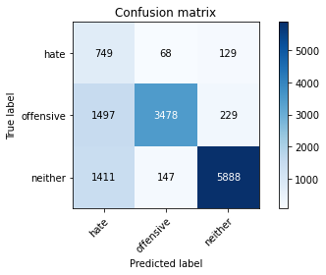

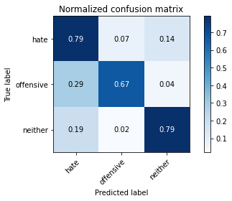

precision recall f1-score support

hate 0.20 0.79 0.33 946

offensive 0.94 0.67 0.78 5204

neither 0.94 0.79 0.86 7446

accuracy 0.74 13596

macro avg 0.70 0.75 0.66 13596

weighted avg 0.89 0.74 0.79 13596

average eval_loss: 0.5733159605413676, accuracy: 0.7439688143571639

training 2 epoch...

503.61868047714233 seconds used......

2 training finished! average train loss: 0.4894848938818401

evaluating...

Confusion matrix, without normalization

[[ 710 99 137]

[1139 3849 216]

[1210 226 6010]]

Normalized confusion matrix

[[0.75052854 0.10465116 0.1448203 ]

[0.2188701 0.73962337 0.04150653]

[0.16250336 0.03035187 0.80714478]]

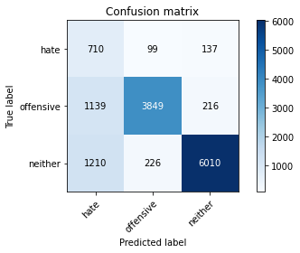

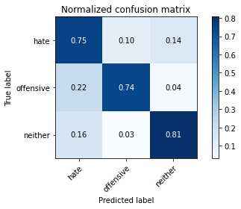

precision recall f1-score support

hate 0.23 0.75 0.35 946

offensive 0.92 0.74 0.82 5204

neither 0.94 0.81 0.87 7446

accuracy 0.78 13596

macro avg 0.70 0.77 0.68 13596

weighted avg 0.89 0.78 0.82 13596

average eval_loss: 0.5242243130417431, accuracy: 0.7773609885260371

training 3 epoch...

503.6485929489136 seconds used......

3 training finished! average train loss: 0.35633402887821297

evaluating...

Confusion matrix, without normalization

[[ 733 94 119]

[1132 3852 220]

[1352 266 5828]]

Normalized confusion matrix

[[0.77484144 0.09936575 0.12579281]

[0.21752498 0.74019985 0.04227517]

[0.181574 0.03572388 0.78270212]]

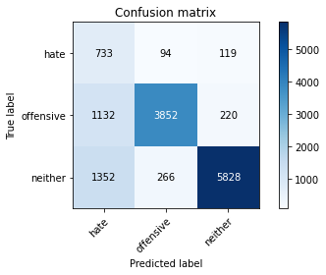

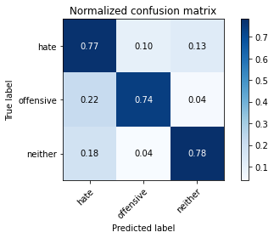

precision recall f1-score support

hate 0.23 0.77 0.35 946

offensive 0.91 0.74 0.82 5204

neither 0.95 0.78 0.86 7446

accuracy 0.77 13596

macro avg 0.70 0.77 0.68 13596

weighted avg 0.88 0.77 0.81 13596

average eval_loss: 0.6232454069287462, accuracy: 0.7658870255957635

Confusion matrix, without normalization

[[1472 82 281]

[1966 3548 411]

[2836 155 7763]]

Normalized confusion matrix

[[0.80217984 0.04468665 0.15313351]

[0.33181435 0.59881857 0.06936709]

[0.26371583 0.01441324 0.72187093]]

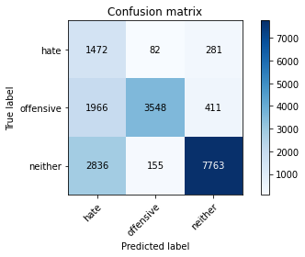

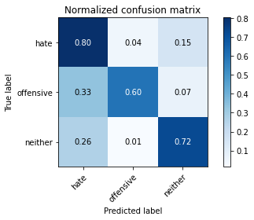

precision recall f1-score support

hate 0.23 0.80 0.36 1835

offensive 0.94 0.60 0.73 5925

neither 0.92 0.72 0.81 10754

accuracy 0.69 18514

macro avg 0.70 0.71 0.63 18514

weighted avg 0.86 0.69 0.74 18514

average eval_loss: 0.6725977334006816, accuracy: 0.6904504699146592

[25]:

0.6904504699146592

2 run

training 1 epoch...

501.44051790237427 seconds used......

1 training finished! average train loss: 0.6435940426518924

evaluating...

Confusion matrix, without normalization

[[ 698 86 162]

[1185 3742 277]

[1053 205 6188]]

Normalized confusion matrix

[[0.73784355 0.09090909 0.17124736]

[0.22770945 0.71906226 0.05322829]

[0.14141821 0.02753156 0.83105023]]

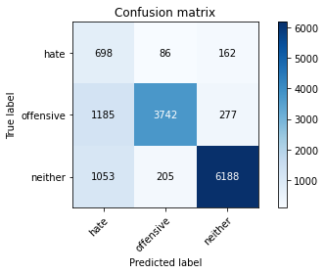

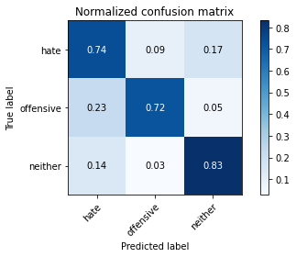

precision recall f1-score support

hate 0.24 0.74 0.36 946

offensive 0.93 0.72 0.81 5204

neither 0.93 0.83 0.88 7446

accuracy 0.78 13596

macro avg 0.70 0.76 0.68 13596

weighted avg 0.88 0.78 0.82 13596

average eval_loss: 0.5090032255386605, accuracy: 0.7817005001471021

training 2 epoch...

500.27608466148376 seconds used......

2 training finished! average train loss: 0.4918593522701366

evaluating...

Confusion matrix, without normalization

[[ 658 96 192]

[1053 3825 326]

[ 824 200 6422]]

Normalized confusion matrix

[[0.69556025 0.10147992 0.20295983]

[0.20234435 0.73501153 0.06264412]

[0.11066344 0.02686006 0.8624765 ]]

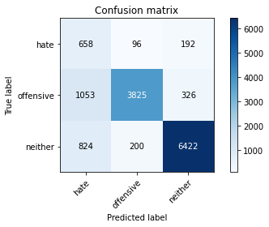

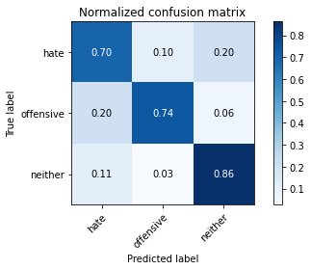

precision recall f1-score support

hate 0.26 0.70 0.38 946

offensive 0.93 0.74 0.82 5204

neither 0.93 0.86 0.89 7446

accuracy 0.80 13596

macro avg 0.70 0.76 0.70 13596

weighted avg 0.88 0.80 0.83 13596

average eval_loss: 0.47617880297167337, accuracy: 0.8020741394527803

training 3 epoch...

500.5843744277954 seconds used......

3 training finished! average train loss: 0.3642376817349274

evaluating...

Confusion matrix, without normalization

[[ 677 94 175]

[1101 3752 351]

[1076 148 6222]]

Normalized confusion matrix

[[0.71564482 0.09936575 0.18498943]

[0.21156802 0.72098386 0.06744812]

[0.14450712 0.01987644 0.83561644]]

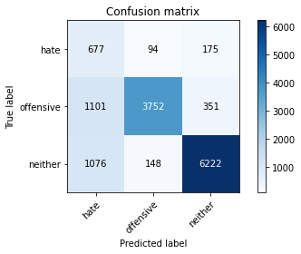

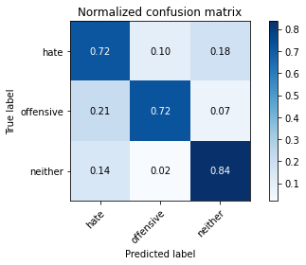

precision recall f1-score support

hate 0.24 0.72 0.36 946

offensive 0.94 0.72 0.82 5204

neither 0.92 0.84 0.88 7446

accuracy 0.78 13596

macro avg 0.70 0.76 0.68 13596

weighted avg 0.88 0.78 0.82 13596

average eval_loss: 0.5279706644661286, accuracy: 0.7833921741688732

Confusion matrix, without normalization

[[1283 100 452]

[1566 3829 530]

[1941 225 8588]]

Normalized confusion matrix

[[0.69918256 0.05449591 0.24632153]

[0.2643038 0.64624473 0.08945148]

[0.18049098 0.02092245 0.79858657]]

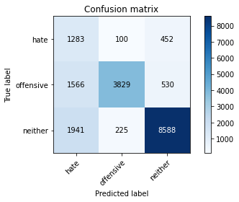

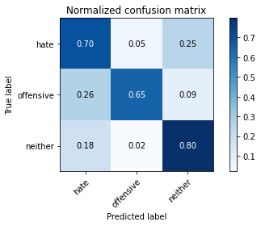

precision recall f1-score support

hate 0.27 0.70 0.39 1835

offensive 0.92 0.65 0.76 5925

neither 0.90 0.80 0.85 10754

accuracy 0.74 18514

macro avg 0.70 0.71 0.66 18514

weighted avg 0.84 0.74 0.77 18514

average eval_loss: 0.5744567111166713, accuracy: 0.7399805552554823

3 run

training 1 epoch...

501.8383722305298 seconds used......

1 training finished! average train loss: 0.6392802236217453

evaluating...

Confusion matrix, without normalization

[[ 689 75 182]

[1251 3650 303]

[1061 159 6226]]

Normalized confusion matrix

[[0.72832981 0.07928118 0.19238901]

[0.24039201 0.70138355 0.05822444]

[0.14249261 0.02135375 0.83615364]]

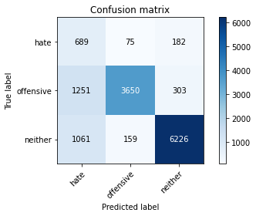

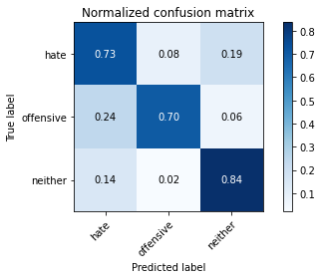

precision recall f1-score support

hate 0.23 0.73 0.35 946

offensive 0.94 0.70 0.80 5204

neither 0.93 0.84 0.88 7446

accuracy 0.78 13596

macro avg 0.70 0.76 0.68 13596

weighted avg 0.88 0.78 0.81 13596

average eval_loss: 0.5068188742679708, accuracy: 0.7770667843483378

training 2 epoch...

501.12059688568115 seconds used......

2 training finished! average train loss: 0.48948731599337025

evaluating...

Confusion matrix, without normalization

[[ 676 102 168]

[1026 3901 277]

[ 997 179 6270]]

Normalized confusion matrix

[[0.71458774 0.10782241 0.17758985]

[0.19715603 0.74961568 0.05322829]

[0.13389739 0.02403975 0.84206285]]

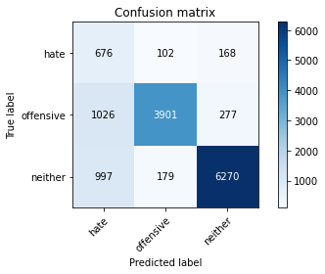

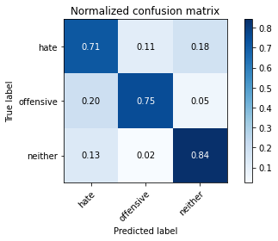

precision recall f1-score support

hate 0.25 0.71 0.37 946

offensive 0.93 0.75 0.83 5204

neither 0.93 0.84 0.89 7446

accuracy 0.80 13596

macro avg 0.71 0.77 0.70 13596

weighted avg 0.89 0.80 0.83 13596

average eval_loss: 0.4861743504729341, accuracy: 0.7978081788761401

training 3 epoch...

501.29189896583557 seconds used......

3 training finished! average train loss: 0.3635917306779679

evaluating...

Confusion matrix, without normalization

[[ 742 87 117]

[1299 3747 158]

[1543 296 5607]]

Normalized confusion matrix

[[0.78435518 0.09196617 0.12367865]

[0.24961568 0.72002306 0.03036126]

[0.20722536 0.03975289 0.75302176]]

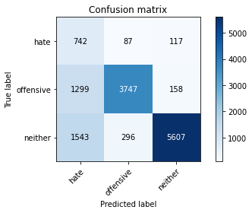

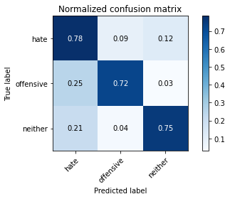

precision recall f1-score support

hate 0.21 0.78 0.33 946

offensive 0.91 0.72 0.80 5204

neither 0.95 0.75 0.84 7446

accuracy 0.74 13596

macro avg 0.69 0.75 0.66 13596

weighted avg 0.88 0.74 0.79 13596

average eval_loss: 0.6701464294620296, accuracy: 0.742571344513092

Confusion matrix, without normalization

[[1464 122 249]

[1666 3921 338]

[2740 366 7648]]

Normalized confusion matrix

[[0.79782016 0.06648501 0.13569482]

[0.28118143 0.66177215 0.05704641]

[0.25478892 0.03403385 0.71117724]]

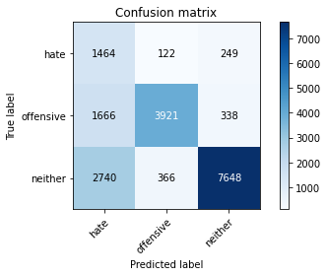

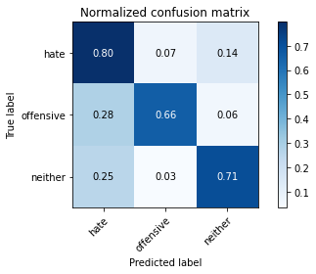

precision recall f1-score support

hate 0.25 0.80 0.38 1835

offensive 0.89 0.66 0.76 5925

neither 0.93 0.71 0.81 10754

accuracy 0.70 18514

macro avg 0.69 0.72 0.65 18514

weighted avg 0.85 0.70 0.75 18514

average eval_loss: 0.7781729434594737, accuracy: 0.7039537647185914

[18]:

4 run

training 1 epoch...

501.0484802722931 seconds used......

1 training finished! average train loss: 0.6395869693705734

evaluating...

Confusion matrix, without normalization

[[ 737 74 135]

[1448 3518 238]

[1381 130 5935]]

Normalized confusion matrix

[[0.77906977 0.0782241 0.14270613]

[0.2782475 0.67601845 0.04573405]

[0.18546871 0.01745904 0.79707225]]

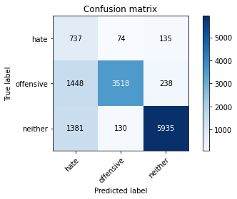

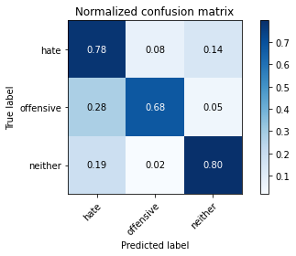

precision recall f1-score support

hate 0.21 0.78 0.33 946

offensive 0.95 0.68 0.79 5204

neither 0.94 0.80 0.86 7446

accuracy 0.75 13596

macro avg 0.70 0.75 0.66 13596

weighted avg 0.89 0.75 0.80 13596

average eval_loss: 0.558683817461133, accuracy: 0.7494851426890262

training 2 epoch...

501.2103319168091 seconds used......

2 training finished! average train loss: 0.48802806466645016

evaluating...

Confusion matrix, without normalization

[[ 769 60 117]

[1787 3248 169]

[1486 185 5775]]

Normalized confusion matrix

[[0.81289641 0.06342495 0.12367865]

[0.3433897 0.62413528 0.03247502]

[0.19957024 0.02484555 0.77558421]]

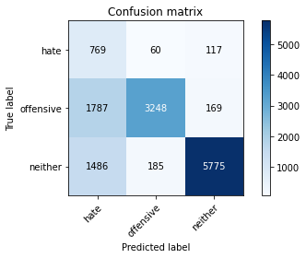

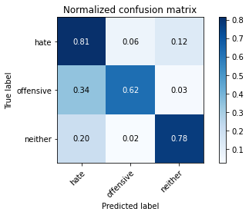

precision recall f1-score support

hate 0.19 0.81 0.31 946

offensive 0.93 0.62 0.75 5204

neither 0.95 0.78 0.86 7446

accuracy 0.72 13596

macro avg 0.69 0.74 0.64 13596

weighted avg 0.89 0.72 0.78 13596

average eval_loss: 0.6185546671642976, accuracy: 0.7202118270079435

training 3 epoch...

501.2955927848816 seconds used......

3 training finished! average train loss: 0.35955731613930336

evaluating...

Confusion matrix, without normalization

[[ 735 80 131]

[1285 3719 200]

[1400 215 5831]]

Normalized confusion matrix

[[0.7769556 0.0845666 0.1384778 ]

[0.24692544 0.71464258 0.03843198]

[0.18802041 0.02887456 0.78310502]]

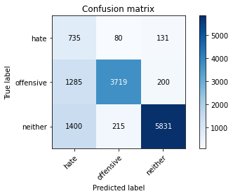

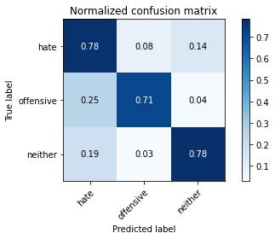

precision recall f1-score support

hate 0.21 0.78 0.34 946

offensive 0.93 0.71 0.81 5204

neither 0.95 0.78 0.86 7446

accuracy 0.76 13596

macro avg 0.70 0.76 0.67 13596

weighted avg 0.89 0.76 0.80 13596

average eval_loss: 0.6295272500747267, accuracy: 0.7564724919093851

Confusion matrix, without normalization

[[1513 71 251]

[2247 3360 318]

[2828 192 7734]]

Normalized confusion matrix

[[0.82452316 0.0386921 0.13678474]

[0.37924051 0.56708861 0.05367089]

[0.26297192 0.01785382 0.71917426]]

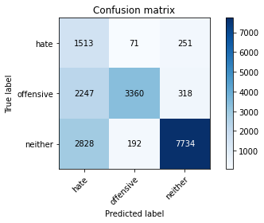

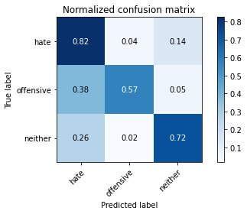

precision recall f1-score support

hate 0.23 0.82 0.36 1835

offensive 0.93 0.57 0.70 5925

neither 0.93 0.72 0.81 10754

accuracy 0.68 18514

macro avg 0.70 0.70 0.62 18514

weighted avg 0.86 0.68 0.73 18514

average eval_loss: 0.698315677677581, accuracy: 0.680944150372691

5 run

training 1 epoch...

500.2447428703308 seconds used......

1 training finished! average train loss: 0.6369862332631461

evaluating...

Confusion matrix, without normalization

[[ 722 79 145]

[1296 3683 225]

[1435 167 5844]]

Normalized confusion matrix

[[0.76321353 0.08350951 0.15327696]

[0.2490392 0.70772483 0.04323597]

[0.19272092 0.02242815 0.78485093]]

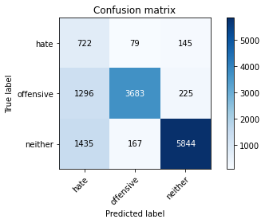

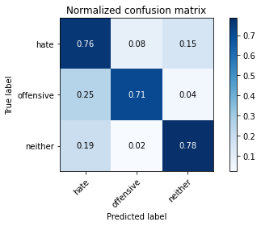

precision recall f1-score support

hate 0.21 0.76 0.33 946

offensive 0.94 0.71 0.81 5204

neither 0.94 0.78 0.86 7446

accuracy 0.75 13596

macro avg 0.70 0.75 0.66 13596

weighted avg 0.89 0.75 0.80 13596

average eval_loss: 0.55290325408911, accuracy: 0.7538246543100912

training 2 epoch...

500.2900233268738 seconds used......

2 training finished! average train loss: 0.4878861938835474

evaluating...

Confusion matrix, without normalization

[[ 787 82 77]

[1307 3768 129]

[1932 214 5300]]

Normalized confusion matrix

[[0.83192389 0.08668076 0.08139535]

[0.25115296 0.72405842 0.02478862]

[0.25946817 0.02874026 0.71179157]]

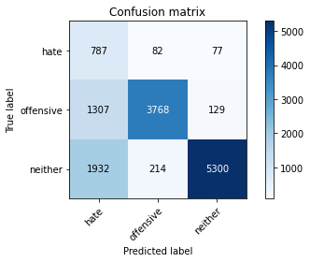

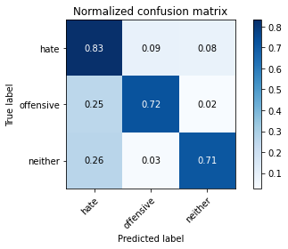

precision recall f1-score support

hate 0.20 0.83 0.32 946

offensive 0.93 0.72 0.81 5204

neither 0.96 0.71 0.82 7446

accuracy 0.72 13596

macro avg 0.70 0.76 0.65 13596

weighted avg 0.90 0.72 0.78 13596

average eval_loss: 0.6734246683252209, accuracy: 0.7248455428067079

training 3 epoch...

499.855171918869 seconds used......

3 training finished! average train loss: 0.3596005294882471

evaluating...

Confusion matrix, without normalization

[[ 720 104 122]

[1220 3803 181]

[1516 251 5679]]

Normalized confusion matrix

[[0.76109937 0.10993658 0.12896406]

[0.23443505 0.73078401 0.03478094]

[0.20359925 0.03370937 0.76269138]]

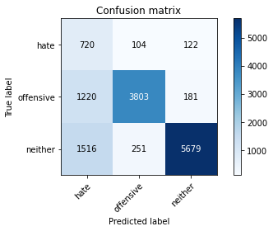

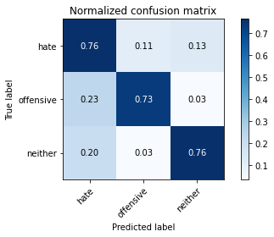

precision recall f1-score support

hate 0.21 0.76 0.33 946

offensive 0.91 0.73 0.81 5204

neither 0.95 0.76 0.85 7446

accuracy 0.75 13596

macro avg 0.69 0.75 0.66 13596

weighted avg 0.88 0.75 0.80 13596

average eval_loss: 0.6676262706189471, accuracy: 0.7503677552221242

Confusion matrix, without normalization

[[1590 92 153]

[1879 3841 205]

[3780 230 6744]]

Normalized confusion matrix

[[0.86648501 0.05013624 0.08337875]

[0.3171308 0.64827004 0.03459916]

[0.35149712 0.02138739 0.62711549]]

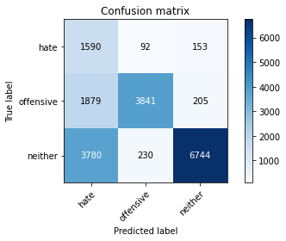

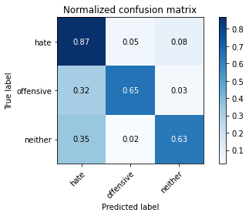

precision recall f1-score support

hate 0.22 0.87 0.35 1835

offensive 0.92 0.65 0.76 5925

neither 0.95 0.63 0.76 10754

accuracy 0.66 18514

macro avg 0.70 0.71 0.62 18514

weighted avg 0.87 0.66 0.72 18514

average eval_loss: 0.8212312956221933, accuracy: 0.6576104569514961

[20]:

0.6576104569514961

6 run

training 1 epoch...

499.72408962249756 seconds used......

1 training finished! average train loss: 0.6447117257039213

evaluating...

Confusion matrix, without normalization

[[ 761 65 120]

[1527 3451 226]

[1521 141 5784]]

Normalized confusion matrix

[[0.80443975 0.06871036 0.12684989]

[0.29342813 0.66314374 0.04342813]

[0.20427075 0.01893634 0.77679291]]

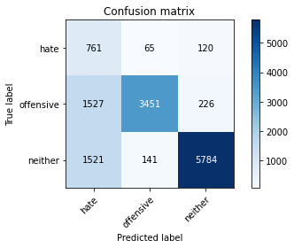

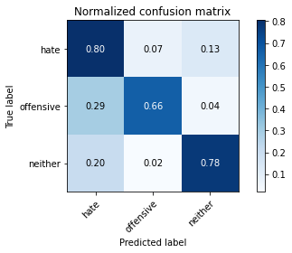

precision recall f1-score support

hate 0.20 0.80 0.32 946

offensive 0.94 0.66 0.78 5204

neither 0.94 0.78 0.85 7446

accuracy 0.74 13596

macro avg 0.70 0.75 0.65 13596

weighted avg 0.89 0.74 0.79 13596

average eval_loss: 0.5920943629654015, accuracy: 0.735216240070609

training 2 epoch...

500.38917684555054 seconds used......

2 training finished! average train loss: 0.4926645128240048

evaluating...

Confusion matrix, without normalization

[[ 677 76 193]

[1230 3691 283]

[ 946 155 6345]]

Normalized confusion matrix

[[0.71564482 0.08033827 0.20401691]

[0.23635665 0.70926211 0.05438125]

[0.12704808 0.02081655 0.85213537]]

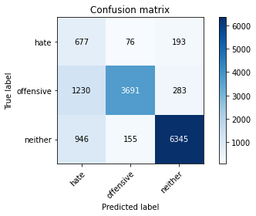

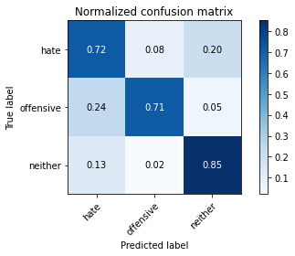

precision recall f1-score support

hate 0.24 0.72 0.36 946

offensive 0.94 0.71 0.81 5204

neither 0.93 0.85 0.89 7446

accuracy 0.79 13596

macro avg 0.70 0.76 0.68 13596

weighted avg 0.89 0.79 0.82 13596

average eval_loss: 0.47711242763873407, accuracy: 0.7879523389232127

training 3 epoch...

499.7755796909332 seconds used......

3 training finished! average train loss: 0.3674015685631998

evaluating...

Confusion matrix, without normalization

[[ 729 85 132]

[1200 3787 217]

[1320 281 5845]]

Normalized confusion matrix

[[0.77061311 0.08985201 0.13953488]

[0.23059185 0.72770945 0.04169869]

[0.17727639 0.03773838 0.78498523]]

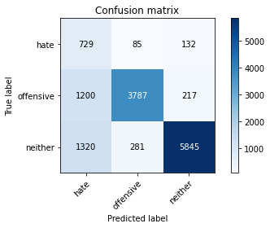

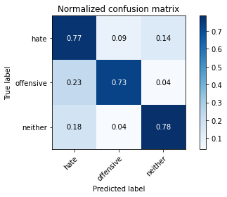

precision recall f1-score support

hate 0.22 0.77 0.35 946

offensive 0.91 0.73 0.81 5204

neither 0.94 0.78 0.86 7446

accuracy 0.76 13596

macro avg 0.69 0.76 0.67 13596

weighted avg 0.88 0.76 0.80 13596

average eval_loss: 0.6167295311851536, accuracy: 0.7620623712856722

Confusion matrix, without normalization

[[1521 78 236]

[2055 3480 390]

[3003 145 7606]]

Normalized confusion matrix

[[0.82888283 0.04250681 0.12861035]

[0.34683544 0.58734177 0.06582278]

[0.27924493 0.01348336 0.70727171]]

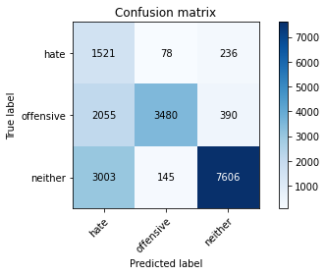

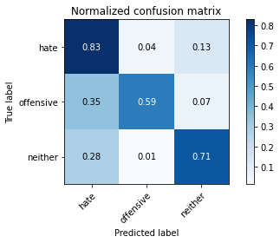

precision recall f1-score support

hate 0.23 0.83 0.36 1835

offensive 0.94 0.59 0.72 5925

neither 0.92 0.71 0.80 10754

accuracy 0.68 18514

macro avg 0.70 0.71 0.63 18514

weighted avg 0.86 0.68 0.73 18514

average eval_loss: 0.6748820151610714, accuracy: 0.680944150372691

[23]:

0.680944150372691