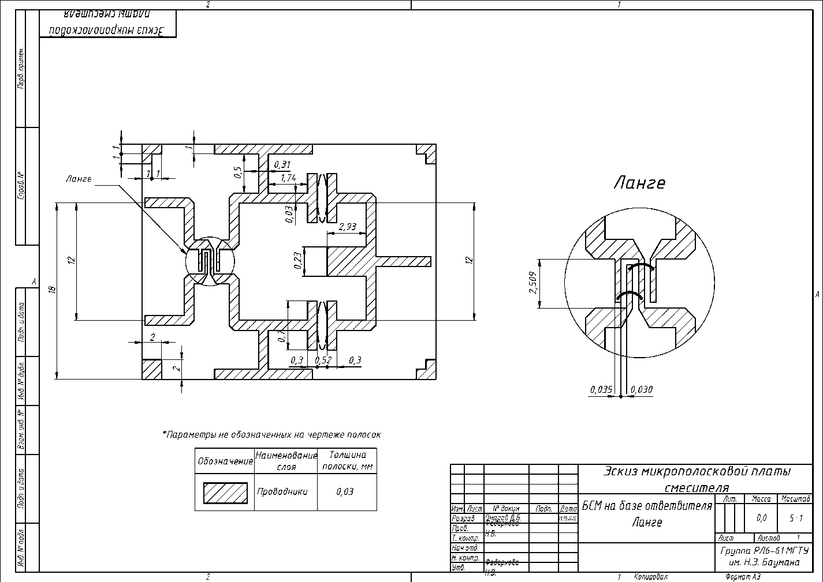

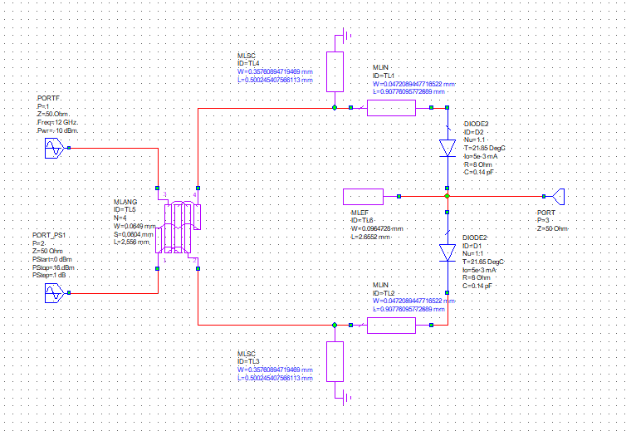

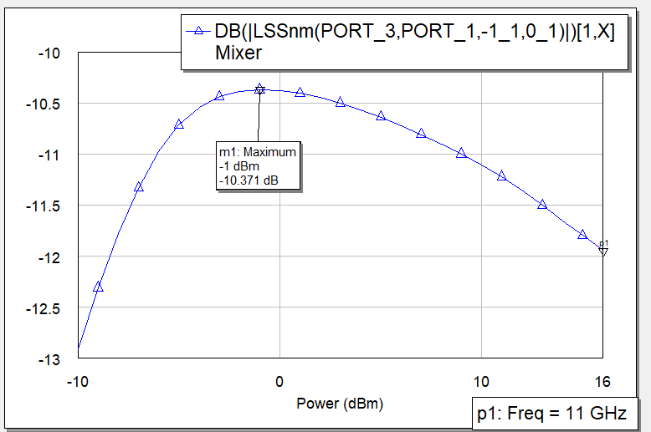

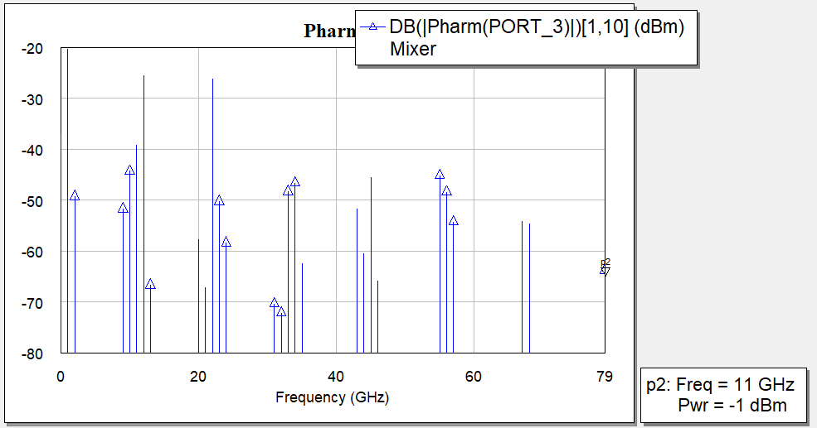

|  |  |
| --- | --- |
|  |  |
|  |  |

32 -72.178

31 -70.367

21 -67.266

13 -66.726

46 -65.863

79 -63.757

35 -62.505

44 -60.46

24 -58.418

20 -57.746

68 -54.671

57 -54.278

67 -54.239

9 -51.745

43 -51.675

23 -50.273

2 -49.273

56 -48.419

33 -48.3

34 -46.62

45 -45.544

55 -45.156

10 -44.339

11 -39.232

0 -36.878

22 -26.202

12 -25.554

1 -20.371

1 дб компр

