Code screenshots

(1)Use code provided by professor to read in data

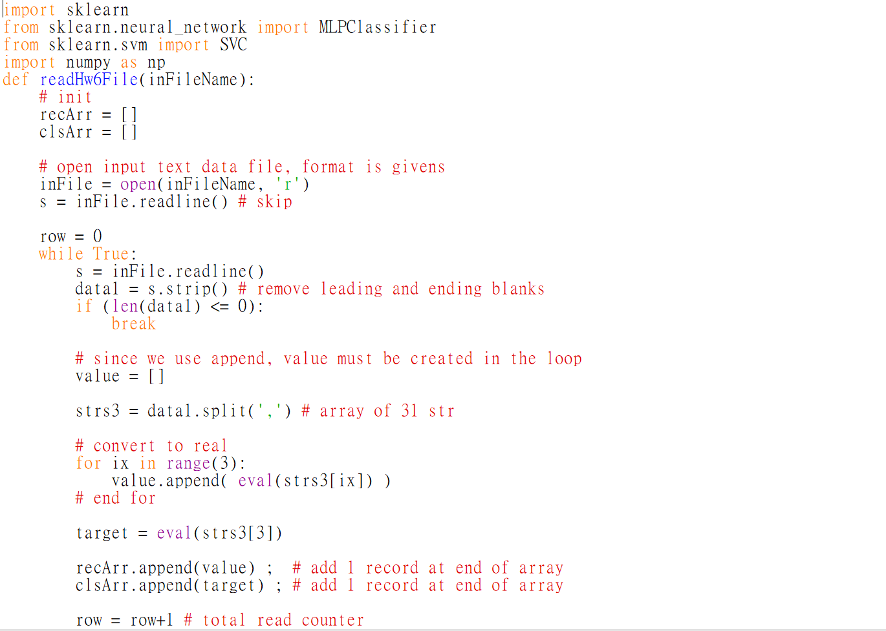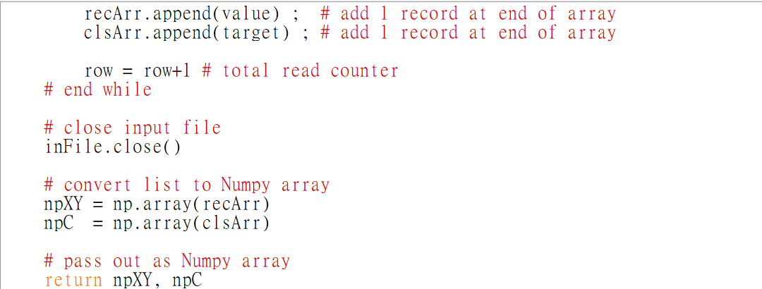

(2)MLP part

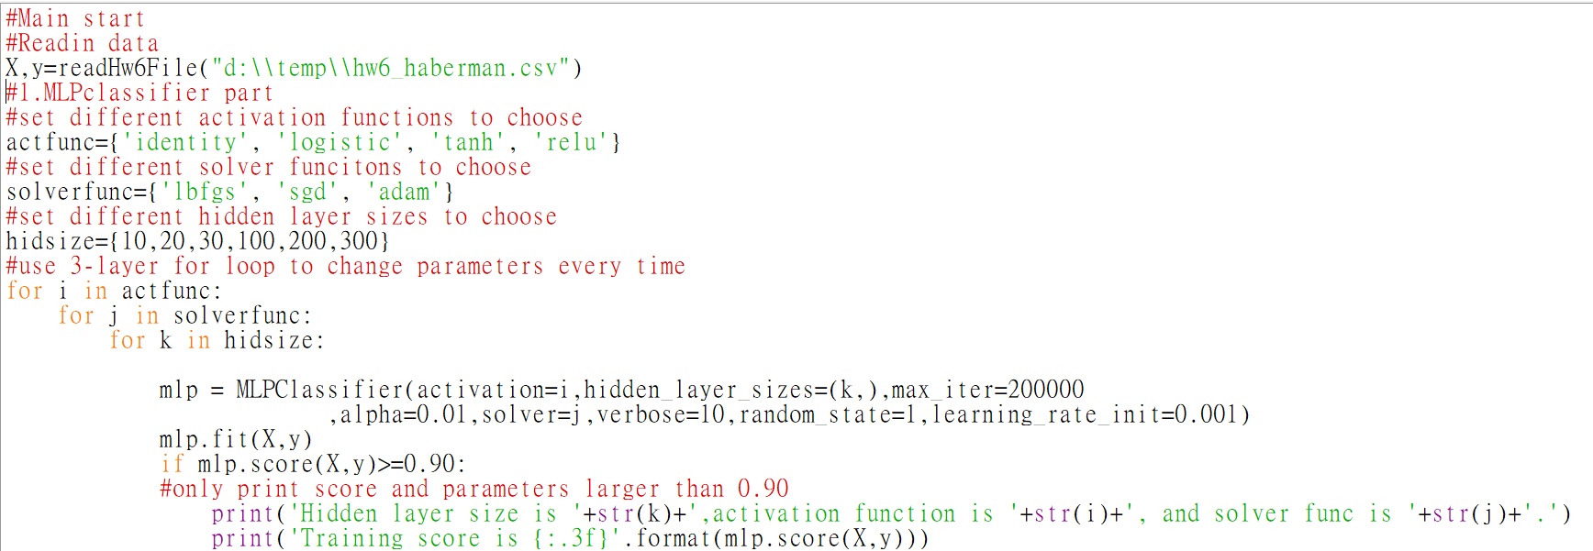

(2)SVC part

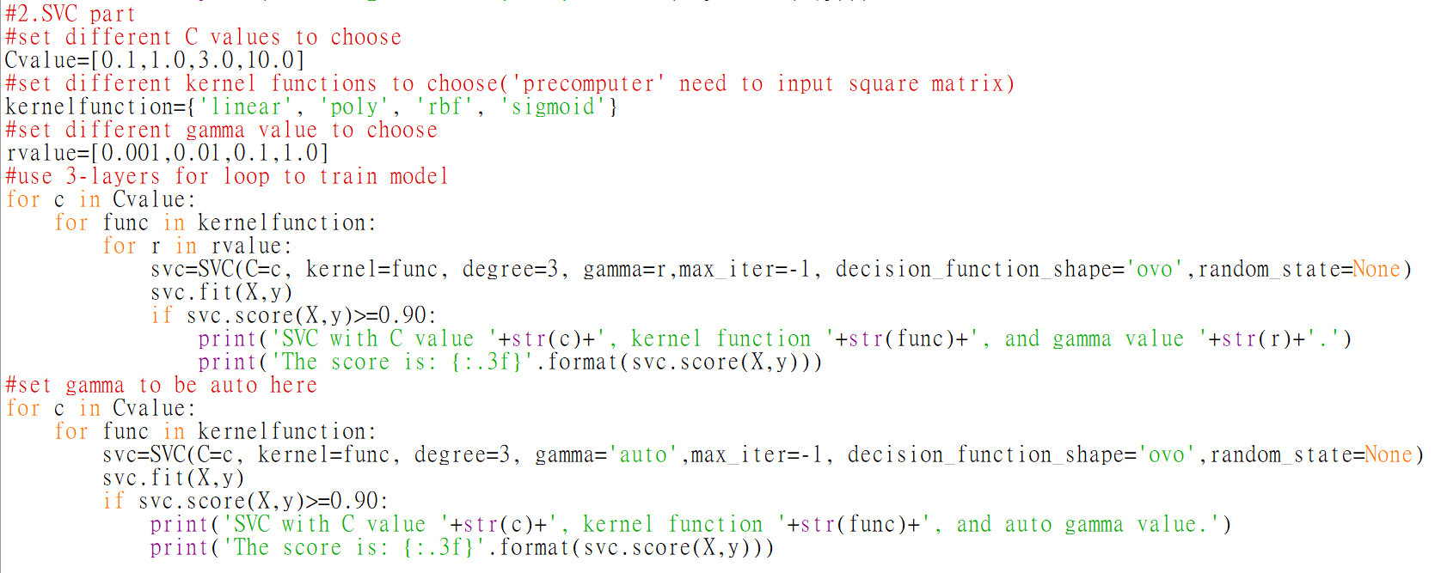

Compile Result:

Part 1:MLP classifier

(1)MLP classifier doing iteration

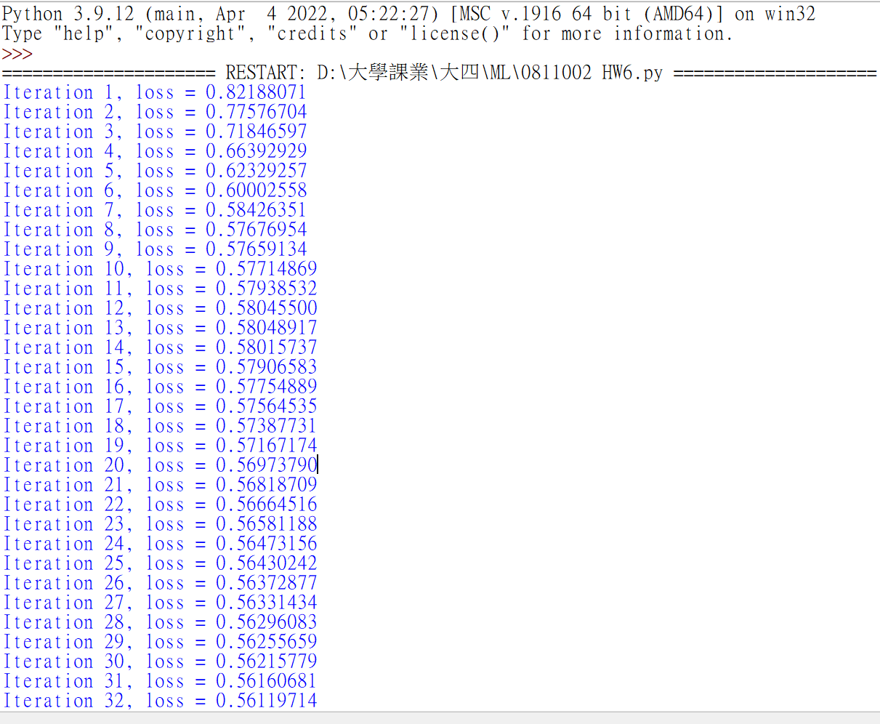

(2) Iteration result converged, but training score less than 0.90, so nothing printed.

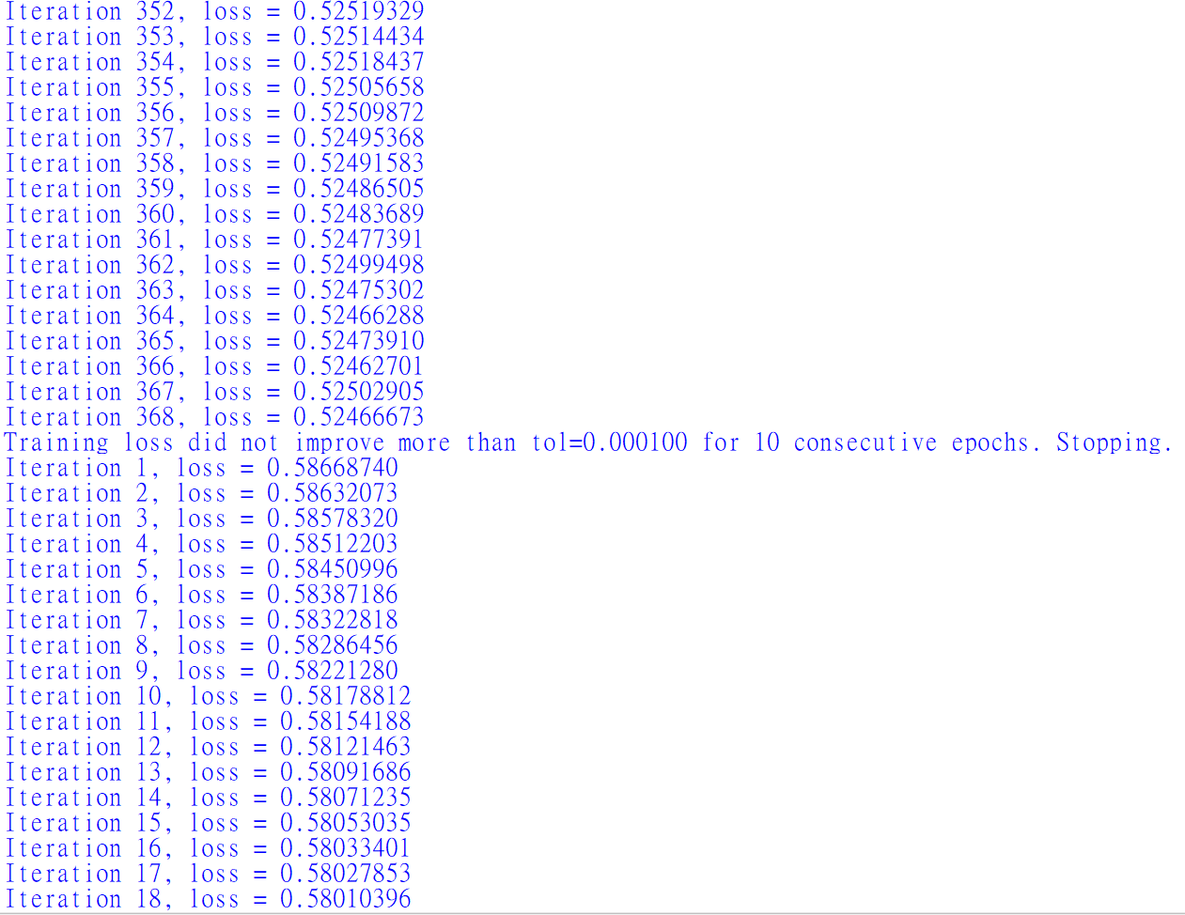

(3)Trying few models

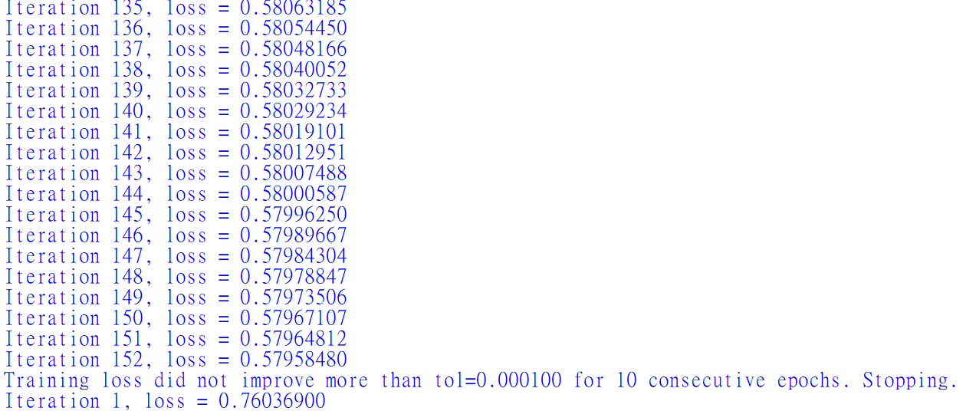

(4)Set max iteration number up to 200,000, but still not converge. Even though, the model I have now is good enough (training score larger than 0.90).(這部分有問過老師，使用lbfgs不容易收斂，而MLP這時會使用迭代到當下的模型來做training score，沒迭代完仍有生成一個模型，而且分數夠高)

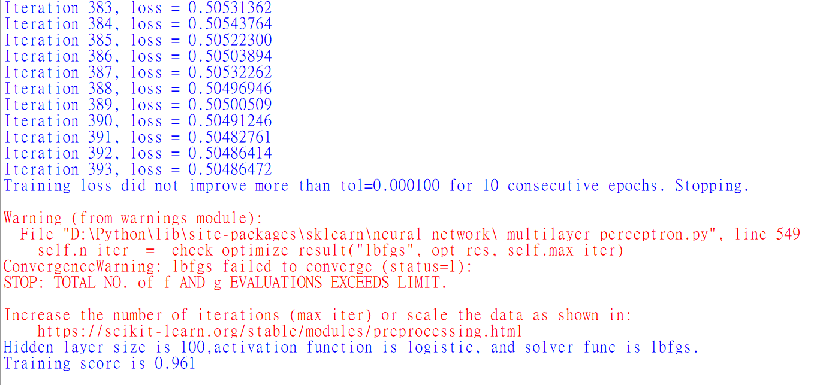

(5)更換參數(hidden layer size, activation)，以lbfgs表現最好，但會出現不收斂的問題

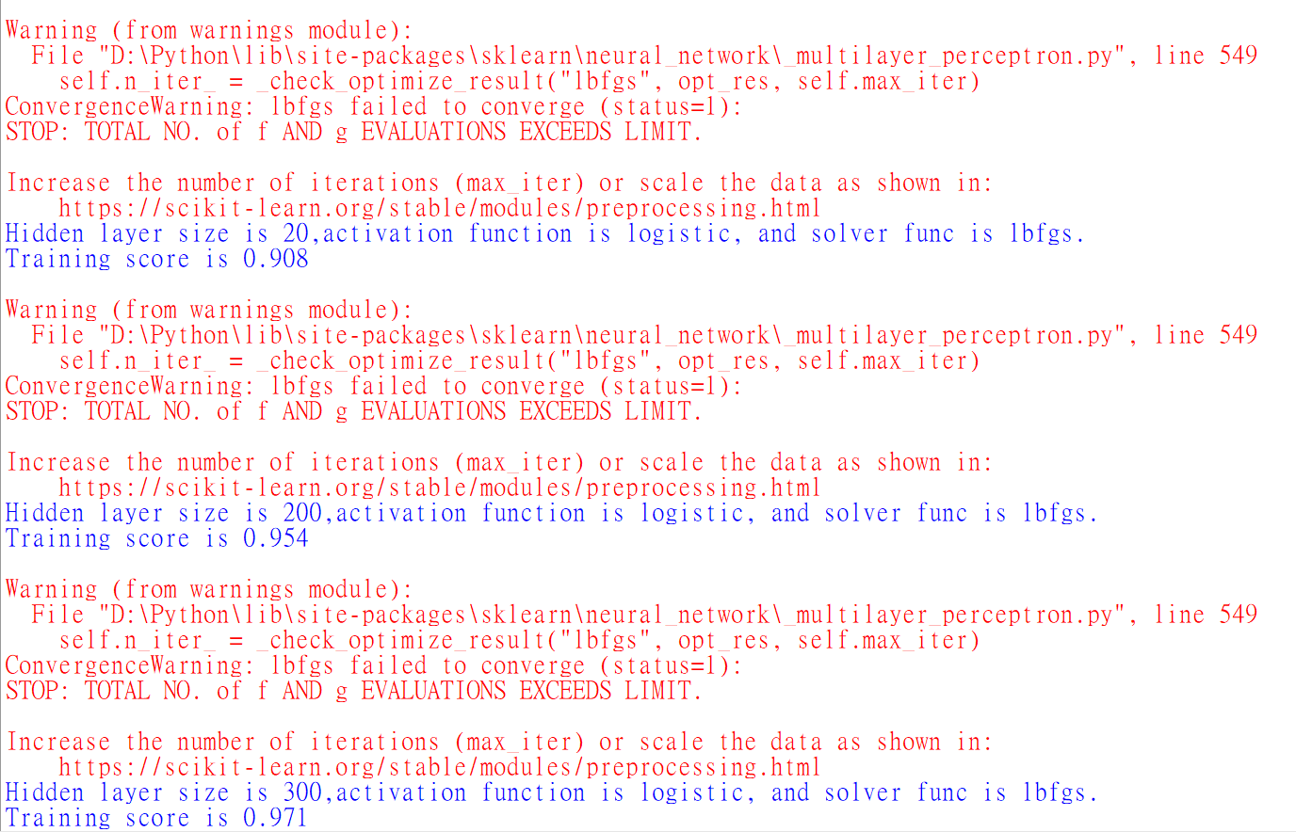

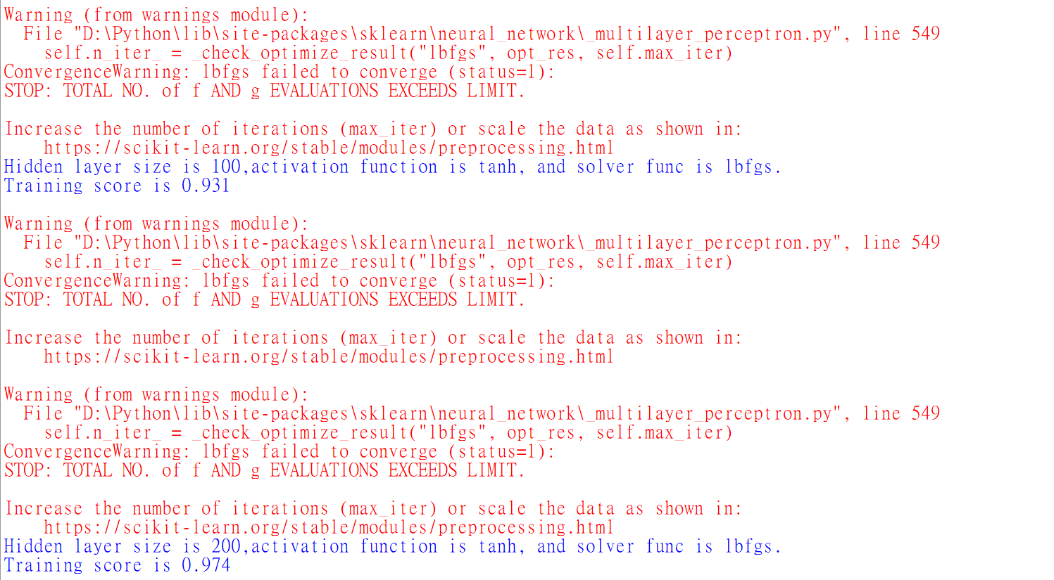

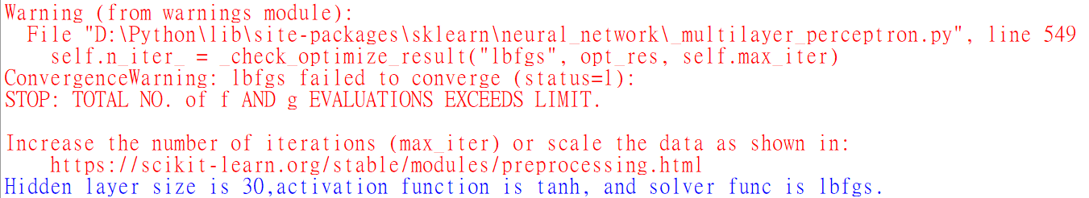

Part 2: SVC

