LFI Scanner GUI

The LFIScannerWindow class provides a graphical user interface for performing Local File Inclusion (LFI) vulnerability scans. This Tkinter-based application allows users to configure scan parameters, select target files, and view results in multiple formats.

UI Components

Scan Configuration Tab

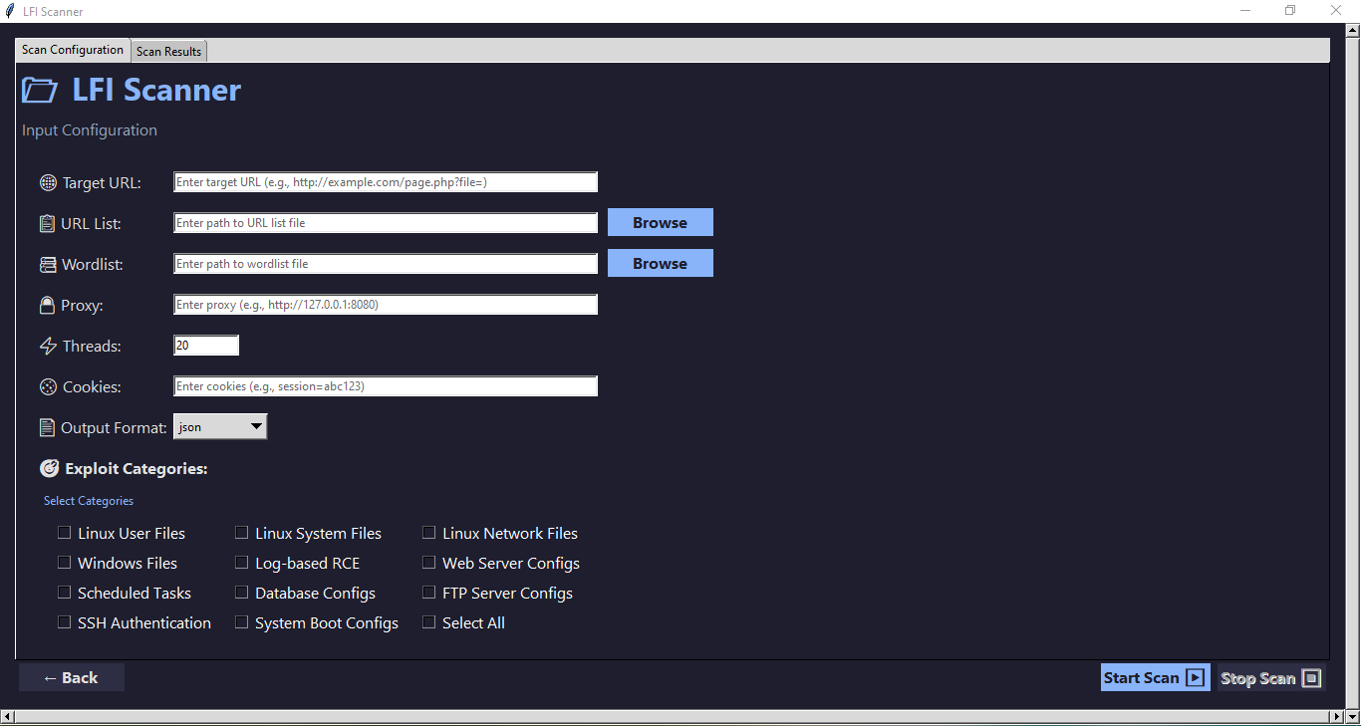

This tab contains all the settings needed to configure a scan:

Target Configuration

Target URL : Single URL input field with placeholder text

URL List : File path input with browse button to select a file containing multiple URLs

Wordlist : File path input with browse button to select a wordlist for testing

Scan Options

Proxy : Optional proxy configuration

Threads : Numeric input to control number of concurrent threads

Cookies : Cookie input field for authenticated scanning

Output Format : Dropdown menu to select output format (JSON, CSV, XML)

Exploit Categories

A categorized checklist for selecting which types of files try to read:

Linux User Files,Linux, System Files,Linux Network Files ,Windows Files,Log-based RCE,Web Server Configs,Scheduled Tasks,Database Configs,FTP Server Configs,SSH Authentication,

System Boot Configs)

A "Select All" checkbox allows toggling all categories at once.nfiguration Tab

Scan Results Tab

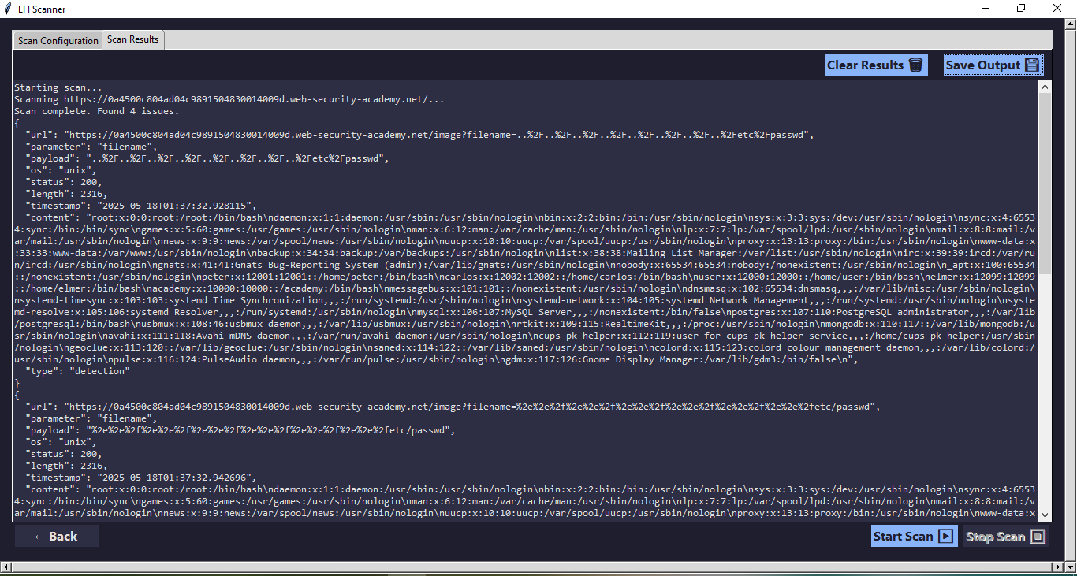

Results Display : Scrollable text area showing scan results

Save Output : Button to save results to a file

Clear Results : Button to clear displayed results