SSTI FULL DOC

# 4.1.2.1 Architectural Foundation

## 1. Core Components

### System Building Blocks

| **Component** | **Code Reference** | **Purpose** |
| --- | --- | --- |
| Main Scanner Class | SSTIScanner | Coordinates scanning workflow |
| Parameter Discovery | SiteCrawler | Finds input fields/URL parameters |
| Vulnerability Detectors | ErrorBasedEngineDetector + EvaluationBasedEngineDetector | Confirms SSTI existence |
| Exploitation System | SSTIExploiter | Executes attacks post-detection |
| Payload Repository | TemplateDB | Stores engine-specific payloads |
| Scenario System | ScenarioHandler | Handles special cases/lab environments |

## **Technology Stack**

*Critical dependencies and their roles in the system:*

| **Library** | **Purpose** | **Usage Context** |
| --- | --- | --- |
| requests | HTTP request handling with session persistence | Target interaction, vulnerability probing |
| BeautifulSoup (bs4) | HTML/XML parsing for parameter discovery | Site crawling, form extraction |
| argparse | Command-line interface (CLI) configuration | User input handling |
| concurrent.futures | Parallel execution of scanning tasks | Multi-threaded parameter testing |
| re | Regex pattern matching | Error analysis, payload detection |
| urllib3 | Low-level HTTP client with SSL/TLS controls | Proxy configuration, warning suppression |
| json/csv | Report generation in structured formats | Output serialization |
| datetime | Timestamping of findings | Report metadata |

### **Key Library Explanations**

1. **requests**
   * Manages all HTTP(S) communications
   * Handles cookies, redirects, and proxy configurations
   * Provides timeout controls for safe scanning
2. **BeautifulSoup**
   * Analyzes HTML structure during site crawling phase
   * Extracts form parameters and hidden inputs
   * Identifies reflection points in rendered content
3. **concurrent.futures.ThreadPoolExecutor**
   * Enables parallel scanning of multiple parameters
   * Manages thread pool for reflection tests (Phase 2)
   * Accelerates engine detection (Phase 3)
4. **argparse**
   * Processes command-line arguments (URLs, output format, etc)
   * Implements help system and input validation
   * Configures proxy settings and thread counts
5. **re**
   * Identifies template engine fingerprints in error messages
   * Extracts executed command output between TINJ_* markers
   * Validates parameter reflection through pattern matching

### 2. Template Payload Database

*Centralized repository for vulnerability patterns and exploit templates*

**Key Roles**:

* Stores engine fingerprints (regex patterns)
* Contains validation payloads (e.g., {{7*7}})
* Provides exploit templates (command/file access)
* Documents engine-specific constraints

**Critical Integration Points**:

* Used by ErrorBasedEngineDetector and EvaluationBasedEngineDetector
* Accessed by SSTIExploiter during attack execution
* Version-controlled via template_db.json

##### Schema Overview

{  
 "engines": {  
 "EngineName": {  
 "detection": {  
 "error_regex": ["Pattern1", "Pattern2"],  
 "evaluation": {  
 "payload": "TEST_EXPRESSION",  
 "expected": "EXPECTED_RESULT"  
 },  
 "reflection_markers": ["DELIMITERS"]  
 },  
 "exploit": {  
 "command_exec": {  
 "payload": "EXPLOIT_TEMPLATE",  
 "description": "Usage context"  
 },  
 "file_read": {  
 "payload": "FILE_ACCESS_TEMPLATE"  
 }  
 }  
 }  
 }  
}

#### Key Components

1. **Detection Signatures**
   * error_regex: Patterns to identify engines from error messages
   * evaluation: Mathematical tests to confirm template execution
   * reflection_markers: Character sequences that indicate template context
2. **Exploit Templates**
   * command_exec: OS command injection payloads
   * file_read: File system access patterns
   * reverse_shell: Pre-built connection templates

##### Integration with Scanning Workflow

1. **Detection Phase**

# ErrorBasedEngineDetector uses error_regex  
if re.search(pattern, response.text):  
 identify_engine()

1. **Verification Phase**

# EvaluationDetector uses evaluation payloads  
send(TEMPLATE_DB["Jinja2"]["detection"]["evaluation"]["payload"])

1. **Exploitation Phase**

# SSTIExploiter retrieves payload templates  
payload = TEMPLATE_DB[engine]["exploit"]["command_exec"]["payload"].replace("COMMAND", user_input)

## 3. Component Hierarchy

### Structural Relationships

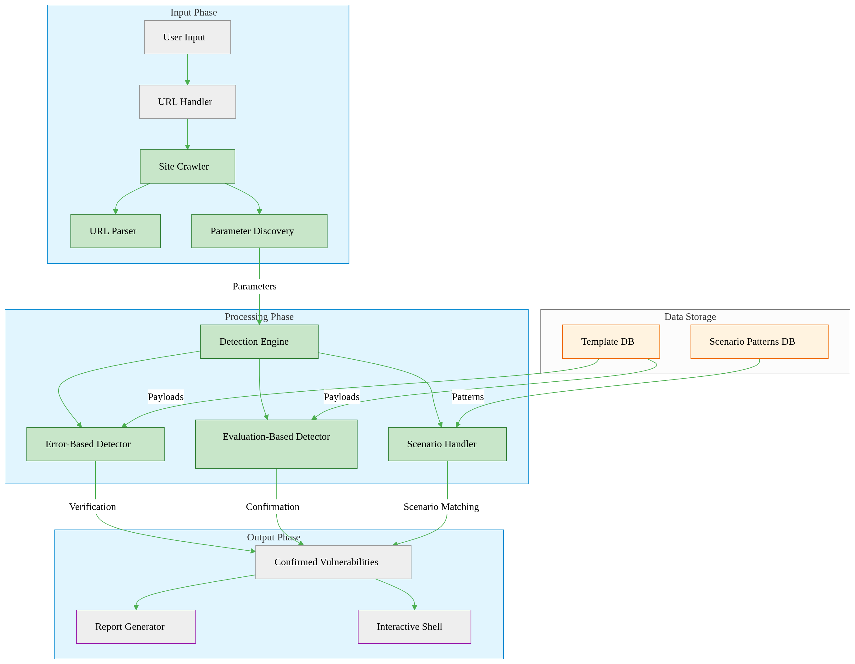

**The scanner consists of 4 essential components:**

1. **SSTIScanner**
   * The brain of the system
   * Manages the scanning workflow:  
     URL Input → Parameter Discovery → Engine Detection → Exploitation
   * Handles threading and session management
2. **Detection Tools**
   * **Error Detector**: Looks for template engine fingerprints in error messages
   * **Evaluation Detector**: Sends math payloads (e.g., {{7*7}}) to detect execution
   * Work together to confirm vulnerabilities
3. **SSTIExploiter**
   * Takes verified vulnerabilities and:
     + Executes system commands
     + Reads files
     + Maintains interactive sessions
4. **Support Systems**
   * **Site Crawler**: Discovers parameters by analyzing pages/forms
   * **Template Database**: Stores engine-specific attack payloads

* **ScenarioHandler**: Special logic for lab environments

# 4.1.2.2 Scanning Workflow

## Phase 1: Target Initialization

*Prepares the scanning environment and validates the target*

### GUI Interface Overview

GUI Input Interface  
*Caption: Scanner input interface showing configuration fields*

### User Inputs

* **Target Specification**:
  + Single URL (e.g., https://example.com/search)
  + *OR* text file containing multiple URLs (one per line)
* **Configuration Options**:
  + Number of parallel scanning threads
  + Proxy server address/port (optional)
  + Output report format (JSON/CSV/XML)
  + Specific parameters to test (optional list)

### Input Flow Sequence

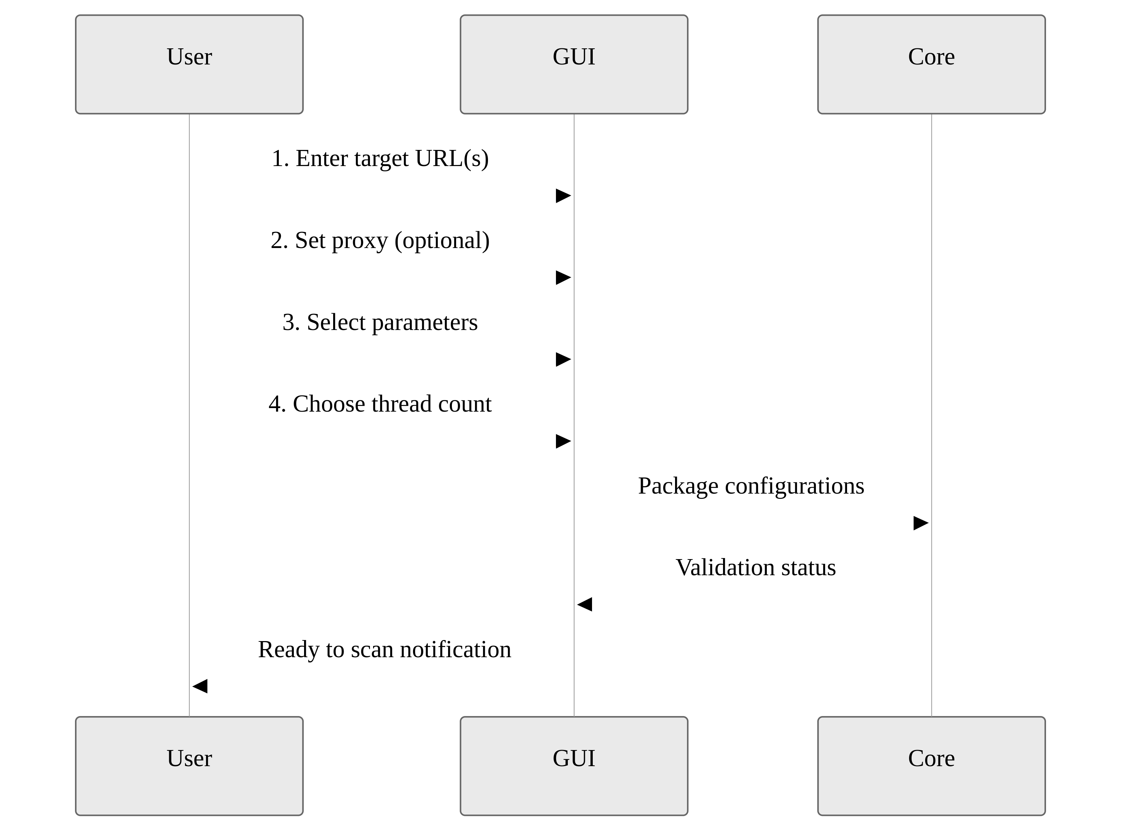

### Step 1: Session Setup

# SSTIScanner.__init__  
self.session = requests.Session()  
self.session.proxies = proxies

* Creates persistent HTTP connection preserving:
  + Authentication cookies
  + Custom headers
  + SSL/TLS session state
* Disables SSL certificate verification for debugging

### Step 2: Proxy Configuration

* Applies user-provided proxy settings to all traffic
* Supports both HTTP/HTTPS proxy types
* Maintains connection reuse for efficiency

### Step 3: Reachability Check

1. Sends test request to first URL
2. Validates response:
   * **Success**: HTTP 200 status → Continue scan
   * **Failure**:
     + Invalid URL format → Terminates immediately
     + Connection timeout → Logs error, skips URL

### Step 4: Scenario Pre-Check

# ScenarioHandler.detect_scenario  
if re.search(r"Basic server-side template injection", response_text):  
 return Scenario2

* Scans initial response content for:
  + Predefined vulnerability markers
* Decision logic:  
  *If scenario pattern detected* → Specialized handling  
  *If no patterns found* → Standard scanning

### Failure Handling

* **Invalid URLs**: Terminates with format examples
* **Unreachable targets**: Displays troubleshooting tips
* **Proxy failures**: Attempts direct connection fallback

*This phase only establishes working conditions - no vulnerability testing occurs here.*

## Phase 2: Parameter Discovery

*Identifies potential injection points through comprehensive analysis*

### Key Objective:

Find all user-controllable inputs that reflect values back in responses

### Step 1: Site Crawling

# SiteCrawler.crawl()  
forms = soup.find_all('form')  
inputs = [input_tag['name'] for form in forms for input_tag in form.find_all('input')]  
  
# SiteCrawler._extract_params_from_url()  
query = urlparse(url).query  
params = parse_qs(query).keys()

1. **Initial URL Analysis**
   * Starts at user-provided URL
   * Follows same-domain links up to configurable depth
   * Preserves session cookies for authenticated areas
2. **Multi-Source Extraction**
   * **HTML Forms**:
     + <input> fields (text/email/search types)
     + <textarea> content
     + Hidden parameters (<input type="hidden">)
   * **URL Query Strings**:
     + Parameters after ? (e.g., ?search=test)
   * **Link Parameters**:
     + URL parameters in <a href=""> tags

### Step 2: Reflection Verification

# test_parameter_reflection()  
test_res = session.get(url, params={param: "TINJ_REFL_TEST"})  
verify_res = session.get(url, params={param: "TINJ_VERIF_123"})  
if test_value in test_res.text and verify_value in verify_res.text:  
 return True

**Strict Two-Stage Validation:**

1. **Initial Test**
   * Injects unique string (e.g., TINJ_REFL_7BxY9z)
   * Checks exact match in:
     + Response body content
     + HTTP headers
     + Redirect URLs
2. **Confirmation Test**
   * Sends different verification string (e.g., TINJ_VERIF_4QwP2m)
   * Requires both strings to appear unmodified

**Filter Logic:**  
Parameter survives only if:

* Reflects both test values exactly
* No encoding/truncation detected

### Output Handling

* **Passed Parameters**: Queued for engine detection
* **Failed Parameters**: Permanently excluded
* **Discovery Report**:

{  
 "discovered_parameters": ["search", "email", "filter"],  
 "reflected_parameters": ["search", "email"]  
}

### Special Considerations

1. Avoids destructive operations during crawling
2. Limits recursion depth to prevent infinite loops

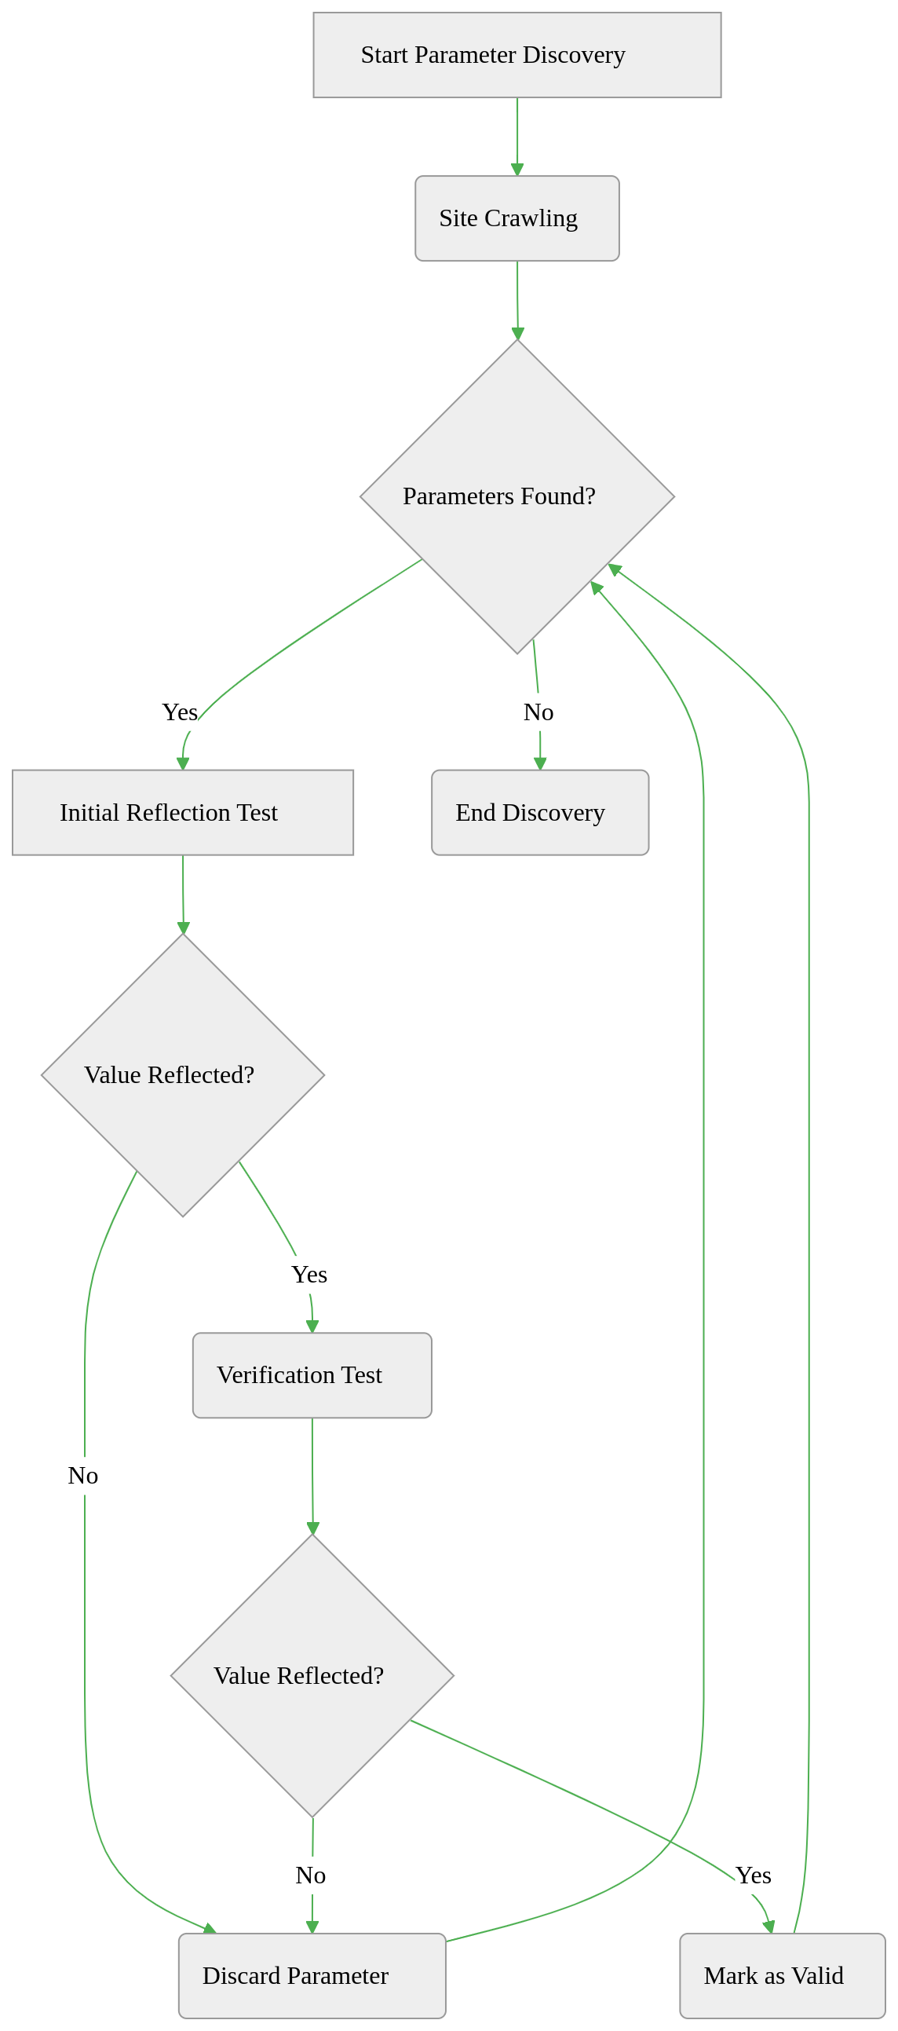

## Phase 3: Engine Identification

*Determines the template engine through pattern analysis and execution testing*

### Key Objective:

Confirm the server-side template engine (e.g., Jinja2, Twig) using two verification methods

### Step 1: Error Pattern Analysis

# ErrorBasedEngineDetector.detect()  
response = session.get(url, params={param: error_payload})  
for pattern in engine_patterns:  
 if re.search(pattern, response.text):  
 return engine

**Method**:

1. Sends malformed template syntax to trigger errors
   * Example payload: ${<\%[%'}}%\
2. Analyzes error messages for fingerprints:
   * **Jinja2**: Contains "jinja2.exceptions.TemplateSyntaxError"
   * **Twig**: Shows "Twig_Error_Syntax"
3. Records partial matches for secondary verification

**Outcome**:

If **Error Fingerprint Found** → High-confidence engine identification  
Else → Proceed to Step 2

### Step 2: Evaluation-Based Detection

# EvaluationBasedEngineDetector.detect()  
payload = self.payload_map[engine]["payload"]  
response = session.get(url, params={param: payload})  
if data["expected"] in response.text:  
 return engine

**Method**:

* Sends engine-specific arithmetic payloads:
  + **Jinja2**: {{7*'7'}} → Expected output: "7777777"
  + **Twig**: {{7*7}} → Expected output: "49"
* Checks for mathematical execution evidence:
  + Direct output match (e.g., "49" appears in response)
  + Partial pattern match (e.g., "777" in truncated responses)

**Verification Logic**:

* **Full Match**: Confirms template engine definitively
* **Partial Match**: Cross-references with error analysis results
* **No Match**: Marks engine as "Unknown" for manual review

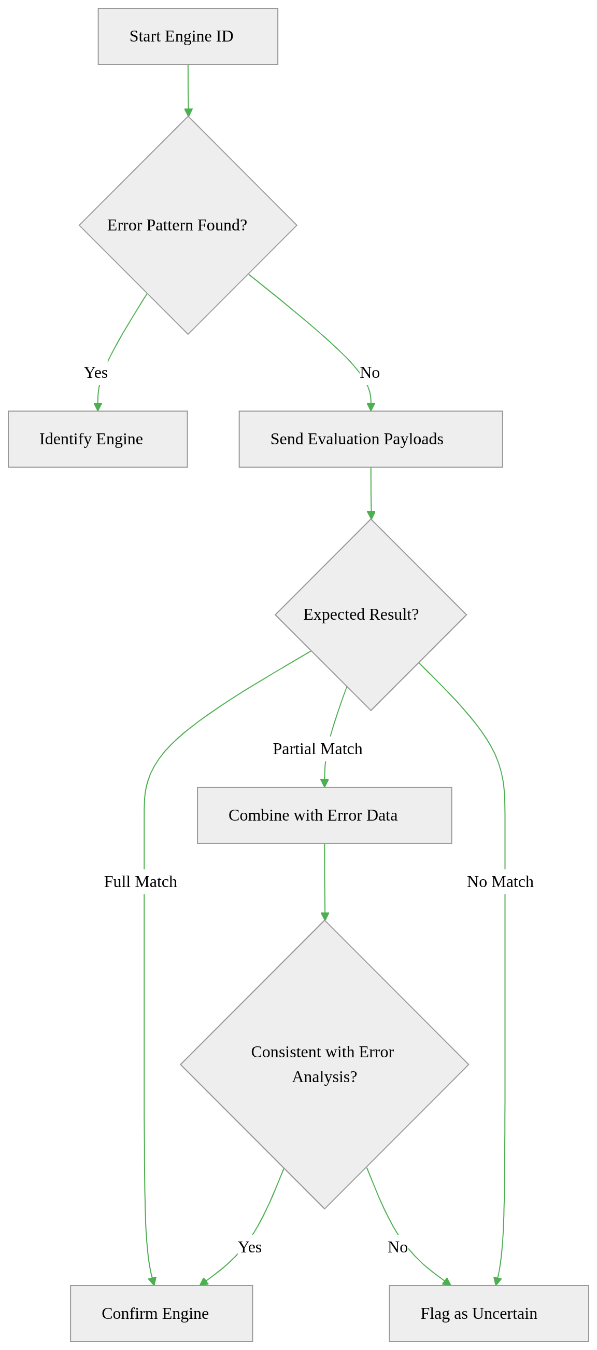

## Phase 4: Post-Detection Actions

*Executes payloads and delivers results after confirming vulnerabilities*

### Key Objective:

Leverage identified vulnerabilities for controlled exploitation and reporting

### Step 1: Exploitation Launch

# SSTIExploiter.execute_command()  
payload = self.payloads["exec"].replace("COMMAND", command)  
response = self.session.get(url, params={self.param: payload})

**Process**:

1. Retrieves engine-specific payloads from TemplateDB:
   * **Command Execution**: {{ self.__init__.__globals__... }} (Jinja2)
   * **File Read**: ${product.getClass()...} (Freemarker)
2. Injects payload into confirmed vulnerable parameter
3. Validates command execution/output sanitization

**Safety Measures**:

* Timeout enforcement (15s default)
* Payload sandboxing to prevent accidental damage

### Step 2: Interactive Shell

# interactive_shell()  
while True:  
 cmd = input("tinj-shell» ")  
 if cmd.startswith("read "):  
 print(exploiter.read_file(cmd[5:]))  
 else:  
 print(exploiter.execute_command(cmd))

**Features**:

* Real-time command execution interface
* Context-aware parsing:
  + read /etc/passwd → Auto-uses file read payload
  + whoami → Uses command execution template
* Output filtering to remove template artifacts



**Example Flow**:

1. User types whoami
2. Tool selects command execution template for detected engine
3. Injects {{ self.__init__...popen('whoami') }}
4. Server returns TINJ_STARTrootTINJ_END
5. Tool displays cleaned output: root

### Step 3: Report Generation

**Output Formats**:

| **Format** | **Structure** | **Use Case** |
| --- | --- | --- |
| JSON | Nested objects with full technical details | Developer analysis |
| CSV | Tabular data with key fields | Spreadsheet integration |
| XML | Hierarchical vulnerability listing | Enterprise system ingestion |

**Report Contents**:

* Vulnerable URL(s)
* Confirmed parameter(s)
* Template engine identified
* Evidence snippets
* Timestamp of discovery

### Concurrency Management

* Thread pool reused from earlier phases
* Parallel tasks:
  + Background report writing
  + Shell input/output handling
  + Payload retries on timeout

This phase transforms detection results into actionable outcomes while maintaining operational safety.

