SSRF Scanner GUI

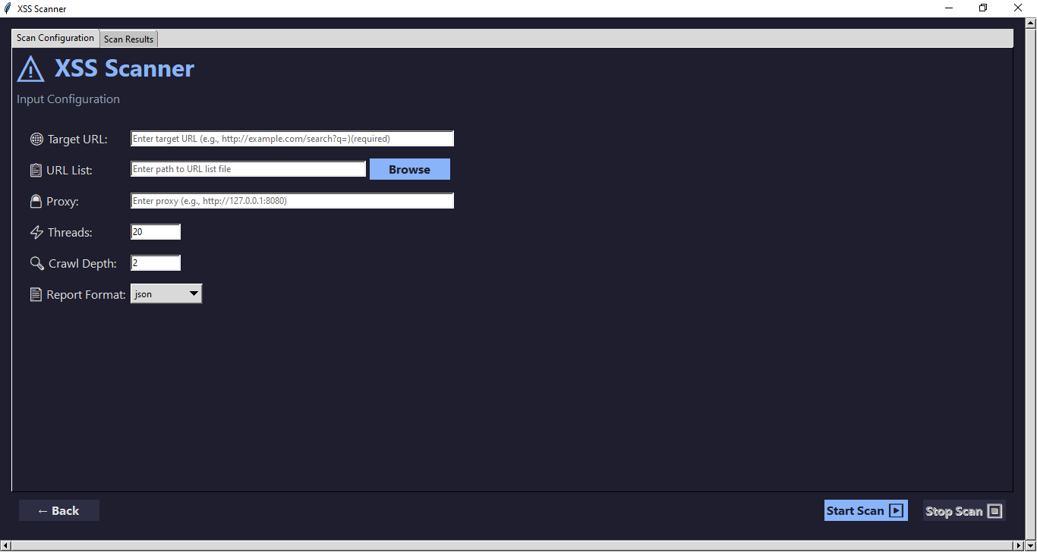

Scan Configuration

Target URL: Single URL to scan (required if no URL list provided)

URL List: File containing multiple URLs to scan (alternative to single URL)

Proxy: Optional proxy configuration for traffic interception

Threads: Number of concurrent workers (default: 20)

Crawl Depth: How deep to crawl from initial URL (default: 2)

Output Format: JSON, CSV, or XML

Results Display

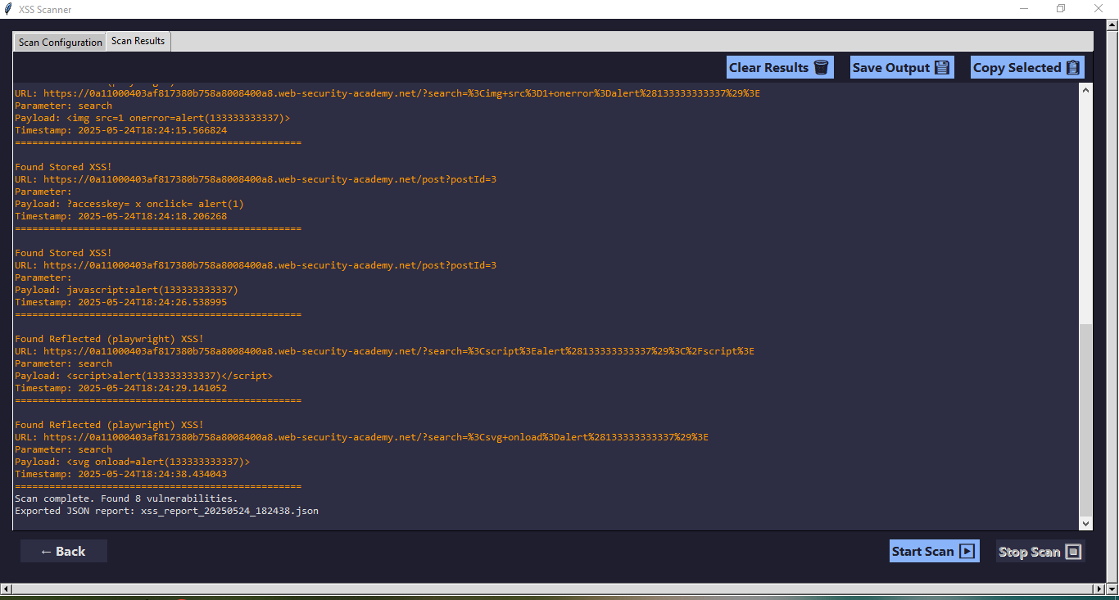

Controls

Start Scan : Initiates the scan with the configured parameters

Stop Scan : Stops an ongoing scan

Save Output : Saves the scan results to a file

Clear Results : Clears the results display area

Back : Returns to the parent window/application