

جامعة آل البيت

**Al-Al Bayt University**

**Web Vulnerability Scanner**

**Presented by:**

|  |  |
| --- | --- |
| Ahmad Ali Shwaiyat: | 2100906056 |
| Mohammad Abdallah Alzoubi: | 2100906042 |
| Yousef Mohammad Yousef Hjooj: | 2100906076 |
| Abdalrahman Reda Albeshtawi: | 2100906014 |

**Supervisor: Dr. Khaled Batiha**

**Submitted in Partial Fulfillment of the Requirements for bachelor’s degree in Cybersecurity**

**Prince Al Hussein bin Abdullah Faculty of Information Technology**  
**Computer Science**

**Al-Mafraq- Jordan**

**DECLARATION**

As part of the requirements for a bachelor's degree in Cybersecurity, we Mohammad Alzoubi, Ahmad Shwaiyat, Yousef Hjooj, and Abd Abdalrahman Albeshtawi

state that the project titled “**Web Vulnerability Scanner**” is our creation. We confirm that all data, sources, and information used in this project have been appropriately referenced and acknowledged.

Furthermore, we declare that this project has not been previously submitted for credit, towards another program or test at any institution.

**Table of Contents**

Chapter 1: Introduction 4

1.1 Project Problem 4

1.2 Project Goals 4

1.3 What is an automated web vulnerability ? 5

1.4 Why are vulnerability scanners Important? 5

1.5 What the project covers 6

1.6 Beneficiaries 7

Chapter 2: Overview of Target vulnerabilities 8

2.1 Server-side Request Forgery (SSRF) 8

2.2 Server-side Template Injection (SSTI) 8

2.3 Path Traversal 9

2.4 Cross-Site Scripting (XSS) 9

Chapter 3: Detection Methodologies 13

3.1 SSRF Detection Technique 13

3.2 SSTI Detection Technique 24

3.3 Path Traversal Detection Technique 24

3.4 XSS Detection Technique 25

Chapter 4: Building the Vulnerability Scanner 30

4.1 How the Scanner works? 30

**4.1.1** SSRF 30

**4.1.2** **SSTI** 30

4.2 Choice of Programming and Libraries 30

4.3 User Graphic interface (GUI) 30

4.4 Comparisons with other vulnerability 30

Chapter 5: Conclusion 30

5.1 Summary of Achievements 30

5.2 Potential Enhancements 30

5.3 References 30

# Introduction

## Project Problem

Modern web applications are increasingly targeted by cyberattacks due to vulnerabilities such as SQL injection, cross-site scripting (XSS), insecure APIs, and misconfigured servers. Manual vulnerability detection is time-consuming, error-prone, and requires specialized expertise. Many organizations, especially small-to-medium enterprises (SMEs), lack the resources to implement robust security practices, leaving their systems exposed to breaches. This project addresses the critical need for an automated, accessible, and efficient web vulnerability scanner to identify and mitigate risks proactively.

## Project Goals

The main goals of this project are:

1. To develop an automated web vulnerability scanner that identifies and reports common security weaknesses.
2. To improve the security posture of web applications by enabling early detection and remediation of vulnerabilities.
3. To provide a user-friendly tool that can be used by developers, security teams, and organizations regardless of their technical expertise.

## What is an automated web vulnerability ?

An automated web vulnerability scanner is a software tool designed to systematically identify security weaknesses in web applications, APIs, and servers by combining predefined rules, machine learning (ML), and simulated attack patterns. It eliminates the need for manual penetration testing, enabling rapid, scalable, and repeatable security assessments.

## Why are vulnerability scanners Important?

1. Cost Efficiency: Reduce expenses associated with manual security audits.
2. Proactive Defense: Identify vulnerabilities before attackers exploit them.
3. Compliance: Meet regulatory standards (e.g., GDPR, PCI-DSS).
4. Reputation Protection: Prevent data breaches that damage organizational trust.
5. Continuous Monitoring: Enable real-time scanning in DevOps pipelines (shift-left security).

## What the project covers

Path Traversal

* Definition: Exploits improper input sanitization to access unauthorized files (e.g., /../../etc./passwd).
* Impact: Data theft, system compromise.
* Detection: Inject traversal sequences (e.g., ../, %2e%2e%2f) and analyze server responses for file disclosures.

Cross-Site Scripting (XSS)

* Definition: Injects malicious scripts into web pages (e.g., <script>alert(1)</script>).
* Types: Stored (persistent), Reflected (URL-based), DOM-based (client-side).
* Detection: Submit payloads and check for unencoded output in HTML/JS contexts.

Server-Side Request Forgery (SSRF)

* Definition: Forces a server to make unauthorized internal requests (e.g., to AWS metadata endpoints).
* Impact: Internal network reconnaissance, cloud credential theft.
* Detection: Send URLs with internal IPs (e.g., http://169.254.169.254) and monitor responses.

1.5.4 Server-Side Template Injection (SSTI)

* Definition: Injects malicious code into templating engines (e.g., Jinja2, Smarty).
* Impact: Remote code execution (RCE), data leaks.
* Detection: Test with template syntax (e.g., {{7*7}} → 49 indicates vulnerability).

## Beneficiaries

* Developers: Integrate security into CI/CD pipelines.
* Penetration Testers: Accelerate vulnerability discovery.
* Organizations: Reduce breach risks and audit costs.
* End Users: Safeguard personal data from exploits.

# Overview of Target vulnerabilities

## Server-side Request Forgery (SSRF)

A Server-side Request Forgery (SSRF) vulnerability occurs when an attacker manipulates a server-side application into making HTTP requests to a domain of their choice. This vulnerability exposes the server to arbitrary external requests directed by the attacker.

**What is SSRF?**

Server-side request forgery is a web security vulnerability that allows an attacker to cause the server-side application to make requests to an unintended location.

In a typical SSRF attack, the attacker might cause the server to make a connection to internal-only services within the organization's infrastructure. In other cases, they may be able to force the server to connect to arbitrary external systems. This could leak sensitive data, such as authorization credentials.

**What is the impact of SSRF attacks?**

A successful SSRF attack can often result in unauthorized actions or access to data within the organization. This can be in the vulnerable application, or on other back-end systems that the application can communicate with. In some situations, the SSRF vulnerability might allow an attacker to perform arbitrary command execution.

An SSRF exploit that causes connections to external third-party systems might result in malicious onward attacks. These can appear to originate from the organization hosting the vulnerable application.

## Server-side Template Injection (SSTI)

**What is server-side template injection?**

Server-side template injection is when an attacker is able to use native template syntax to inject a malicious payload into a template, which is then executed server-side.

Template engines are designed to generate web pages by combining fixed templates with volatile data. Server-side template injection attacks can occur when user input is concatenated directly into a template, rather than passed in as data. This allows attackers to inject arbitrary template directives in order to manipulate the template engine, often enabling them to take complete control of the server. As the name suggests, server-side template injection payloads are delivered and evaluated server-side, potentially making them much more dangerous than a typical client-side template injection.

## Path Traversal

**What is path traversal?**

Path traversal is also known as directory traversal. These vulnerabilities enable an attacker to read arbitrary files on the server that is running an application. This might include:

Application code and data.

Credentials for back-end systems.

Sensitive operating system files.

In some cases, an attacker might be able to write to arbitrary files on the server, allowing them to modify application data or behavior, and ultimately take full control of the server.

## Cross-Site Scripting (XSS)

XSS attacks rely on injecting a malicious script in a benign website to run on a user’s browser. In other words, XSS attacks exploit the user’s trust in the vulnerable web application, hence the damage.

**Types of XSS**

1. **Reflected XSS**: This attack relies on the user-controlled input reflected to the user. For instance, if you search for a particular term and the resulting page displays the term you searched for (reflected), the attacker would try to embed a malicious script within the search term.
2. **Stored XSS**: This attack relies on the user input stored in the website’s database. For example, if users can write product reviews that are saved in a database (stored) and being displayed to other users, the attacker would try to insert a malicious script in their review so that it gets executed in the browsers of other users.
3. **DOM-based** XSS: This attack exploits vulnerabilities within the Document Object Model (DOM) to manipulate existing page elements without needing to be reflected or stored on the server. This vulnerability is the least common among the three.

**Causes and Implications**

Cross-site scripting (XSS) is a web security vulnerability that allows an attacker to inject malicious scripts into a web page viewed by other users. As a result, the unsuspecting users end up running the unauthorized script in their browsers, although the website they are visiting is trusted to be benign. Therefore, XSS can be a severe threat because it exploits users’ trust in a site.

**What Makes XSS Possible**

There are many reasons why XSS vulnerabilities are still found in web apps. Below, we list a few of them.

**1) Insufficient input validation and sanitization**

Web applications accept user data, e.g., via forms, and use this data in the dynamic generation of HTML pages. Consequently, malicious scripts can be embedded as part of the legitimate input and will eventually be executed by the browser unless adequately sanitized.

**2) Lack of output encoding**

The user can use various characters to alter how a web browser processes and displays a web page. For the HTML part, it is critical to properly encode characters such as <, >, ", ', and & into their respective HTML encoding. For JavaScript, special attention should be given to escape ', ", and \. Failing to encode user-supplied data correctly is a leading cause of XSS vulnerabilities.

**3) Improper use of security headers**

Various security headers can help mitigate XSS vulnerabilities. For example, Content Security Policy (CSP) mitigates XSS risks by defining which sources are trusted for executable scripts. A misconfigured CSP, such as overly permissive policies or the improper use of unsafe-inline or unsafe-eval directives, can make it easier for the attacker to execute their XSS payloads.

**4) Framework and language vulnerabilities**

Some older web frameworks did not provide security mechanisms against XSS; others have unpatched XSS vulnerabilities. Modern web frameworks automatically escape XSS by design and promptly patch any discovered vulnerability.

**5) Third-party libraries**

Integrating third-party libraries in a web application can introduce XSS vulnerabilities; even if the core web application is not vulnerable.

**Implications of XSS**

There are many implications of XSS. Below, we list a few of them.

**1) Session hijacking**

As XSS can be used to steal session cookies, attackers can take over the session and impersonate the victim if successful.

**2) Phishing and credential theft**

Leveraging XSS, attackers can present a fake login prompt to the user. In one recent case, the browser’s page was partially hidden by a dialogue box requesting users to connect to their cryptocurrency wallet.

**3) Social engineering**

Using XSS, an attacker can create a legitimate-looking pop-up or alert within a trusted website. This can trick users into clicking malicious links or visiting malicious websites.

**4) Content manipulation and defacement**

In addition to phishing and social engineering, an attacker might use XSS to change the website for other purposes, such as inflicting damage on the company’s reputation.

**5) Data exfiltration**

XSS can access and exfiltrate any information displayed on the user’s browser. This includes sensitive information such as personal data and financial information.

**6) Malware installation**

A sophisticated attacker can use XSS to spread malware. In particular, it can deliver drive-by download attacks on the vulnerable website.

**Reflected XSS** is a type of XSS vulnerability where a malicious script is reflected to the user’s browser, often via a **crafted URL** or **form submission**. Consider a search query containing <script>alert(document.cookie)</script>; many users wouldn’t be suspicious about such a URL, even if they look at it up close. If processed by a vulnerable web application, it will be executed within the context of the user’s browser.

One simple reflected XSS vulnerability is when the user searches for some term, and the search string is included verbatim in the results page. This simple scenario provides an easy target for the attacker to exploit.

Although discovering such vulnerabilities is not always easy, fixing them is straightforward. User input such as <script>alert('XSS')</script> should be santized or HTML-encoded to &lt;script&gt;alert('XSS')&lt;/script&gt;.

**Stored XSS**, or Persistent XSS, is a web application security vulnerability that occurs when the application stores user-supplied input and later embeds it in web pages served to other users without proper sanitization or escaping. Examples include web forum posts, product reviews, user comments, and other data stores. In other words, stored XSS takes place when user input is saved in a data store and later included in the web pages served to other users without adequate escaping.

Stored XSS begins with an attacker injecting a malicious script in an input field of a vulnerable web application. The vulnerability might lie in how the web application processes the data in the comment box, forum post, or profile information section. When other users access this stored content, the injected malicious script executes within their browsers. The script can perform a wide range of actions, from stealing session cookies to performing actions on behalf of the user without their consent.

# Detection Methodologies

## SSRF Detection Technique

The SSRF Scanner is a multi-functional tool designed to detect Server-Side Request Forgery (SSRF) vulnerabilities. Key features include:

* **Content Fetching**: Retrieves HTML content from URLs.
* **HTML Parsing**: Extracts links, form actions, input values, and input names.
* **SSRF Testing**: Injects payloads to test for vulnerabilities.
* **Request Crafting**: Sends HTTP requests with custom headers and payloads (GET/POST).
* **OS Detection**: Identifies server OS via response headers (e.g., Server header).
* **Collaboration Support**: Detects out-of-band interactions using domains like Burp Collaborator.
* **Output Formats**: Generates results in JSON or CSV.
* **Efficiency:** Supports multithreading, URL lists, and proxy configurations

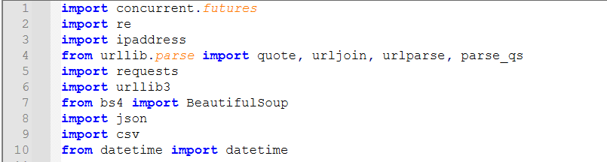

**concurrent . futures**  
Used for running tasks concurrently using threads or processes (helps with parallel execution).

**re**  
Provides support for **regular expressions**, allowing pattern matching and text searching.

**ipaddress**  
Allows manipulation and validation of **IPv4 and IPv6 addresses**.

**urllib.parse (quote, urljoin, urlparse, parse_qs)**  
Tools for **manipulating and parsing URLs**, such as encoding, joining, and extracting components or query parameters.

**requests**  
A popular library for making **HTTP requests** (GET, POST, etc.) to communicate with web servers.

**urllib3**  
A powerful, low-level HTTP client, often used internally by libraries like requests.

**bs4 (BeautifulSoup)**  
Used for **parsing and extracting data from HTML or XML** documents (web scraping).

**json, csv**: Result formatting/output.

**datetime**  
Provides classes for working with **dates and times**, useful for timestamps and scheduling.

**Disable SSL Warnings**



Suppresses SSL certificate warnings when making insecure HTTPS requests.

Global Variables



Stores scan results as a list of dictionaries containing details about successful SSRF attempts.

**Detection Functions**

1. detect_os(response)  
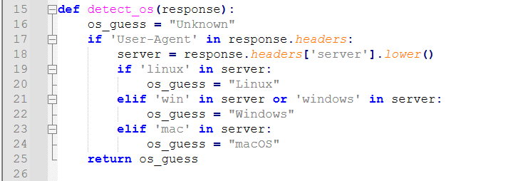

Detect the operating system of the server by inspecting the Server header.

**Attack Functions**

1) ssrf_post(url, payload, param, session=None, return_bool=False, proxies=None)

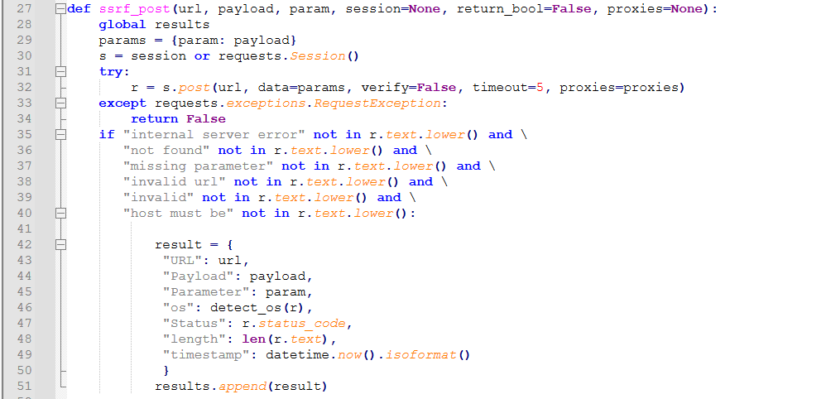

Performs an SSRF POST request with a given payload injected into a parameter.

2. load_payloads(filename)

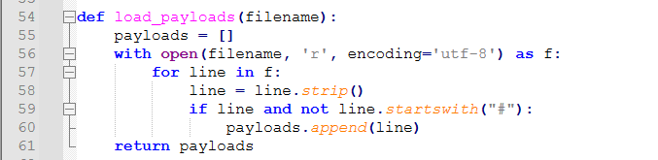

Loads payloads from a file (e.g., payload.txt) line by line.

3. fetch_content(url, timeout=5.0, proxies=None)

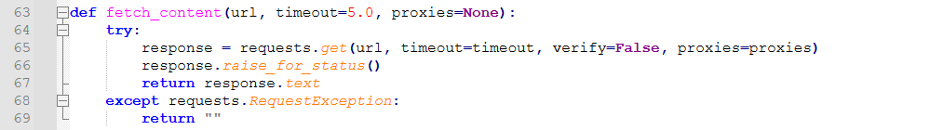

Fetches page content using GET requests.

4. extract_actions(content), extract_values(content), extract_names(content)



Use regex to extract:

Form action attributes, Input value attributes , Input name attributes Used to identify where to inject payloads.

5. extract_base_url(full_url)

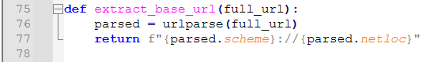

Returns the base URL (scheme + domain) of a full URL.  
6. filter_similar_urls(urls)

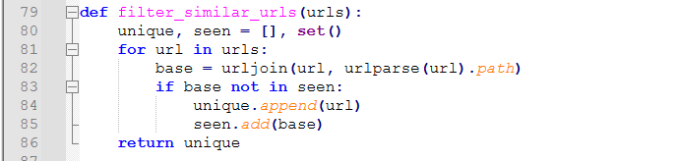

Filters duplicate URLs by comparing base paths.

7. is_valid_ip_with_port(ip_port)

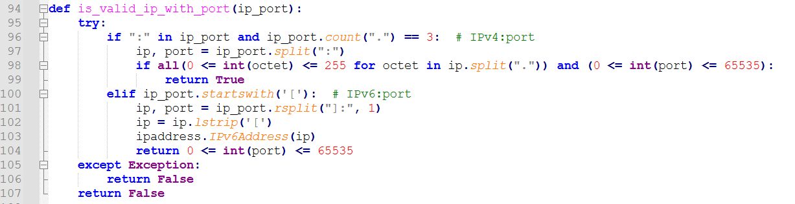

Validates IPv4 or IPv6 addresses with optional port numbers.  
8. path_payload(...)

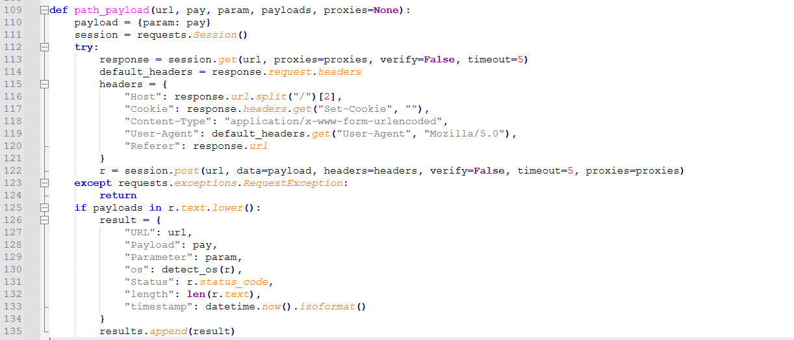

Injects payloads into the path of a URL and sends POST requests with custom headers.  
9. send_with_referer(...)

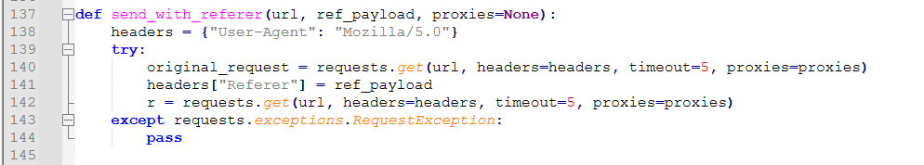

Sets a custom Referer header in a GET request.  
10. collaborator(target_url, collab_domain, proxies=None)

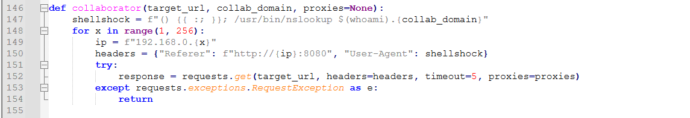

Attempts to trigger an external DNS lookup to a collaborator domain (e.g., Burp Collaborator).

11. url_encode(original_url)



URL-encodes a string.

12. extract_links(url, proxies=None)

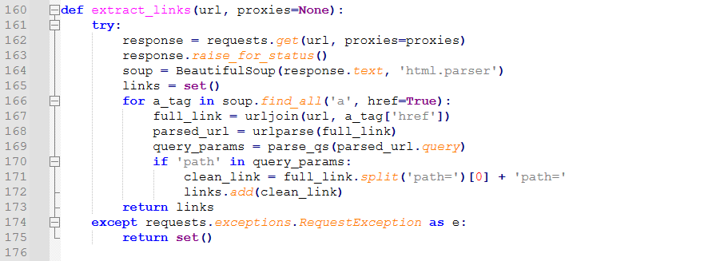

Uses BeautifulSoup to extract all <a href> links and looks for path= query parameters.

13.process_payload(…)



Takes an IP template and modifies the middle part with a number i to generate a new internal IP address and send it to ssrf_post().(Bruteforce attack)

14. save_to_json(data, filename)

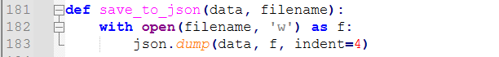

Saves results to a JSON file.

15. display_json(data)

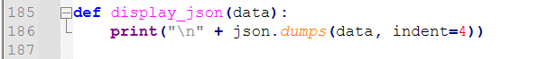

Prints JSON-formatted results to console.

16. save_to_csv(data, filename)

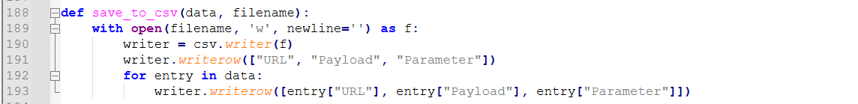

Saves results to a CSV file.

17. display_csv(data)



Prints CSV-style formatted results to console.

**Main Scanner Logic**

1. process_single_url(base_url, ssrf_payloads, path_payloads, args, proxies)

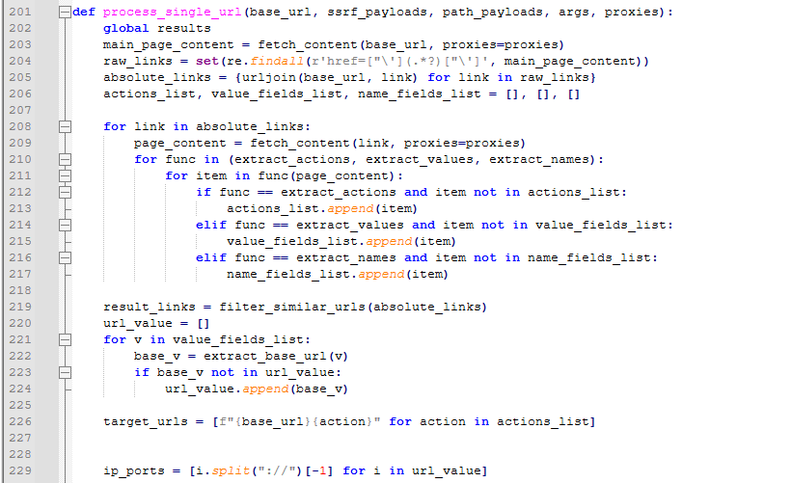

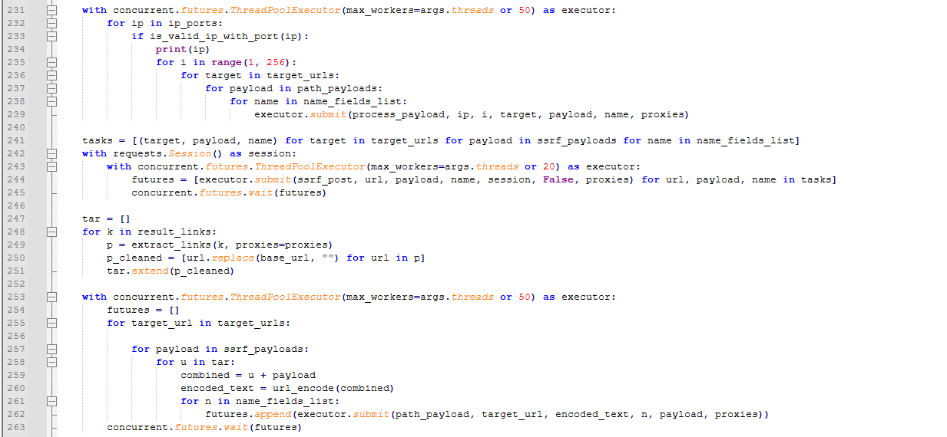

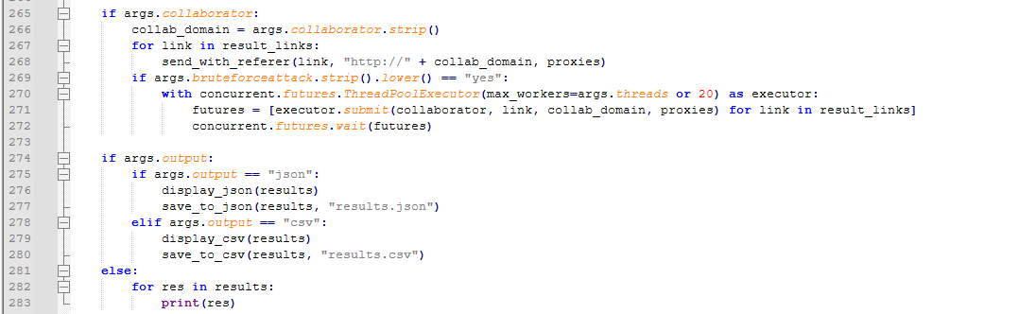

This is the heart of one-target scanning:

Crawl main page to collect all links (href=) and normalize to absolute URLs.

For each link:

1. Fetch page content.
2. Extract all action=, value=, name= fields.
3. Deduplicate similar URLs and base URLs.
4. Build list of SSRF targets by combining base URL + each extracted form action.
5. Brute‑force path-based SSRF
6. For each discovered hostname:port from URL values, try varying trailing numbers 1–255.
7. Concurrently submit path_payload to each form endpoint.
8. Using all (form‑action, ssrf_payload, param_name) combinations, POST concurrently.
9. Chained SSRF via “path=”
10. Extract additional “path=” links from all result pages, append each SSRF payload, URL‑encode, re‑POST.
11. Blind SSRF (Collaborator) If configured, run send_with_referer and full collaborator scan.
12. Output Print or save to JSON/CSV, depending on CLI flags.

2. class SSRFScanner:

A) def __init__(….)

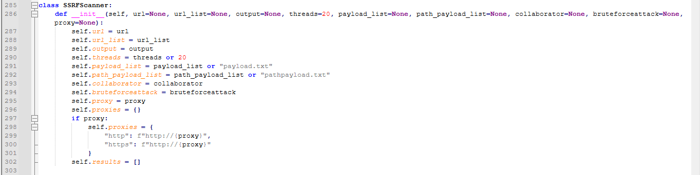

Initializes the scanner with:

Target URL or list

Payload files, Collaborator domain, Proxy settings, Thread count, Output format

B) scan(self)

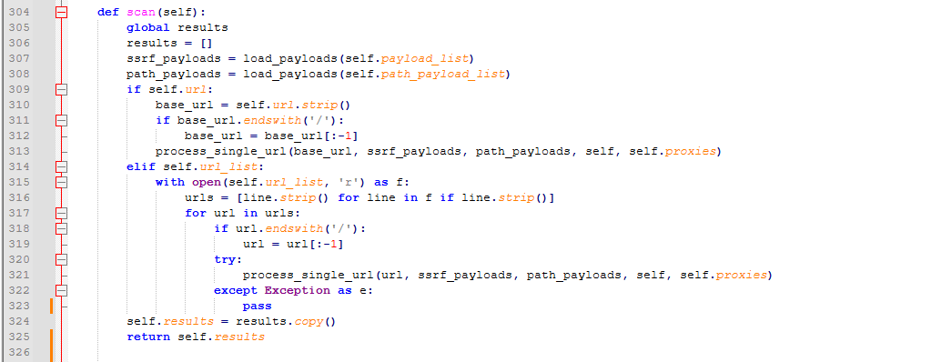

Runs the scanner against each URL.

## SSTI Detection Technique

## Path Traversal Detection Technique

## XSS Detection Technique

The XSSHunter is an advanced tool designed to detect Cross-Site Scripting (XSS) vulnerabilities. Key features include:

* **Crawling**: Discovers and processes links, forms, and URL parameters on the target site.
* **Payload Injection**: Tests reflected, stored, DOM-based, and polyglot XSS using context-specific payloads.
* **Concurrent Execution**: Uses multithreading for efficient crawling and testing.
* **DOM Testing**: Leverages Playwright for browser-based DOM XSS detection.
* **Proxy Integration**: Supports Burp Suite proxy for traffic interception.
* **Output Formats**: Generates reports in JSON, CSV, or XML.
* **Rate Limiting**: Configurable delays between requests to avoid detection.

**Imports & Setup**

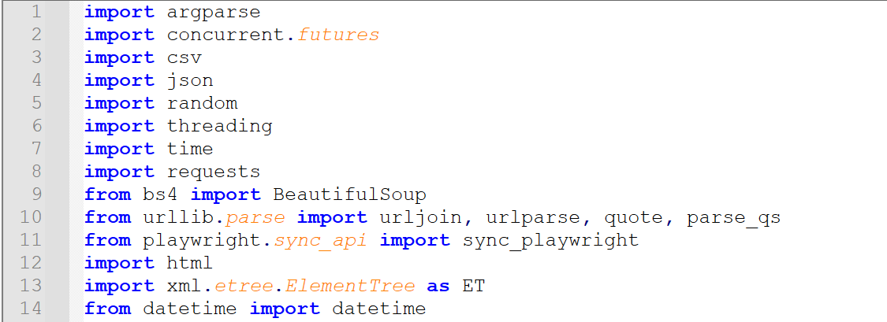

**argparse**  
Handles command-line argument parsing (target URL, workers, output format).

**concurrent.futures**  
Manages multithreading for parallel crawling and testing.

**requests**  
Sends HTTP requests to interact with the target application.

**bs4 (BeautifulSoup)**  
Parses HTML content to extract forms, links, and input fields.

**urllib.parse (urljoin, urlparse, quote, parse_qs)**  
Manipulates URLs and encodes payloads.

**playwright**  
Automates Chromium for DOM XSS detection (e.g., hashchange, sink testing).

**json, csv, xml.etree.ElementTree**  
Formats and saves scan results.

**datetime**  
Adds timestamps to vulnerability reports.

**Key Methods**

1. get_xss_payloads(context)  
   Returns XSS payloads based on context:
   * reflected: Classic payloads (e.g., " onmouseover="alert(1)).
   * dom: Hash-based and JavaScript URI payloads.
   * polyglot: Multi-context payloads.
   * sink_specific: Payloads targeting sinks like innerHTML or document.write.
2. crawl(url, depth)  
   Recursively crawls the target URL:
   * Extracts links and forms using BeautifulSoup.
   * Tests forms and URL parameters with payloads.
   * Limits depth to avoid infinite loops.
3. test_form(form_details, payload)  
   Injects payloads into form fields and submits requests. Detects:
   * Reflected XSS via response content.
   * Stored XSS using keywords like "thank you".
4. test_url_param(base_url, param, payload)  
   Tests URL parameters by appending payloads (e.g., ?param=<script>alert(1)</script>).
5. detect_vulnerabilities(response, payload, context, source)  
   Checks responses for:
   * Reflected payloads (encoded/decoded).
   * Event handlers (e.g., onload=, onmouseover=).
   * Stored XSS indicators.
6. run_dom_test(payload, test_type, sink)  
   Uses Playwright to test DOM-based XSS:
   * Triggers hashchange events.
   * Injects payloads into JavaScript sinks.
   * Detects alert/print execution via browser automation.
7. report_vulnerability(vuln_type, payload, location)  
   Logs findings and stores them in vulnerabilities list.
8. export_json()**,**export_csv()**,**export_xml()  
   Saves results to files in specified formats.

**Main Logic**

1. start_scan()
   * Initiates crawling and DOM testing concurrently.
   * Uses ThreadPoolExecutor for parallel execution.
   * Triggers report generation after completion.
2. run_dom_tests()  
   Executes DOM tests in parallel:
   * Standard DOM payloads.
   * Sink-specific tests (e.g., innerHTML, hashchange).

**Output**

Results include:

* Vulnerability type (e.g., Reflected, DOM, Stored).
* Payload used.
* Location (URL or form action).
* Timestamp.

**Here’s a flowchart to visualize the workflow of the XSSHunter scanner.**

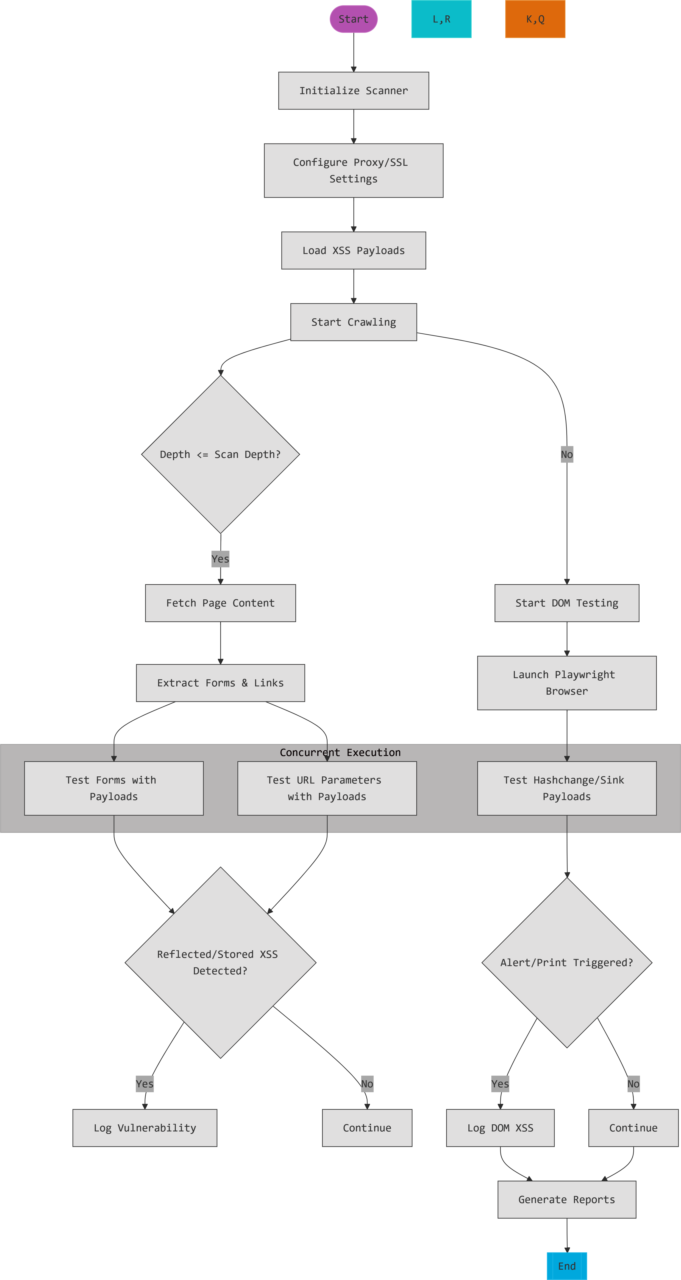

# Building the Vulnerability Scanner

## How the Scanner works?

### SSRF



### **SSTI**

#### Architectural Foundation

1. Core Components

System Building Blocks

| **Component** | **Code Reference** | **Purpose** |
| --- | --- | --- |
| Main Scanner Class | SSTIScanner | Coordinates scanning workflow |
| Parameter Discovery | SiteCrawler | Finds input fields/URL parameters |
| Vulnerability Detectors | ErrorBasedEngineDetector + EvaluationBasedEngineDetector | Confirms SSTI existence |
| Exploitation System | SSTIExploiter | Executes attacks post-detection |
| Payload Repository | TemplateDB | Stores engine-specific payloads |
| Scenario System | ScenarioHandler | Handles special cases/lab environments |

**Technology Stack**

*Critical dependencies and their roles in the system:*

| **Library** | **Purpose** | **Usage Context** |
| --- | --- | --- |
| requests | HTTP request handling with session persistence | Target interaction, vulnerability probing |
| BeautifulSoup (bs4) | HTML/XML parsing for parameter discovery | Site crawling, form extraction |
| argparse | Command-line interface (CLI) configuration | User input handling |
| concurrent.futures | Parallel execution of scanning tasks | Multi-threaded parameter testing |
| re | Regex pattern matching | Error analysis, payload detection |
| urllib3 | Low-level HTTP client with SSL/TLS controls | Proxy configuration, warning suppression |
| json/csv | Report generation in structured formats | Output serialization |
| datetime | Timestamping of findings | Report metadata |

**Key Library Explanations**

**requests**

Manages all HTTP(S) communications

Handles cookies, redirects, and proxy configurations

Provides timeout controls for safe scanning

**BeautifulSoup**

Analyzes HTML structure during site crawling phase

Extracts form parameters and hidden inputs

Identifies reflection points in rendered content

**concurrent.futures.ThreadPoolExecutor**

Enables parallel scanning of multiple parameters

Manages thread pool for reflection tests (Phase 2)

Accelerates engine detection (Phase 3)

**argparse**

Processes command-line arguments (URLs, output format, etc)

Implements help system and input validation

Configures proxy settings and thread counts

**re**

Identifies template engine fingerprints in error messages

Extracts executed command output between TINJ_* markers

Validates parameter reflection through pattern matching

2. Template Payload Database

*Centralized repository for vulnerability patterns and exploit templates*

**Key Roles**:

Stores engine fingerprints (regex patterns)

Contains validation payloads (e.g., {{7*7}})

Provides exploit templates (command/file access)

Documents engine-specific constraints

**Critical Integration Points**:

Used by ErrorBasedEngineDetector and EvaluationBasedEngineDetector

Accessed by SSTIExploiter during attack execution

Version-controlled via template_db.json

Schema Overview

{  
 "engines": {  
 "EngineName": {  
 "detection": {  
 "error_regex": ["Pattern1", "Pattern2"],  
 "evaluation": {  
 "payload": "TEST_EXPRESSION",  
 "expected": "EXPECTED_RESULT"  
 },  
 "reflection_markers": ["DELIMITERS"]  
 },  
 "exploit": {  
 "command_exec": {  
 "payload": "EXPLOIT_TEMPLATE",  
 "description": "Usage context"  
 },  
 "file_read": {  
 "payload": "FILE_ACCESS_TEMPLATE"  
 }  
 }  
 }  
 }  
}

Key Components

**Detection Signatures**

error_regex: Patterns to identify engines from error messages

evaluation: Mathematical tests to confirm template execution

reflection_markers: Character sequences that indicate template context

**Exploit Templates**

command_exec: OS command injection payloads

file_read: File system access patterns

reverse_shell: Pre-built connection templates

Integration with Scanning Workflow

**Detection Phase**

# ErrorBasedEngineDetector uses error_regex  
if re.search(pattern, response.text):  
 identify_engine()

**Verification Phase**

# EvaluationDetector uses evaluation payloads  
send(TEMPLATE_DB["Jinja2"]["detection"]["evaluation"]["payload"])

**Exploitation Phase**

# SSTIExploiter retrieves payload templates  
payload = TEMPLATE_DB[engine]["exploit"]["command_exec"]["payload"].replace("COMMAND", user_input)

3. Component Hierarchy

Structural Relationships

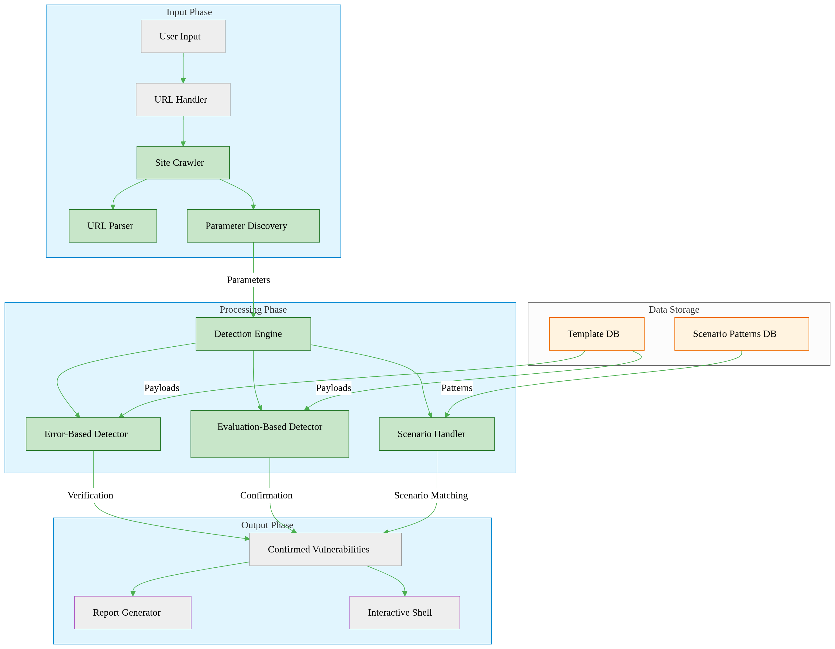

**The scanner consists of 4 essential components:**

**SSTIScanner**

The brain of the system

Manages the scanning workflow:  
URL Input → Parameter Discovery → Engine Detection → Exploitation

Handles threading and session management

**Detection Tools**

**Error Detector**: Looks for template engine fingerprints in error messages

**Evaluation Detector**: Sends math payloads (e.g., {{7*7}}) to detect execution

Work together to confirm vulnerabilities

**SSTIExploiter**

Takes verified vulnerabilities and:

Executes system commands

Reads files

Maintains interactive sessions

**Support Systems**

**Site Crawler**: Discovers parameters by analyzing pages/forms

**Template Database**: Stores engine-specific attack payloads

**ScenarioHandler**: Special logic for lab environments

4.1.2.2 Scanning Workflow

Phase 1: Target Initialization

*Prepares the scanning environment and validates the target*

GUI Interface Overview

GUI Input Interface  
*Caption: Scanner input interface showing configuration fields*

User Inputs

**Target Specification**:

Single URL (e.g., https://example.com/search)

*OR* text file containing multiple URLs (one per line)

**Configuration Options**:

Number of parallel scanning threads

Proxy server address/port (optional)

Output report format (JSON/CSV/XML)

Specific parameters to test (optional list)

Input Flow Sequence

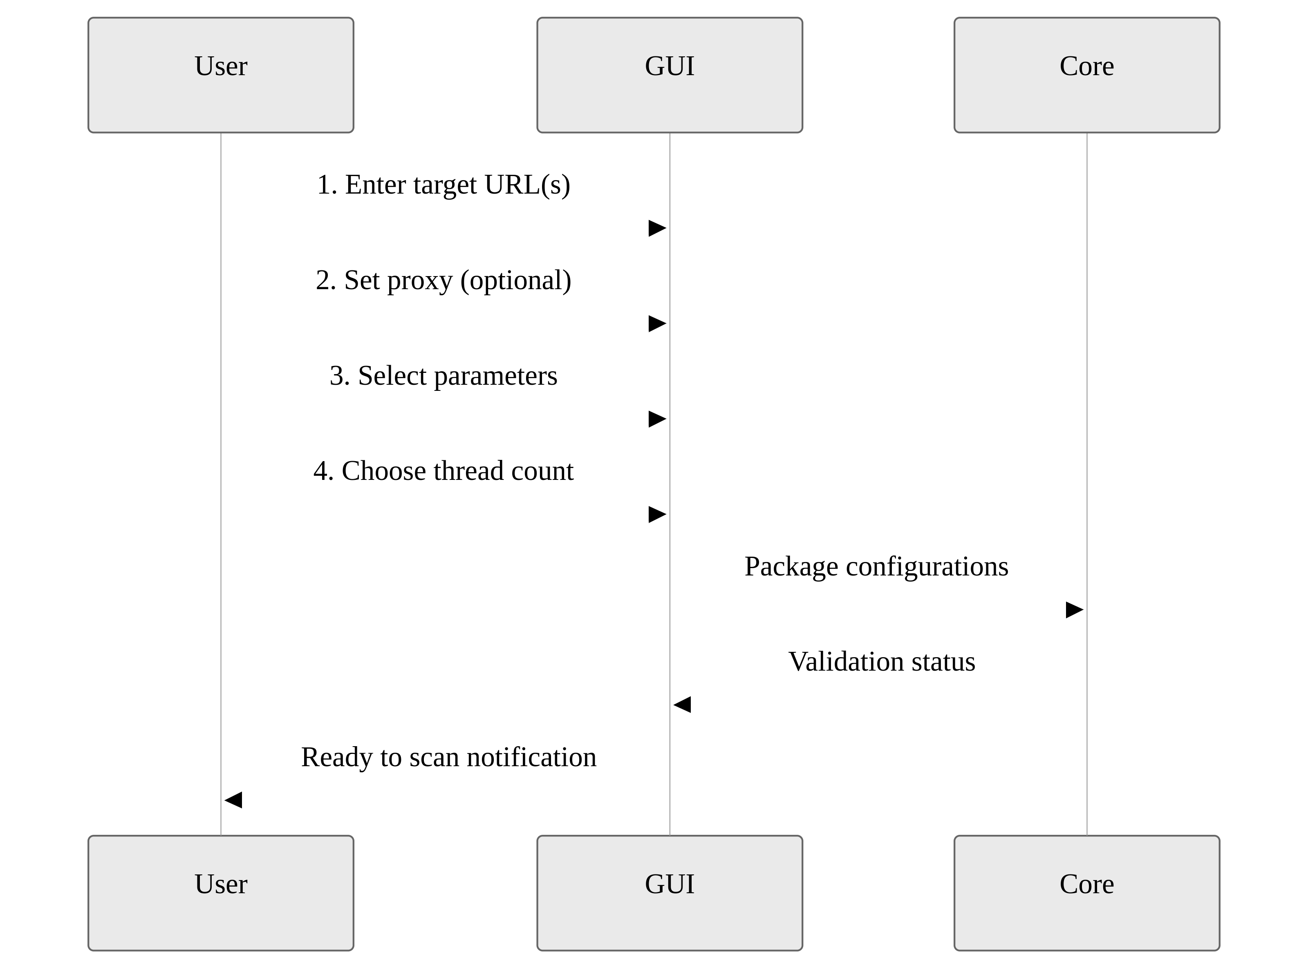

Step 1: Session Setup

# SSTIScanner.__init__  
self.session = requests.Session()  
self.session.proxies = proxies

Creates persistent HTTP connection preserving:

Authentication cookies

Custom headers

SSL/TLS session state

Disables SSL certificate verification for debugging

Step 2: Proxy Configuration

Applies user-provided proxy settings to all traffic

Supports both HTTP/HTTPS proxy types

Maintains connection reuse for efficiency

Step 3: Reachability Check

Sends test request to first URL

Validates response:

**Success**: HTTP 200 status → Continue scan

**Failure**:

Invalid URL format → Terminates immediately

Connection timeout → Logs error, skips URL

Step 4: Scenario Pre-Check

# ScenarioHandler.detect_scenario  
if re.search(r"Basic server-side template injection", response_text):  
 return Scenario2

Scans initial response content for:

Predefined vulnerability markers

Decision logic:  
*If scenario pattern detected* → Specialized handling  
*If no patterns found* → Standard scanning

Failure Handling

**Invalid URLs**: Terminates with format examples

**Unreachable targets**: Displays troubleshooting tips

**Proxy failures**: Attempts direct connection fallback

*This phase only establishes working conditions - no vulnerability testing occurs here.*

Phase 2: Parameter Discovery

*Identifies potential injection points through comprehensive analysis*

Key Objective:

Find all user-controllable inputs that reflect values back in responses

Step 1: Site Crawling

# SiteCrawler.crawl()  
forms = soup.find_all('form')  
inputs = [input_tag['name'] for form in forms for input_tag in form.find_all('input')]  
  
# SiteCrawler._extract_params_from_url()  
query = urlparse(url).query  
params = parse_qs(query).keys()

**Initial URL Analysis**

Starts at user-provided URL

Follows same-domain links up to configurable depth

Preserves session cookies for authenticated areas

**Multi-Source Extraction**

**HTML Forms**:

<input> fields (text/email/search types)

<textarea> content

Hidden parameters (<input type="hidden">)

**URL Query Strings**:

Parameters after ? (e.g., ?search=test)

**Link Parameters**:

URL parameters in <a href=""> tags

Step 2: Reflection Verification

# test_parameter_reflection()  
test_res = session.get(url, params={param: "TINJ_REFL_TEST"})  
verify_res = session.get(url, params={param: "TINJ_VERIF_123"})  
if test_value in test_res.text and verify_value in verify_res.text:  
 return True

**Strict Two-Stage Validation:**

**Initial Test**

Injects unique string (e.g., TINJ_REFL_7BxY9z)

Checks exact match in:

Response body content

HTTP headers

Redirect URLs

**Confirmation Test**

Sends different verification string (e.g., TINJ_VERIF_4QwP2m)

Requires both strings to appear unmodified

**Filter Logic:**  
Parameter survives only if:

Reflects both test values exactly

No encoding/truncation detected

Output Handling

**Passed Parameters**: Queued for engine detection

**Failed Parameters**: Permanently excluded

**Discovery Report**:

{  
 "discovered_parameters": ["search", "email", "filter"],  
 "reflected_parameters": ["search", "email"]  
}

Special Considerations

Avoids destructive operations during crawling

Limits recursion depth to prevent infinite loops

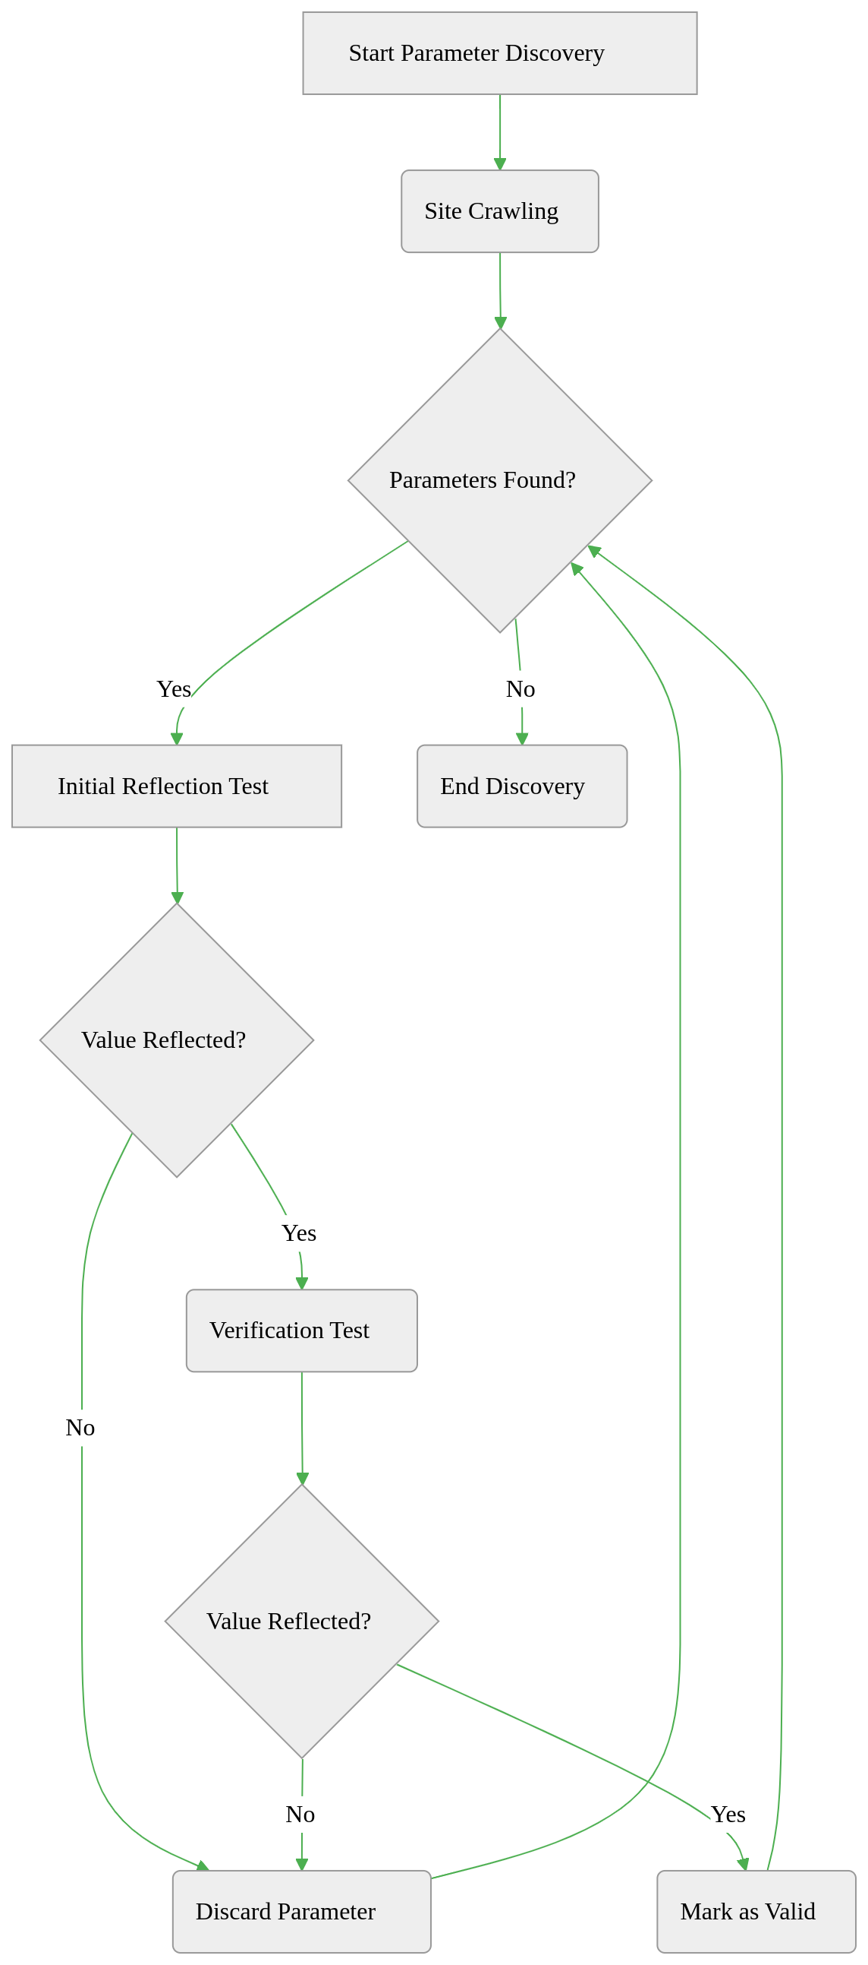

Phase 3: Engine Identification

*Determines the template engine through pattern analysis and execution testing*

Key Objective:

Confirm the server-side template engine (e.g., Jinja2, Twig) using two verification methods

Step 1: Error Pattern Analysis

# ErrorBasedEngineDetector.detect()  
response = session.get(url, params={param: error_payload})  
for pattern in engine_patterns:  
 if re.search(pattern, response.text):  
 return engine

**Method**:

Sends malformed template syntax to trigger errors

Example payload: ${<\%[%'}}%\

Analyzes error messages for fingerprints:

**Jinja2**: Contains "jinja2.exceptions.TemplateSyntaxError"

**Twig**: Shows "Twig_Error_Syntax"

Records partial matches for secondary verification

**Outcome**:

If **Error Fingerprint Found** → High-confidence engine identification  
Else → Proceed to Step 2

Step 2: Evaluation-Based Detection

# EvaluationBasedEngineDetector.detect()  
payload = self.payload_map[engine]["payload"]  
response = session.get(url, params={param: payload})  
if data["expected"] in response.text:  
 return engine

**Method**:

Sends engine-specific arithmetic payloads:

**Jinja2**: {{7*'7'}} → Expected output: "7777777"

**Twig**: {{7*7}} → Expected output: "49"

Checks for mathematical execution evidence:

Direct output match (e.g., "49" appears in response)

Partial pattern match (e.g., "777" in truncated responses)

**Verification Logic**:

**Full Match**: Confirms template engine definitively

**Partial Match**: Cross-references with error analysis results

**No Match**: Marks engine as "Unknown" for manual review

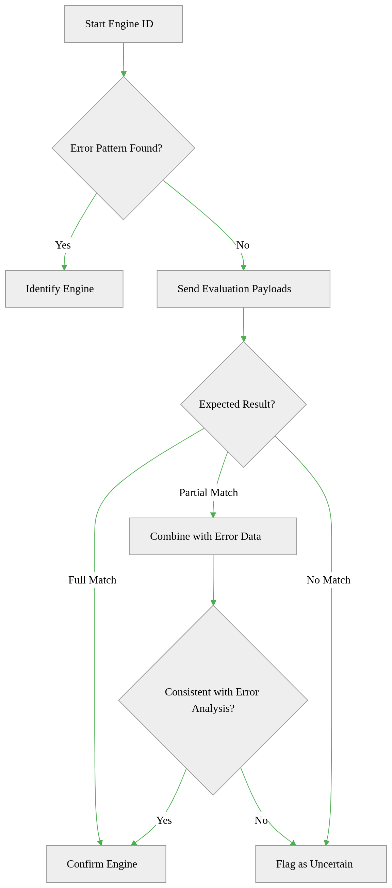

Phase 4: Post-Detection Actions

*Executes payloads and delivers results after confirming vulnerabilities*

Key Objective:

Leverage identified vulnerabilities for controlled exploitation and reporting

Step 1: Exploitation Launch

# SSTIExploiter.execute_command()  
payload = self.payloads["exec"].replace("COMMAND", command)  
response = self.session.get(url, params={self.param: payload})

**Process**:

Retrieves engine-specific payloads from TemplateDB:

**Command Execution**: {{ self.__init__.__globals__... }} (Jinja2)

**File Read**: ${product.getClass()...} (Freemarker)

Injects payload into confirmed vulnerable parameter

Validates command execution/output sanitization

**Safety Measures**:

Timeout enforcement (15s default)

Payload sandboxing to prevent accidental damage

Step 2: Interactive Shell

# interactive_shell()  
while True:  
 cmd = input("tinj-shell» ")  
 if cmd.startswith("read "):  
 print(exploiter.read_file(cmd[5:]))  
 else:  
 print(exploiter.execute_command(cmd))

**Features**:

Real-time command execution interface

Context-aware parsing:

read /etc/passwd → Auto-uses file read payload

whoami → Uses command execution template

Output filtering to remove template artifacts



**Example Flow**:

User types whoami

Tool selects command execution template for detected engine

Injects {{ self.__init__...popen('whoami') }}

Server returns TINJ_STARTrootTINJ_END

Tool displays cleaned output: root

Step 3: Report Generation

**Output Formats**:

| **Format** | **Structure** | **Use Case** |
| --- | --- | --- |
| JSON | Nested objects with full technical details | Developer analysis |
| CSV | Tabular data with key fields | Spreadsheet integration |
| XML | Hierarchical vulnerability listing | Enterprise system ingestion |

**Report Contents**:

Vulnerable URL(s)

Confirmed parameter(s)

Template engine identified

Evidence snippets

Timestamp of discovery

Concurrency Management

Thread pool reused from earlier phases

Parallel tasks:

Background report writing

Shell input/output handling

Payload retries on timeout

This phase transforms detection results into actionable outcomes while maintaining operational safety.

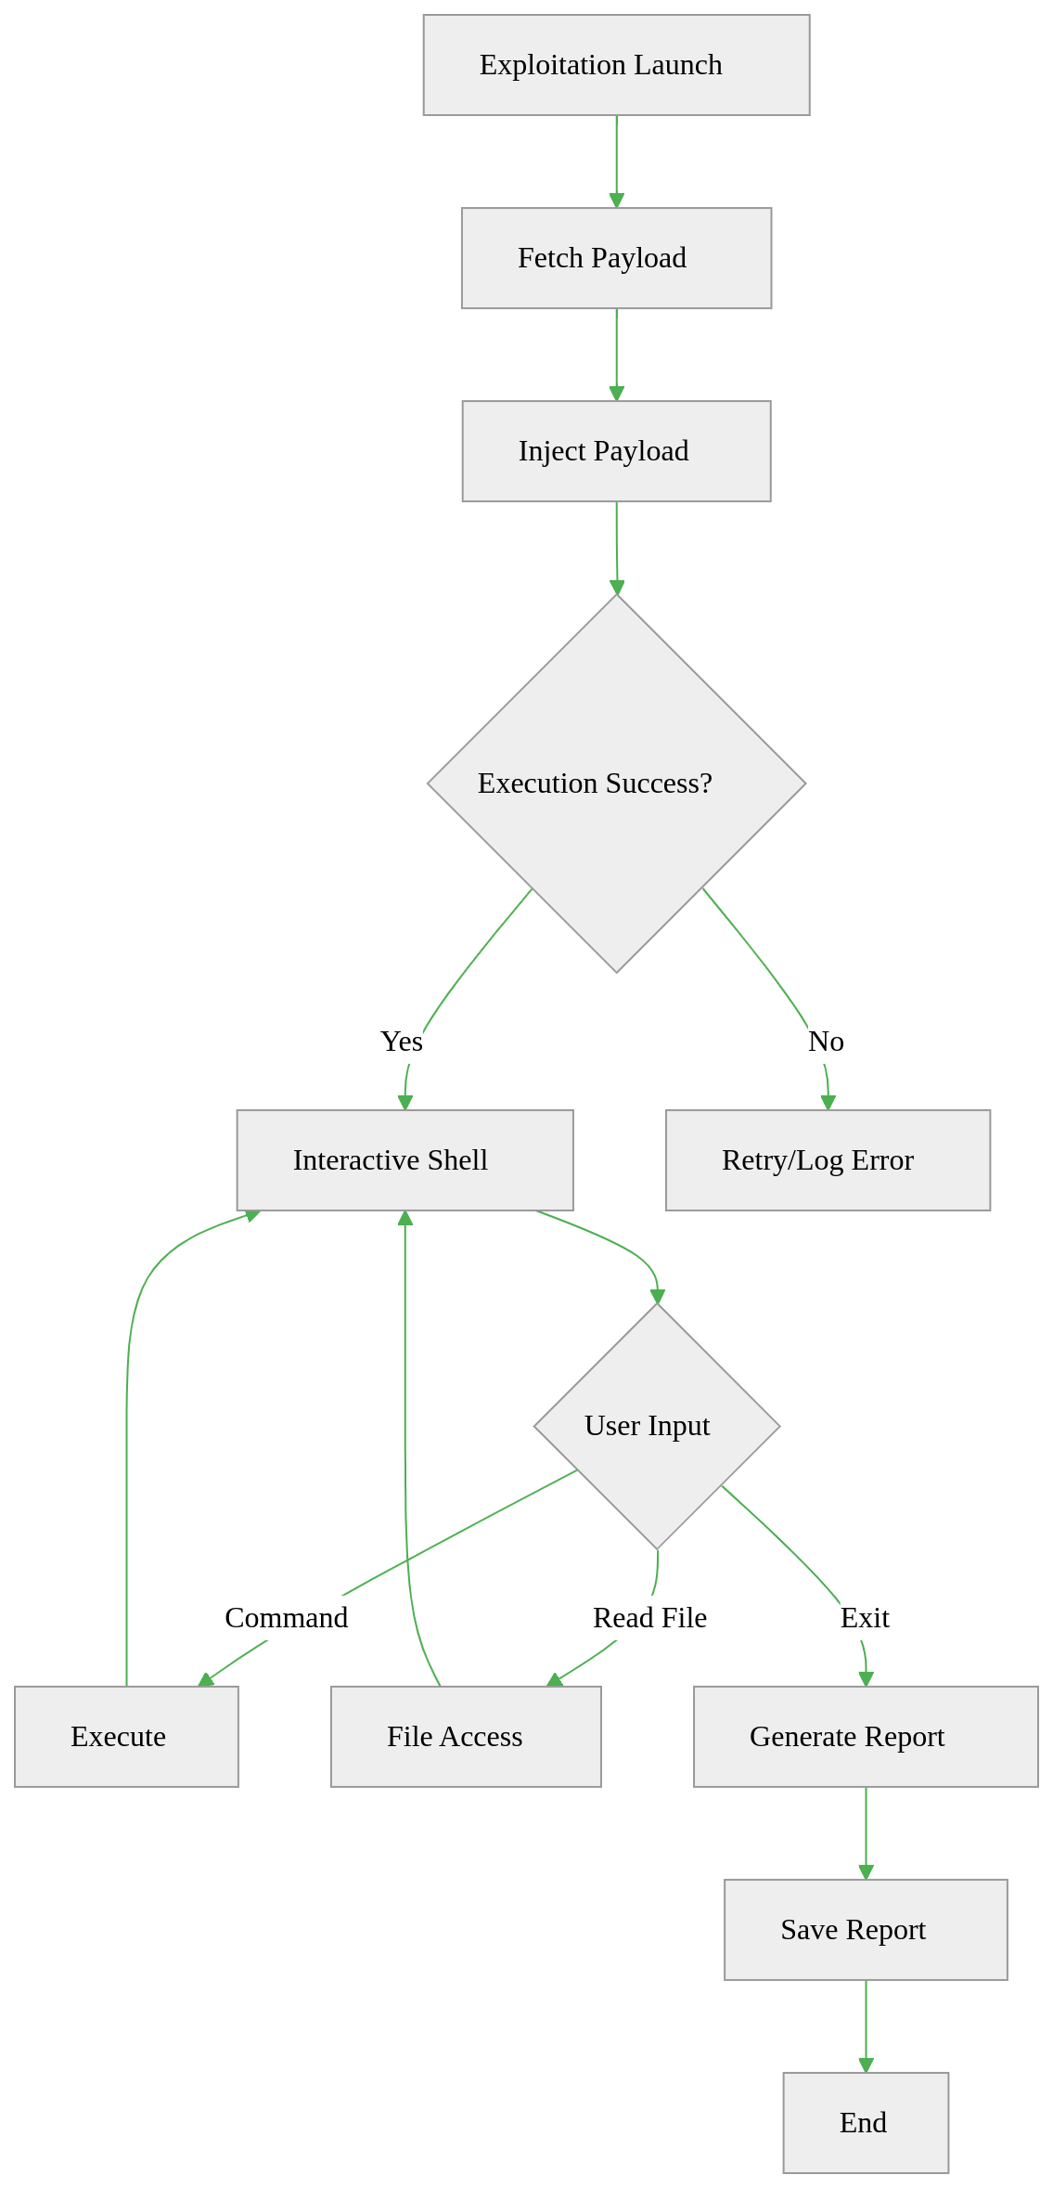

## Choice of Programming and Libraries

## User Graphic interface (GUI)

## Comparisons with other vulnerability

# Conclusion

## Summary of Achievements

## Potential Enhancements

## References