SSTI

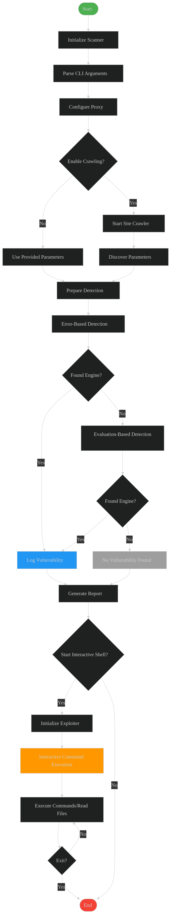

Key components mapped to your code:

1. **Site Crawler**: Handled by SiteCrawler class with BFS crawling
2. **Detection Methods**:
   * Error-based (ErrorBasedEngineDetector)
   * Evaluation-based (EvaluationBasedEngineDetector)
3. **Exploitation**:
   * SSTIExploiter class handling command execution/file reading
   * interactive_shell function for user interaction
4. **Reporting**:
   * JSON/CSV report generation in generate_report
5. **CLI Flow**:
   * Argument parsing and configuration
   * Proxy setup and verbosity control

Visual Features:

1. Color-coded nodes for different phases
2. Clear decision points (diamonds)
3. Parallel detection workflows
4. Interactive exploitation loop
5. Error handling paths