תיק מתכנת:

אדר בודומסקי 206539363

יובל ג'יראד 209148550

שי פינסקי 316135029

אריאל דהן 315682054

**שימוש ב-API:**

* Stripe לטובת תשלום אינטרנטי
* OAuth לטובת התחברות באמצעות חשבון גוגל
* NextAuth לטובת התחברות מאובטחת

מבנה DB:

בחרנו להשתמש ב-MongoDB לאחסון פרטי המשתמשים והמוצרים (קישור לתמונה שמאוחסנת בFIREBASE) וב-Firebase לאחסון תמונות. בנוסף, השתמשנו ב-Stripe לצורך יצירת תשלומים מאובטחים וטופס מילוי פרטי תשלום גם מאכסן היסטורית תשלומים.

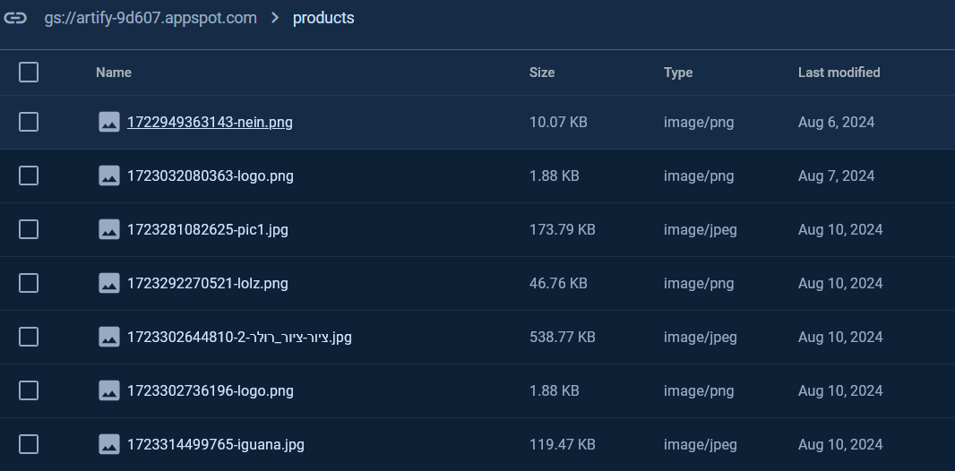

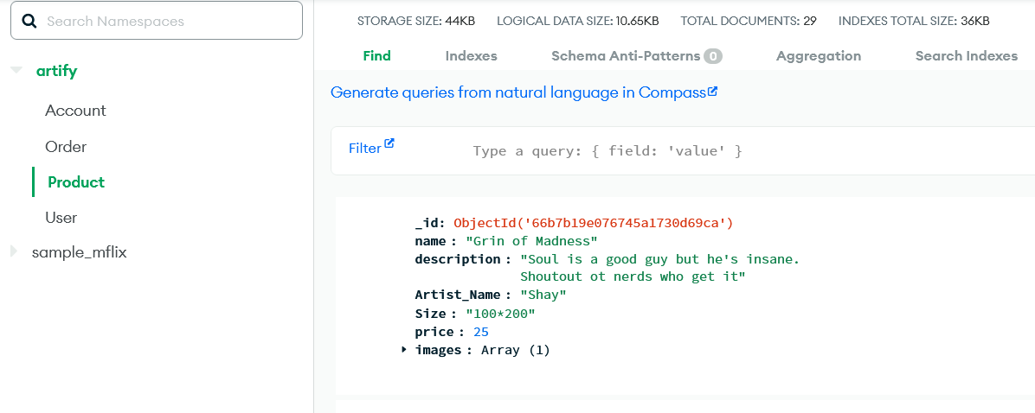

Artify Application Components and Functions

# Log-in Page

|  |  |  |  |  |
| --- | --- | --- | --- | --- |
| **Component/Function** | **Functionality** | **Activation** | **Parameters** | **Returns** |
| LoginForm | Renders the login form and handles the process of validating the user info. | Login button in the user menu. | User object. | JSX with a login form. |
| onSubmit() | Handles the form submission and setting the logged user, on success routes user back to homepage. | Login button in the login page. | Submitted user email and password. | Nothing. |

# Registration Page

|  |  |  |  |  |
| --- | --- | --- | --- | --- |
| **Component/Function** | **Functionality** | **Activation** | **Parameters** | **Returns** |
| registerForm | Renders the registration form and handles the process of creating a new user account. | Clicking the 'Register' button in the user menu. | Username, email, and password. | JSX with a registration form. |
| onSubmit() | Handles the form submission, creating a new user account in the database. And automatically logging to the new user. | Submitting the registration form. | Username, email, and password. | Nothing. |

# Home Page

|  |  |  |  |  |
| --- | --- | --- | --- | --- |
| **Component/Function** | **Functionality** | **Activation** | **Parameters** | **Returns** |
| Home Banner | Displays a landing page for the website. | Clicking on the ‘Artify’ logo at the top of screen or the ‘Home’ button in the Navigation bar. | None | JSX with a simple landing page. |

# MarketPlace

|  |  |  |  |  |
| --- | --- | --- | --- | --- |
| **Component/Function** | **Functionality** | **Activation** | **Parameters** | **Returns** |
| ProductsCard | On click navigates to the product details. | Clicking on “MarketPlace” button in the Navigation Bar. | Product ID with URL. | JSX with detailed product information. |

# Exhibition

|  |  |  |  |  |
| --- | --- | --- | --- | --- |
| **Component/Function** | **Functionality** | **Activation** | **Parameters** | **Returns** |
| productPreview | Displays a product in a small preview card. | Clicking on “Exhibitions” button in the Navigation Bar. | Product ID and data. | A single product card. |

# Product Form

|  |  |  |  |  |
| --- | --- | --- | --- | --- |
| **Component/Function** | **Functionality** | **Activation** | **Parameters** | **Returns** |
| AddProductForm | Allows logged users to add a new product to the market place and exhibitions. | Clicking on the 'Add Product' button in the Nav bar. | Product details. | JSX with a form to add new products. |

# Product Management

|  |  |  |  |  |
| --- | --- | --- | --- | --- |
| **Component/Function** | **Functionality** | **Activation** | **Parameters** | **Returns** |
| ManageProductsClient | Displays a list of products with options to view or delete them. | Navigating to the 'Manage Products' page through the user menu. | Array of products. | JSX with of a table with product details and action buttons. |
| handleDelete() | Delete product from the site and remove the product from the data bases. | Clicking the trash bin icon button in “Manage Product” page. | product | Nothing, will remove product from both data bases and UI. |
| ProductDetails | Display the full information card of a single product. | Pressing a product card in the market place page or the eye icon in the manage products page. | Product details. | JSX of the image along with product information and an ‘Add To Cart’ button. |
| handleAddProductToCart() | Adds a product to the cart. | Pressing the ‘Add To Cart’ button on a product details page. | Product details. | Updated cart. |

# Purchases

|  |  |  |  |  |
| --- | --- | --- | --- | --- |
| **Component/Function** | **Functionality** | **Activation** | **Parameters** | **Returns** |
| OrderClient | Displays a list of purchases made by the logged user. With the option to view specific orders. | Navigating with the 'Your Purchases’ button through the user menu. | Array of orders. | JSX with a table of purchase details and action button. |
| OrderDetails | Displays a list of all items under a specific order. | Clicking the eye icon button in “Your Purchases” page. | Order | JSX with a list of items in an order and action buttons. |
| OrderItem | Displays a specific item of a specific order. | Clicking the eye icon button in “Your Purchases” page. | item | JSX of an item in an order and action button. |
| DownloadImage | Displays a ‘Download Image’ button. | Clicking the eye icon button in “Your Purchases” page. | item | JSX of a button for image download. |
| handleDownload() | Opens art work on a different tab. | Clicking the ‘Download Image’ button in a specific order page. | none | Nothing, opens a new tab with the image. |

# Cart

|  |  |  |  |  |
| --- | --- | --- | --- | --- |
| **Component/Function** | **Functionality** | **Activation** | **Parameters** | **Returns** |
| CartClient | Renders the shopping cart with its items, allowing logged users to proceed to checkout. | Pressing the cart icon. | User object and cart items. | JSX representing the shopping cart interface. |
| ContentItem | Renders a single item for the cart interface. | Pressing the cart icon. | Cart item. | JSX for the specific item with a button for item removal from cart. |
| handleRemove ProductFromCart() | Removes a product from a cart Product list. | Pressing the ‘Remove’ button in the cart. | Cart item. | Nothing. |

# Checkout

|  |  |  |  |  |
| --- | --- | --- | --- | --- |
| **Component/Function** | **Functionality** | **Activation** | **Parameters** | **Returns** |
| CheckoutClient | Handles payment processing and displays the appropriate UI. | Pressing the checkout button in cart page. | User object and cart items. | JSX representing the checkout page. |
| CheckoutForm | Handles form input checks and filling. | Pressing the checkout button in cart page. | User object and cart items. | JSX representing the checkout form. |
| handleSubmit() | Handles submission of payment by using stripe API. | Pressing ‘Pay Now’ on the Checkout page. | Checkout form. | Nothing. |

# General Components

|  |  |  |  |  |
| --- | --- | --- | --- | --- |
| **Component/Function** | **Functionality** | **Activation** | **Parameters** | **Returns** |
| Footer | Displays the footer of the website. | None, always on display. | None. | JSX representing the footer. |
| Navbar | Displays the Navigation bar. | None, always on display. | None. | JSX representing the nav bar. |
| UserMenu | Displays pop up list of user options. | Pressing the user emoji icon on the navigation bar. | Current user. | JSX representing the user menu. |
| MenuItem | Displays a single button of the user menu. | Pressing the user emoji icon on the navigation bar. | Current user. And function to be activated when pressing the button. | JSX representing a user menu button. |
| CartCount | Displays a cart Icon button. And amount of items in the cart. | None, always on display. | None. | JSX representing the Cart icon. |
| DarkLightButton | Displays the dark/light mode toggler. | None, always on display. | None. | JSX representing the theme icon. |
| NavigationItems | Displays buttons to navigate the website. | None, always on display. | Current user. | JSX representing the navigation options. |
| NavItem | Displays a single button of the navigation items. | None, always on display. | Current user. | JSX representing a navigation option. |

# Custom Hook - useCart

This hook establishes a context for managing a shopping cart, providing functions to add, remove, and clear items, as well as handle payments and image downloads. It stores cart data in local storage for persistence across sessions. The hook tracks total quantity, amount, and product details in the cart. It offers a custom useCart hook for easy access to cart functionality throughout the application.

**קישורים למידע שנעזרנו בו:**

* [**https://www.mongodb.com/products/platform/atlas-database**](https://www.mongodb.com/products/platform/atlas-database)
* [**https://firebase.google.com/docs**](https://firebase.google.com/docs)
* [**https://console.cloud.google.com/**](https://console.cloud.google.com/)
* [**https://www.youtube.com/@NetNinja**](https://www.youtube.com/@NetNinja)
* [**https://www.youtube.com/@javascriptmastery**](https://www.youtube.com/@javascriptmastery)
* [**https://www.prisma.io/docs**](https://www.prisma.io/docs)