BCS Practitioner Certificate in Requirements Engineering
Classroom Activities: Delegate Pack

The Case Study: AutoRent Vehicle Rentals
AutoRent is a vehicle rental company. It rents cars and vans to customers from a network of local branches. AutoRent has commissioned a new computer system to run its rental operations.
The two key roles in the business:
Sales Person. Works at the front desk. Deals with customers, records new rentals, takes payments and records vehicle returns.
Workshop Supervisor. Works in the garage. Inspects every vehicle when it comes back from a rental and decides whether it is fit to go out again.
Keep this page to hand. Every activity across the three days builds on this scenario.

Activity 1: Spot the Problem (Topic 1)

Your Task
You have just joined the AutoRent project as the new business analyst. The previous analyst left suddenly, and the list below is the requirements list they left behind.
Read each requirement and ask yourself: if you were the developer who had to build this, or the customer paying for it, would you be happy?
There is at least one problem in every requirement. Some have more than one. For each requirement, note down what is wrong with it. Use the list of common problems with requirements from the slides as your checklist.
You do not need to fix the requirements yet. Just identify the problems. We will learn how to write them properly later in the course.
Work in your groups. You have 8 minutes.

The Requirements List
R1. The system shall be fast.
R2. The system shall allow the Sales Person to record a rental and record a return and produce monthly revenue reports and send marketing emails to previous customers.
R3. The system might allow customers to extend their rental if the Workshop Supervisor thinks it is a good idea.
R4. The system shall use a MySQL database with a three-tier architecture to store customer records.
R5. The system shall display available vehicles quickly and the search should be user-friendly.
R6. The system shall allow the Sales Person to record a vehicle inspection.
R7. Only the Workshop Supervisor shall be able to record a vehicle inspection.
R8. The system shall process refunds in accordance with the refund policy.
Your notes:
R1:
R2:
R3:
R4:
R5:
R6:
R7:
R8:

Activity 2: Before, During, After

Your Task
Interviews and workshops share a shape: things you do before, things you do during, and things you do after. Below are 18 actions from the AutoRent project. Some belong to an interview, some to a workshop, some to both.
As a table, sort every action into BEFORE, DURING or AFTER by writing its number in the correct column of the answer grid below. Every action goes in exactly one column.
You have 6 minutes. First table with a fully correct grid wins.

The 18 Actions
1. Send the Sales Person an agenda listing the topics you want to cover
2. Book a meeting room with a whiteboard and no interruptions for the requirements session
3. Define the objective: "agree the end to end returns process by 4pm"
4. Decide you will use scenario analysis and a rich picture during the session
5. Read the branch operations manual to prepare your question set
6. Choose which stakeholders must attend, and check the decision-maker is among them
7. Introduce yourself and explain how the information will be used
8. Explain the project background and why this person’s input matters
9. Ask "talk me through last Saturday’s busiest hour"
10. Ask a probing follow-up: "and what exactly happens when the card payment fails?"
11. Keep the discussion on track and park the interesting tangent about staff rotas
12. Make sure the quietest person in the room gets to speak before the branch manager answers again
13. Take notes throughout, or have a scribe capture the discussion
14. Summarise what you heard and let them correct you before anyone leaves
15. Assign every action an owner and a deadline
16. Write up the session notes
17. Send the summary and actions to everyone who attended and ask them to confirm accuracy
18. Book the follow-up session for the gaps your analysis has found

Your Answer Grid
BEFORE | DURING | AFTER

Activity 3: Choose Your Weapon – Technique Selection

Your Task
The AutoRent project is live and you are the BA team. Below are six situations from the project. For each one, choose the ONE best elicitation technique, and be ready to defend it two ways:
Knowledge type: what kind of knowledge are you hunting, and what does the technique matrix say about reaching it?

The Six Scenarios
Scenario 1. The Workshop Supervisor has inspected vehicles for fifteen years. Every interview so far has produced only "you just know when a van is not right." His inspection standard must be built into the new system’s digital checklist.
Technique:

Scenario 2. AutoRent’s head office holds a shelf of documents: the current rental terms and conditions, the branch operations manual, and three years of damage-claim reports. You start on the project Monday. No stakeholder is available until the following week.
Technique:

Scenario 3. The Sales Persons and the Workshop Supervisors disagree about who should be able to release a vehicle back into the rental pool after repair. Both groups feel strongly, and the branch managers want the argument settled once, with everyone committed to the outcome.
Technique:

Scenario 4. AutoRent wants an online booking feature. Customers have never had one, and when asked what they would want, the customer panel keeps saying things like "just make it easy" and "like other websites, I suppose." Nobody can describe anything concrete.
Technique:

Scenario 5. Head office suspects the five branches each process returns slightly differently, with local workarounds nobody has ever written down or even mentioned. The staff at each branch insist they all "just follow the standard process."
Technique:

Scenario 6. The finance director can give you exactly thirty minutes, once. She holds the rules for deposits, refunds and account-customer credit limits, rules that are documented nowhere but which she can state precisely when asked.
Technique:

Activity 4: The Sorting Office – Classify the Requirements

Your Task
Below are 12 requirements from the AutoRent project. As a table, classify each one as General, Technical, Functional or Non-functional by writing its number in the correct column of the grid below.
You have 6 minutes. One point per correct answer with a one-word reason (the category or sub-category name is enough). First table finished with the most correct wins.

The 12 Requirements
1. The system shall allow a Sales Person to record a new rental.
2. All customer-facing screens shall follow AutoRent’s brand guidelines and colour palette.
3. The system shall return vehicle search results within 2 seconds.
4. The system shall run on the existing branch desktop computers.
5. The project shall be delivered within this financial year using the current IT team.
6. A new Sales Person shall be able to complete a standard rental unaided after one hour of training.
7. The system shall send completed rental transactions to the existing finance system using AutoRent’s standard interface format.
8. The system shall comply with GDPR as defined in the data protection policy.
9. The system shall allow the Workshop Supervisor to update an inspection record.
10. Online booking pages shall meet WCAG accessibility standards.
11. In the event of total system failure, branches shall continue trading using the paper fallback procedure.
12. Completed rental records shall be retained for seven years and then securely deleted.

Your Answer Grid
GENERAL | TECHNICAL | FUNCTIONAL | NON-FUNCTIONAL

Activity 5: From Conversation to Catalogue

Worked Example: a Completed Requirements Catalogue Entry
The requirements catalogue is a structured list of requirements, each recorded with a set of attributes. Here is what one complete entry looks like. Every entry carries four kinds of information: its identity (ID, name), its meaning (description, type), its history (source, owner), and its test (priority, acceptance criteria).
ID | REQ-014
Name | Record vehicle inspection
Description | The system shall allow the Workshop Supervisor to record the outcome of a vehicle inspection, including the checks performed and whether the vehicle is fit for re-rental.
Type | Functional (data entry)
Source | Workshop Supervisor, interview 14 July
Owner | Workshop Supervisor
Priority | High
Acceptance criteria | An inspection record can be saved with all mandatory checks completed; a vehicle cannot be marked fit for re-rental with any check missing.
Note: attribute sets vary between organisations. This is a typical core set.

The Case Study
From your interview with Priya, AutoRent’s Operations Manager:
"Right, the big one first: customers keep ringing to ask if a vehicle is available, so I want them to be able to check availability themselves online, and ideally book it there and then. When they book, we obviously need their licence details captured, that is a legal thing, we cannot rent without a verified licence. Oh, and the whole thing needs to be quick, customers give up if websites are slow. It must work properly on phones too, most of our customers are on their phones. And whatever gets built has to talk to the branch system the staff already use, I am not having two separate systems. One more thing, when we are heaving on a summer Saturday, it cannot fall over."

Your Task
1. Write TWO requirements catalogue entries from Priya’s statement, using the worked example as your model. Pick any two requirements you find in her words. For priority, use High, Medium or Low. Use the blank templates below.
2. Write TWO user stories from the CUSTOMER’s perspective, in full "As a..., I want..., so that..." format: one for checking availability, one for booking online.
Work as a table. You have 13 minutes.

Catalogue Entry 1
ID
Name
Description
Type
Source
Owner
Priority
Acceptance criteria

Catalogue Entry 2
ID
Name
Description
Type
Source
Owner
Priority
Acceptance criteria

Your Two User Stories
Story 1: As a ______________, I want ______________________________________, so that ______________________________________
Story 2: As a ______________, I want ______________________________________, so that ______________________________________

Activity 6: Fix Them At Last

Your Task
Day one promise, redemption time. Get out your Activity 1 sheet. On day one you could see that R1 and R5 were bad, but you could not fix them. You have now classified requirement types, learned that non-functional requirements need numbers, and just watched five poorly expressed requirements get repaired on the slide.
Rewrite R1 and R5 properly. R5 is hiding a trap, find it. You have 4 minutes.
Reminder, the originals:
R1: The system shall be fast.
R5: The system shall display available vehicles quickly and the search should be user-friendly.

Your Rewrites
R1 rewritten:

R5 rewritten (careful, the trap):

Stretch (if your table finishes early), R3 rewritten: "The system might allow customers to extend their rental if the Workshop Supervisor thinks it is a good idea."

Activity 7: Letter the Requirements (MoSCoW)

Your Task
The business objective, non-negotiable: launch online booking to cut branch phone volume by 30% within six months.
Letter each of the eight requirements below M, S, C or W. For every letter, be ready to answer one question: if we launched without it, would the objective fail?
Work as a table. You have 6 minutes.

The Eight Requirements
1. Customers can check vehicle availability online. Letter: ______
2. Customers can pay online at the time of booking. Letter: ______
3. Customers can choose a preferred colour for their vehicle. Letter: ______
4. Online bookings appear automatically in the branch system staff use. Letter: ______
5. Customers can cancel their booking online. Letter: ______
6. The website shows a live chat function staffed by branch teams. Letter: ______
7. Customers receive an automatic email confirmation of their booking. Letter: ______
8. The system integrates with a future loyalty points scheme. Letter: ______

Activity 8: True or False – the Use Case Diagram

Your Task
Use the Vehicle Rental System use case diagram below. Mark each of the ten statements TRUE or FALSE. For every FALSE, be ready to say WHY it is false, the whys are where the marks are.
Work as a table. You have 4 minutes.
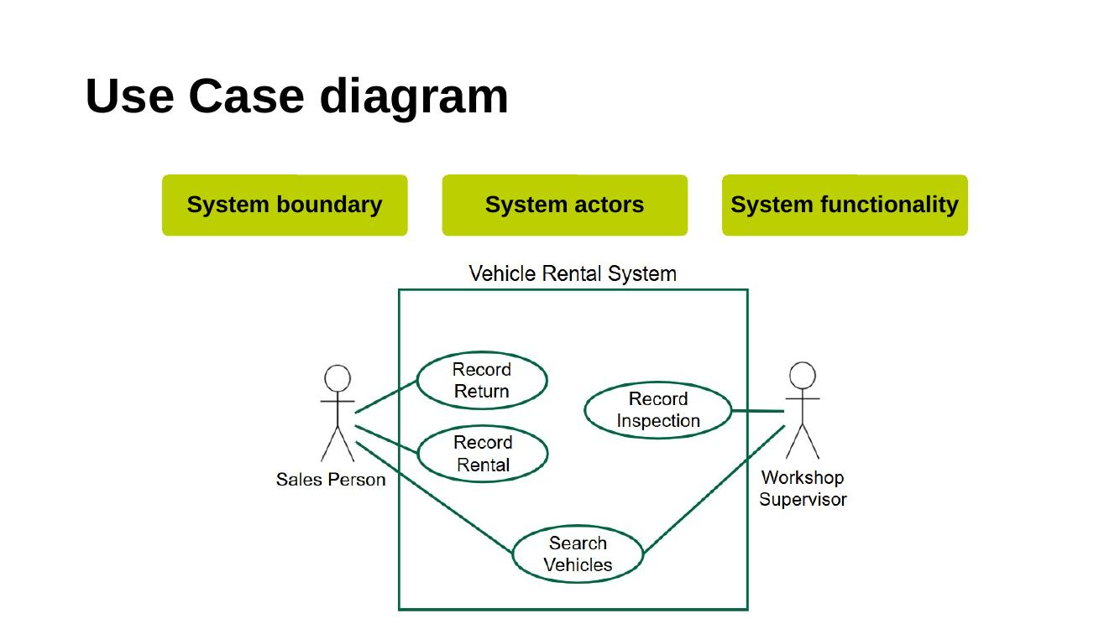
1. The Sales Person can record a vehicle inspection. T / F
2. Both actors can search vehicles. T / F
3. The Workshop Supervisor is part of the Vehicle Rental System. T / F
4. The diagram shows that a rental must be recorded before a return can be recorded. T / F
5. The system provides exactly four functions. T / F
6. Only the Workshop Supervisor can record an inspection. T / F
7. The diagram tells us what customer data the system stores. T / F
8. The rectangle around the use cases defines the scope of the system. T / F
9. The diagram shows how long it takes to record a rental. T / F
10. An actor can be another system, not just a person. T / F

Activity 9: Spot the Classes

Your Task
Read the scenario below. You are NOT drawing anything. Two questions only:
1. What CLASSES does the scenario contain? The test: is it a thing AutoRent needs to remember information about?
2. What ATTRIBUTES does each class hold? The test: is it a single piece of information about that thing?
Work as a table. You have 5 minutes.

The Scenario
"AutoRent is launching online accounts. A customer registers with their name, email address and a password. Once registered, they can make bookings online. For every booking, AutoRent records the start date, the end date, and the agreed daily rate."

Your Classes and Attributes
Class 1: Attributes:
Class 2: Attributes:
Class 3: Attributes:

Activity 10: Interrogate the Class Model

Your Task
The full AutoRent class model is below. You will not draw anything in this activity, the model is done. Your whole job is to read it accurately, which is exactly what the exam asks of you.
Answer the seven questions as a table. For every answer, state which line and which END of the line you read, reading direction is half the marks. You have 6 minutes.
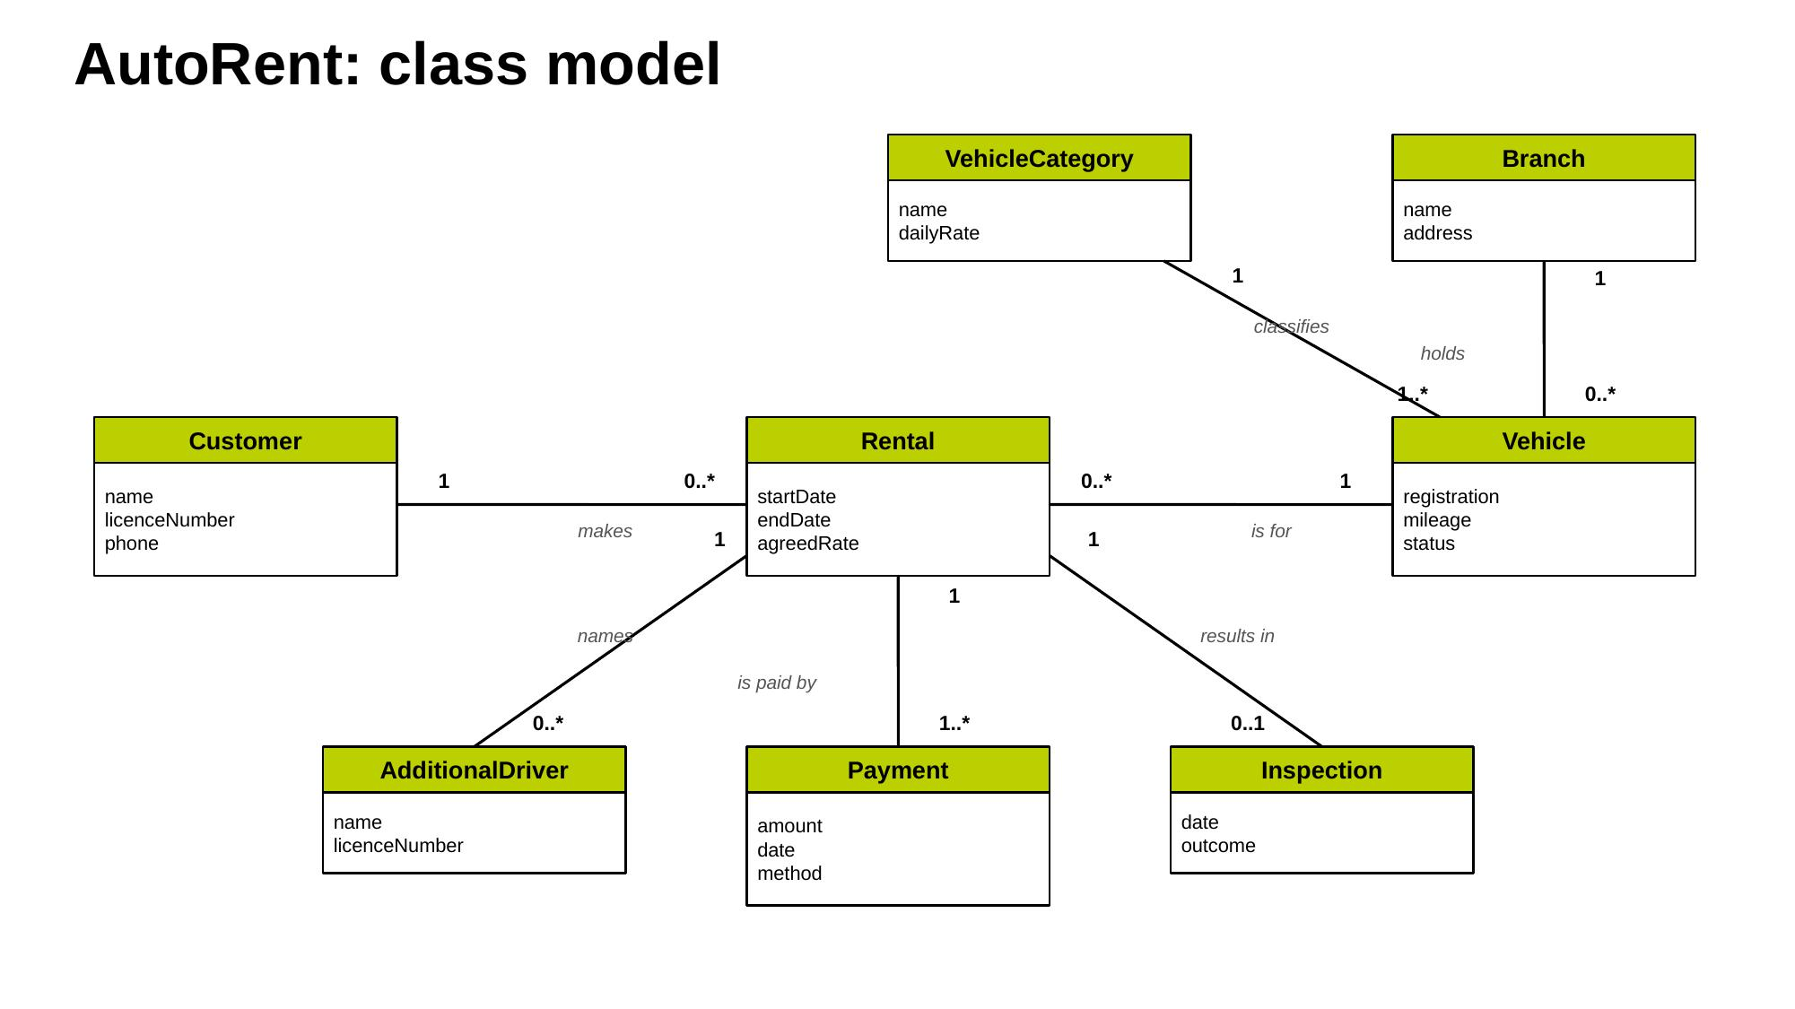
1. Can a rental exist without a customer?

2. What business rule does 1..* between Rental and Payment encode, and why is it not 0..*?

3. Inspection is 0..1 against Rental. Explain both numbers.

4. Can one vehicle be held at two branches?

5. AutoRent wants to create an Electric Vans category before buying any electric vans. Does the model allow it? What would you change, and who decides?

6. The insurance policy caps additional drivers at three per rental. Does the model enforce that? Fix it.

7. Compare this model with the use case diagram from Activity 8: which class has NO use case that creates its data?

Activity 11: Who Is Speaking?

Your Task
A validation review of the AutoRent requirements is underway. Below are nine things said in the room. For each, name WHO is speaking, from the seven stakeholder groups on the slide. One of them is a trick.
Work as a table. You have 4 minutes.
1. "This requirement about damage charges, that is not how the process works in my department. We photograph first, then quote." Who: __________
2. "I cannot see how we would ever prove this one was delivered. What would a pass even look like?" Who: __________
3. "Before we go further, has the scope grown since I approved the budget? This feels bigger than what I signed." Who: __________
4. "That real-time availability requirement, our vehicle data only syncs from the branches overnight. The current architecture cannot do real-time." Who: __________
5. "Under GDPR you cannot retain licence images that long. The retention requirement needs redrafting." Who: __________
6. "This document is on the wrong template and half the requirements have no version numbers." Who: __________
7. "Building this particular screen is far more complicated than it looks, the payment terminal integration alone is weeks of work." Who: __________
8. "As the author of these requirements, I approve them all, signed off, done." Who: __________
9. "That is exactly what my branch needs, but the wording says branch manager approves refunds, in my area the deputy does it when I am off site." Who: __________

Activity 12: The Review Meeting – Approve, Amend or Rework?

Your Task
Your table IS the review panel for a section of the AutoRent BRD. For each of the five requirements below: does it pass validation as written? If not, WHO around the review table would raise the issue?
Then give the panel’s verdict on the section as a whole, using the three post-review outcomes: sign off as is, sign off after minor amendment, or significant rework and re-review.
Work as a table. You have 7 minutes.
R-31: The system shall allow the Sales Person to record a vehicle return, capturing return date, mileage and fuel level.
Pass / Fail. If fail, who raises it and why:
R-32: The system shall process refunds appropriately.
Pass / Fail. If fail, who raises it and why:
R-33: Customer licence images shall be retained permanently for convenience.
Pass / Fail. If fail, who raises it and why:
R-34: The system shall display real-time vehicle availability across all branches, updated within one second.
Pass / Fail. If fail, who raises it and why:
R-35: Only the Workshop Supervisor shall be able to mark a vehicle fit for re-rental.
Pass / Fail. If fail, who raises it and why:
Panel verdict on the section (one of the three outcomes), with reason:

Activity 13: Formal or Informal, Agile or Linear?

Your Task
Validation takes four shapes: Formal Linear, Informal Linear, Formal Agile, Informal Agile. For each situation below, circle the quadrant it belongs to. Be ready to defend your answer.
Work as a table. You have 4 minutes.
1. The completed AutoRent BRD is reviewed in a chaired meeting with the sponsor signing off.
Formal Linear / Informal Linear / Formal Agile / Informal Agile
2. During backlog refinement, the team and Product Owner rework three user stories’ acceptance criteria.
Formal Linear / Informal Linear / Formal Agile / Informal Agile
3. Time pressure means the BA walks the sponsor through the key requirements at her desk and notes her comments.
Formal Linear / Informal Linear / Formal Agile / Informal Agile
4. At project initiation, stakeholders review and agree the initial solution scope and starting backlog.
Formal Linear / Informal Linear / Formal Agile / Informal Agile
5. A sprint review demonstrates the booking screen and the Product Owner accepts the stories against their acceptance criteria.
Formal Linear / Informal Linear / Formal Agile / Informal Agile
6. The reworked BRD returns for its second chaired review after major changes.
Formal Linear / Informal Linear / Formal Agile / Informal Agile

Activity 14: Name the Element

Your Task
Six elements of requirements management are on the slide. Below are eight moments from the AutoRent project. Name the element at work in each.
Work as a table. You have 4 minutes.
1. A new requirement is captured in Priya’s follow-up interview and immediately becomes REQ-041. Element: __________
2. The catalogue records that REQ-012 (online rental extension) is linked to REQ-019 (extension recalculates the price). Element: __________
3. Against REQ-017 the catalogue reads: "raised by the Workshop Supervisor, elicitation workshop, 5 June." Element: __________
4. The team stores all requirements in a dedicated tool that auto-numbers versions and maintains the links between requirements. Element: __________
5. A stakeholder asks to change a baselined requirement and is handed a change request form. Element: __________
6. After a change is approved, the BRD, the affected models and the test plan are all updated, each stamped with a new version number, and the old versions archived. Element: __________
7. When a question arises about why REQ-017 exists, the BA goes straight back to the Workshop Supervisor because the catalogue says whose yes counts. Element: __________
8. Before v2.3 of the BRD goes to review, the project office confirms v2.3 is the current version and v2.2 is marked superseded. Element: __________

Activity 15: Run the Change

The Situation
The AutoRent system went to baseline three weeks ago. Today the Operations Manager corners you at the coffee machine: "Customers keep complaining they can only extend a rental by three days. Make it seven. It is tiny, just change the number, no need for all the forms, yes?"

The Catalogue Information You Need
- REQ-012 is the three-day extension rule.
- Cross-references: REQ-019 (every extension recalculates the price) and REQ-024 (extended rentals must not overlap the vehicle’s next booking).
- The booking screen and two test scripts reference the three-day limit.

Your Task: Run the Four Steps, In Order
Step 1, Document: write the change request. What goes on the form?

Step 2, Analyse: list everything your impact analysis flags.

Step 3, Consult: name at least three parties who must be consulted, and what each would say.

Step 4, Decide: you are not the decider. Write the one-sentence recommendation the change authority will read.

Activity 16: Vertical or Horizontal?

Your Task
Two directions of traceability. For each trace below, circle VERTICAL or HORIZONTAL. Be ready to say why.
Work as a table. You have 4 minutes.
1. REQ-021 (check availability online) traces up to the objective: cut branch phone volume by 30%.
VERTICAL / HORIZONTAL
2. REQ-017 traces back to the Workshop Supervisor’s workshop of 5 June, and forward to test script TS-09 and the delivered inspection screen.
VERTICAL / HORIZONTAL
3. Asked "why does this requirement exist at all?", the BA points to the business objective it serves.
VERTICAL / HORIZONTAL
4. Asked "was this requirement actually delivered and tested?", the BA follows it forward to its test results.
VERTICAL / HORIZONTAL
5. A regulation changes, and the team finds every affected requirement by following the links down from the legal parent requirement.
VERTICAL / HORIZONTAL
6. An auditor asks to see the journey of REQ-012 from the person who raised it to the screen that implements it.
VERTICAL / HORIZONTAL
Remember: vertical answers WHY (up to business objectives). Horizontal answers WHERE FROM and WHERE TO (source to delivery and back).

