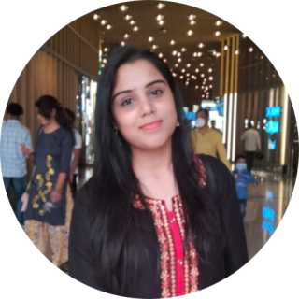z

**04-09-1997**

**SHWETA YADAV**









**PROJECTS**

* **TourZilla**

This is team project on **Tour and Travels** based on **PHP** and **MYSQL.**

My role was **frontend developer** in this project.

* **TechLearning**

This is **E-Learning** project based on **PHP** and **MYSQL**.

* **Portfolio**

Professional Portfolio Website.

1 Year Apprenticeship Traning in **HINDUSTAN AERONAUTICS LIMITED (HAL)** , Faizabad Road, Lucknow. **2019**



**9120699927**



**CONTACT**

**cknow, Uttar pd MYSQL Tour and Travels. COMPUTING. my role is LANGUAGES**

**SKILLS**

**cknow, Uttar pd MYSQL Tour and Travels. COMPUTING. my role is HOBBIES**

**HINDI** ◼◼◼◼◼

ENGLISH

◼◼◼◼◼

**OBJECTIVE**

To become a successful professional. To achieve a higher position in my professional career. Always ready to learn new technique and solution in computer professional.



**EDUCATION**

**HIGH SCHOOL** **2014**

H.A.L **(Hindustan Aeronautics Limited )** Inter Collage.

**INERMEDIATE** **2016**

Smriti Rajaram College.

cknow, Uttar pd MYSQL Tour and Travels. COMPUTING. my role is

**I.T.I (Industrial Traning Insitute)** **2017**

Pathways Education from Aliganj, Lucknow .

**DIPLOMA** **2021**

Pursuing Diploma in **IT NETWORKING & CLOUD COMPUTING.**

w, Uttar pd MYSQL Tour and Travels. COMPUTING. my role is pd MYSQL Tour and Travels. COMPUTING. my role is SQL Tour and Travels. COMPUTING. my role is **EXPERIENCE**

**JAVASCRIPT**

◼◼◼◼◼

**BOOTSTRAP**

◼◼◼◼◼

**PHP**

◼◼◼◼◼

**MYSQL**

◼◼◼◼◼

**CSS**

◼◼◼◼◼

**HTML**

◼◼◼◼◼



**shwetay629@gmail.com**



**539 kha / 6 Badi Jugouli Gomti Nagar Lucknow, Uttar Pradesh**