**Shri Shamrao Patil (Yadravkar) Educational & Charitable Trust’s**

**SHARAD INSTITUTE OF TECHNOLOGY,**

**POLYTECHNIC, YADRAV.**



***DEPARTMENT OF INFORMATION TECHNOLOGY***

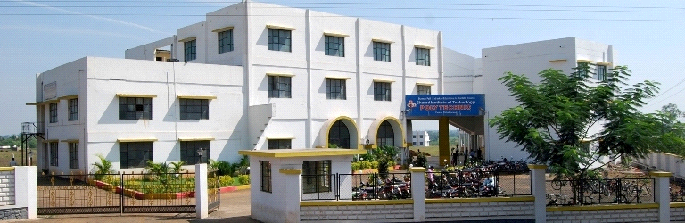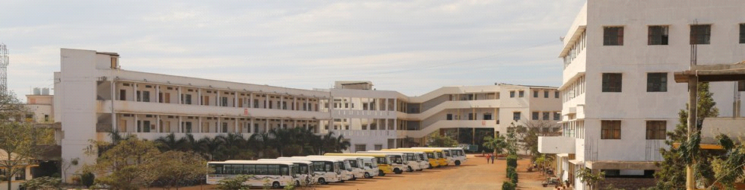

***MICRO PROJECT PROPOSAL***

**IN**

**Web Based Application development with PHP**

**FOR**

**T.Y I.T 2020-21**

**MICRO-PROJECT PROPOSAL**

**OF WEB BASED APPLICATION DEVELOPMENT WITH PHP**

**DEVELOP AUDIO PLAYER USING PHP**

**1.0 Rationale:-**

1. An MP3 player is an electronic device that can play MP3 digital audio files. It is a type

of digital audio player (DAP), or portable media player.

2 .For Entertainment purpose it is very good.

**2.0 Intended Course Outcomes:-**

1. Performs operations based on array.

2. Use form controls with validation to collect users input.

1. **Literature Review:-**

1. Media player is a type of application software for playing multimedia computer files like audio and video files. Media players commonly display standard media control icons known from physical devices such as tape recorders and CD players, such as play (  ), pause ( [Octicons-playback-pause.svg](https://en.wikipedia.org/wiki/File:Octicons-playback-pause.svg) ), fastforward, backforward, and stop ( [Octicons-primitive-square.svg](https://en.wikipedia.org/wiki/File:Octicons-primitive-square.svg) ) buttons. In addition, they generally have progress bars (or "playback bars") to locate the current position in the duration of the media file.

* + - Be very easy to playing music.
    - Be fully accessible on any devices.

**4.0 Proposed Methodology:-**

At first we will create our project group and then decide the project topic. After deciding the project topic, we will collect some information about it. We will find out some videos on the project, i.e., “Develop a Audio player using PHP”. Then we will collect some examples that uses playbox, different buttons, image views, different function and CSS. We will try to implement the best design practices for creating Audio Player. We will then try to implement it on Sublime Text software that is used for the coding of the programs. Then we will create the project report. Then finally we will submit the project and project report.

**5.0 Resources Required:-**

|  |  |  |  |  |
| --- | --- | --- | --- | --- |
| **Sr. No.** | **Name of Resources** | **Specification** | **Qty.** | **Remark** |
| 1 | Computer system | OS windows 7 professional Processor-Intel core Duo E7500 RAM-2GB | 3 | It is used to create the project. |
| 2 | Software | 1. Sublime Text 2. Microsoft Word | 3  3 | 1. It is used for coding purpose.  2. It is used to create the project, report and proposal. |
| 3 | Server | Xampp control | 3 | Server Connection |

**6.0 Action Plan:-**

|  |  |  |  |  |
| --- | --- | --- | --- | --- |
| **Sr. No.** | **Details of Activity** | **Planned**  **Start Date** | **Planned Finished Date** | **Name of Responsible Team Members** |
| **1** | At first we will create our project group. | 29/03/21 | 31/03/21 | Ritika Bedmutha  Shweta Bhosale  Neha Bhore |
| **2** | Then we will search the project topics related to our subject. | 05/04/21 | 09/04/21 | Ritika Bedmutha  Shweta Bhosale  Neha Bhore |
| **3** | We will take suggestions from our guide for selecting our project. | 12/04/21 | 16/04/21 | Ritika Bedmutha  Shweta Bhosale  Neha Bhore |
| **4** | After selection of project topic we will search the basic information related to it. | 19/04/21 | 23/04/21 | Ritika Bedmutha  Shweta Bhosale  Neha Bhore. |
| **5** | Then the collection of information will be done. | 24/04/21 | 26/04/21 | Ritika Bedmutha  Shweta Bhosale  Neha Bhore |
| **6** | Later we will visit to our guide for suggesting us some more information on topic and some corrections in collected information. | 27/04/21 | 30/04/21 | Ritika Bedmutha  Shweta Bhosale  Neha Bhore |
| **7** | If there are some corrections then they will be corrected. | 01/05/21 | 05/05/21 | Ritika Bedmutha  Shweta Bhosale  Neha Bhore |
| **8** | After correcting it, we will again visit our guide to show the corrections. | 07/05/21 | 11/05/21 | Ritika Bedmutha  Shweta Bhosale  Neha Bhore |
| **9** | Then we will collect some examples that uses playbox, different buttons, image views, different functions, and CSS | 13/05/21 | 18/05/21 | Ritika Bedmutha  Shweta Bhosale  Neha Bhore |
| **10** | We will have a visit to our guide after searching some information. | 19/05/21 | 22/05/21 | Ritika Bedmutha  Shweta Bhosale  Neha Bhore |
| **11** | If there are some suggestions then guide will suggest and we will try to make it correct as per the guide's requirement. | 24/05/21 | 26/05/21 | Ritika Bedmutha  Shweta Bhosale  Neha Bhore |
| **12** | After making some changes We will try to implement the best design practices for creating Audio Player. | 27/05/21 | 29/05/21 | Ritika Bedmutha  Shweta Bhosale  Neha Bhore |
| **13** | Then we will start implementing it on the software required i.e., Sublime Text, and run on Xampp server. | 31/05/21 | 04/06/21 | Ritika Bedmutha,  Shweta Bhosale  Neha Bhore |
| **14** | Then by that time, we will make the project report. | 05/06/21 | 07/06/21 | Ritika Bedmutha  Shweta Bhosale  Neha Bhore |
| **15** | We will have visit to our guide to present our project. | 08/06/21 | 09/06/21 | Ritika Bedmutha  Shweta Bhosale  Neha Bhore |
| **16** | Then we will finally submit our project and project report till this date. | 10/06/21 | 10/06/21 | Ritika Bedmutha  Shweta Bhosale  Neha Bhore |

**7.0 Name of Team Members with Roll No:-**

**Name of Student Roll No**

1. Ritika Rahul Bedmutha 13501

2. Neha Shital Bhore 13502

3. Shweta Deepak Bhosale 13503