**Industrial Training Report**

on

### (Online Quiz Website)

at

### (Udemy)

Submitted by

**Shweta Maurya**

1803010211

In the partial fulfillment for the award of the degree of

**Bachelor of Engineering**

in

Computer Science and Engineering



Inderprastha Engineering College,Ghaziabad

U.P

Oct , 2021

## Certificate

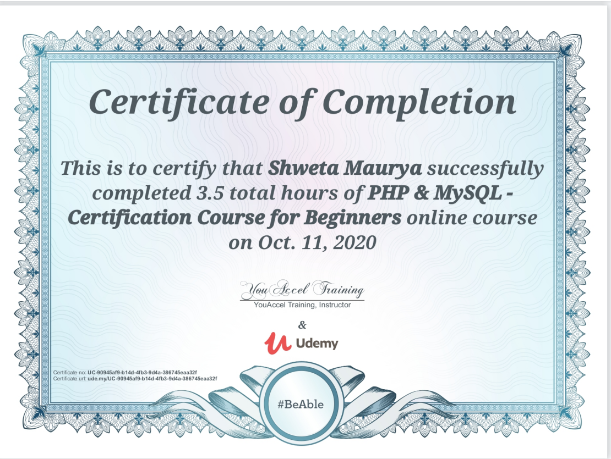

## Declaration

I **Shweta Maurya** hereby declare that I have undertaken **3**weeks Industrial Training Report at **Udemy** during a partial fulfillment of requirements for the award of degree of B.Tech (Computer Science and Engineering) at INDERPRASTHA ENGINEERING COLLEGE GHAZIABAD U.P .

Shweta Maurya

Date:

03-12-2021

## Acknowledgement

The successful completion of any project requires guidance help from a number of people. I take my immense pleasure in expressing a whole hearted thanks to all the officials who guided me all the way through my training in the organization.I therefore take this opportunity to express my profound sense of gratitude to all those who extended their whole hearted help and support to me in carrying out the project work.

I express my deep gratitude to Coursea/Udemy who provided me an insight into the working that enhanced my knowledge and with their support and cooperation this report has taken a presentable form.

Shweta Maurya

# Contents

1. [INTRODUCTION TO ORGANIZATION(s)](#_bookmark0) 1

[1.1](#_bookmark1) . . . . . . . . . . . . . . . . . . . . . . . . . . . . . . . . . . . 1

[1.1.1](#_bookmark2) . . . . . . . . . . . . . . . . . . . . . . . . . . . . . . . 1

1. [SOFTWARE TRAINING WORK UNDERTAKEN](#_bookmark3) 2

[2.1](#_bookmark4) . . . . . . . . . . . . . . . . . . . . . . . . . . . . . . . . . . . 2

[2.1.1](#_bookmark5) . . . . . . . . . . . . . . . . . . . . . . . . . . . . . . . 2

1. [PROJECT WORK](#_bookmark6) 3

[3.1](#_bookmark7) . . . . . . . . . . . . . . . . . . . . . . . . . . . . . . . . . . . 3

[3.1.1](#_bookmark8) . . . . . . . . . . . . . . . . . . . . . . . . . . . . . . . 3

1. [RESULTS AND DISCUSSION](#_bookmark9) 4

[References](#_bookmark10) 5

## Preface

It is well evident that work experience is an indispensable part of every pro- fessional course. In the same manner practical training in any organization is must for Bachelor of Engineering course. This training gives more knowl- edge about real corporate world environment. It also helps the individual to improve his/her skills to a great extent and assess his/her personality in corporate life.

Classroom study is quite important for gaining theoretical knowledge, but practical knowledge is equally important for the candidates to improve skills in real working environment in any field of study.

To be a good engineer, one must be aware of the industrial environment and must know about project management, working in the industry and so on. To bridge the gap between college and industrial environment summer training is one of the effective ways of learning. During this period, a stu- dent practice in the industry and gains experience and knowledge about the working in industry.

## Abstract

Online Examination System is an on-line test simulator is to take online examination, test in an efficient manner and no time wasting for manually checking of the test paper. The main objective of this web based online examination system is to efficiently evaluate the student thoroughly through a fully automated system that not only saves lot of time but also gives fast and accurate results. For students they give papers according to their convenience from any location by using internet and time and there is no need of using extra thing like paper, pen etc.  
  
Online examination system helps students to offer a quick and easy way to appear for the test. It also provides the results immediately after the examination with 100% accuracy and security. Student can enter to perform exam only with their valid username and password. This examination contains multiple choice questions and appropriate number of options. There are no limitations on number of options and it can be randomized so same set of question will not appear to all student so it prevent manipulation. More than one option can be correct but the user can select only one option. This provides time limit. The user can see their results after completing the exam. This helps the students to write the exam from far distance and which can provide security and simplicity and other beneficial features to the user.

**Chapter 1**

**INTRODUCTION TO ORGANIZATION(s)**

**Udemy, Inc.** is an American [massive open online course](https://en.wikipedia.org/wiki/Massive_open_online_course" \o "Massive open online course) (MOOC) provider aimed at professional adults and students. It was founded in May 2010 by Eren Bali, [Gagan Biyani](https://en.wikipedia.org/wiki/Gagan_Biyani" \o "Gagan Biyani), and Oktay Caglar.

As of Jan 2020, the platform has more than 35 million students and 57,000 instructors teaching courses in over 65 languages. There have been over 400 million course enrollments. Students and instructors come from 180+ countries and 2/3 of the students are located outside of the U.S.

Students take courses largely as a means of improving job-related skills. Some courses generate credit toward technical [certification](https://en.wikipedia.org/wiki/Certification" \o "Certification). Udemy has made a special effort to attract corporate trainers seeking to create coursework for employees of their company.[]](https://en.wikipedia.org/wiki/Udemy" \l "cite_note-InfoWeek4-16-13-5) As of 2020, there are more than 130,000 courses on the website.

**Chapter 2**

**SOFTWARE TRAINING WORK UNDERTAKEN**

* PHP
* MySQL Server
* NetBeans / FrontPage / NotePad

**2.1 Hardware Requirement**

* Intel 3.0 ghz or higher processor
* 2 GB RAM
* 10 GB HDD Space

**Chapter 3 PROJECT WORK**

**3.1**

**3.1.1**

Online Examination System is an on-line test simulator is to take online examination, test in an efficient manner and no time wasting for manually checking of the test paper. The main objective of this web based online examination system is to efficiently evaluate the student thoroughly through a fully automated system that not only saves lot of time but also gives fast and accurate results. For students they give papers according to their convenience from any location by using internet and time and there is no need of using extra thing like paper, pen etc.  
  
Online examination system helps students to offer a quick and easy way to appear for the test. It also provides the results immediately after the examination with 100% accuracy and security. Student can enter to perform exam only with their valid username and password. This examination contains multiple choice questions and appropriate number of options. There are no limitations on number of options and it can be randomized so same set of question will not appear to all student so it prevent manipulation. More than one option can be correct but the user can select only one option. This provides time limit. The user can see their results after completing the exam. This helps the students to write the exam from far distance and which can provide security and simplicity and other beneficial features to the user.

3.1.2 **Limitation of Existing Examination System**

We have study ABC College and find existing system is manual entry and keeping of the details of the student who are registered already. And it is very difficult for each student to come to the exam center. It is very difficult to the students from far distance to reach the exam center. This system is required to prepare registration\application form, question paper for the students and required to print a lot of number manually. To calculate how many students registered, and verification of details of these students in a month by hand is very difficult. This requires quite a lot of time and wastage of money as it requires quite lot of manpower to do that. Another factor that takes into account that is the possibility of errors. The limitation of existing system is that it is not all personalized. It cannot be used for personal and quick reference. Even the other staff members can make quick entries if the responsible person is not present.

* Time Consuming for creating question paper
* Time to check right and wrong answers
* Calculation of Marks
* Human error
* Limitation of no of student can give examination at a time
* Require teacher to monitor exam center
* Student needs to come exam center for giving test

**Proposed System and its Advantages**  
The modern computerized system is developed with the aim to overcome the drawbacks of existing manual system. We have study manual examination system of ABC college and identify possible automation. The proposed system has got many advantages. People from different parts of the world can register very easily. The new system is more personalized. It is maze in such a manner that all the new users can understand all the options in it very easily. It is made in a quick and easy referential manner. Access to all important matters are not always locked and can be opened easily at the time of urgency. The advantages of proposed system are that security is maintained in the new system. Securities for all important data are maintained confidentially. As it is easily understandable and user friendly, quick entries can be made in this system

* Provides complete online web based solution, including student registration, giving tests, storing of results.
* Complete web based administration, administrator can manage examination and question bank from web interface.
* No geographical boundary
* Student can give examination from anywhere of the world by 24X7
* 100% accuracy in result calculation
* Randomization of question set

**Database Tables Used**

* STUDENT MASTER
* EXAMINATION MASTER
* QUESTION MASTER
* ANSWER MASTER
* TEST
* RESULTS
* ADMIN

**Schema diagram of online examination system**

**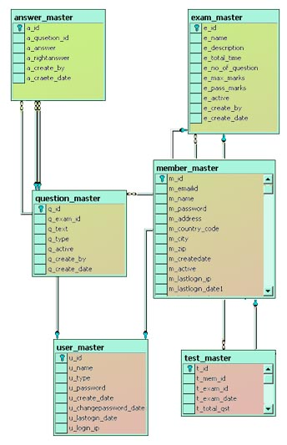**

**ER Diagrams for Online Examination System**

**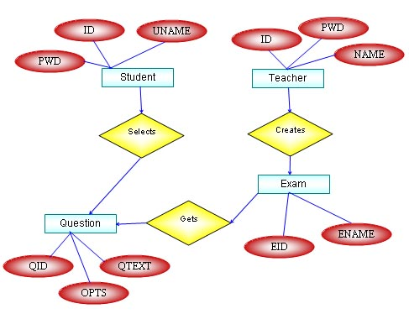**

**DFD - Data Flow Diagram for Online Examination System**

**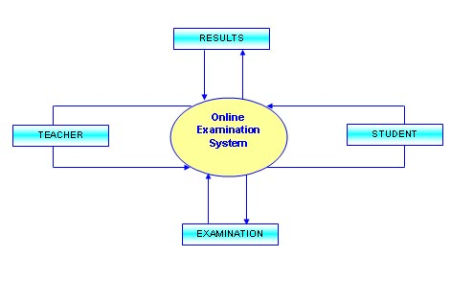**

**Chapter 4**

**RESULTS AND DISCUSSION**

**Future Improvements**  
We have prepare new system after identify issue in existing manual examination system. Scope of this online examination system is very broad in terms of other manually taking exams. However we can improve our system in next version like.

* Linking of other online site
* Include graphical and media file as question and answers
* Use of JQuery for more smooth interface

# References

* Book : Php And Mysql In Easy by Mike Mcgrath
* Book : Beginning PHP and MySQL by Jason Gilmore
* [www.programmer2programmer.net](http://www.programmer2programmer.net/)
* [www.readymadeproject.coom](http://www.readymadeproject.coom/)
* <http://ajprofessionals.googlepages.com/>
* [www.wikipedia.org](http://www.wikipedia.org/)
* [www.php.net](http://www.php.net/)