**VISVESVARAYATECHNOLOGY UNIVERSITY**

**JNANA SANGAM, BELAGAVI-590018 KARNATAKA, INDIA**

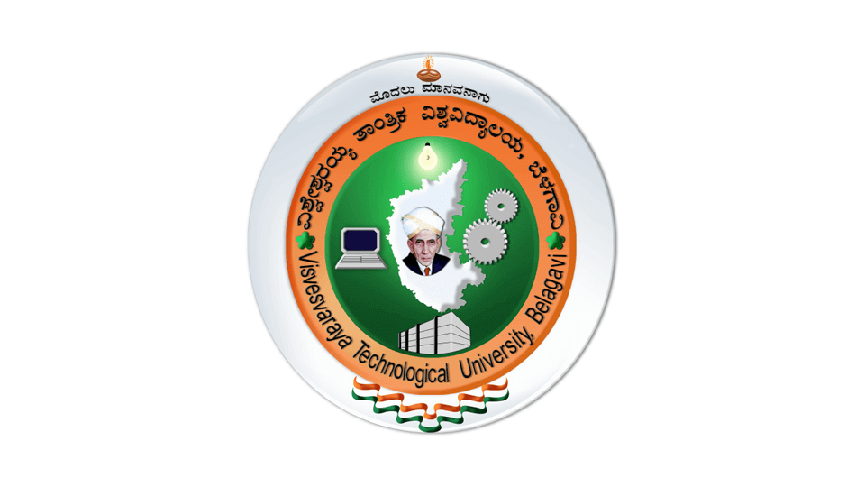 **An Internship Report on**

**“Python -Machine learning”**

Submitted in partial fulfillment of the requirements as prescribed for the award of degree of

Bachelor of enginnering

In

Electronics and communication engineering

Submitted By

SHWETA NINGANAGOUDA PATIL

4GK21EC038

Internship carried out at

Technology private Limited

**KR PETE KRISHNA GOVERNMENT ENGINEERING COLLEGE**,

Department of electronics and communication engineering

KR PET -571426 ,MANDYA

2023-2024

**DECLARATION**

I **SHWETA NINGANAGOUDA PATIL (4GK21EC038)** student of fifth Semester, Department of Computer Science & Engineering, KR Pete Krishna Government Engineering College, KR Pet,Mandya hereby declare that this internship work on **“Python -machine Learning”** has been carried out under the guidance of **Dr. Nagabushan** Associate Professor, Dept. of ECE. This internship work is submitted to Visvesvaraya Technological University in partial fulfillment of the requirement for the award of degree of Bachelor of Engineering in Computer Science & Engineering for the academic year 2023-2024.

SHWETA NINGANAGOUD PATIL

(4GK21EC038)

# ACKNOWLEDGEMENT

The foundation for any successful venture is laid out not just by the individual accomplishing the task, but also by several other people who believe that the individual can excel and put in their every bit in every endeavor he/she embarks on, at every stage in life. And the success is derived when opportunity meets preparation, also supported by a well-coordinated approach and attitude.

I express my sincere gratitude to **Dr. DINESH K**, Principal, AT KR Pete Krishna Government Engineering College, for providing us the required environment and for his valuable suggestion.

My sincere thanks to **Dr. Nagabushan**, Head of the Dept. Computer Science and Engineering, KR Pete Krishna Government Engineering College, KR Pete , for her valuable support and for rendering us resources for this seminar.

I am indeed indebted to **Prof Shanmugam,** coordinator and guide for their continued support, advice and valuable inputs during the course of this seminar work.

Last, but not the least I would like to thank my family, who has acted as a beacon of light throughout my life.

My sincere gratitude goes out to all my comrades and well-wishers who have supported me through all the ventures.

**ABSTRACT**

Artificial Intelligence, Machine Learning and Open cv are the buzzwords that have been able to grasp the interest of many researchers since various numbers of years. Enabling computers to think, decide and act like humans has been one of the most significant and noteworthy developments in the field of computer science. Various algorithms have been designed over time to make machines impersonate the human brain and many programming languages have been used to implement those algorithms. Python is one such programming language that provides a rich library of modules and packages for use in scientific computing and machine learning. This paper aims at exploring the basic concepts related to machine learning and attempts to implement a few of its applications using python. This paper majorly used Scikit-Learn library of Python for implementing the applications developed for the purpose of research.

**Keywords:** Machine Learning, Python, AI, ML, NumPy, Matplotlib, Workflow of machine learning,

**TABLE OF CONTENTS**

DECLARATION

ACKNOWLEDGEMENT

ABSTRACT

**CHAPTER 1**

**ABOUT THE ORGANIZATION**

Karunadu Technologies Pvt. Ltd. Is a leading IT software solutions and services industry focussing on quality standards and customer values. We offer broad range of customized software applications powered by concrete technology and industry expertise.,Karunadu Technologies Pvt. Ltd. Offers end to end embedded solutions and services. We deal with broad range of product development along with customized features ensuring at most customer satisfaction.,Karunadu Technologies Pvt. Ltd. is also a leading Skills and Talent Development company that is building a manpower pool for global industry requirements.,We empower individual with knowledge, skills and competencies that assist them to escalate as integrated individuals with a sense of commitment and dedication.,Karunadu Technologies Pvt. Ltd. also helps companies to find right individuals matching the requirements. We engage in Outsourcing of talented candidates. We find you the best talent of pre-screened, interested candidates to your



Fig 1.1 Karunadu Technology Logo

**1.2 Company Services**

**Chapter 2**

**Topics Learnt during the course**

The Objectives of the internship is to apply theoretical knowledge of ”Machine Learning using Python” to solve real time complex problems,in order to achieve these following basic concepts we learnt:

* Python
* Machine Learning

Python

Python is a**high-level, general-purpose, and interpreted programming language** used in various sectors including machine learning, artificial intelligence, data analysis, web development, and many more.

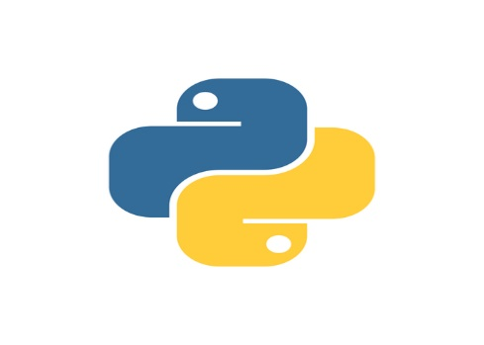

Fig: Python Logo

