<?php
echo"Hello world!";
?>

Hello world!

<?php
$Name="Vaibhavi Barve";
echo"My name is";
?>

My name is

<?php
$Name="Vaibhavi Barve";
echo"My name is";
echo "My name is:".$Name;
?>

My name isMy name is:Vaibhavi Barve

<!DOCTYPE HTML>
<HTML>
<head>
<title>php</title>
</head>
<body>
<h2>My personal information</h2>
<?php
$Name="Vaibhavi Barve";
echo"My name is";
echo "My name is:".$Name;
?>
</body>
</HTML>

My personal information
My name isMy name is:Vaibhavi Barve

<!DOCTYPE HTML>
<HTML>
<head>
<title>php</title>
</head>
<body>
<h2>My personal information</h2>
<?php
$Name="Vaibhavi Barve";
echo"My name is";
echo "<br>";
echo "My name is:".$Name;
?>
</body>
</HTML>

My personal information
My name is
My name is:Vaibhavi Barve

<!DOCTYPE HTML>
<HTML>
<head>
<title>php</title>
</head>
<body>
<h2>My personal information</h2>
<?php
$Name="Vaibhavi Barve";
echo"My name is";
echo "<br>";
echo "My name is:".$Name;
echo "<h3>My name is:".$Name."</h3>";
?>
</body>
</HTML>

My personal information
My name is
My name is:Vaibhavi Barve

My name is:Vaibhavi Barve
<?php
$Name="Vaibhavi barve";
$Age=20;
$NewAge=$Age+5;
echo"My name is:".$Name." and my age is:".$NewAge;
?>

My name is:Vaibhavi barve and my age is:25

<?php
$num1=16;
$num2=9;
echo" num1=".$num1;
echo"<br>";
echo" num2=".$num2;
echo"<br>";
echo"<br>";
$sum=$num1+$num2;
echo"The addition of ".$num1." and ".$num2." is: ".$sum;
echo"<br>";
echo"<br>";
$sub=$num1-$num2;
echo"The subtraction of ".$num1." and ".$num2." is:".$sub;
echo"<br>";
echo"<br>";
$mul=$num1*$num2;
echo"The product of ".$num1." and ".$num2." is:".$mul;
echo"<br>";
echo"<br>";
$div=$num1/$num2;
echo"The division of ".$num1." and ".$num2." is:".$div;
echo"<br>";
echo"<br>";
$mod=$num1%$num2;
echo"The modulus of ".$num1." and ".$num2." is:".$mod;
?>

num1=16
num2=9
The addition of 16 and 9 is: 25
The subtraction of 16 and 9 is:7
The product of 16 and 9 is:144
The division of 16 and 9 is:1.7777777777778
The modulus of 16 and 9 is:7

<?php
$a=70;
echo "a=".$a;
echo "<br><br>";
echo "Pre-increment:".++$a;
echo "<br>";
echo"Value of a after pre-increment:".$a;
echo "<br><br>";
echo "Post-increment:".$a++;
echo "<br>";
echo"Value of a after post-increment:".$a;
echo"<br><br>";
echo "Pre-decrement:".--$a;
echo "<br>";
echo"Value of a after pre-decrement:".$a;
echo "<br><br>";
echo "Post-decrement:".$a--;
echo "<br>";
echo"Value of a after post-deccrement:".$a;
?>

a=70
Pre-increment:71
Value of a after pre-increment:71
Post-increment:71
Value of a after post-increment:72
Pre-decrement:71
Value of a after pre-decrement:71
Post-decrement:71
Value of a after post-deccrement:70

<?php
$x=9;
$s=45;
echo "x=".$x;
echo"<br>";
echo "s=".$s;
echo"<br><br>";
if($x>$s){
echo $x." is greater than ".$s;
}
else if($x<$s)
{
echo $x." is lesser than ".$s;
}
else{
echo"Cannot produce any output";
}
$a=12;
$l=12;
$m="12";
echo "<br><br>";
echo "a=".$a;
echo "<br>";
echo "l=".$l;
echo "<br>";
echo "m=".$m;
echo"<br><br>";
if($a==$l)
{
echo $a." (a) is equal to ".$l." (l)";
}
else if($a==$m)
{
echo $a."(a) is equal to ".$m." (m)";
}
else{
echo"Cannot produce any output";
}
echo "<br><br>";
if($a===$l)
{
echo $a." (a) is equal to ".$l." (l) with data type";
}
else if($a===$m)
{
echo $a." (a)is equal to ".$m." (m) with data type";
}
else{
echo"Cannot produce any output";
}
echo"<br><br>";
$num1=14;
$num2=35;
echo"num1=".$num1;
echo"<br>";
echo"num2=".$num2;
echo"<br><br>";
if($num1>=$num2)
{
echo $num1." is greater than/equal to ".$num2;
}
else if($num1<=$num2)
{
echo $num1." is lesser than/equal to ".$num2;
}
else{
echo"Cannot produce any output";
}
echo"<br><br>";
$Number1=60;
$Number2=1;
echo"Number1=".$Number1;
echo"<br>";
echo"Number2=".$Number2;
echo"<br><br>";
if($Number1!=$Number2){
echo $Number1." is not equal to ".$Number2;
}
else{
echo $Number1." is equal to ".$Number2;
}
?>

x=9
s=45
9 is lesser than 45
a=12
l=12
m=12
12 (a) is equal to 12 (l)
12 (a) is equal to 12 (l) with data type
num1=14
num2=35
14 is lesser than/equal to 35
Number1=60
Number2=1
60 is not equal to 1

<?php
$n=12;
echo"Number is:".$n;
echo"<br>";
if ($n%2==0){
echo"You entered even number.";
}
else{
echo"You entered odd number.";
}
?>

Number is:12
You entered even number.

<?php
$Age=20;
echo"My age=".$Age;
echo"<br>";
if($Age<18){
echo"You are teenager.";
}
else if($Age>=18 && $Age<60){
echo"You are adult.";
}
else if($Age>=60){
echo"You are senior citizen.";
}
else{
echo"No proper input!!! please enter valid age!";
}

My age=20
You are adult.

<?php
$colour="Green";
switch($colour){
case "Red":
echo "Stop.";
break;
case "Yellow":
echo "Slow down & wait for Red light.";
break;
case "Green":
echo "Go ahead.";
break;
case "Flashing yellow":
echo "Slow down & prpceed with caution.";
break;
case "Green arrow":
echo "Go in direction of arrow";
break;
default:
echo"Code unsuccessful!!";
}
?>

Go ahead.

<?php
$Marks=95;
switch($Marks){
case $Marks>=90 and $Marks<=100:
echo"A";
break;
case $Marks>=80 and $Marks<=89:
echo"B";
break;
case 70-79:
echo"C";
break;
case 60-69:
echo"D";
break;
case 0-60:
echo"F";
break;
default:
echo"No marks entered!";
}
?>

<?php
for($i=5;$i>=1;$i--)
echo $i."<br>";
?>

5
4
3
2
1

<?php
$i=5;
$data=" ";
for($d=1;$d<=10;$d++)
$data=$data.$i."*".$d."=".$i*$d."<br>";
echo $data;
?>

5*1=5
5*2=10
5*3=15
5*4=20
5*5=25
5*6=30
5*7=35
5*8=40
5*9=45
5*10=50

<?php
$i=2;
while($i<=20)
{
echo $i."<br>";
$i++;
}
?>

2
3
4
5
6
7
8
9
10
11
12
13
14
15
16
17
18
19
20

<?php
$i=30;
do{
echo $i."<br>";
$i--;
}
while($i>=0)
?>

30
29
28
27
26
25
24
23
22
21
20
19
18
17
16
15
14
13
12
11
10
9
8
7
6
5
4
3
2
1
0

<?php
$Car=["KUV","Mercedes","Balleno","Lamborghini","Eeco"];
echo $Car[1];
?>

Mercedes

<?php
$Car=["KUV","Mercedes","Balleno","Lamborghini","Eeco"];
echo $Car[1];
echo"<br>";
$Car[3]="BMW";
echo $Car[3];
echo"<br>";
for($i=0;$i<count($Car);$i++)
{
echo $Car[$i];
echo "<br>";
}
?>

Mercedes
BMW
KUV
Mercedes
Balleno
BMW
Eeco

<?php
$Fruits=array("Mango","Grapes","Orange","Banana");
for($i=0;$i<count($Fruits);$i++){
echo $Fruits[$i];
echo " ";
}
?>

Mango Grapes Orange Banana

<?php
$Fruits=array("Mango","Grapes","Orange","Banana");
for($i=0;$i<count($Fruits);$i++){
echo $Fruits[$i];
echo " ";
}
echo "<br>";
foreach ($Fruits as $value_fruits)
{
echo $value_fruits;
echo "<br>";
}
?>

Mango Grapes Orange Banana
Mango
Grapes
Orange
Banana

<?php
$Car=["KUV","Mercedes","Balleno","Lamborghini","Eeco"];
echo $Car[1];
echo"<br>";
$Car[3]="BMW";
echo $Car[3];
echo"<br>";
for($i=0;$i<count($Car);$i++)
{
echo $Car[$i];
echo "<br>";
}
echo"<br><br>";
foreach ($Car as $value_car)
{
echo $value_car;
echo "<br>";
}
?>

Mercedes
BMW
KUV
Mercedes
Balleno
BMW
Eeco
KUV
Mercedes
Balleno
BMW
Eeco

<!DOCTYPE HTML>
<HTML>
<head>
<title>
Examination form
</title>
</head>
<body>
<form action="get_php19.php"method="get">
<h1>----Examination Centre Selection Form----</h1>
<label>First Name:</label>
<input type="text" name="FirstName">
<br><br>
<label>Last Name:</label>
<input type="text" name="LastName">
<br><br>
<label>Gender:</label>
<Input type="radio" value="Male" name="Gender">
<label>Male</label>
<Input type="radio" value="Female" name="Gender">
<label>Female</label>
<br><br>
<label>Date of birth:</label>
<input type="date" name="Dateofbirth">
<br><br>
<label>Center:</label>
<select name="Center">
<option value=" ">Select State</option>
<option value="GA">Goa</option>
<option value="MH">Maharashtra</option>
<option value="KA">Karnataka</optio>
<option value="GJ">Gujarat</option>
</select>
<br><br>
<input type="submit" value="Submit">
</form>
</body>
</HTML>

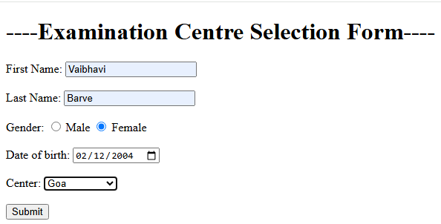

<!DOCTYPE html>
<html lang="en">
<head>
<meta charset="UTF-8">
<meta name="viewport" content="width=device-width, initial-scale=1.0">
<title>Document</title>
</head>
<body>
<label>First Name:</label><?php echo $_GET["FirstName"]; ?>
<br><br>
<label>Last Name:</label><?php echo $_GET["LastName"]; ?>
<br><br>
<label>Gender:</label><?php echo $_GET["Gender"]; ?>
<br><br>
<label>Date of birth:</label><?php echo date("d-m-y") $_GET["Dateofbirth"]; ?>
<br><br>
<label>Center:</label><?php echo $_GET["Center"]; ?>
</body>
</html>

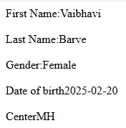

<!DOCTYPE html>
<html lang="en">
<head>
<meta charset="UTF-8">
<meta name="viewport" content="width=device-width, initial-scale=1.0">
<title>Document</title>
</head>
<body>
<label>First Name:</label><?php echo $_POST["FirstName"]; ?>
<br><br>
<label>Last Name:</label><?php echo $_POST["LastName"]; ?>
<br><br>
<label>Gender:</label><?php echo $_POST["Gender"]; ?>
<br><br>
<label>Date of birth:</label><?php("dd-mm-yyyy") echo $_POST["Dateofbirth"]; ?>
<br><br>
<label>Center:</label><?php echo $_POST["Center"]; ?>
</body>
</html>

<?php
$servername="localhost";
$username="root";
$password="";
$dbname="db1";
$conn=new mysqli($servername,$username,$password,$dbname);
if($conn->connect_error)
{
die("Connection failed:".$conn->connect_error);
}else{
echo "Connection is successful ";
$ins="INSERT INTO T1 (`firstname`,`lastname`,`email`,`password`,`gender`,`class`) values ('Deepa','Hule','dh@gamil.com','123','F','SY')";
$result=$conn->query($ins);
if($result===TRUE)
{
echo "Records inserted successfully!";
}
else{
echo "Error:".$conn->error;
}
}
$conn->close();
?>

Connection is successful Records inserted successfully!
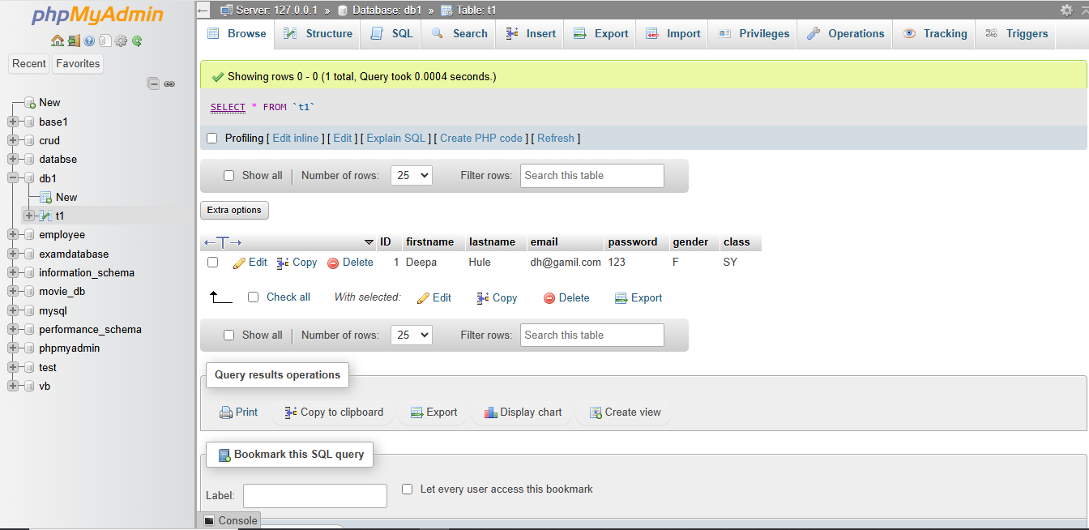

<?php
$servername="localhost";
$username="root";
$password="";
$dbname="db1";
$conn=new mysqli($servername,$username,$password,$dbname);
if($conn->connect_error)
{
die("Connection failed:".$conn->connect_error);
}else{
echo "Connection is successful ";
$ins="INSERT INTO T1 (`firstname`,`lastname`,`email`,`password`,`gender`,`class`) values ('Deepa','Hule','dh@gamil.com','123','F','SY'),('Yash','Rathod','yr691@gmail.com','456','M','TY')";
$result=$conn->query($ins);
if($result===TRUE)
{
echo "Records inserted successfully!";
}
else{
echo "Error:".$conn->error;
}
}
$conn->close();
?>

echo "Error:".$conn->error;
'Hule','dh@gamil.com','123','F','SY'),('Yash','Rathod','yr691@gmail.com','456','M','TY')";

Connection is successful Records inserted successfully!
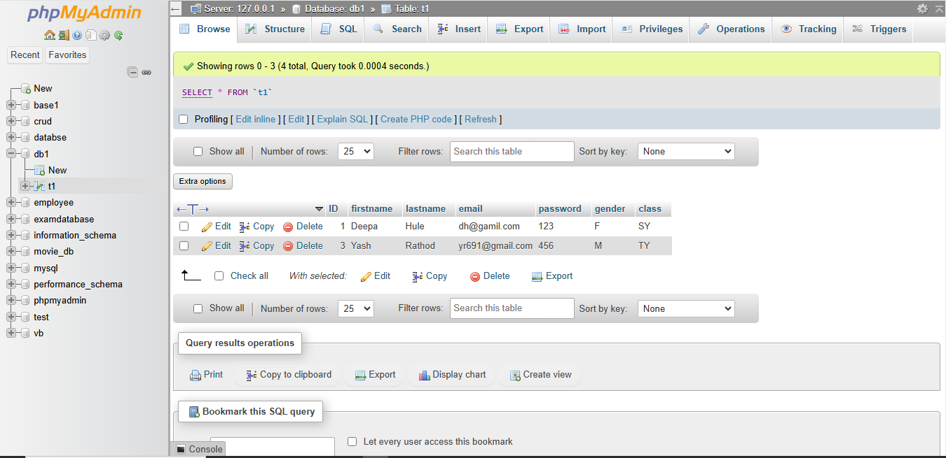

<?php
$servername="localhost";
$username="root";
$password="";
$dbname="db1";
$conn=new mysqli($servername,$username,$password,$dbname);
if($conn->connect_error)
{
die("Connection failed:".$conn->connect_error);
}else{
echo "Connection is successful ";
$upd="Update T1 set `email`='huledeepa7295@gmail.com',password='975'where ID='1'";
$result=$conn->query($upd);
if($result===TRUE)
{
echo "Records updated successfully!";
}
else{
echo "Error:".$conn->error;
}
}
$conn->close();
?>

Connection is successful Records updated successfully!
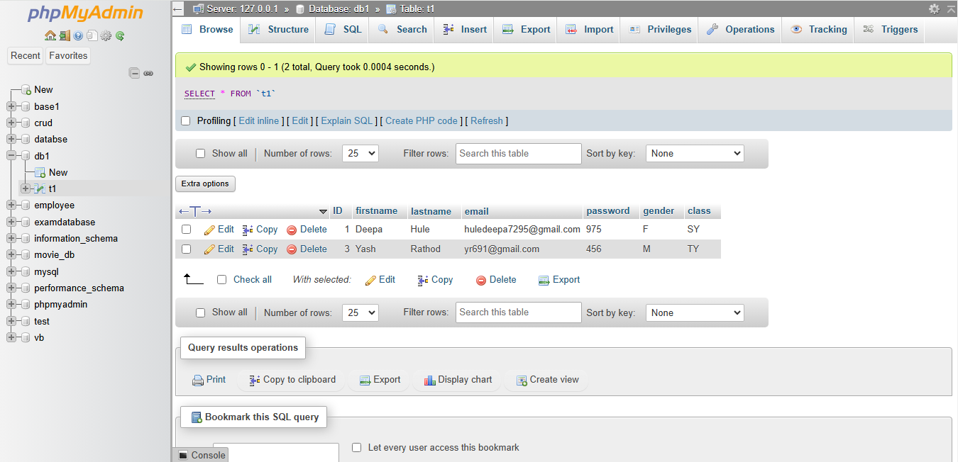

<?php
$servername="localhost";
$username="root";
$password="";
$dbname="db1";
$conn=new mysqli($servername,$username,$password,$dbname);
if($conn->connect_error)
{
die("Connection failed:".$conn->connect_error);
}else{
echo "Connection is successful ";
$del="Delete from T1 where `ID`='3'";
$result=$conn->query($del);
if($result===TRUE)
{
echo "Records deleted successfully!";
}
else{
echo "Error:".$conn->error;
}
}
$conn->close();
?>

Connection is successful Records deleted successfully!
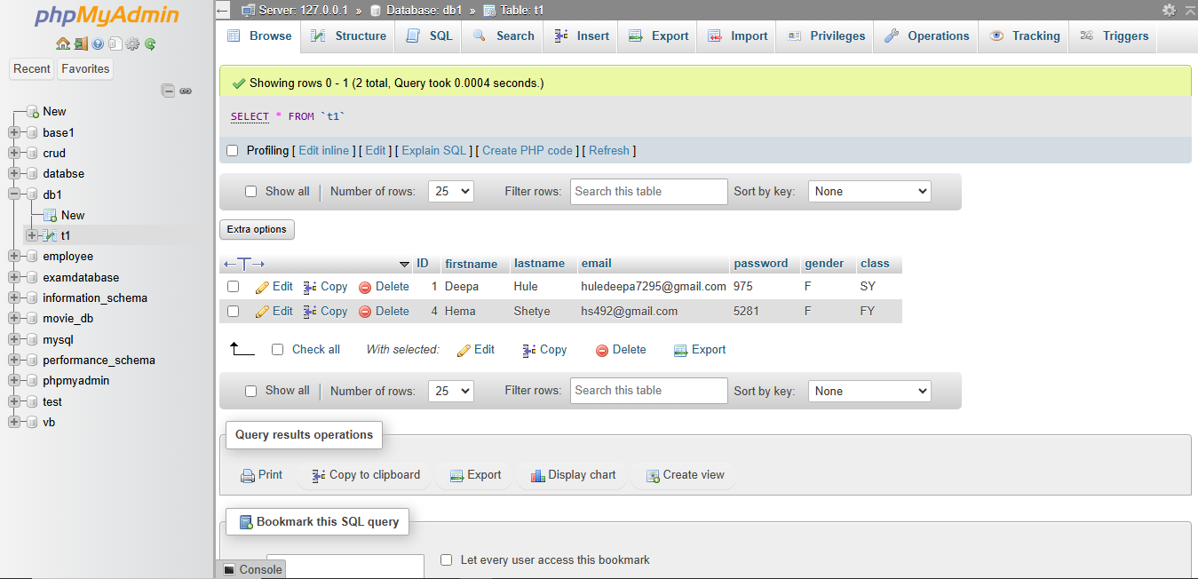

<?php
$servername="localhost";
$username="root";
$password="";
$dbname="db1";
$conn=new mysqli($servername,$username,$password,$dbname);
if($conn->connect_error)
{
die("Connection failed:".$conn->connect_error);
}else{
echo "Connection is successful ";
echo "<br>";
$sel="Select * from T1";
$result=$conn->query($sel);

if($result->num_rows>0)
{
while($row=$result->fetch_assoc()){
echo "ID:".$row["ID"],"First name:".$row["firstname"], "Last name:".$row["lastname"], "Email:".$row["email"],"Password:".$row["password"],"Gender:".$row["gender"],"Class:".$row["class"];
}
}else{
echo "0 rows returned";
}
}
$conn->close();
?>

Connection is successful
ID:1First name:DeepaLast name:HuleEmail:huledeepa7295@gmail.comPassword:975Gender:FClass:SYID:4First name:HemaLast name:ShetyeEmail:hs492@gmail.comPassword:5281Gender:FClass:FYID:6First name:RakeshLast name:NaikEmail:nr@gmail.comPassword:12345Gender:MClass:FYID:7First name:TaraLast name:DesaiEmail:taradesai@gmail.comPassword:678910Gender:FClass:TYID:8First name:KaushikLast name:GawasEmail:gk*36912@gmail.comPassword:816Gender:MClass:SYID:9First name:RohitLast name:GawadeEmail:rg&1234@gmail.comPassword:3064Gender:MClass:SY

