Task 2:

Below screen shot shows errors (At the bottom in error list) after ExploreCalifornia.Monolith.sln was built.

Error 1:

A curly bracket was added on line number 40 to fix this error

Error 2:

The spelling of Main is wrong here.

Error 3

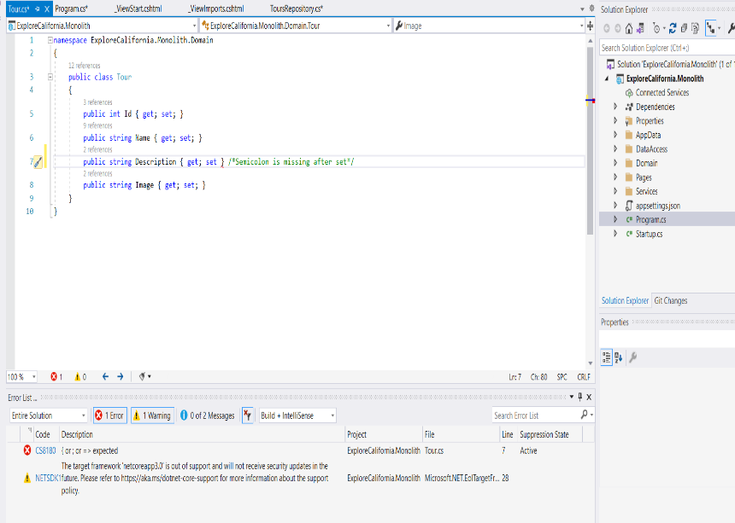A semicolon ( ; ) was missing after keyword set on line number 8.

Error 4

On Line number 22 booking.name should be **booking.Name.** N should be upper case.

Error 5

This is not an error but without fixing this solution will not show anything on the main page.

Index.cshtml file has all code commented which needs to be uncommented. This issue is solved by selecting code and hitting uncomment button at top right corner.

Build Case: After fixing the error mentioned above the solution was successfully built and its showing 0 errors.

Output after running code

