CourseCraft — UML Design Package
Case Study 108 | Version 1.0 | 1 October 2026
Purpose: A clear map of who uses CourseCraft, how its main parts fit together, and what happens from enrolment through certificate.

1. Design overview
CourseCraft is organised into focused modules. Learners and staff use the platform dashboards, while payment and video delivery are handled through separate provider interfaces. The course, progress, quiz, and certificate rules stay within CourseCraft, so one external provider does not control another part of the learner journey.

1.1 Actors and design boundary
- Learner: browses, enrols, watches, attempts a quiz, and retrieves a certificate.
- Faculty: manages assigned course information and checks learner progress.
- Content editor: validates and publishes lesson assets supplied by faculty.
- Administrator: manages users/roles, course publication, and reports.
- Payment provider: confirms payment state through an adapter.
- Video delivery service: supplies protected playback for a lesson asset.

1.2 Diagram index
- [Use case diagram](diagrams/use_case.png) — user goals and system boundary.
- [Class diagram](diagrams/class.png) — core domain classes and relationships.
- [Sequence diagram](diagrams/sequence.png) — enrol, watch lessons, and earn a certificate.
- [Activity diagram](diagrams/activity.png) — end-to-end learner activity and decision flow.
- [Enrolment state diagram](diagrams/state.png) — lifecycle and guarded transitions.
The rendered diagrams accompany this document as separate PNGs in the delivery bundle. Names and rules are aligned with the SRS and Test Plan. Proposed certificate eligibility remains subject to university approval.

2. Use case model

UC-01 — Enrol in a course
Primary actor: Learner. The learner is signed in, and the course is published with enrolment open. The learner chooses the course and starts enrolment. CourseCraft creates a pending record and sends the payment request to the provider. Only a verified payment result activates course access. If payment fails, the learner sees the status and can retry if allowed. Repeated provider messages are handled safely and do not create duplicate enrolments. The outcome is one enrolment reference with a clear status.

UC-02 — Watch lessons and record progress
Primary actor: Learner. The learner has an active, paid enrolment. CourseCraft checks access, opens the protected video through its delivery adapter, saves lesson progress, and updates the completion percentage. If the video is unavailable, the learner sees a retry/help message; payment status is not changed.

UC-03 — Complete quiz and earn a certificate
Primary actor: Learner. With a paid enrolment, the learner submits the course quiz. CourseCraft saves the score and checks the approved completion and pass rules. At the supplied 70% threshold, a learner who has finished every required lesson and passed the quiz receives one certificate. If a condition is missing, the system explains what remains; requesting an already-issued certificate returns the same record.

UC-04 — Manage course content
Faculty submit course details and recordings. Editors check and prepare the supplied assets; Centre administrators publish a course after the required information and content are ready. The dashboard shows each course’s progress through the content workflow. Faculty recording remains outside the IT team’s control.

UC-05 — Review course dashboard
Faculty use their dashboard to review enrolments, learner progress, quiz results, ratings, and learner questions for courses they teach. Editors follow recording and production status. Administrators see centre-wide readiness and operational summaries. Every view is limited to the user’s role and course assignment.

3. Class model notes
The class diagram uses the following main concepts:
- User has one or more Roles; role assignment controls access.
- Course contains required Lessons, optional/configured Quiz, and a configured passing threshold.
- Enrolment links a Learner and Course and has a lifecycle state plus a payment reference/status.
- LessonProgress belongs to one enrolment and lesson; it supports idempotent completion and percentage calculation.
- QuizAttempt records the learner’s submission, score, and outcome.
- Certificate references the eligible enrolment and has a unique identifier/verification status.
- PaymentAdapter and VideoDeliveryAdapter are interfaces to external providers; provider-specific classes implement those interfaces.

Key invariants
- One current enrolment per learner-course is the default; re-enrolment/refund behavior needs Centre policy.
- Completion percentage is derived from required lessons; it is bounded to 0–100 inclusive.
- A score is bounded to 0–100; under the supplied baseline, 70% or higher is a pass.
- A certificate requires paid enrolment, 100% completion of required lessons, and a quiz score of at least 70%, unless the Centre approves a documented exception.
- A certificate is unique per learner-course completion. Provider callbacks cannot directly create certificates.

4. Sequence: enrol, watch lessons, and earn a certificate
The sequence diagram shows the successful path plus failure/eligibility branches. Payment remains an external transaction; course access is activated only from a verified provider result. Video requests travel through an adapter; the application stores lesson progress and computes completion. Certificate eligibility is evaluated after quiz scoring and progress checks, not by the payment or video provider.

5. Activity and state models
The activity diagram connects enrolment to learning, quiz completion, and certificate issuance. It includes alternative paths for payment failure, inaccessible video, incomplete progress, and failed quiz. The enrolment state diagram focuses on enrolment/payment lifecycle:
Created → PendingPayment → ActivePaid → Completed with failure/cancellation/refund paths. “Completed” describes course completion; it is distinct from “certificate issued.” Certificate issuance is a separate domain event after the eligibility guard passes.

6. Cohesion and coupling rationale

Cohesion
- Enrolment Service owns enrolment identity, state transitions, and course access entitlement.
- Payment Adapter owns provider request/response translation and verification, not course progress or certificate decisions.
- Video Adapter owns playback token/URL translation and delivery errors, not lesson completion policy.
- Progress Service owns lesson completion aggregation and the bounded completion percentage.
- Quiz Service owns attempts, scoring, and threshold comparison.
- Certificate Service owns eligibility evaluation, idempotent issue, and verification record.
- Course/Content Service owns catalogue metadata and lesson asset readiness.
Each module has one clear reason to change, supporting focused tests and maintainability.

Loose coupling
CourseCraft talks to payment and video services through stable interfaces. Provider-specific fields are mapped at adapter boundaries. Payment status is stored as a reference and normalized state; no raw card data enters course logic. Video delivery is requested using a lesson asset reference, so changing a CDN/provider does not rewrite enrolment or certificate rules. Asynchronous provider callbacks are verified and processed idempotently. Core certificates depend on internal enrolment/progress/quiz state rather than a direct call to an external provider.

Traceability across artifacts
- Use cases UC-01–UC-05 correspond to FR-01–FR-12 in the SRS.
- Enrolment and payment states inform TC-FR02/03 and the Test Plan decision cases.
- Completion, score, and certificate invariants inform the boundary-value and decision-table tests.
- NFR video availability, role security, and scalability targets are tested at adapter/service boundaries.

7. Open design decisions
Confirm identity provider, payment/video vendors, data retention, refund/withdrawal rules, quiz retakes, any exceptions to the supplied 70% pass threshold, faculty

Use case diagram
CourseCraft UML design view
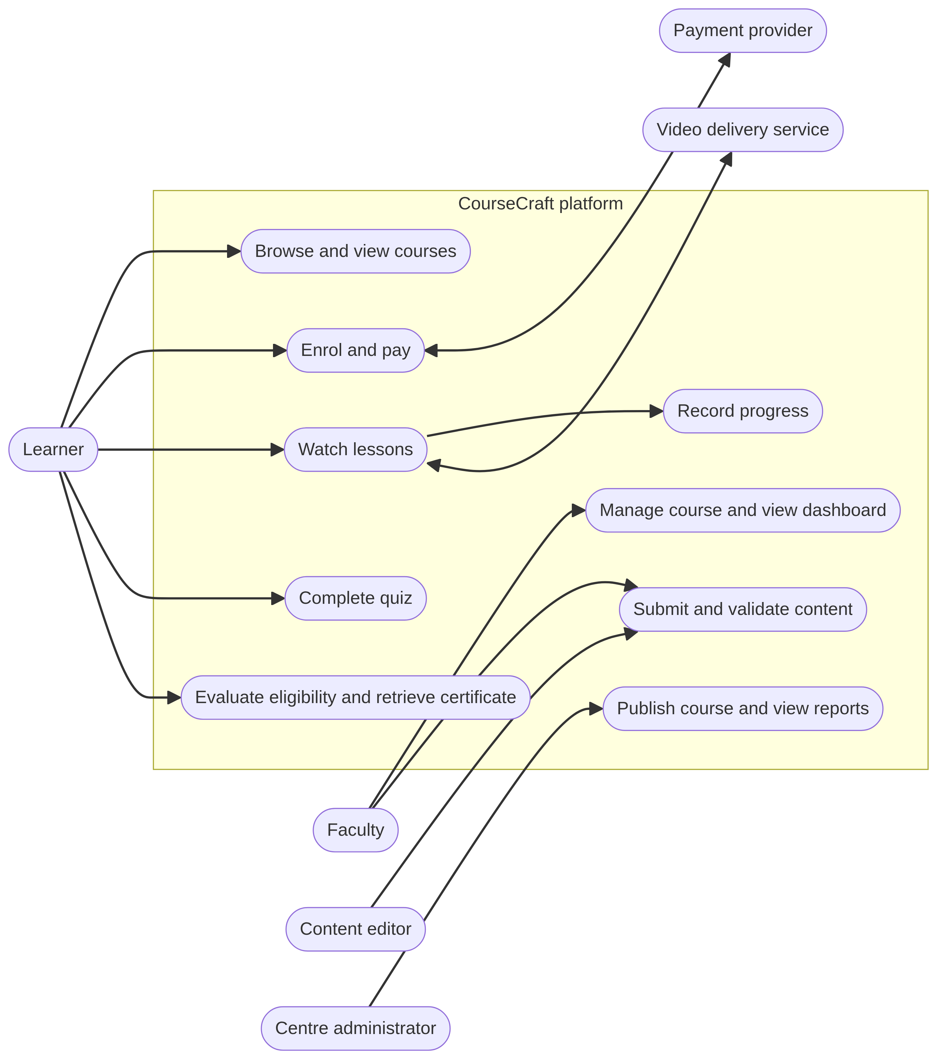

Class diagram
CourseCraft UML design view
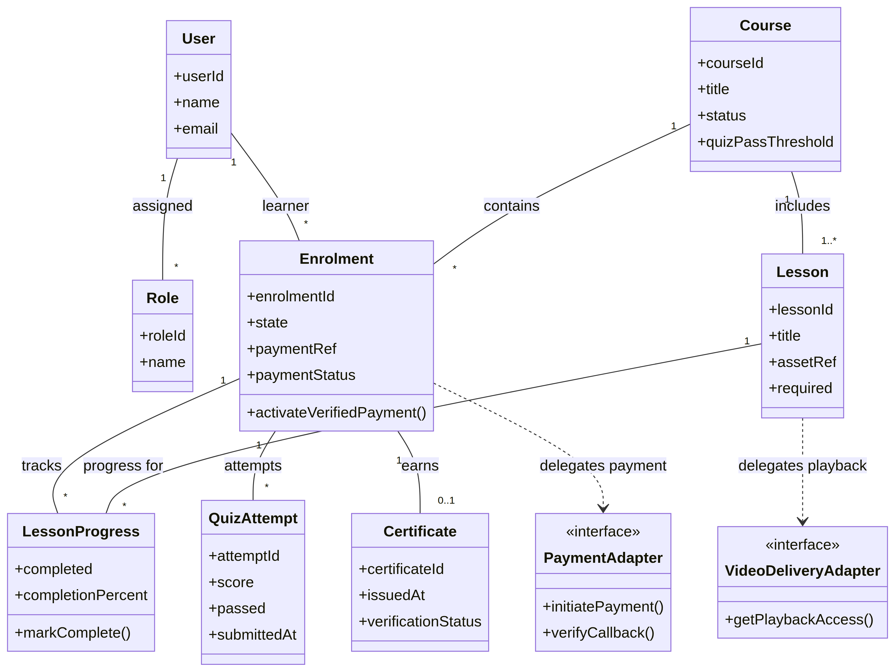

Sequence diagram: enrol, watch lessons, and earn a certificate
CourseCraft UML design view
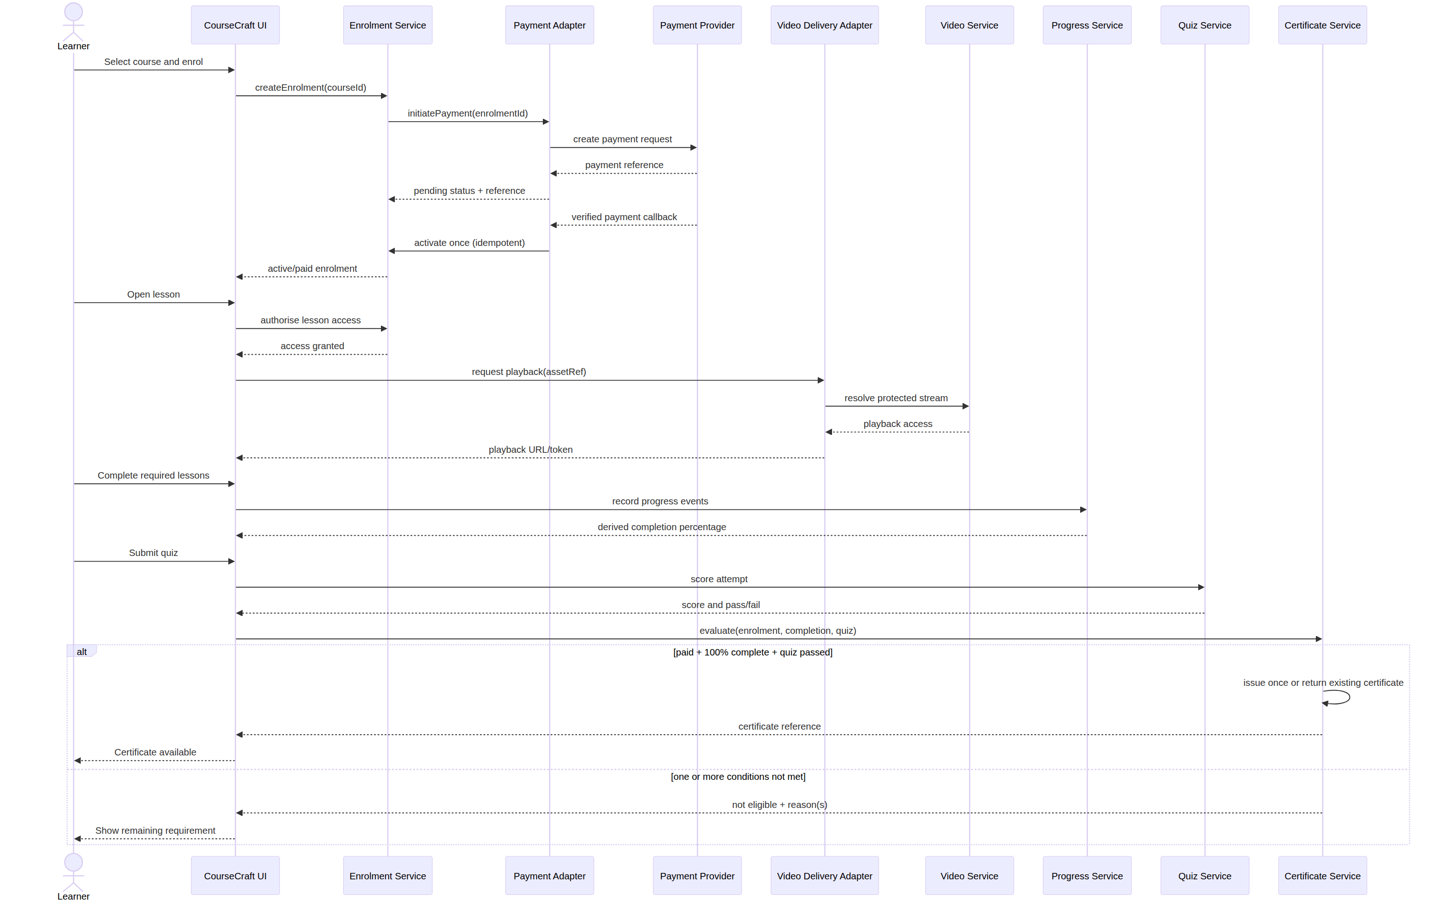

Activity diagram
CourseCraft UML design view
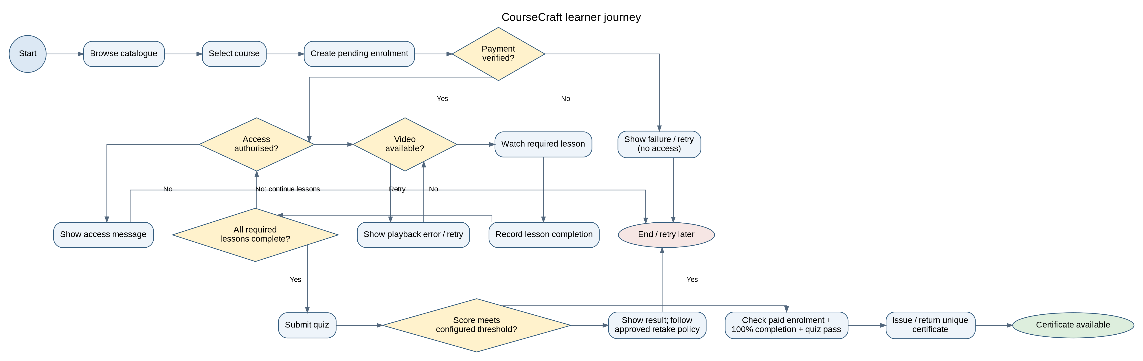

Enrolment state diagram
CourseCraft UML design view
