Visvesvaraya Technological University, Belagavi – 590018.

PROJECT PHASE-I REPORT ON

Intelligent Robotic System for Cow Dung Collection in Cattle Sheds
Submitted in partial fulfillment for the award of degree of
BACHELOR OF ENGINEERING
in
INFORMATION SCIENCE AND ENGINEERING
Submitted by
Sudeeksha | 4CB23IS109
Shweta Naik | 4CB23IS102
Sinchana CK | 4CB23IS103
Swasthi H Achar | 4CB23IS117
Under the Guidance of
Ms.Geethalaxmi
Asst. Professor, Department of Information Science And Engineering

DEPARTMENT OF INFORMATION SCIENCE AND
ENGINEERING

CANARA ENGINEERING COLLEGE
(An Autonomous Institution, Under VTU Belagavi, Recognized by
AICTE, Accredited by NBA(CSE,ISE,ECE) and NAAC ’A’ GRADE) Sudhindra Nagar, Benjanapadavu, Mangaluru - 574219,
Karnataka.
AY 2025-26

CANARA ENGINEERING COLLEGE
(An Autonomous Institution, Under VTU Belagavi, Recognized by
AICTE, Accredited by NBA(CSE,ISE,ECE) and NAAC ’A’ GRADE)
Sudhindra Nagar, Benjanapadavu, Mangaluru - 574219, Karnataka.
DEPARTMENT OF INFORMATION SCIENCE AND
ENGINEERING


CERTIFICATE
Certified that the Project work Phase-I entitled “Intelligent Robotic System for Cow Dung Collection in Cattle Sheds” carried out by
Sudeeksha | 4CB23IS109
Shweta Naik | 4CB23IS102
Sinchana CK | 4CB23IS103
Swasthi H Achar | 4CB23IS117
the bonafide students of VI semester INFORMATION SCIENCE AND ENGINEERING in partial fulfillment for the award of Bachelor of Engineering in INFORMATION SCIENCE AND ENGINEERINGE of the Visvesvaraya Technological University, Belagavi during the year 2025-2026. It is certified that all corrections/suggestions given during internal reviews are included for Internal Assessment. The Project Phase-I report has been approved as it satisfies the academic requirements in respect of Phase-I Project work prescribed for the said degree.
Ms.Geethalaxmi | Ms. Sadhana | Dr. Ganesh Pai
Project Guide | Project-Coordinator  Internal Viva: | HoD
Examiner’s Name |  | Signature with Date
1. ..................... |  | .....................
2. ..................... |  | .....................

CANARA ENGINEERING COLLEGE
(An Autonomous Institution, Under VTU Belagavi, Recognized by
AICTE, Accredited by NBA(CSE,ISE,ECE) and NAAC ’A’ GRADE)
Sudhindra Nagar, Benjanapadavu, Mangaluru - 574219, Karnataka.
DEPARTMENT OF INFORMATION SCIENCE AND ENGINEERING


DECLARATION
We hereby declare that the entire work embodied in this Project Phase-I Report titled “Intelligent Robotic System for Cow Dung Collection in Cattle Sheds” has been carried out by us at CANARA ENGINEERING COLLEGE, Mangaluru under the supervision of Ms.Geethalaxmi, for the partial fulfillment of Bachelor of Engineering in INFORMATION SCIENCE AND ENGINEERING. This report has not been
submitted to this or any other University for the award of any other de-
gree.
Sudeeksha | 4CB23IS109
Shweta Naik | 4CB23IS102
Sinchana CK | 4CB23IS103
Swasthi H Achar | 4CB23IS117

Acknowledgement
We dedicate this page to acknowledge and thank those responsible for the shaping of the Project Phase-I. Without their guidance and help, the experience while constructing the dissertation would not have been so smooth and efficient.
We sincerely thank our Project guide Ms.Geethalaxmi, Assistant/Associate Professor/Professor, Information Science And Engineering for his/her guidance and valuable suggestions which helped us to complete this Project Phase-I. We also thank our Project coordinators Ms. Sadhana , Dept of Information Science And Engineering, for their consistant encouragement.
We owe a profound gratitude to Dr. Ganesh Pai, Head of the Department,Information Science And Engineering, whose kind support and guidance helped us to complete this work successfully. We also take this opportunity to thank our Dean Academics and Vice-Principal Dr. Demian Antony D’Mello and We are extremely thankful to our Principal, Dr Nagesh H R, for their support and encouragement.
We would like to thank all faculty and staff of the Department of DEPTNAME who have always been with us extending their support, precious suggestions, guidance, and encouragement through the Project Phase-I.We also express our gratitude to our beloved friends and parents for their constant encouragement and support.
Sudeeksha
Shweta Naik
Sinchana CK
Swasthi H Achar

Abstract
With increasing demands for hygienic maintenance in cattle sheds, manual cleaning of cow dung has become a tedious and laborious task. This project shows an intelligent robotic system for automatic cow dung detection and collection to reduce human effort and to improve sanitation in rural dairy farms.
The system is based on vision technique and employs a camera for continuously monitoring real-time images of cattle shed. The images are processed in a YOLO based deep learning model for the accurate detection of cow dung and its location. Then, the processing unit (e.g. Raspberry Pi) uses the detected coordinates to control the movement of the robot. The navigation system then uses this information to control the motors to steer the robot toward the detected waste.
The cow dung is collected by a mechanical collection mechanism consisting of a scraper and a rotating brush, and the manure is deposited in an onboard storage container. It is designed to work efficiently on a variety of floor surfaces and has a simple alert system when the storage unit is full. The overall methodology integrates computer vision, embedded control and mechanical design into a unified automated solution.
This project has a great potential in dairy farms, rural areas, and smart agriculture applications, where it can improve the hygiene, reduce the manual labor, and enhance the operational efficiency. It can be further extended with sophisticated navigation, IoT-based monitoring and automated disposal systems.
Keywords : Cow Dung Detection, Robotic Waste Collection, YOLO,
Computer Vision, Smart Agriculture, Autonomous Navigation

Table of Contents
Acknowledgement i
Abstract ii
Table of Contents iv
List of Figures v
List of Tables vi

- Introduction 1
  - Background . . . . . . . . . . . . . . . . . . . . . . . . . . 1
  - Motivation and Problem statement . . . . . . . . . . . . . 1
  - Objectives . . . . . . . . . . . . . . . . . . . . . . . . . . . 1
  - Scope and limitations . . . . . . . . . . . . . . . . . . . . . 1
  - Relevance and Type . . . . . . . . . . . . . . . . . . . . . 1
  - Organization of the report . . . . . . . . . . . . . . . . . . 1
- Literature Survey 2
  - Title of Research Article 1 . . . . . . . . . . . . . . . . . . 2
    - Brief Findings of Article 1 . . . . . . . . . . . . . . 2
    - Design/Methodology/Techniques Adopted in Arti-
cle 1 . . . . . . . . . . . . . . . . . . . . . . . . . . 2
    - Results Achieved in Article 1 . . . . . . . . . . . . 3
  - Title of Research Article 2 . . . . . . . . . . . . . . . . . . 3
    - Brief Findings of Article 2 . . . . . . . . . . . . . . 3
    - Design/Methodology/Techniques Adopted in Arti-
cle 2 . . . . . . . . . . . . . . . . . . . . . . . . . . | 3
2.2.3 Results Achieved in Article 2 . . . . . . . . . . . . | 3
2.3 Title of Research Article n [apple2014pillars] . . . . . . . | 3
2.3.1 Brief Findings of Article n . . . . . . . . . . . . . .  2.3.2 Design/Methodology/Techniques Adopted in Arti- | 3
cle n . . . . . . . . . . . . . . . . . . . . . . . . . . | 3
2.3.3 Results Achieved in Article n . . . . . . . . . . . . | 3
2.4 Comparision Table . . . . . . . . . . . . . . . . . . . . . . | 4
2.5 Gap’s Identified and Addressed . . . . . . . . . . . . . . . | 4
2.6 Summary . . . . . . . . . . . . . . . . . . . . . . . . . . . | 4
3 Software Requirements Specification | 5
3.1 Functional Requirements . . . . . . . . . . . . . . . . . . . | 5
3.1.1 Image Acquisition . . . . . . . . . . . . . . . . . . . | 6
3.1.2 AI-Based Detection . . . . . . . . . . . . . . . . . . | 6
3.1.3 Navigation and Control . . . . . . . . . . . . . . . . | 6
3.1.4 Collection and Storage . . . . . . . . . . . . . . . . | 6
3.2 Non-Functional Requirements . . . . . . . . . . . . . . . . | 8
3.2.1 Safety Requirements . . . . . . . . . . . . . . . . . | 8
3.2.2 Performance Requirements . . . . . . . . . . . . . . | 9
3.2.3 User Interface Design . . . . . . . . . . . . . . . . | 9
3.2.4 3.4 Hardware and Software Requirements . . . . . . | 10
3.3 Summary . . . . . . . . . . . . . . . . . . . . . . . . . . . | 13
4 Conclusions of Phase-I and Phase-II Future work | 14
References | 15
A Drill-bit/Trunitin Plagiarism Report | 15
B Patent/Publication | 16

List of Figures
3.1 Use Case Diagram of Intelligent Robotic Cow Dung Collec-
tion System . . . . . . . . . . . . . . . . . . . . . . . . . . | 7
3.2 Alert Notification System . . . . . . . . . . . . . . . . . .  3.3 System Architecture of Intelligent Robotic Cow Dung Col- | 9
lection System . . . . . . . . . . . . . . . . . . . . . . . . . | 11
3.4 Flowchart of Cow Dung Detection and Collection Process . | 12

List of Tables
2.1 Comparison of existing work and Gap Identification . . . 4

Chapter 1 Introduction
1.1 Background
Paragraphs....
1.2 Motivation and Problem statement
Paragraphs....
1.3 Objectives
Obj1 to Objn
1.4 Scope and limitations
Paragraphs....
1.5 Relevance and Type
Paragraphs....

1.6 Organization of the report
Paragraphs....
1
Chapter 2

Literature Survey
Literature from text books/Journals/Conference papers,/Monograms/Handbooks/I.S codes and other sources need to be collected.
- Discussion from industry and academia experts, field surveys is to be noted and documented in a systematic way.
- Literature survey need to be written as a reference for the project work to mention how the work related is carried out by other researchers and what parameters are tested.
- Minimum 10 Reference Papers have to be cited.

2.1 Title of Research Article 1
[choki2022design] Paragraphs....
2.1.1 Brief Findings of Article 1
Paragraphs....

2.1.2 Design/Methodology/Techniques Adopted in Article 1
Paragraphs....
2
Intelligent Robotic System for Cow Dung Collection in Cattle Shed Chapter 2

2.1.3 Results Achieved in Article 1

2.2 Title of Research Article 2
[govindaraj2020online] Paragraphs....
2.2.1 Brief Findings of Article 2
Paragraphs....
2.2.2 Design/Methodology/Techniques Adopted in Article 2
Paragraphs....
2.2.3 Results Achieved in Article 2

2.3 Title of Research Article n [apple2014pillars]
Paragraphs....
2.3.1 Brief Findings of Article n
Paragraphs....
2.3.2 Design/Methodology/Techniques Adopted in Article n
Paragraphs....

2.3.3 Results Achieved in Article n

Department of Information Science And Engineering, CEC, Benjanapadavu,Mangaluru Page 3

Chapter 2

2.4 Comparision Table
Table 2.1: Comparison of existing work and Gap Identification
Project Title and Author | Problem Addressed | Implementation and  Results | Limitations/ Future Scope
Design of Electronic Voting System for Visually Impaired Persons Using Arduino Mega 2560 By Dema  choki et.al ,2022 | The author has mainly described the issues that are faced by the disable persons. | By using the Arduino Mega 2560 board, we developed a prototype of a secured, electronic voting system for visually impaired people. | - Limited Precision  - Limited  Scalability
Online Voting System by Using Three  Step Verification By  N.Sreenivasa et.al,2022 | By visualizing the overview these project implies Elections are the primary | This research work demonstrates novel online voting systems | • Online voting systems are susceptible to security risks
A Visionary Approach  To Smart Voting System Rohit S Rao  et.al,2021 | In light of the global  COVID-19 pandemic, the need for an online voting system. | Adjusting advanced democratic frameworks to disclose the electing interaction less expensive | • Not many security protocols

2.5 Gap’s Identified and Addressed
After L.S elbroate what Gaps have been identified and Explain how those gaps are going to be filled through your objectives.

2.6 Summary
Every chapter should end with summary section, this section have to summarize in brief what-all discussed in the present chapter and what all are going to be discussed in next chapter.
Chapter 3

Software Requirements Specification

3.1 Functional Requirements
Functional requirements define the behavior and operations of the proposed system when specific inputs are provided. The system is designed to detect and collect cow dung efficiently using AI-based vision and robotic mechanisms. The following are the functional requirements of the system: • The system shall continuously capture real-time images or video from the cattle shed environment using a camera module.
- The system shall process the captured frames using a trained YOLO model to detect the presence of cow dung.
- The system shall accurately identify and generate the location (coordinates) of detected cow dung.
- The system shall compute movement directions (left, right, forward) based on detected position. • The system shall control motors to navigate the robot toward the detected waste location.
- The system shall activate the collection mechanism to gather cow dung using scraper and brush.
- The system shall store collected waste in an onboard storage container.
5
- The system shall provide an alert when the storage container reaches full capacity. • The system shall operate continuously without interruption for extended periods.
- The system shall function correctly under different environmental and lighting conditions.

3.1.1 Image Acquisition
The system captures real-time images of the cattle shed using a camera module. These images are used as input for detecting cow dung and monitoring the environment continuously.

3.1.2 AI-Based Detection
The captured images are processed using a trained YOLO model to detect cow dung. The system generates bounding boxes and identifies the exact position of waste for further action.

3.1.3 Navigation and Control
The processing unit analyzes detection results and determines the movement direction. The robot navigates toward the detected location using motor drivers and control signals.

3.1.4 Collection and Storage
The system uses a scraper and rotating brush mechanism to collect cow dung and transfer it into an onboard storage container. The storage unit holds waste until it reaches full capacity, after which an alert is generated.

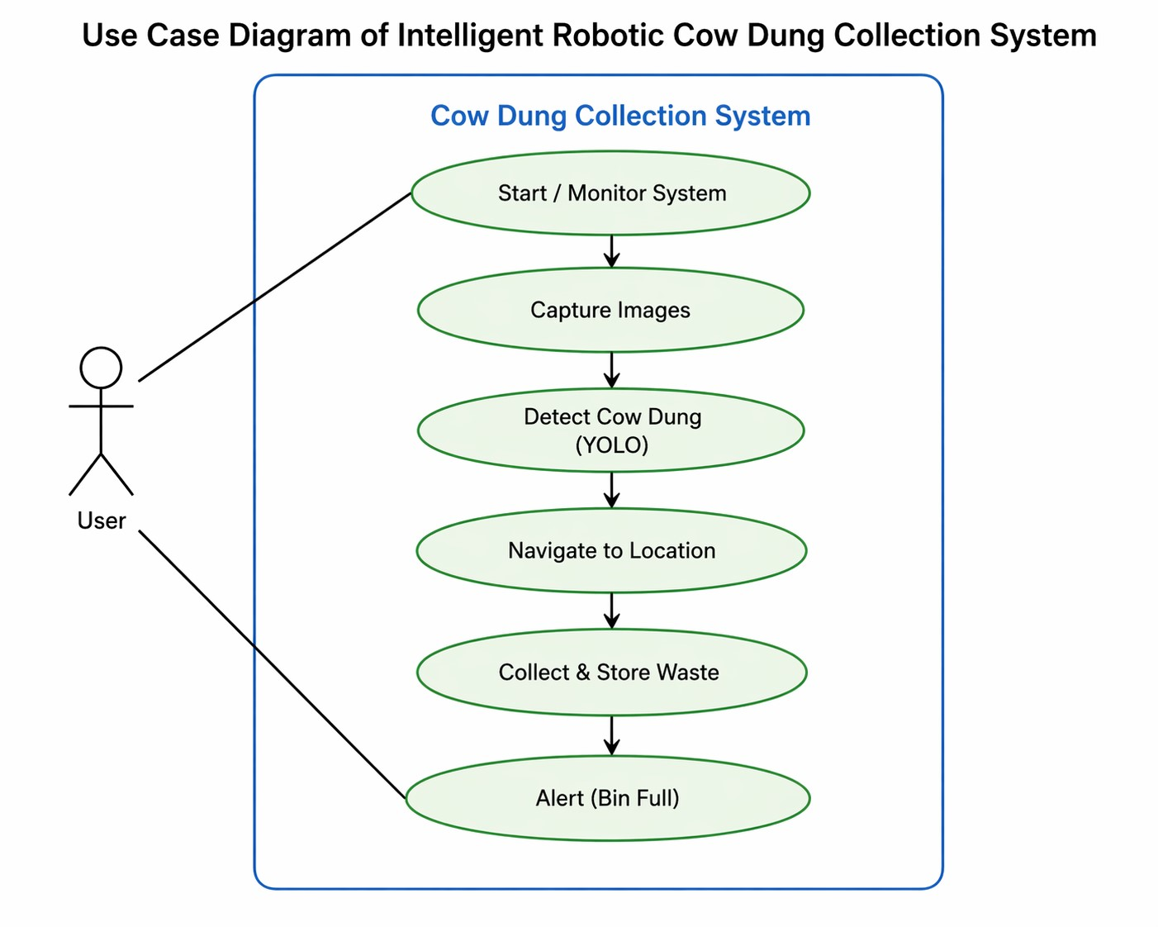
Figure 3.1: Use Case Diagram of Intelligent Robotic Cow Dung Collection System
The use case diagram illustrates the interaction between the user and the proposed system. The user can start and monitor the system operation, while the system performs automated tasks such as capturing images, detecting cow dung using the YOLO model, and navigating toward the detected location.
Once the waste is detected, the robot collects and stores it in the onboard storage bin. When the storage reaches its maximum capacity, the system generates an alert to notify the user. This diagram clearly represents the overall workflow and functional behavior of the system in a simple and understandable manner.

3.2 Non-Functional Requirements
Non-functional requirements define the quality attributes and constraints of the proposed system. These requirements ensure that the system performs efficiently, reliably, and safely under different operating conditions. Unlike functional requirements, these do not describe what the system does, but how well it performs its tasks.
The proposed AI-based cow dung collection system must be robust, efficient, and user-friendly. It should operate continuously in a cattle shed environment with minimal human intervention while maintaining accuracy in detection and smooth navigation. The system should be scalable for future enhancements such as IoT integration and automated disposal mechanisms.
The system must also be reliable under varying environmental conditions such as changes in lighting, floor surfaces, and presence of obstacles. It should consume minimal power and provide consistent performance over long durations. Additionally, the system should be easy to operate and maintain, especially for rural users with minimal technical knowledge.

3.2.1 Safety Requirements
The system must ensure safe operation within the cattle shed environment to avoid harm to animals, humans, and equipment. The robot should move at a controlled speed to prevent collisions and ensure stability during operation.
All electrical components must be properly insulated to prevent short circuits or damage due to moisture present in the shed. The mechanical parts such as scraper and rotating brush should be designed in a way that they do not cause injury during operation.
The system should also include basic fault handling mechanisms such as stopping operation in case of unexpected obstacles or system failure. Proper structural design must ensure durability and safe functioning over extended usage.

3.2.2 Performance Requirements
The system must provide real-time detection of cow dung using the trained YOLO model with high accuracy. It should process input frames efficiently without noticeable delay and generate quick navigation decisions.
The robot should be capable of moving smoothly across different types of surfaces . The collection mechanism must operate effectively to ensure maximum waste removal with minimal residue.
The system should support continuous operation for a reasonable duration without overheating or performance degradation. It should also maintain consistent detection and navigation accuracy throughout its operation.

3.2.3 User Interface Design
The user interface of the proposed system is designed to be simple and easy to use, especially for rural users with minimal technical knowledge. The system does not require a complex dashboard or continuous manual interaction. Instead, it provides basic system feedback and alert notifications to inform the user about the system status.The primary interaction between the user and the system is through an alert mechanism.
Alert Notification System
StorageMonitoring
Alert(Buzzer/LED)
UserNotification
Figure 3.2: Alert Notification System
The alert notification system ensures that the user is informed at the right time without continuously monitoring the system. This improves usability and reduces manual effort, making the system more practical for real-world deployment in cattle sheds.

3.2.4 3.4 Hardware and Software Requirements
This section describes the hardware and software components required for the implementation of the Intelligent Robotic System for Cow Dung Collection. The system integrates computer vision, embedded systems, and mechanical components to achieve automated detection and collection.
Hardware Requirements
- Processor: Raspberry Microcontroller for processing and control
- Camera: USB Webcam / Pi Camera Module for real-time image capture
- Motor Drivers: L298N or equivalent for controlling motors
- Motors: DC motors for robot movement and cleaning mechanism
- Power Supply: Rechargeable battery for system operation
- Sensors: Basic sensors for obstacle detection / storage monitoring
- Collection Mechanism: Scraper and rotating brush system
- Storage Unit: Container to store collected cow dung
- Alert System: Buzzer / LED for notification
Software Requirements
- Operating System: Linux / Windows

• Programming Language: Python 3.x
- Libraries: OpenCV, NumPy
- Deep Learning Model: YOLO (for object detection)
- Framework: PyTorch

• IDE/Editor: VS Code
• Tools: Roboflow (for dataset annotation), pip package manager
System Architecture
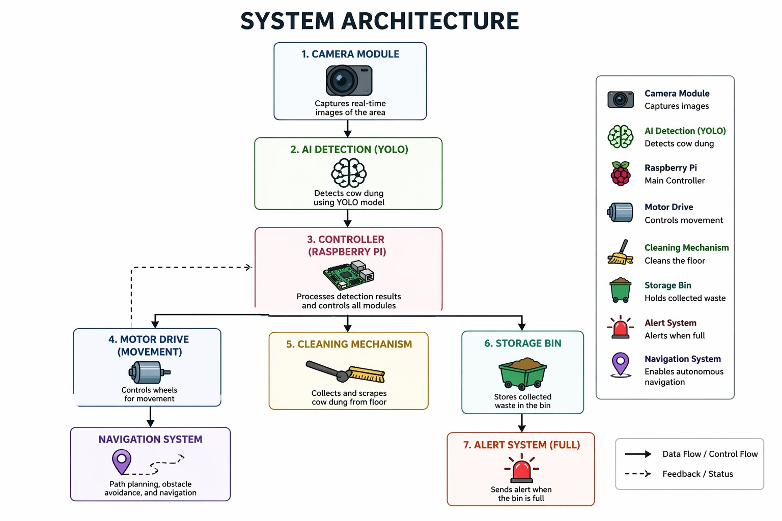
Figure 3.3: System Architecture of Intelligent Robotic Cow Dung Collection System
The system architecture represents the overall structure and interaction between different modules of the proposed system. It consists of components such as the camera, AI-based detection module (YOLO), controller (Raspberry Pi), motor drive system, cleaning mechanism, storage unit, and alert system.
The process begins with the camera capturing real-time images of the cattle shed environment. These images are passed to the YOLO-based detection module, which identifies the presence and location of cow dung. The detected coordinates are then sent to the Raspberry Pi, which acts as the central processing unit.
Based on the detection results, the controller generates appropriate movement commands and sends them to the motor drive system. The robot navigates toward the detected location and activates the cleaning mechanism, which collects the cow dung using a scraper or brush system. The collected waste is stored in an onboard storage container.
Once the storage bin reaches its capacity, the alert system notifies the user through a buzzer or LED indication. This modular architecture ensures smooth integration of detection, navigation, collection, and alert functionalities for efficient autonomous operation.
Process Flowchart
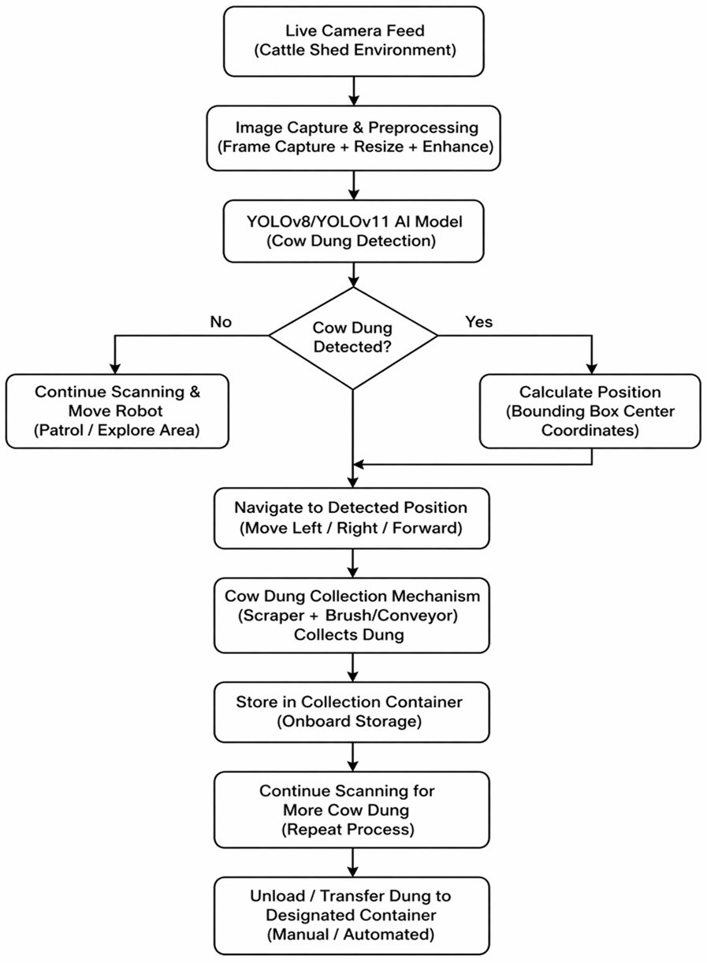
Figure 3.4: Flowchart of Cow Dung Detection and Collection Process
The flowchart illustrates the step-by-step working of the proposed system. The process starts with capturing live images from the camera, followed by preprocessing steps such as resizing and enhancement to improve detection accuracy.
The processed images are then passed to the YOLO model, which detects the presence of cow dung. If cow dung is detected, the system calculates its position and navigates the robot toward the detected location. Once the robot reaches the target, the cleaning mechanism is activated to collect the waste and store it in the onboard container.
If no cow dung is detected, the robot continues scanning the environment until waste is identified. This ensures continuous monitoring and efficient operation of the system. Once the storage bin becomes full, the system triggers an alert and the collected waste can be unloaded to a designated disposal area.This workflow ensures an efficient and automated process for detecting, navigating, collecting, and storing cow dung within the cattle shed.

3.3 Summary
This chapter presented the Software Requirements Specification of the proposed Intelligent Robotic System for Cow Dung Collection. It covered both functional and non-functional requirements, providing a clear understanding of the system behavior and performance expectations.
The hardware and software requirements were discussed in detail, outlining the necessary components and tools required for system implementation. Additionally, diagrams such as the system architecture and process flowchart were included to visually represent the working of the system.
Overall, this chapter provides a structured overview of how the system is designed to operate, ensuring clarity in implementation and serving as a foundation for further development in the subsequent phases of the project.

Chapter 4

Conclusions of Phase-I and Phase-II Future work
This chapter includes an assessment of the success of the work carried out. Comparison tables of results obtained and statement of conclusion. If the expected results are not obtained, the reason for the same can be identified.
Suggestions for scope for the future work is presented to explain how the work can be carried for value addition, for a different design, for implementing a different test scenario or implementation on a different platform.
Appendix A

Drill-bit/Trunitin Plagiarism Report
In this section Drill-bit Plagiarism/Trunitin Report of Project Report has to be included.(Min less than 25 percentage )
Appendix B

Patent/Publication
In this section if the Project team have filed a patent/project is patentable , then Patent Non-Disclosure Report has to attached at end of project report as per the format.
In this section if the project team published a Paper on their project in any Scopus /Web of science indexed National/International conferences /journals details has to be included.
- Title of the paper :
- National/International conferences /journals details :
- Authors details :
- Published/DOI Link :
If paper not published but Accepted, then acceptance details like mail/letter screen shot can be included.

Project Summary
This project presents an AI-based intelligent robotic system for automated detection and collection of cow dung in cattle sheds. The system uses realtime visual monitoring to detect the presence of cow dung and activate collection only in the areas where the waste is present. These video frames from the camera feed are given to a trained YOLO-based model which correctly identifies cow dung by outputting the bounding box coordinates.
Once the detection is complete, the position of the waste is calculated by the system and the robot is guided to the detected position with the help of a processing unit such as Raspberry Pi. A scraper at the front and a rotating brush collect the cow dung and put it into a storage container onboard.
The proposed solution aims to minimize manual labour, improve hygiene and increase efficiency in cattle shed maintenance. The architecture is scalable and can be extended with advanced navigation techniques, IoT based monitoring, automated waste disposal and smart farming integrations to enable real-time tracking and control.

