**A PROJECT REPORT ON**

# “COOKING RECIPES PORTAL: FOODEMY”

SUBMITTED TO MIT SCHOOL OF

ENGINEERING, LONI

## BY

**SHWETA PASI (MITU20BTIT0061)**

**DEEP BAGUL (MITU20BTIT0021)**

**AYUSH NEELKANTH (MITU20BTIT0016)**

**SAKET GADGE (MITU20BTIT0044)**

**Mini Project Report**

**Under the guidance of**

Prof. Ayesha Butalia



**Department of Information**

**Technology MIT School of Engineering**

**MIT Art, Design and Technology University,**

**Pune MAEER’s Rajbaug Campus,**

**Loni-Kalbhor, Pune 412201 2020-21**

**Prof. Dr. Ayesha Butalia Prof.Dr. Rekha Sugandhi**

**Guide HOD**

# ACKNOWLEDGEMENT

I express my profound thanks to my Guide **Prof. Dr. Ayesha Butalia** for his expert guidance, encouragement and inspiration during this Dissertation work.

I sincerely thank to **Prof. Dr. Rekha Sugandhi**, Head, Department of Information Technology, MIT School of Engineering, MIT-ADT University, Pune, for providing necessary facilities for completing the project.

I am grateful to **Prof. Dr. Kishore Ravande**, Principal, MIT School of Engineering, MIT-ADT University, Pune, for providing me the facilities to carry out my project work.

I also thank all the faculty members in the Department for their support and advice. I am very much grateful and thankful to my Parents for their immense love, affection, help, cooperation and encouragement to complete this course.

Finally, a special thanks to all my classmates and friends who helped and encouraged me to complete successfully my project work.

-Shweta, Deep, Saket, Ayush

**Synopsis:**

In this project, we will be making a website that helps users read and upload food recipes.

This is an intermediary level project that requires preferably the latest version of HTML (for best performance).

Food is an essential part of our daily lives. We live in a modern world where people are learning to be self-reliant and one of the aspects of this self-reliance is cooking their own meals. Our website aims at making easy for the modern man to find recipes here and regain their sense of individuality. One can also help others by uploading their recipes with ingredients varying in different regions.

This site is convenient, effective and easy to use thereby making it the modern man’s go to site for all food related queries.

**Table of Contents:**

|  |  |  |
| --- | --- | --- |
| **Sr. No.** | **SECTION** | **Page No.** |
| 1 | Introduction |  |
| 2 | Software Requirements |  |
| 3 | Design/Implementation |  |
| 4 | Testing/Result and Analysis |  |
| 5 | Conclusions and Future Enhancements |  |
| 6 | References |  |

**Introduction:**

The main purpose of this website is to revolutionise cooking at home, with its easy-to-use approach. The home page is filled with recommendations for a good meal but you can also search for the recipe of your choice, which are in turn uploaded by different users of this website all over the world. Another perk that users get in this site is the fact that they also get to see different videos to see how other users have cooked that particular meal. You have a login menu, to keep your data saved with the website and you can use that option to keep a track of all the recipes you have used before. You can also contact the customer care from the about option. Finally, you can also drop your feedback and let us at Foodemy know how we can make your experience better the next time you decide to visit Foodemy.

**SOFTWARE REQUIREMENTS**

* HTML
* JAVASCRIPT
* CSS

**DESIGN AND IMPLEMENTATION:**

There are a number of steps for the design and implementation of our project:

· Home Page

· Login Dropdown

· Feedback Bar

· Recipes sidebar

· Recommended Dishes

· Upload Image/Text/Video option

· Contact Us option in the About tab.

**TESTING RESULT/ANALYSIS:**

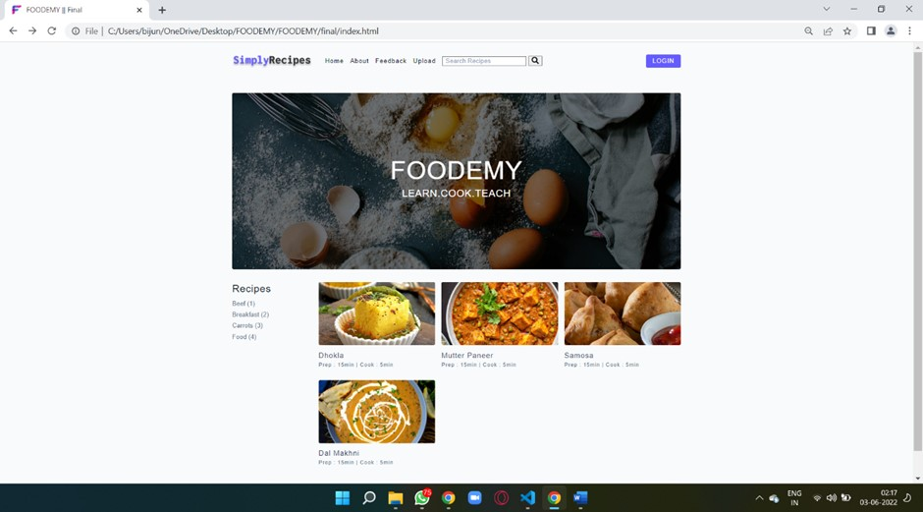

* ***HOME PAGE***

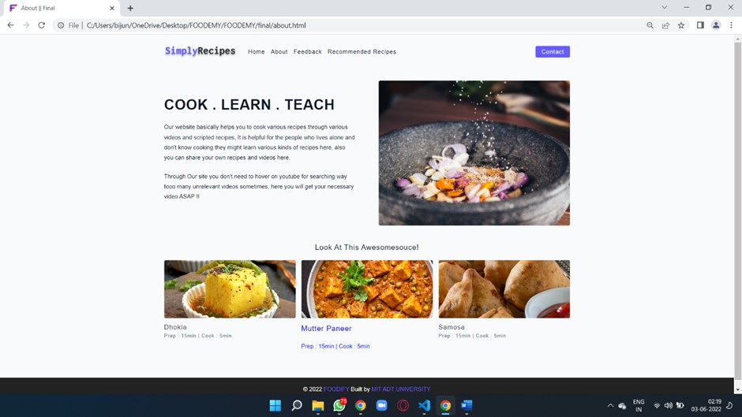

* ***ABOUT SECTION***

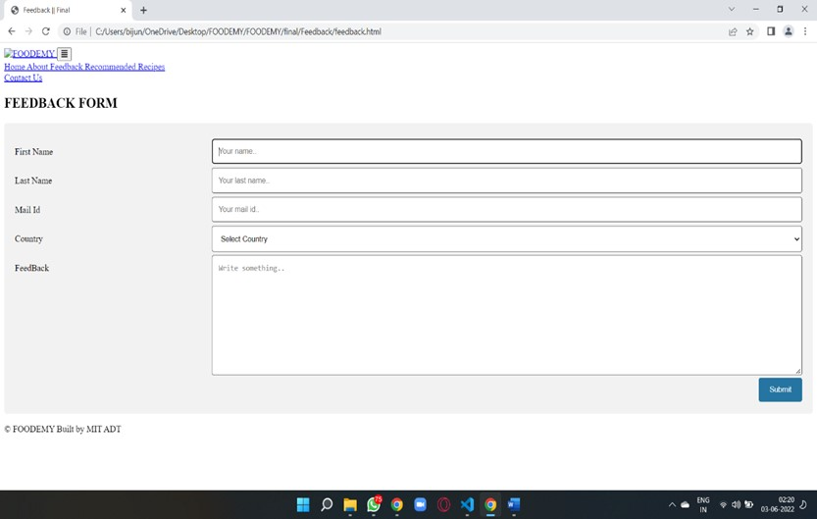

* ***FEEDBACK FORM***

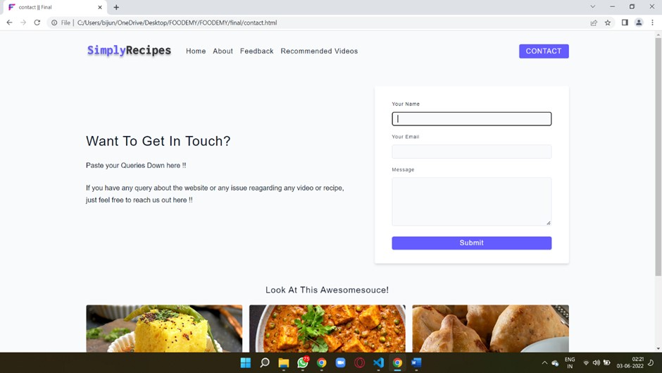

* ***CONTACT SECTION***

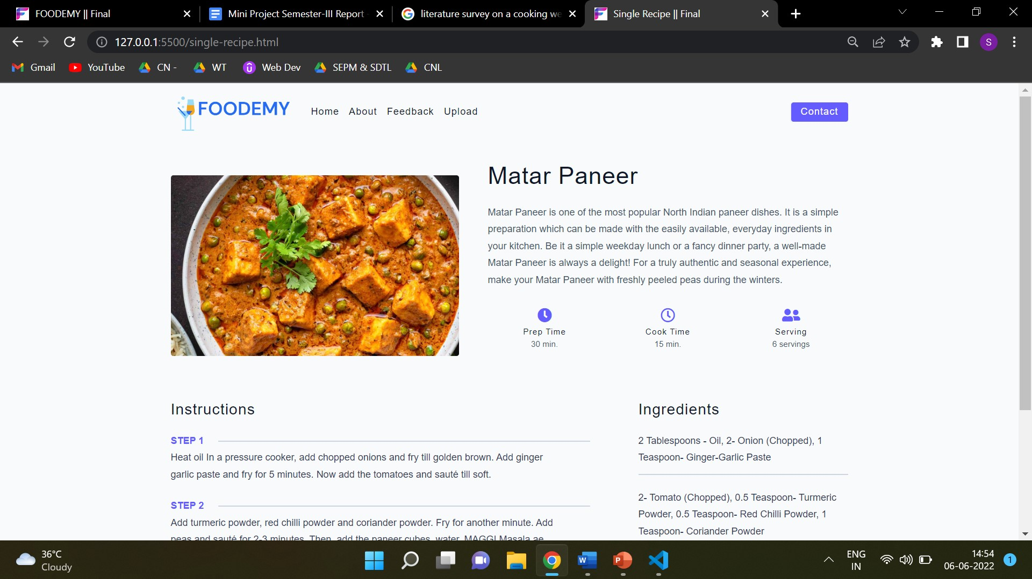

* ***RECIPE SECTION***

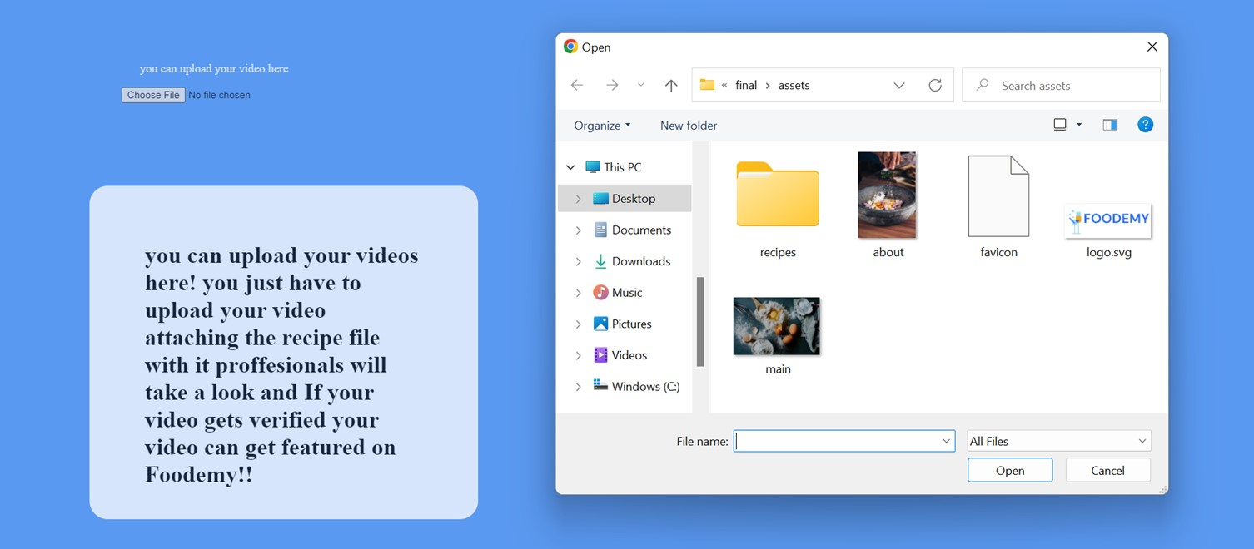

* ***UPLOAD SECTION***

**ANALYSIS:**

The program once put to execution, performs the task perfectly well.

Its functionalities include:

* 1. Displaying the home screen to the user.
  2. Asking user to LOGIN
  3. Displays the feedback option
  4. Shows recommended dishes
  5. Also gives the user an upload option

**CONCLUSION & FUTURE ENHANCEMENTS:**

This website was created as an attempt to make getting recipes from the internet an easier task. The simple approach of this website is what we are hoping this website will be popular among the users. With the help of this website a user can not only accept help but also help other by providing recipes. So, to conclude this website makes cooking easy for any and every user and makes them self-reliant.