Project Report: Diabetes Risk Prediction Using Data Analytics
Program: AICTE | IBM SkillsBuild Data Analytics with AI Internship
Submitted By: Miss. Shweta Ravindra Desai.

1. Introduction
Diabetes has become one of the most common health challenges nowadays. The main goal of this project is to analyze a large healthcare dataset of 50,000 patients and find out how factors like age, BMI, and blood sugar levels affect diabetes risk. Instead of just looking at static numbers, this project bridges the gap by building a real-time interactive web dashboard to explore the data dynamically.

2. Dataset Details
- Source: Kaggle (Diabetes Risk Prediction Dataset)
- Total Records: 50,000 patient records
- Important Features Analyzed:
  - Age & Gender: Basic demographic details of patients.
  - BMI (Body Mass Index): Used to measure body fat based on height and weight.
  - Blood Glucose & HbA1c: Key medical tests for tracking sugar levels.
  - Lifestyle Metrics: Sleep hours and daily routines.
  - Target Variable: Diabetes_Risk (Categorized as Low, Moderate, and High).

3. Step-by-Step Methodology
I completed this project by following standard data analytics steps:
- Data Loading: Imported the dataset using Python and Pandas inside a Jupyter Notebook environment.
- Data Preprocessing: Checked for missing values, cleaned columns, and verified data types to ensure accuracy.
- Exploratory Data Analysis (EDA): Used Matplotlib and Seaborn libraries to generate initial charts and find hidden trends.
- Dashboard Development: Created an interactive web app using Streamlit and Plotly so users can filter and analyze data on the fly.

4. Key Findings & Visualizations
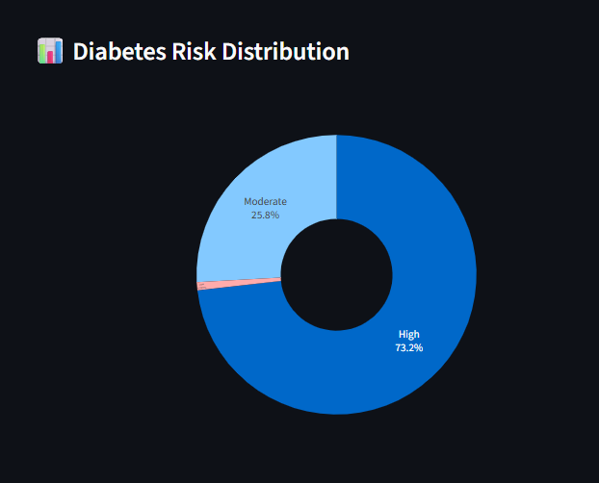
- A. Diabetes Risk Distribution Observation: The analysis breaks down the dataset to show how many patients fall into Low, Moderate, and High risk groups.

- B. Age and BMI Relationship Observation: The scatter plot shows a clear trend where individuals with higher BMI and older age groups experience a higher density of risk.
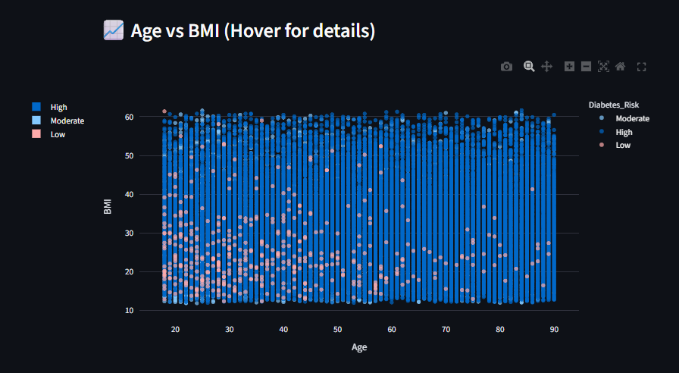

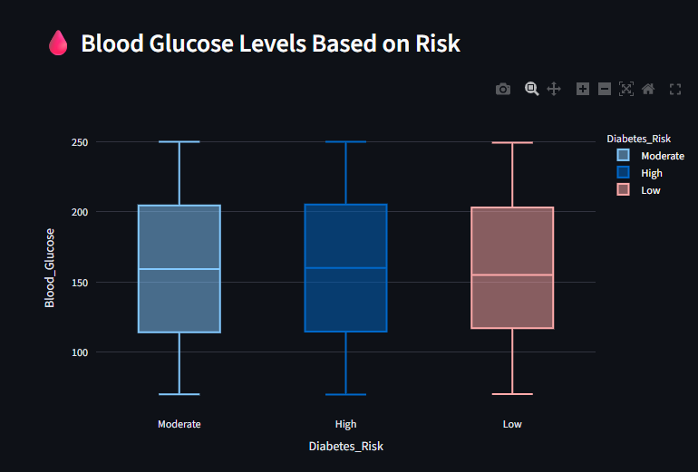
- C. Blood Glucose Levels Observation: Box plots confirm that patients categorized under 'High Risk' consistently show elevated fasting blood glucose levels.

- D. Health Metrics Correlation Observation: The correlation heatmap highlights the direct mathematical relationship between blood glucose, HbA1c, and overall risk.

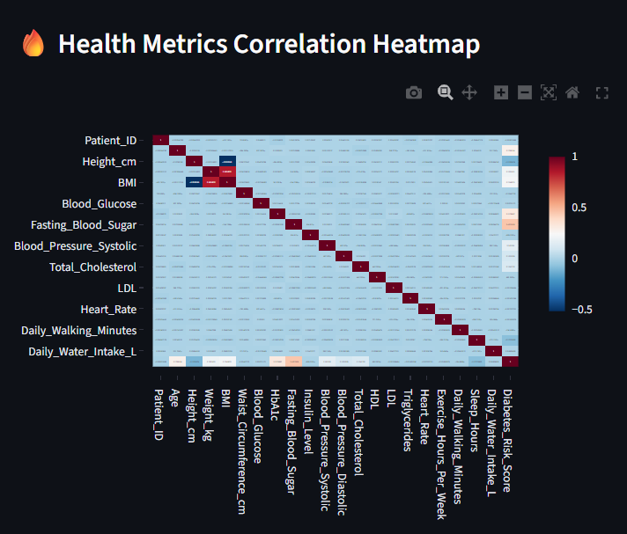

5. Interactive Dashboard Overview
The Streamlit dashboard makes the dataset easy to interact with through:
- Sidebar Filters: Multi-select for gender and a slider for age range filtering.
- Live KPIs: Instant updates on total patients analyzed, average age, average BMI, and average glucose levels.
- Hover-enabled Plots: Detailed tooltips on charts to check individual data points instantly.

6. Conclusion
Working on this project gave me practical experience in handling healthcare data using Python. The findings prove that regular monitoring of BMI and blood glucose is vital for early prevention. The interactive dashboard serves as a functional tool that brings the analysis to life.

