FlowerStation

Send Flower Anywhere

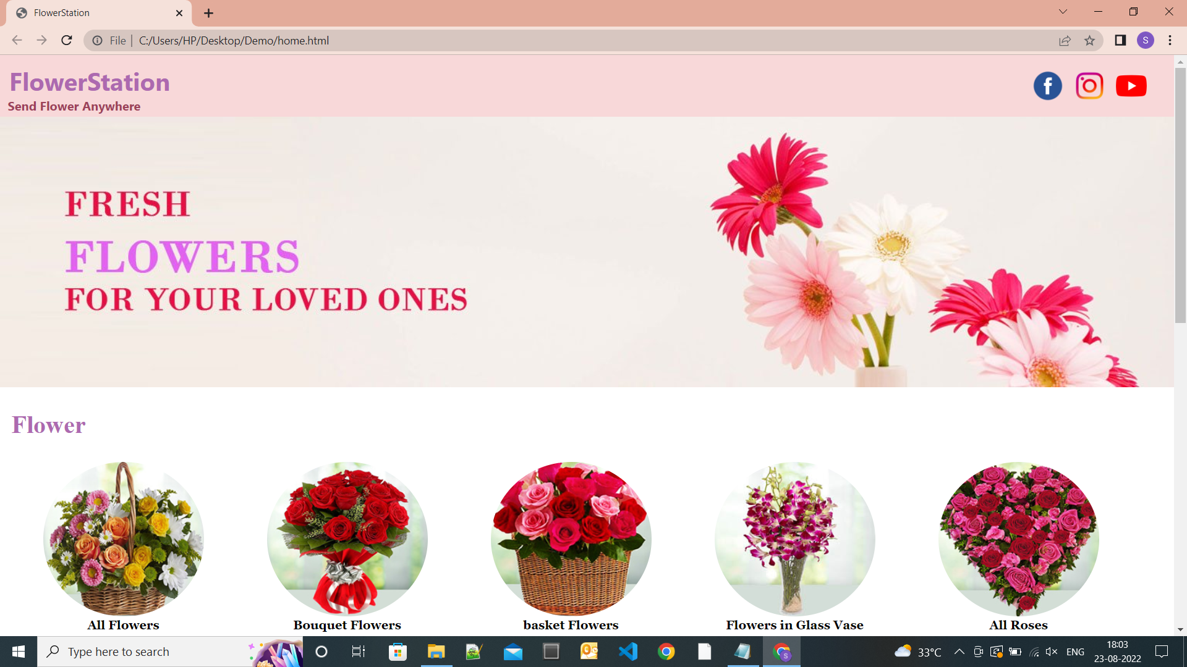

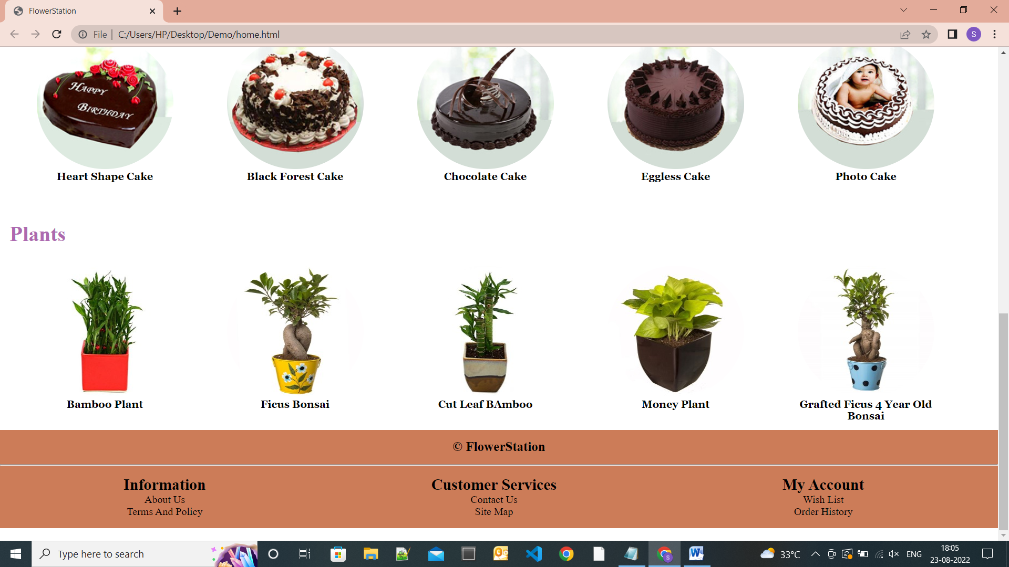

Shweta Sharma

Edureka

**Overview**

Flowers have always been the most special gifts for any occasion. It might be a birthday celebration, weddings, parties or the graduation ceremony, etc. the presence of the flowers is undeniable. Hence, sending flower using technology save your time and energy. FlowerStation is India’s leading florist company. We do not just provide flowers in various ways but, we also deliver them on the doorstep of those you want them delivered to. Metropolitan lifestyle demands this kind of a service which we are glad to give. We have a wide and unique range of items to select from which includes chocolates, cakes and gifts for every occasion.

**Modules**

1. Home Page
2. Login and Logout Page
3. Product Page
4. Payment Page
5. Feedback Page

**Technology used in FlowerStation**

**Frontend and Backend-**

1. HTML
2. CSS
3. Bootstrap
4. Java Script
5. Mongodb

**Code complier-**

1. Visual Studio
2. Git bash
3. Github
4. Node.js

**References**

<https://www.phoolwala.com/>

<https://www.fnp.com/>

<https://www.floristsinindia.com/>

<https://www.interflora.in/flowers-to-delhi>

<https://www.w3schools.com/>